Wood Buffalo Environmental Association
Ambient Air Monitoring Station
Site Documentation

IPC Blackrod

LAST UPDATED: March 02, 2026

Table of Contents
General Site Information 4
Station 4
Location 4
Owner/Operator/Approval Holder 4
Site Description 5
Site Influences 5
Localized Sources 5
Roadway Influences 5
Major Point Sources 5
Analytical Equipment 6
Meteorological Equipment 6
Support Equipment 6
Site photos 11
Station Photos 16

Tables and Figures
Figure 3.0 – Plan view image for AMS 31 site. 7
Figure 4.0 – Aerial photo showing AMS 31. 8
Figure 5.0 – Elevation view image for AMS 31. 9
Figure 6.0 – Environment looking North. 10
Figure 6.1 – Environment looking East. 11
Figure 6.2 – Environment looking South. 12
Figure 6.3 – Environment looking West. 13
Figure 6.4 – Meteorological tower. 14
Figure 7.0 – Photo showing the inlet and sample manifold. 15
Figure 7.1 – Curb shot of the monitoring station. 16
Figure 7.2 –Photo of front and back of instrument rack. 17
Figure 8.0 – Windrose (Five Year). 18

General Site Information
Revision Date: March 02, 2026

Station
Station ID | AMS 31
Station name | IPC Blackrod
Date station established | November 21, 2024

Location
Station street address | NA
Legal land description | 15-25-76-18-W4
Latitude | 55.61877
Longitude | -112.65449
UTM East | 570168.862
UTM North | 5650300.787
Nearest community | Wandering river
Community population | 500

Owner/Operator/Approval Holder
Operating Agency | Wood Buffalo Environmental Association
Name of Approval Holder | IPC Blackrod
Approval number | 00301778-00-01
Contact Name | Greg Currie
Address | Lac La Biche, AB T0A 3M0
Phone number | +1 403 536 4693
Email address | Greg.currie@international-petroleum.com

Site Description
Land use by sector | 0 – 90 degrees | Compressor shack
Land use by sector | 91 – 180 degrees | Well pads
Land use by sector | 181 – 270 degrees | SAGD facility
Land use by sector | 271 – 360 degrees | SAGD facility
Site elevation
(Above sea level)
Angle of elevation to nearby building | Admin bldg | <5 degrees
Airflow restrictions | North | None
Airflow restrictions | East | None
Airflow restrictions | South | None
Airflow restrictions | West | None
Sample manifold | Type | All glass
Sample manifold | Inlet height above roof | >1 meter
Meteorological Sensors | Type | Cup and vane
Meteorological Sensors | Height above ground | 10
Meteorological Sensors | Distance from station | 7

Site Influences

Localized Sources (within 20 metres of station)
Type | Distance (m) | Description
Admin Bldg | 8
Portable toilet | 5

Roadway Influences
Type | Traffic Volume | Distance (m) | Description
Dirt/gravel | Medium |  | Used by site workers

Major Point Sources
Facility Name | Source Type | Production Capacity | Distance from site (m) | Compass direction from site
IPC Blackrod | SAGD Facility |  |  | W

Analytical Equipment
Parameter | Owner | Make | Model | Serial Number | Date Installed
SO2 | Blackrod | Thermo Instruments | 43i | 1160290014 | Nov 20, 2024
H2S | Blackrod | Thermo Instruments | 43iQTL | 12228021056 | Nov 21, 2024
NO2 | Blackrod | Thermo Instruments | 42i | 1173480006 | Nov 20, 2024
THC | Blackrod | Thermo Instruments | 51i | 1505164580 | Feb 3, 2026

Meteorological Equipment
Parameter | Make | Model | Serial Number | WMO Site Class | Date Installed
AT/RH | Vaisala | HMP155 | W3726142 | 4 | Dec 09, 2024
WS | Met One | 010C-1 | E15359 | 2 | Nov 21, 2024
WD | Met One | 020C-1 | E13779 | 2 | Nov 21, 2024

Support Equipment
Name | Description | Make | Model | Serial Number
Datalogger | Datalogger | Campbell Scientific | CR3000 | 1220
Zero air generator | Zero Air Generator | Teledyne/API | 701 | 72
HVAC | Heating and air conditioning system. Wall mount unit | BARD | 1 ton | NA
Shelter / Building | Air monitoring portable | ITB | 8 x 16 trailer | NA
Gas Dilution Calibrator | Mass flow-controlled gas dilution | Teledyne/API | T700 | 1220
Tower | 10 Meter crank up | Aluma | T-135 | 217224002

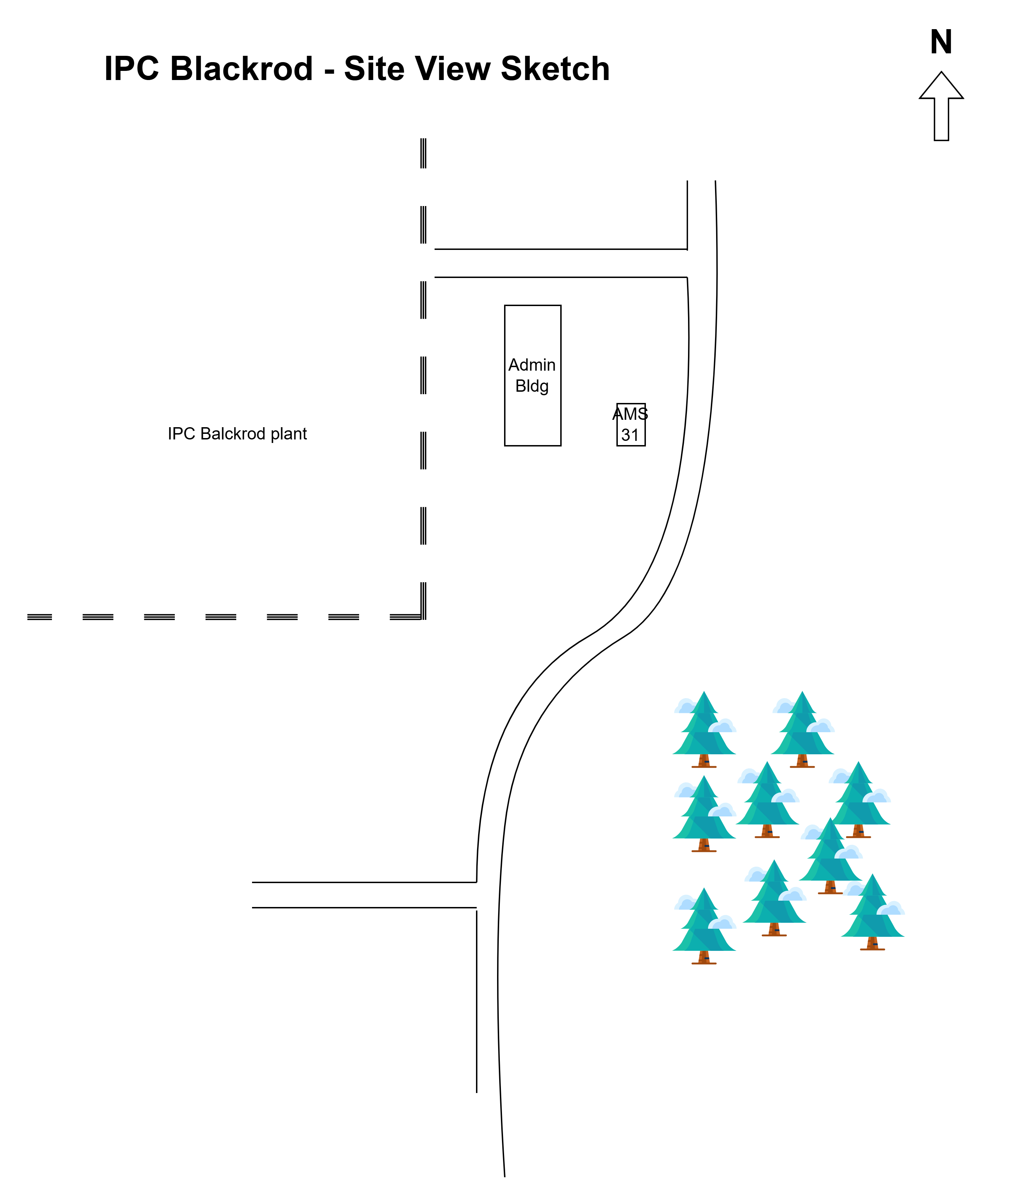

  - Figure 3.0 – Plan view image for AMS 31 site.

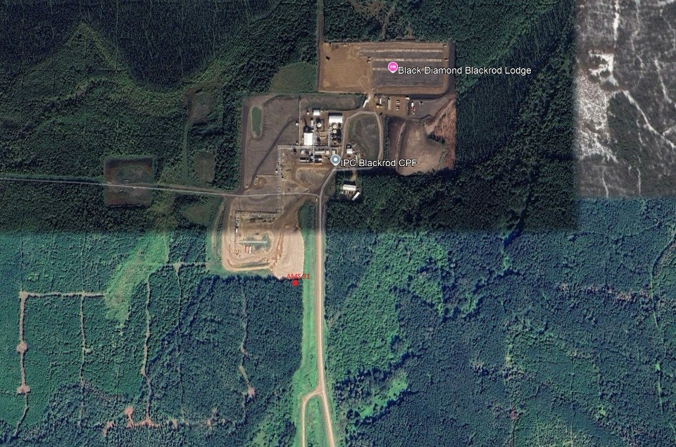
  - Figure 4.0 – Aerial photo showing AMS 31.
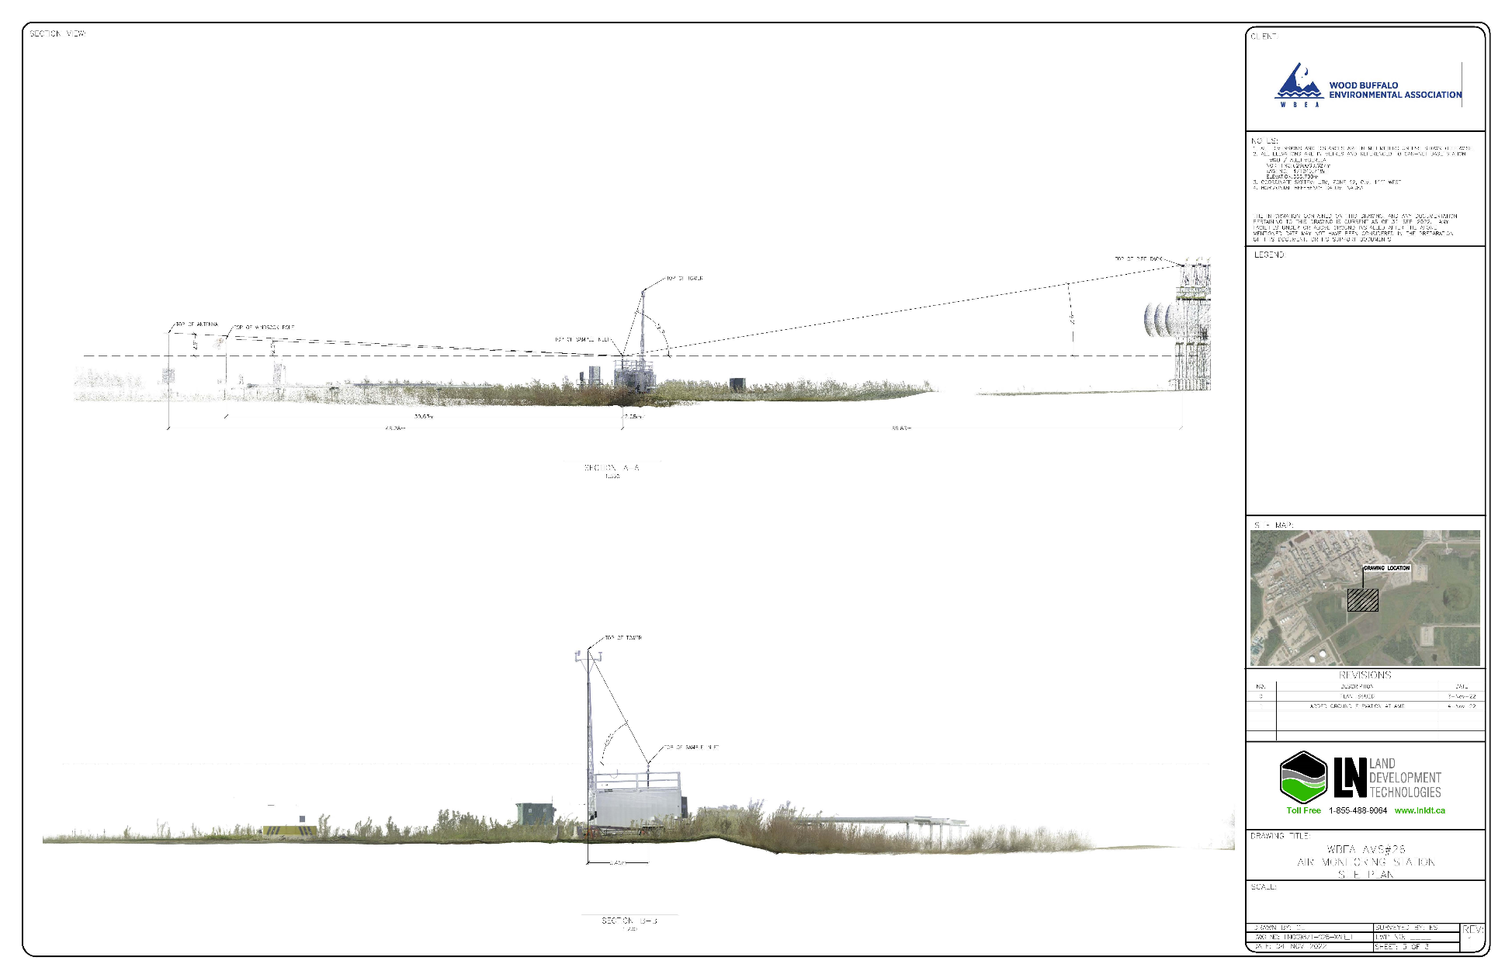
  - Figure 5.0 – Elevation view image for AMS 31.

Site photos
The following photos show the environment surrounding the monitoring station.
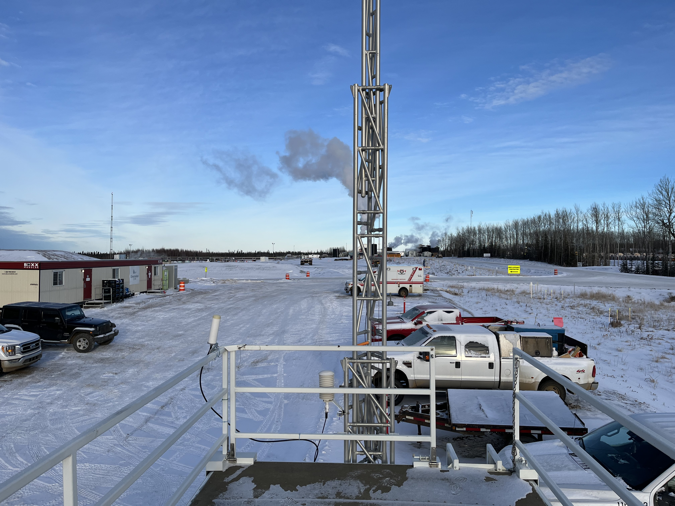
  - Figure 6.0 – Environment looking North.

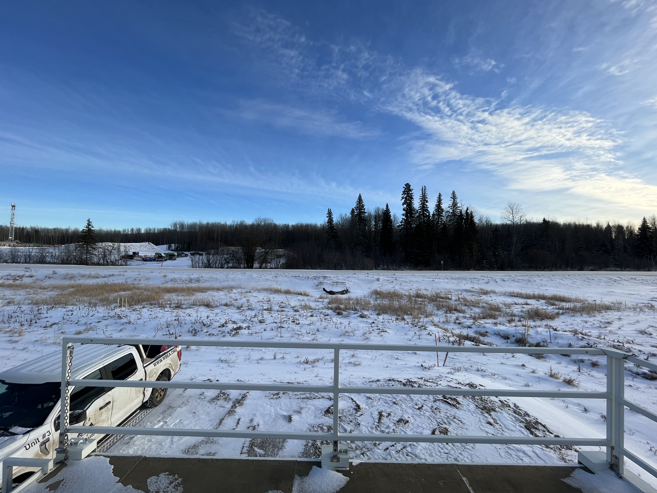
  - Figure 6.1 – Environment looking East.
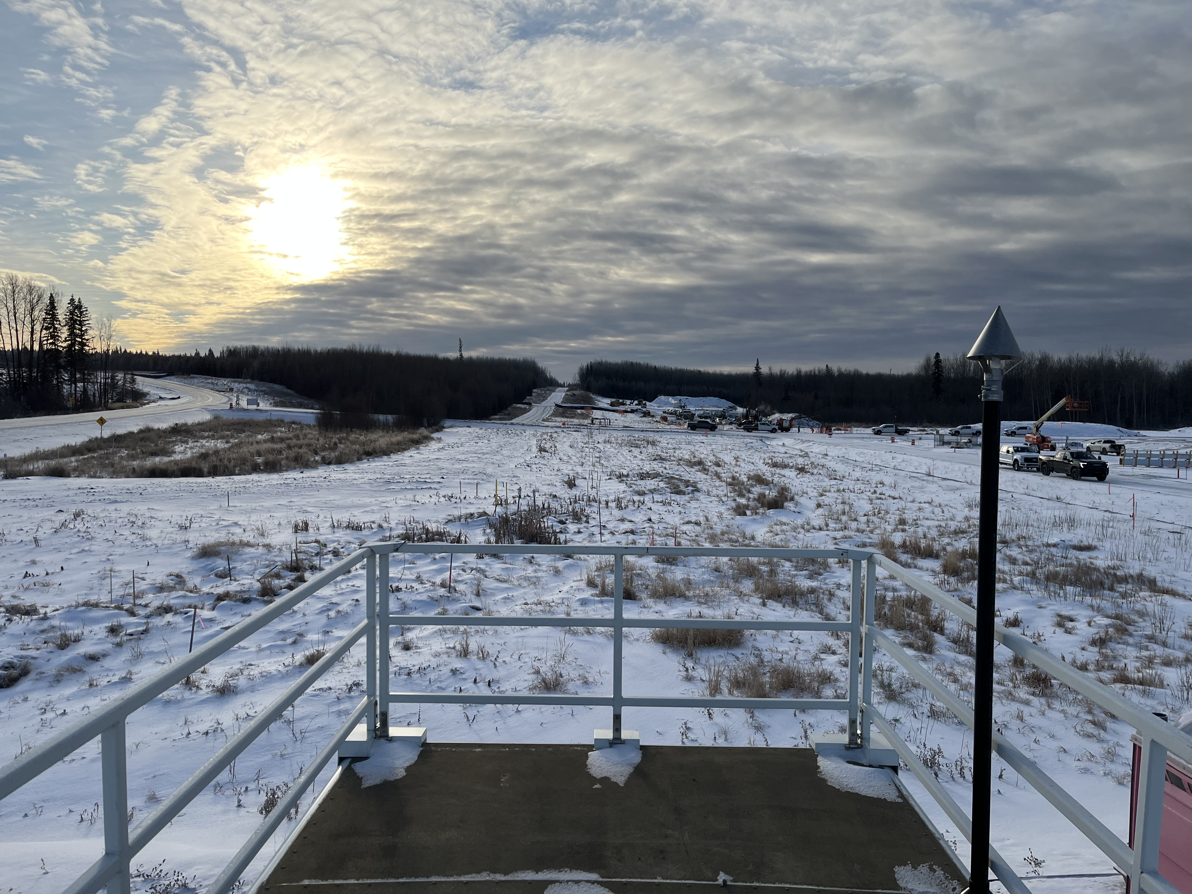
  - Figure 6.2 – Environment looking South.
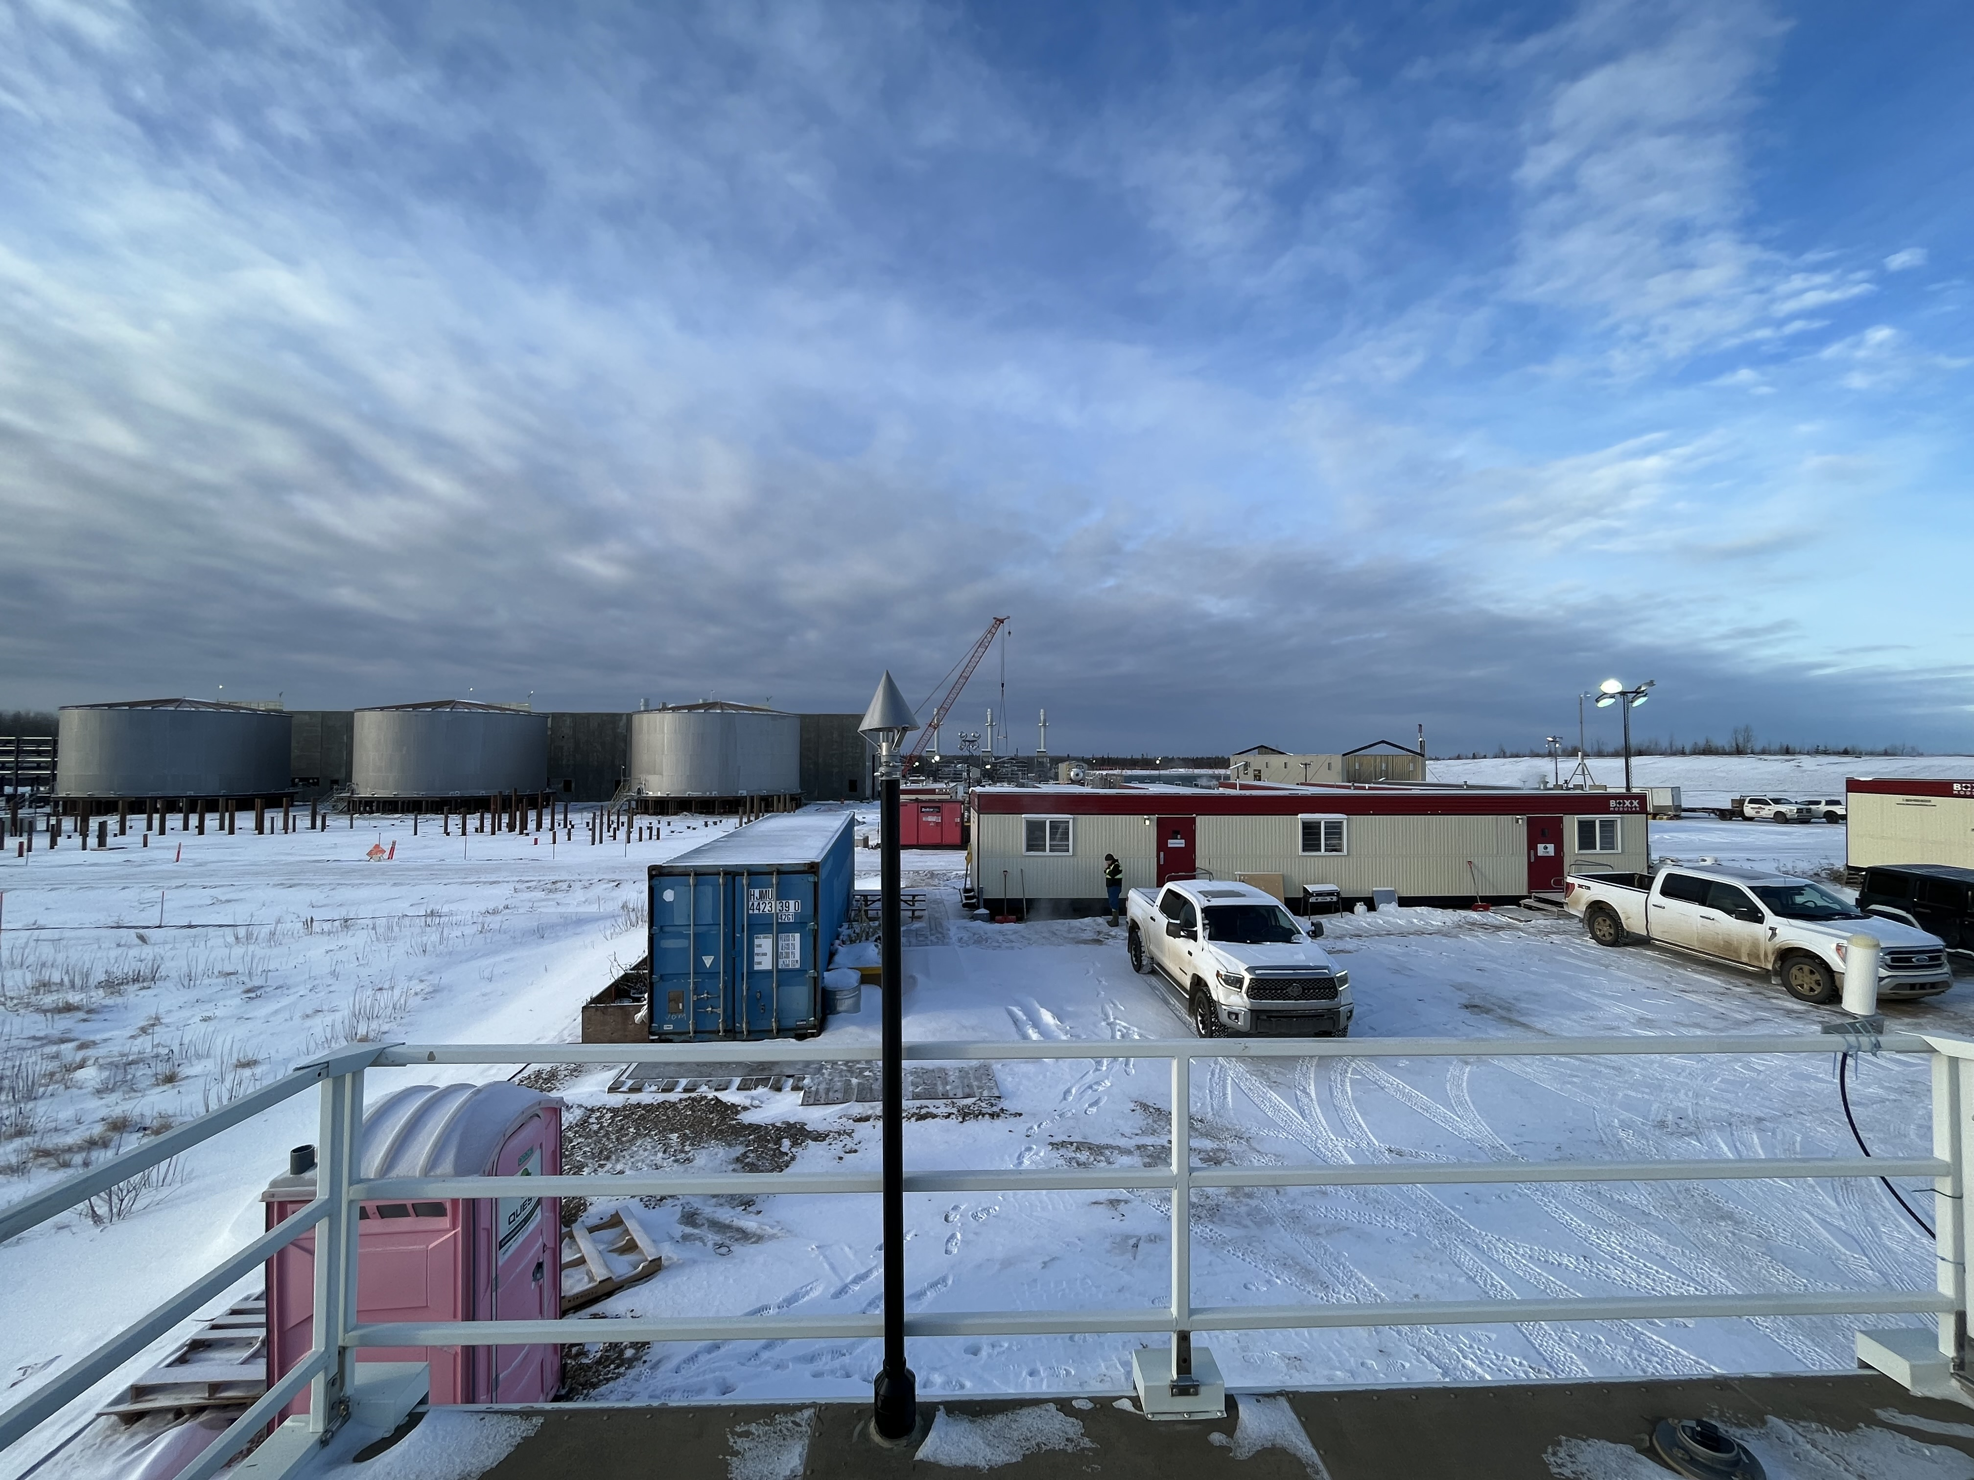
  - Figure 6.3 – Environment looking West.

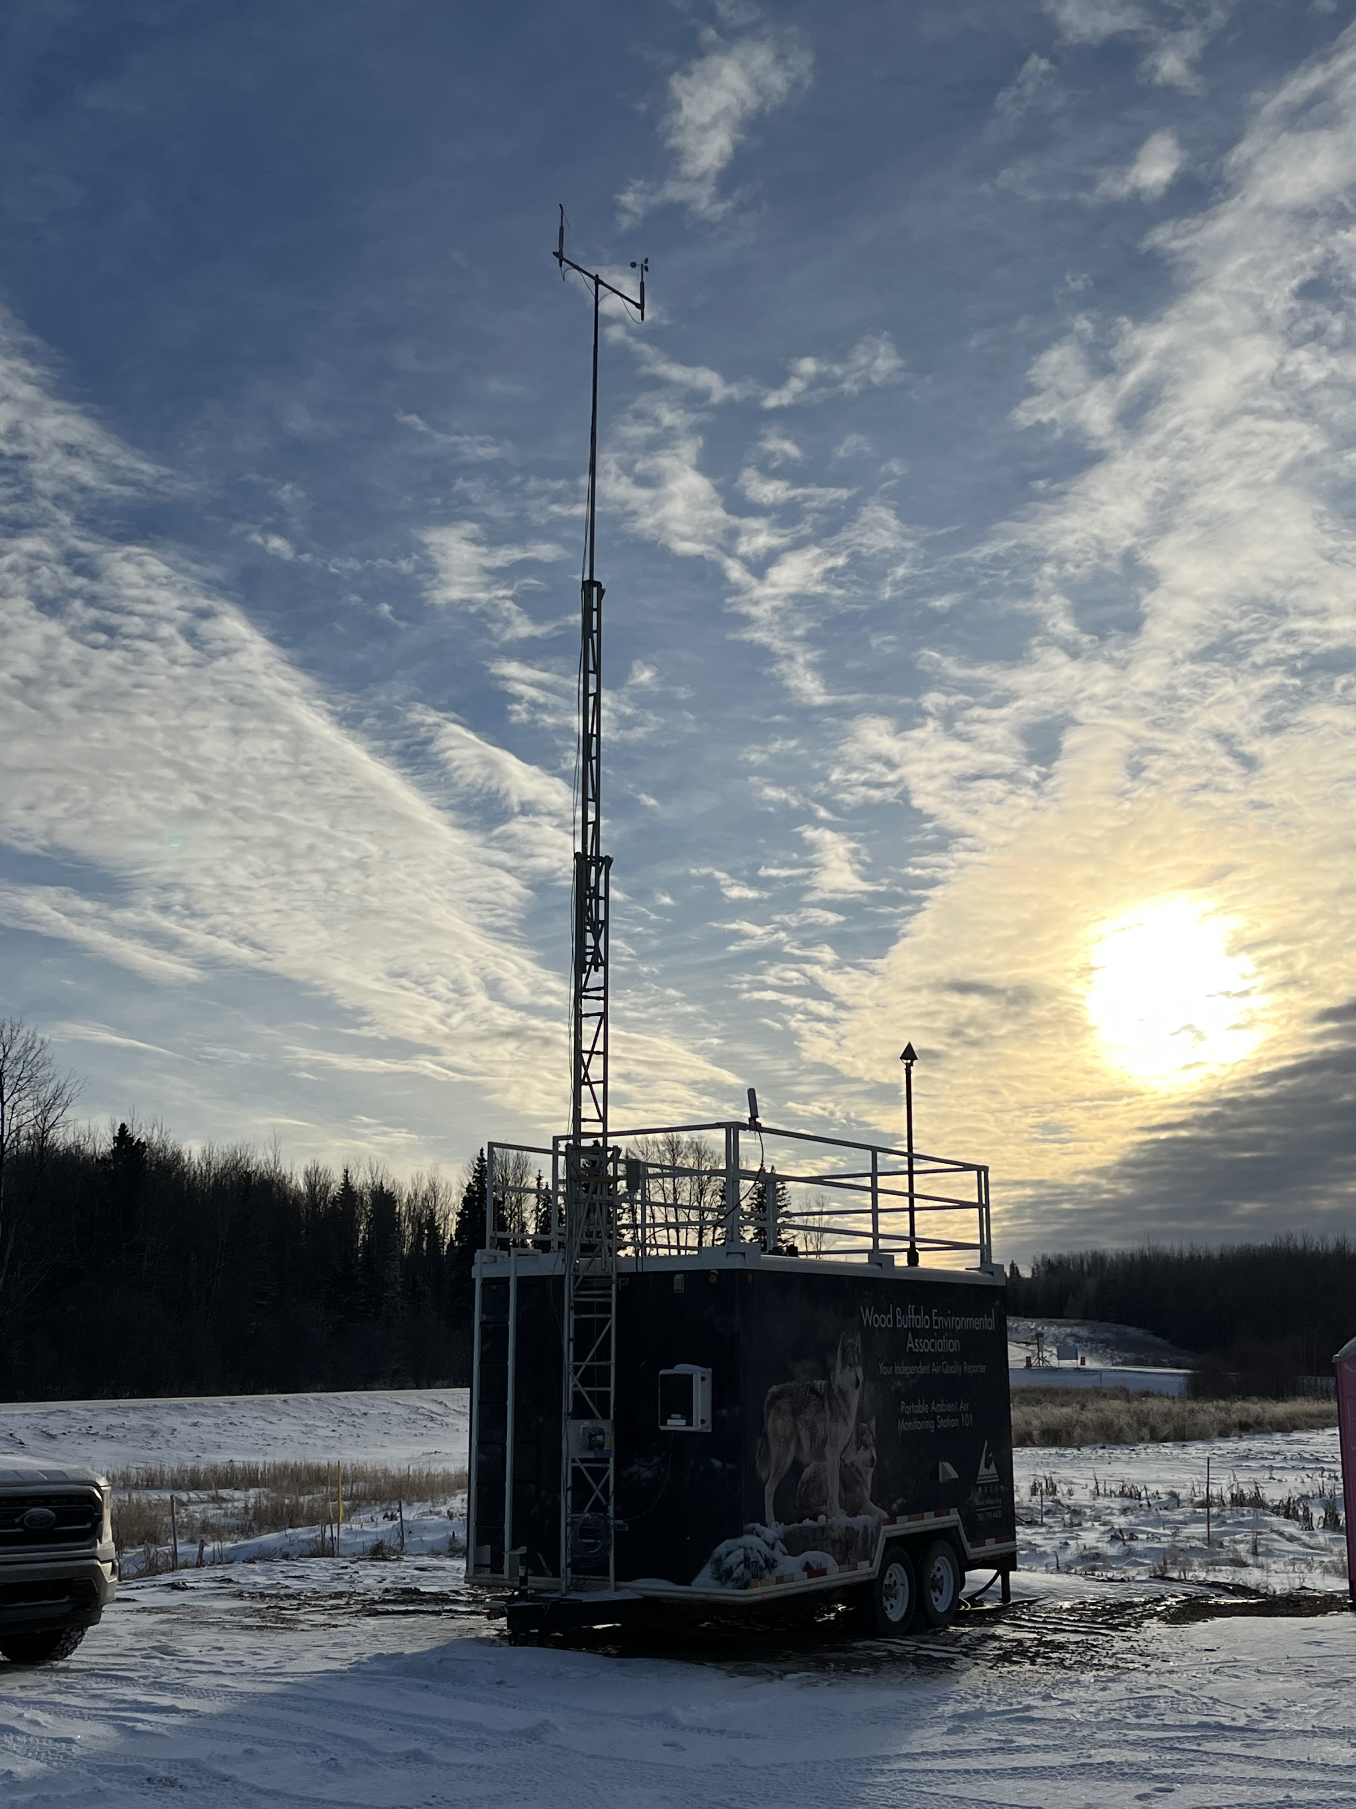
  - Figure 6.4 – Meteorological tower.

Station Photos
The following photos show the monitoring station and instrumentation.
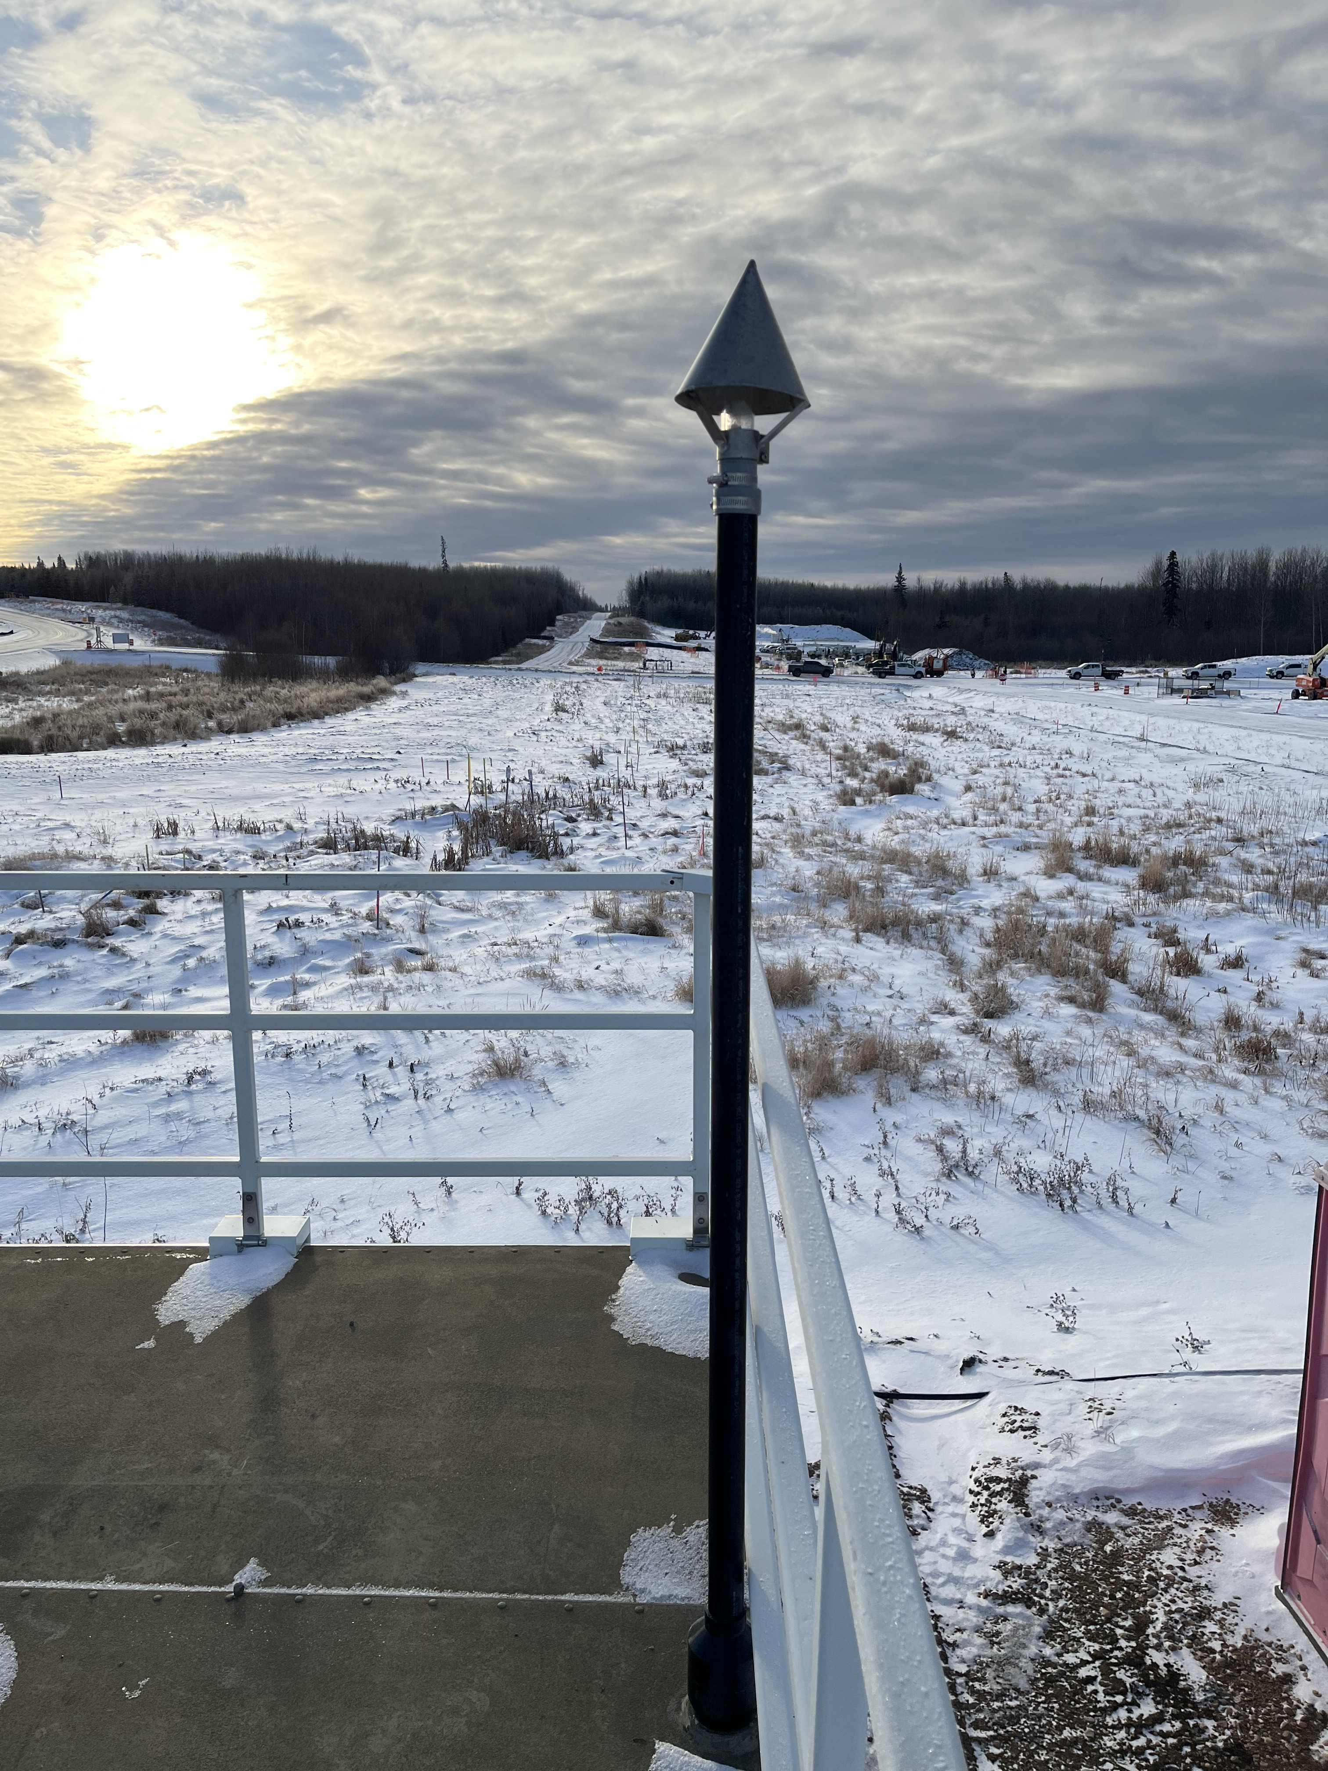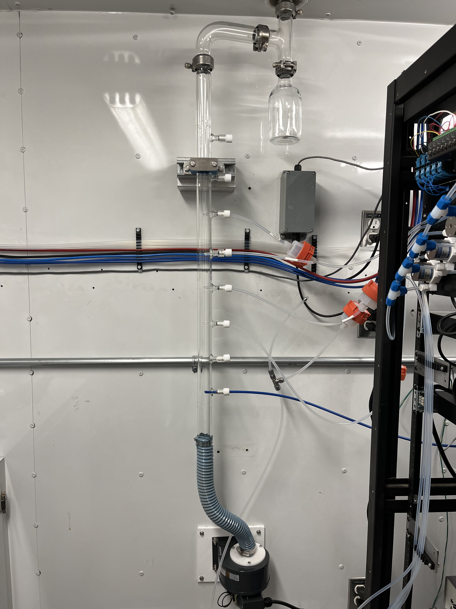
  - Figure 7.0 – Photo showing the inlet and sample manifold.

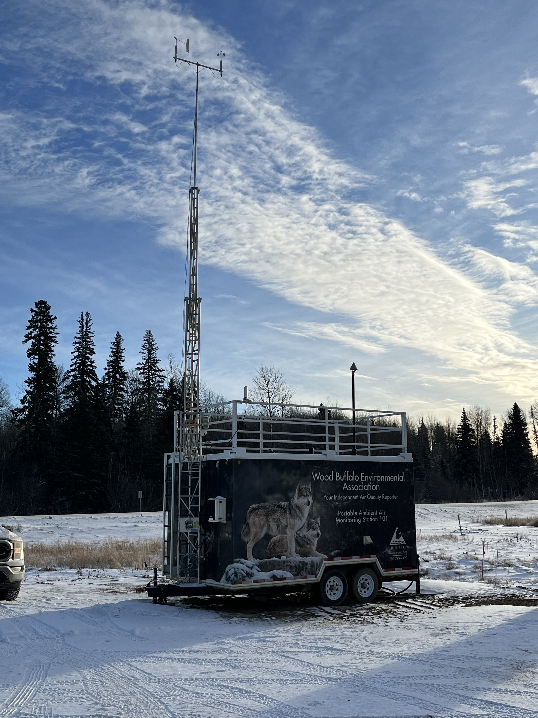
  - Figure 7.1 – Curb shot of the monitoring station.
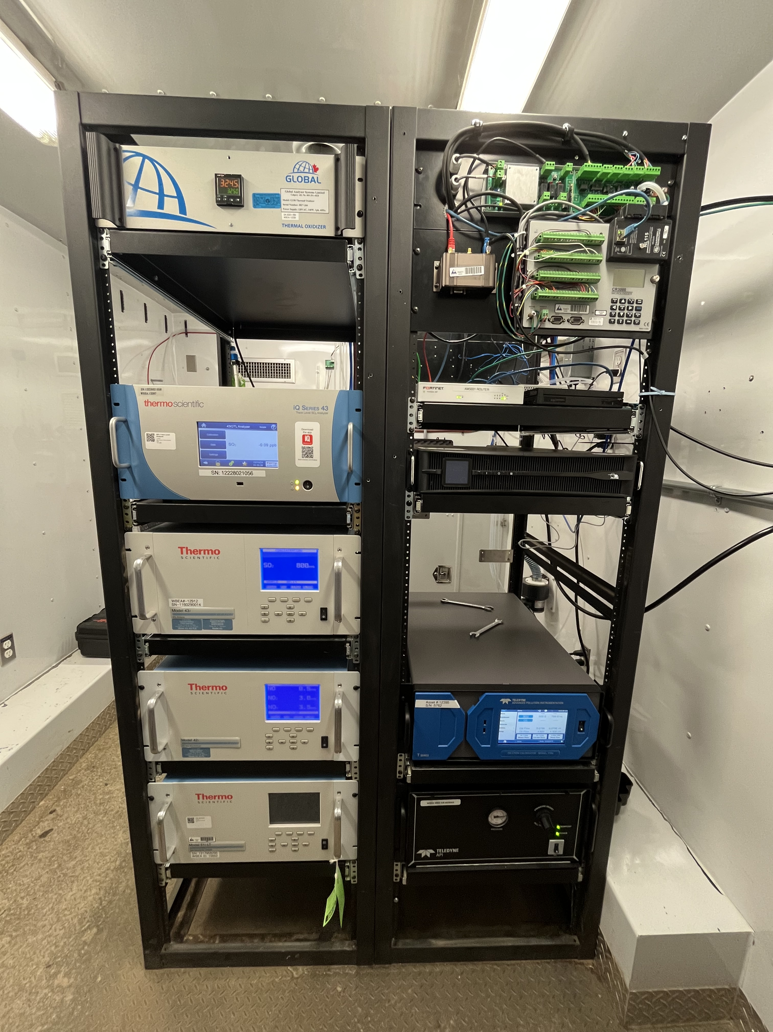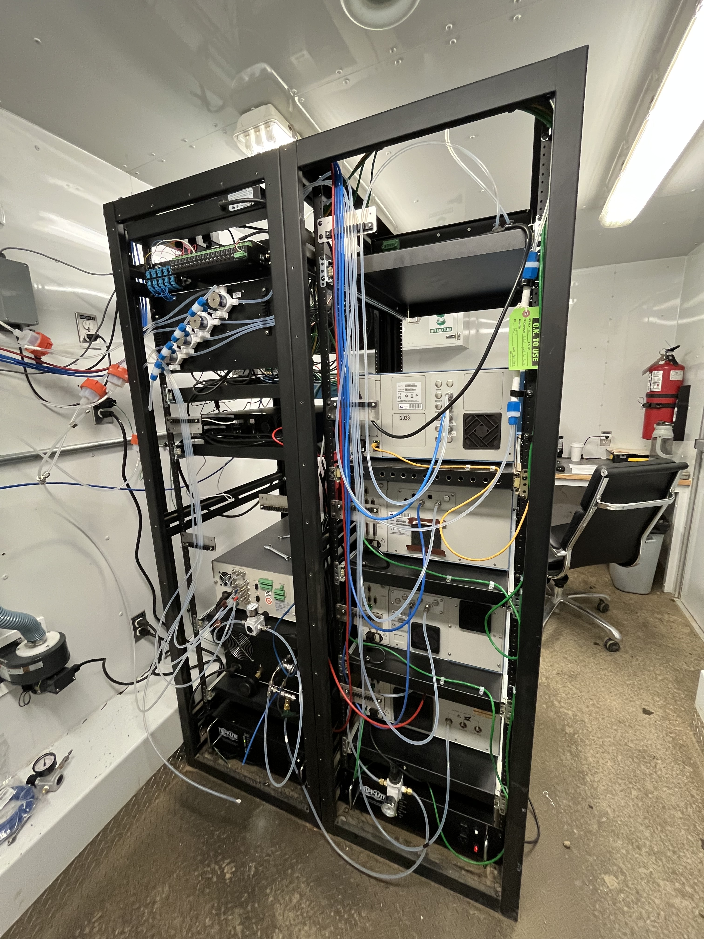
  - Figure 7.2 –Photo of front and back of instrument rack.

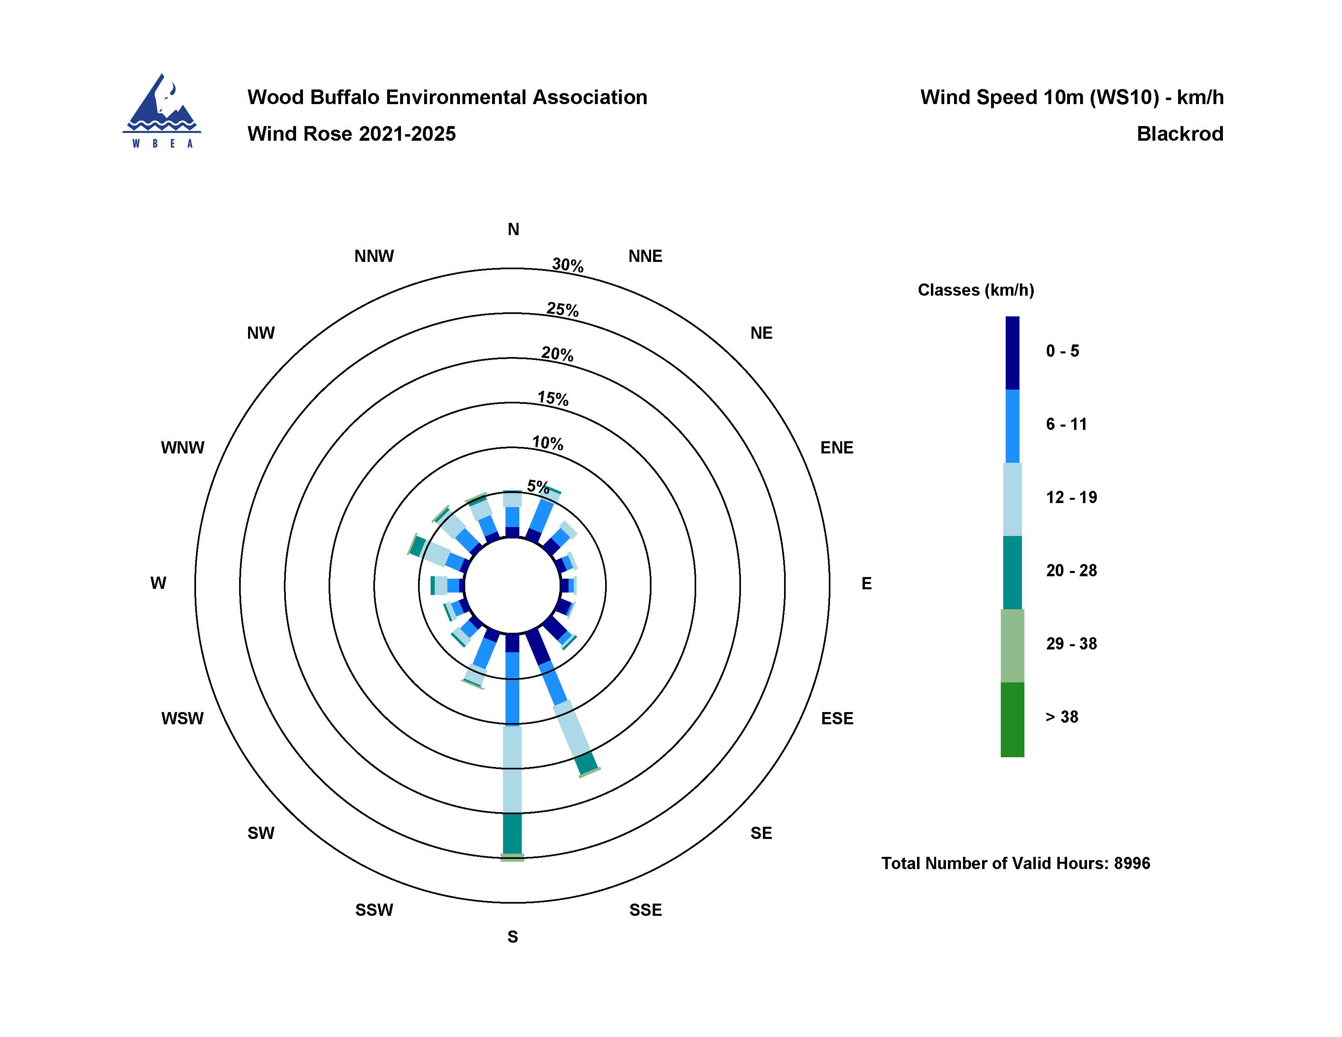
  - Figure 8.0 – Windrose (Five Year).

