Wood Buffalo Environmental Association
Ambient Air Monitoring Station
Site Documentation

Monday Creek

LAST UPDATED: March 02, 2026

Table of Contents
General Site Information 4
Station 4
Location 4
Owner/Operator/Approval Holder 4
Site Description 5
Site Influences 5
Localized Sources 5
Roadway Influences 5
Major Point Sources 6
Analytical Equipment 6
Meteorological Equipment 6
Support Equipment 6
Site photos 10
Station Photos 15

Tables and Figures
Figure 1.0 – Area topographic map showing AMS 33. 7
Figure 2.0 – Plan view image for AMS 33 site. 8
Figure 3.0 – Aerial photo showing AMS 33. 9
Figure 4.0 – Environment looking North. 10
Figure 4.1 – Environment looking East. 11
Figure 4.2 – Environment looking South. 12
Figure 4.3 – Environment looking West. 13
Figure 5.0 – Meteorological tower. 14
Figure 6.0 – Photo showing the inlet and sample manifold. 15
Figure 7.0 – Curb shot of the monitoring station. 16
Figure 8.0 –Photo of front and back of instrument rack. 17
Figure 9.0 – Windrose (Five Year). 18

General Site Information

Station
Station ID | AMS 33
Station name | Monday Creek
Date station established | November 7, 2024

Location
Station street address | Located close to a non-operational well-pad L03 and L04 at Cenovus SAGD site
Legal land description | 3-16-76-6 W4
Latitude | 55.593883
Longitude | -110.834154
UTM East | 507816.87
UTM North | 6159249.07
Nearest community | Conklin
Community population | 178

Owner/Operator/Approval Holder
Operating Agency | Wood Buffalo Environmental Association
Name of Approval Holder | Cenovus Energy Inc.
Approval number | 48522-01-00
Contact Name | Sean Nichols
Address | 500 Centre Street SE Calgary, AB T2P 0M5
Phone number | 780-608-7176
Email address | Sean.nichols@cenvous.com

Site Description
Land use by sector | 0 – 90 degrees | SAGD Operations
Land use by sector | 91 – 180 degrees | SAGD Operations
Land use by sector | 181 – 270 degrees | SAGD Operations
Land use by sector | 271 – 360 degrees | SAGD Operations
Site elevation  (Above sea level) | 569.6m
Angle of elevation to nearby building | Greatest angle | N/A
Angle of elevation to nearby building | Building direction | N/A
Airflow restrictions | North | N/A
Airflow restrictions | East | N/A
Airflow restrictions | South | N/A
Airflow restrictions | West | N/A
Distance to nearest trees (m) | North | N/A
Distance to nearest trees (m) | East | N/A
Distance to nearest trees (m) | West | N/A
Distance to nearest trees (m) | South | 70
Sample manifold | Type | All glass
Sample manifold | Inlet height above roof | 1 meter
Meteorological Sensors | Type | Cup and vane
Meteorological Sensors | Height above ground | 10
Meteorological Sensors | Distance from station | 7

Site Influences

Localized Sources
Type | Distance (m) | Description

Roadway Influences
Type | Traffic Volume | Distance (m) | Description
Dirt/gravel | Medium | 20 | Used by site workers

Major Point Sources
Facility Name | Source Type | Production Capacity | Distance from site (m) | Compass direction from site
Cenovus Christina Lake | SAGD Facility |  | 2700 | SW

Analytical Equipment
Parameter | Owner | Make | Model | Serial Number | Date Installed
SO2 | Cenovus | Thermo Instruments | 43i | 1152430005 | 2024
H2S | Cenovus | Thermo Instruments | 43iQTL | 12333331547 | 2024
NOx | Cenovus | Thermo Instruments | 42i | 1170050148 | 2026

Meteorological Equipment
Parameter | Make | Model | Serial Number | WMO Site Class | Date Installed
AT/RH | Vaisala | HMP155 | G4330034 | 4 | 2024
WS | Met One | 010C-1 | D16123 | 2 | 2024
WD | Met One | 020C-1 | N13744 | 2 | 2024

Support Equipment
Name | Description | Make | Model | Serial Number
Datalogger | Datalogger | Campbell Scientific | CR3000 | 7881
Zero air generator | Zero Air Generator | Teledyne/API | 701 | 832
HVAC | Heating and air conditioning system. Wall mount unit | BARD | 1 ton | NA
Shelter / Building | Air monitoring portable | ITB | 8 x 16 trailer | NA
Gas Dilution Calibrator | Mass flow-controlled gas dilution | Teledyne/API | T700 | 3253
Tower | 10 Meter crank up | Aluma | T-135 | 217224002

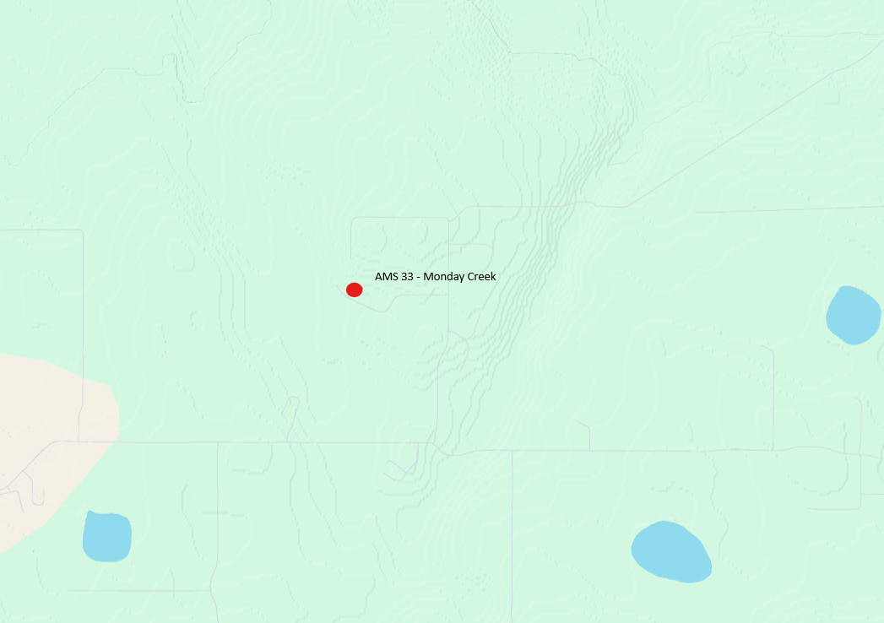
  - Figure 1.0 – Area topographic map showing AMS 33.

  - Figure 2.0 – Plan view image for AMS 33 site.

  - Figure 3.0 – Aerial photo showing AMS 33.

Site photos
The following photos show the environment surrounding the monitoring station.
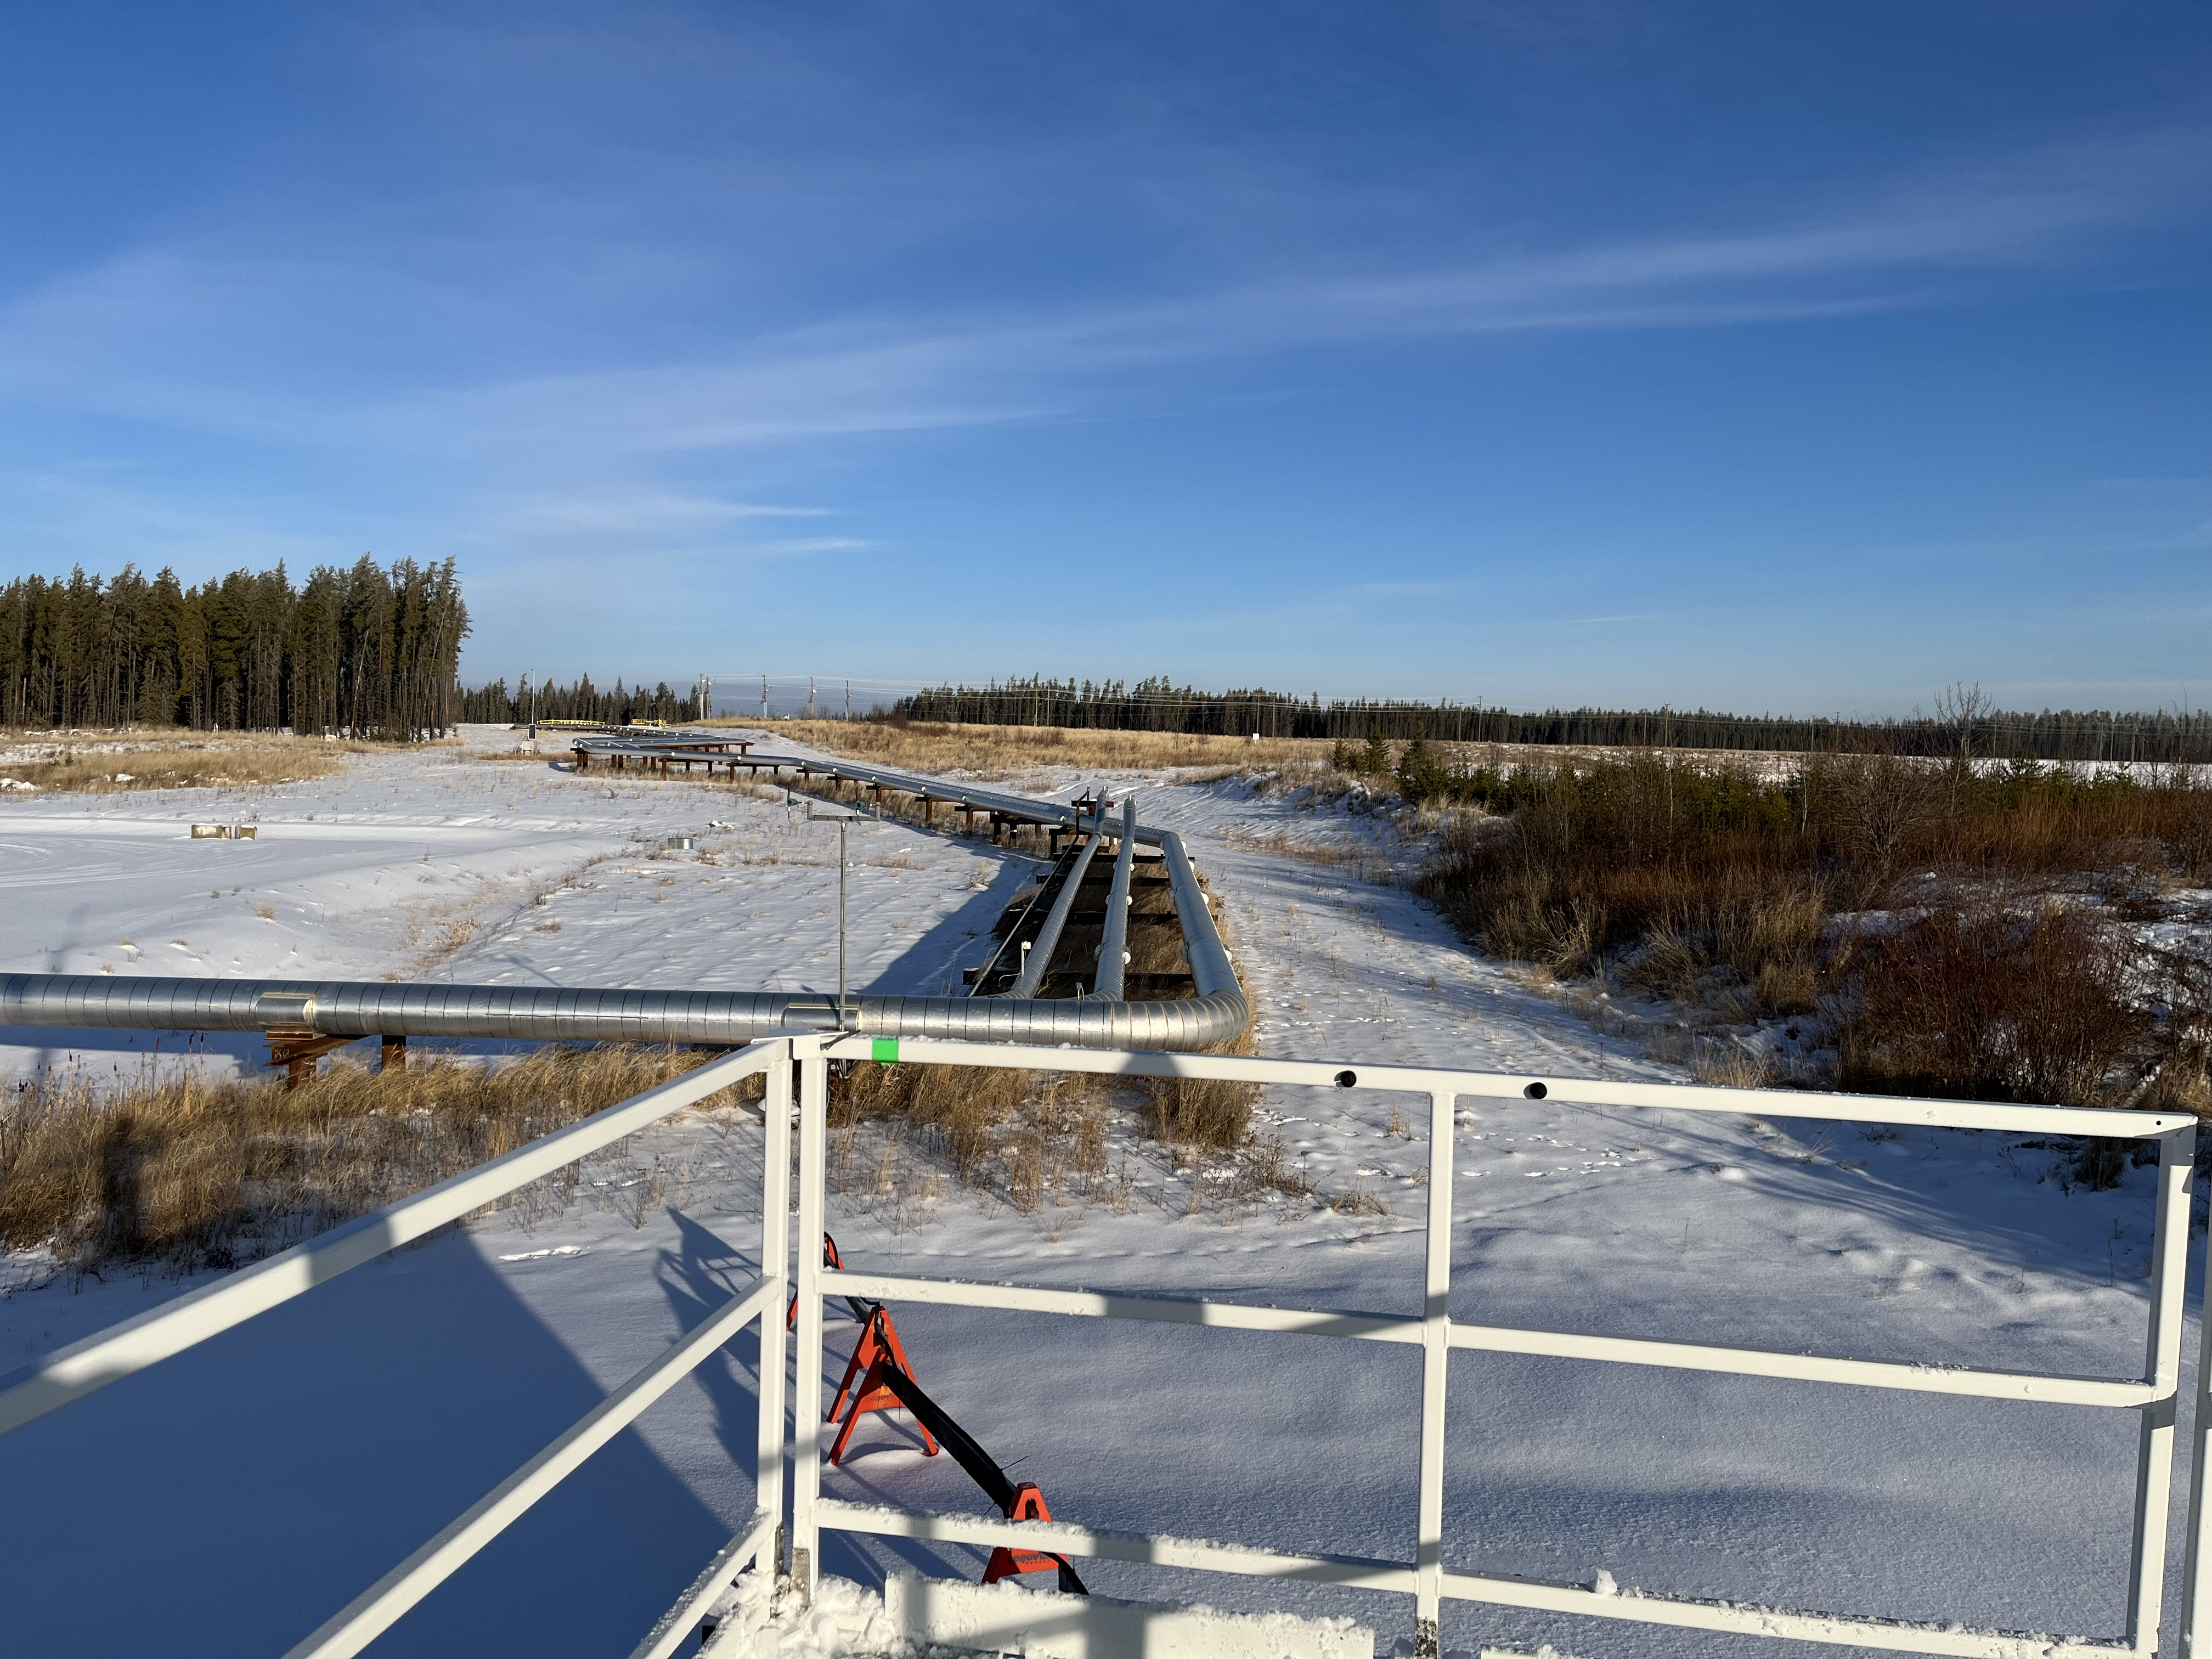
  - Figure 4.0 – Environment looking North.

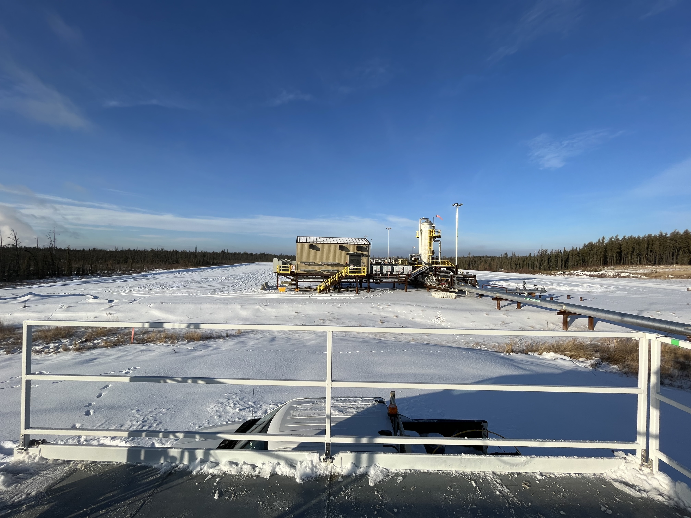
  - Figure 4.1 – Environment looking East.
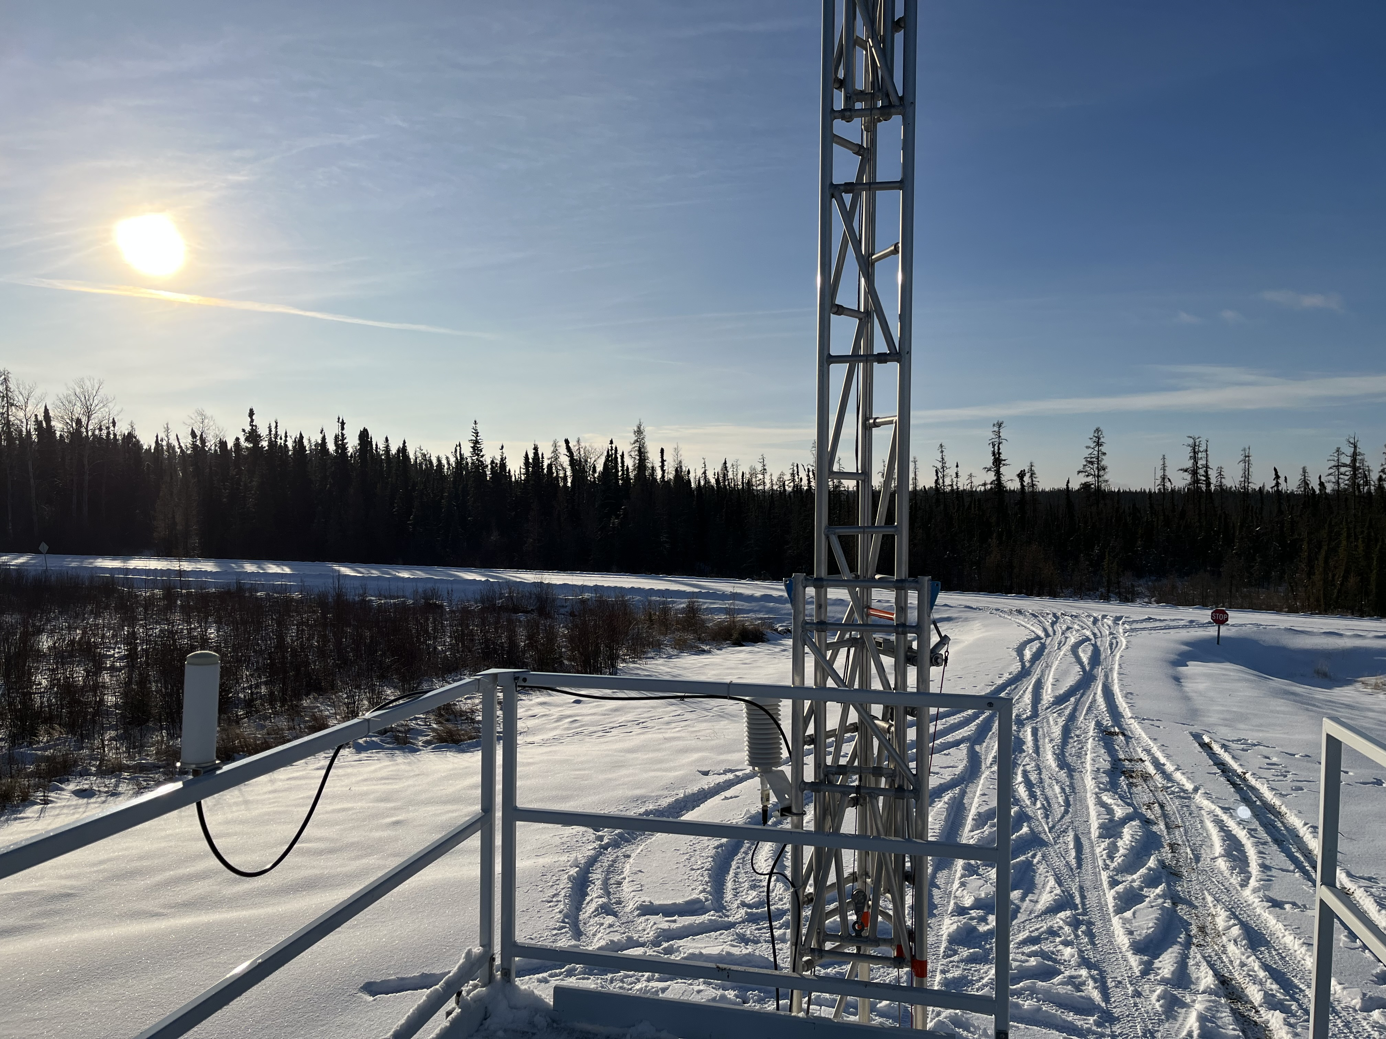
  - Figure 4.2 – Environment looking South.
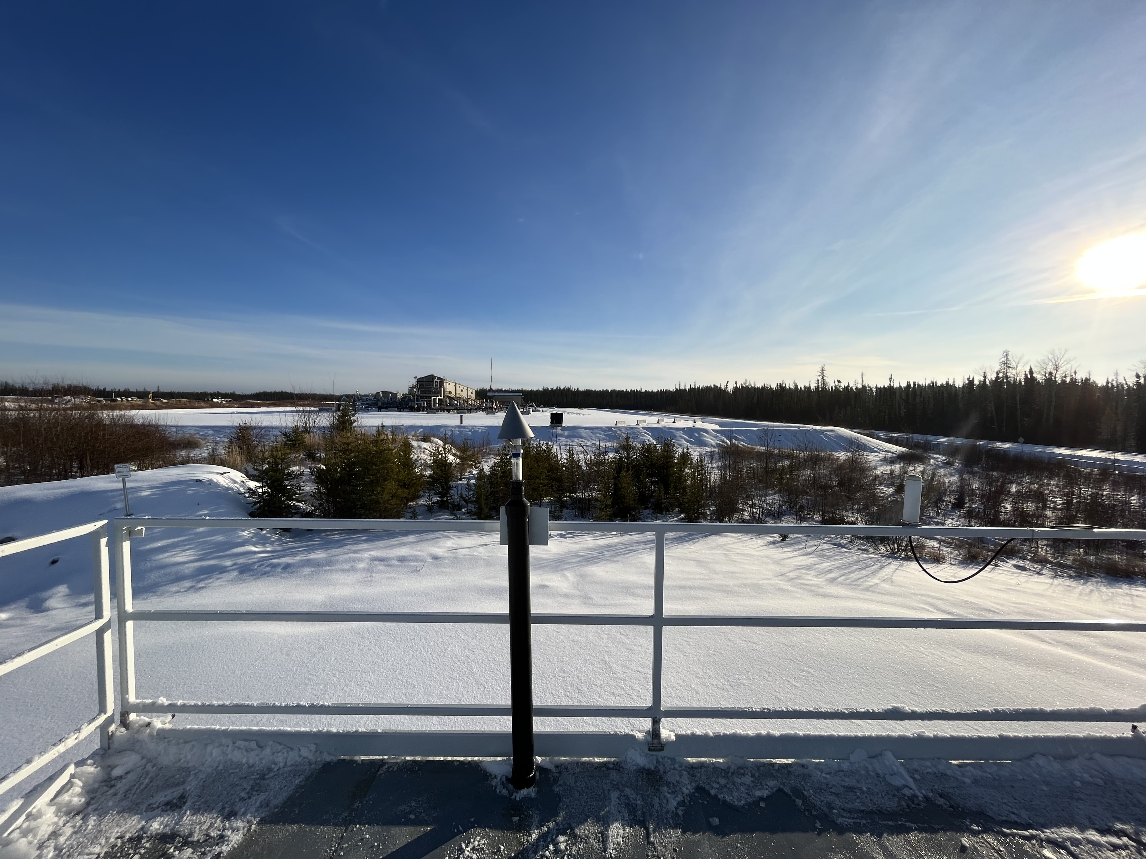
  - Figure 4.3 – Environment looking West.

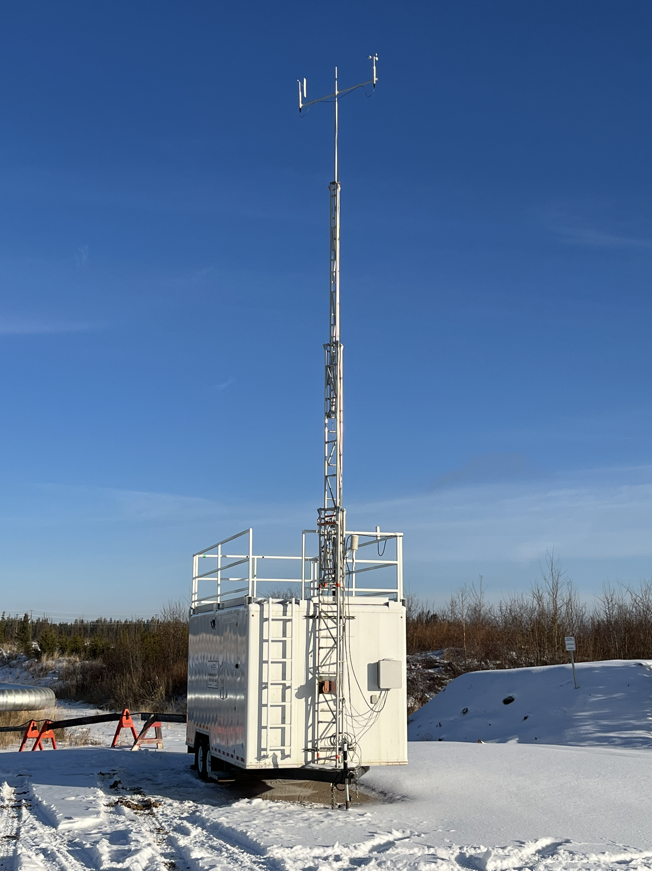
  - Figure 5.0 – Meteorological tower.

Station Photos
The following photos show the monitoring station and instrumentation.
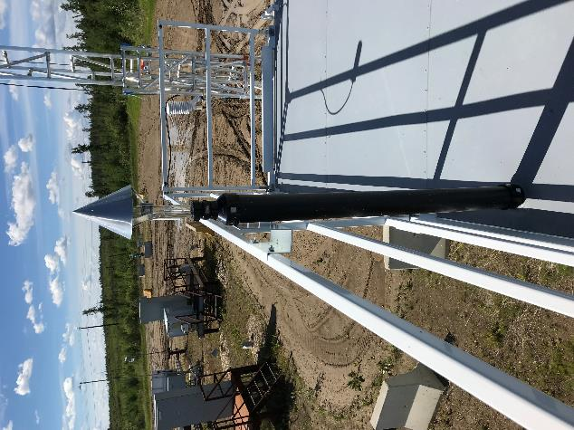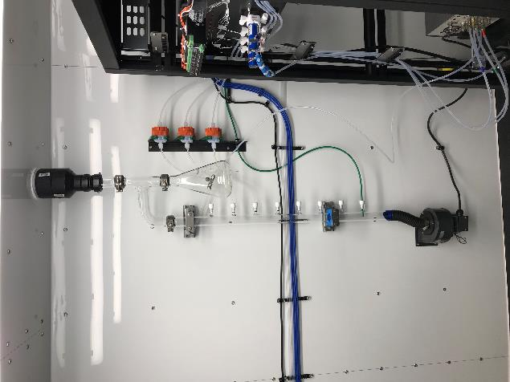
  - Figure 6.0 – Photo showing the inlet and sample manifold.

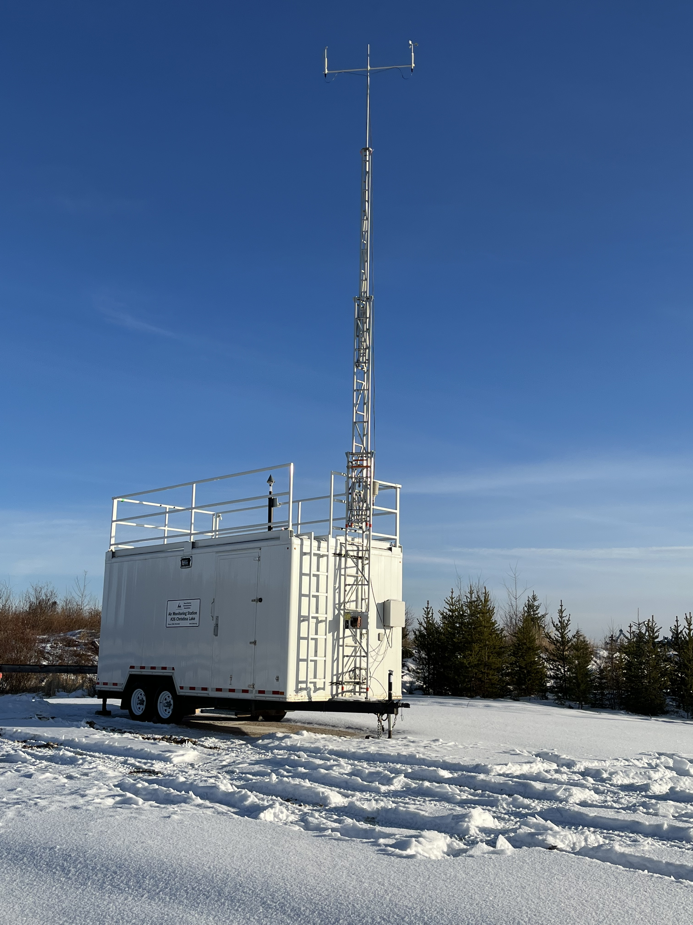
  - Figure 7.0 – Curb shot of the monitoring station.
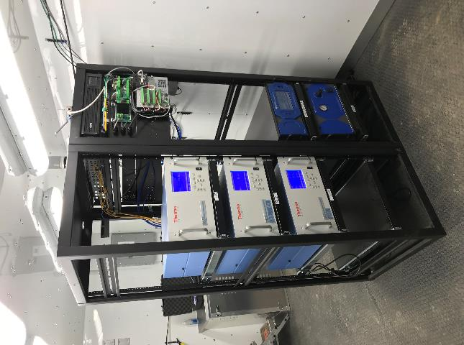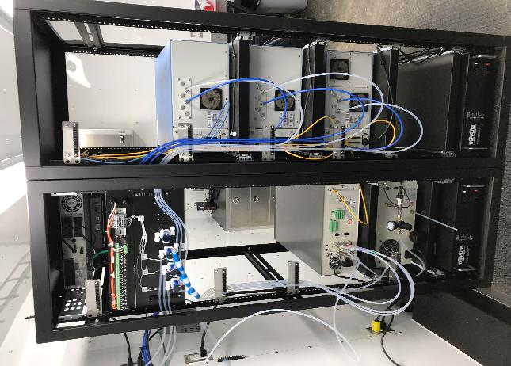
  - Figure 8.0 –Photo of front and back of instrument rack.

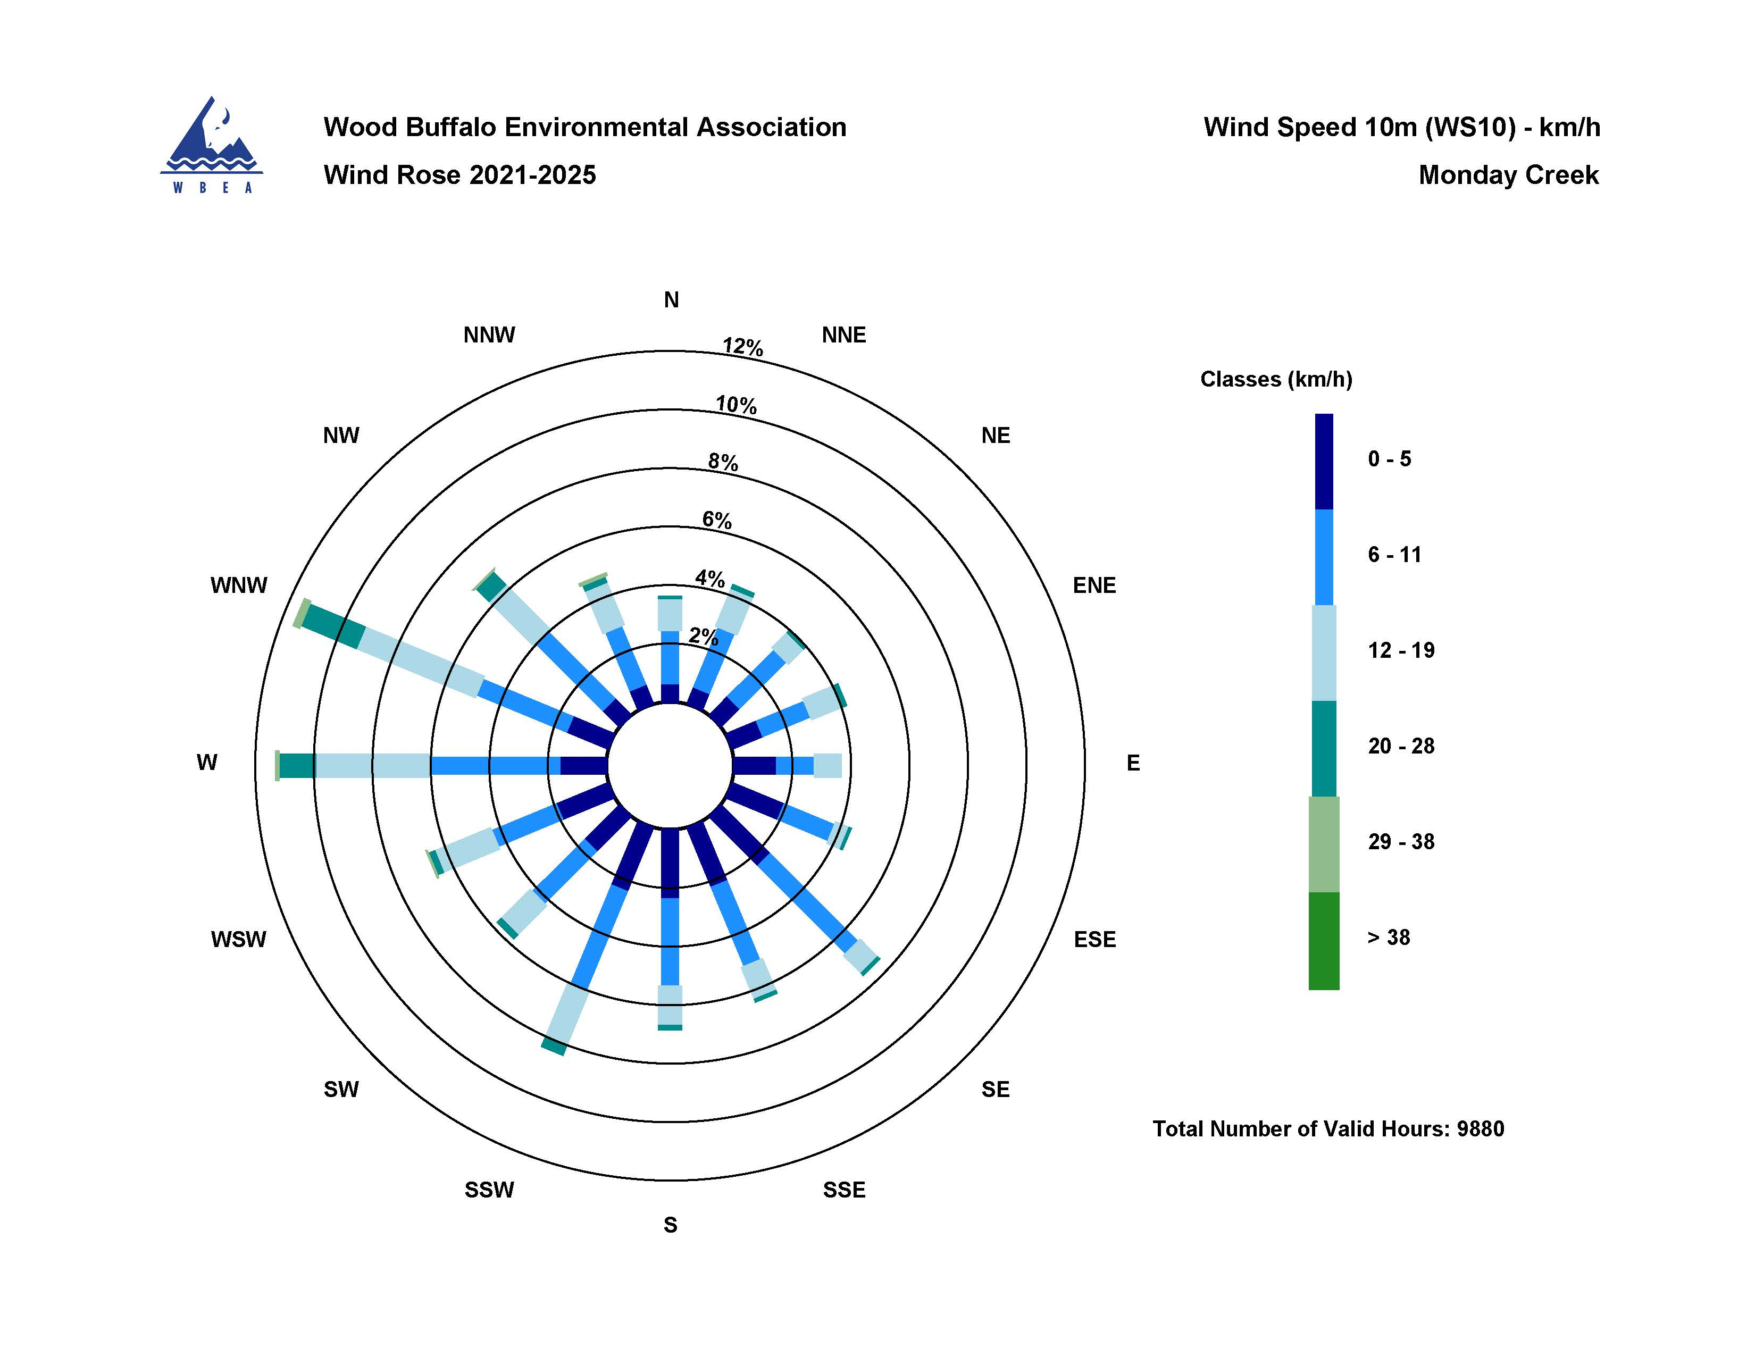
  - Figure 9.0 – Windrose (Five Year).

