Wood Buffalo Environmental Association
Ambient Air Monitoring Station
Site Documentation

AMS 512 - Hangingstone Expansion

LAST UPDATED: February 18, 2026

Table of Contents
Station 4
Location 4
Owner/Operator/Approval Holder 4
Site Description 4
Site Influences 5
Localized Sources (within 20 metres of station) 5
Roadway Influences 5
Major Point Sources 5
Station Equipment 6
Analytical Equipment 6
Meteorolgical Equipment 6
Support Equipment 6
Site photos 11
Station Photos 16

Tables and Figures
Figure 1 – Area topographic map showing AMS 512 8
Figure 2 – Aerial photo showing AMS 512 9
Figure 3 – Plan view sketch for AMS 512 site 10
Figure 4 – Elevation view image for AMS 512 site 11
Figure 5 – Environment looking North 12
Figure 6 – Environment looking East 13
Figure 7 – Environment looking South 14
Figure 8 – Environment looking West 15
Figure 9 – Meteorological Tower 16
Figure 10 – Photo showing the inlet and sample manifold 17
Figure 11 – Curb shot of the monitoring station 18
Figure 12 –Photo of the front and the back of instrument rack 19
Figure 13 – Windrose (2020-2025) 20

General Site Information

Station
Station ID | AMS 512
Station name | Hangingstone Expansion
Date station established | July 1, 2024

Location
Station street address | NA
Legal land description | 12-13-84-11-W4
Airshed Zone | Wood Buffalo Environmental Association
Latitude | 56.283250
Longitude | -111.608580
UTM East | 462323
UTM North | 6237772
Nearest community | Fort McMurray
Community population | 68,002
Census Year | 2021

Owner/Operator/Approval Holder
Operating Agency | Wood Buffalo Environmental Association
Address of Operating Agency | Unit 3, 805 Memorial Drive, Fort McMurray, Alberta T9K 0K4
Name of Approval Holder | Greenfire Resources
Approval number | 153105-01-00
Contact Name | Thomas Courte
Address | NA
Phone number | 403-993-9736
Email address | tcourte@greenfireres.com

Site Description
Land use by sector | 0 – 90 degrees | Lay-down yard/Muskeg
Land use by sector | 91 – 180 degrees | Muskeg/Access Road
Land use by sector | 181 – 270 degrees | SAGD plant
Land use by sector | 271 – 360 degrees | Lay-down yard/Access Road/Muskeg
Site elevation (m)
(above sea level)
Angle of elevation to nearby buildings | Greatest angle | N/A
Angle of elevation to nearby buildings | Building direction | N/A
Airflow restrictions | North | N/A
Airflow restrictions | East | N/A
Airflow restrictions | South | N/A
Airflow restrictions | West | N/A
Distance to nearest trees (m) | North | 100m
Distance to nearest trees (m) | East | 50m
Distance to nearest trees (m) | West | 50m
Distance to nearest trees (m) | South | 40m
Sample manifold | Type | All glass
Sample manifold | Inlet height above roof | 1 metre
Meteorological Sensors | Type | Cup and vane
Meteorological Sensors | Height above ground (m) | 10
Meteorological Sensors | Distance from station (m) | 0

Site Influences

Localized Sources (within 20 metres of station)
Type | Distance (m) | Description
Lay down | 20m | Lay down for equipment and rig mats

Roadway Influences
Type | Traffic Volume | Distance (m) | Description
Access Road | Low | 20m | Roadway used by site workers
Main Access Road | High | 100m | Main Road to go to Site

Major Point Sources
Facility Name | Source Type | Production Capacity | Distance from site (km) | Compass direction from site
Green fire Expansion | SAGD |  | 0.7 | SW
Green fire Demo Plant | SAGD |  | 4.8 | NW

Station Equipment
Equipment Owner:

Analytical Equipment
Parameter | Make | Model | Serial Number | Date Installed
SO2 | Thermo Environmental | 43i | 1173410001 | June 2024
H2S | Thermo Environmental | 34iTLE | 1336160090 | June 2024
NO2 | Teledyne/API | T200 | 7029 | June 2024
H2S | Global Converter | G150 | 11638 | June 2024

Meteorolgical Equipment
Parameter | Make | Model | Serial Number | WMO Site Class | Date Installed
AT/RH | Vaisala | HMP155 | H5110025 | 4 | June 2024
WS | Met One | 010C-1 | B10017 | 4 | June 2024
WD | Met One | 020C-1 | D13603 | 4 | June 2024

Support Equipment
Name | Description | Make | Model | Serial Number
Datalogger | Datalogger | Campbell Scientific | CR3000 | 2575
Gas Dilution Calibrator | Dynamic dilution calibrator | Teledyne/API | T700 | 2445
Zero air generator | Zero Air Generator | Teledyne/API | 701 | 138
Shelter / Building | Air monitoring portable | ITB | 8 x 16 trailer | ITB-13-16018
HVAC | Heating and air conditioning system. Wall mount unit | BARD | 1 ton | N/A

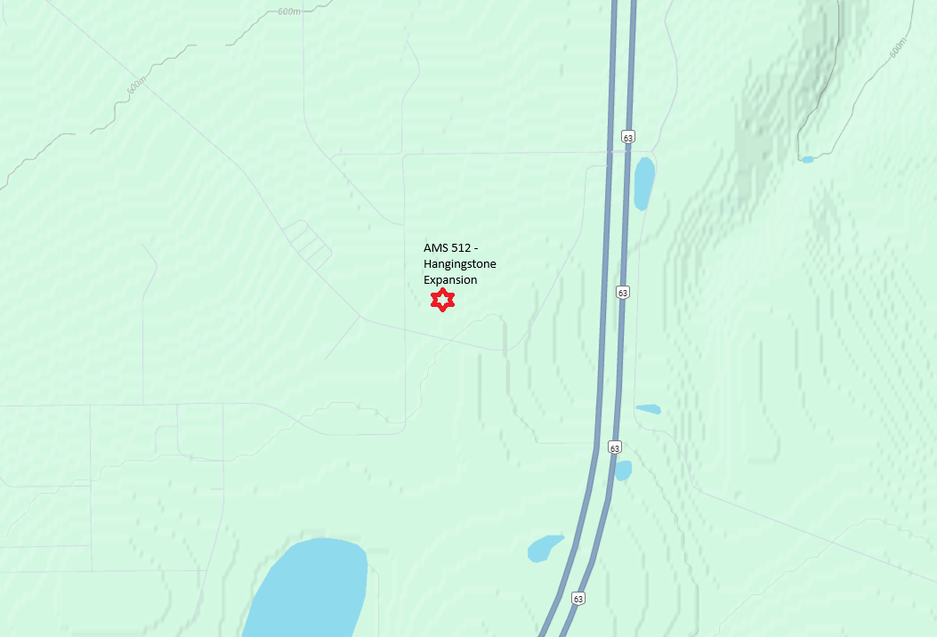
  - Figure 1 – Area topographic map showing AMS 512

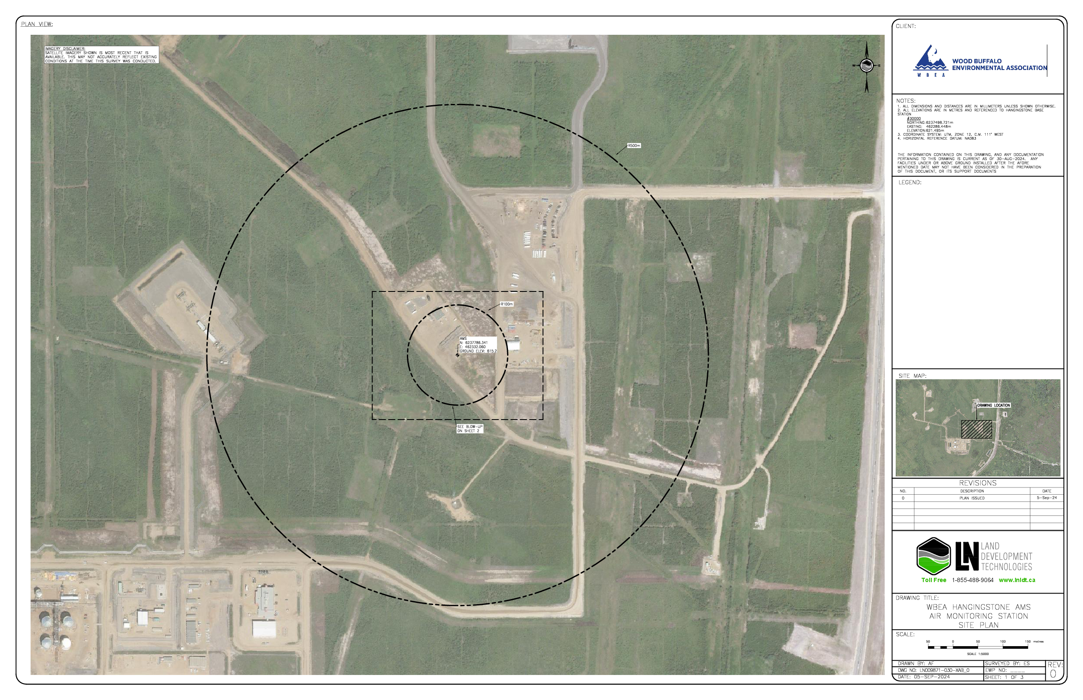
  - Figure 2 – Aerial photo showing AMS 512

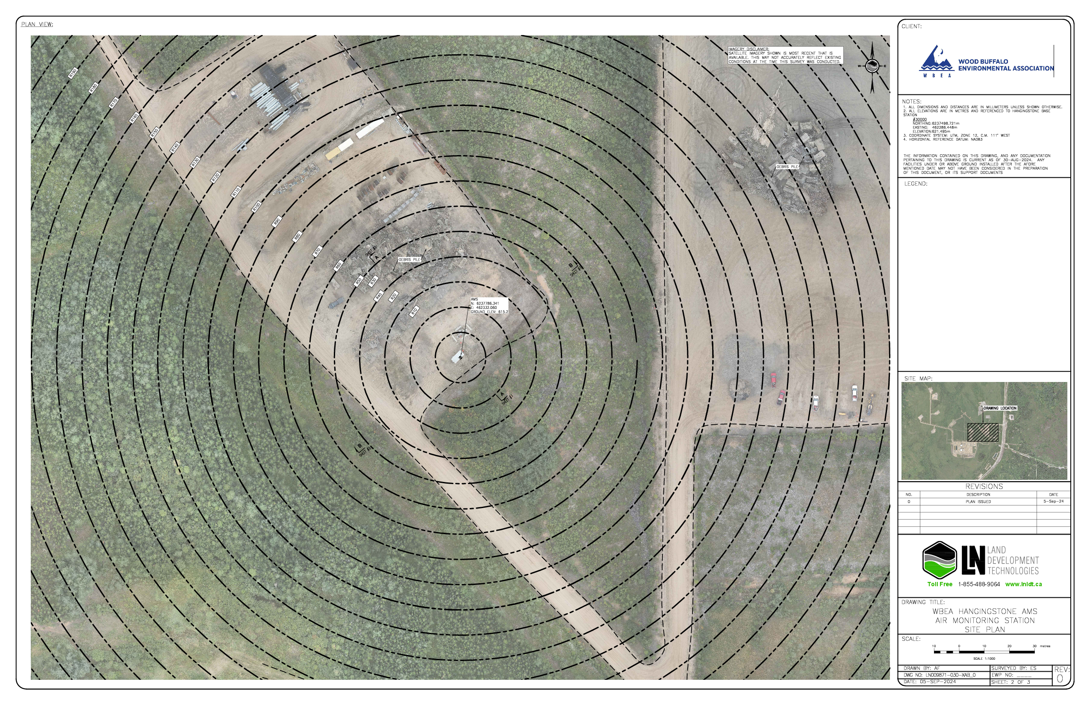
  - Figure 3 – Plan view sketch for AMS 512 site

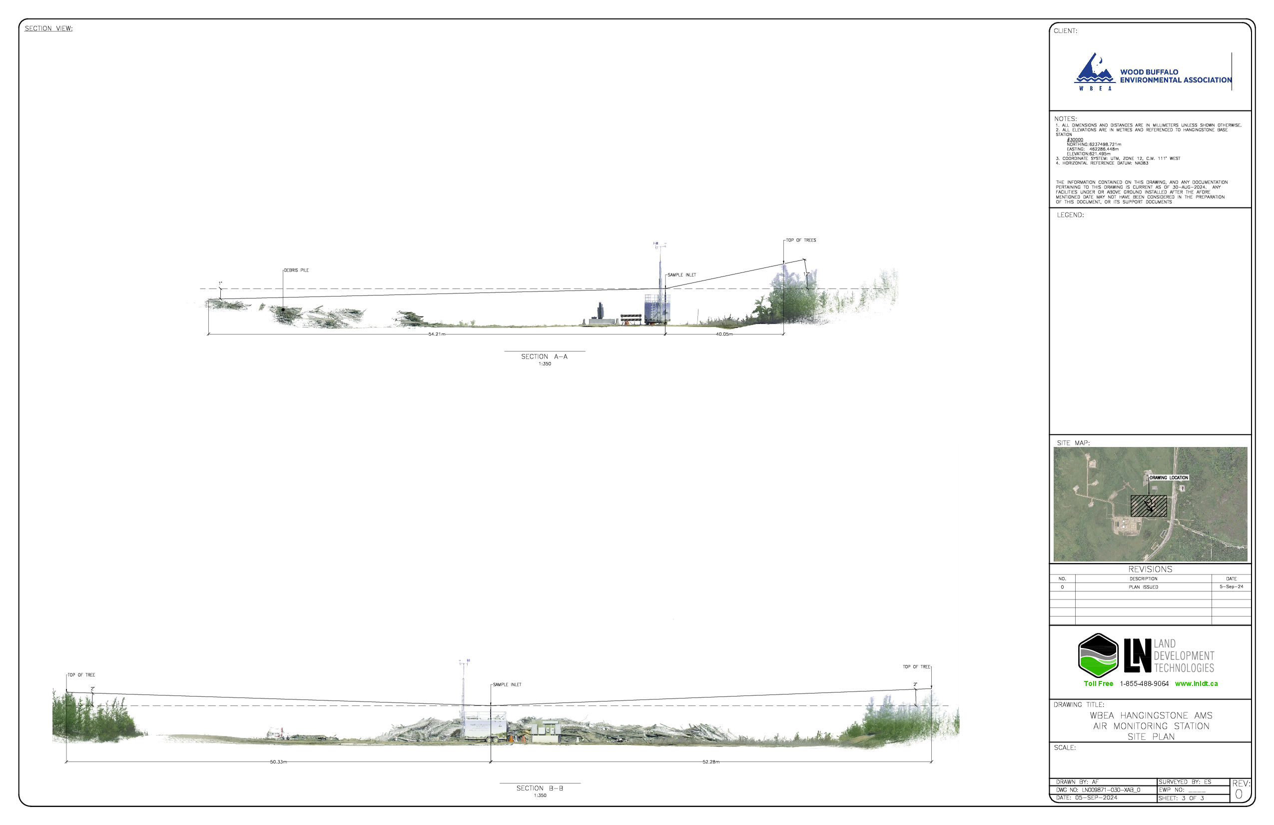
  - Figure 4 – Elevation view image for AMS 512 site

Site photos
The following photos show the environment surrounding the monitoring station.

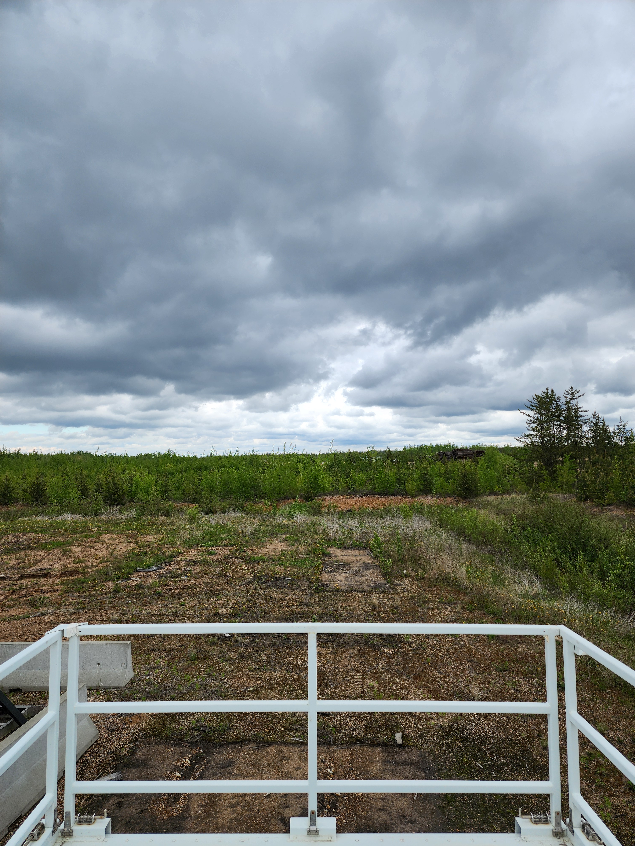
  - Figure 5 – Environment looking North
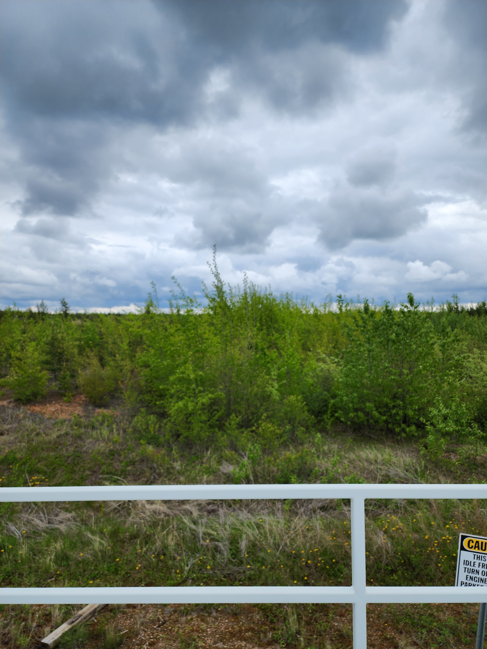

  - Figure 6 – Environment looking East
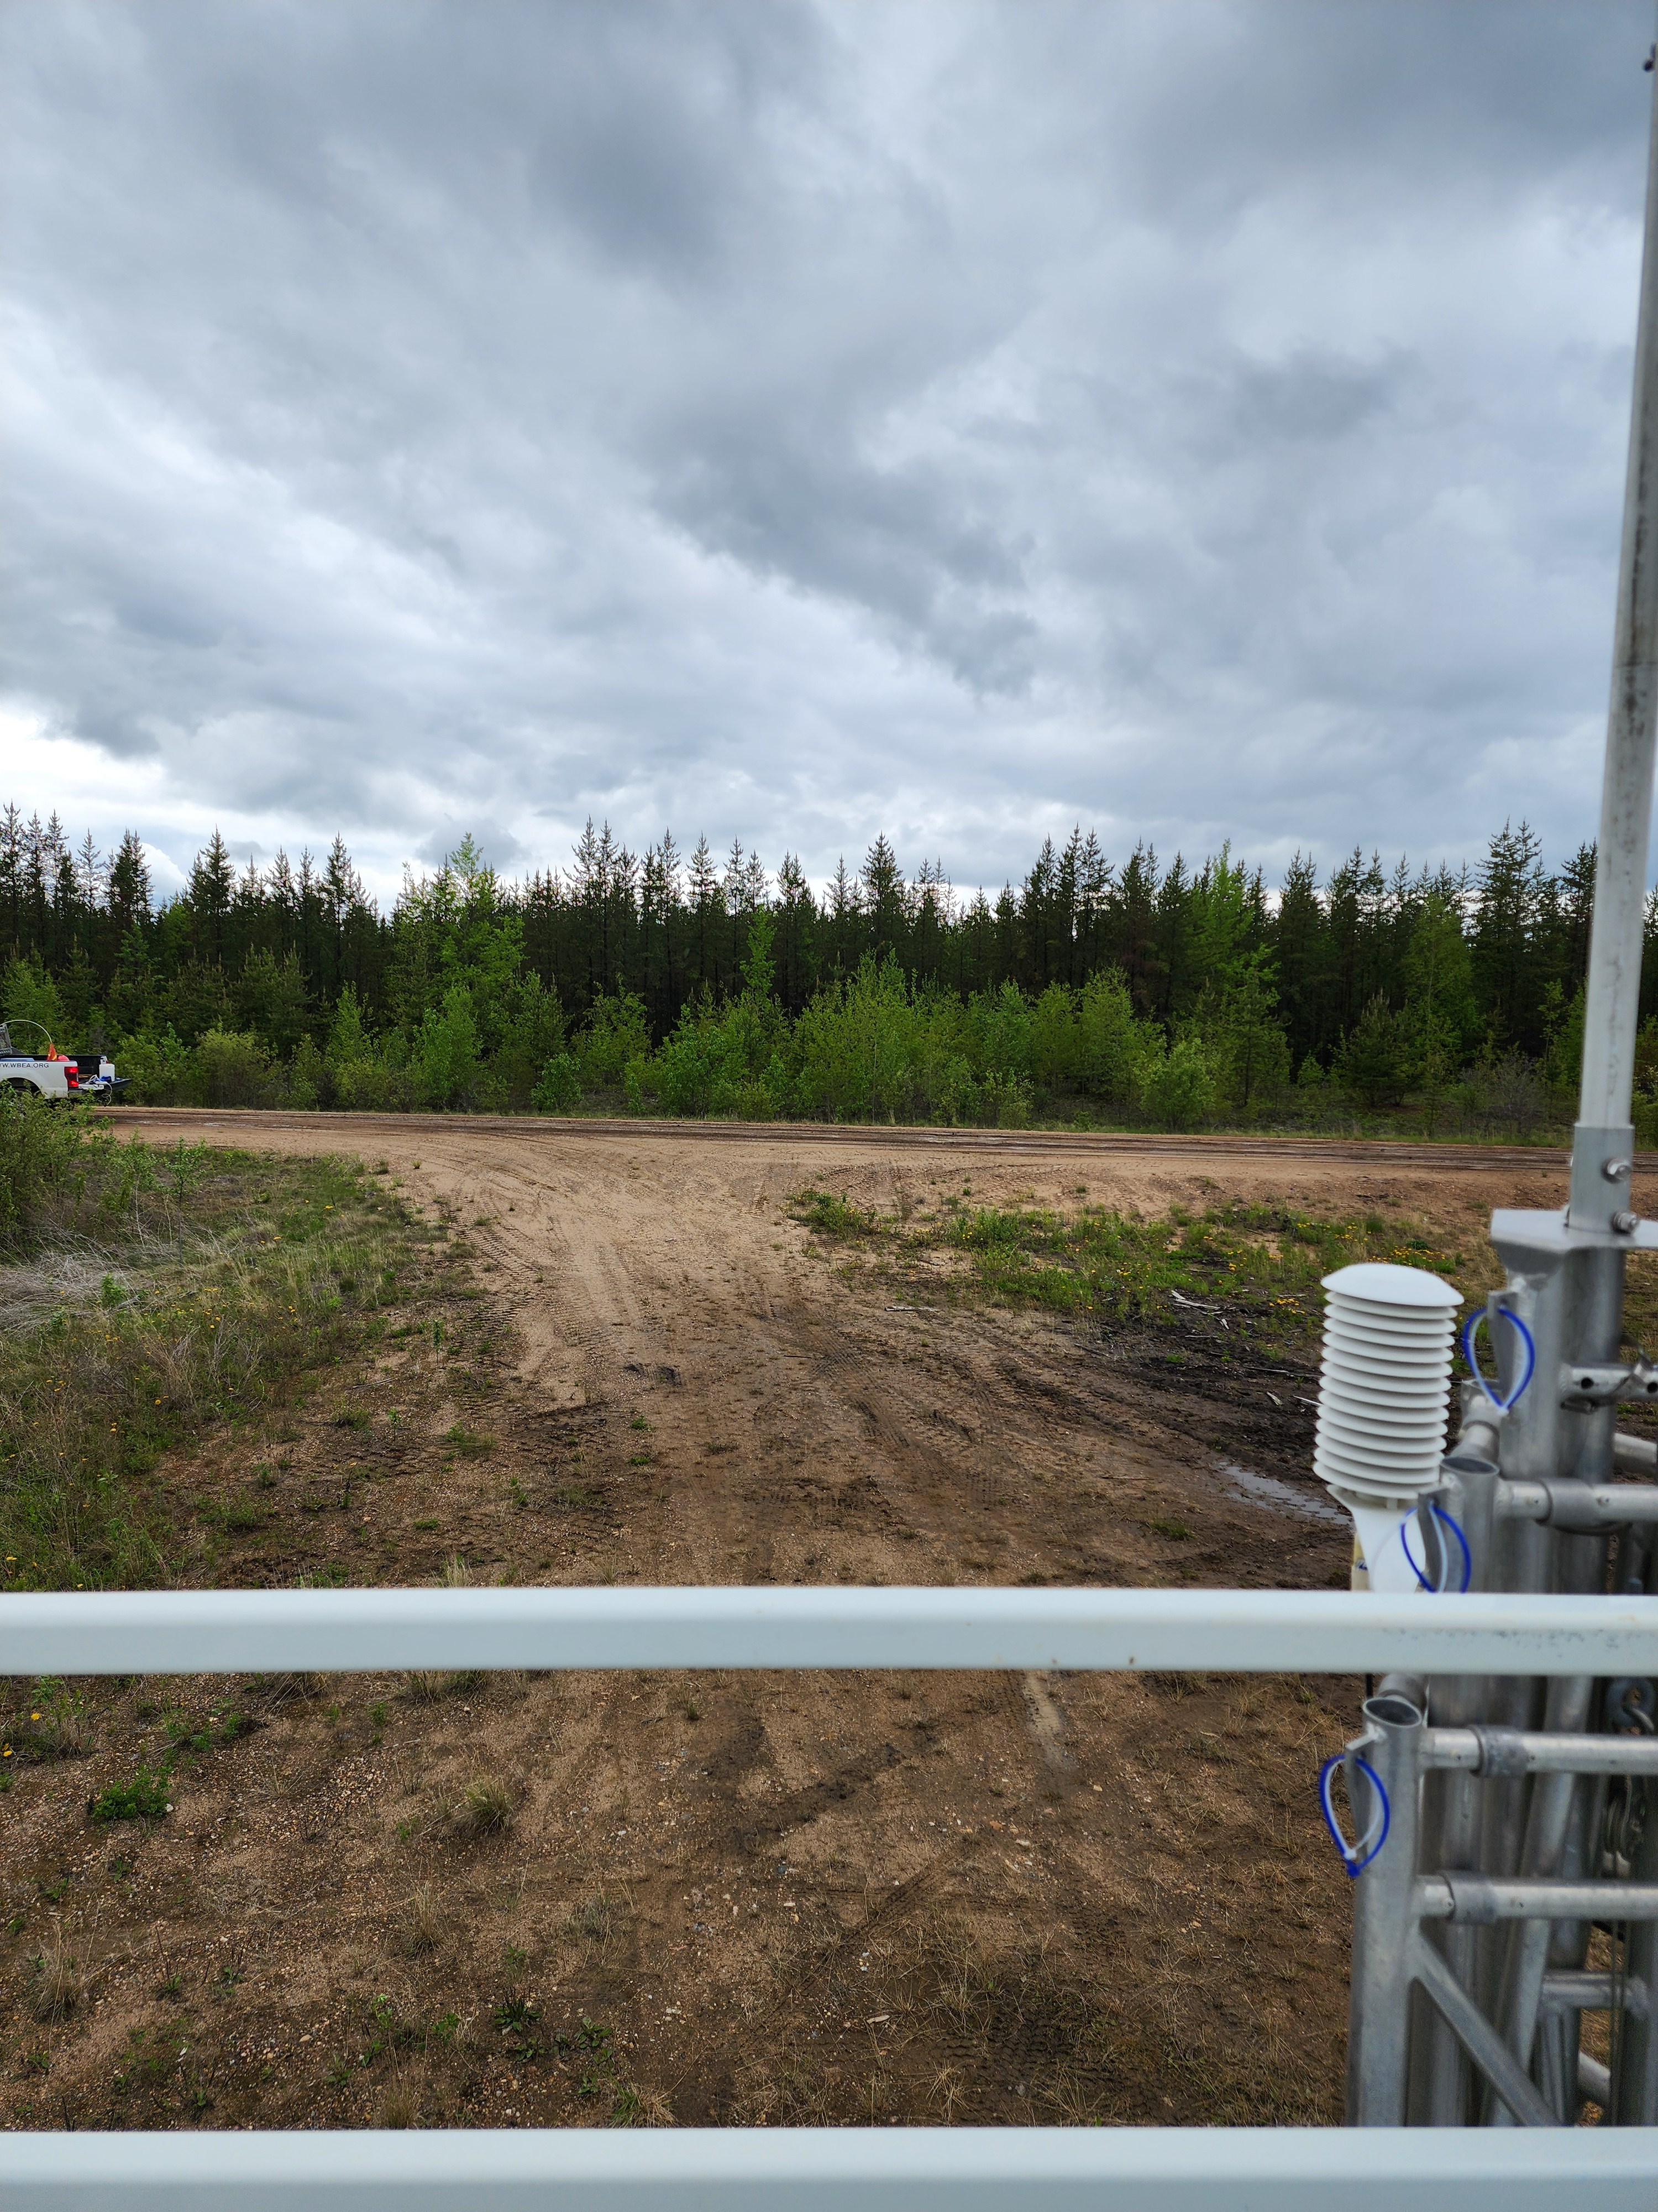

  - Figure 7 – Environment looking South
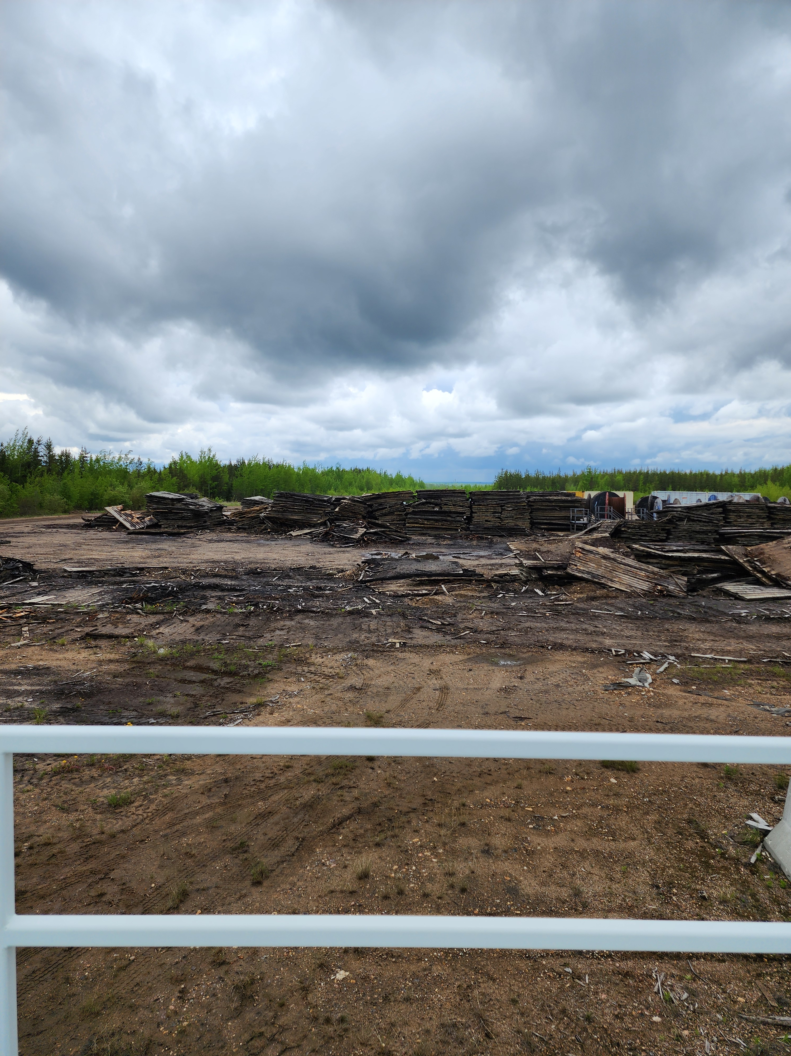

  - Figure 8 – Environment looking West

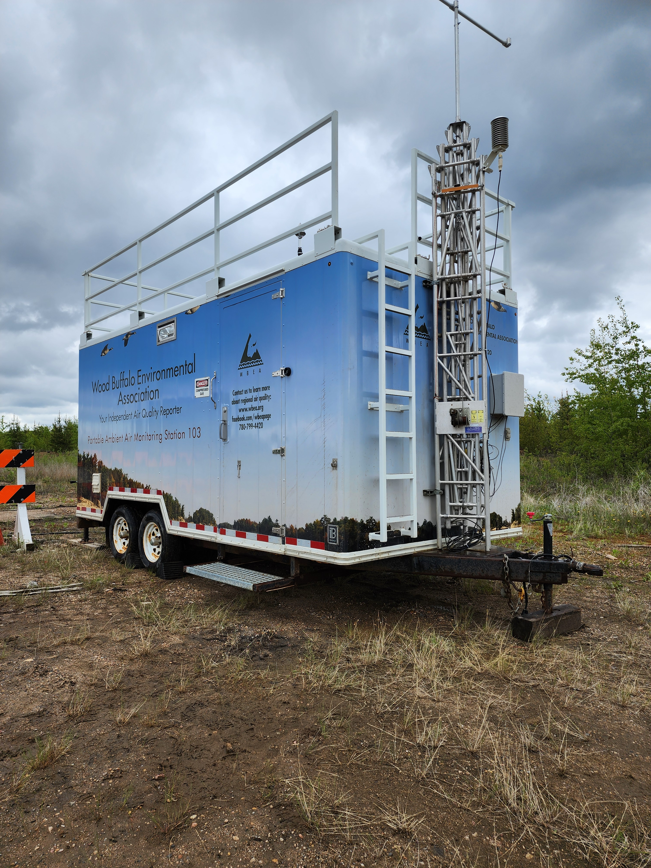
  - Figure 9 – Meteorological Tower

Station Photos
The following photos show the monitoring station and instrumentation.
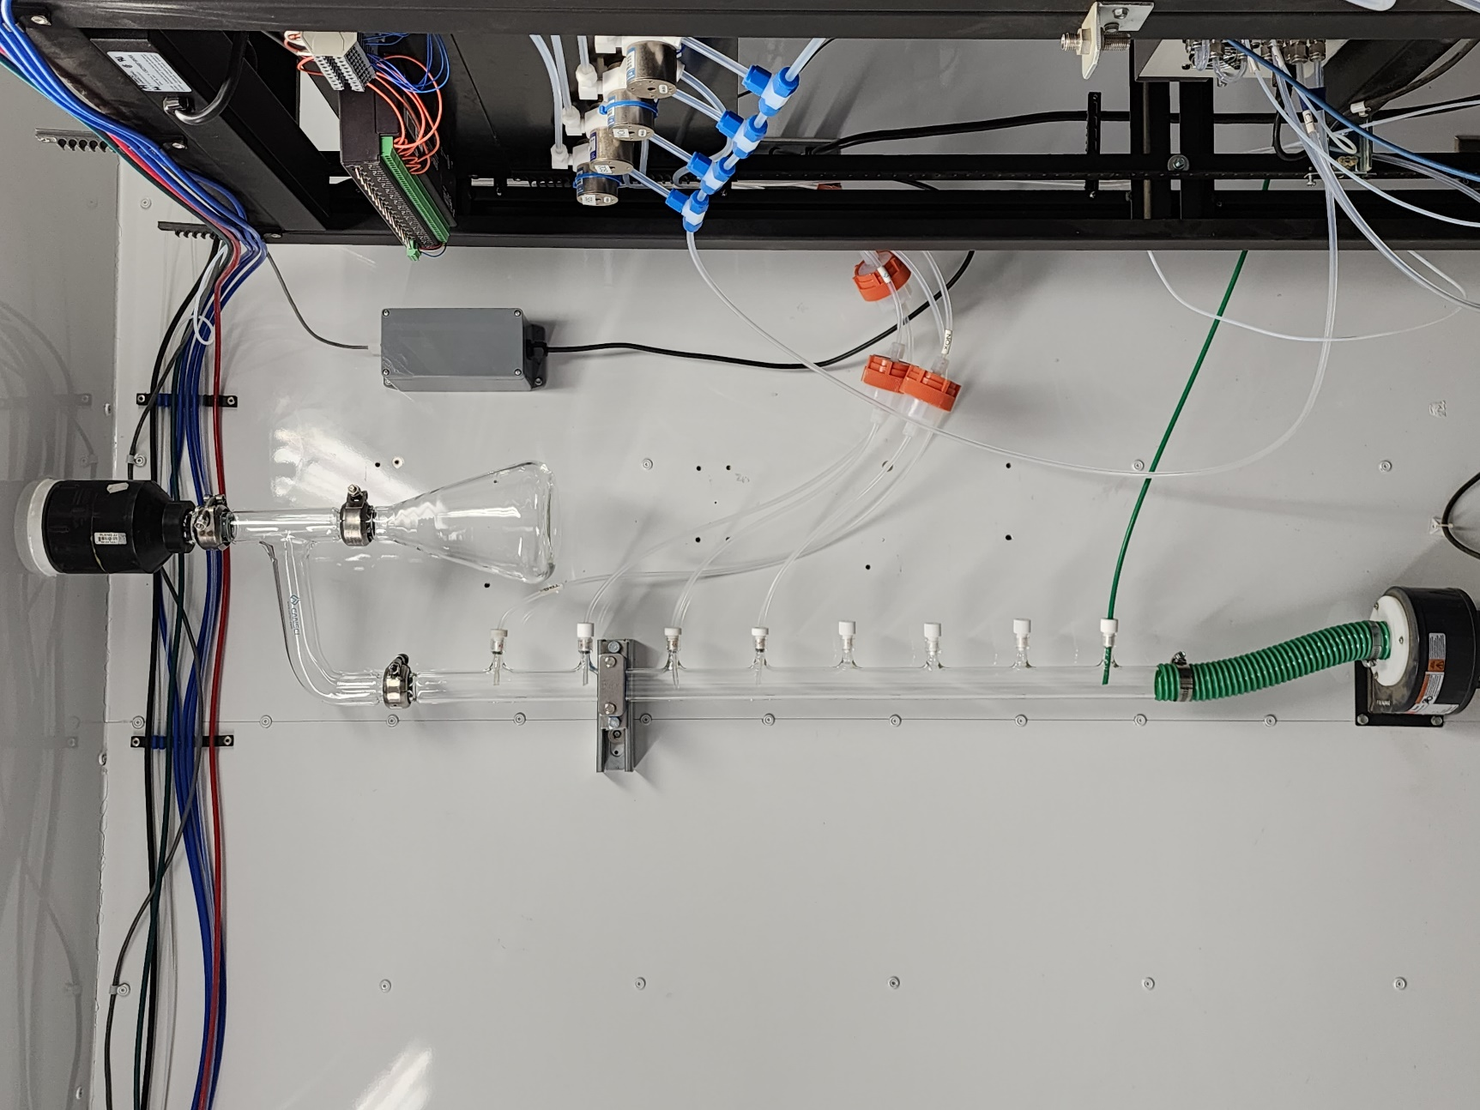
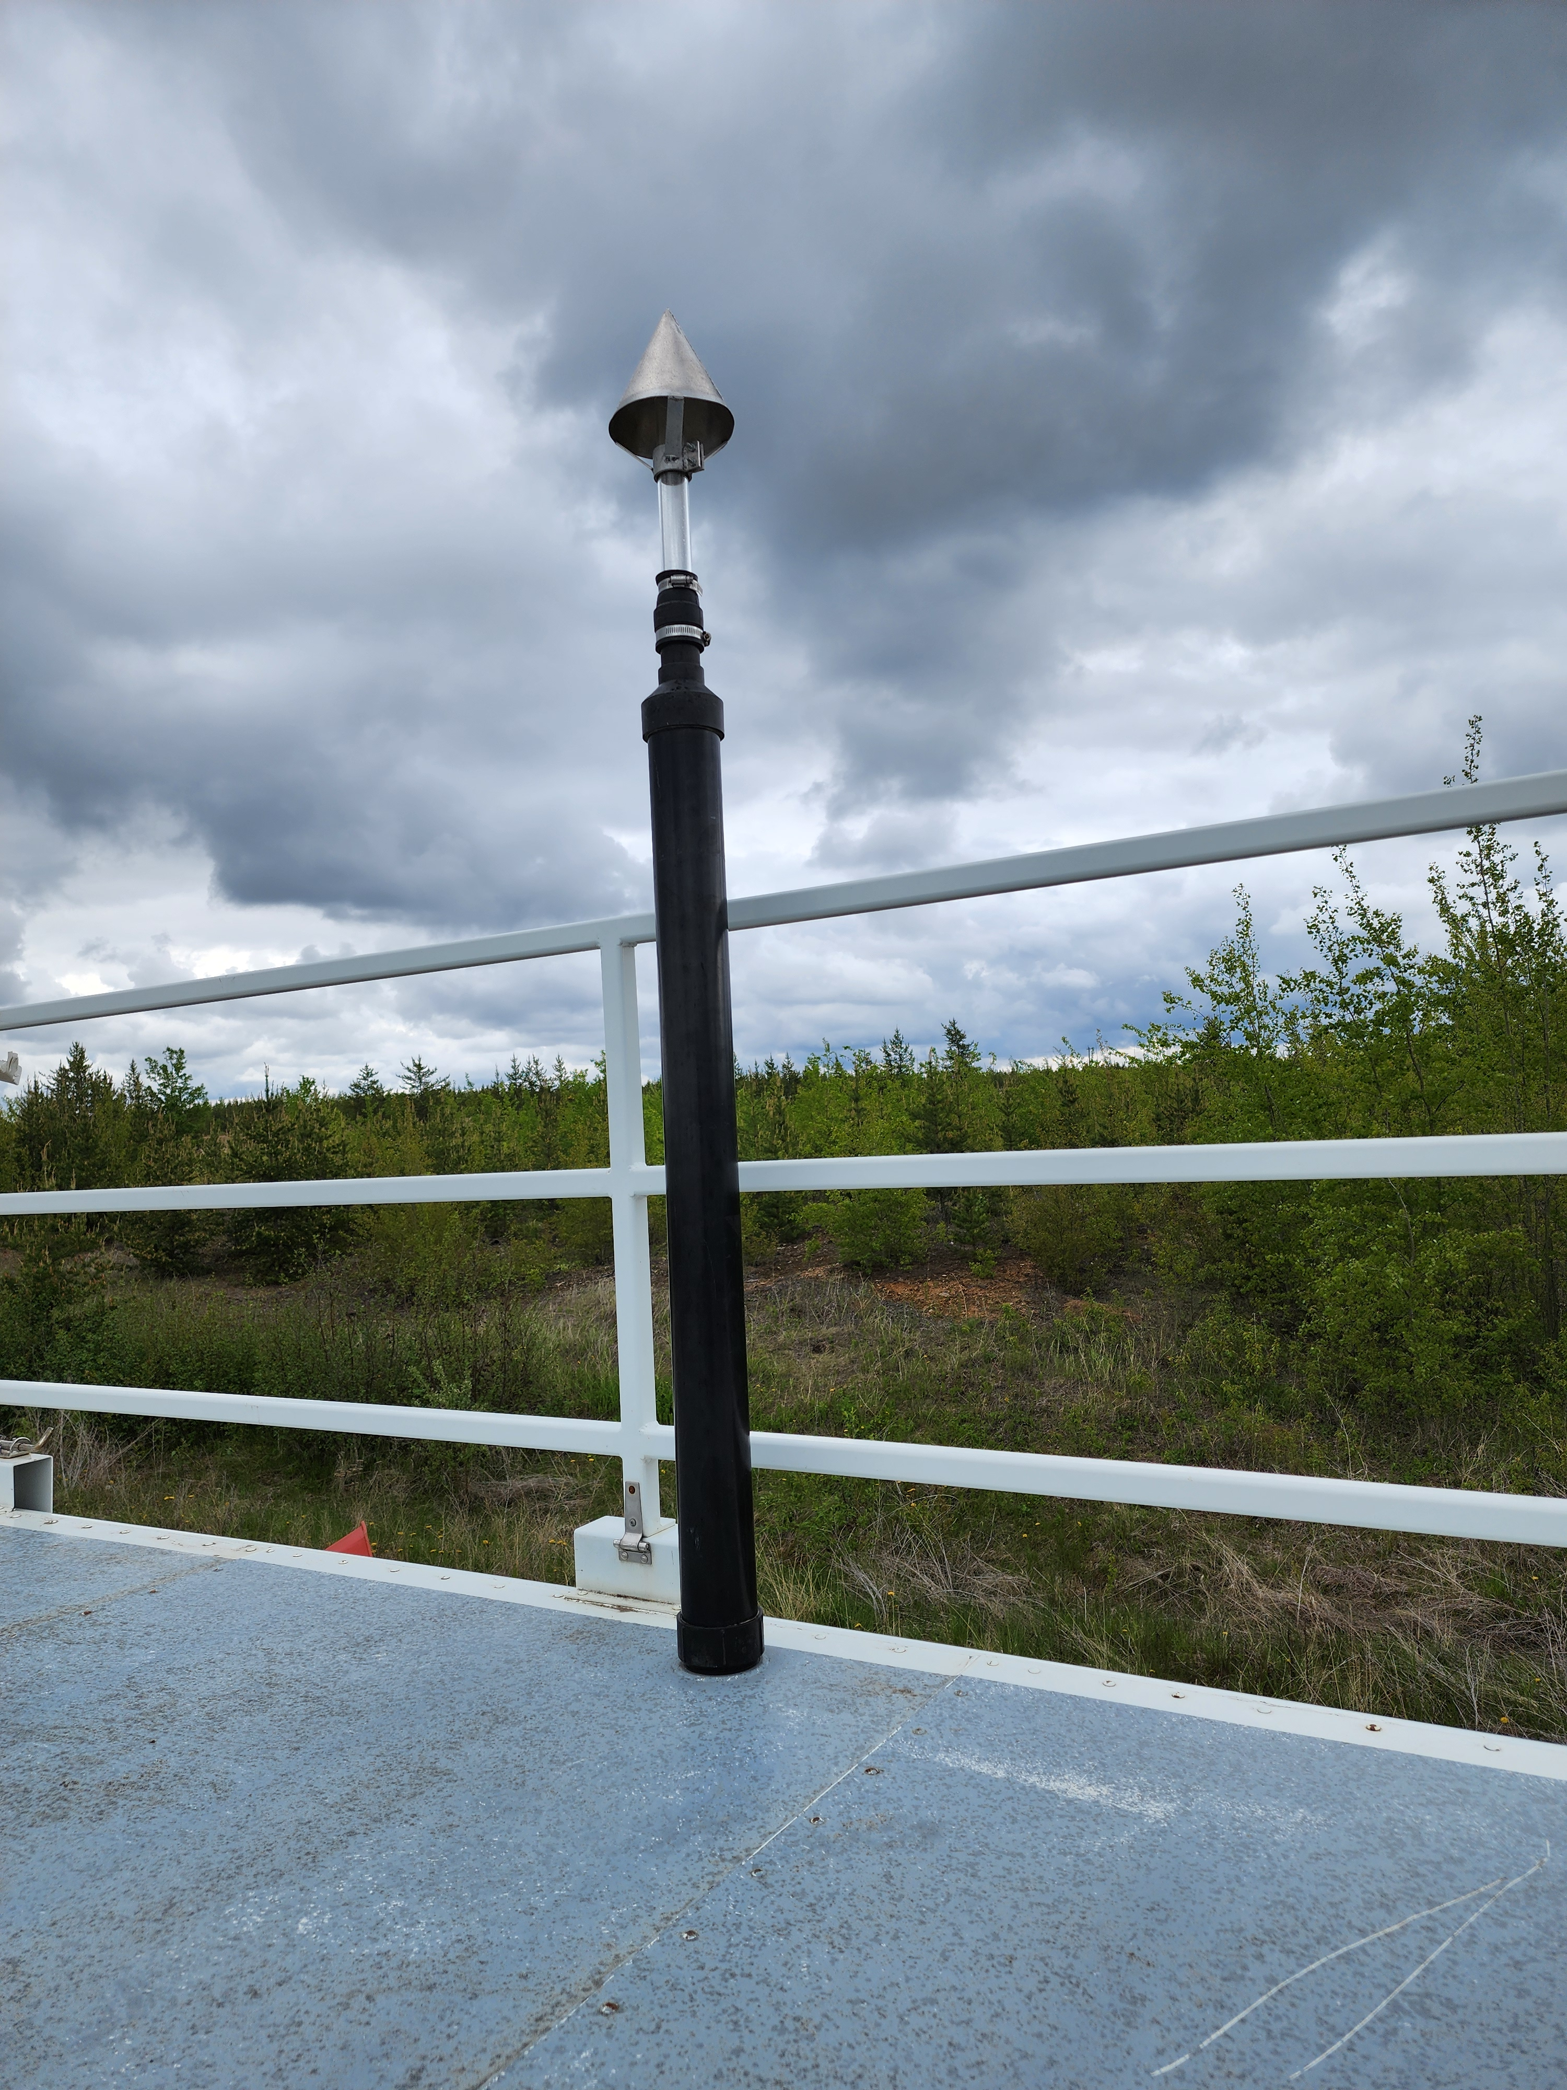

  - Figure 10 – Photo showing the inlet and sample manifold

  - Figure 11 – Curb shot of the monitoring station
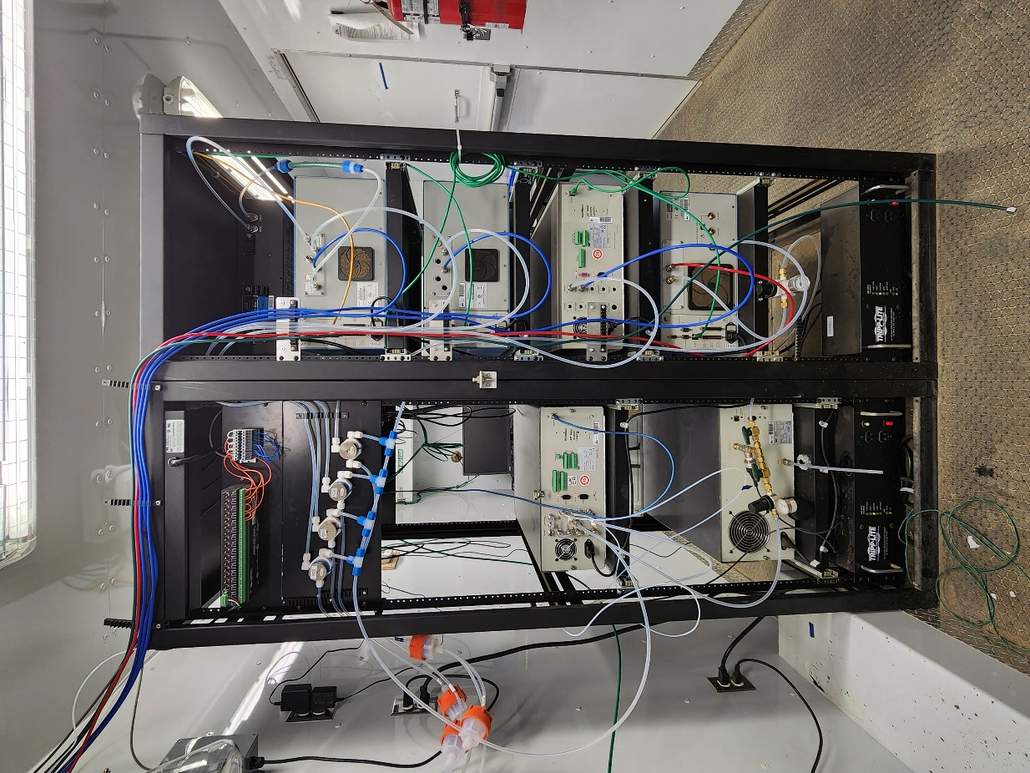
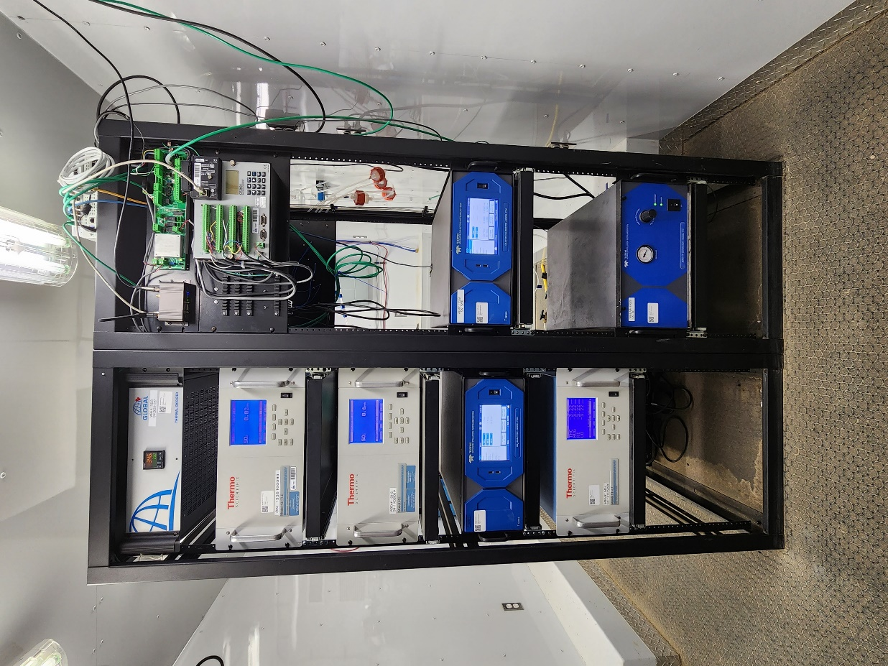

  - Figure 12 –Photo of the front and the back of instrument rack
  - 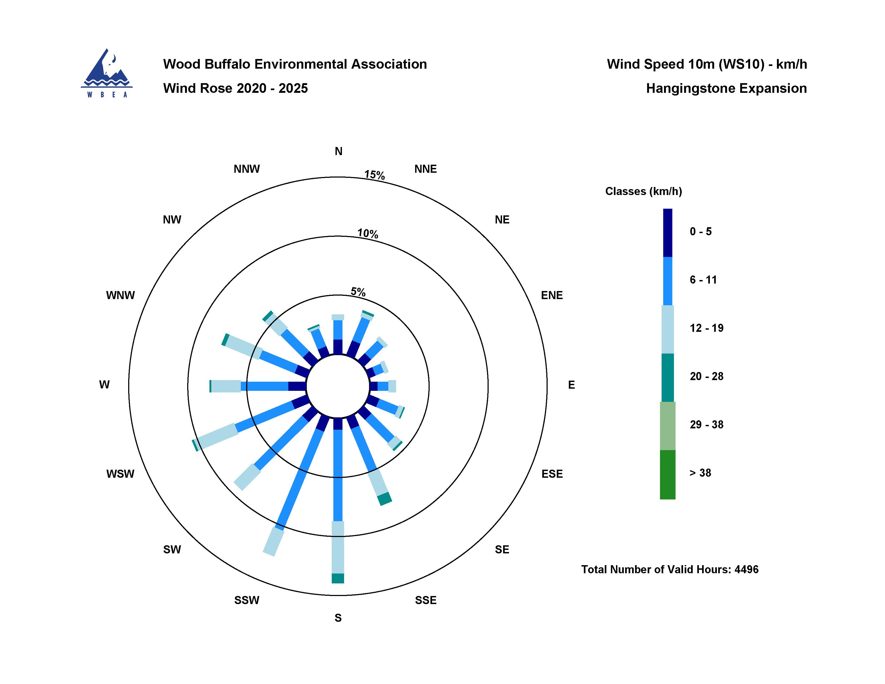

  - Figure 13 – Windrose (2020-2025)

