Wood Buffalo Environmental Association
Ambient Air Monitoring Station
Site Documentation

AMS 14 - Anzac

LAST UPDATED: March 10, 2026

Table of Contents
General Site Information 4
Station 4
Location 4
Owner/Operator/Approval Holder 4
Site Description 4
Site Influences 5
Localized Sources (within 20 metres of station) 5
Roadway Influences 5
Major Point Sources 5
Station Equipment 6
Analytical Equipment 6
Meteorological Equipment 6
Support Equipment 6
Site photos 11
Station Photos 16

Tables and Figures
Figure 1 – Area topographic map showing AMS 14 7
Figure 2 – Aerial photo showing AMS 14 8
Figure 3 – Plan view sketch for AMS 14 site 9
Figure 4 – Elevation view sketch for AMS 14 site 10
Figure 5 – Environment looking North 11
Figure 6 – Environment looking East 12
Figure 7 – Environment looking South 13
Figure 8 – Environment looking West 14
Figure 9 – Meteorological Tower 15
Figure 10 – Photo showing the inlet and sample manifold 16
Figure 11 – Curb shot of the monitoring station 17
Figure 12 –Photo of the front and the back of instrument rack 18
Figure 13 – Windrose 20m (2021-2025) 19

General Site Information

Station
Station ID | AMS 14
Station name | Anzac
Date station established | January 1, 2006

Location
Station street address | Stony Mountain Road
Legal land description | 16-09-086-07 W4
Airshed Zone | Wood Buffalo Environmental Association
Latitude | 56.4489083333
Longitude | -111.037975
UTM East | 497659
UTM North | 6256044
Nearest community | Anzac
Community population | 659
Census Year | 2025

Owner/Operator/Approval Holder
Operating Agency | Wood Buffalo Environmental Association
Address of Operating Agency | Unit 3, 805 Memorial Drive, Fort McMurray, Alberta T9K 0K4
Name of Approval Holder | CNOOC International
Approval number | 137467-01-00; 236394-00-00
Contact Name | Nandakumar Rajendran
Address | Suite 2300, 500 Centre St. SE, Calgary, AB, T2G 1A6
Phone number | 780-742-6873
Email address | Nandakumar.Rajendran@intl.cnoocltd.com

Site Description
Land use by sector | 0 – 90 degrees | Trees
Land use by sector | 91 – 180 degrees | Trees
Land use by sector | 181 – 270 degrees | House
Land use by sector | 271 – 360 degrees | Trailer
Site elevation (m)  (above sea level) | 497 m
Angle of elevation to nearby buildings | Greatest angle | 18
Angle of elevation to nearby buildings | Building direction | West
Airflow restrictions | North | None
Airflow restrictions | East | None
Airflow restrictions | South | None
Airflow restrictions | West | House
Sample manifold | Type | All glass
Sample manifold | Inlet height above roof | 1 meter
Distance to nearest trees (m) | North | 39 meters
Distance to nearest trees (m) | East | 30 meters
Distance to nearest trees (m) | West | NA
Distance to nearest trees (m) | South | NA
Meteorological Sensors | Type | Cup and vane
Meteorological Sensors | Height above ground (m) | 20 m
Meteorological Sensors | Distance from station (m) | 3 m

Site Influences

Localized Sources (within 20 metres of station)
Type | Distance (m) | Description
Trailer | 18 m | Communication shack
House | 14 m | House W of station

Roadway Influences
Type | Traffic Volume | Distance (m) | Description
Pavement | Low | 62 m | Main road of Anzac
Access road | Low | 16 m | Access road to the station
Railway | Low | 70 m

Major Point Sources
Facility Name | Source Type | Production Capacity | Distance from site (km) | Compass direction from site
Nexen Long Lake | SAGD | 70,000 bbl/day | 4.38 | SW

Station Equipment
Equipment Owner: WBEA

Analytical Equipment
Parameter | Make | Model | Serial Number | Date Installed
SO2 | Thermo Scientific | 43i | 710321322 | 2023-07-07
TRS | Thermo Scientific | 43i-LTE | 1218153582 | 2022
NO2 | Thermo Scientific | 42i | 1152430008 | 2022
NMHC | Thermo Scientific | 55i | 1331259521 | 2025-01-06
O3 | Thermo Scientific | 49i | 1426262595 | 2024-01-04
PM2.5 | Teledyne | T640 | 825 | 2022
PM10 | Thermo Scientific | 2000i | 2000i 294821408 | 2016
PM10 | Thermo Scientific | 2000i | 2000i 204581405 | 2016
PM2.5 | Thermo Scientific | 2000i | 2000i 203871308 | 2016
PM2.5 | Thermo Scientific | 2000i | 2000iW205911510 | 2016
PAH | Tisch Environmental | TE-PIF+BL | 1001055 | 2016
VOC | Tisch Environmental | TE-123 | 1024 | 2022

Meteorological Equipment
Parameter | Make | Model | Serial Number | WMO Site Class | Date Installed
AT/RH | Vaisala | HMP155 | U2120856 | 2 | 2024-11-04
WS | Met One | 010C-1 | U11126 | 3 | 2024-04-09
WD | Met One | 020C-1 | C21020 | 3 | 2024-04-09
Leaf Wetness | Decagon Devices | LWS-L | 23946-6 |  | 2022

Support Equipment
Name | Description | Make | Model | Serial Number
Datalogger | Datalogger | Campbell Scientific | CR3000 | 2582
Gas Dilution Calibrator | Dynamic dilution calibrator | Teledyne/API | T700 | 3060
Zero air generator | Zero Air Generator | Teledyne/API | T701H | 357
Shelter / Building | Air monitoring portable | ITB | 8 x 16 trailer | ITB 21 18397
HVAC | Heating and air conditioning system. Wall mount unit | BARD | 1 ton

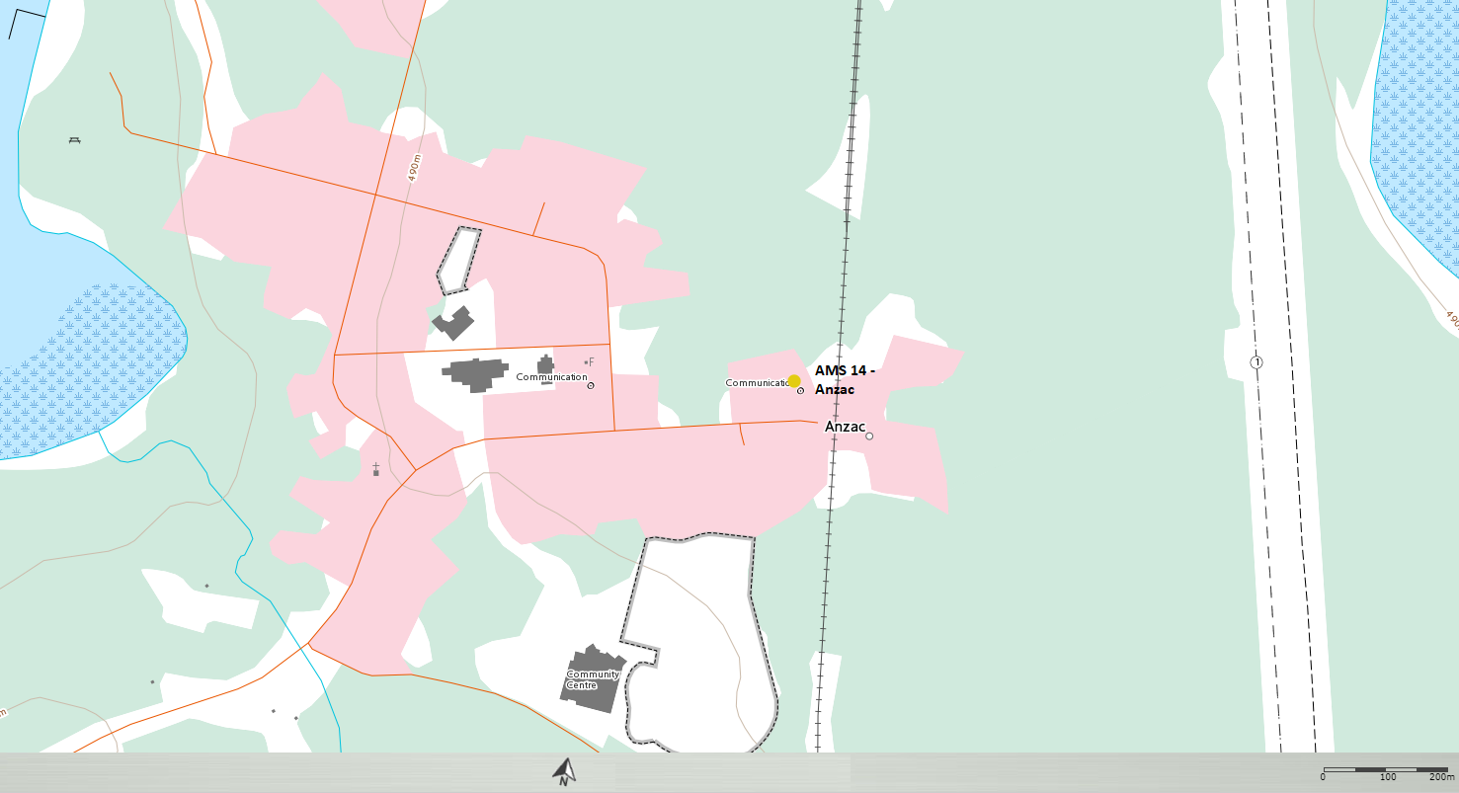
  - Figure 1.0 – Area topographic map showing AMS 14.

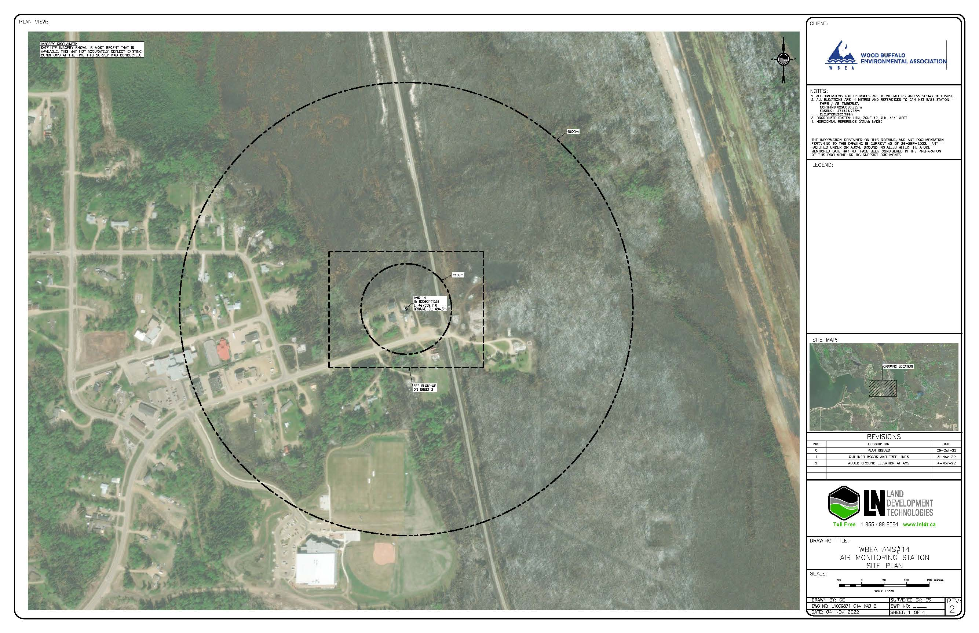
  - Figure 2.0 – Aerial image showing AMS 14.
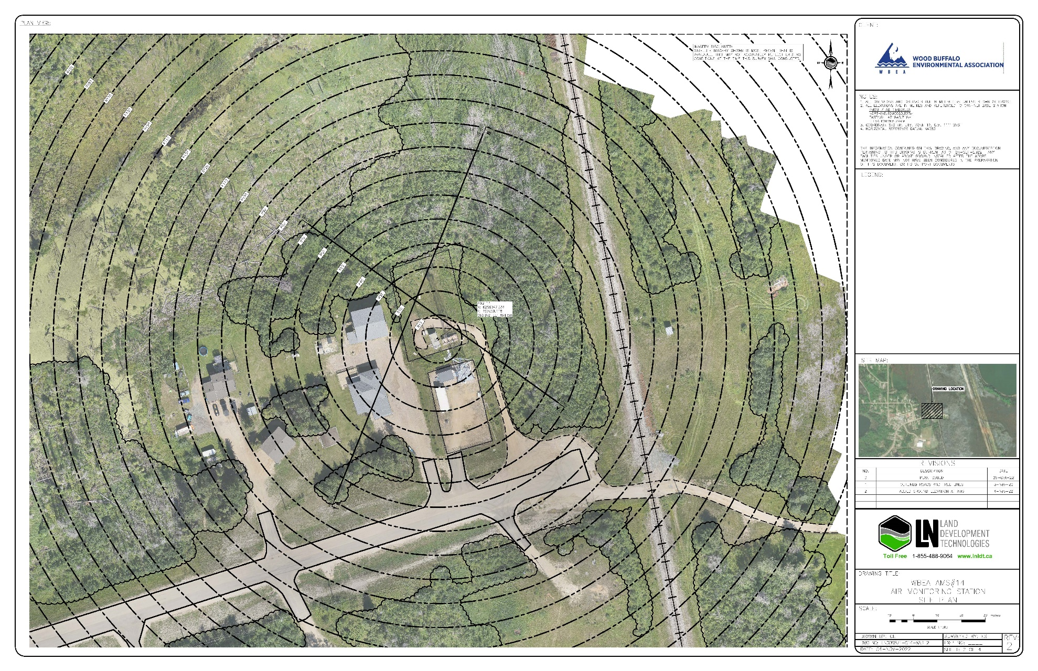
  - Figure 3.0 – Plan view image for AMS 14 site.

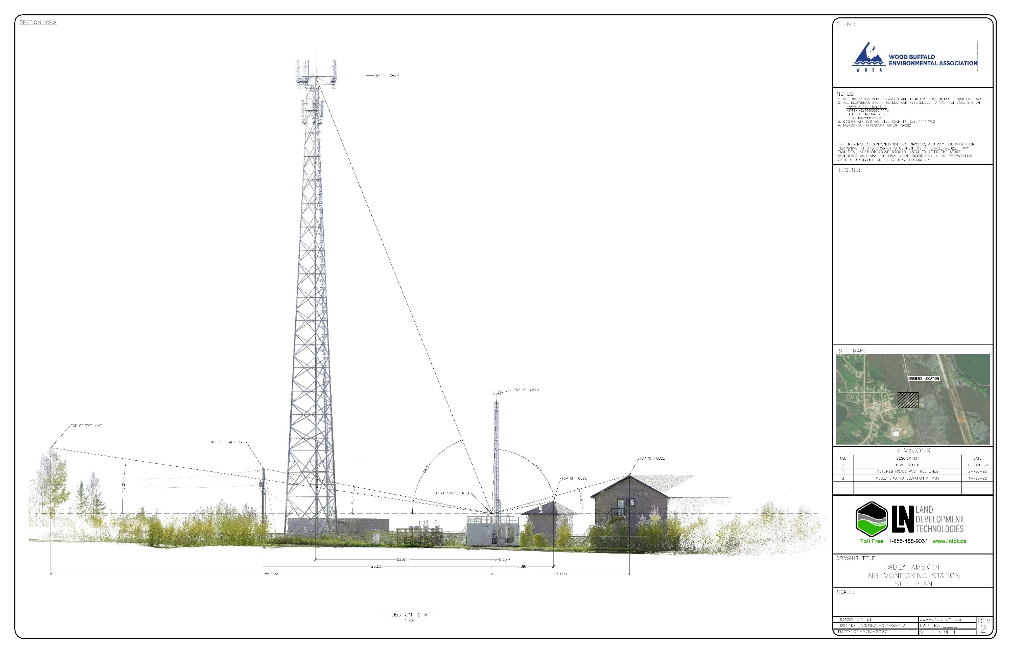
  - Figure 4.0 – Elevation view image for AMS 14 site.

Site photos
The following photos show the environment surrounding the monitoring station.

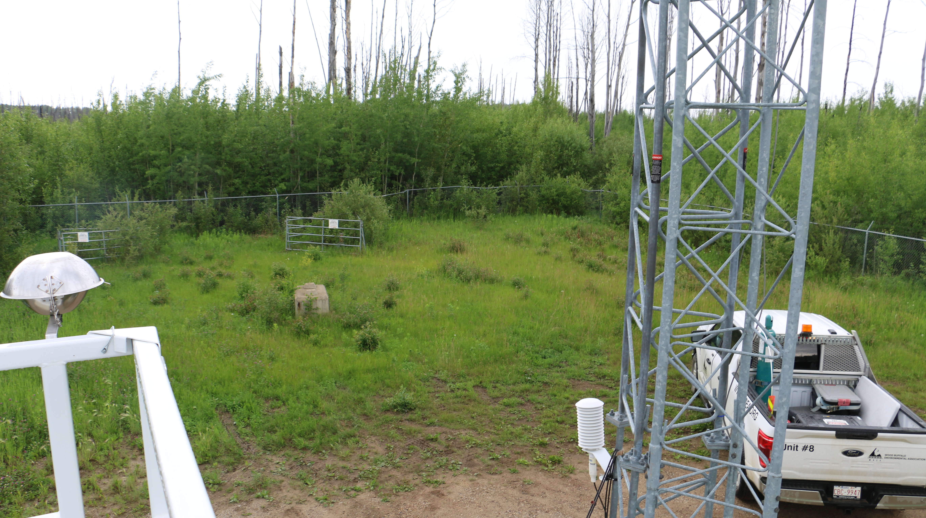
  - Figure 5.0 – Environment looking North.

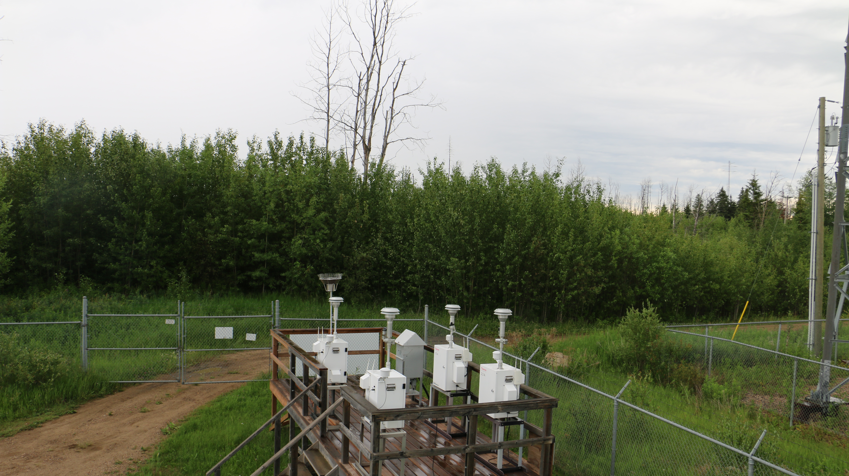
  - Figure 6 – Environment looking East.
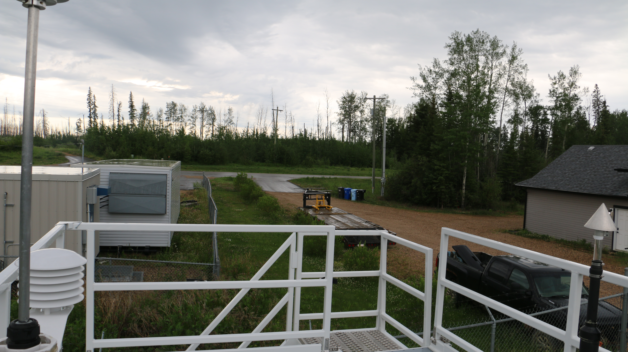
  - Figure 7 – Environment looking South.
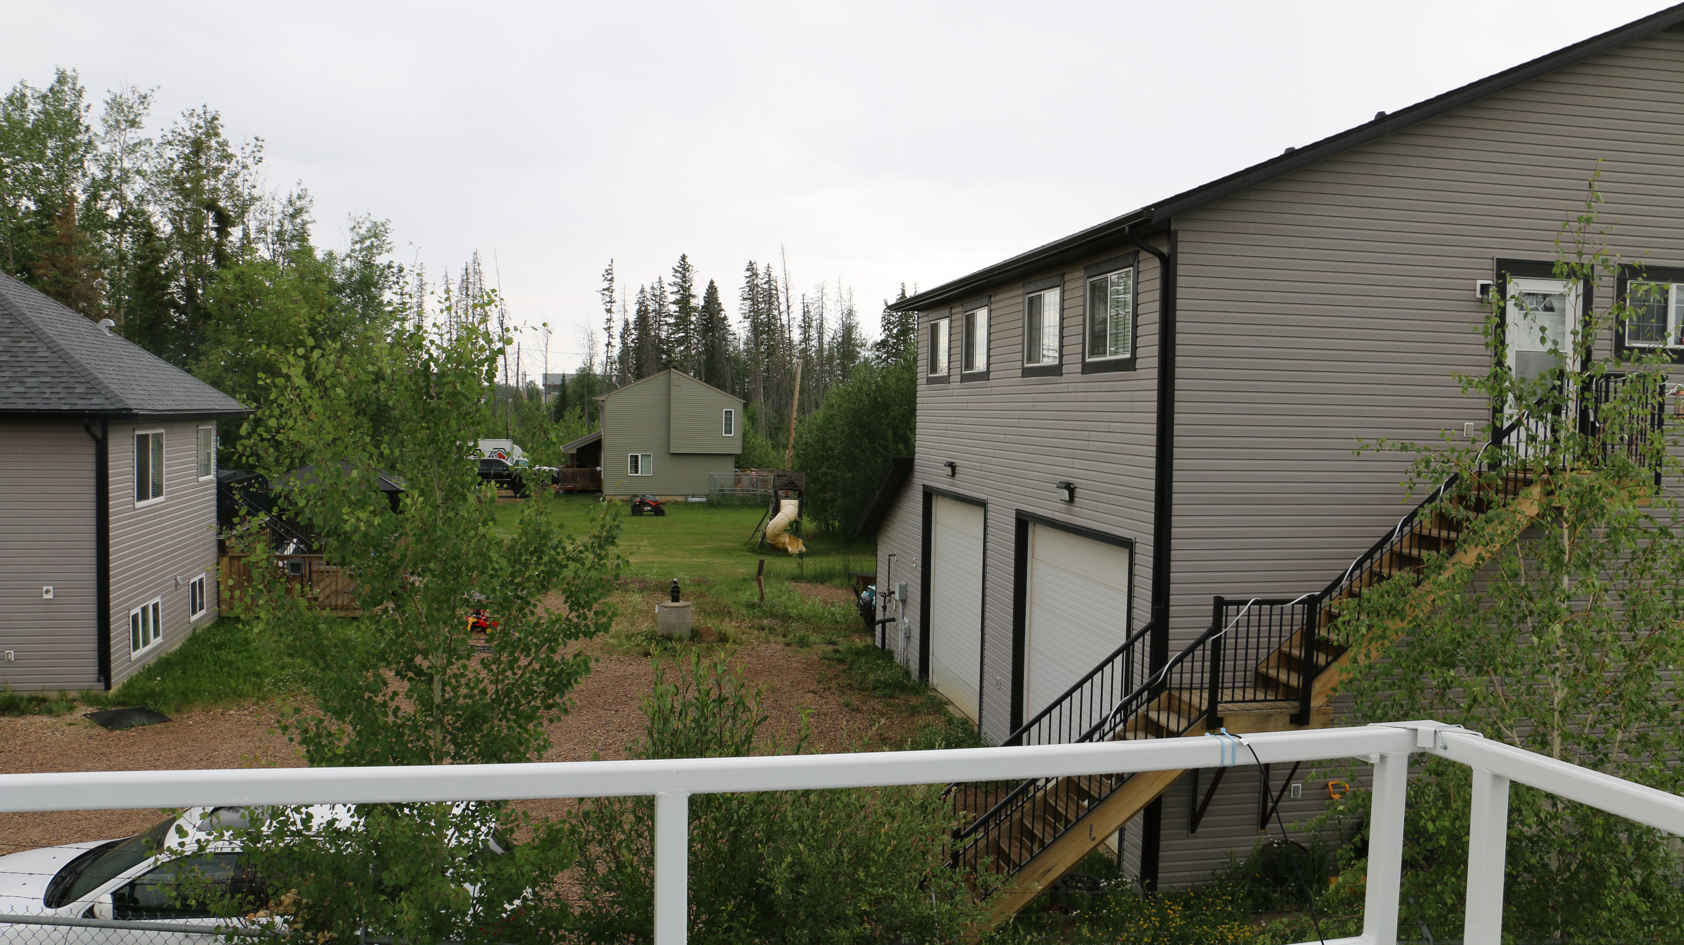
  - Figure 8 – Environment looking West.
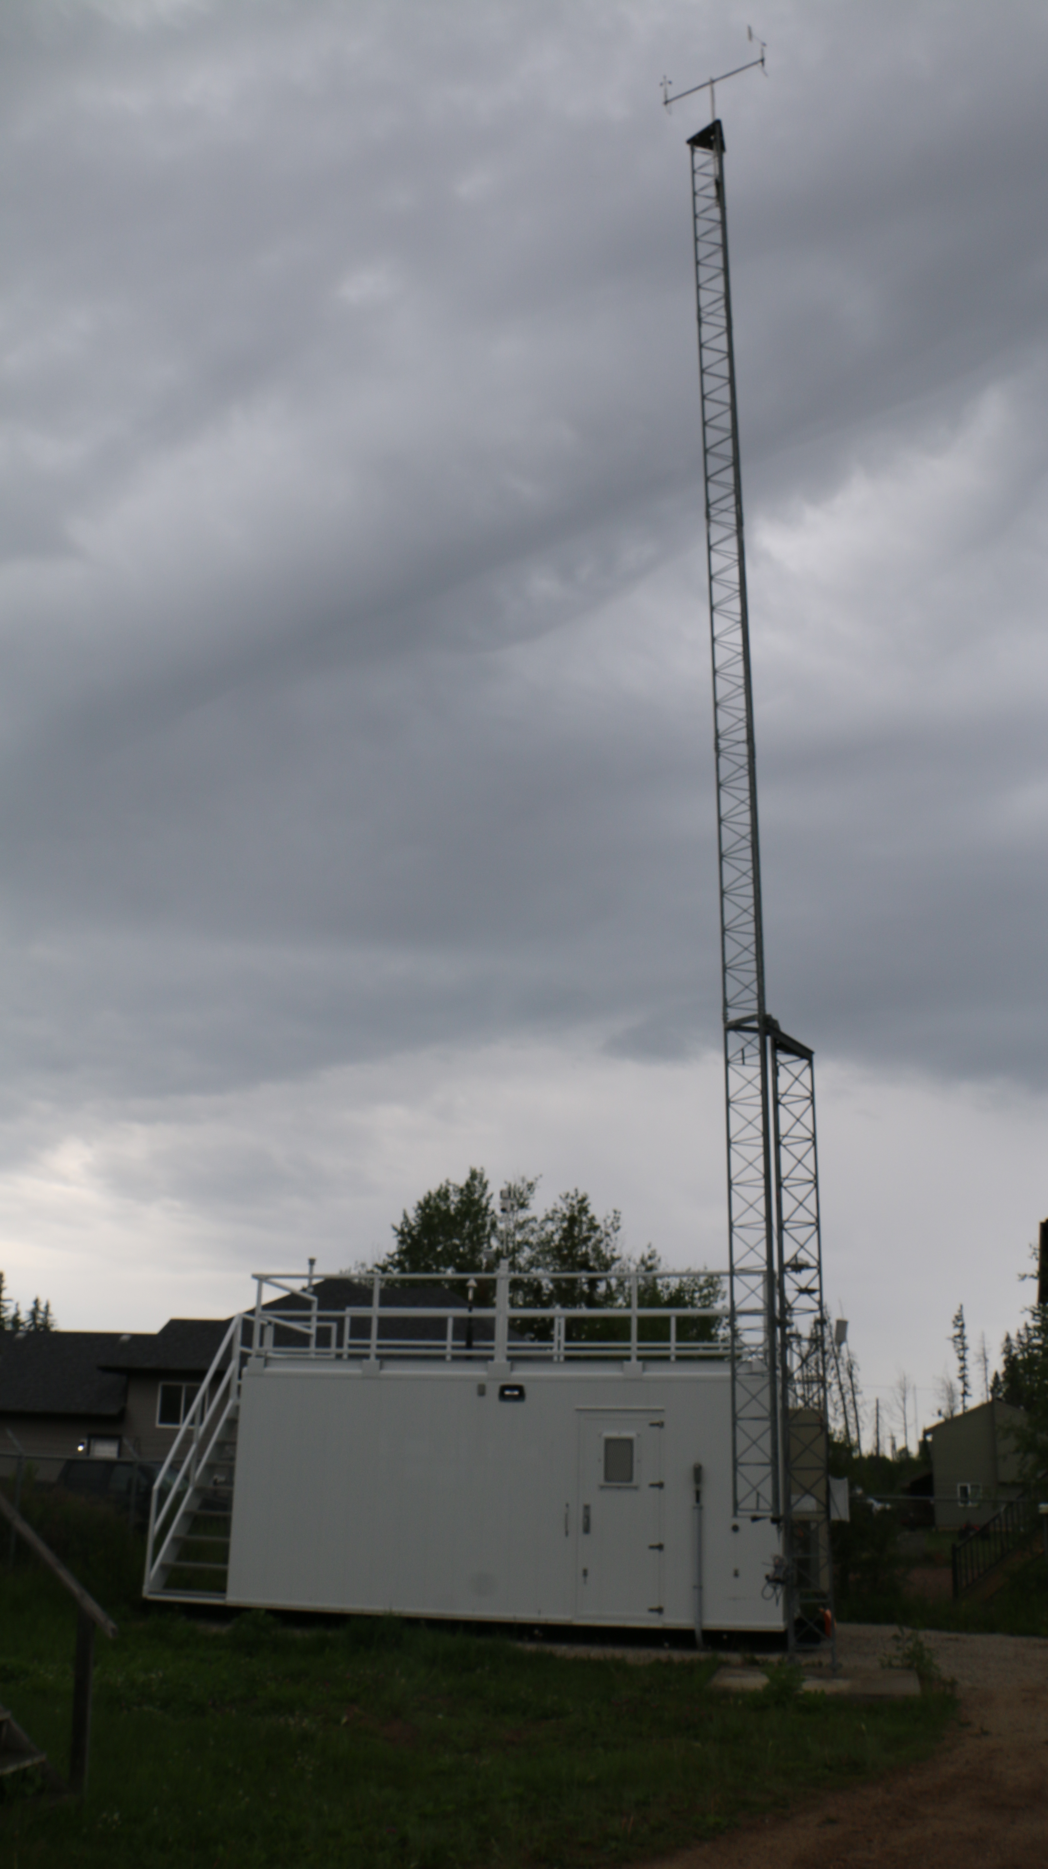
  - Figure 9 – Meteorological Tower.

Station Photos
The following photos show the monitoring station and instrumentation.

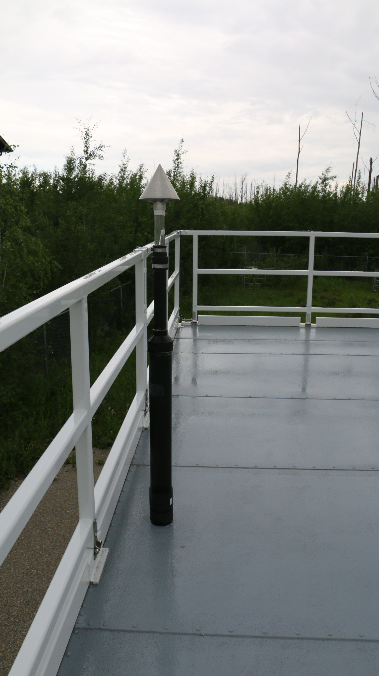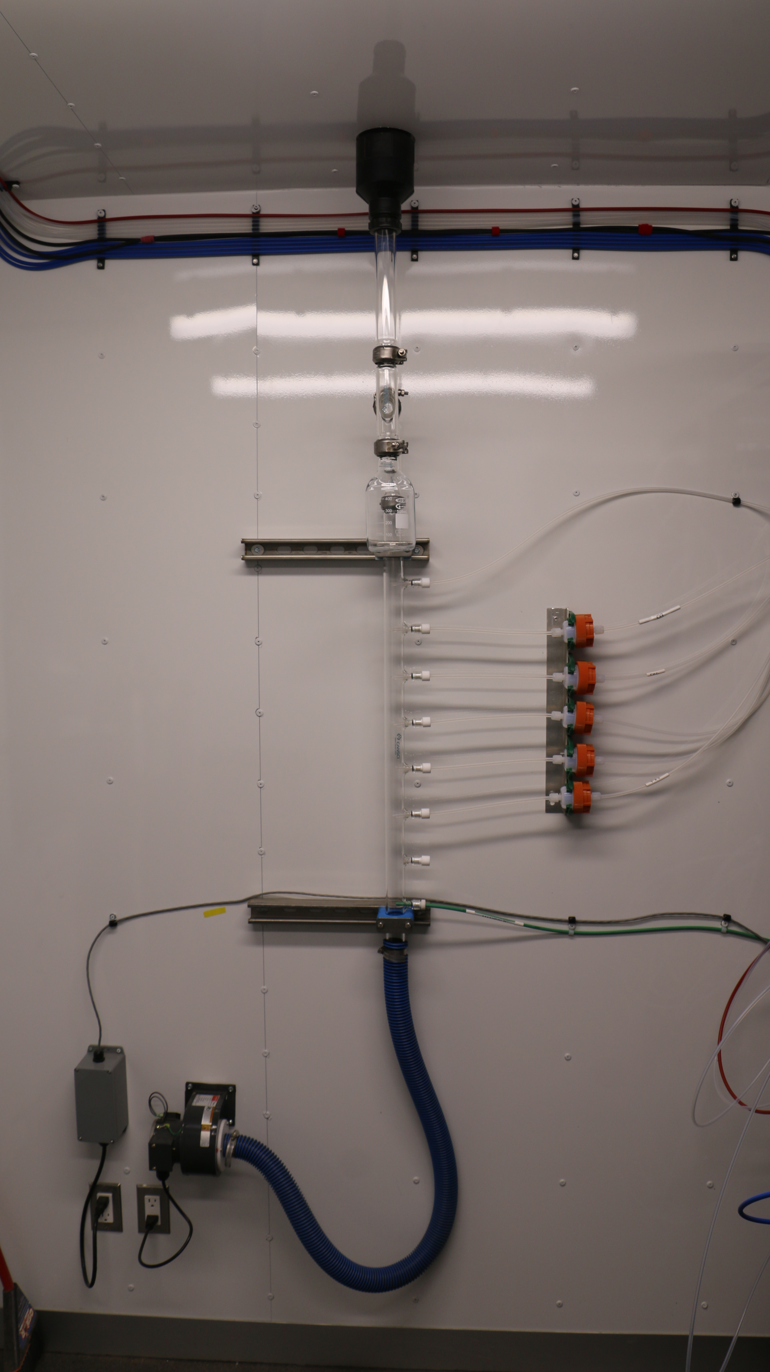
  - Figure 10 – Photo showing the inlet and sample manifold.

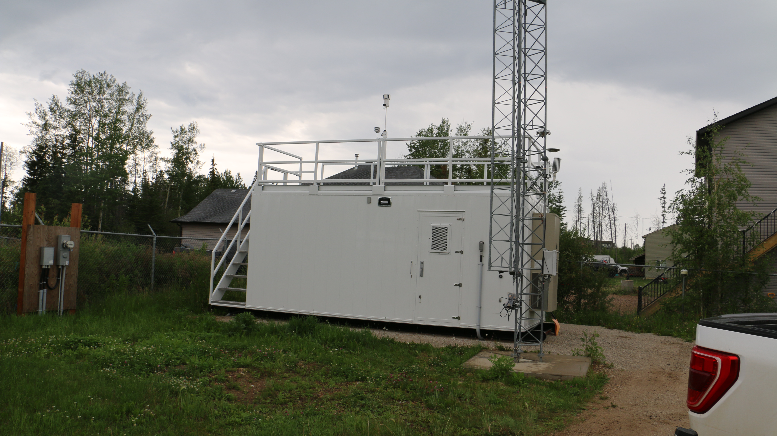
  - Figure 11 – Curb shot of the monitoring station.
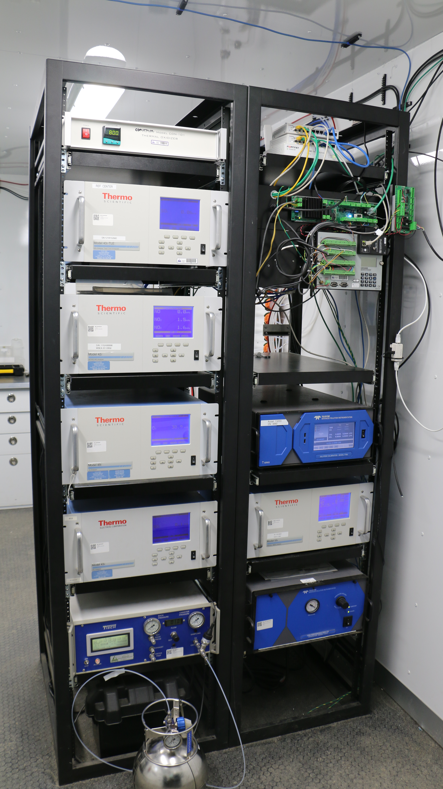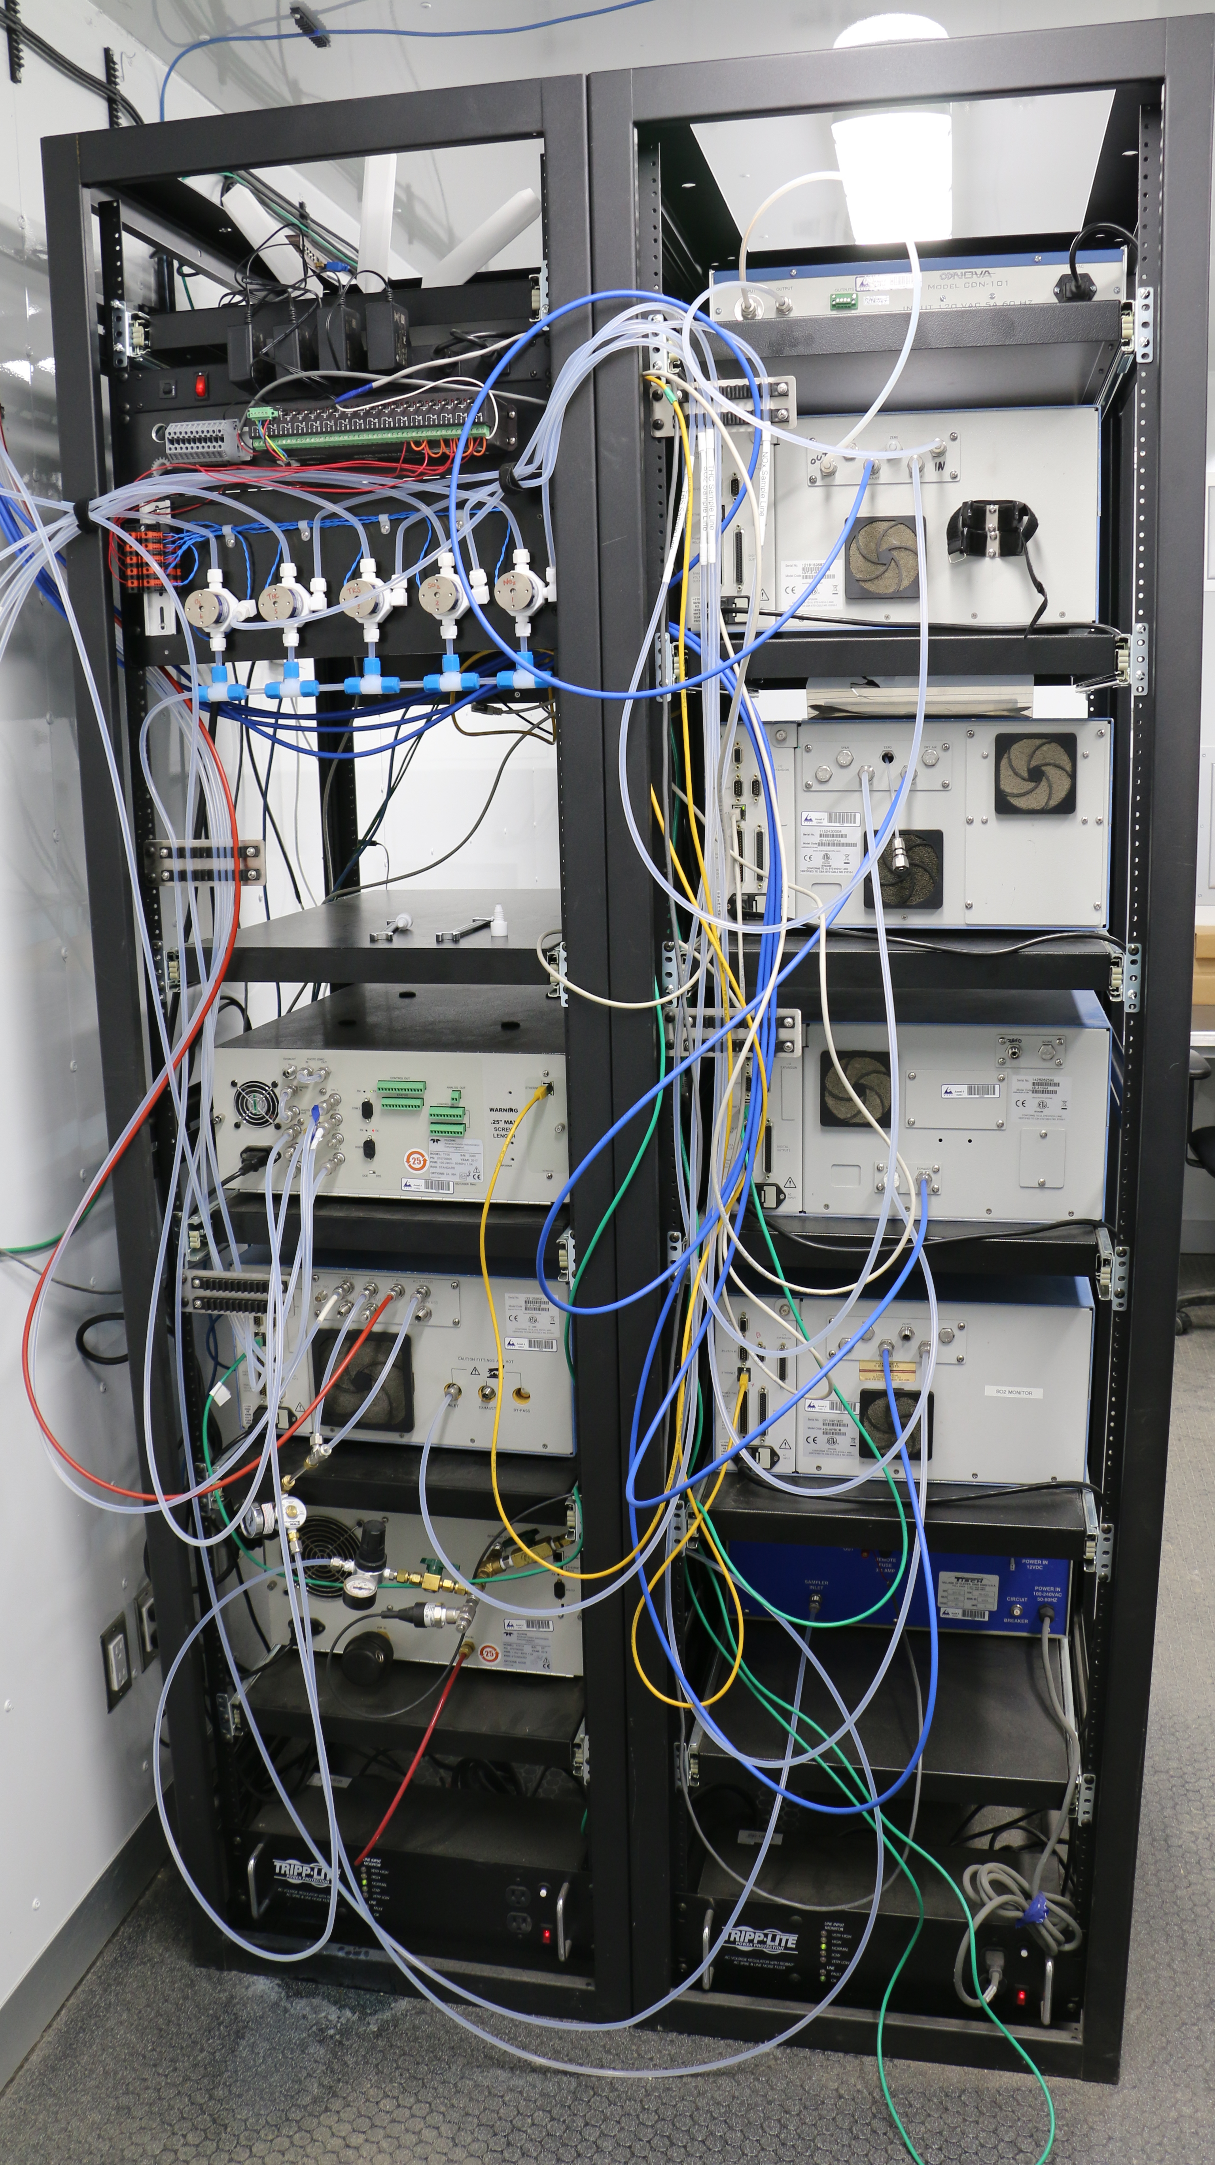
  - Figure 12 –Photo of the front and the back of instrument rack.
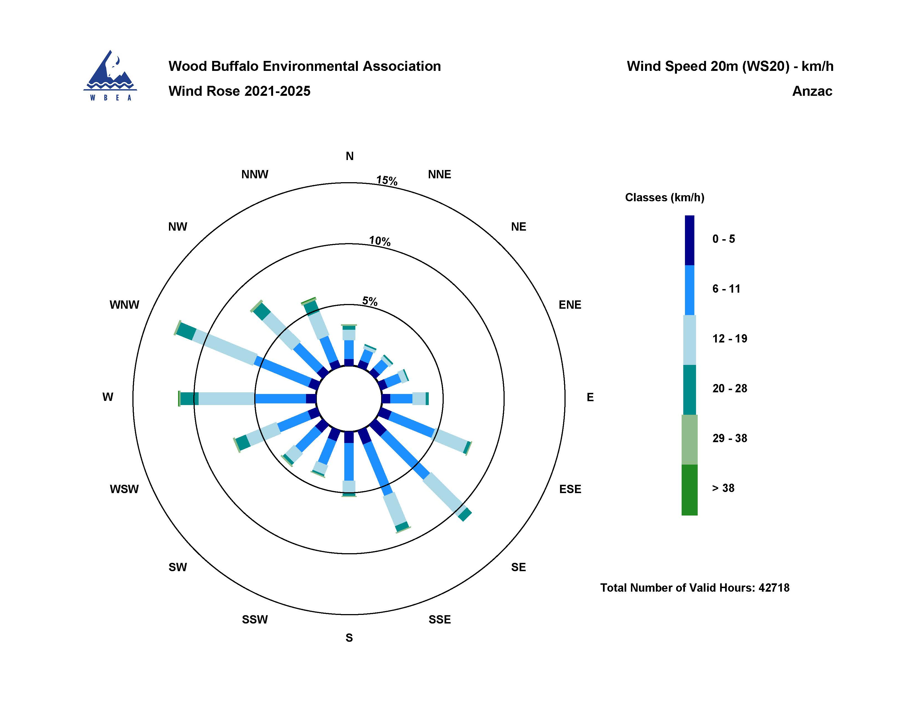
  - Figure 13 Windrose (2021-2025).

