Wood Buffalo Environmental Association
Ambient Air Monitoring Station
Site Documentation

Jackfish 1

LAST UPDATED: February 18, 2026

Table of Contents
General Site Information 4
Station 4
Location 4
Owner/Operator/Approval Holder 4
Site Description 4
Site Influences 5
Localized Sources (within 20 metres of station) 5
Roadway Influences 5
Major Point Sources 5
Station Equipment 6
Analytical Equipment 6
Meteorological Equipment 6
Support Equipment 6
Site photos 11
Station Photos 16

Tables and Figures
Figure 1 – Area topographic map showing AMS 506 7
Figure 2 – Aerial image showing AMS 506 8
Figure 3 – Plan view image for AMS 506 site 9
Figure 4 – Elevation view image for AMS 506 site 10
Figure 5 – Environment looking North 11
Figure 6 – Environment looking East 12
Figure 7 – Environment looking South 13
Figure 8 – Environment looking West 14
Figure 9 – Meteorological Tower 15
Figure 10 – Photo showing the inlet and sample manifold 16
Figure 11 – Curb shot of the monitoring station 17
Figure 12 –Photo of the front and the back of instrument rack 18
Figure 13 – Windrose (2021-2025) 19

General Site Information
Revision Date: February 18, 2026

Station
Station ID | AMS 506
Station name | Jackfish 1
Date station established | Aug 16, 2018

Location
Station street address | Located SE of Jackfish construction camp
Legal land description | 8-28-75-6-W4
Airshed Zone | Wood Buffalo Environmental Association
Latitude | 55.523816
Longitude | -110.865345
UTM East | 508503
UTM North | 6153091
Nearest community | Conklin
Community population | 154
Census Year | 2021

Owner/Operator/Approval Holder
Operating Agency | Wood Buffalo Environmental Association
Address of Operating Agency | Unit 3-805 Memorial Drive, Fort McMurray, Alberta T9K 0K4
Name of Approval Holder | Canadian Natural Resources Limited
Approval number | 224816-01-00
Contact Name | Shawn Milligan
Address | 2100, 855 - 2 Street SW Calgary, Alberta, Canada T2P 4J8
Phone number | 403 896-3109
Email address | shawn.milligan@cnrl.com

Site Description
Land use by sector | 0 – 90 degrees | SAGD Operations
Land use by sector | 91 – 180 degrees | SAGD Operations
Land use by sector | 181 – 270 degrees | SAGD Operations
Land use by sector | 271 – 360 degrees | SAGD Operations
Site elevation (m)  (above sea level) | 620
Angle of elevation to nearby buildings | Greatest angle | 0
Angle of elevation to nearby buildings | Building direction | NA
Airflow restrictions | North | Trees
Airflow restrictions | East | Trees
Airflow restrictions | South | Trees
Airflow restrictions | West | Trees
Distance to nearest trees (m) | North | 100
Distance to nearest trees (m) | East | 75
Distance to nearest trees (m) | West | 40
Distance to nearest trees (m) | South | 25
Sample manifold | Type | All glass
Sample manifold | Inlet height above roof | 1 metre
Wind Sensors | Type | Cup and vane
Wind Sensors | Height above ground (m) | 10
Wind Sensors | Distance from station (m) | attached

Site Influences

Localized Sources (within 20 metres of station)
Type | Distance (m) | Description
none | n/a | n/a

Roadway Influences
Type | Traffic Volume | Distance (m) | Description
Dirt/gravel | Low | 20 | Used by site workers

Major Point Sources
Facility Name | Source Type | Distance from site (km) | Compass direction from site
CNRL | SAGD Plant | 400 | N

Station Equipment
Equipment Owner: WBEA

Analytical Equipment
Parameter | Make | Model | Serial Number | Date Instrument Installed | WBEA Data Start Date
SO₂ | Thermo Environmental | 43i | 1160290011 | 2022 | September, 2018
H₂S | Thermo Environmental | 43i-TLE | 1180540020 | 2023 | September, 2018
NO/NO_{x}/NO2 | Thermo Environmental | 42iQ | 12400232071 | 2025 | September, 2018

Meteorological Equipment
Parameter | Make | Model | Serial Number | WMO Site Class | Date Sensor Installed | WBEA Data Start Date
AT/RH | Vaisala | HMP155 | N5050067 | Class 3 | 2022 | September, 2018
WS | Met One | 010C-1 | Y18362 | Class 3 | 2022 | September, 2018
WD | Met One | 020C-1 | R14654 | Class 3 | 2022 | September, 2018

Support Equipment
Name | Description | Make | Model | Serial Number
Datalogger | Datalogger | Campbell Scientific | CR3000 | 11041
Zero air generator | Zero Air Generator | Teledyne/API | 701 | 4427
Shelter / Building | Air monitoring portable | ITB | 8 x 16 trailer | ITB1315940
Gas Dilution Calibrator | Mass flow controlled gas dilution | Teledyne/API | T700 | 3252
Tower | 10 Metre crank up | Aluma | T-135 | AT213029-Y-3-1
H2S converter | H2S converter | Global Analyzer Systems | G150 | 2022-218

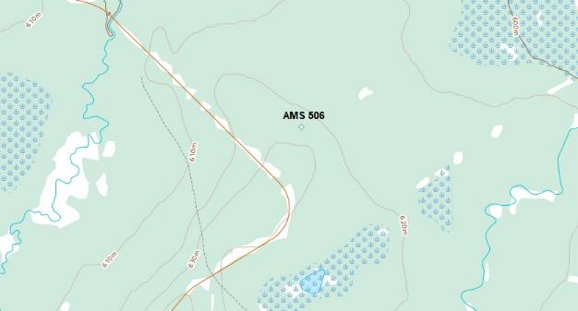
  - Figure 1 – Area topographic map showing AMS 506

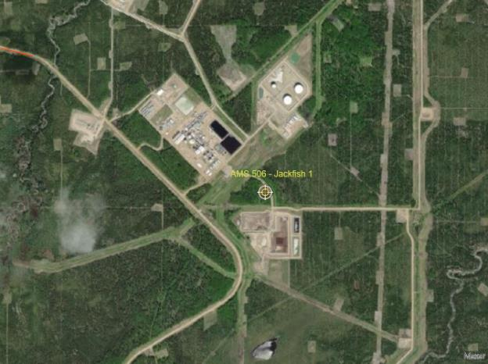
  - Figure 2 – Aerial image showing AMS 506

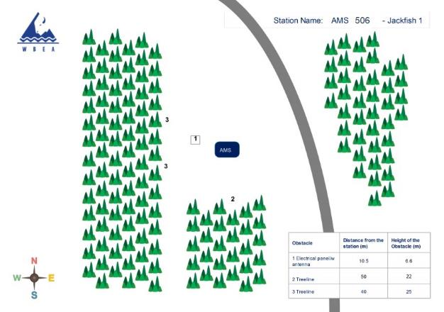
  - Figure 3 – Plan view image for AMS 506 site

The elevation view is currently not available for this site.
  - Figure 4 – Elevation view image for AMS 506 site

Site photos
The following photos show the environment surrounding the monitoring station.

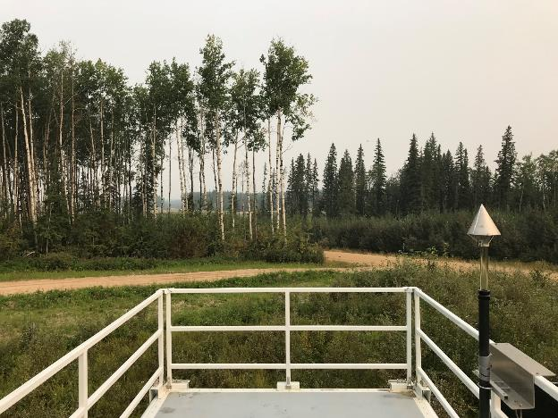
  - Figure 5 – Environment looking North

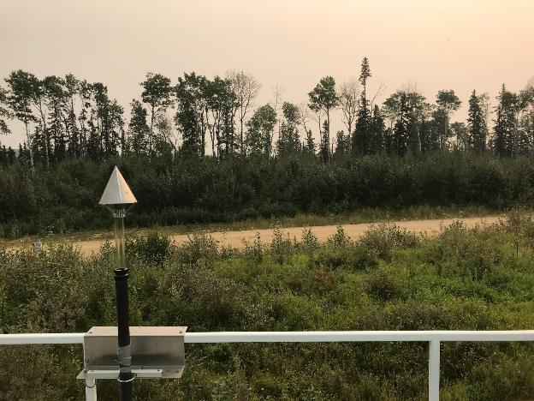
  - Figure 6 – Environment looking East

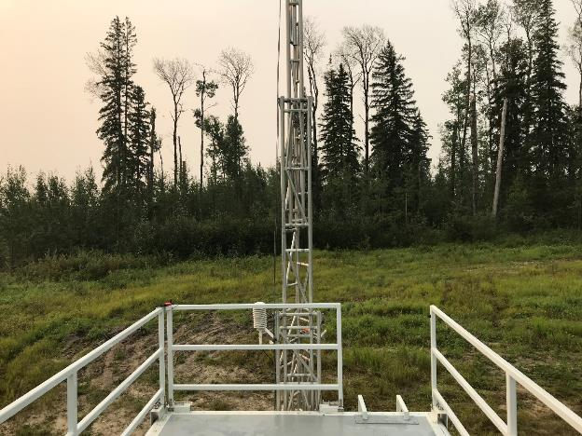
  - Figure 7 – Environment looking South

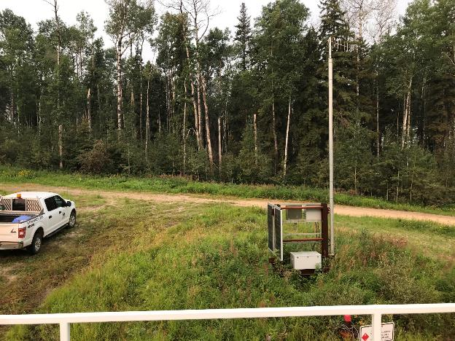
  - Figure 8 – Environment looking West

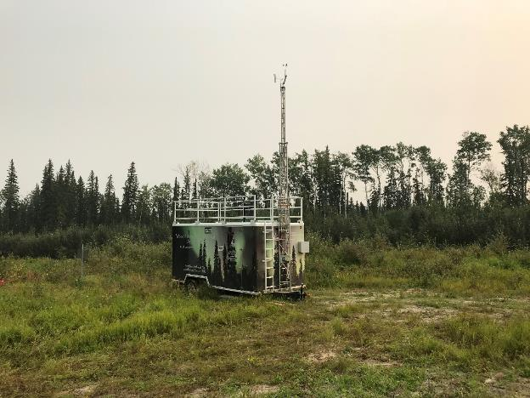
  - Figure 9 – Meteorological Tower

Station Photos
The following photos show the monitoring station and instrumentation.

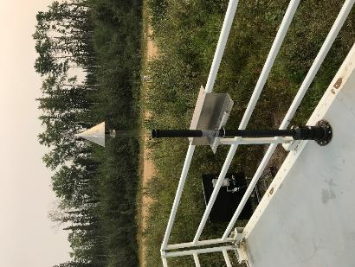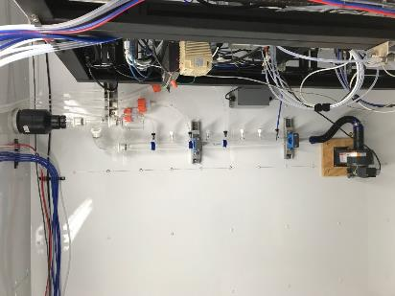
  - Figure 10 – Photo showing the inlet and sample manifold

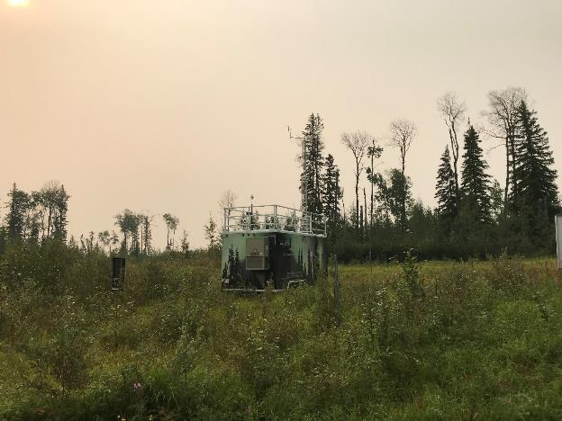
  - Figure 11 – Curb shot of the monitoring station

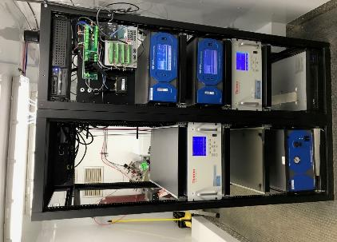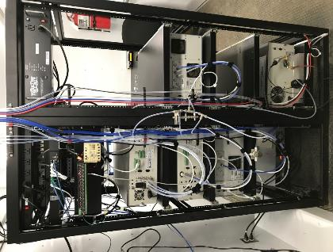
  - Figure 12 –Photo of the front and the back of instrument rack

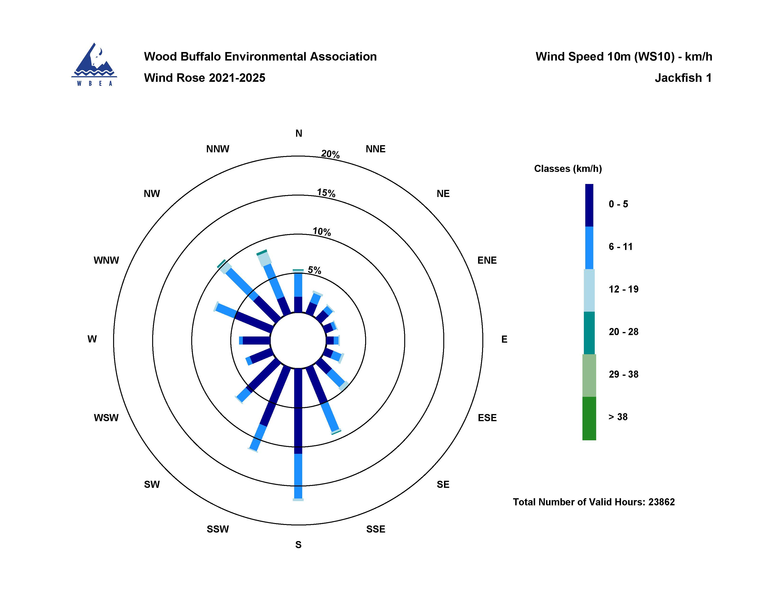
  - Figure 13 – Windrose (2021-2025)

