Wood Buffalo Environmental Association
Ambient Air Monitoring Station
Site Documentation

Sawbones Bay

LAST UPDATED: February 18, 2026

Table of Contents
General Site Information 4
Station 4
Location 4
Owner/Operator/Approval Holder 4
Site Description 4
Site Influences 5
Localized Sources (within 20 metres of station) 5
Roadway Influences 5
Major Point Sources 5
Station Equipment 6
Analytical Equipment 6
Meteorological Equipment 6
Support Equipment 6
Site photos 10
Station Photos 13

Tables and Figures
Figure 1 – Area Topographic map showing AMS 505 7
Figure 2 – Aerial image showing AMS 505 8
Figure 3 – Plan view sketch for AMS 505 – Sawbones Bay 9
Figure 4 – Environment looking North. Figure 5 – Environment looking East. 10
Figure 6 – Environment looking South. Figure 7 – Environment looking West. 11
Figure 8 – Meteorological Tower 12
Figure 9 – Photo showing the inlet and sample manifold. 13
Figure 10 – Curb shot of the monitoring station. 14
Figure 11 –Photo of the front and the back of instrument rack 15
Figure 12 – Windrose (2021-2025) 16

General Site Information
Revision Date: February 18, 2026

Station
Station ID | AMS 505
Station name | Sawbones Bay
Date station established | June 23, 2021

Location
Station street address | Station located in laydown yard at Christina Lake facility
Legal land description | 1-16-77-5 W4
Airshed Zone | Wood Buffalo Environmental Association
Latitude | 55.667847
Longitude | -110.705711
UTM East | 518511
UTM North | 6169152
Nearest community | Conklin
Community population | 229
Census Year | 2018

Owner/Operator/Approval Holder
Operating Agency | Wood Buffalo Environmental Association
Address of Operating Agency | Unit 3-805 Memorial Drive, Fort McMurray, Alberta T9K 0K4
Name of Approval Holder | MEG Energy Corp.
Approval number | 00216466-01-00
Contact Name | Natasha Rowden
Address | NA
Phone number | 403-770-5558
Email address | Natasha.rowden@megenergy.com

Site Description
Land use by sector | 0 – 90 degrees | Forest
Land use by sector | 91 – 180 degrees | Forest
Land use by sector | 181 – 270 degrees | SAGD operations
Land use by sector | 271 – 360 degrees | Forest
Site elevation (m)  (above sea level) | 471 m
Angle of elevation to nearby buildings | Greatest angle | 0
Angle of elevation to nearby buildings | Building direction | None
Airflow restrictions | North | None
Airflow restrictions | East | None
Airflow restrictions | South | None
Airflow restrictions | West | None
Distance to nearest trees (m) | North | 190
Distance to nearest trees (m) | East | 75
Distance to nearest trees (m) | West | NA
Distance to nearest trees (m) | South | 15
Sample manifold | Type | All glass
Sample manifold | Inlet height above roof | 1 metre
Wind Sensors | Type | Cup and vane
Wind Sensors | Height above ground (m) | 10 m
Wind Sensors | Distance from station (m) | 0 m

Site Influences

Localized Sources (within 20 metres of station)
Type | Distance (m) | Description
SAGD Operations | 500m W | MEG Energy operations
Laydown yard | 100m S | Heavy equipment

Roadway Influences
Type | Traffic Volume | Distance (m) | Description
Roadway | Low | 100 | Gravel access road
Roadway | Low | 500 | Gravel access road

Major Point Sources
Facility Name | Source Type | Distance from site (km) | Compass direction from site
MEG Christina Lake | SAGD operations | 500m | West

Station Equipment
Equipment Owner: WBEA

Analytical Equipment
Parameter | Make | Model | Serial Number | Date Instrument Installed | WBEA Data Start Date
SO₂ | Thermo Scientific | 43i | 710321323 | 2021 | July, 2017
H₂S | Thermo Scientific | 43i-QTL | 12113311965 | 2023 | July, 2017
NO/NO_{x}/NO2 | Teledyne/API | T200 | 4259 | 2025 | July, 2017

Meteorological Equipment
Parameter | Make | Model | Serial Number | WMO Site Class | Date Sensor Installed | WBEA Data Start Date
AT/RH | Vaisala | HMP155 | N2910504 | Class 3 | 2021 | July, 2017
WS | Met One | 010C-1 | CA 03845 | Class 4 | 2023 | July, 2017
WD | Met One | 020C-1 | B4693 | Class 4 | 2023 | July, 2017

Support Equipment
Name | Description | Make | Model | Serial Number
Datalogger | Datalogger | Campbell Scientific | CR3000 | 6894
Gas Dilution Calibrator | Dynamic dilution calibrator | Teledyne/API | T700 | 3807
Zero air generator | Zero Air Generator | Teledyne/API | 701 | 690
Shelter / Building | Air monitoring portable | ITB | 8 x 16 trailer | ITB1315940
HVAC | Heating and air conditioning system. Wall mount unit | BARD | 1 ton | NA
H2S Converter | H2S Converter | Direct Optics | G150 | 2022-224

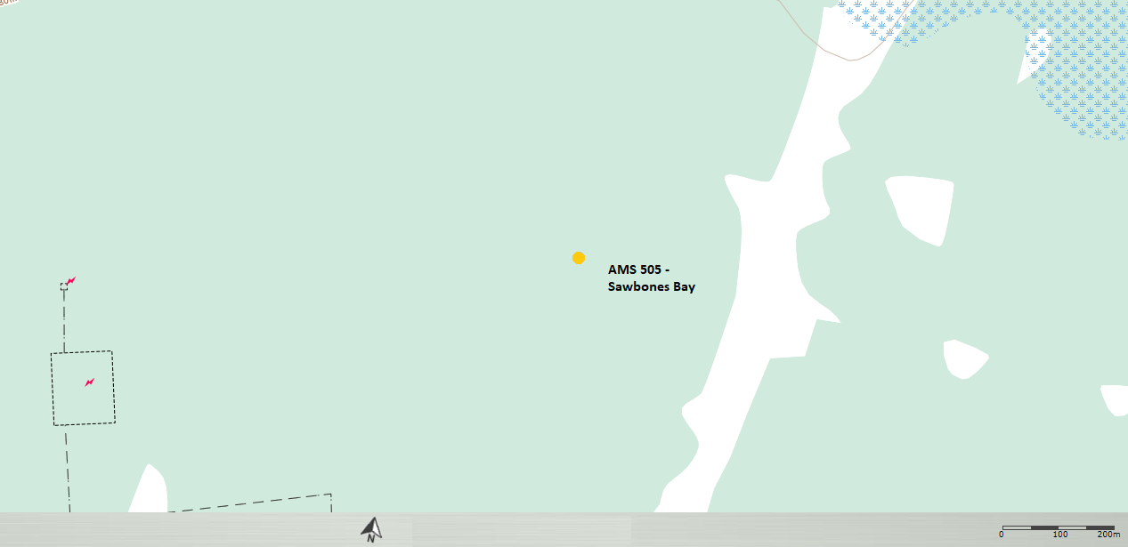
  - Figure 1 – Area Topographic map showing AMS 505
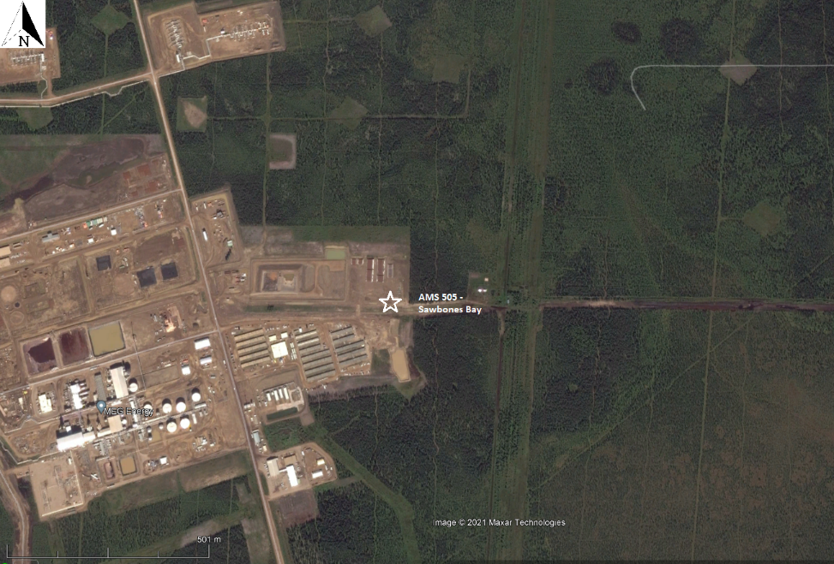
  - Figure 2 – Aerial image showing AMS 505
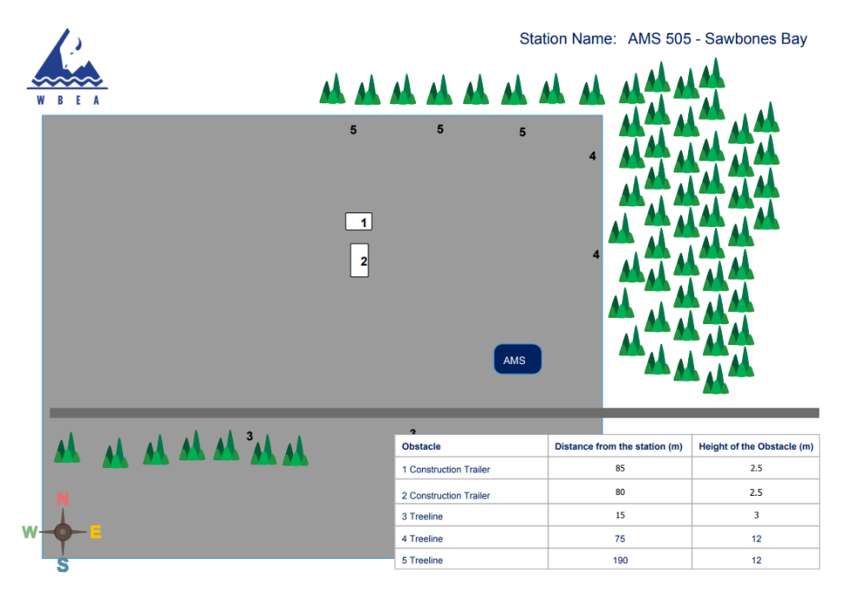
  - Figure 3 – Plan view sketch for AMS 505 – Sawbones Bay

Site photos
The following photos show the environment surrounding the monitoring station.

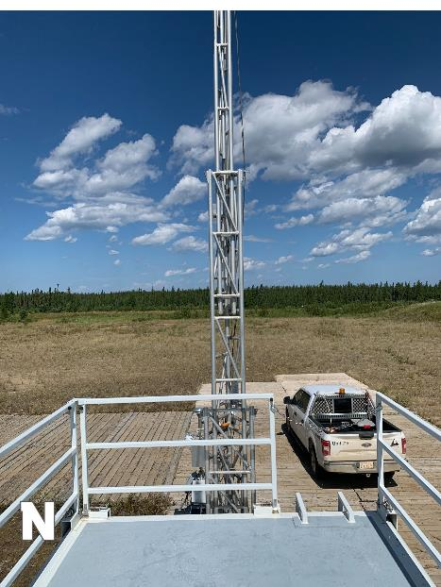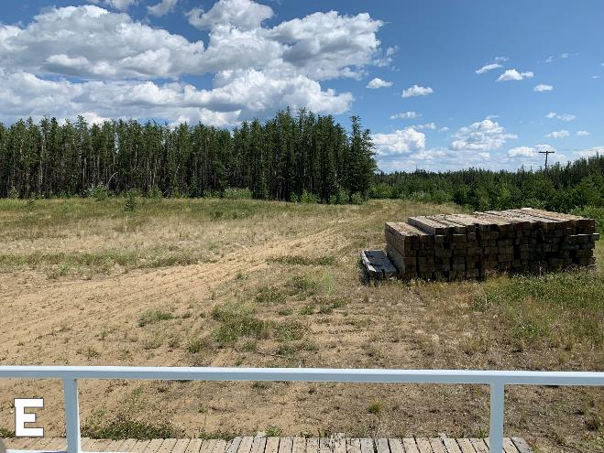
  - Figure 4 – Environment looking North. Figure 5 – Environment looking East.
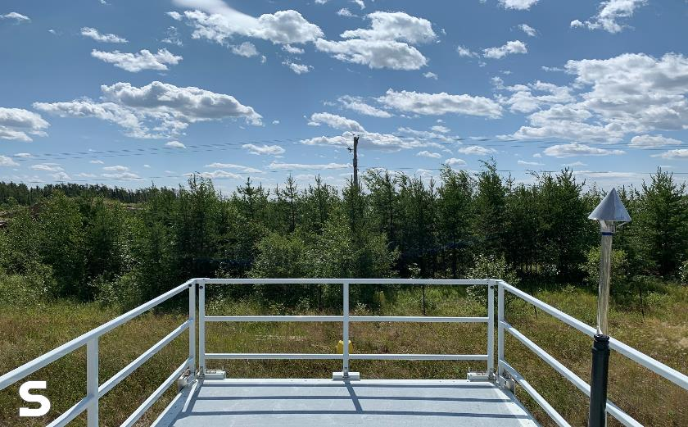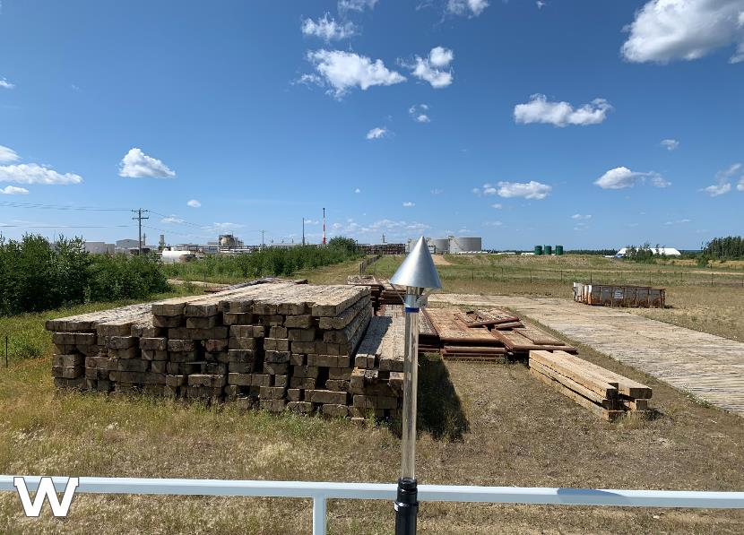
  - Figure 6 – Environment looking South. Figure 7 – Environment looking West.

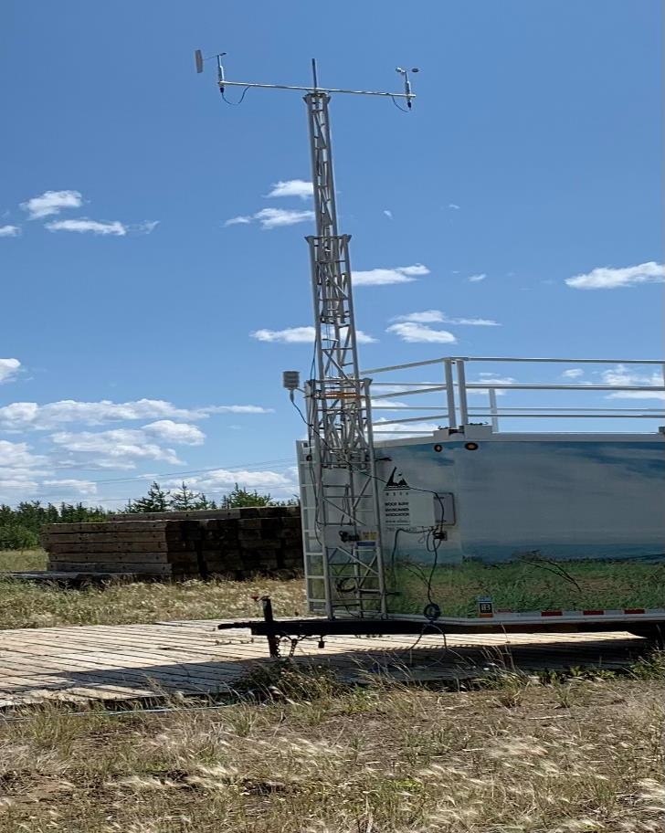
  - Figure 8 – Meteorological Tower

Station Photos
The following photos show the monitoring station and instrumentation.
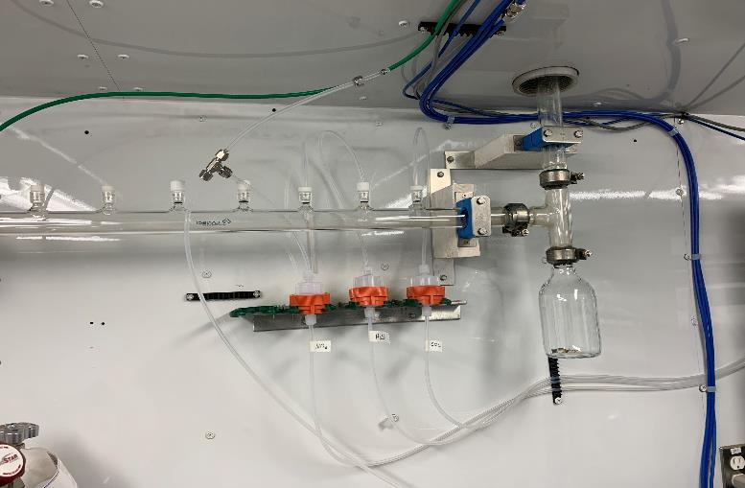
  - Figure 9 – Photo showing the inlet and sample manifold.

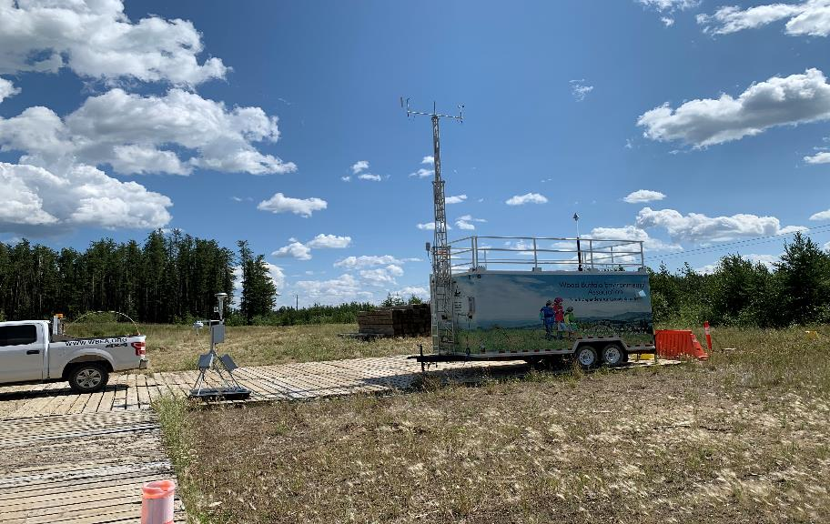
  - Figure 10 – Curb shot of the monitoring station.

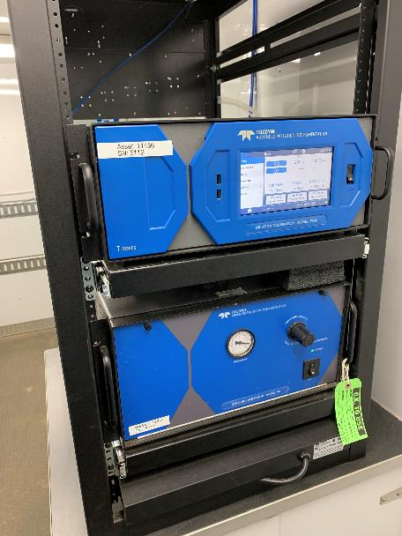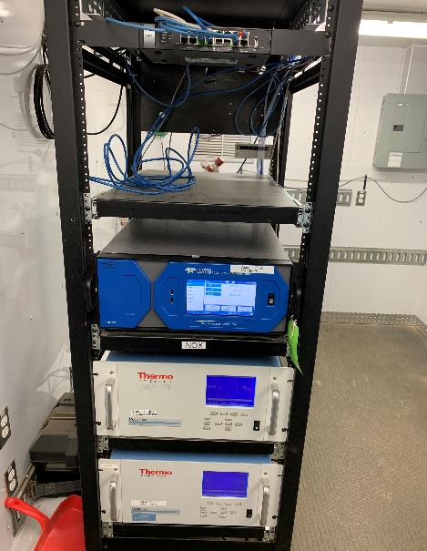
  - Figure 11 –Photo of the front and the back of instrument rack
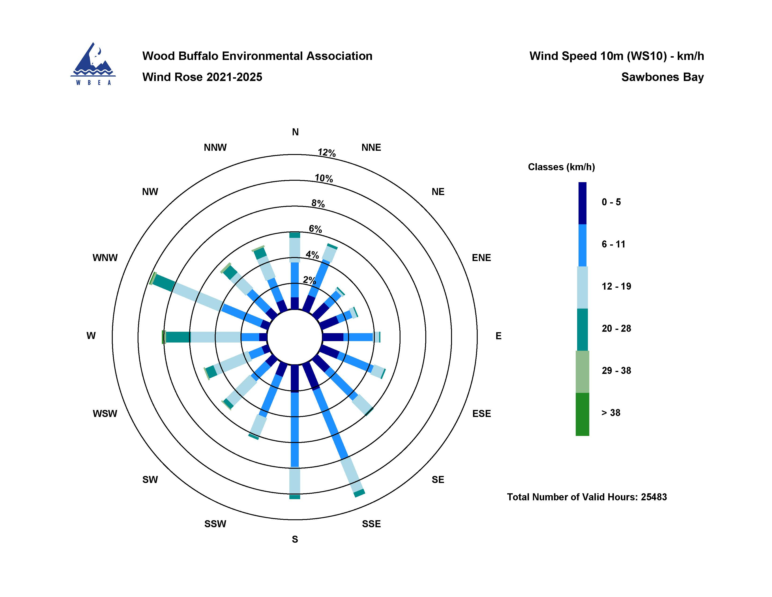
  - Figure 12 – Windrose (2021-2025)

