Wood Buffalo Environmental Association
Ambient Air Monitoring Station
Site Documentation

Leismer

LAST UPDATED: February 18, 2026

Table of Contents
General Site Information 4
Station 4
Location 4
Owner/Operator/Approval Holder 4
Site Description 4
Site Influences 5
Localized Sources (within 20 metres of station) 5
Roadway Influences 5
Major Point Sources 5
Station Equipment 6
Analytical Equipment 6
Meteorological Equipment 6
Support Equipment 6
Site photos 10
Station Photos 13

Tables and Figures
Figure 1 – Area Topographic map showing AMS 501 7
Figure 2– Aerial photo showing AMS 501 8
Figure 3 – Plan view sketch for AMS 501 - Leismer 9
Figure 4 – Environment looking North Figure 5 – Environment looking East 10
Figure 6 – Environment looking South Figure 7 – Environment looking West 11
Figure 8 – Meteorological Tower 12
Figure 9 – Photo showing the inlet and sample manifold 13
Figure 10 – Curb shot of the monitoring station 14
Figure 11 –Photo of the front and the back of instrument rack 15
Figure 12 – Windrose (2021-2025) 16

General Site Information
Revision Date: February 18, 2026

Station
Station ID | AMS 501
Station name | Leismer
Date station established | June 2013

Location
Station street address | Located at the main gate of the Athabasca Oil Corporation SAGD plant.
Legal land description | 4-01-079-10 W4
Airshed Zone | Wood Buffalo Environmental Association
Latitude | 55.81294255
Longitude | -111.44054535
UTM East | 472392
UTM North | 6185349
Nearest community | Conklin
Community population | 154
Census Year | 2021

Owner/Operator/Approval Holder
Operating Agency | Wood Buffalo Environmental Association
Address of Operating Agency | Unit 3-805 Memorial Drive, Fort McMurray, Alberta T9K 0K4
Name of Approval Holder | Athabasca Oil Corporation
Approval number | 289664-01-00; 241311-01-00
Contact Name | Peter Millman
Address | NA
Phone number | 587-233-1382
Email address | pmillman@atha.com

Site Description
Land use by sector | 0 – 90 degrees | Gate/Main Road
Land use by sector | 91 – 180 degrees | Road/Trees
Land use by sector | 181 – 270 degrees | Trees
Land use by sector | 271 – 360 degrees | Trees/laydown yard
Site elevation (m)  (above sea level) | 668 m
Angle of elevation to nearby buildings | Greatest angle | 0
Angle of elevation to nearby buildings | Building direction | NA
Airflow restrictions | North | None
Airflow restrictions | East | None
Airflow restrictions | South | None
Airflow restrictions | West | None
Distance to nearest trees (m) | North | 150
Distance to nearest trees (m) | East | 150
Distance to nearest trees (m) | West | 35
Distance to nearest trees (m) | South | 35
Sample manifold | Type | All glass
Sample manifold | Inlet height above roof | 1 metre
Wind Sensors | Type | Cup and vane
Wind Sensors | Height above ground (m) | 10 m
Wind Sensors | Distance from station (m) | 0 m

Site Influences

Localized Sources (within 20 metres of station)
Type | Distance (m) | Description
SAGD operations | 100 m | Athabasca Oil SAGD operations

Roadway Influences
Type | Traffic Volume | Distance (m) | Description
Roadway | Medium | 15 m | Main road access into SAGD plant

Major Point Sources
Facility Name | Source Type | Distance from site (km) | Compass direction from site
Atha Oil corp. | SAGD | 100 m | West

Station Equipment
Equipment Owner: WBEA

Analytical Equipment
Parameter | Make | Model | Serial Number | Date Instrument Installed | WBEA Data Start Date
SO₂ | Thermo Scientific | 43i | 1160290011 | 2018 | July, 2014
H₂S | Thermo Scientific | 43i-TLE | 1180540020 | 2023 | July, 2014
NO/NO_{x}/NO₂ | Thermo Scientific | 42iQ | 12400232071 | 2025 | July, 2014

Meteorological Equipment
Parameter | Make | Model | Serial Number | WMO Site Class | Date Sensor Installed | WBEA Data Start Date
AT/RH | Vaisala | HMP155 | N5050067 | Class 3 | 2025 | July, 2014
WS | Met One | 010C-1 | Y18362 | Class 4 | 2023 | July, 2014
WD | Met One | 020C-1 | R14654 | Class 4 | 2023 | July, 2014

Support Equipment
Name | Description | Make | Model | Serial Number
Datalogger | Datalogger | Campbell Scientific | CR3000 | 11041
Gas Dilution Calibrator | Dynamic dilution calibrator | Teledyne/API | T700 | 3252
Zero air generator | Zero Air Generator | Teledyne/API | 701 | 4427
Shelter / Building | Air monitoring portable | ITB | 8 x 16 trailer | ITB1315940
HVAC | Heating and air conditioning system. Wall mount unit | BARD | 1 ton | NA

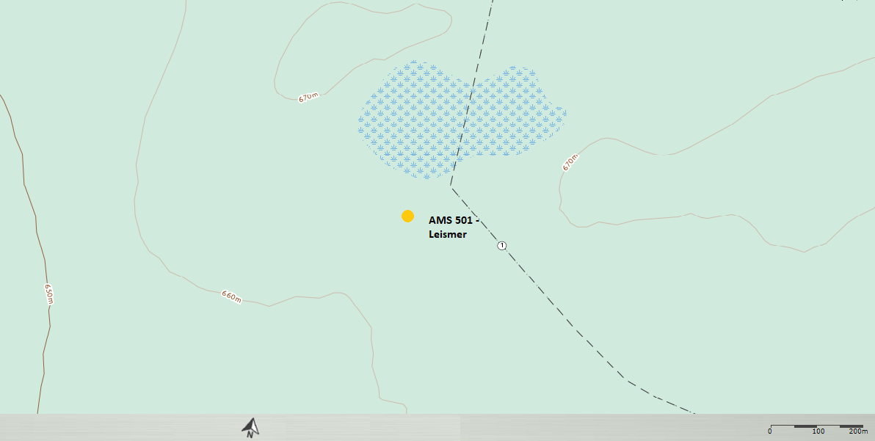
  - Figure 1 – Area Topographic map showing AMS 501

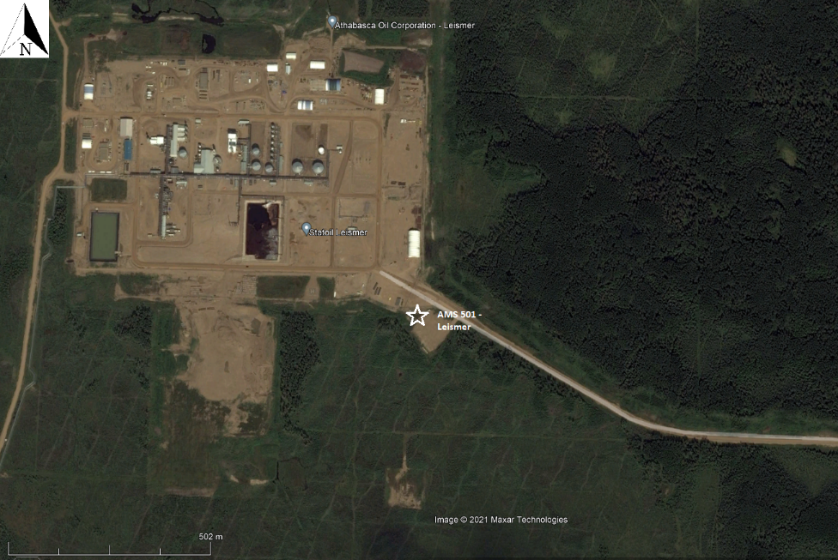
  - Figure 2– Aerial photo showing AMS 501

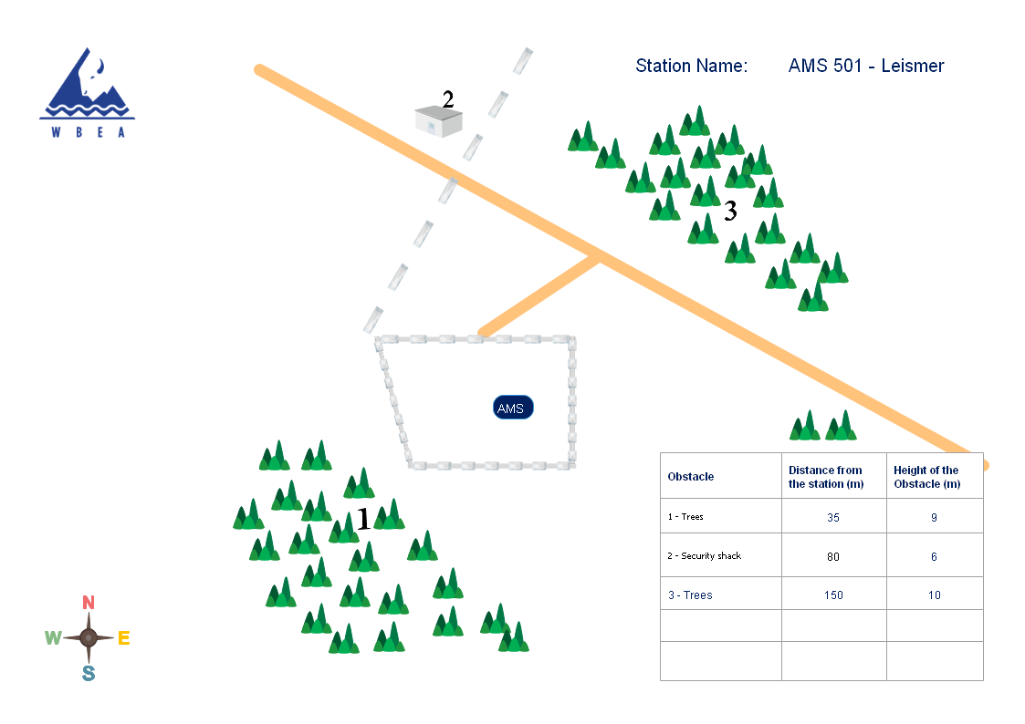
  - Figure 3 – Plan view sketch for AMS 501 - Leismer

Site photos
The following photos show the environment surrounding the monitoring station.

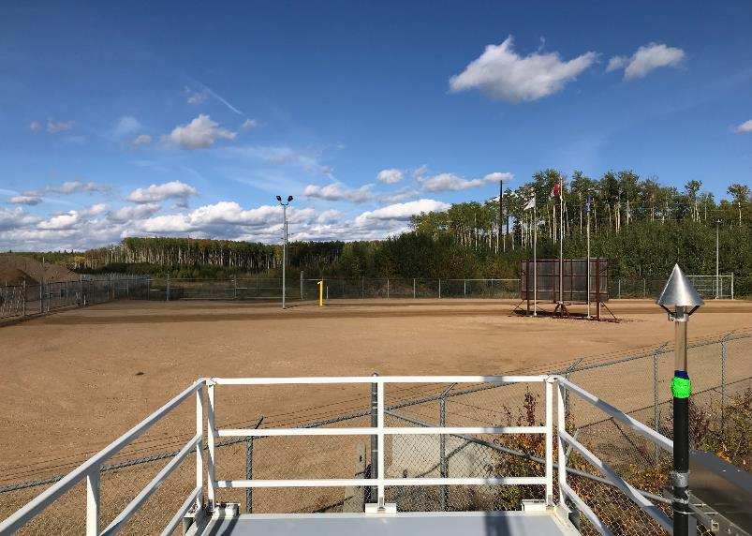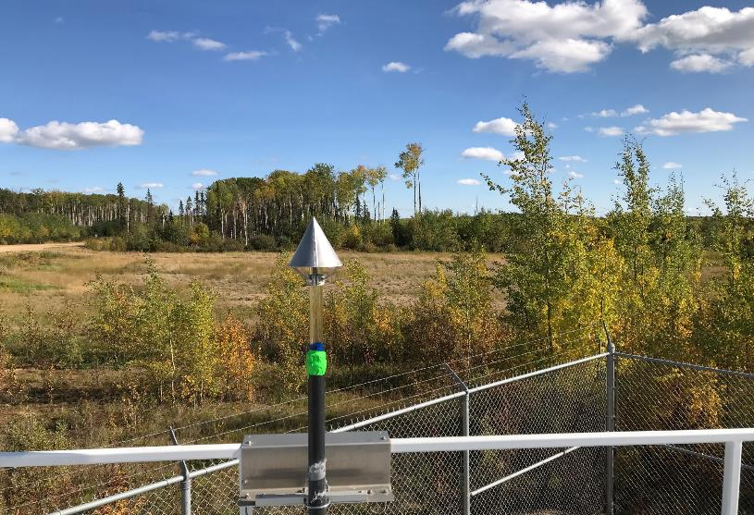
  - Figure 4 – Environment looking North Figure 5 – Environment looking East

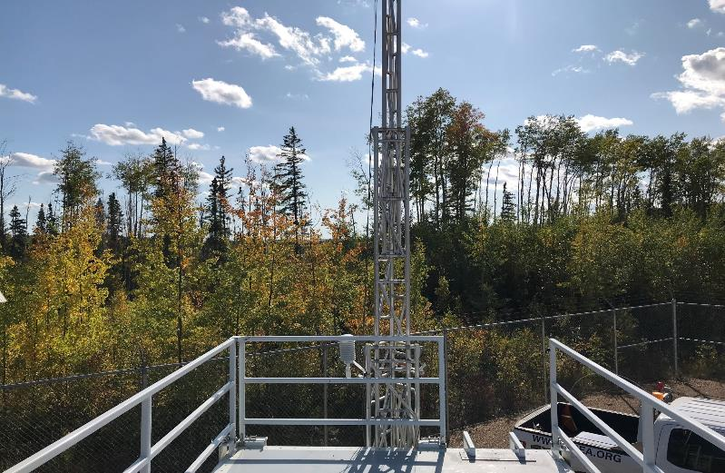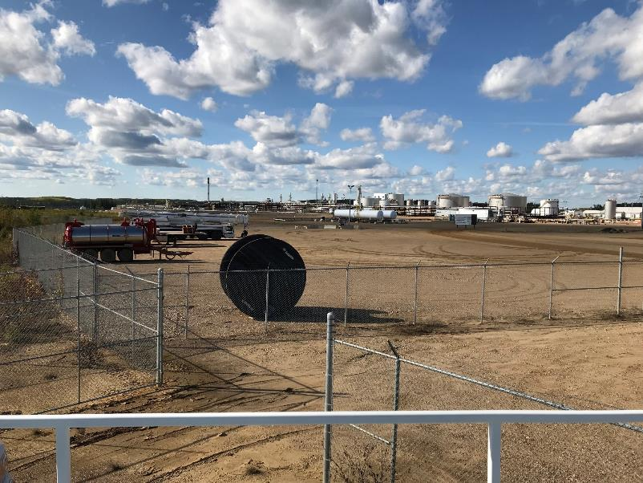
  - Figure 6 – Environment looking South Figure 7 – Environment looking West

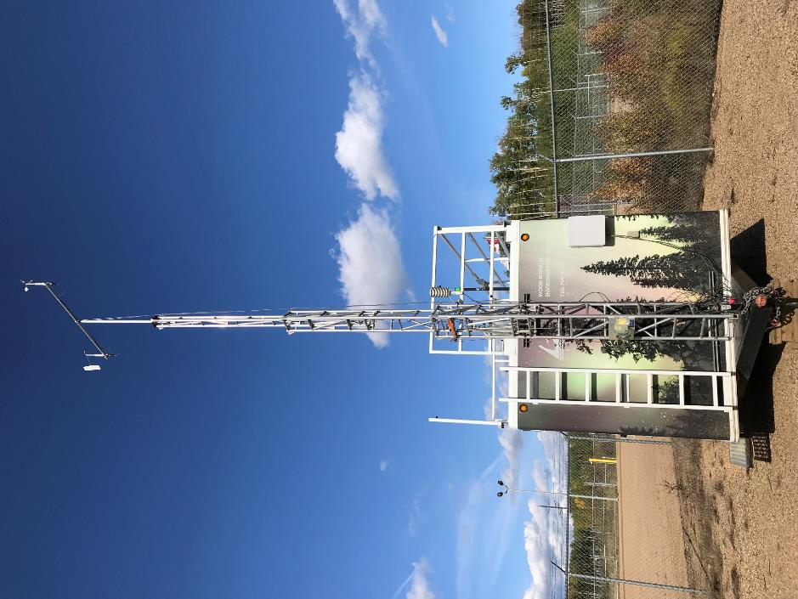
  - Figure 8 – Meteorological Tower

Station Photos
The following photos show the monitoring station and instrumentation.
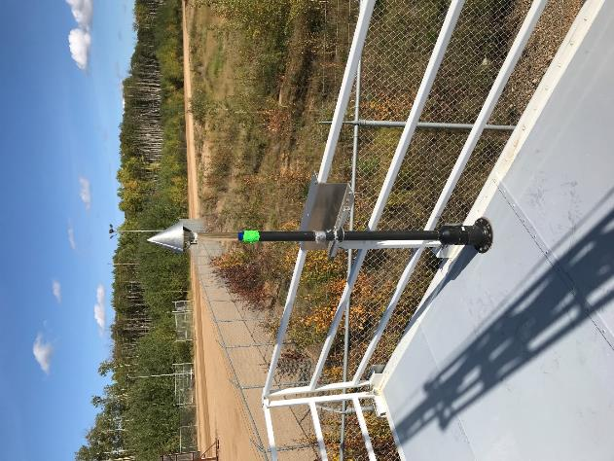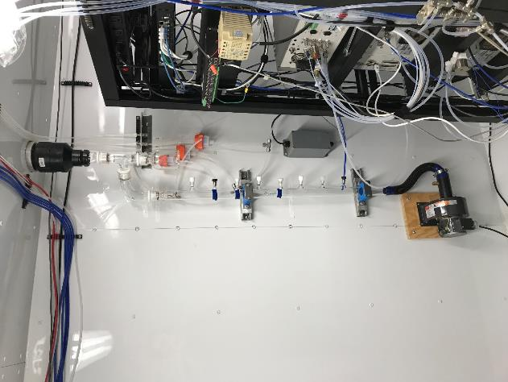
  - Figure 9 – Photo showing the inlet and sample manifold

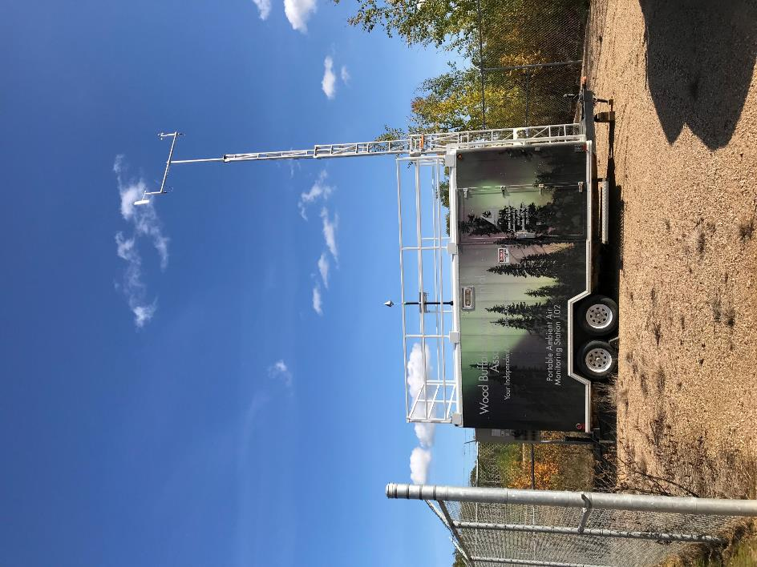
  - Figure 10 – Curb shot of the monitoring station

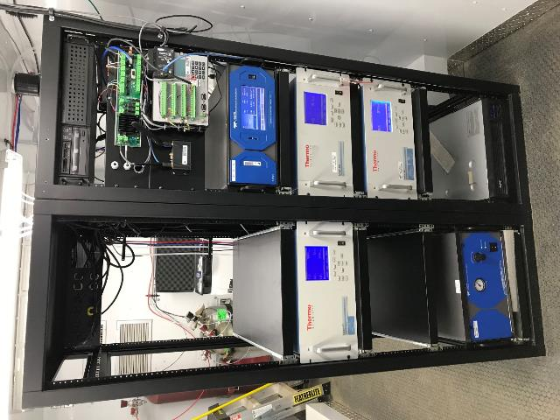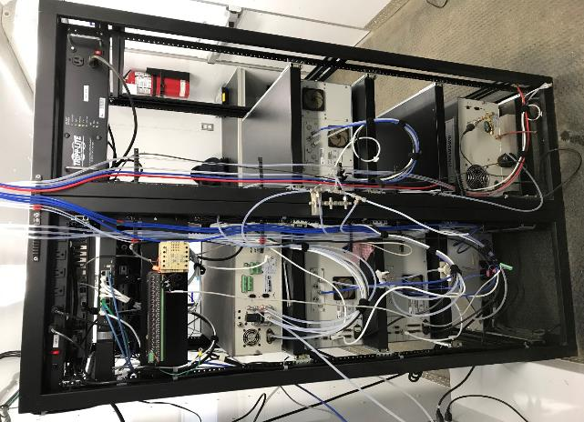
  - Figure 11 –Photo of the front and the back of instrument rack
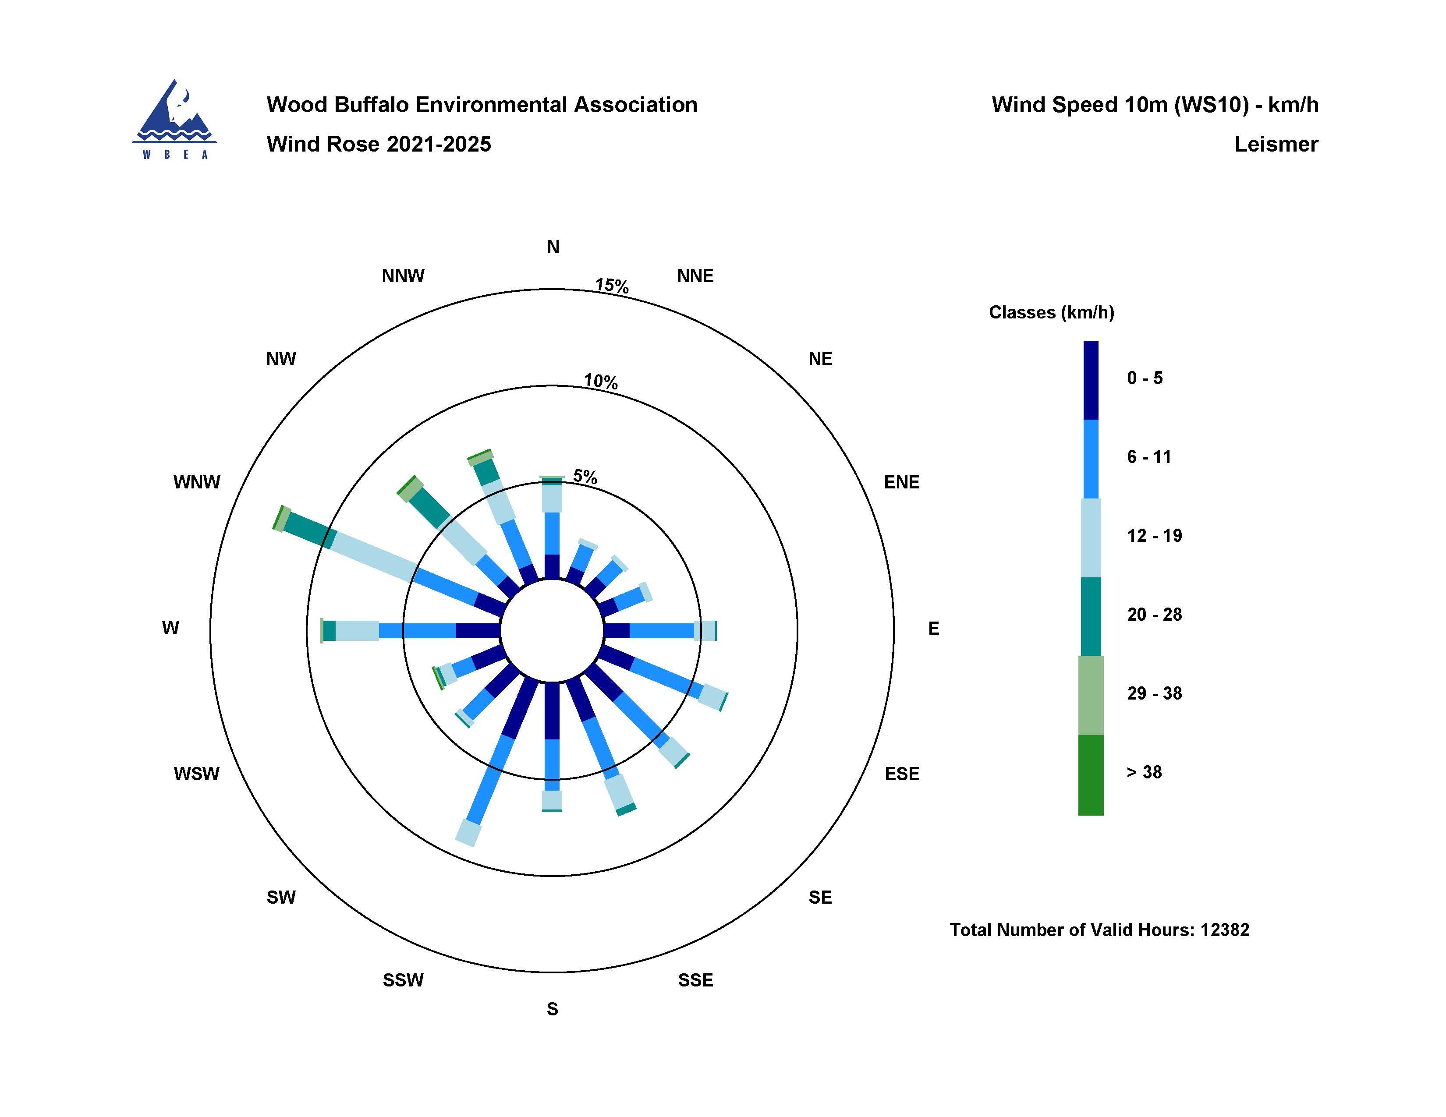
  - Figure 12 – Windrose (2021-2025)

