Wood Buffalo Environmental Association
Ambient Air Monitoring Station
Site Documentation

Ells River

LAST UPDATED: March 02, 2026

Table of Contents
General Site Information 4
Station 4
Location 4
Owner/Operator/Approval Holder 4
Site Description 4
Site Influences 5
Localized Sources (within 20 metres of station) 5
Roadway Influences 5
Major Point Sources 5
Station Equipment 6
Analytical Equipment 6
Meteorolgical Equipment 6
Support Equipment 6
Site photos 11
Station Photos 16

Tables and Figures
Figure 1 – Area Topographic map showing AMS 30 7
Figure 3 – Aerial photo showing AMS 30 9
Figure 5 – Environ Looking North 11
Figure 6 – Environ Looking East 12
Figure 7 – Environ looking South. 13
Figure 8 – Environ Looking West 14
Figure 9 – Meteorological Tower 15
Figure 10 – Photo showing the inlet and sample manifold 16
Figure 11 – Curb shot of the monitoring station 17
Figure 12 –Photo of front and back of instrument rack 18
Figure 13 – Windrose (2021-2025) 19

General Site Information
Revision Date: February 18, 2026

Station
Station ID | AMS 30
Station name | Ells River
Date station established | 2020

Location
Station street address | Located at about 300 m northwest of the Total Joslyn Camp.
Legal land description | 12-04-096-11 W4
Latitude | 57.241180
Longitude | -111.722081
Ground Elevation | 299.9
UTM East | 456424
UTM North | 6344478
Nearest community | Fort Mackay
Community population | 621

Owner/Operator/Approval Holder
Operating Agency | Wood Buffalo Environmental Association
Name of Approval Holder | Canadian Natural Resources Ltd.
Approval number | 149968-01-00
Contact Name | Malathi Velmurugan
Address | 2100, 855 – 2 Street SW Calgary, AB T2P 4J8
Phone number | (780) 714-4436
Email address | Malathi.Velmurugan@cnrl.com

Site Description
Land use by sector | 0 – 90 degrees | Pond
Land use by sector | 91 – 180 degrees | Forest / Highway
Land use by sector | 181 – 270 degrees | Forest
Land use by sector | 271 – 360 degrees | Forest
Site elevation  (above sea level) | 304
Angle of elevation to nearby buildings | Greatest angle | 12 degrees
Angle of elevation to nearby buildings | Building direction | East
Airflow restrictions | North | No
Airflow restrictions | East | No
Airflow restrictions | South | No
Airflow restrictions | West | No
Sample manifold | Type | All glass
Sample manifold | Inlet height above roof | 1 metre
Wind Sensors | Type | Cup and vane
Wind Sensors | Height above ground | 10 metres
Wind Sensors | Distance from station | 7 metres

Site Influences

Localized Sources (within 20 metres of station)
Type | Distance (m) | Description
Cell tower compound | 14 | Compound that holds the equipment for the cell tower to function

Roadway Influences
Type | Traffic Volume | Distance (m) | Description
Paved road | Very low | 50 M West | Old horizon highway
Paved road | High | 250 M East | Horizon highway
Dirt road | Very low | 100 M East | Dirt road around the pond

Major Point Sources
Facility Name | Source Type | Distance from site (km) | Compass direction from site
CNRL Horizon Oil Sands | Oil plant | 10km | North
CNRL Horizon | Open mining | 7km | North

Station Equipment
Equipment Owner: Canadian Natural Resources Ltd.

Analytical Equipment
Parameter | Make | Model | Serial Number | Date Instrument Installed | WBEA Data Start Date
Continuous
SO₂ | Thermo Scientific | 43i | 1008841397 | 2021 | October, 2020
TRS | Thermo Scientific | 43i-TLE | 1170050152 | 2021 | October, 2020
NO/NO_{x}/NO₂ | Thermo Scientific | 42i | 710321429 | 2021 | October, 2020
THC/CH₄/NMHC | Thermo Scientific | 55i | 1152430011 | 2023 | October, 2020
PM _{2.5} | Teledyne/API | T640 | 875 | 2021 | October, 2020
Time-Integrated
PM₁₀ A | Thermo Environmental | 2000i | 2000I2 204961409 | 2021 | -
PM₁₀ B | Thermo Environmental | 2000i | 2000IW 206011510 | 2021 | -
TSP | Thermo Environmental | 2000i | 2000IW 209632110 | 2023 | -
VOC | Tisch Environmental | Te-123 | 1030 | 2021 | -

Meteorolgical Equipment
Parameter | Make | Model | Serial Number | WMO Site Class | Date Sensor Installed | WBEA Data Start Date
AT/RH | Vaisala | HMP155 | F5010003 | 3 | 2021 | October, 2020
WS | Met One | 010C-1 | A3111 | 5 | 2021 | October, 2020
WD | Met One | 020C-1 | E5131 | 5 | 2021 | October, 2020
GR | Eppley Lab Inc. | 8-48 | 34276 | n/a | 2021 | October, 2020

Support Equipment
Name | Description | Make | Model | Serial Number
Datalogger | Datalogger | Campbell Scientific | CR3000 | 11040
Gas Dilution Calibrator | Dynamic dilution calibrator | Teledyne/API | T700 | 5707
Zero air generator | Zero Air Generator | Teledyne/API | T701H | 358
Shelter / Building | Air monitoring portable | ITB | 8 x 16 trailer | 2N9MF73895
HVAC | Heating and air conditioning system. Wall mount unit | BARD | 1 ton | NA
TRS Converter | Thermal oxidizer | CD Nova | CDN-101 | 562

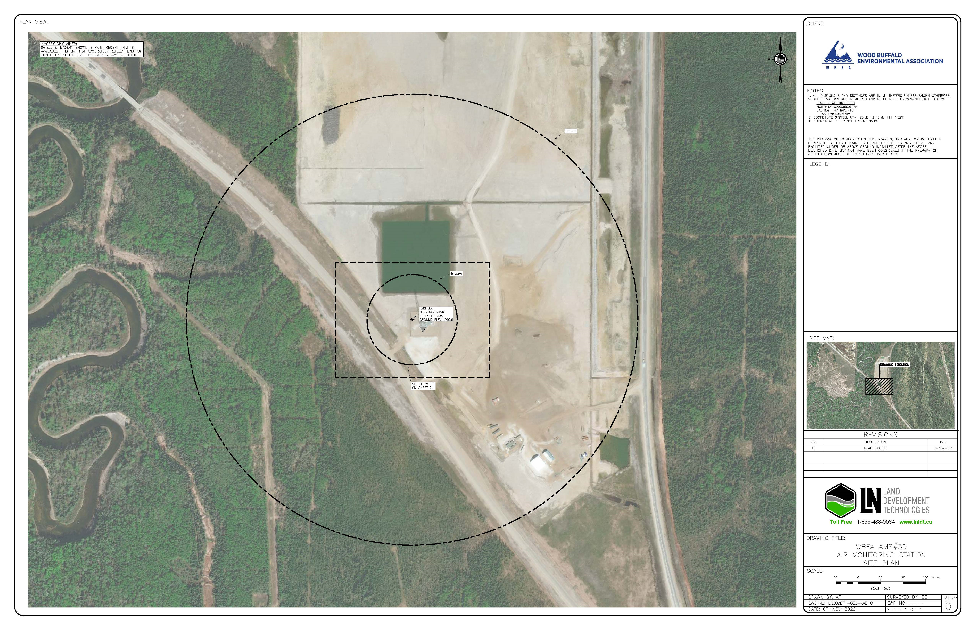
  - Figure 1 – Area Topographic map showing AMS 30

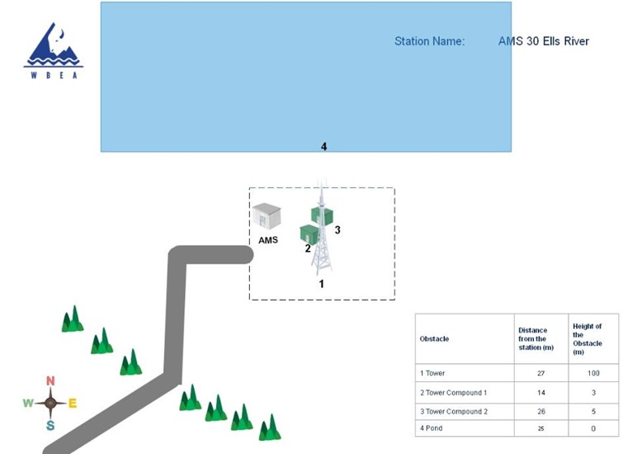
Figure 2 – Plan view sketch for AMS 30 site
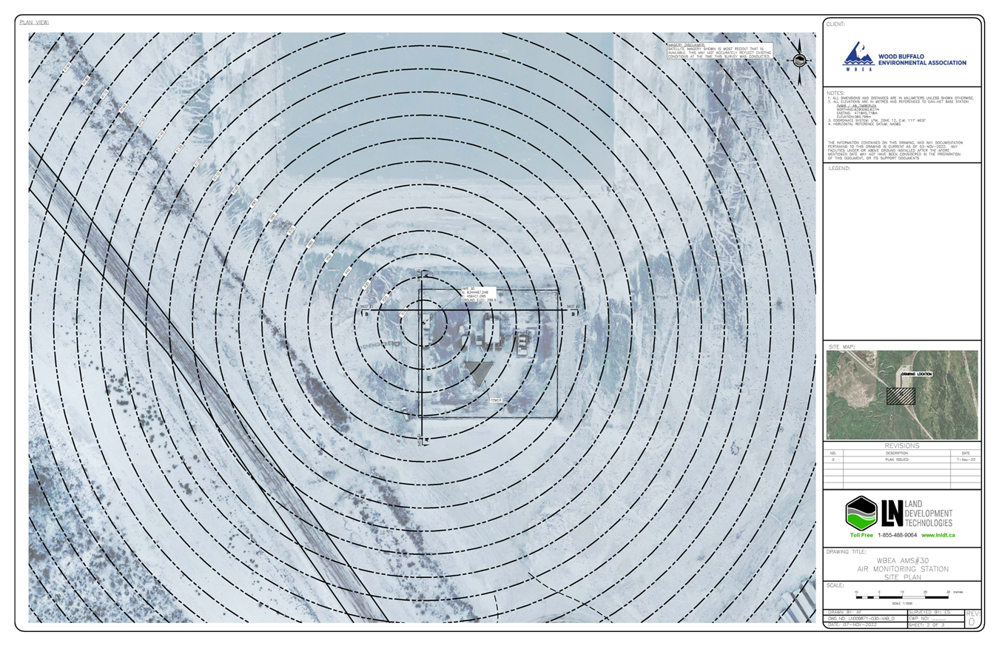
  - Figure 3 – Aerial photo showing AMS 30
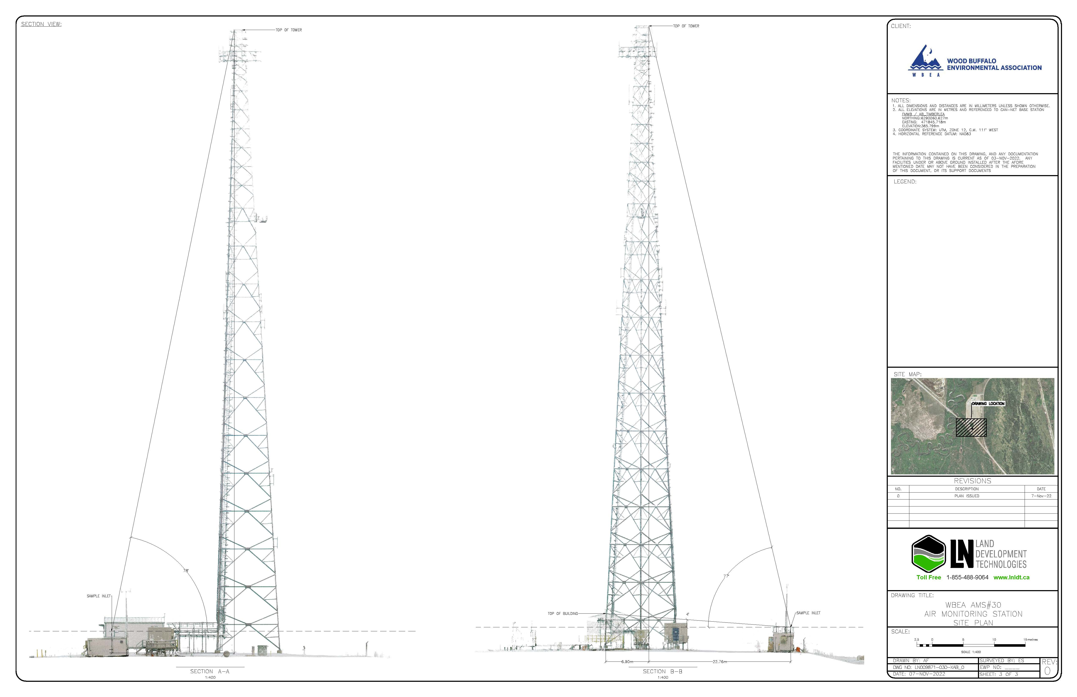Figure 4 – Cross-Sectional Elevation Drawing of AMS 30

Site photos
The following photos show the environment surrounding the monitoring station.

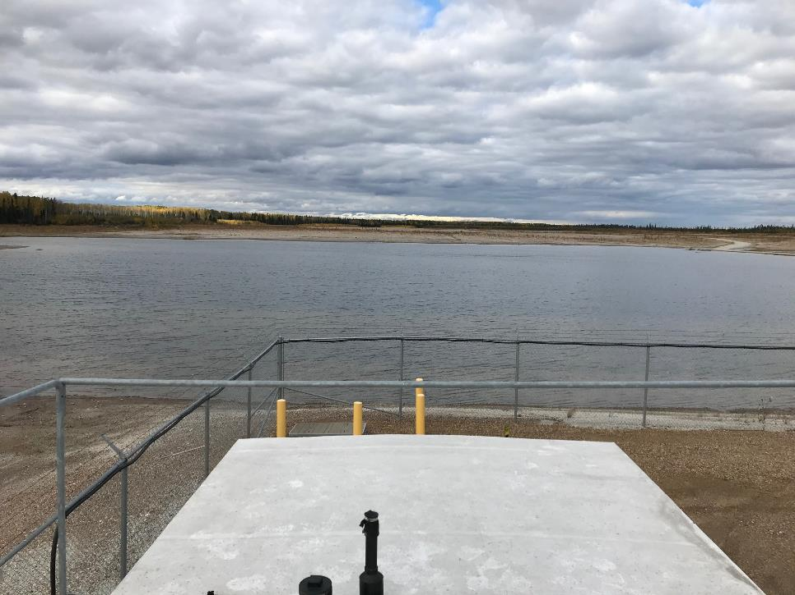
  - Figure 5 – Environ Looking North
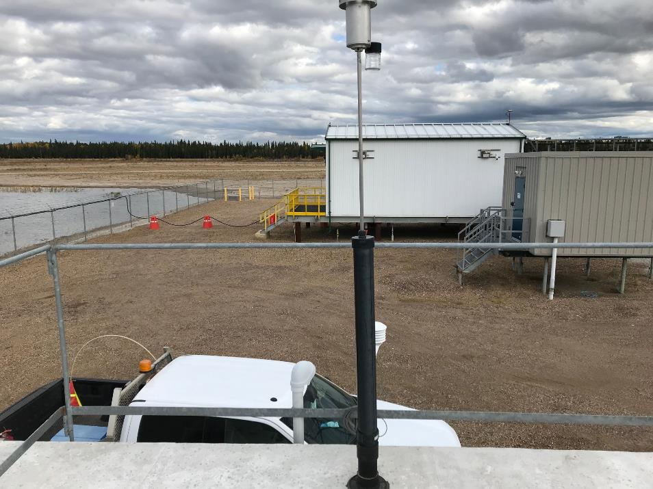
  - Figure 6 – Environ Looking East
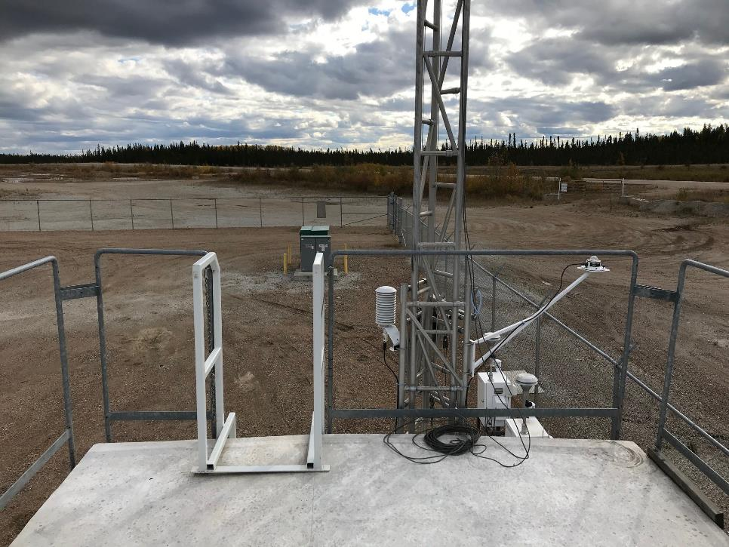
  - Figure 7 – Environ looking South.
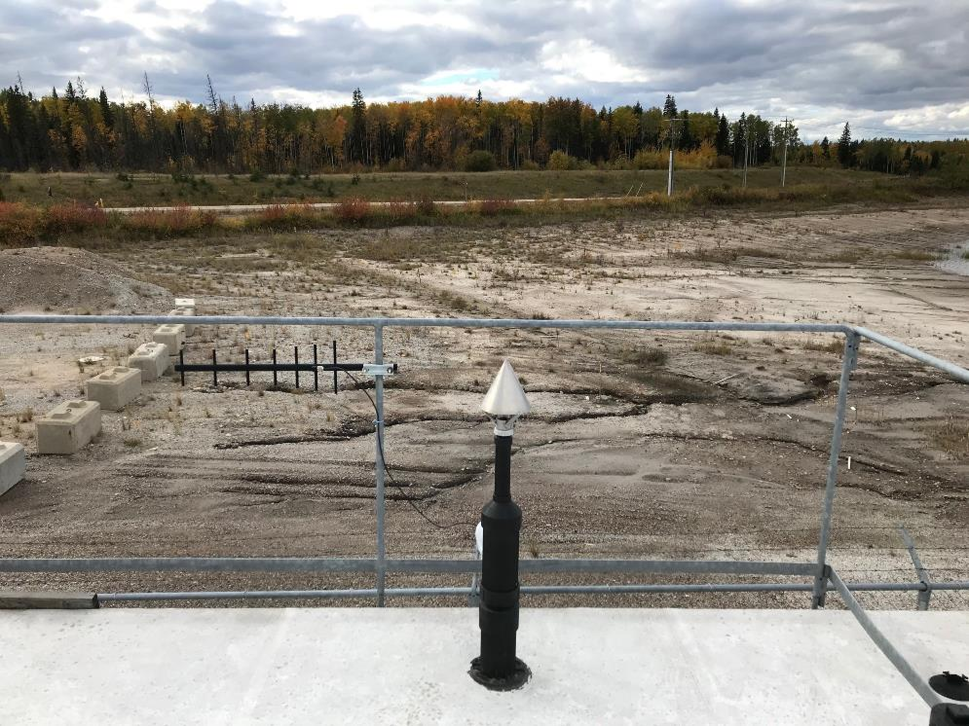
  - Figure 8 – Environ Looking West

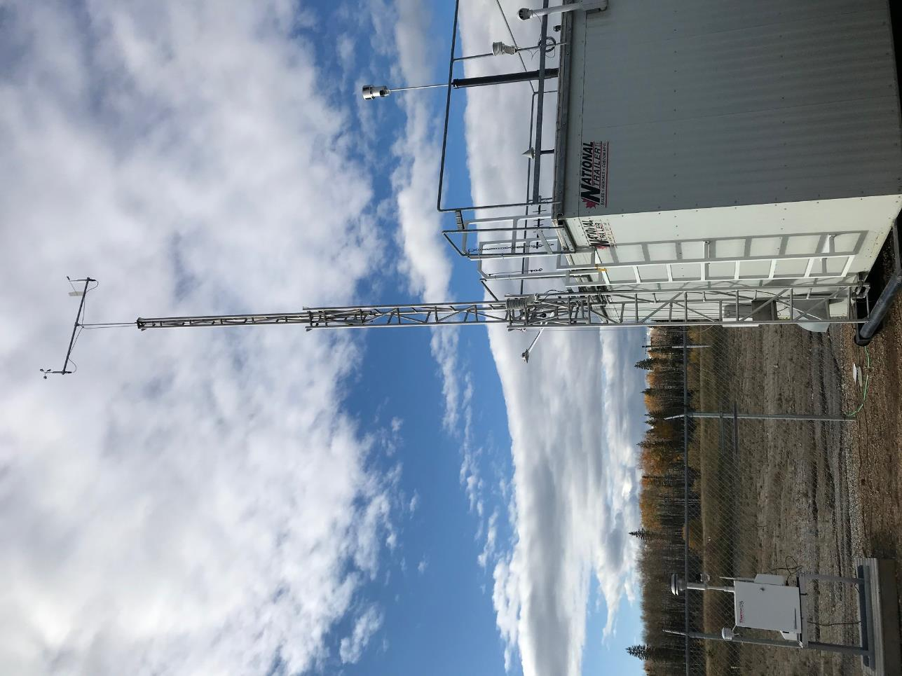
  - Figure 9 – Meteorological Tower

Station Photos
The following photos show the monitoring station and instrumentation.
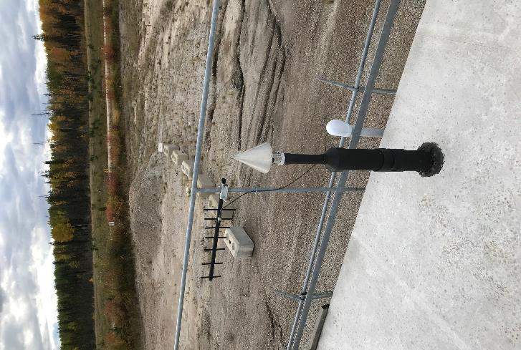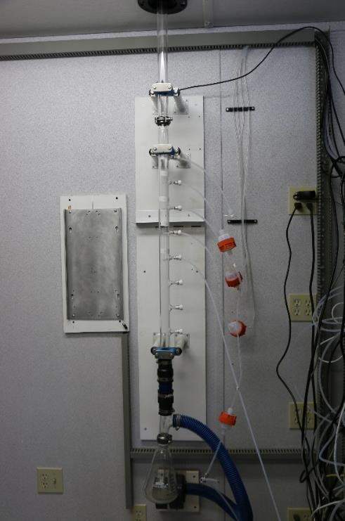
  - Figure 10 – Photo showing the inlet and sample manifold
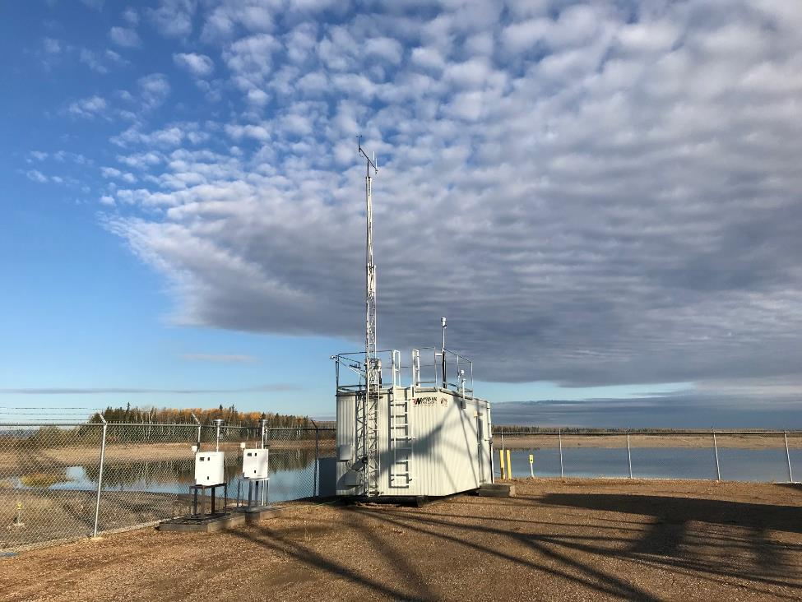
  - Figure 11 – Curb shot of the monitoring station

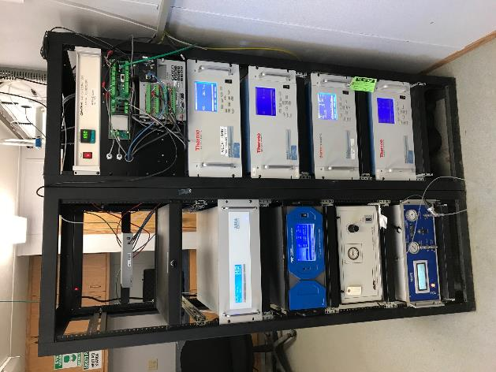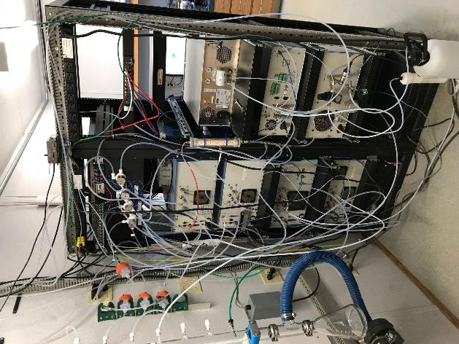
  - Figure 12 –Photo of front and back of instrument rack
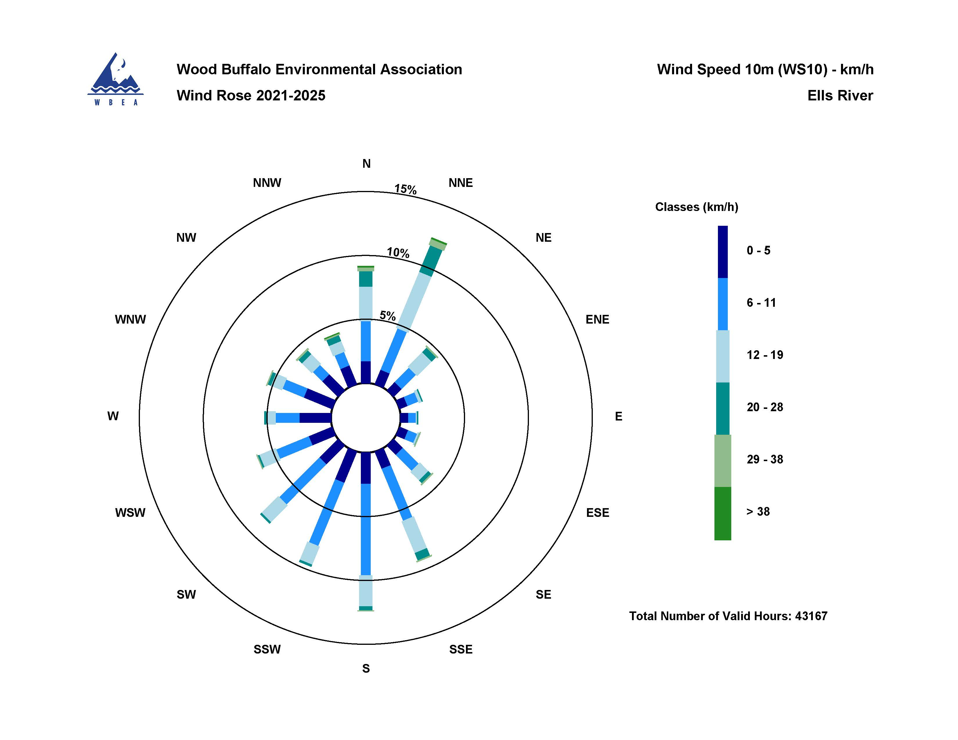
Figure 13 – Windrose (2021-2025)

