Wood Buffalo Environmental Association
Ambient Air Monitoring Station
Site Documentation

Surmont 2

LAST UPDATED: March 2, 2026

Table of Contents
General Site Information 4
Station 4
Location 4
Owner/Operator/Approval Holder 4
Site Description 4
Site Influences 5
Localized Sources (within 20 metres of station) 5
Roadway Influences 5
Major Point Sources 5
Station Equipment 6
Analytical Equipment 6
Meteorological Equipment 6
Support Equipment 6
Site photos 11
Station Photos 16

Tables and Figures
Figure 1 – Area topographic map showing AMS 29 7
Figure 2 – Aerial photo showing AMS 29 8
Figure 3 – Plan view sketch for AMS 29 site 9
Figure 4 – Elevation view image for AMS 29 site 10
Figure 5 – Environment looking North 11
Figure 6 – Environment looking East 12
Figure 7 – Environment looking South 13
Figure 8 – Environment looking West 14
Figure 9 – Meteorological Tower 15
Figure 10 – Photo showing the inlet and sample manifold 16
Figure 11 – Curb shot of the monitoring station 17
Figure 12 –Photo of the front and the back of instrument rack 18
Figure 13 –Photo of the T640 Analyzer 19
Figure 14 – Windrose (2021 – 2025) 20

General Site Information
Revision Date: March 2, 2026

Station
Station ID | AMS 29
Station name | Surmont 2
Date station established | 2019

Location
Station street address | NA
Legal land description | 10-20-83-6-W4
Airshed Zone | Wood Buffalo Environmental Association
Latitude | 56.2124224862
Longitude | -110.914925019
UTM East | 505285
UTM North | 6229755
Nearest community | Anzac
Community population | 659
Census Year | 2025

Owner/Operator/Approval Holder
Operating Agency | Wood Buffalo Environmental Association
Address of Operating Agency | Unit 3, 805 Memorial Drive, Fort McMurray, Alberta T9K 0K4
Name of Approval Holder | ConocoPhillips Canada Resources Corp.
Approval number | 48263-01-00
Contact Name | Heather Pitt
Address | 401 9 Ave SW, Calgary, Alberta, T2P 3C5
Phone number | 780-334-7914
Email address | heather.d.pitt@conocophillips.com

Site Description
Land use by sector | 0 – 90 degrees | Trees
Land use by sector | 91 – 180 degrees | Trees/shed/potable water access point
Land use by sector | 181 – 270 degrees | Trees
Land use by sector | 271 – 360 degrees | Trees/ laydown yard
Site elevation (m)  (above sea level) | 550
Angle of elevation to nearby buildings | Greatest angle | 0
Angle of elevation to nearby buildings | Building direction | NA
Airflow restrictions | North | None
Airflow restrictions | East | None
Airflow restrictions | South | None
Airflow restrictions | West | None
Distance to nearest trees (m) | North | 60 m
Distance to nearest trees (m) | East | 50 m
Distance to nearest trees (m) | West | 100 m
Distance to nearest trees (m) | South | 55 m
Sample manifold | Type | All glass
Sample manifold | Inlet height above roof | 1 metre
Wind Sensors | Type | Cup and vane
Wind Sensors | Height above ground (m) | 10 m
Wind Sensors | Distance from station (m) | 0

Site Influences

Localized Sources (within 20 metres of station)
Type | Distance (m) | Description
Vehicles | 20 m NW | Moving vehicles around station

Roadway Influences
Type | Traffic Volume | Distance (m) | Description
Dirt/gravel road | low | 20 | Used by site personnel for accessing various sections around plant.

Major Point Sources
Facility Name | Source Type | Distance from site (km) | Compass direction from site
ConocoPhillips | SAGD | 0.36 km | NW

Station Equipment
Equipment Owner: ConocoPhillips

Analytical Equipment
Parameter | Make | Model | Serial Number | Date Instrument Installed | WBEA Data Start Date
SO₂ | Thermo Environmental | 43i | 1170050150 | 2016 | April, 2019
H₂S | Thermo Environmental | 43iQTL | 1200326170 | 2023 | April, 2019
NO/NO_{x}/NO₂ | Thermo Environmental | 42i | 1410661329 | 2016 | April, 2019
THC | Thermo Environmental | 51i | 1180540021 | 2021 | April, 2019
PM _{2.5} | Teledyne/API | T640 | 2236 | 2025 | April, 2019

Meteorological Equipment
Parameter | Make | Model | Serial Number | WMO Site Class | Date Sensor Installed | WBEA Data Start Date
AT/RH | Vaisala | HMP155 | R2710618 | 3 | 2016 | April, 2019
WS | Met One | 010C-1 | B4129 | 2 | 2025 | April, 2019
WD | Met One | 020C-1 | U11347 | 2 | 2023 | April, 2019

Support Equipment
Name | Description | Make | Model | Serial Number
Datalogger | Datalogger | Campbell Scientific | CR3000 | 9037
Gas Dilution Calibrator | Dynamic dilution calibrator | Teledyne/API | T700 | 5472
Zero air generator | Zero Air Generator | Teledyne/API | 701 | 135
Shelter / Building | Air monitoring portable | ITB | 8 x 16 trailer | ITB-17-17154
HVAC | Heating and air conditioning system. Wall mount unit | BARD | 1 ton | NA
Tower | 10m Tower | Aluma | T-135 | AT21403Z32
H2S converter | H2S Converter | Global Analyzer Systems | G150 | 2022-220

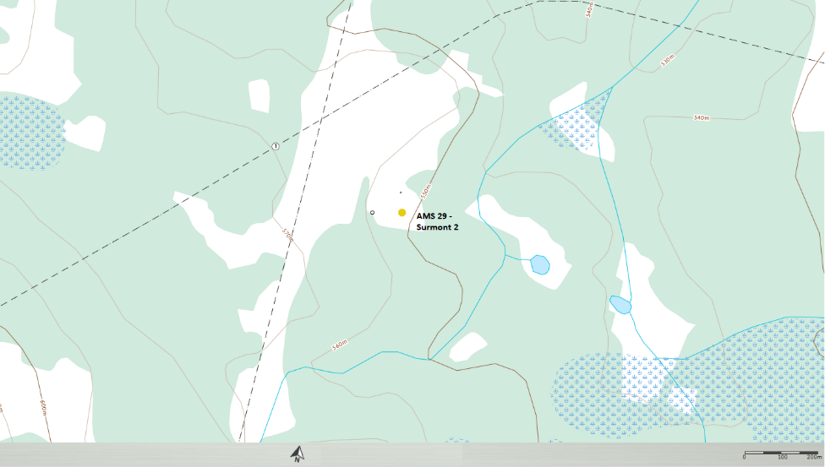
  - Figure 1 – Area topographic map showing AMS 29
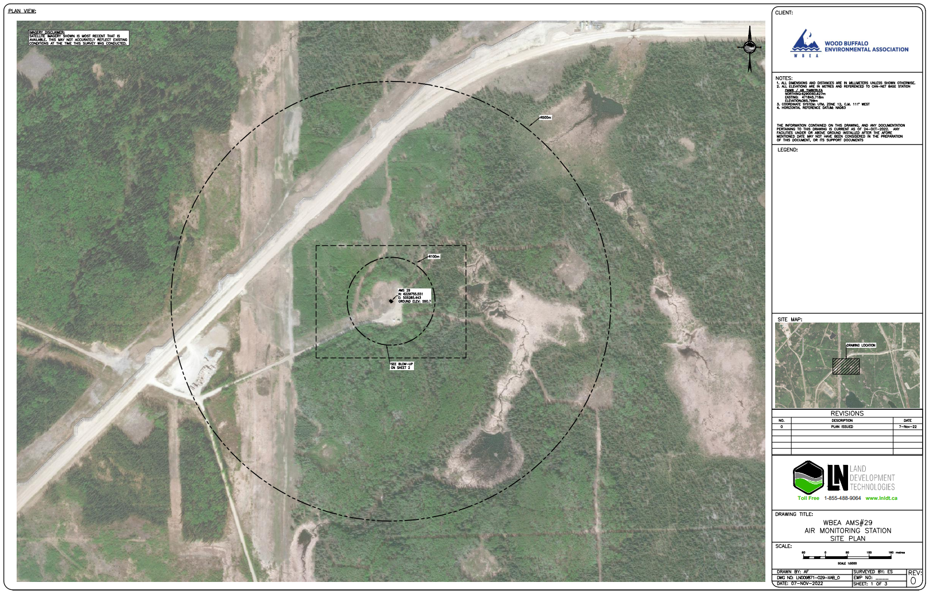
  - Figure 2 – Aerial photo showing AMS 29
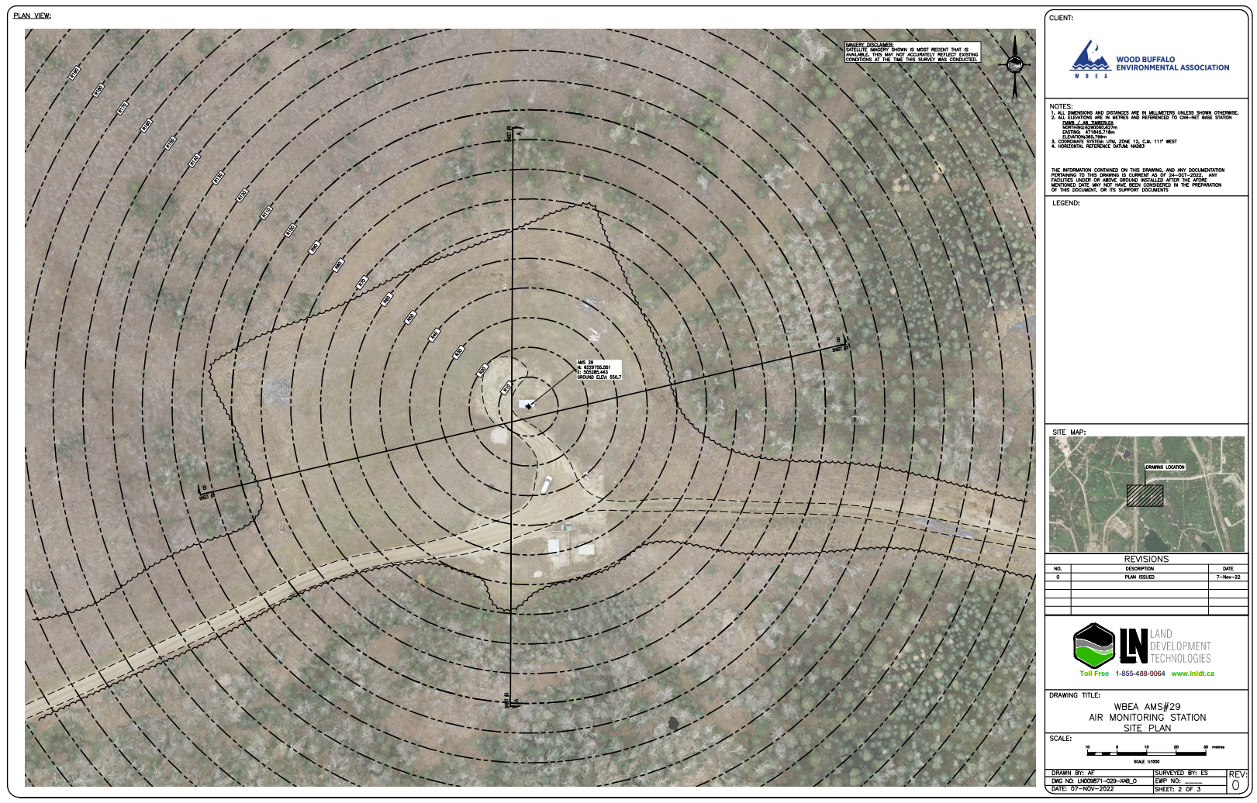
  - Figure 3 – Plan view sketch for AMS 29 site
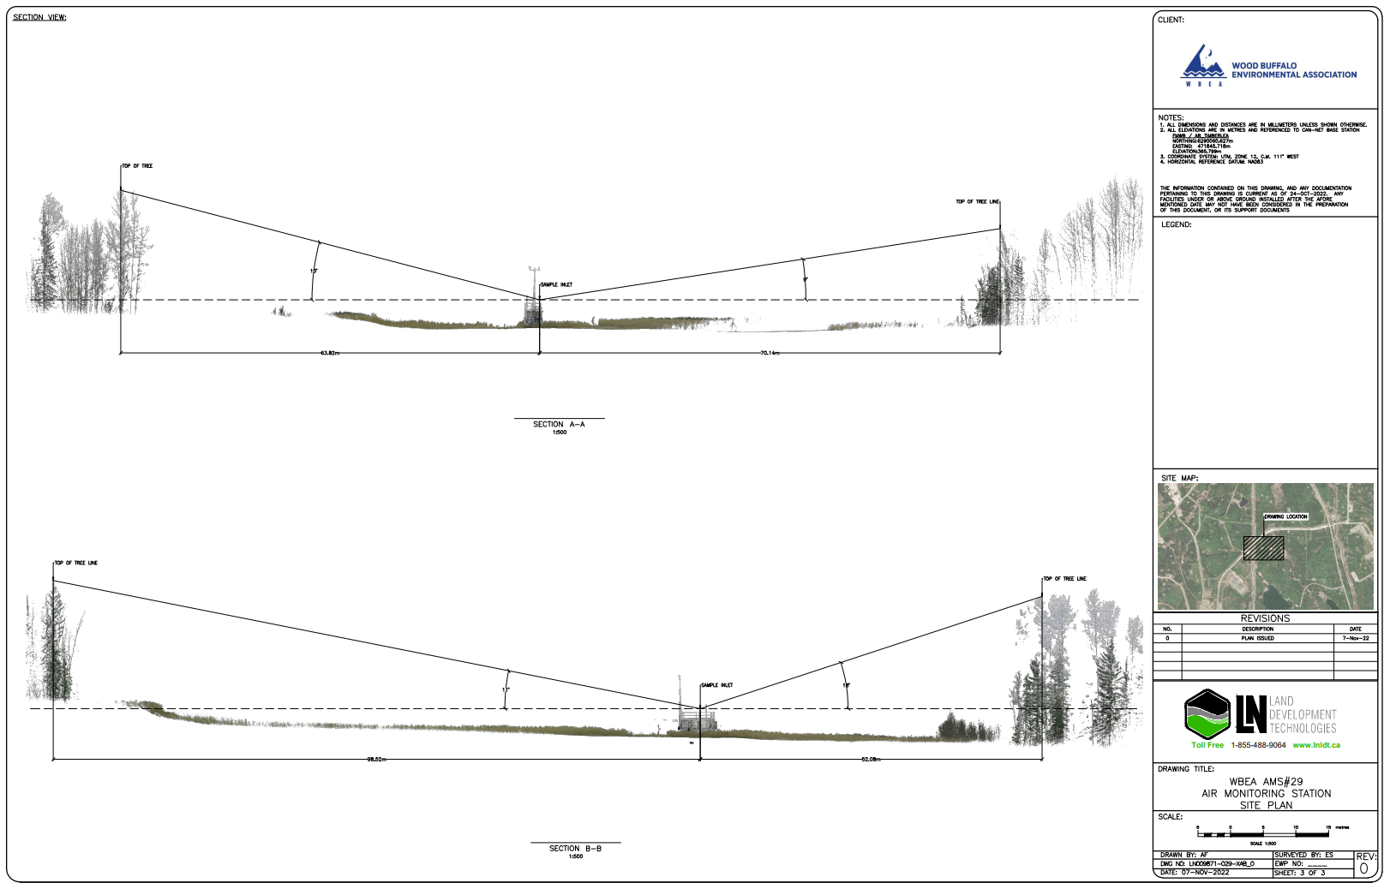
  - Figure 4 – Elevation view image for AMS 29 site

Site photos
The following photos show the environment surrounding the monitoring station.

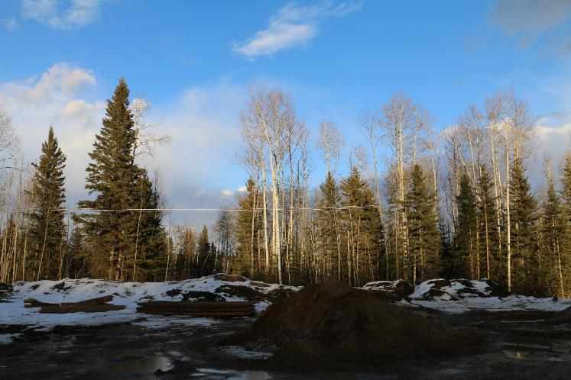
  - Figure 5 – Environment looking North

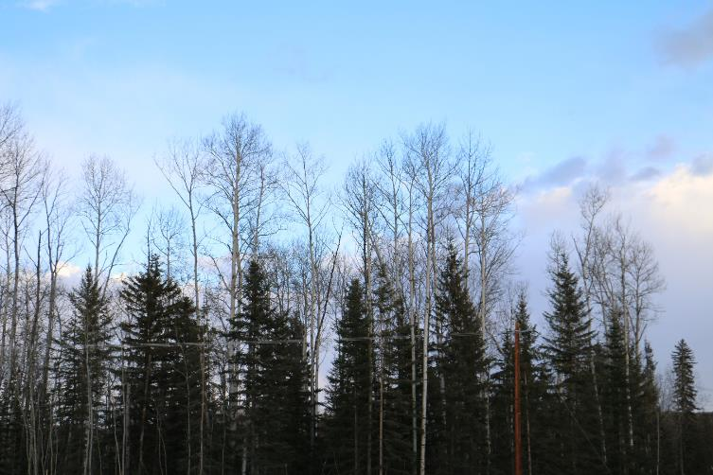
  - Figure 6 – Environment looking East
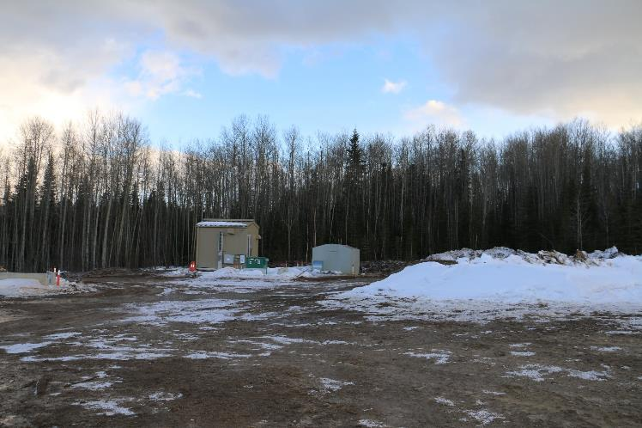
  - Figure 7 – Environment looking South
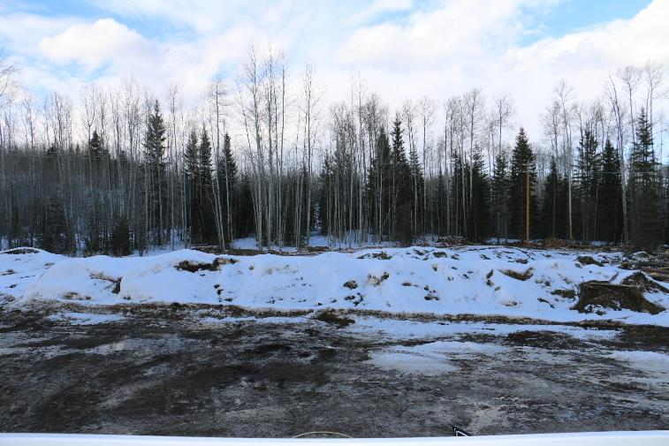
  - Figure 8 – Environment looking West

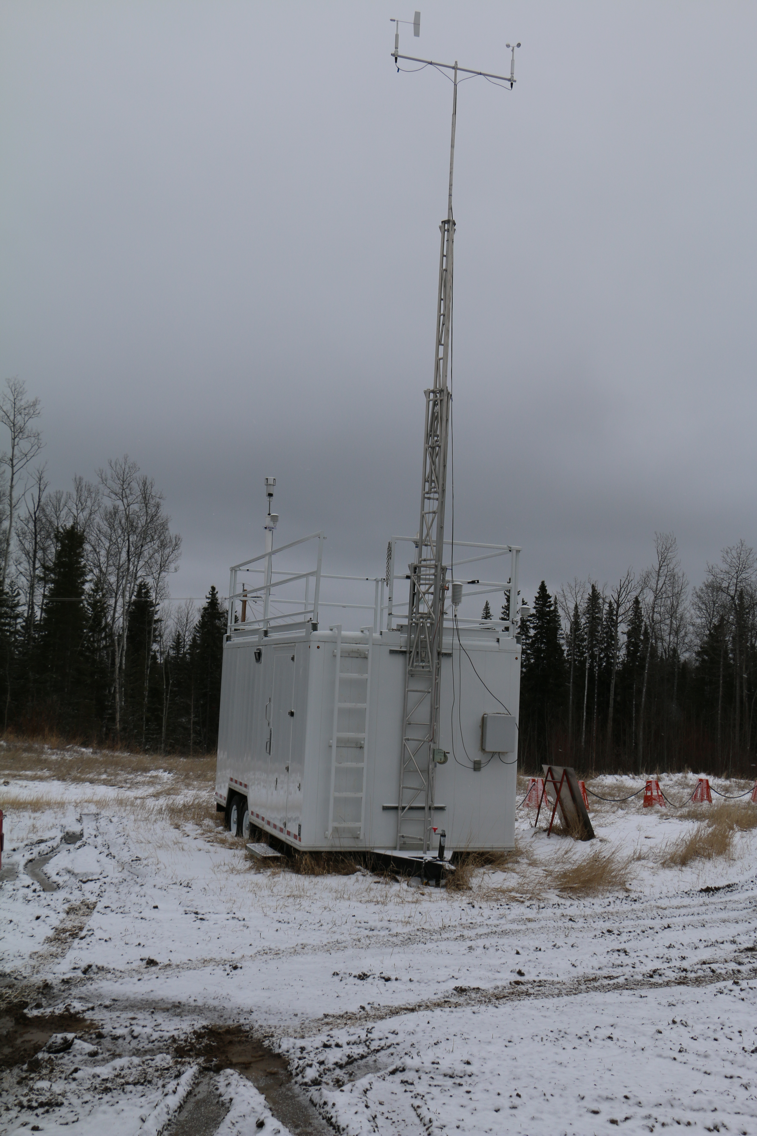
  - Figure 9 – Meteorological Tower

Station Photos
The following photos show the monitoring station and instrumentation.

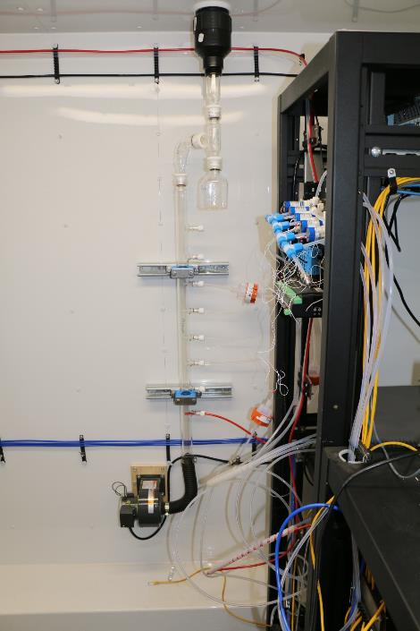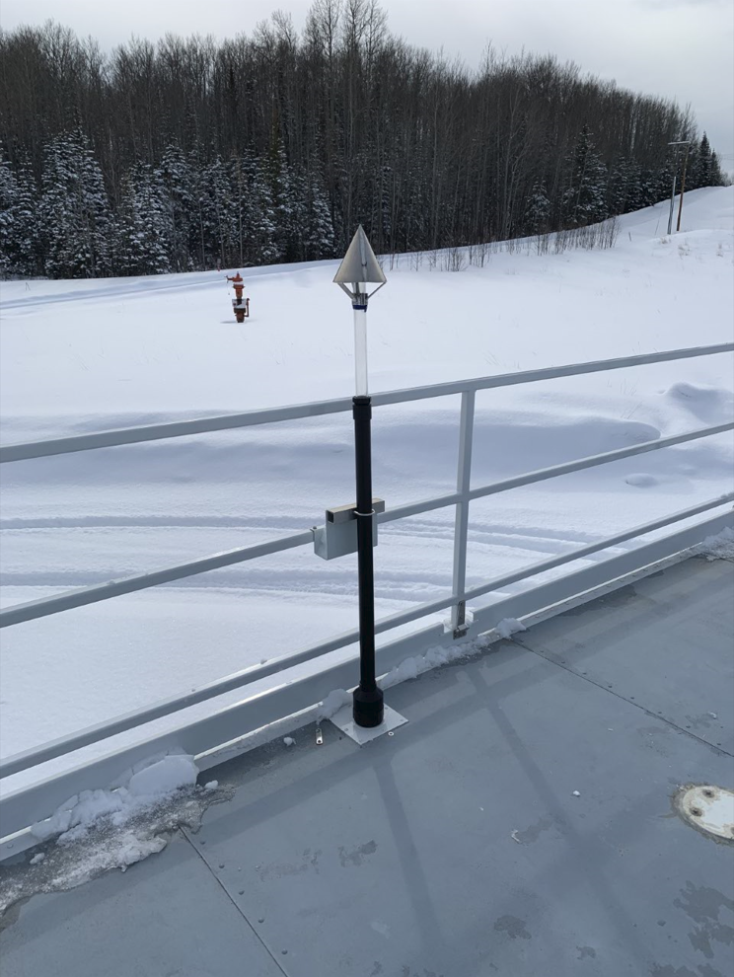
  - Figure 10 – Photo showing the inlet and sample manifold
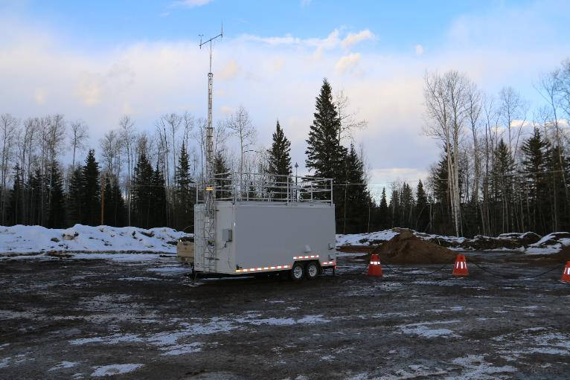
  - Figure 11 – Curb shot of the monitoring station
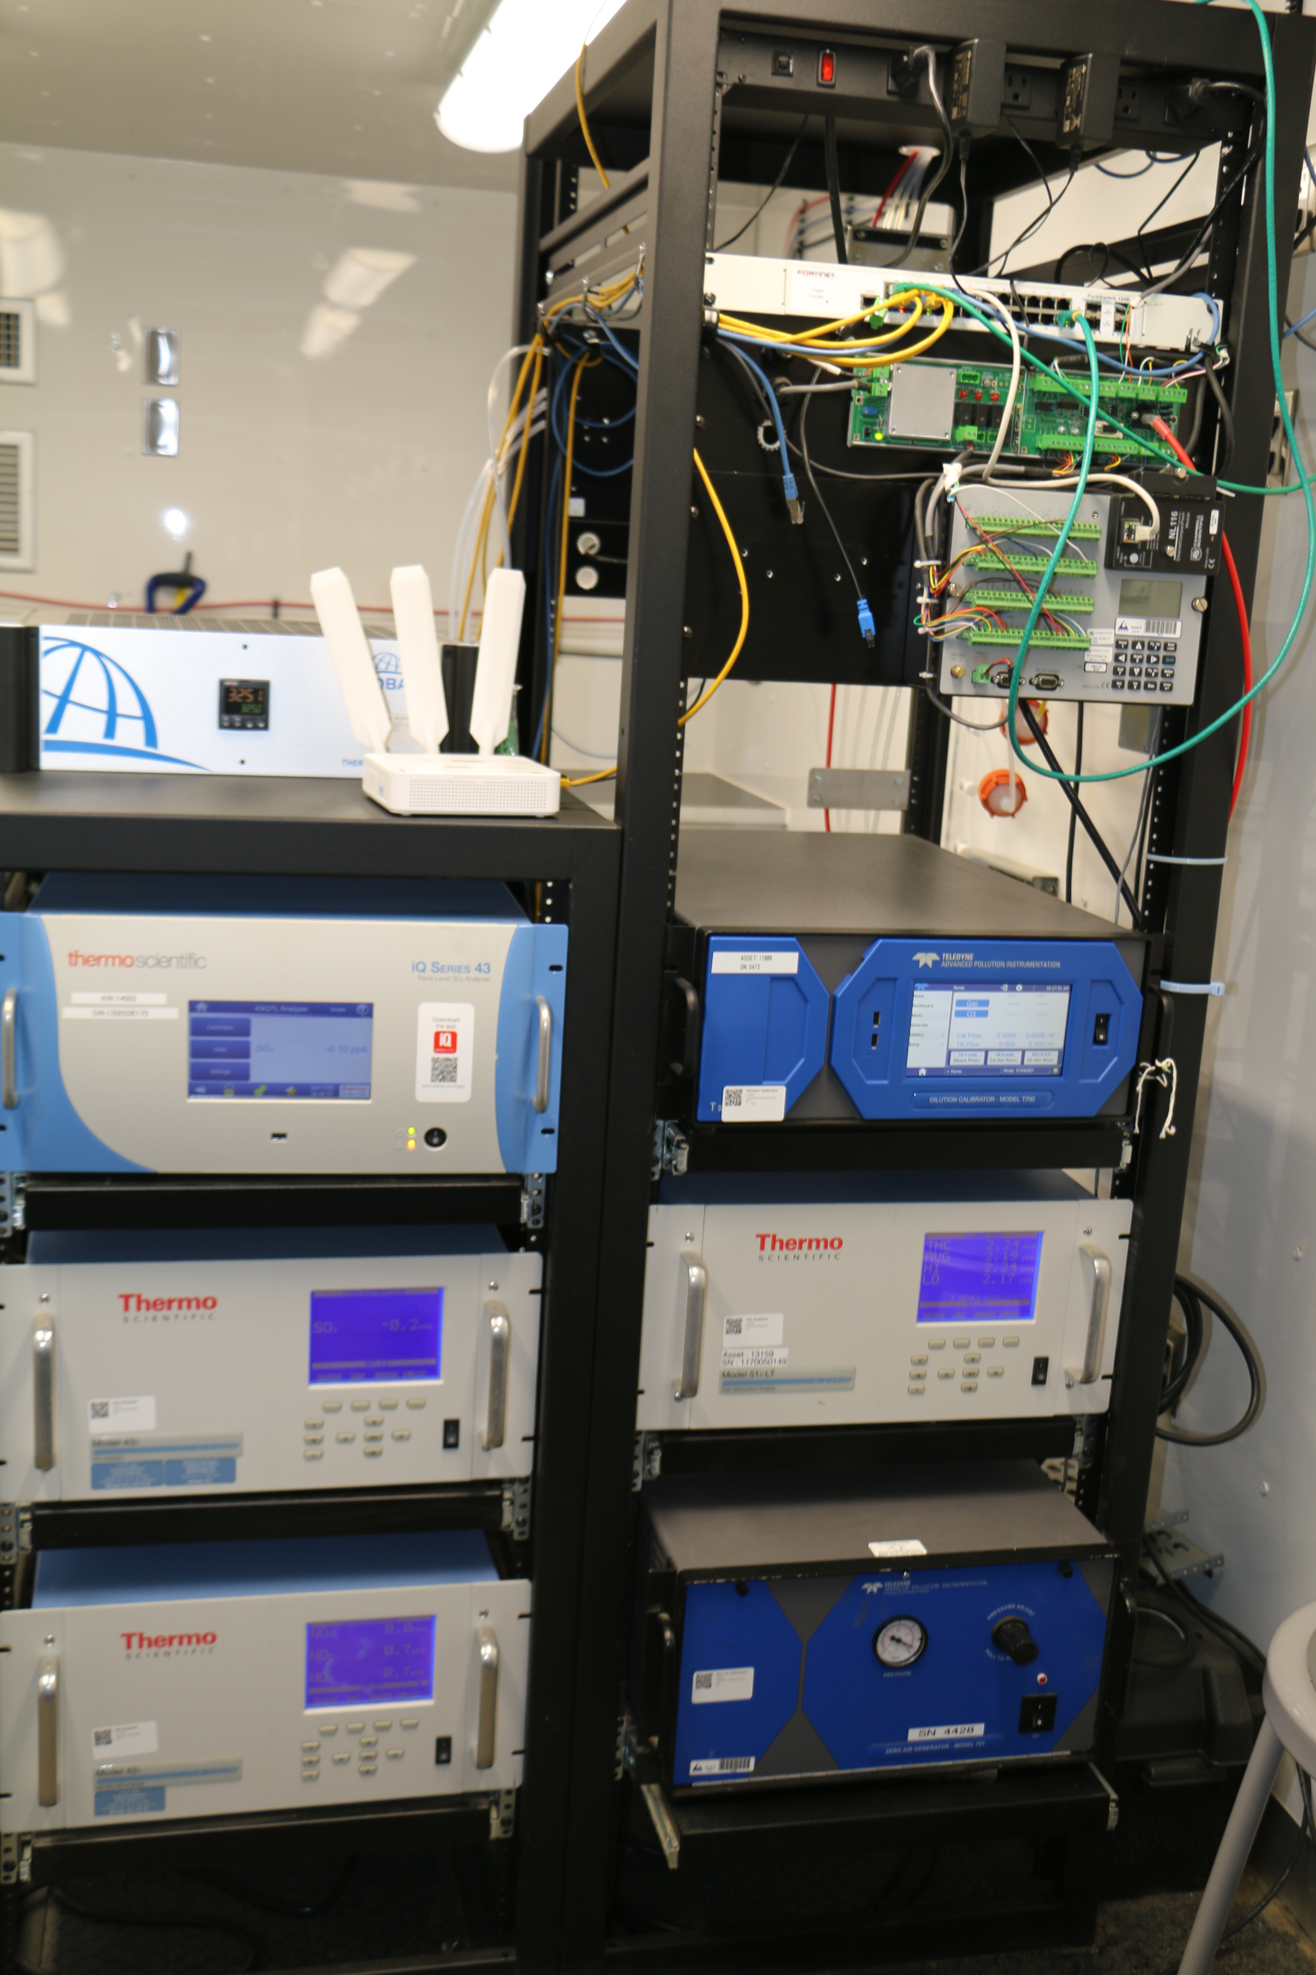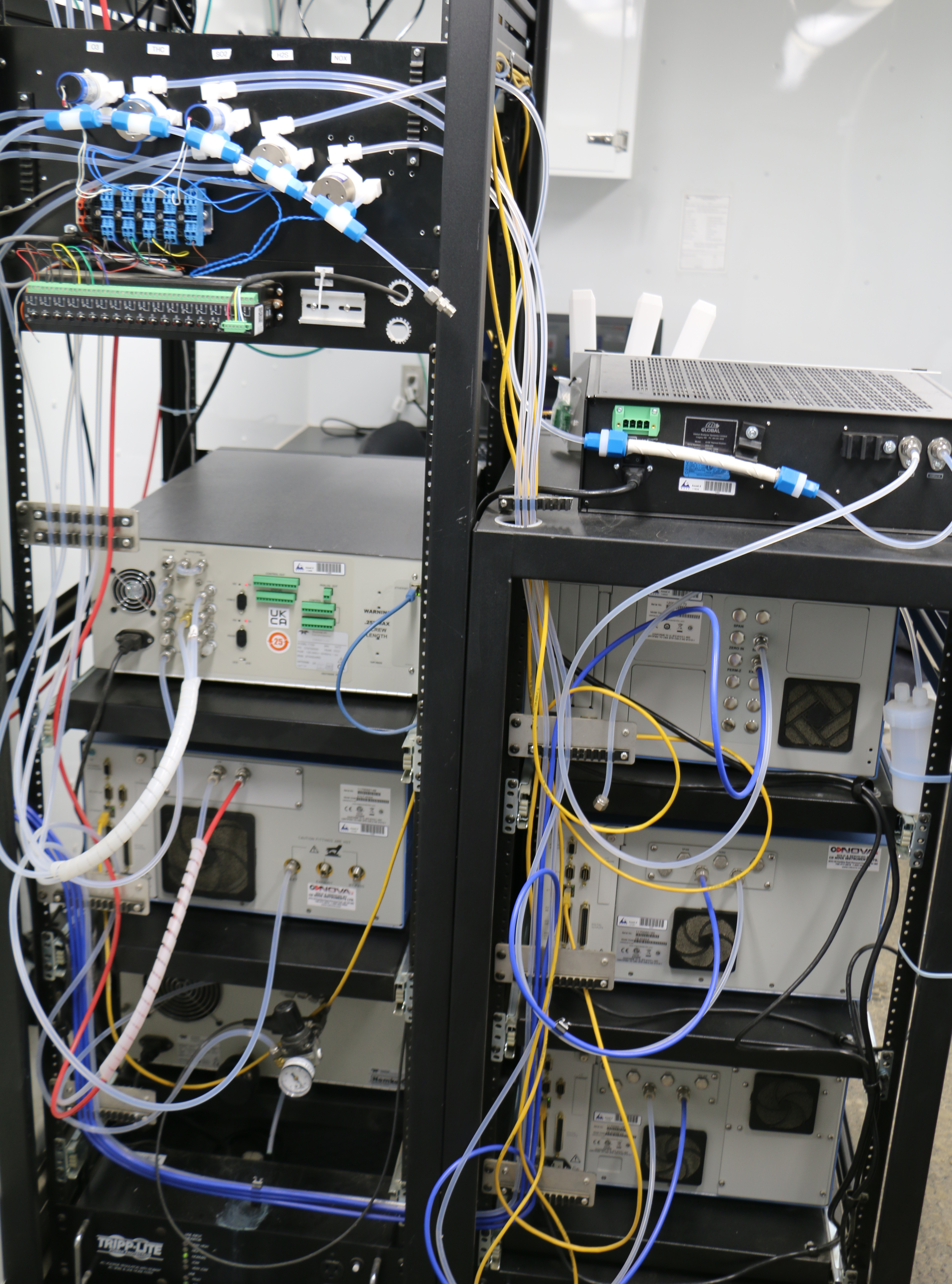
  - Figure 12 –Photo of the front and the back of instrument rack

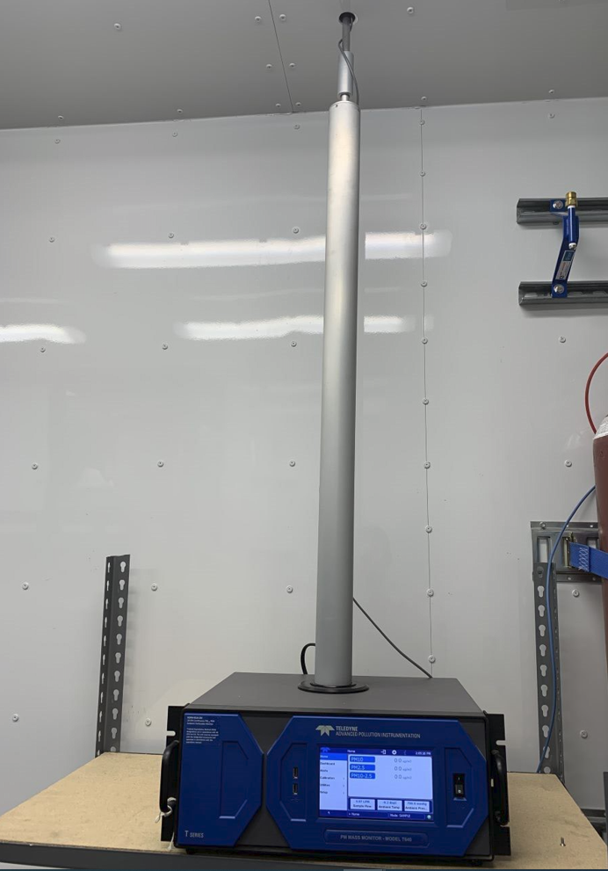
  - Figure 13 –Photo of the T640 Analyzer
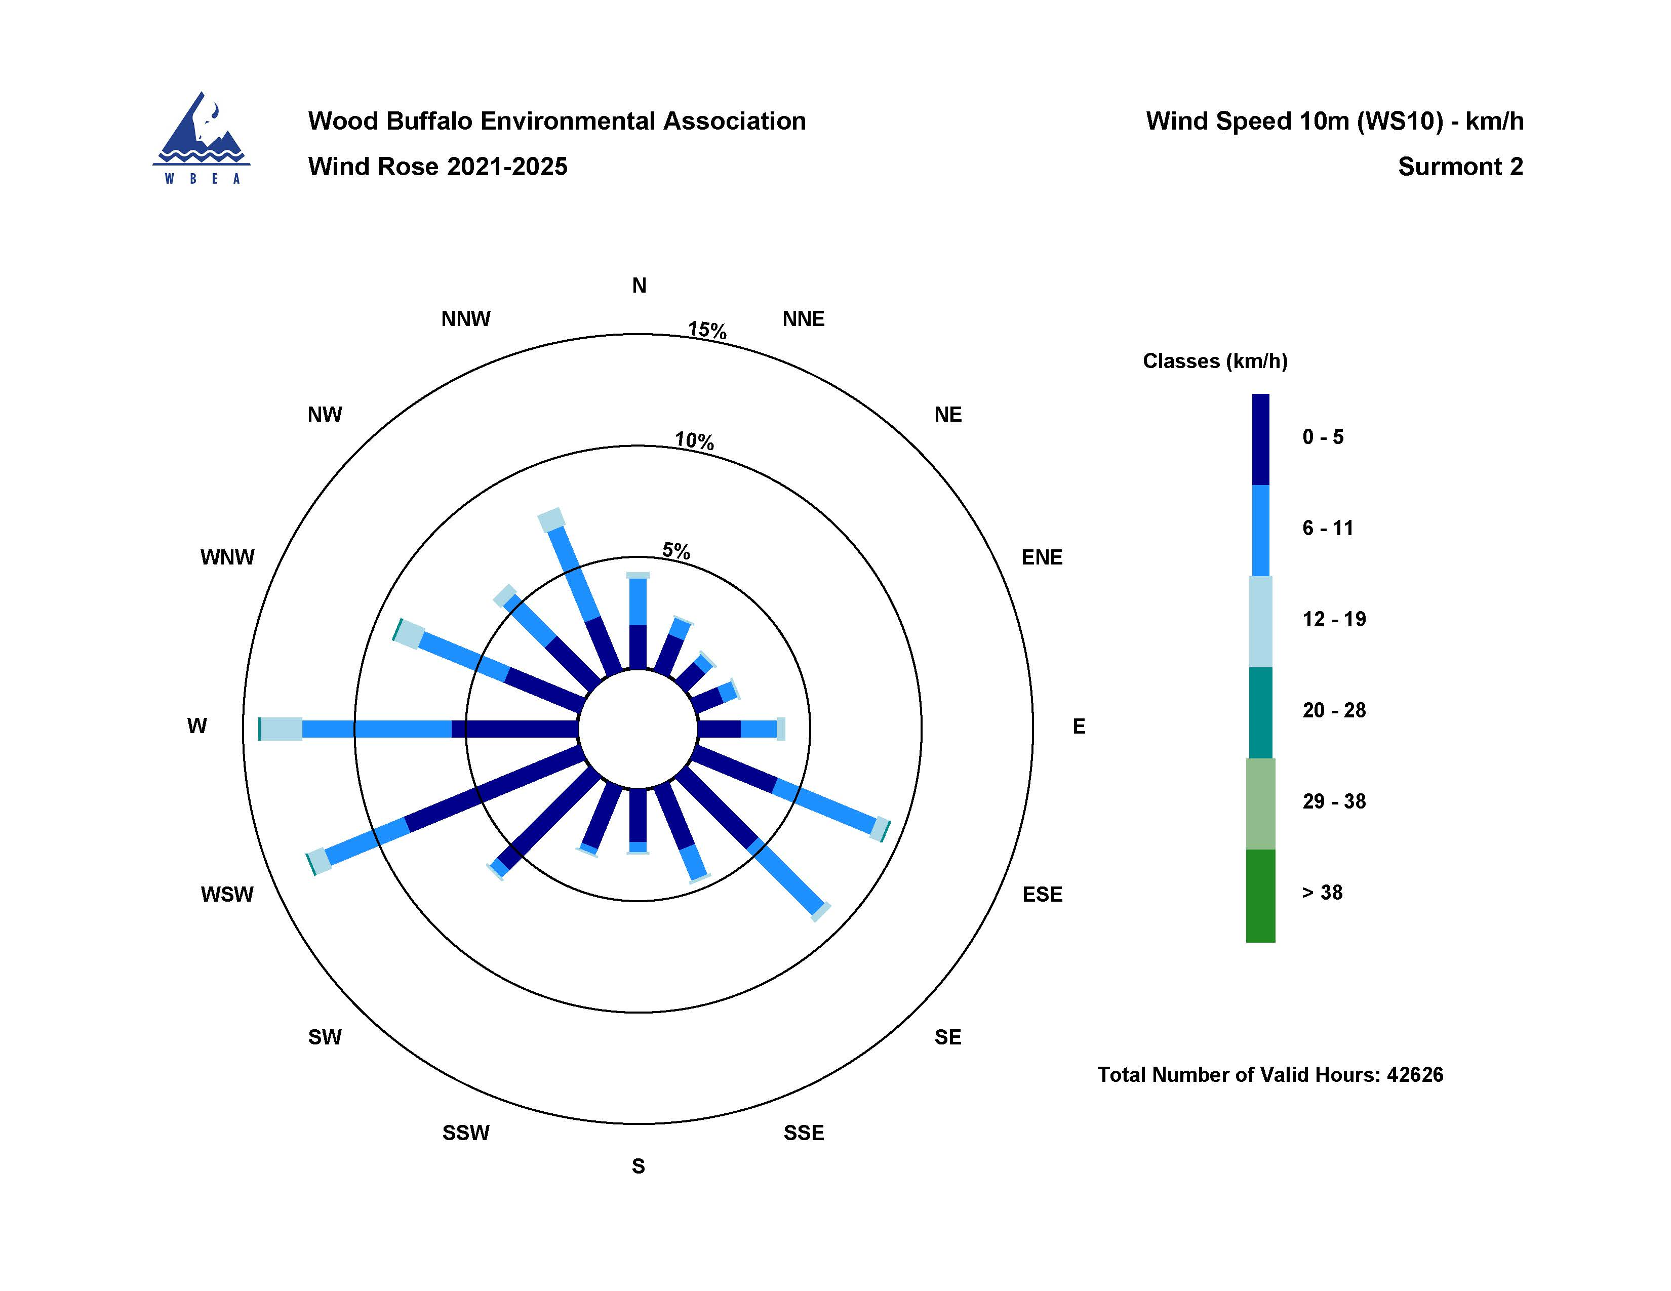

  - Figure 14 – Windrose (2021 – 2025)

