Wood Buffalo Environmental Association
Ambient Air Monitoring Station
Site Documentation

Waskōw ohci Pimâtisiwin

LAST UPDATED: February 18,2026

Table of Contents
General Site Information 4
Station 4
Location 4
Owner/Operator/Approval Holder 4
Site Description 4
Site Influences 5
Localized Sources (within 20 metres of station) 5
Roadway Influences 5
Major Point Sources 5
Station Equipment 6
Analytical Equipment 6
Meteorological Equipment 6
Support Equipment 6
Site photos 11
Station Photos 16

Tables and Figures
Figure 1 – Area topographic map showing AMS 25 7
Figure 2 – Aerial image showing AMS 25 8
Figure 3 – Plan view image for AMS 25 site 9
Figure 4 – Elevation view image for AMS 25 site 10
Figure 5 – Environment looking North 11
Figure 6 – Environment looking East 12
Figure 7 – Environment looking South 13
Figure 8 – Environment looking West 14
Figure 9 – Meteorological Tower 15
Figure 10 – Photo showing the inlet and sample manifold 16
Figure 11 – Curb shot of the monitoring station 17
Figure 12 –Photo of the front of instrument rack 18
Figure 13 – Windrose (2020-2025) 19

General Site Information
Revision Date: March 28, 2024

Station
Station ID | AMS 25
Station name | Waskōw ohci Pimâtisiwin
Date station established | July 2017

Location
Station street address | Environment and Climate Change Canada Oski Otin compound
Legal land description | 5-25-94-11 W4
Airshed Zone | Wood Buffalo Environmental Association
Latitude | 57°11’1.21” N
Longitude | 111°38’21.94” W
UTM East | 461350.886
UTM North | 6337994.691
Nearest community | Fort Mackay
Community population | 742
Census Year | 2016

Owner/Operator/Approval Holder
Operating Agency | Wood Buffalo Environmental Association
Address of Operating Agency | Unit 3-805 Memorial Drive, Fort McMurray, Alberta T9K 0K4
Name of Approval Holder | N/A
Approval number | N/A
Contact Name | Wood Buffalo Environmental Association
Address | Unit 3-805 Memorial Drive, Fort McMurray, Alberta T9K 0K4
Phone number | 780-799-4420
Email address | info@wbea.org

Site Description
Land use by sector | 0 – 90 degrees | Wooded Area
Land use by sector | 91 – 180 degrees | Wooded Area
Land use by sector | 181 – 270 degrees | Oski-otin Compound
Land use by sector | 271 – 360 degrees | Oski-otin Compound, gravel access road
Site elevation (m)  (above sea level) | 261.6 m
Angle of elevation to nearby buildings | Greatest angle | N/A
Angle of elevation to nearby buildings | Building direction | N/A
Airflow restrictions | North | None
Airflow restrictions | East | None
Airflow restrictions | South | None
Airflow restrictions | West | House
Sample manifold | Type | All glass
Sample manifold | Inlet height above roof | 1 metre
Meteorological Sensors | Type | Cup and vane
Meteorological Sensors | Height above ground (m) | 10 m
Meteorological Sensors | Distance from station (m) | 0 m

Site Influences

Localized Sources (within 20 metres of station)
Type | Distance (m) | Description
None | n/a | n/a

Roadway Influences
Type | Traffic Volume | Distance (m) | Description
Main roadway | Low | 30 | Main roadway used by residential vehicles

Major Point Sources
Facility Name | Source Type | Distance from site (km) | Compass direction from site
CNRL Albian | Oil Sands Plant | 10 | Northeast
Syncrude | Oil Sands Plant | 15 | South
CNRL Horizon | Oil Sands Plant | 20 | Northwest

Station Equipment
Equipment Owner: WBEA

Analytical Equipment
Parameter | Make | Model | Serial Number | Date Instrument Installed | WBEA Data  Start Date
SO₂ | Thermo Scientific | 43i | 1118148497 | 2017 | August, 2017
H₂S | Thermo Scientific | 43i-LTE | 1170050146 | 2019 | August, 2017
H₂S | Global Analyzer Systems | G150 | 2024-287 | 2025 | August, 2017

Meteorological Equipment
Parameter | Make | Model | Serial Number | WMO Site Class | Date Instrument Installed | WBEA Data Start Date
AT/RH | Vaisala | HMP155 | P3640812 | 2 | - | August, 2017
WS | Met One | 010C-1 | G3211 | 3 | 2025 | August, 2017
WD | Met One | 020C-1 | U11345 | 3 | - | August, 2017

Support Equipment
Name | Description | Make | Model | Serial Number
Datalogger | Datalogger | Campbell Scientific | CR3000 | 2632
Datalogger | Datalogger | Campbell Scientific | CR1000 | 62004
Gas Dilution Calibrator | Dynamic dilution calibrator | Teledyne/API | T700 | 747
Zero air generator | Zero Air Generator | Teledyne/API | M701 | 4765
Shelter / Building | Air monitoring portable | ITB | 8 x 16 trailer | ITB-15-16517
HVAC | Heating and air conditioning system. Wall mount unit | BARD | 1 ton | -

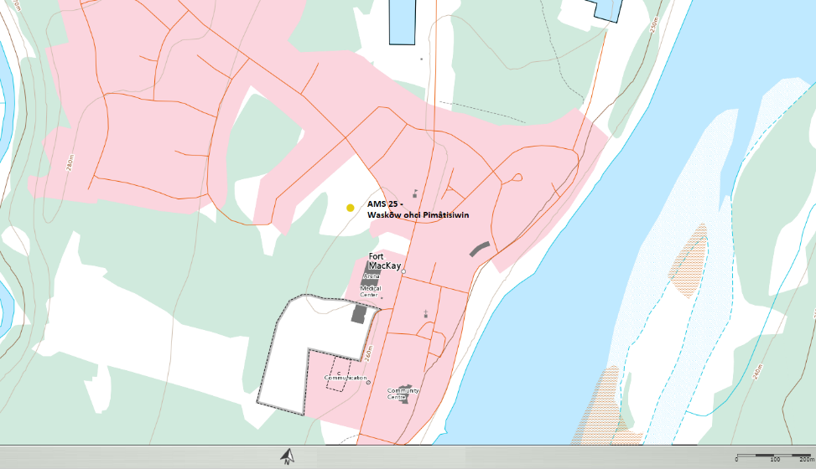
  - Figure 1 – Area topographic map showing AMS 25

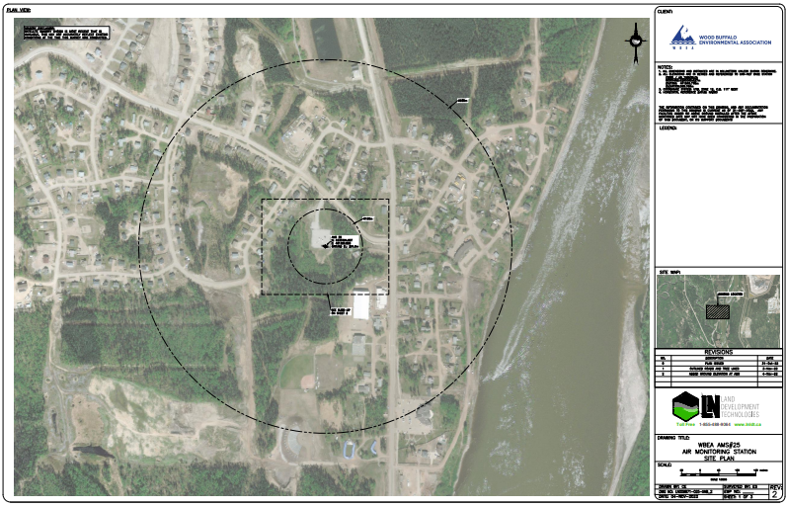
  - Figure 2 – Aerial image showing AMS 25
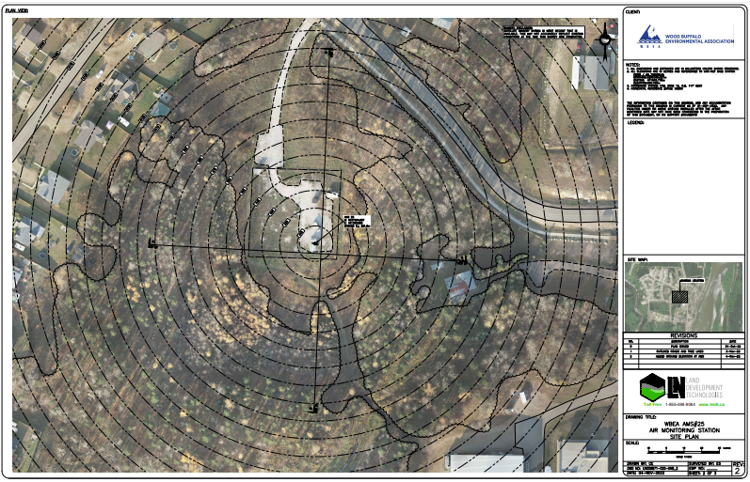
  - Figure 3 – Plan view image for AMS 25 site

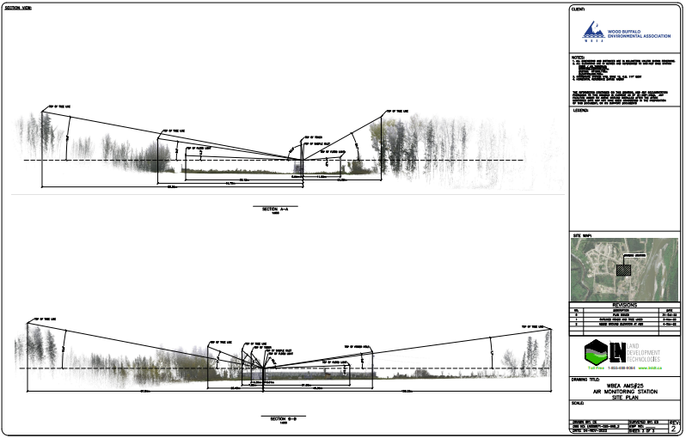
  - Figure 4 – Elevation view image for AMS 25 site

Site photos
The following photos show the environment surrounding the monitoring station.

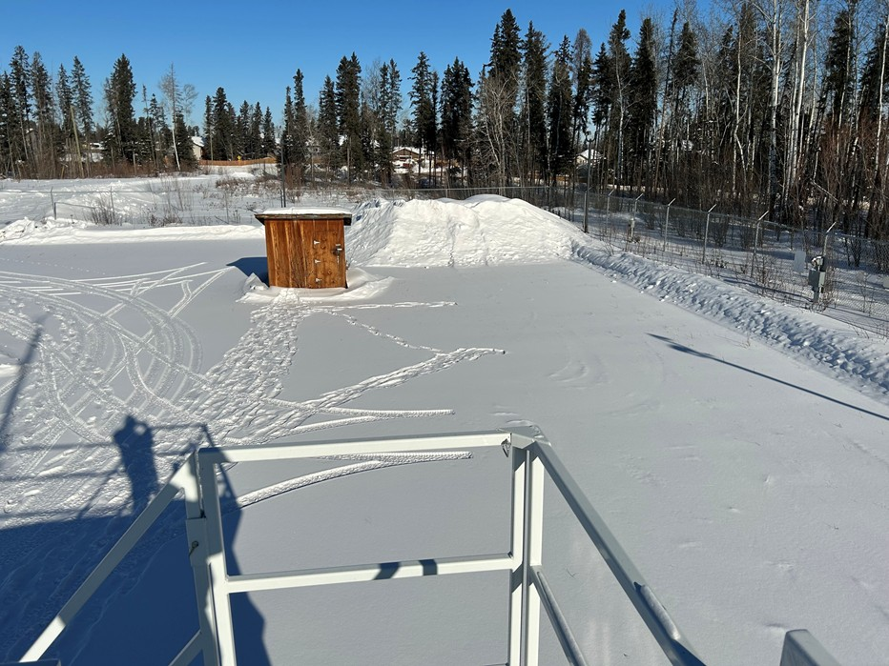
  - Figure 5 – Environment looking North

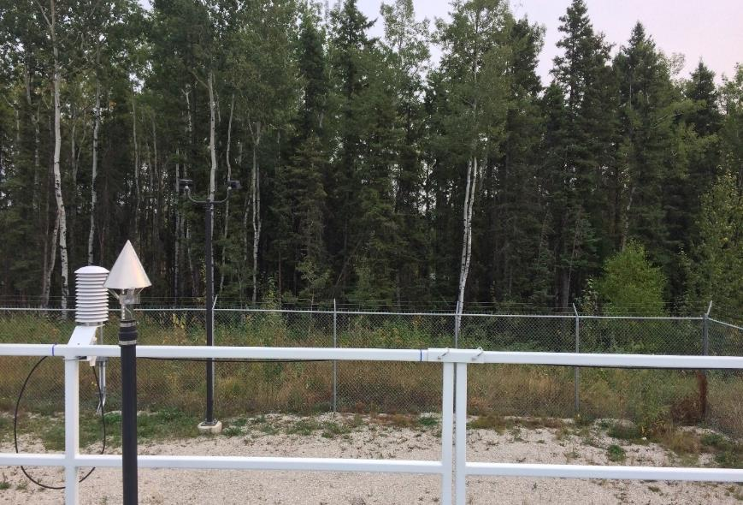
  - Figure 6 – Environment looking East
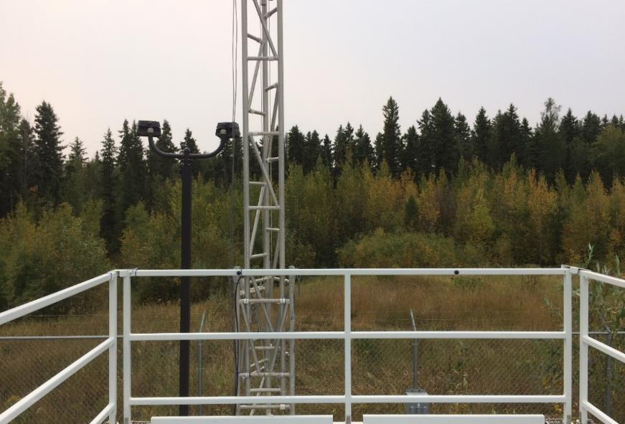
  - Figure 7 – Environment looking South
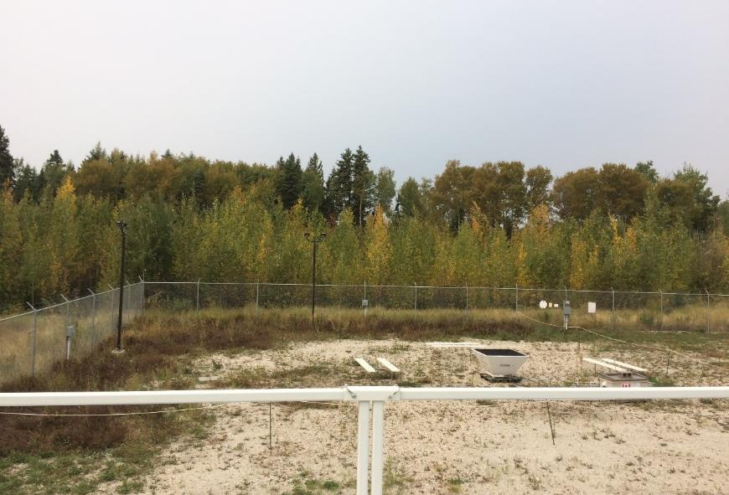
  - Figure 8 – Environment looking West
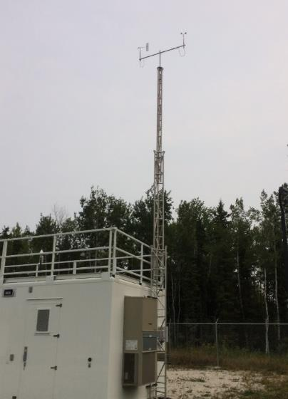
  - Figure 9 – Meteorological Tower

Station Photos
The following photos show the monitoring station and instrumentation.

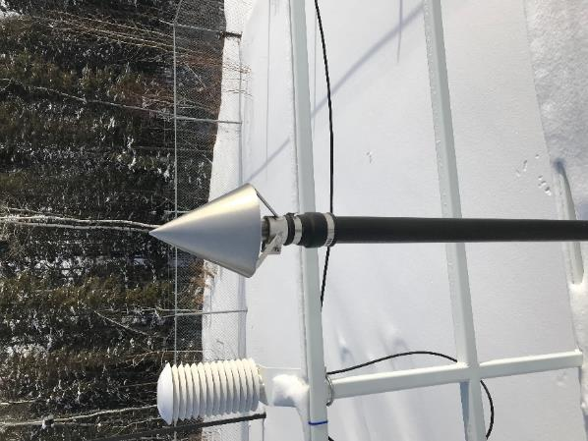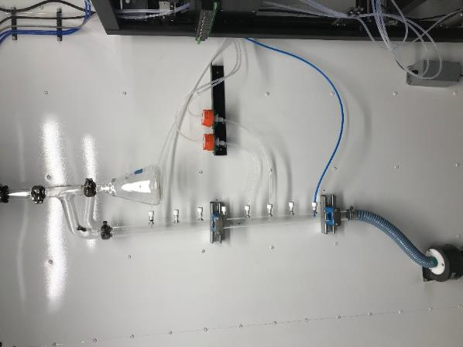
  - Figure 10 – Photo showing the inlet and sample manifold

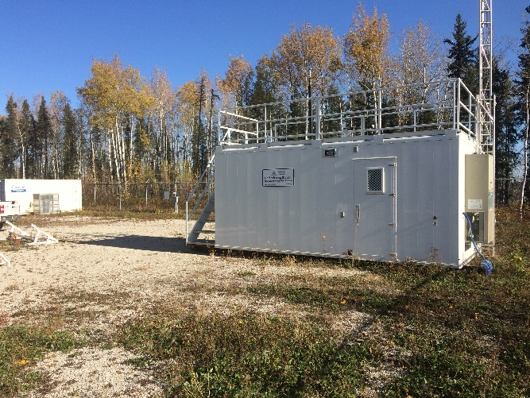
  - Figure 11 – Curb shot of the monitoring station
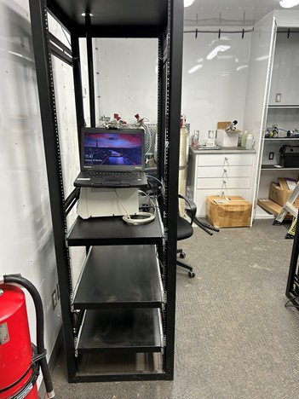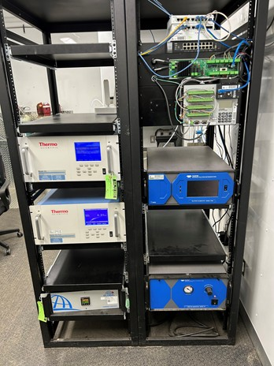
  - Figure 12 –Photo of the front of instrument rack

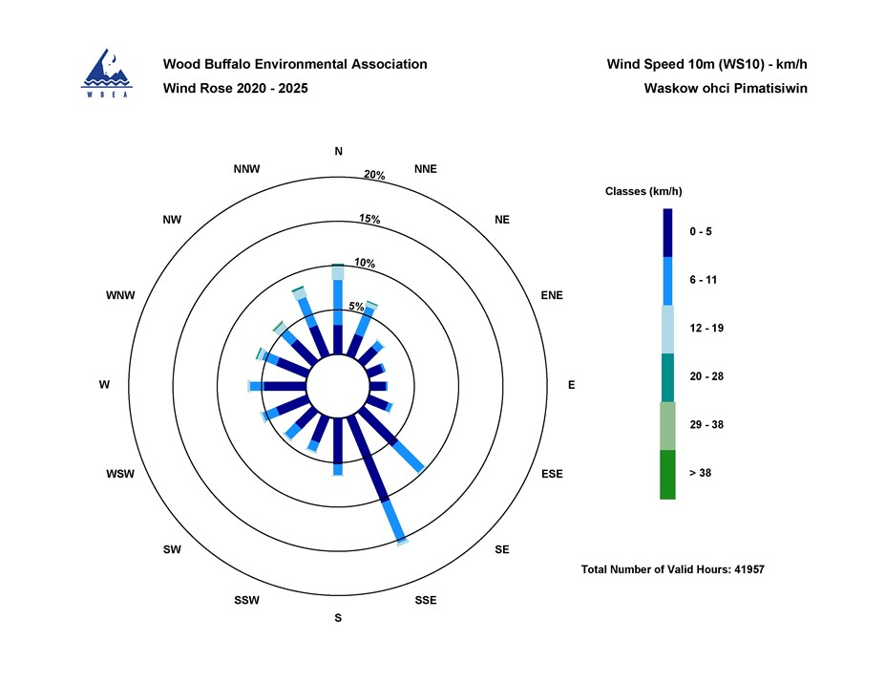
  - Figure 13 – Windrose (2020-2025)

