Wood Buffalo Environmental Association
Ambient Air Monitoring Station
Site Documentation

Fort Hills

LAST UPDATED: March 02,2026

Table of Contents
General Site Information 4
Station 4
Location 4
Owner/Operator/Approval Holder 4
Site Description 4
Site Influences 5
Localized Sources (within 20 metres of station) 5
Roadway Influences 5
Major Point Sources 5
Station Equipment 6
Analytical Equipment 6
Meteorological Equipment 6
Support Equipment 6
Site photos 9
Station Photos 14

Tables and Figures
Figure 1 – Aerial photo showing AMS 23 7
Figure 2 – Plan view sketch for AMS 23 site 8
Figure 3 – Environment looking North 9
Figure 4 – Environment looking East 10
Figure 5 – Environment looking South 11
Figure 6 – Environment looking West 12
Figure 7 – Meteorological Tower 13
Figure 8 – Photo showing the inlet and sample manifold 14
Figure 9 – Curb shot of the monitoring station 15
Figure 10 –Photo of the front and the back of instrument rack 16
Figure 11 –Photo of the T640 PM monitor and inlet 17
Figure 12 – Windrose (2020-2025) 18

General Site Information
Revision Date: March 28, 2024

Station
Station ID | AMS 23
Station name | Fort Hills
Date station established | March 2017

Location
Station street address | Located North of the Southwest Raw Water Pond
Legal land description | 15-24-096-11 W4
Airshed Zone | Wood Buffalo Environmental Association
Latitude | 57.3489012253
Longitude | -111.639688536
UTM East | 461505
UTM North | 6356406
Nearest community | Fort McKay
Community population | 60
Census Year | 2025

Owner/Operator/Approval Holder
Operating Agency | Wood Buffalo Environmental Association
Address of Operating Agency | Unit 3 - 805 Memorial Drive, Fort McMurray, Alberta T9K 0K4
Name of Approval Holder | Fort Hills Energy Corporation
Approval number | 151469-01-00
Contact Name | Ty Callioux
Address | P.O. Box 4001 Fort McMurray, Alberta, T9H 3E3
Phone number | 780-743-7780 (business hours); 780-762-4200 (non-business hours)
Email address | tcallioux@suncor.com

Site Description
Land use by sector | 0 – 90 degrees | Water treatment building
Land use by sector | 91 – 180 degrees | Raw Water Pond
Land use by sector | 181 – 270 degrees | Raw Water Pond
Land use by sector | 271 – 360 degrees | Access road, drilling lay down yard
Site elevation (m)  (above sea level) | 283m
Angle of elevation to nearby buildings | Greatest angle | 20°
Angle of elevation to nearby buildings | Building direction | West
Airflow restrictions | North | N/A
Airflow restrictions | East | N/A
Airflow restrictions | South | N/A
Airflow restrictions | West | N/A
Distance to nearest trees (m) | North | N/A
Distance to nearest trees (m) | East | N/A
Distance to nearest trees (m) | West | N/A
Distance to nearest trees (m) | South | N/A
Sample manifold | Type | All glass
Sample manifold | Inlet height above roof | 1 metre
Wind Sensors | Type | Cup and vane
Wind Sensors | Height above ground (m) | 10m
Wind Sensors | Distance from station (m) | 0m

Site Influences

Localized Sources (within 20 metres of station)
Type | Distance (m) | Description
Raw water pond | 20m | Storage pond for raw process water
Trailer Laydown | 20m | Storage for Trailers

Roadway Influences
Type | Traffic Volume | Distance (m) | Description
Gravel Road | Medium | 100 | Mine access road used by pickup trucks and heavy equipment

Major Point Sources
Facility Name | Source Type | Distance from site (km) | Compass direction from site
Fort Hills | Oil Sands Plant | 0 | N/A
CNRL Horizon | Oil Sands Plant | 10 | Southwest
CNRL Albian | Oil Sands Plant | 15 | South

Station Equipment
Equipment Owner: Suncor – Fort Hills

Analytical Equipment
Parameter | Make | Model | Serial Number | Date Instrument Installed | WBEA Data Start Date
Continuous
SO₂ | Thermo Scientific | 43i | 1160290012 | December, 2021 | June, 2017
TRS | Thermo Scientific | 43i-TLE | 1300156232 | December, 2021 | June, 2017
NO/NO_{x}/NO₂ | Thermo Scientific | 42i | 1152430007 | December, 2021 | June, 2017
THC/CH₄/NMHC | Thermo Scientific | 55i | 12227620777 | December, 2025 | July, 2017
PM_{2.5} | Teledyne API | T640 | 320 | December, 2025 | June, 2017
Time-Integrated
PM₁₀ A | Thermo Scientific | 2000i-A-N | 2000I2-0382-308 | December, 2021 | -
PM₁₀ B | Thermo Scientific | 2000i-A-N | 2000IW 20930 2108 | December, 2021 | -
VOC | Global Analyzer Systems | G170 | 2023-234 | 2023 | -

Meteorological Equipment
Parameter | Make | Model | Serial Number | WMO Site Class | Date Instrument Installed | WBEA Data Start Date
AT/RH | Vaisala | HMP155 | T2950501 | Class 3 | December, 2021 | June, 2017
WS | Met One | 010C-1 | E1038 | Class 3 | December, 2025 | June, 2017
WD | Met One | 020C-1 | B17268 | Class 3 | December, 2025 | June, 2017

Support Equipment
Name | Description | Make | Model | Serial Number
Datalogger | Datalogger | Campbell Scientific | CR3000 | 7882
Gas Dilution Calibrator | Dynamic dilution calibrator | Teledyne/API | T700 | 451
Zero air generator | Zero Air Generator | Teledyne/API | T701 | 1117
Shelter / Building | Air monitoring portable | ITB | 8 x 14 trailer | 2C9CSC2G7M1044018
HVAC | Heating and air conditioning system. Wall mount unit | BARD | 1 ton | 12345
TRS Converter | Thermal Oxidizer | CD Nova | CDN-101 | 594
H2Generator | Hydrogen Generator | Parker Hannifin | 63-0100 | 14950646

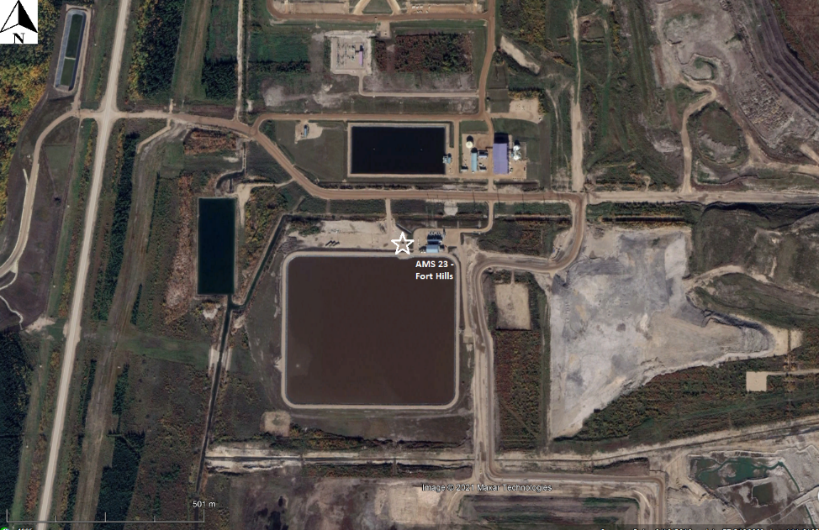
  - Figure 1 – Aerial photo showing AMS 23
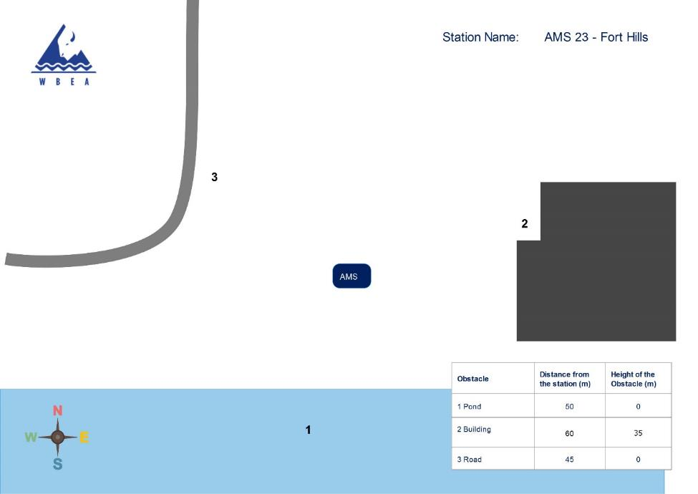
  - Figure 2 – Plan view sketch for AMS 23 site

Site photos
The following photos show the environment surrounding the monitoring station.

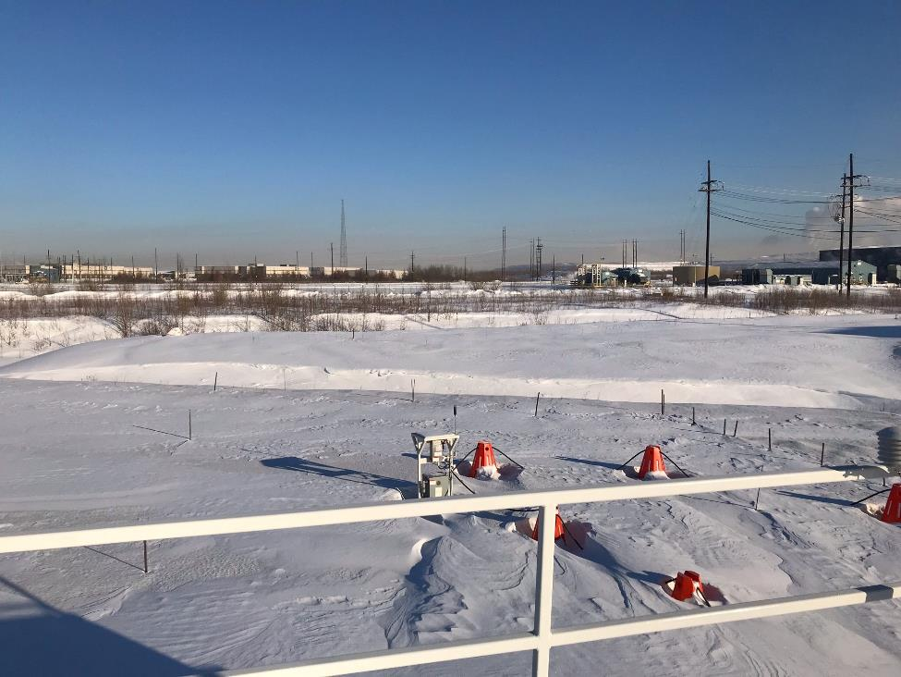
  - Figure 3 – Environment looking North
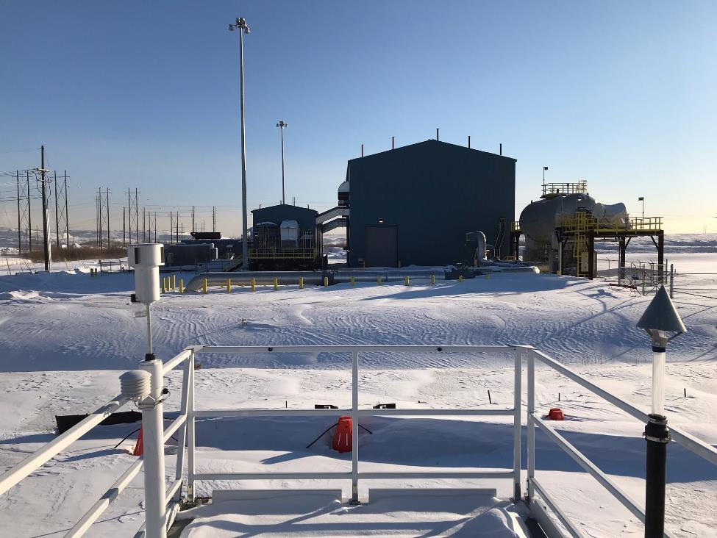

  - Figure 4 – Environment looking East
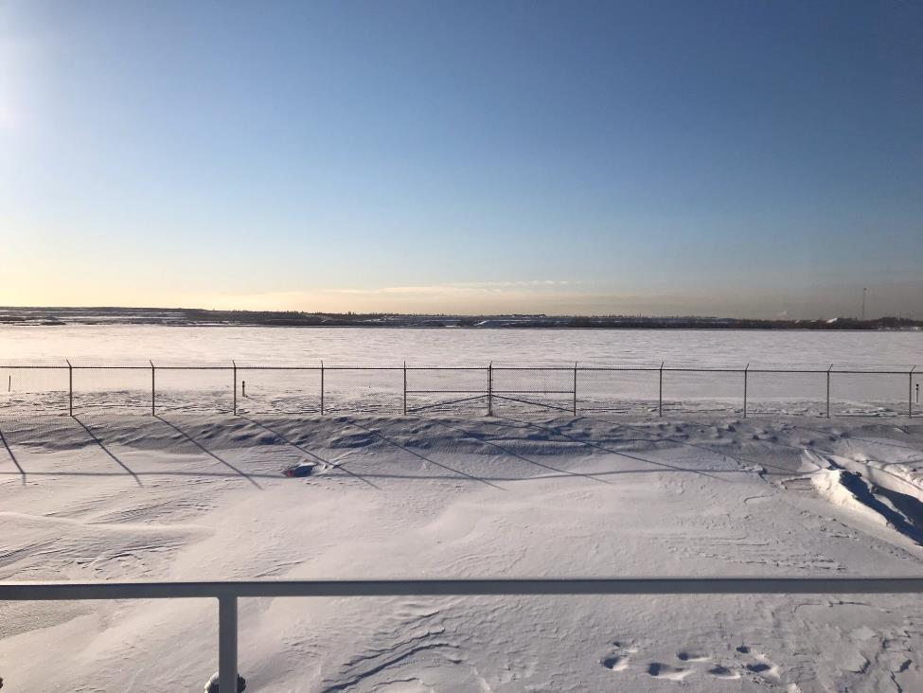

  - Figure 5 – Environment looking South
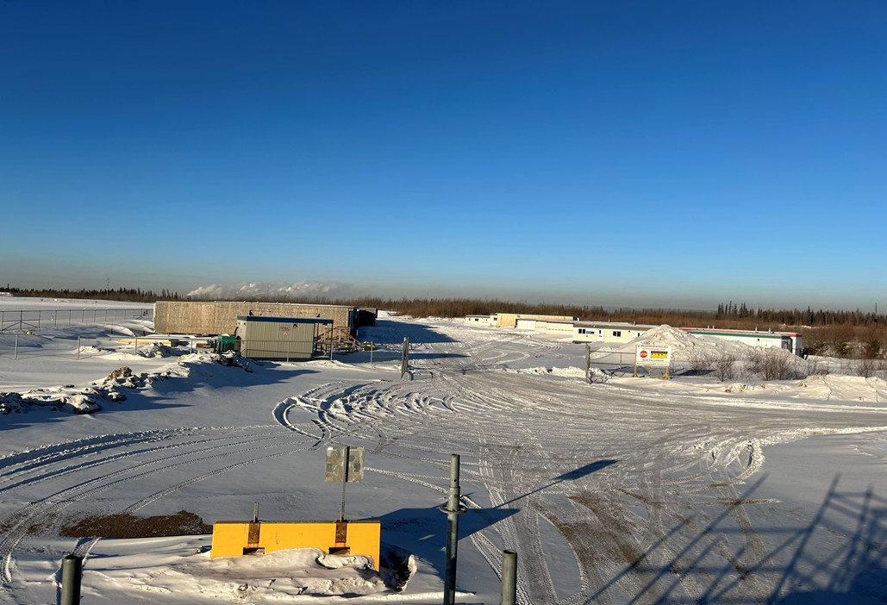

  - Figure 6 – Environment looking West
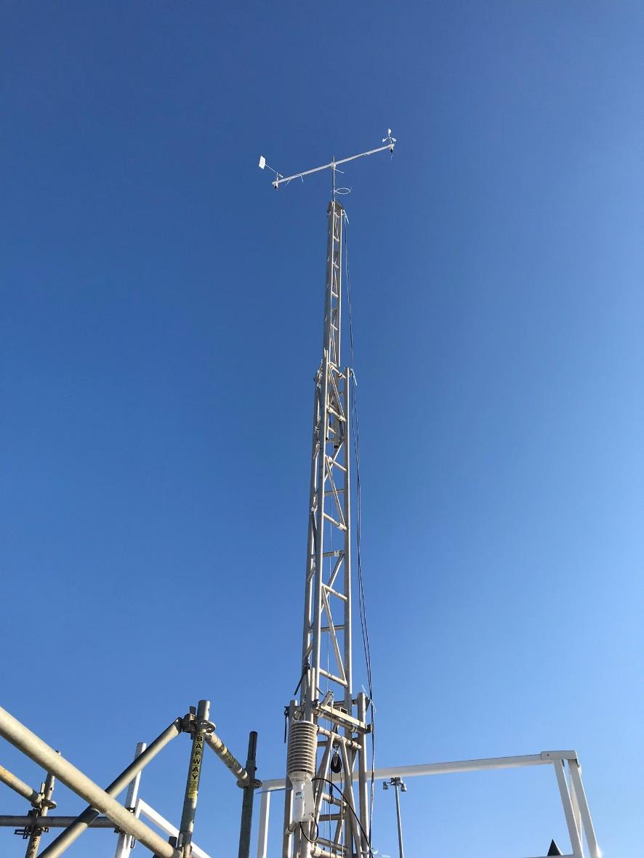

  - Figure 7 – Meteorological Tower

Station Photos
The following photos show the monitoring station and instrumentation.
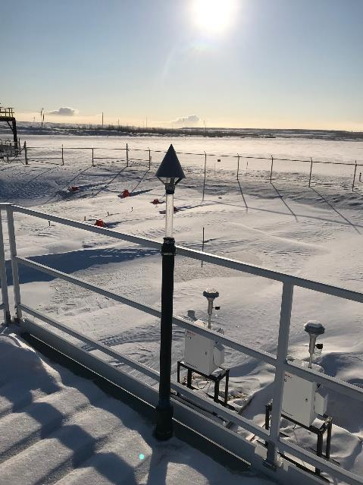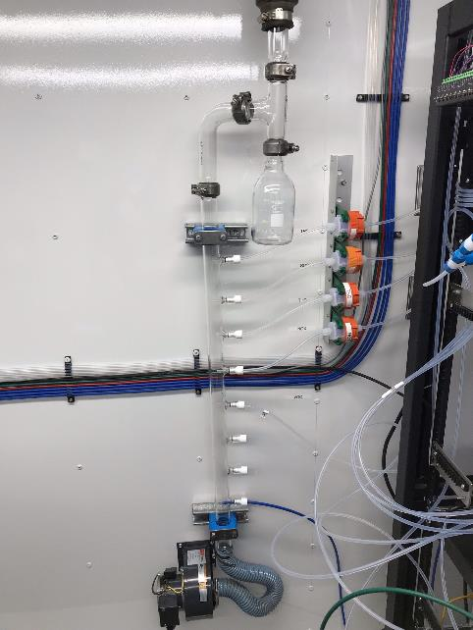
  - Figure 8 – Photo showing the inlet and sample manifold

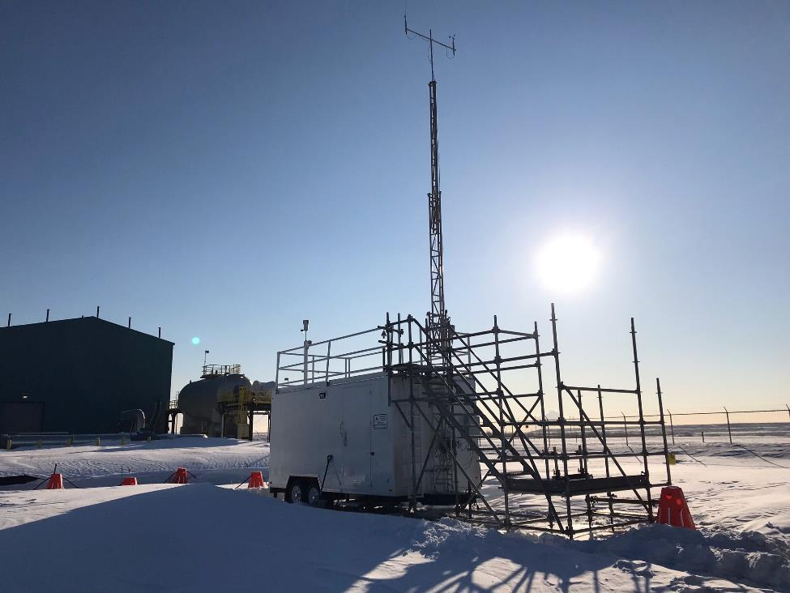
  - Figure 9 – Curb shot of the monitoring station
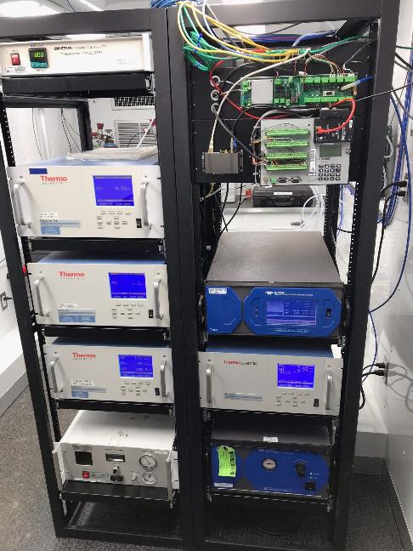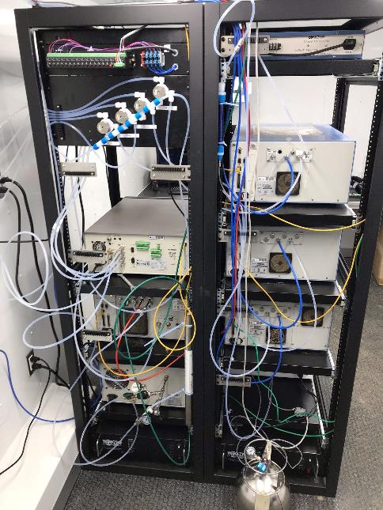
  - Figure 10 –Photo of the front and the back of instrument rack

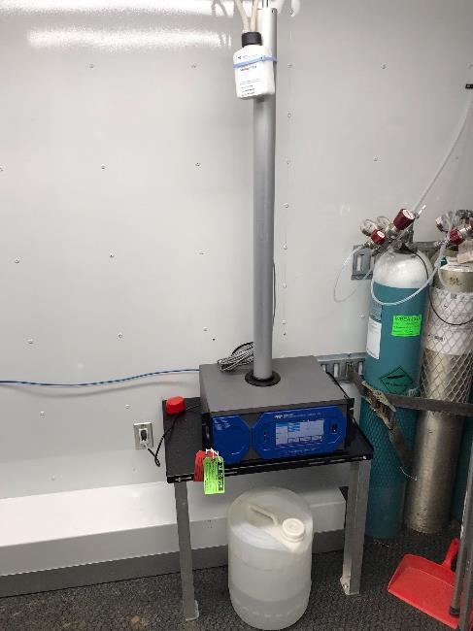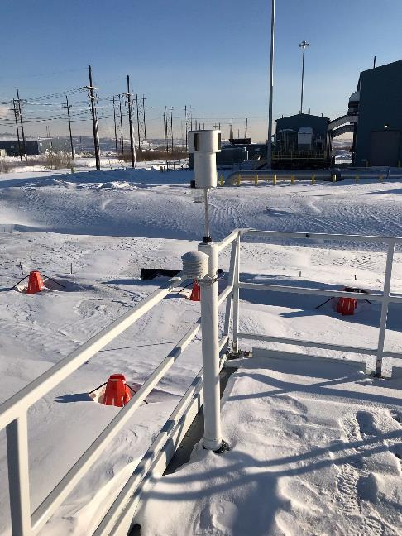

  - Figure 11 –Photo of the T640 PM monitor and inlet
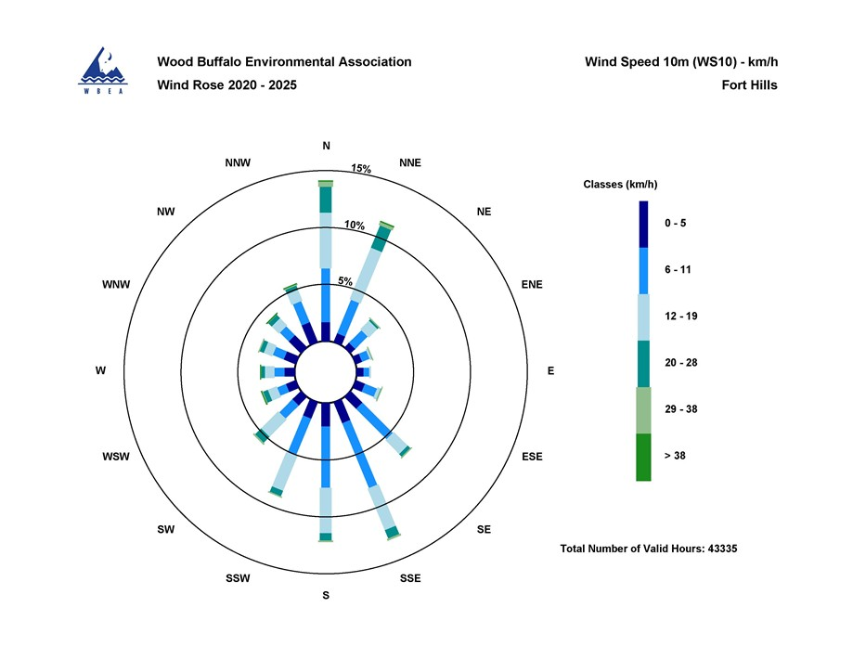

  - Figure 12 – Windrose (2020-2025)

