Wood Buffalo Environmental Association
Ambient Air Monitoring Station
Site Documentation

Janvier

LAST UPDATED: February 19, 2026

Table of Contents
General Site Information 4
Station 4
Location 4
Owner/Operator/Approval Holder 4
Site Description 4
Site Influences 5
Localized Sources (within 20 metres of station) 5
Roadway Influences 5
Major Point Sources 5
Station Equipment 6
Analytical Equipment 6
Meteorological Equipment 6
Support Equipment 6
Site photos 12
Station Photos 17

Tables and Figures
Figure 1 – Area topographic map showing AMS 22 8
Figure 2 – Aerial photo showing AMS 22 9
Figure 3 – Plan view sketch for AMS 22 site 10
Figure 4 – Elevation view image for AMS 22 site 11
Figure 5 – Environment looking North 12
Figure 6 – Environment looking East 13
Figure 7 – Environment looking South 14
Figure 8 – Environment looking West 15
Figure 9 – Meteorological Tower 16
Figure 10 – Photo showing the inlet and sample manifold 17
Figure 11 – Curb shot of the monitoring station 18
Figure 12 –Photo of the front and the back of instrument rack 20
Figure 13 – Windrose (five year) 21

General Site Information
Revision Date: March 28, 2024

Station
Station ID | AMS 22
Station name | Janvier
Date station established | October 2016

Location
Station street address | Block 4; Lot 135 - Adjacent to Nokohoo Road between Teed Ave and Lapouse Ave.
Legal land description | 6-05-80-05-W4
Airshed Zone | Wood Buffalo Environmental Association
Latitude | 55.903242
Longitude | -110.749758
UTM East | 515647
UTM North | 6195323
Nearest community | Janvier
Community population | 437
Census Year | 2021

Owner/Operator/Approval Holder
Operating Agency | Wood Buffalo Environmental Association
Address of Operating Agency | Unit 3-805 Memorial Drive, Fort McMurray, Alberta T9K 0K4
Name of Approval Holder | NA
Approval number | NA
Contact Name | Wood Buffalo Environmental Association
Address | Unit 3-805 Memorial Drive, Fort McMurray, Alberta T9K 0K4
Phone number | 780-799-4420
Email address | info@wbea.org

Site Description
Land use by sector | 0 – 90 degrees | Trees
Land use by sector | 91 – 180 degrees | Main road
Land use by sector | 181 – 270 degrees | Main road
Land use by sector | 271 – 360 degrees | Trees and House
Site elevation (m)  (above sea level) | 471
Angle of elevation to nearby buildings | Greatest angle | 10°
Angle of elevation to nearby buildings | Building direction | SE
Airflow restrictions | North | None
Airflow restrictions | East | None
Airflow restrictions | South | None
Airflow restrictions | West | Trees (45 m from station, 17 m high)
Distance to nearest trees (m) | North | 80 m from station, 17 m high
Distance to nearest trees (m) | East | 80 m from station, 15 m high
Distance to nearest trees (m) | West | 45 m from station, 17 m high
Distance to nearest trees (m) | South | None
Sample manifold | Type | All glass
Sample manifold | Inlet height above roof | 1 metre
Wind Sensors | Type | Cup and vane
Wind Sensors | Height above ground (m) | 20 m
Wind Sensors | Distance from station (m) | 2 m

Site Influences

Localized Sources (within 20 metres of station)
Type | Distance (m) | Description
Vehicles | 20 m west | Gravel road

Roadway Influences
Type | Traffic Volume | Distance (m) | Description
Main access road | low | 25 m | Paved

Major Point Sources
Facility Name | Source Type | Distance from site (km) | Compass direction from site
ConocoPhillips | SAGD | 33.38 | NW
Tervita | Landfill | 11 kms | NW

Station Equipment
Equipment Owner: WBEA

Analytical Equipment
Parameter | Make | Model | Serial Number | Date Instrument Installed | WBEA Data Start Date
Continuous
SO₂ | Thermo Scientific | 43i | 1152430006 | 2016 | January, 2017
TRS | Thermo Scientific | 43i-TLE | 1200326169 | 2023 | January, 2017
NO/NO_{x}/NO₂ | Thermo Scientific | 42i | 1229254994 | 2025 | January, 2017
THC/CH₄/NMHC | Thermo Scientific | 55i | 1317958219 | 2024 | January, 2017
O₃ | Thermo Scientific | 49i | 1227254861 | 2025 | January, 2017
PM _{2.5} | Teledyne/API | T640 | 325 | 2018 | January, 2017
Time-Integrated
PM _{2.5} A | Thermo Scientific | 2000i | 2000i 20388 1308 | 2019 | -
PM _{2.5} B | Thermo Scientific | 2000i | 2000i 20489 1408 | 2019 | -
PM₁₀ A | Thermo Scientific | 2000i | 2000i 20523 1411 | 2020 | -
PM₁₀ B | Thermo Scientific | 2000i | 2000i 20383 1308 | 2020 | -
PAH | Tisch | TE-PUFPLUSBL | 1001108 | 2021 | -
VOC | Tisch | TE-123 | 1018 | 2021 | -
Dustfall | Advantage Manufacturing | - | - | 2022 | -

Meteorological Equipment
Parameter | Make | Model | Serial Number | WMO Site Class | Date Sensor Installed | WBEA Data Start Date
AT/RH | Vaisala | HMP155 | G4330042 | Class 3 | 2018 | January, 2016
WS 20m | Met One | 010C-1 | J4337 | Class 3 | 2025 | October, 2021
WD 20m | Met One | 020C-1 | Y5194 | Class 3 | 2025 | October, 2021

Support Equipment
Name | Description | Make | Model | Serial Number
Datalogger | Datalogger | Campbell Scientific | CR3000 | 2586
Gas Dilution Calibrator | Dynamic dilution calibrator | Teledyne/API | T700 | 3806
Zero air generator | Zero Air Generator | Teledyne/API | T701 | 691
TRS converter | Thermal oxidizer | CD Nova | CDN-101 | 620
Shelter / Building | Air monitoring portable | ITB | 8 x 16 trailer | ITB-15-16494
HVAC | Heating and air conditioning system. Wall mount unit | BARD | 1 ton | 314P143189505-02
Deck | 10x20 | NA | NA | NA

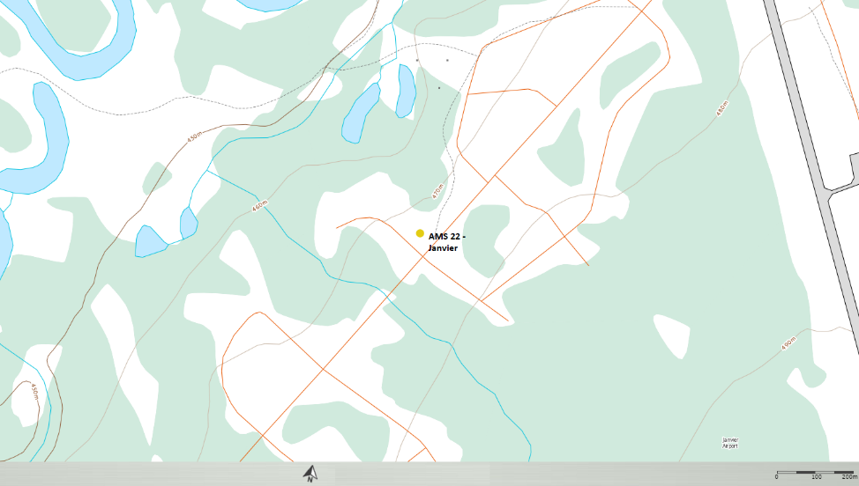
  - Figure 1 – Area topographic map showing AMS 22

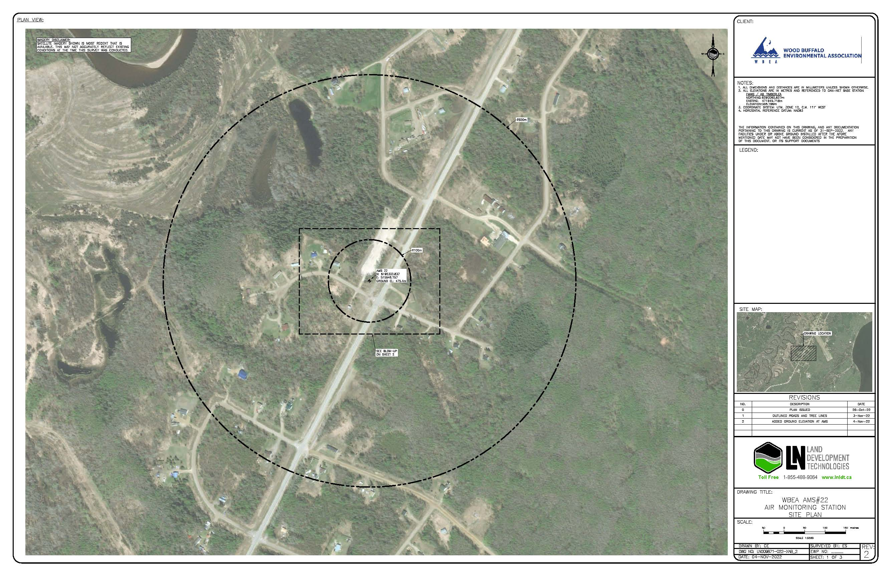
  - Figure 2 – Aerial photo showing AMS 22

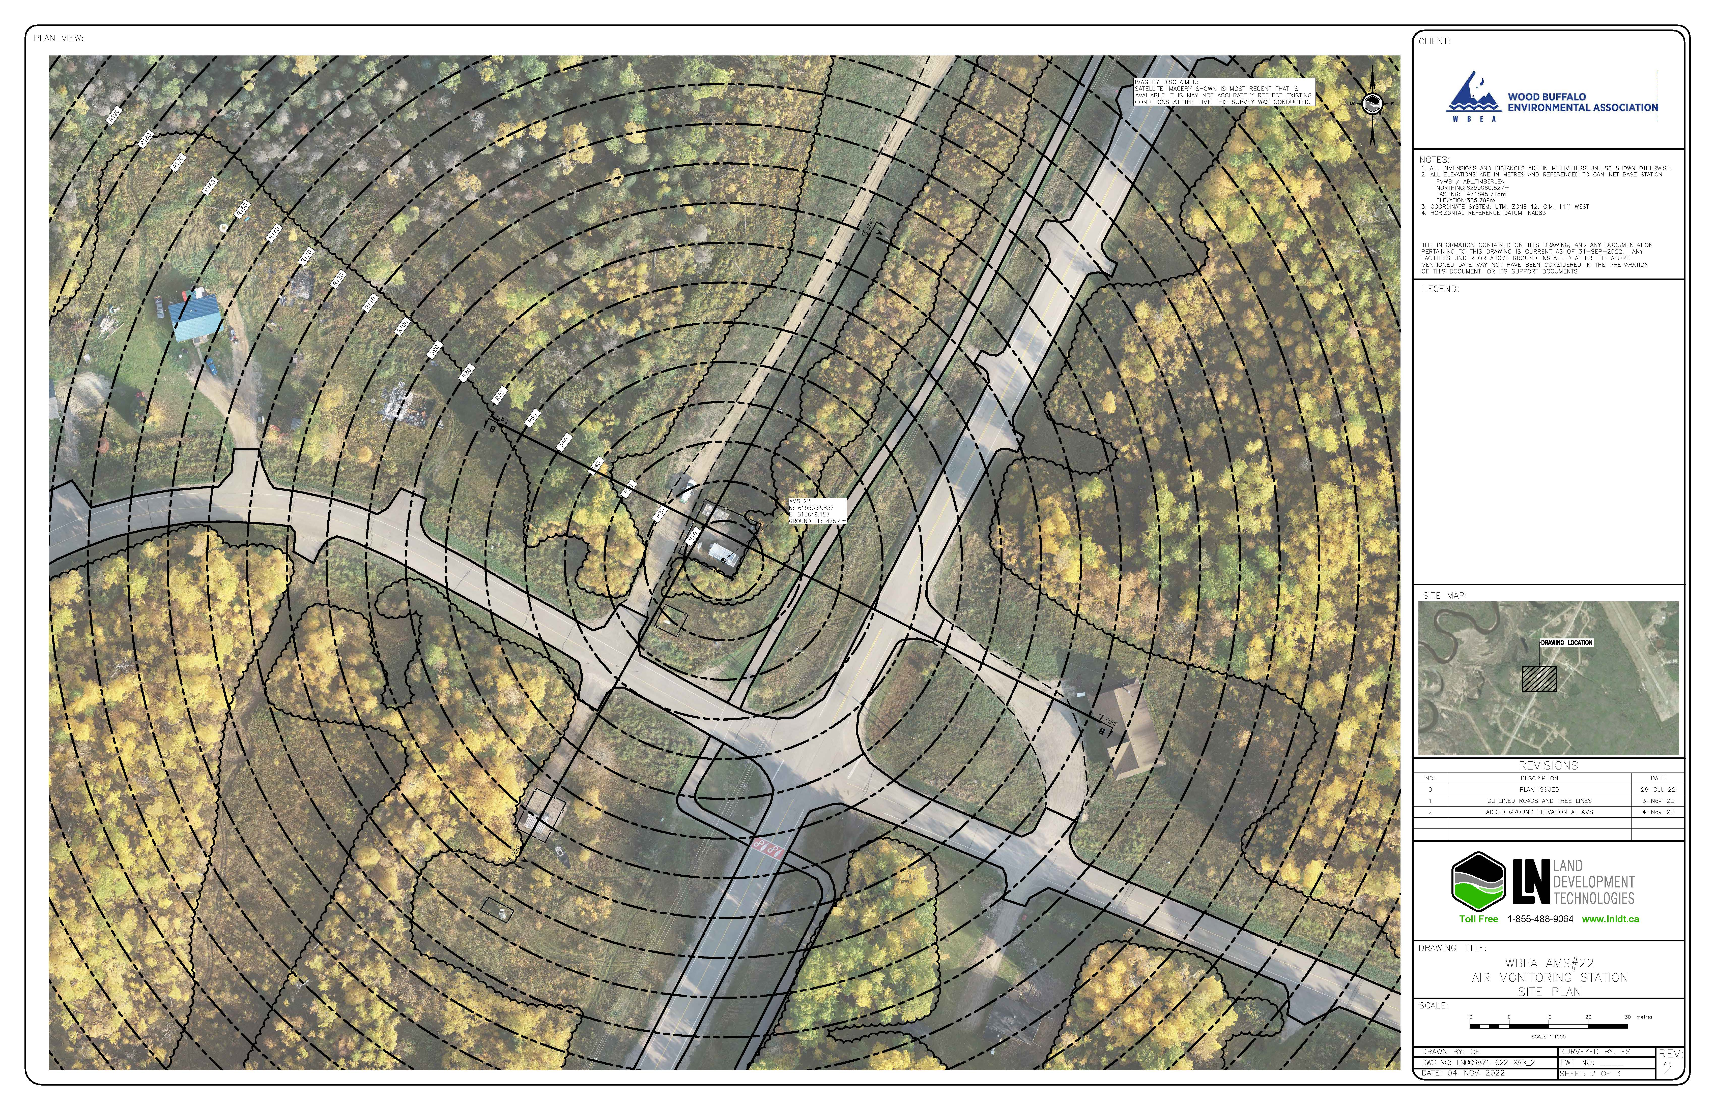
  - Figure 3 – Plan view sketch for AMS 22 site

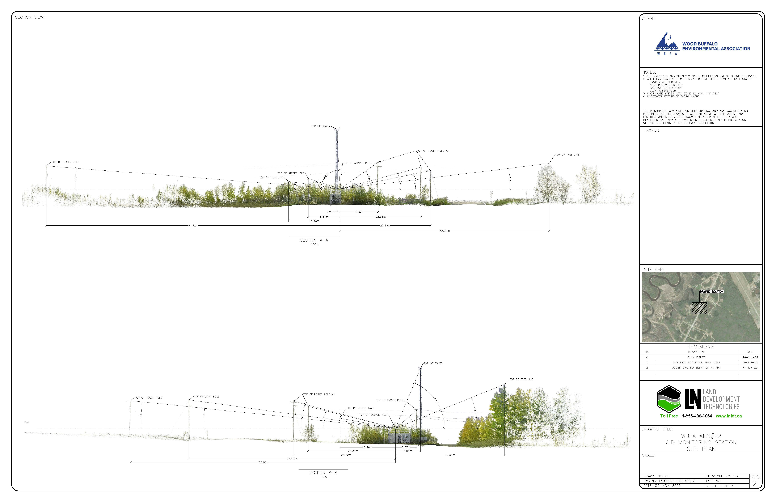
  - Figure 4 – Elevation view image for AMS 22 site

Site photos
The following photos show the environment surrounding the monitoring station.

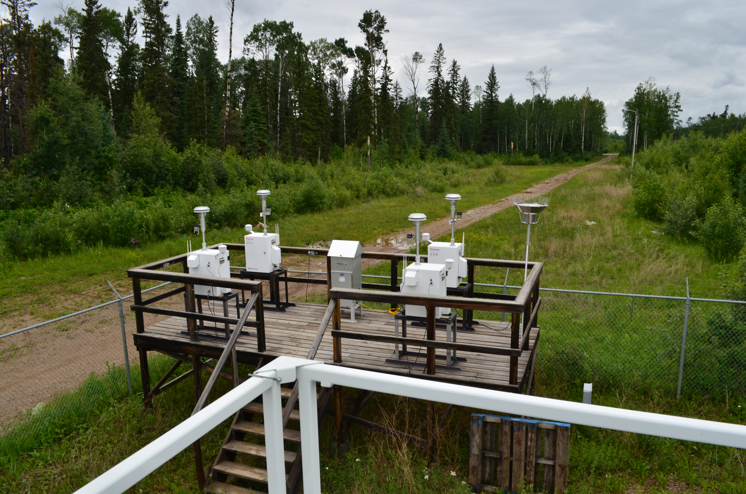
  - Figure 5 – Environment looking North

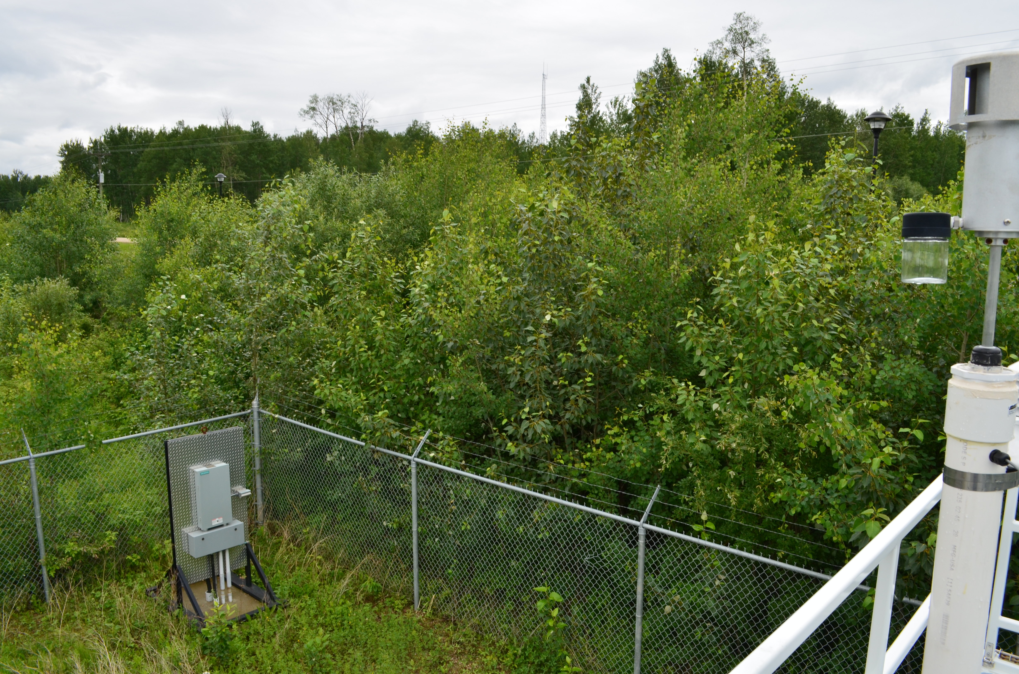
  - Figure 6 – Environment looking East

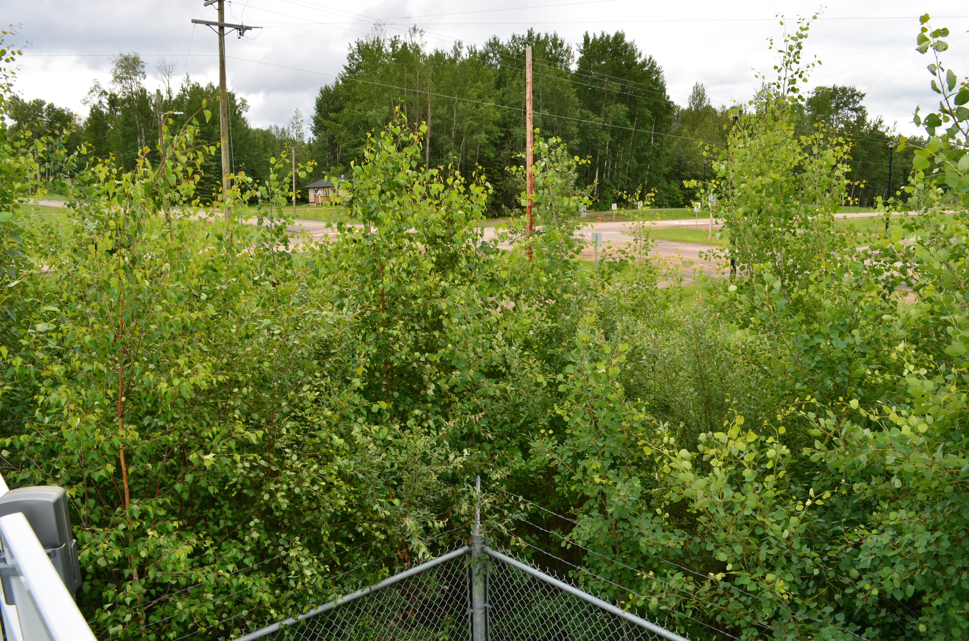
  - Figure 7 – Environment looking South

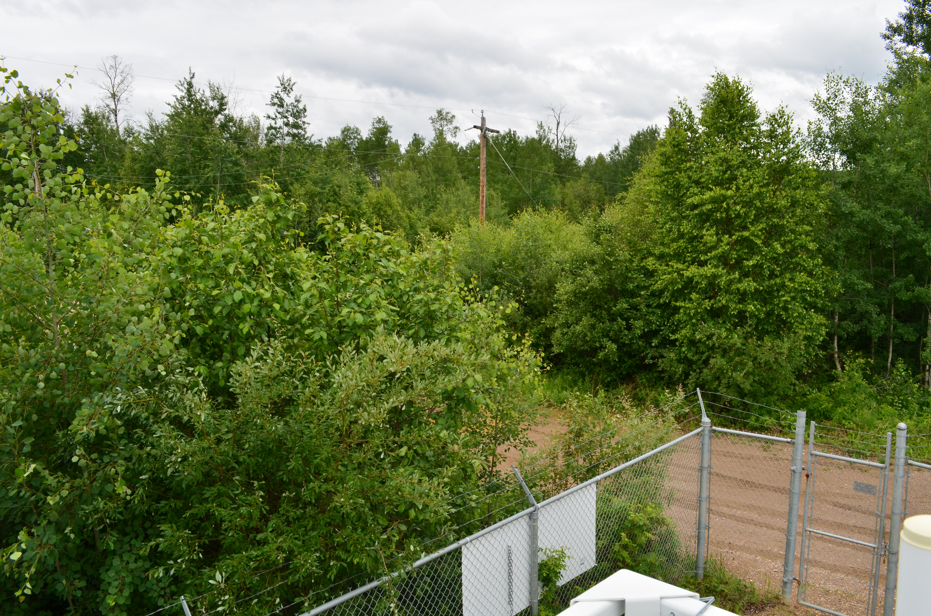
  - Figure 8 – Environment looking West

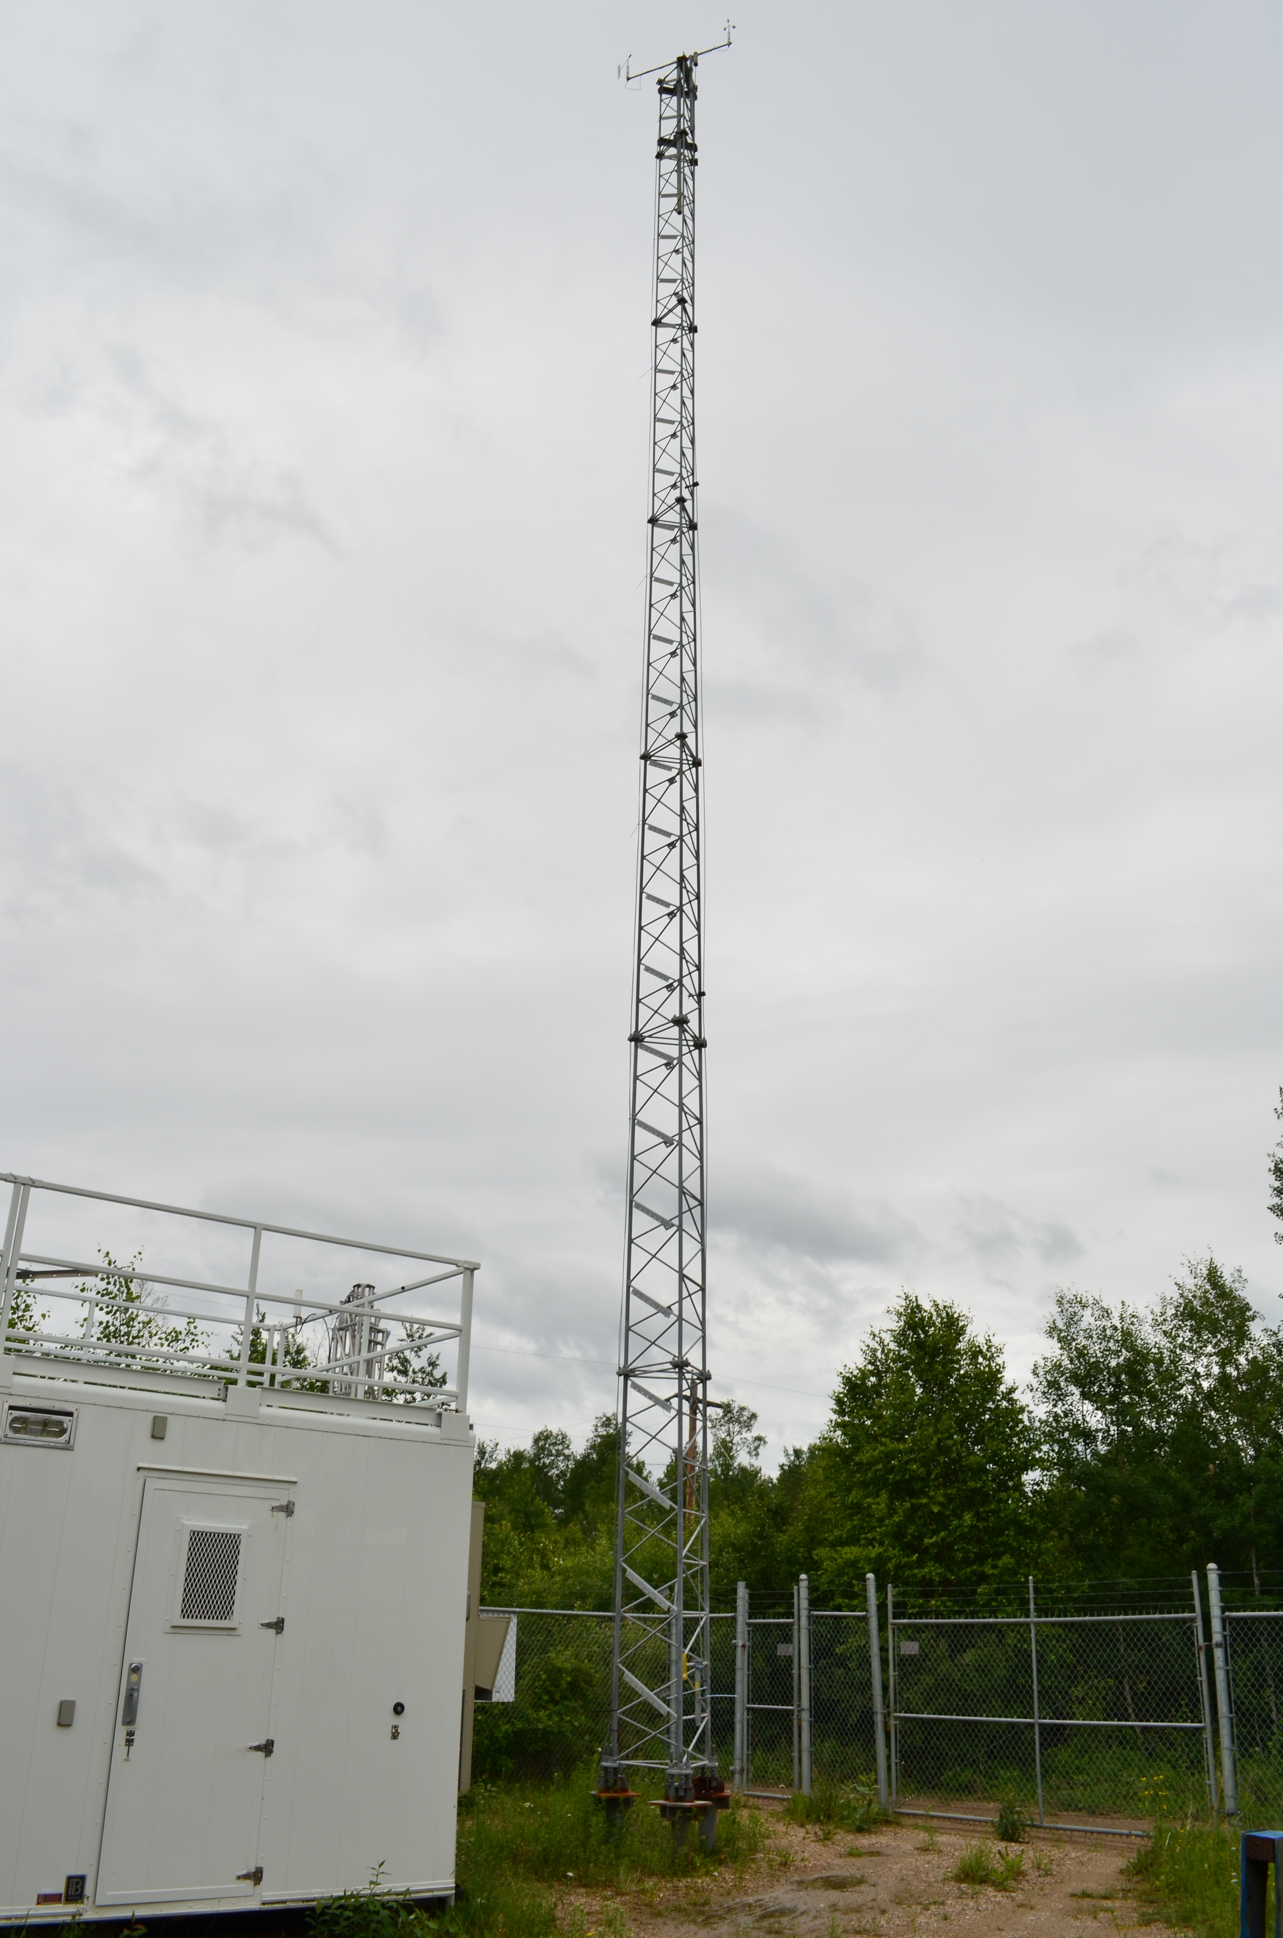
  - Figure 9 – Meteorological Tower

Station Photos
The following photos show the monitoring station and instrumentation.
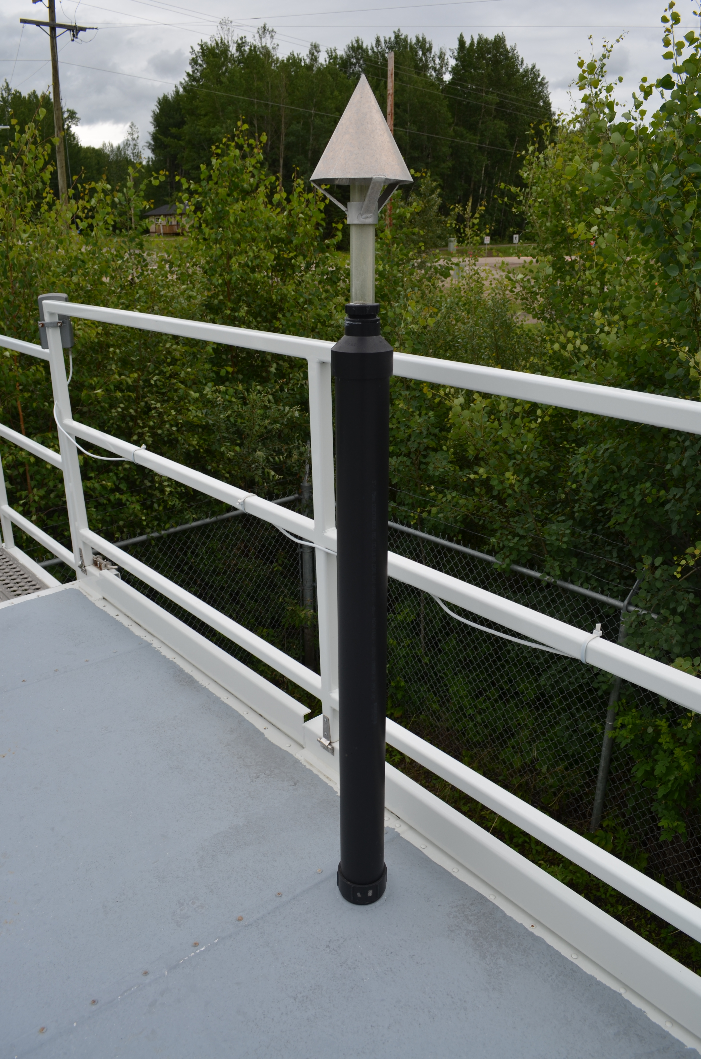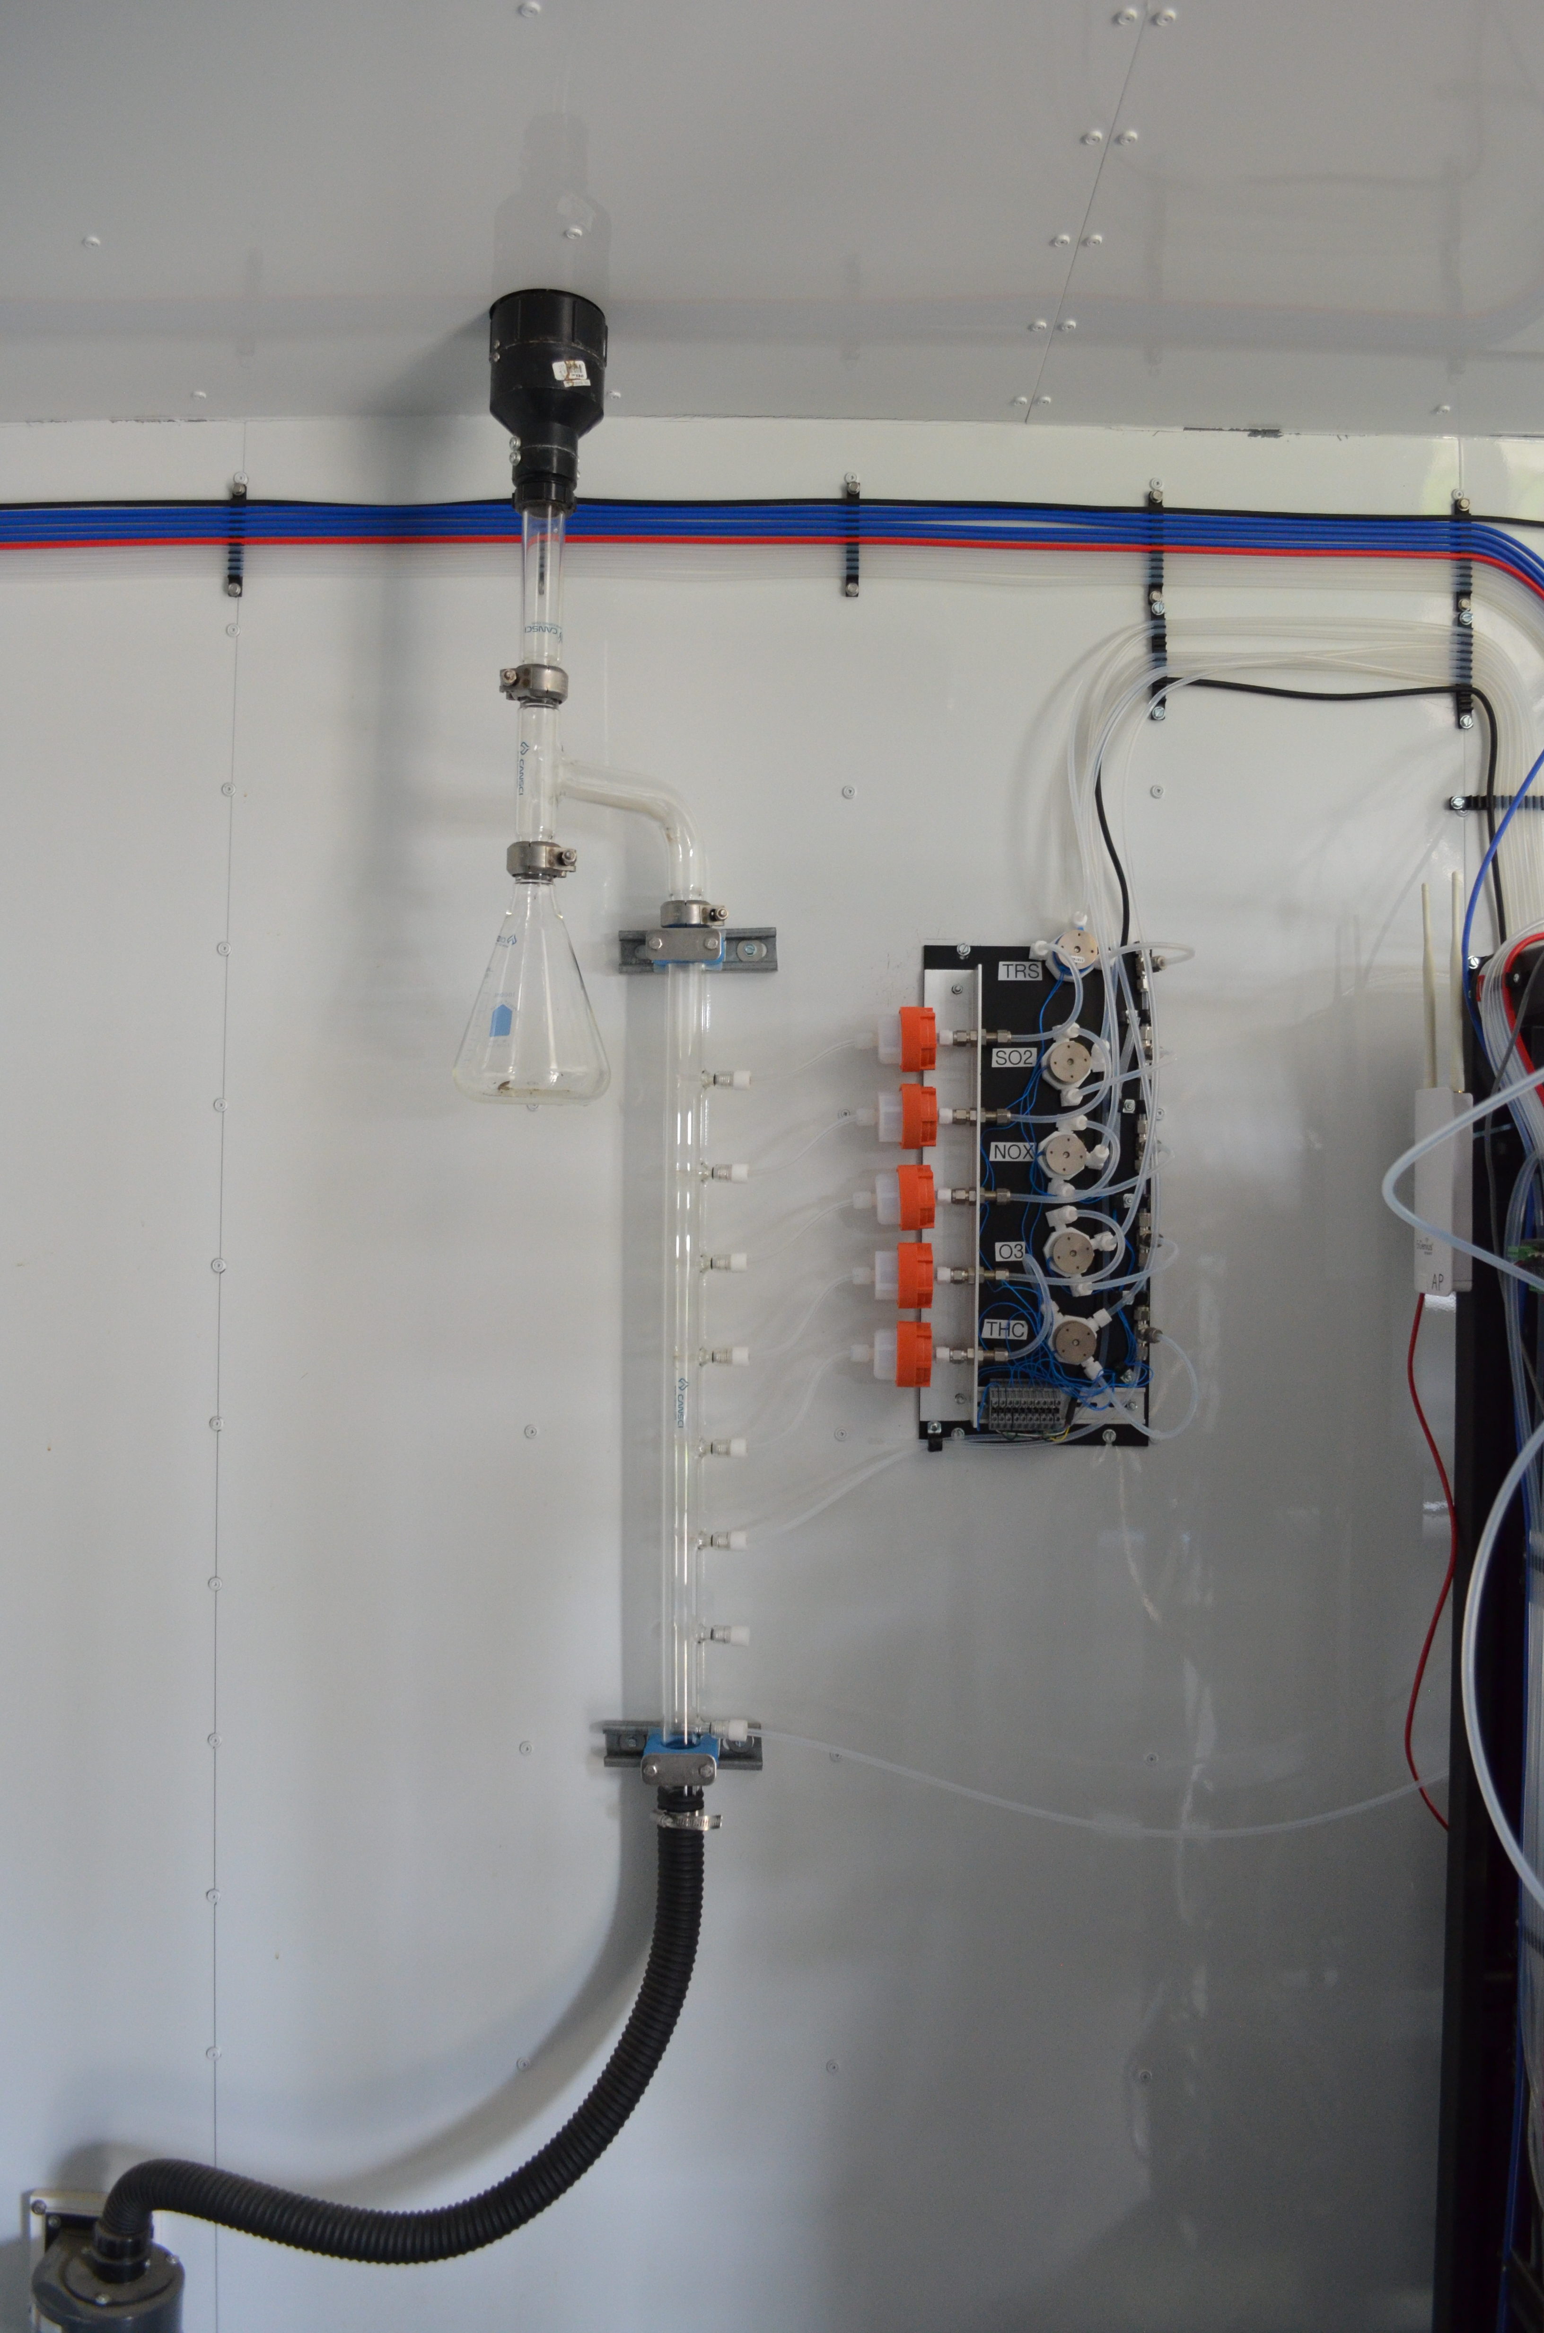
  - Figure 10 – Photo showing the inlet and sample manifold

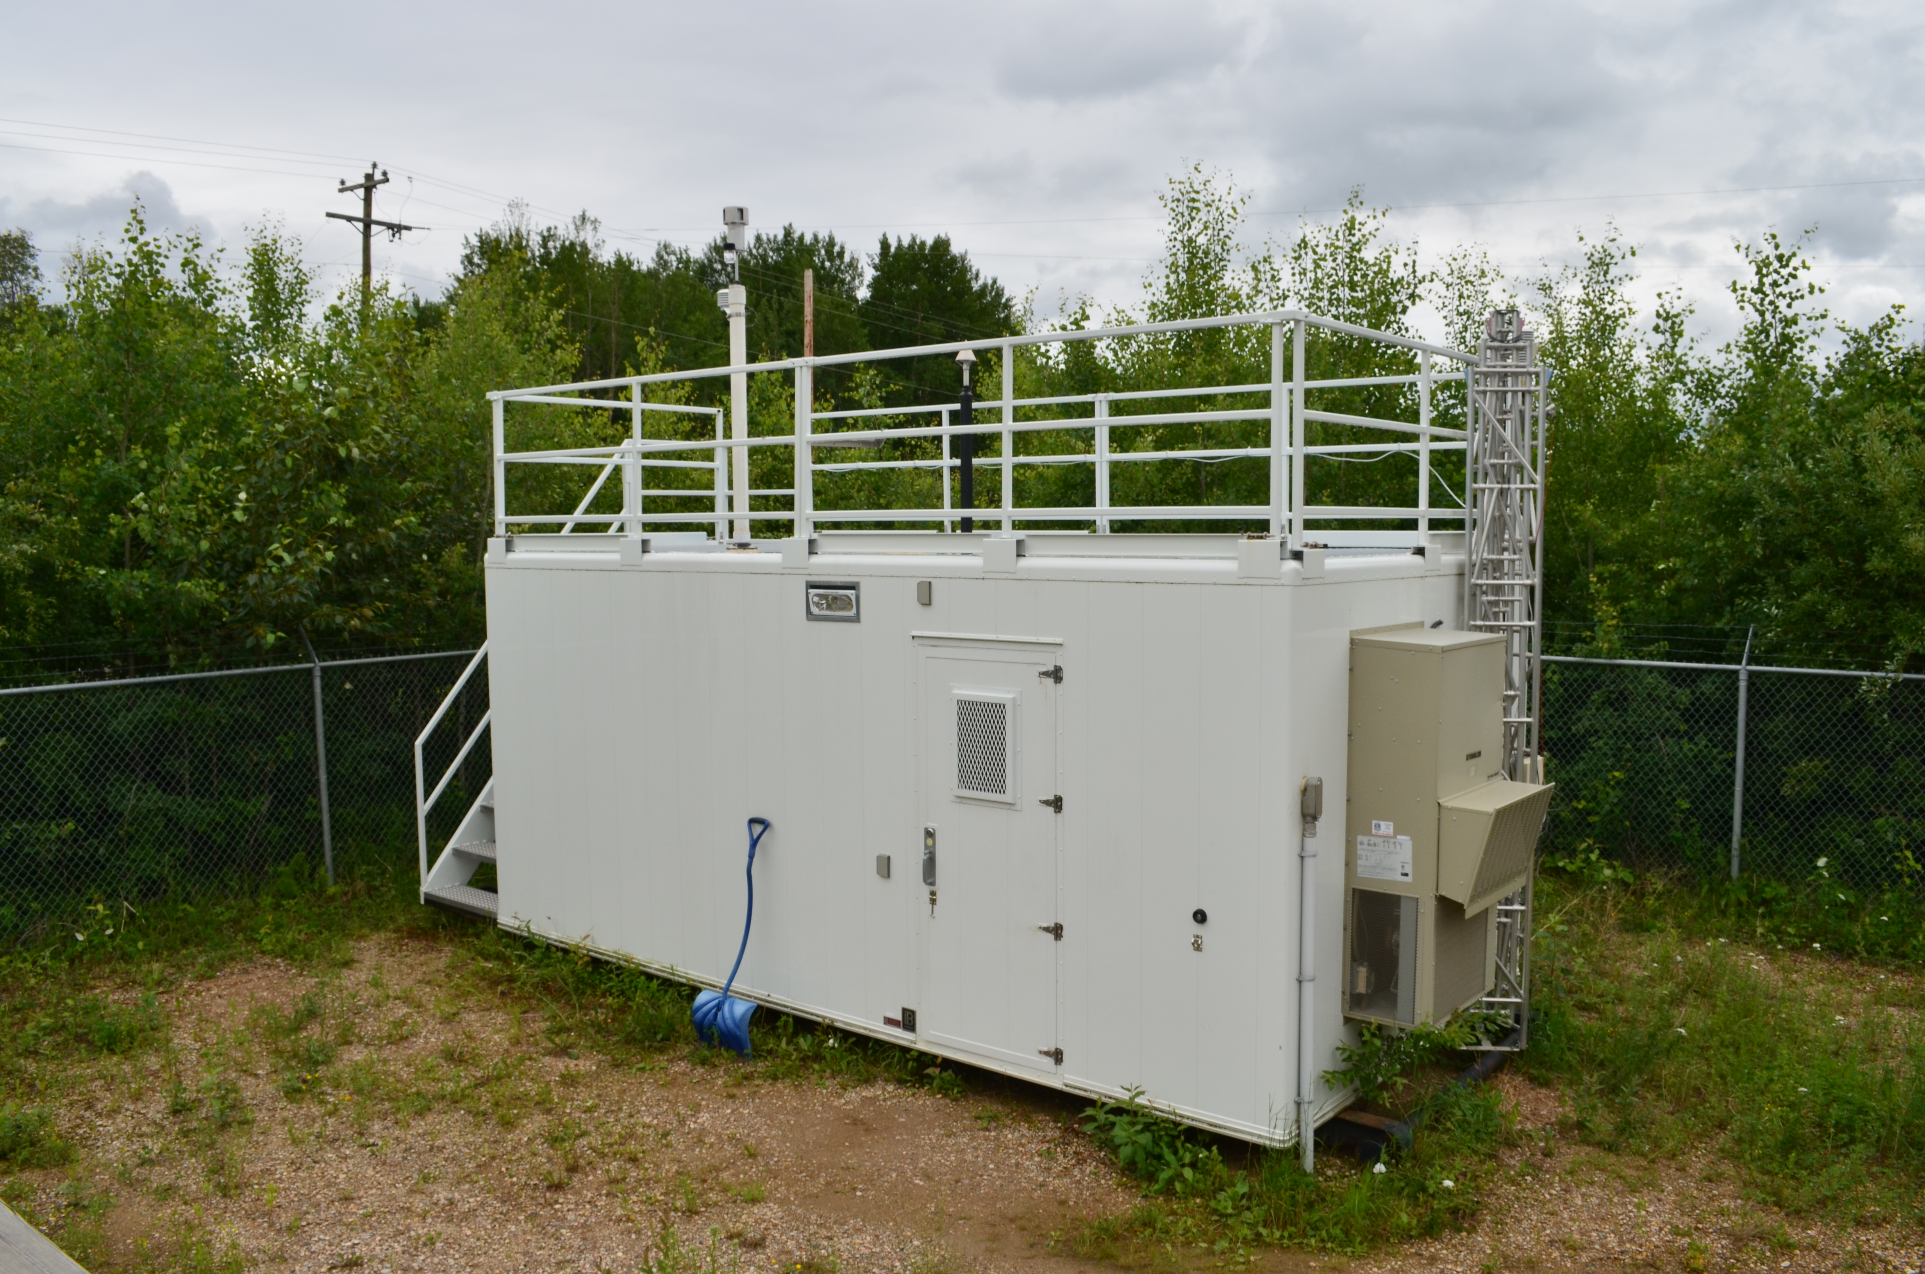
  - Figure 11 – Curb shot of the monitoring station

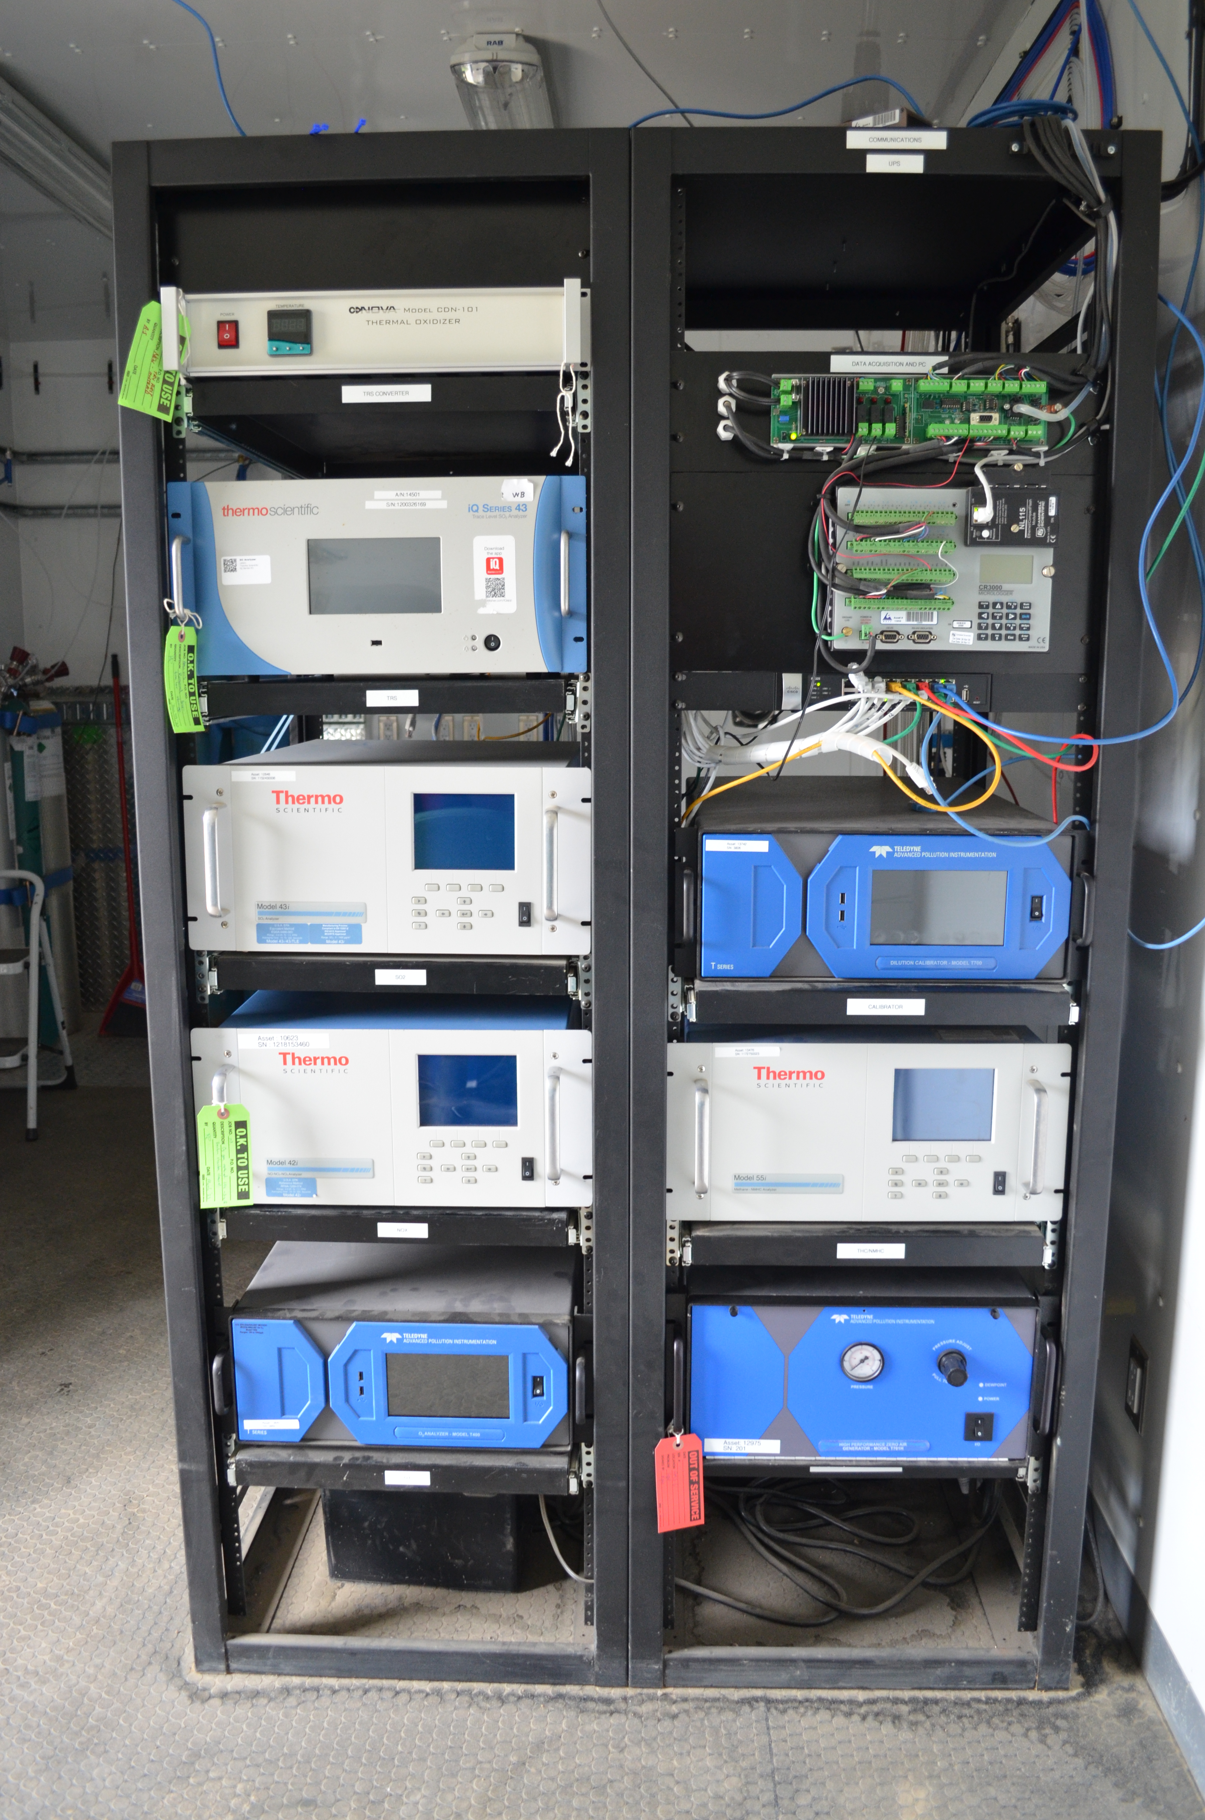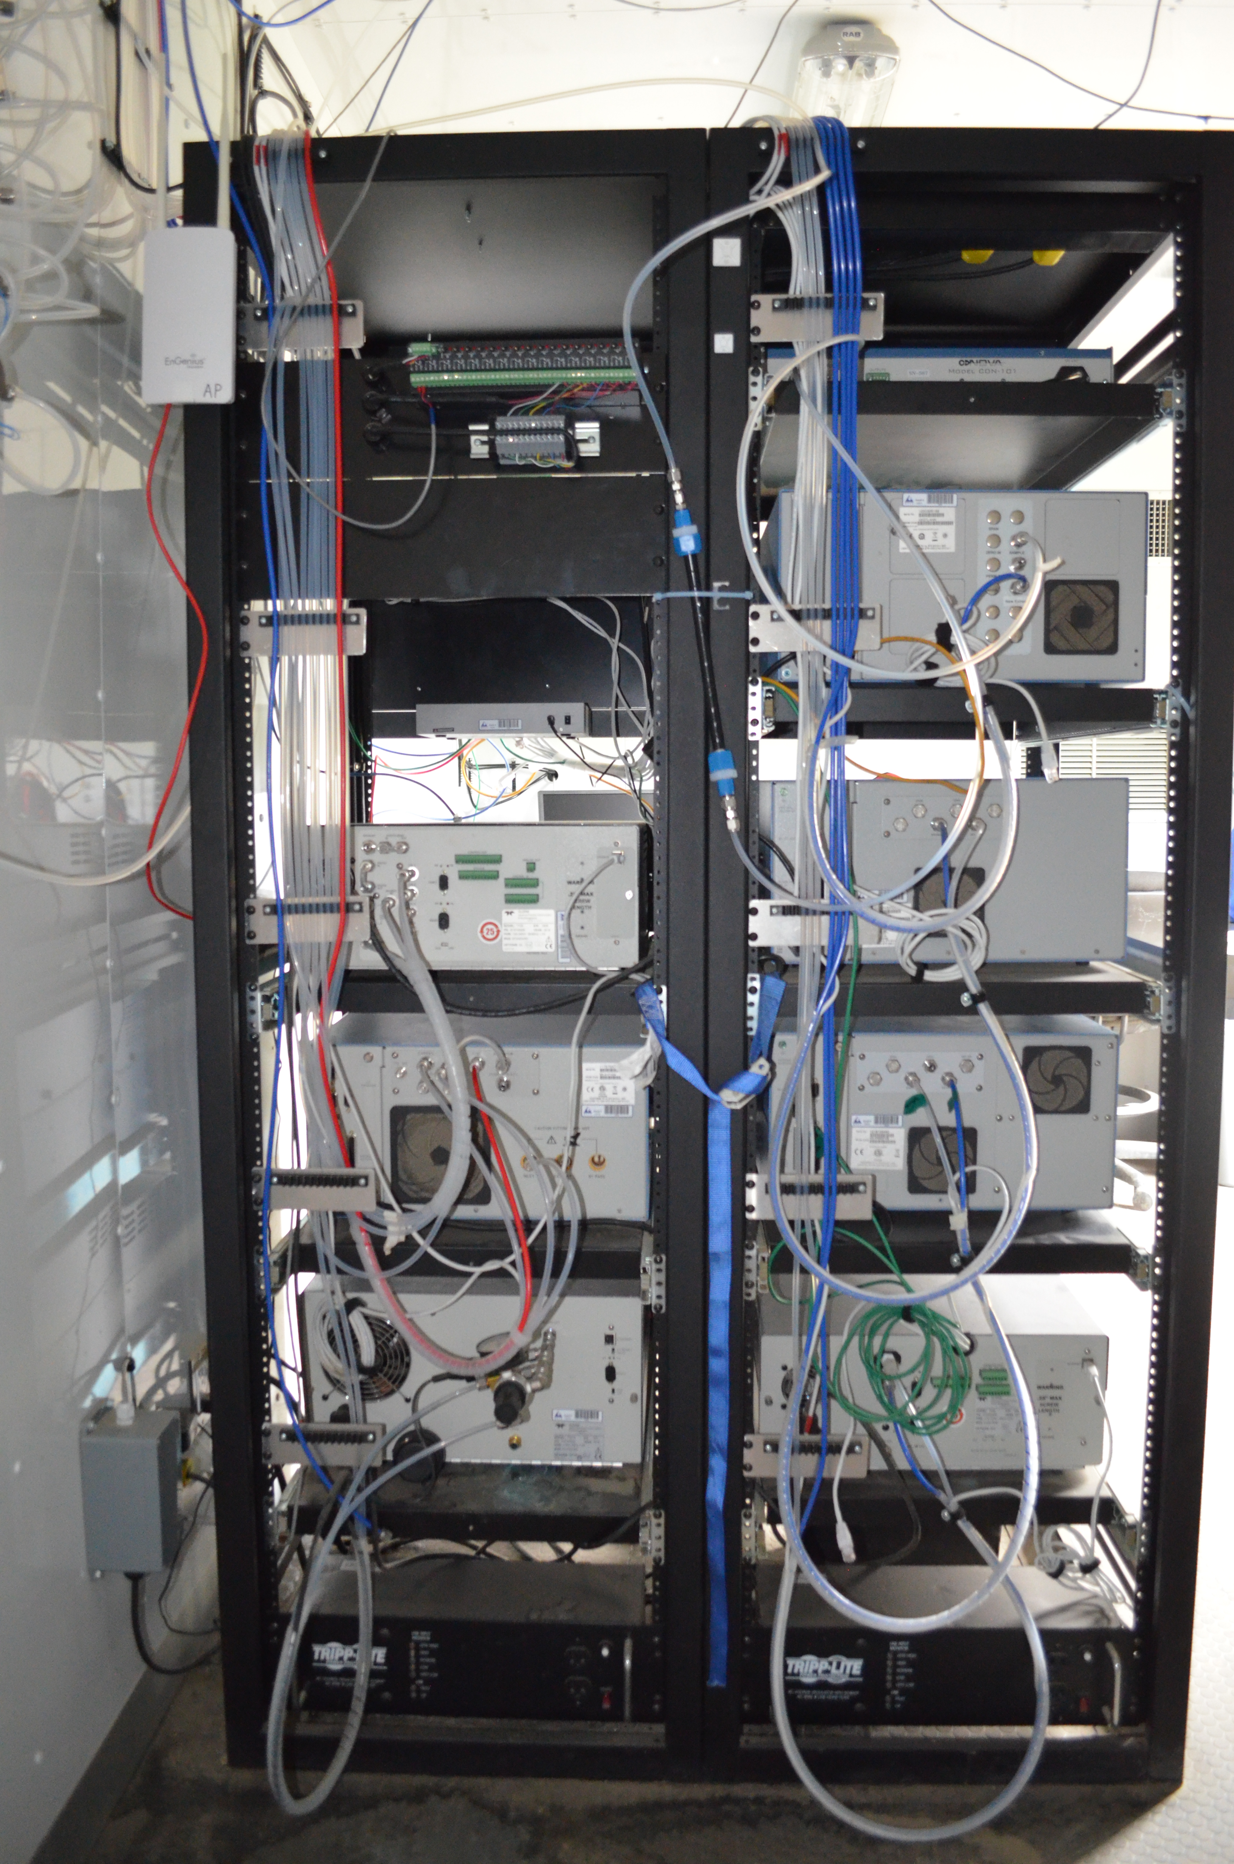
  - Figure 12 -Photo of the front and the back of the instrument rack

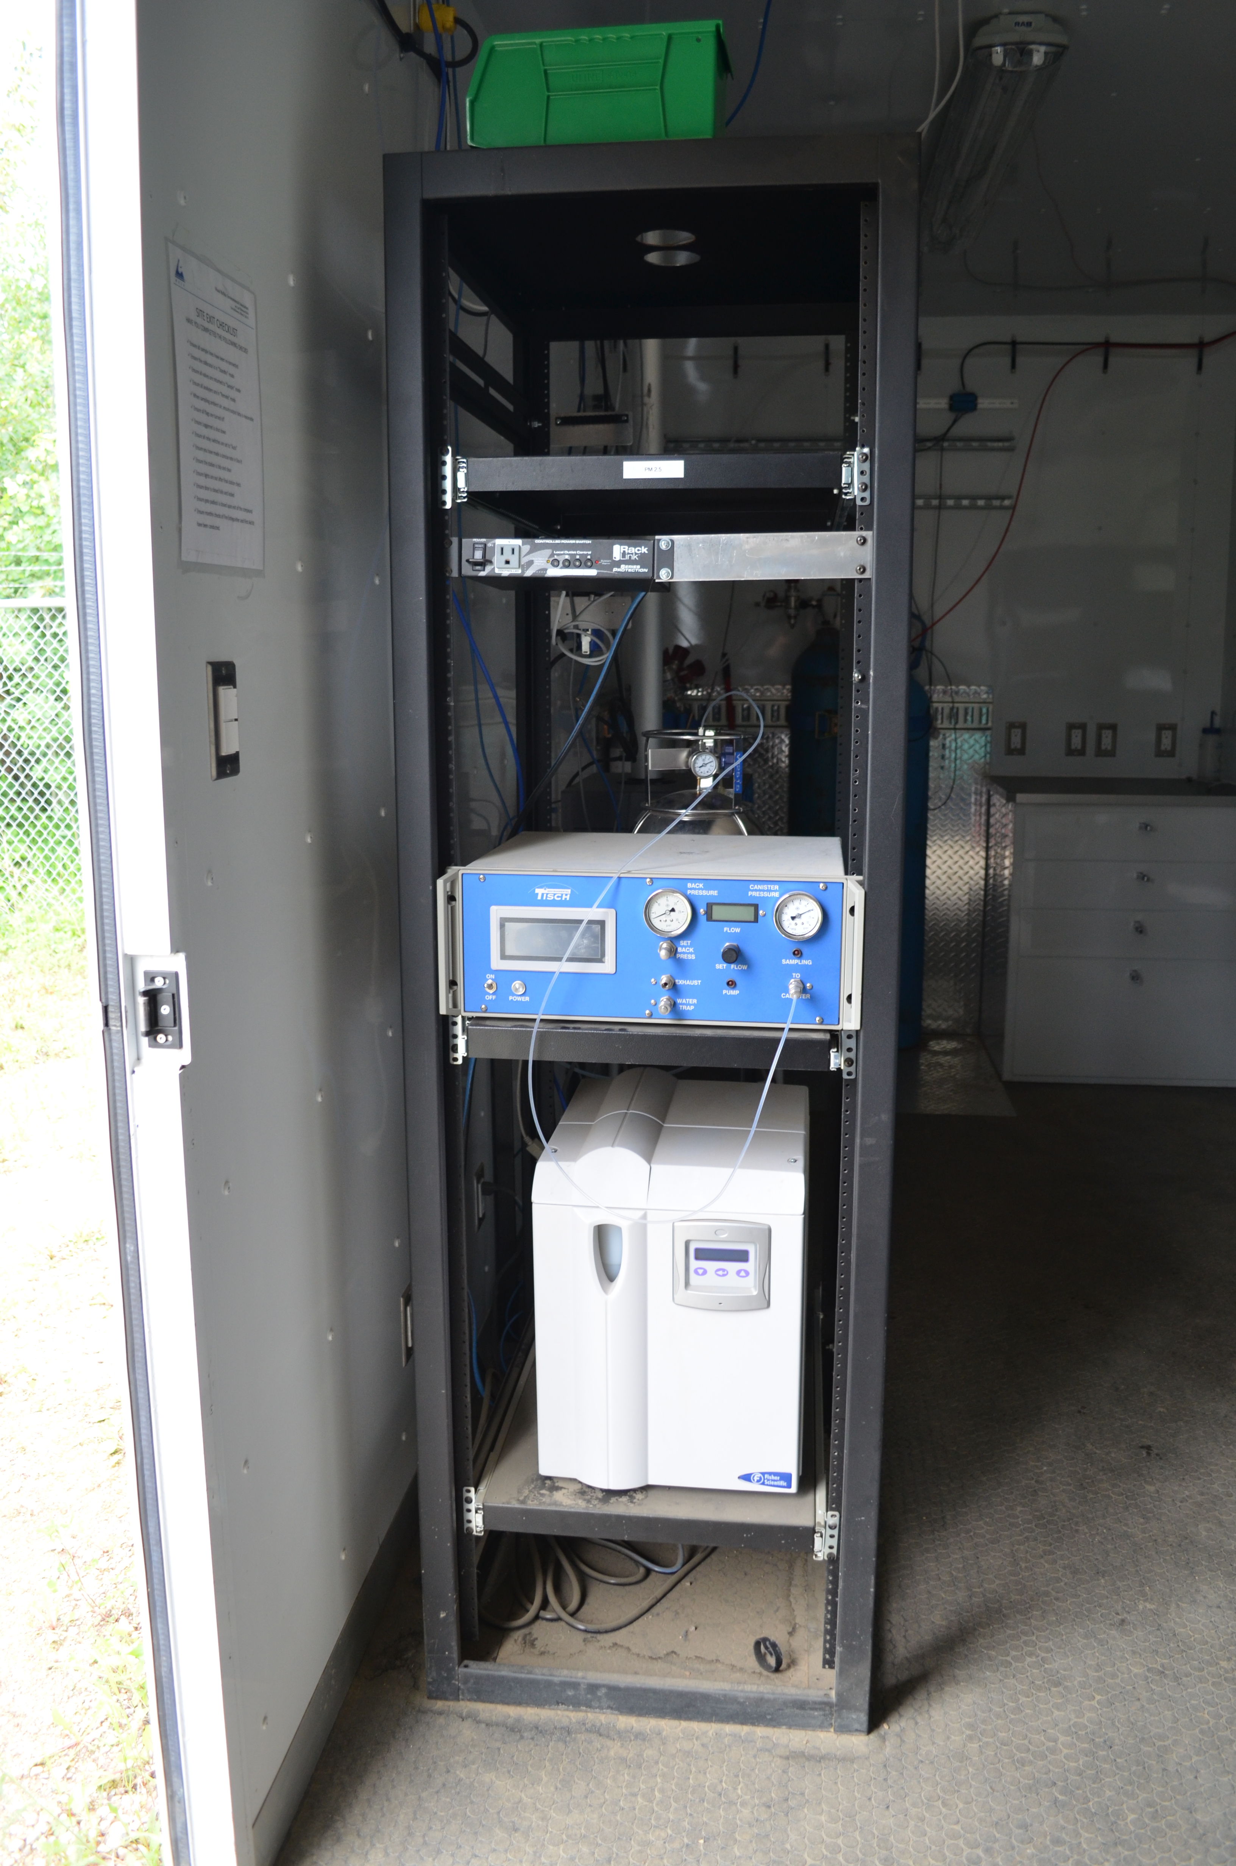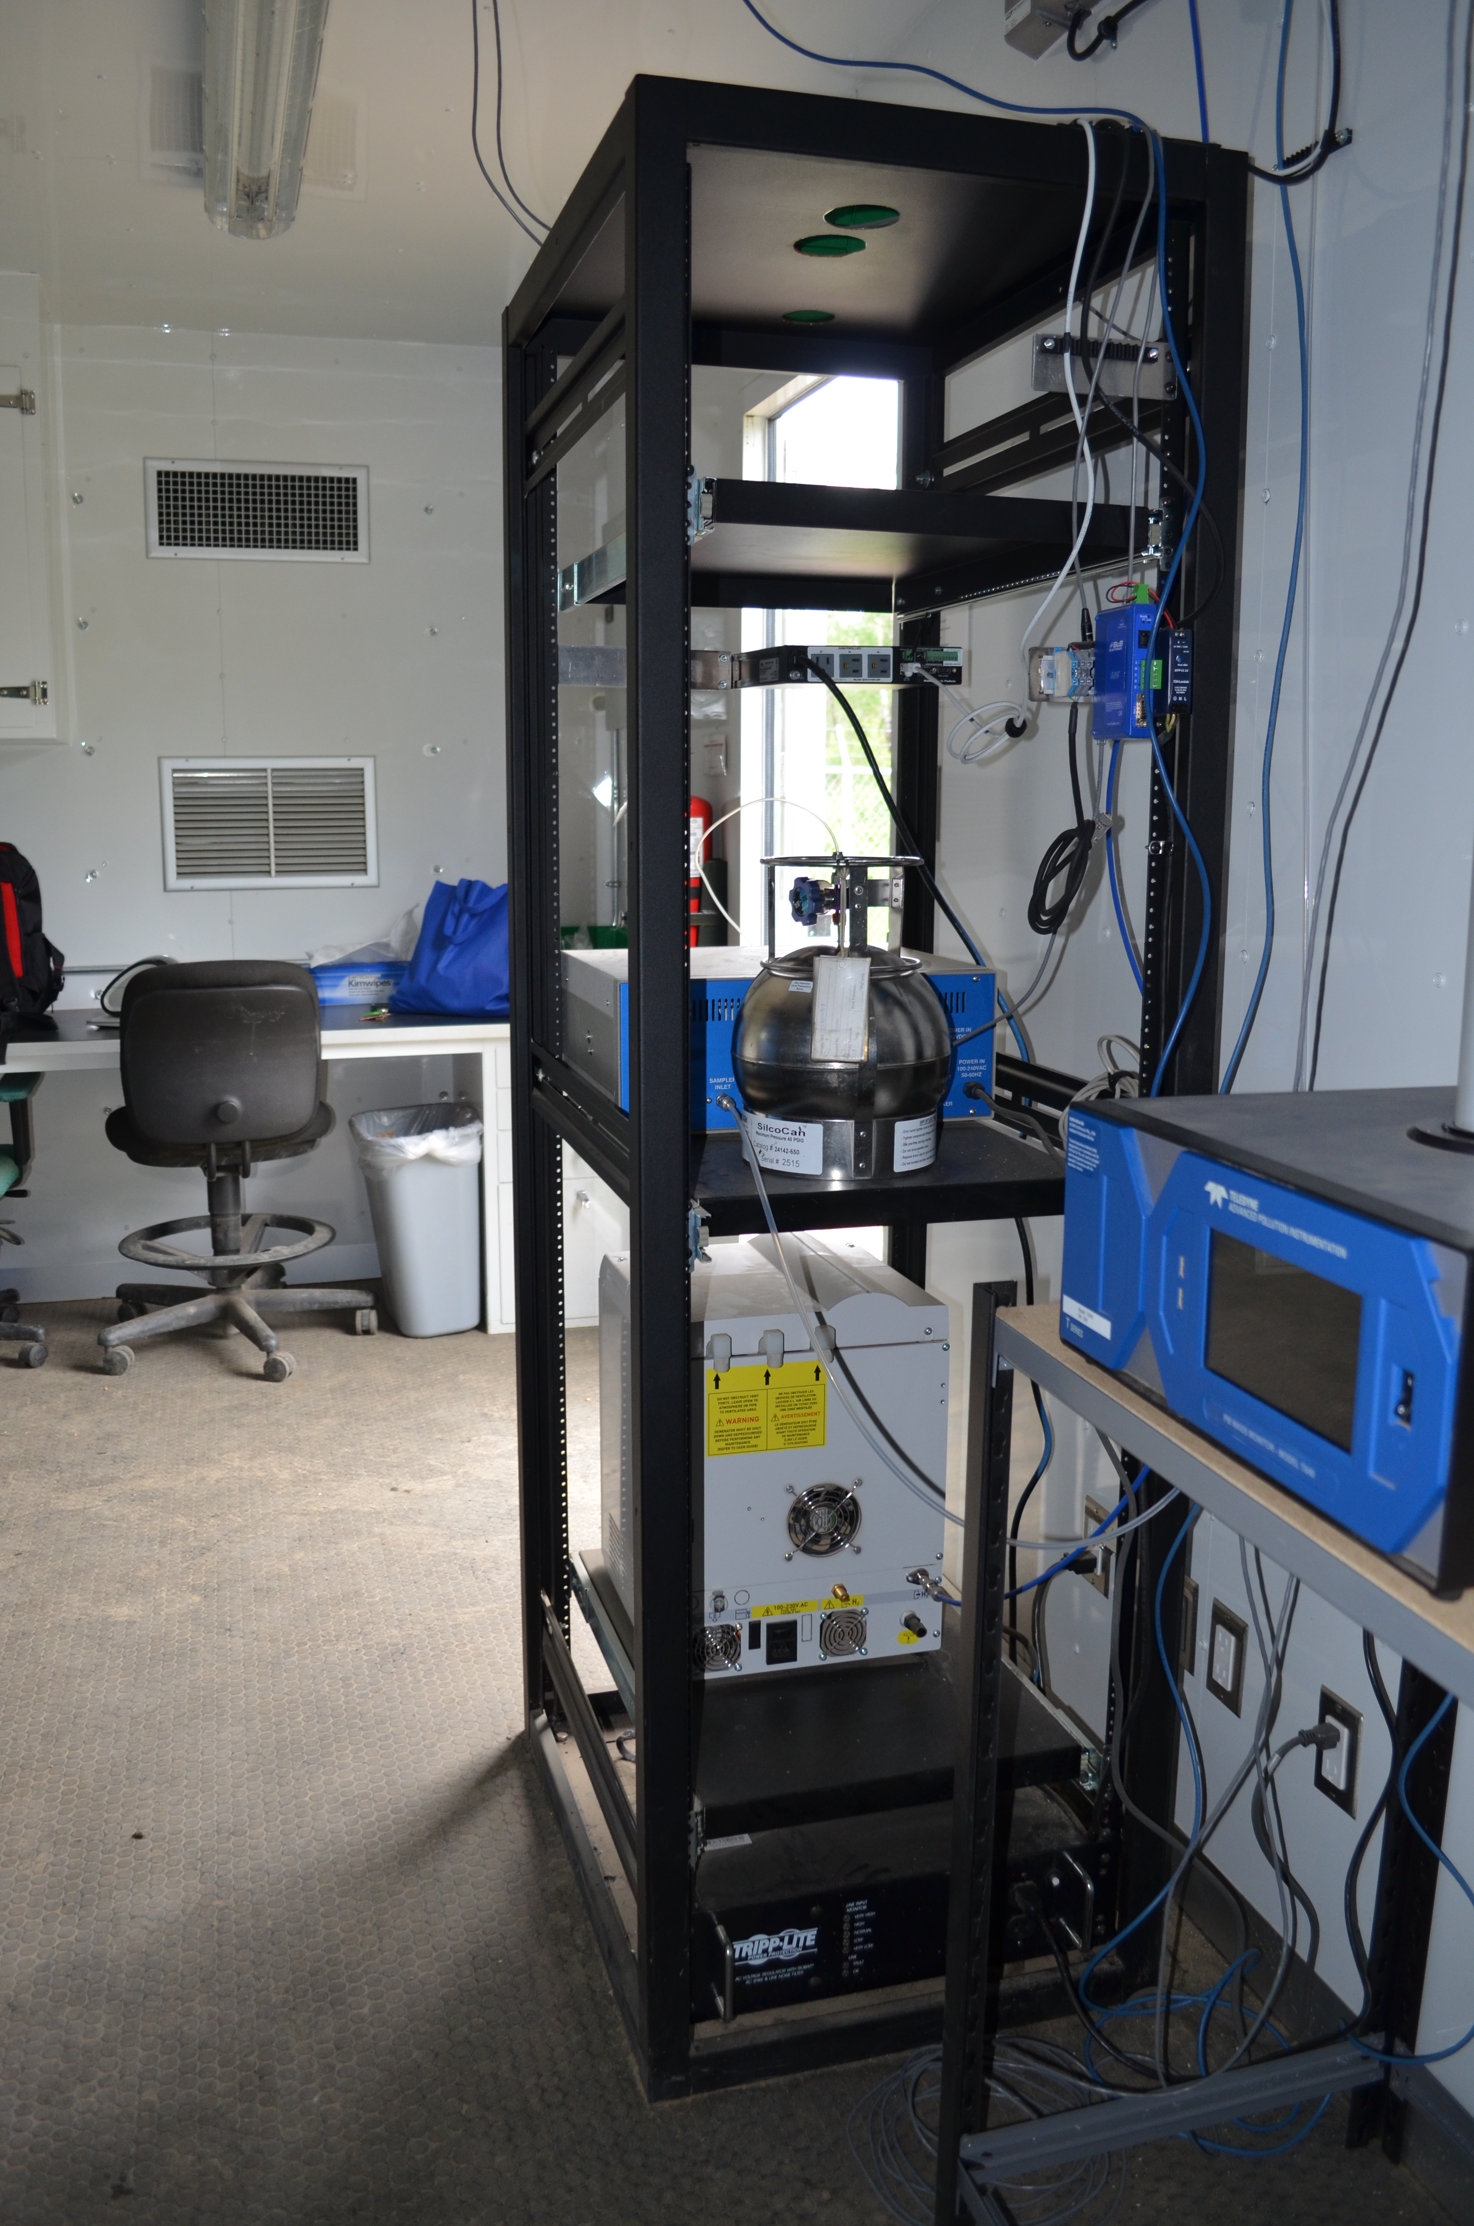
  - Figure 13 –Photo of the front and the back of instrument rack
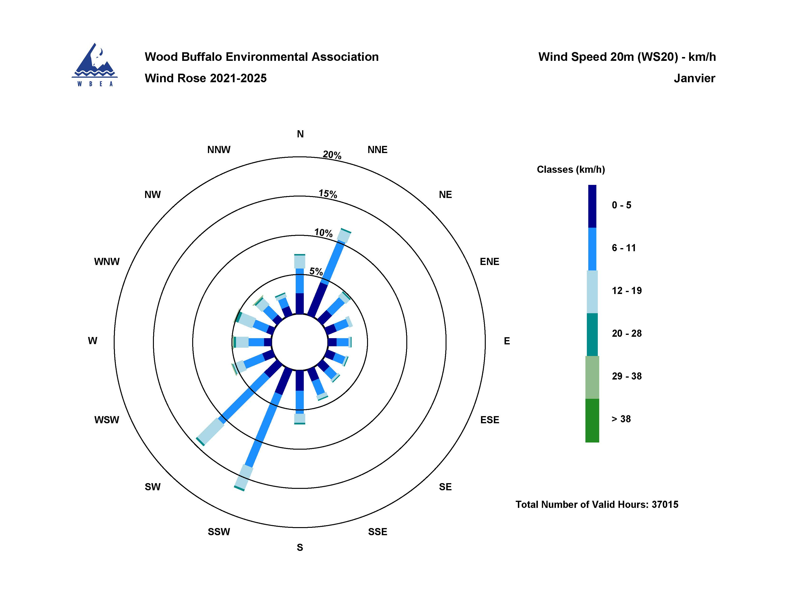
  - Figure 14 – Windrose (five year)

