Wood Buffalo Environmental Association
Ambient Air Monitoring Station
Site Documentation

Conklin

LAST UPDATED: March 02, 2026

Table of Contents
General Site Information 4
Station 4
Location 4
Owner/Operator/Approval Holder 4
Site Description 4
Site Influences 5
Localized Sources (within 20 metres of station) 5
Roadway Influences 5
Major Point Sources 5
Station Equipment 6
Analytical Equipment 6
Meteorolgical Equipment 6
Support Equipment 7
Site photos 12
Station Photos 17

Tables and Figures
Figure 1 – Area Topographic map showing AMS 21 8
Figure 2 – Plan view sketch for AMS 21 site 9
Figure 3 – Aerial photo showing AMS 21 10
Figure 5 – Environment Looking North 12
Figure 6 – Environment Looking East 13
Figure 7 – Environment looking South 14
Figure 8 – Environment Looking West 15
Figure 9 – Meteorological Tower 16
Figure 10 – Photo showing the inlet and sample manifold. 17
Figure 11 – Curb shot of the monitoring station. 18
Figure 12 –Photo of front and back of instrument rack 19
Figure 13 – Windrose (2021-2025) 20

General Site Information
Revision Date: March 28, 2024

Station
Station ID | AMS 21
Station name | Conklin
Date station established | April 01, 2016

Location
Station street address | Father Mercredis Trail
Legal land description | 15-31-076-07 W4
Latitude | 55.632330
Longitude | -111.078877
UTM East | 495034
UTM North | 6165163
Elevation | 559.9
Nearest community | Conklin
Community population | 185
Census Year | 2016

Owner/Operator/Approval Holder
Operating Agency | Wood Buffalo Environmental Association
Name of Approval Holder | NA
Approval number | NA
Contact Name | Wood Buffalo Environmental Association
Address | Unit 3 – 805 Memorial Drive, Fort McMurray, AB
Phone number | 780-799-4420
Email address | info@wbea.org

Site Description
Land use by sector | 0 – 90 degrees | Forest and Residential
Land use by sector | 91 – 180 degrees | Forest and Residential
Land use by sector | 181 – 270 degrees | Forest and Residential
Land use by sector | 271 – 360 degrees | Forest and Residential
Site elevation  (above sea level) | 562
Angle of elevation to nearby buildings | Greatest angle | 0 degree
Angle of elevation to nearby buildings | Building direction | South – CRDAC office
Airflow restrictions | North | Trees
Airflow restrictions | East | None
Airflow restrictions | South | None
Airflow restrictions | West | Conklin Rec center, about 2 km west
Sample manifold | Type | All glass
Sample manifold | Inlet height above roof | 1 meter
Wind Sensors | Type | Cup and vane
Wind Sensors | Height above ground | 10 m
Wind Sensors | Distance from station | Attached to north site of the station

Site Influences

Localized Sources (within 20 metres of station)
Type | Distance (m) | Description
Wetlands | 20 | Peat bog / Marshes – Variety of reeds and grasses.
Admin building | 20 | Conklin Resource Development Advisory Committee Office
Shipping Container | 20 | SEA-CAN
Free-Standing Structure | 20 | Gazebo – made of wood.
Watercraft | 20 | Speed Boat

Roadway Influences
Type | Traffic Volume | Distance (m) | Description
Gravel | Medium | 50 | Father Mercredis Trail – Access Road
Paved | Medium | 200 | Northland Drive

Major Point Sources
Facility Name | Source Type | Distance from site (km) | Compass direction from site
Meg Energy | Oil and Gas | 25 | NE
Cenovus Energy | Oil and Gas | 14 | SE

Station Equipment
Equipment Owner: WBEA

Analytical Equipment
Parameter | Make | Model | Serial Number | Date Instrument Installed | WBEA Data Start Date
Continuous
SO₂ | Thermo Environmental | 43i | 1428701363 | 2016 | April, 2016
TRS | Thermo Environmental | 43i-LTE | 12228021058 | 2024 | April, 2016
TRS | CD Nova | CDN-101 | 565 | 2025 | April, 2016
NO/NO_{x}/NO₂ | Thermo Environmental | 42i | 1218153356 | 2025 | April, 2016
THC/CH₄/NMHC | Thermo Environmental | 55i | 1180320039 | 2024 | April, 2016
O₃ | Thermo Environmental | 49i | 1300156233 | 2025 | April, 2016
PM_{2.5} | Teledyne/API | T640 | 1266 | 2025 | April, 2016
Time-Integrated
PM_{2.5} | Thermo Environmental | 2000i | 2000iW208842002 | 2020 | -
PM_{2.5} | Thermo Environmental | 2000i | 2000iW208822002 | 2020 | -
PM₁₀ | Thermo Environmental | 2000i | 2000iW208812022 | 2020 | -
PM₁₀ | Thermo Environmental | 2000i | 2000iW208832002 | 2020 | -
VOC | Tisch Environmental | TE-123 | 1019 | 2020 | -
PAH | Tisch Environmental | TE-PUF | 1001100 | 2020 | -
Dustfall | Advantage Manufacturing | - | - | 2022 | -

Meteorolgical Equipment
Parameter | Make | Model | Serial Number | WMO Site Class | Date Sensor Installed | WBEA Data Start Date
AT/RH | Vaisala | HMP155 | G4330044 | 3 | 2025 | April, 2016
WD | Met One | 010C-1 | G3858 | 2 | 2025 | April, 2016
WS | Met One | 020C-1 | J433 | 2 | 2016 | April, 2016

Support Equipment
Name | Description | Make | Model | Serial Number
Datalogger | Datalogger | Campbell Scientific | CR3000 | 9628
Gas Dilution Calibrator | Dynamic dilution calibrator | Teledyne/API | T700 | 2656
Zero air generator | Zero Air Generator | Teledyne/API | T701H | 355
Shelter / Building | Air monitoring portable | ITB | 10x20 trailer | ITB-14-16423
HVAC | Heating and air conditioning system. Wall mount unit | BARD | 1 ton | NA
Tower | 10 Tower | Aluma | T-135 | AT-215036-AA-5-3
Deck | Wooden Deck | NA | 10x20 | NA

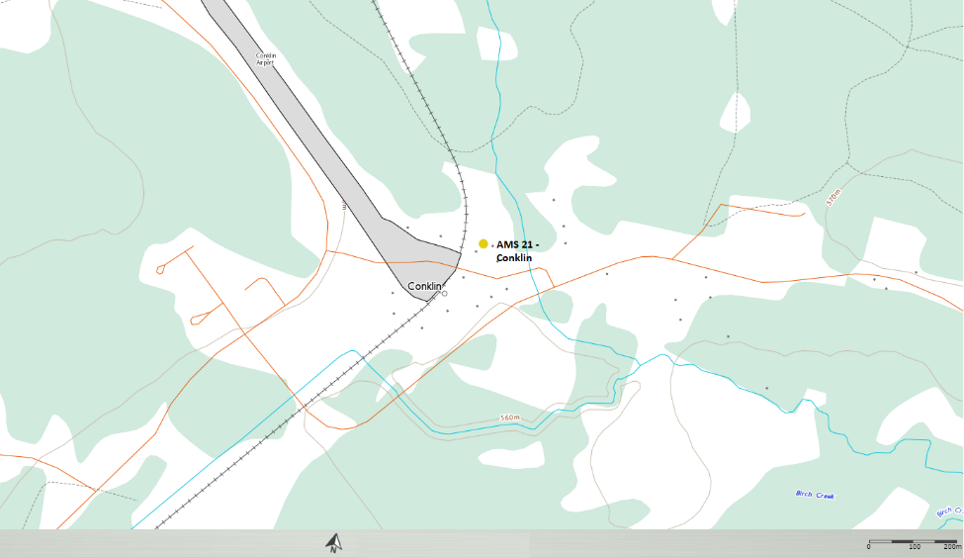
  - Figure 1 – Area Topographic map showing AMS 21

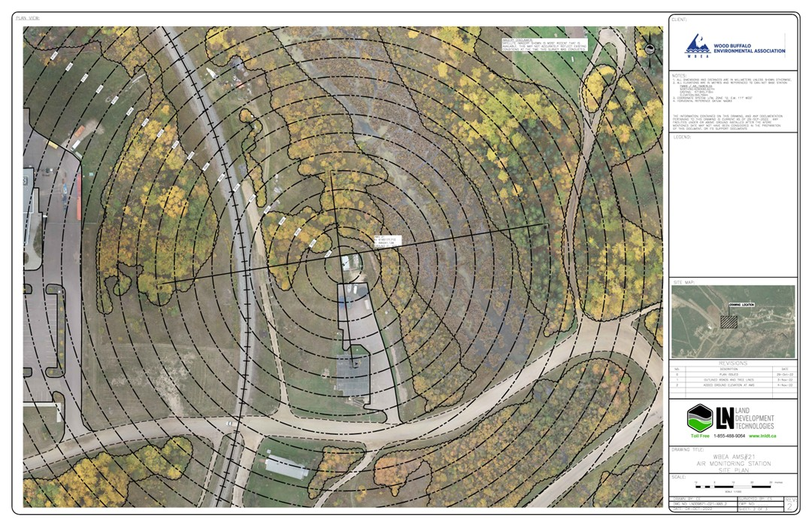
  - Figure 2 – Plan view sketch for AMS 21 site
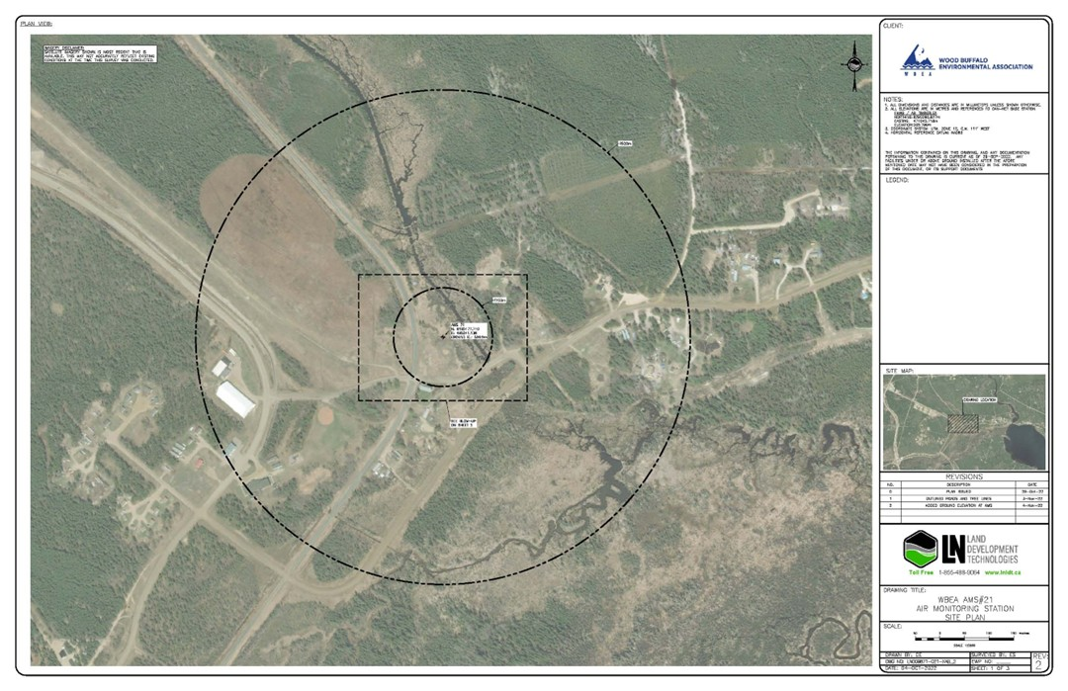
  - Figure 3 – Aerial photo showing AMS 21

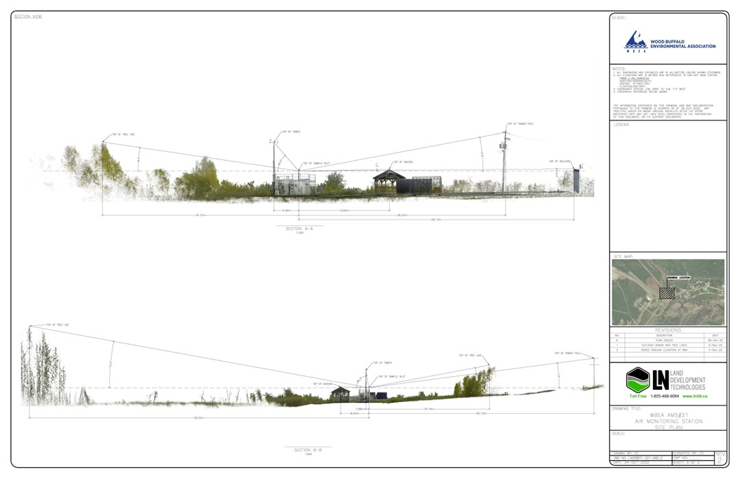
Figure 4 – Cross Section Elevation Drawing of AMS 21

Site photos
The following photos show the environment surrounding the monitoring station.

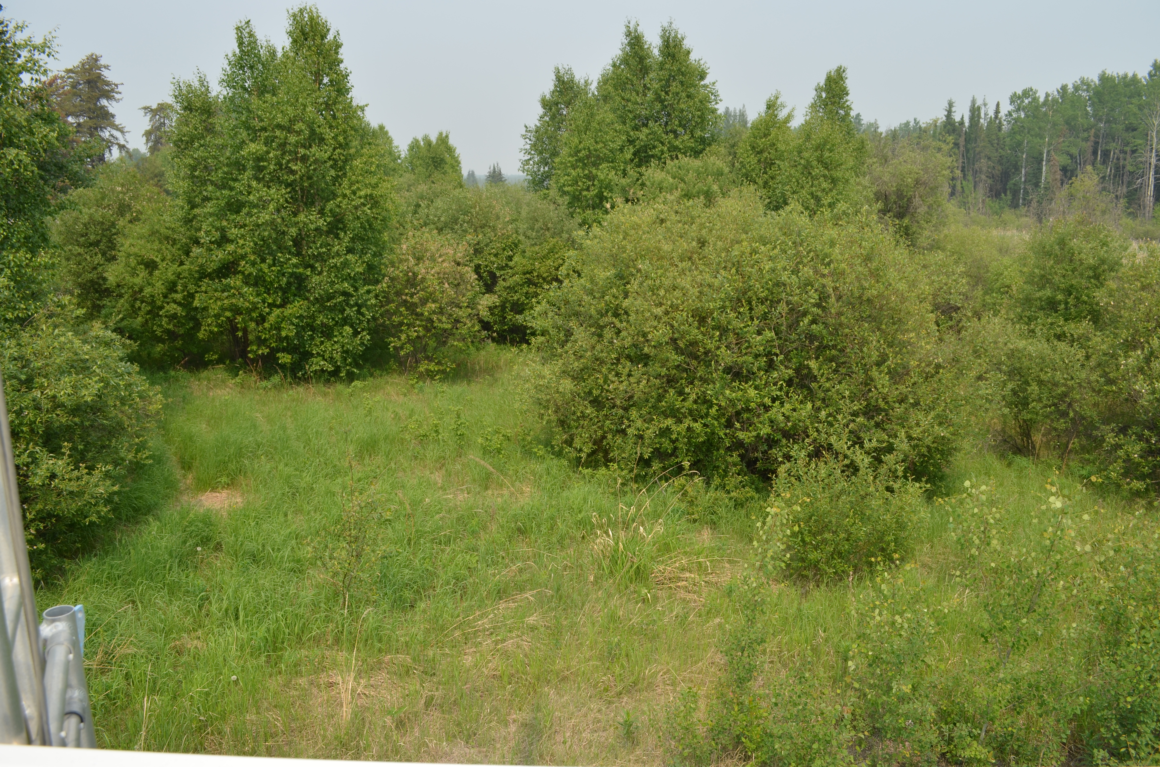
  - Figure 5 – Environment Looking North
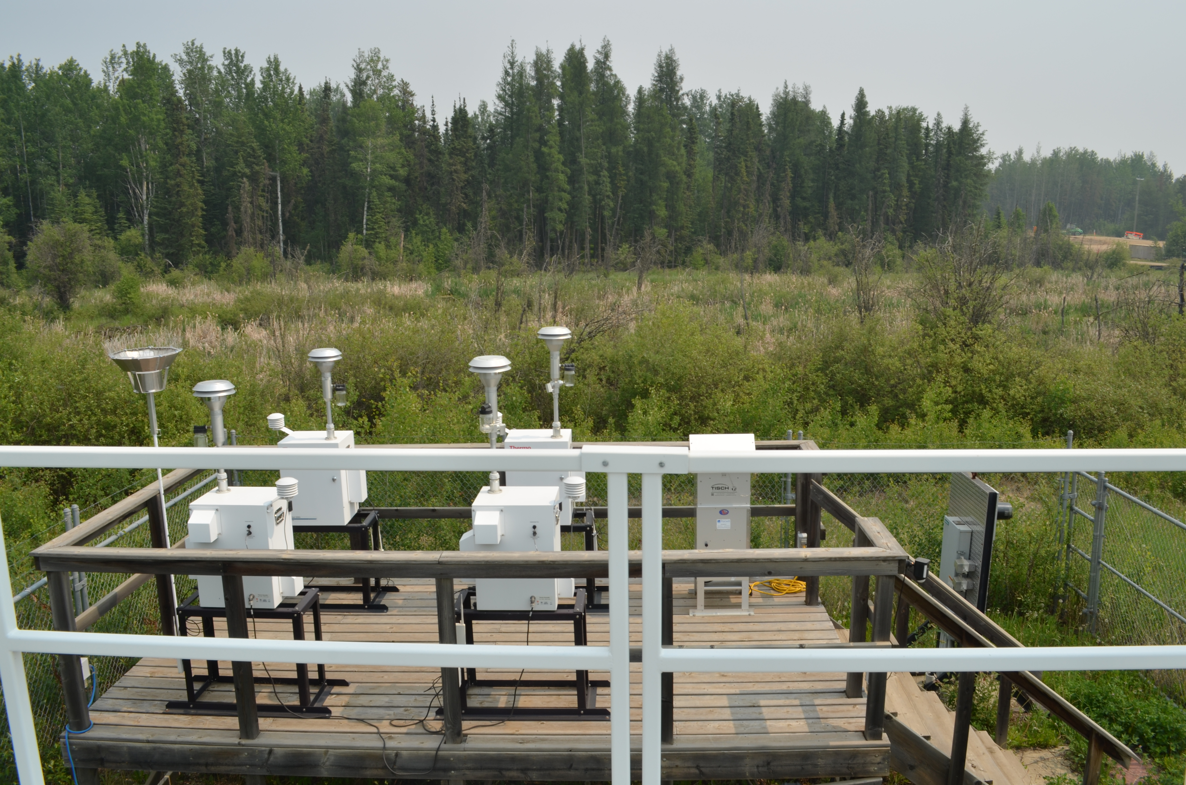
  - Figure 6 – Environment Looking East
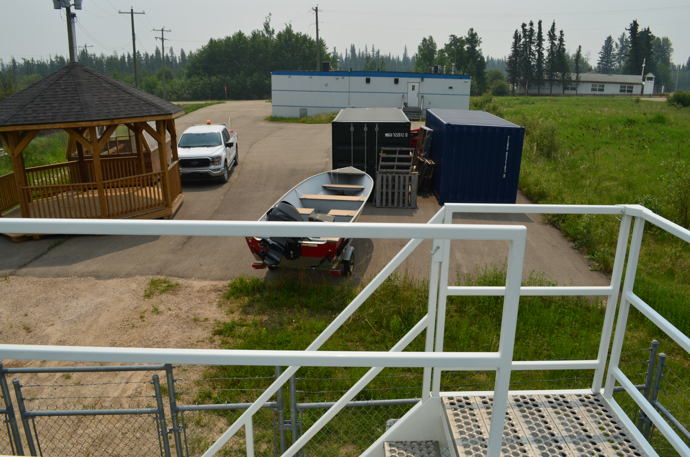
  - Figure 7 – Environment looking South
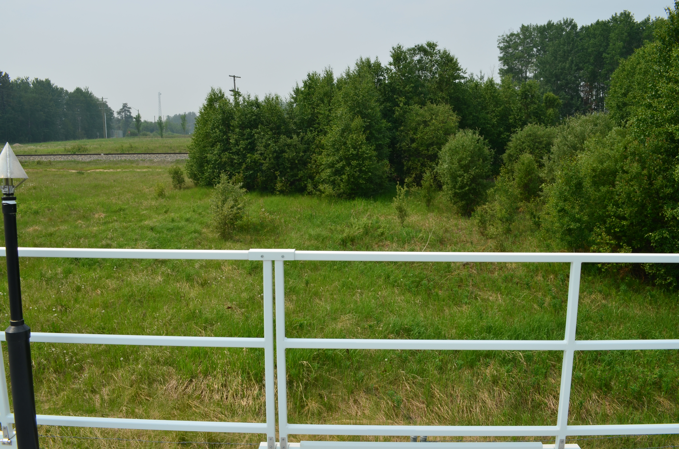
  - Figure 8 – Environment Looking West

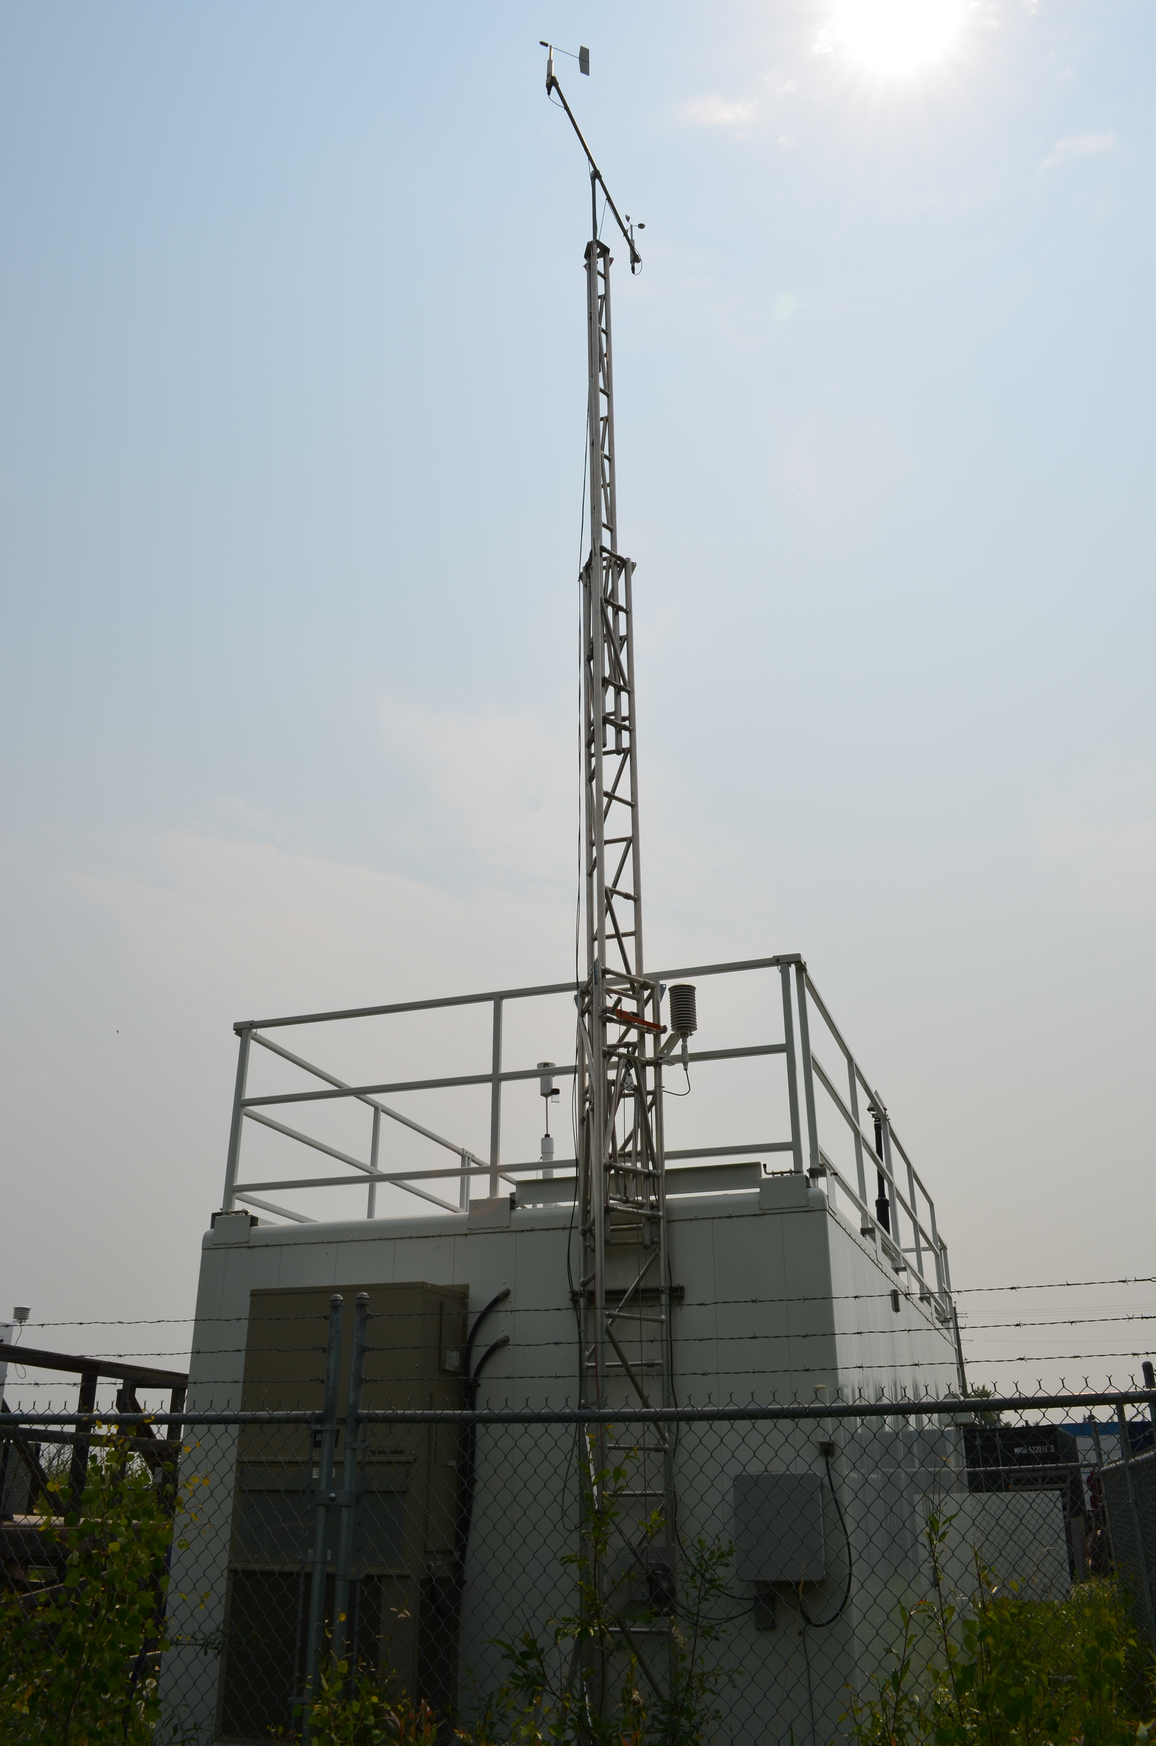
  - Figure 9 – Meteorological Tower

Station Photos
The following photos show the monitoring station and instrumentation.
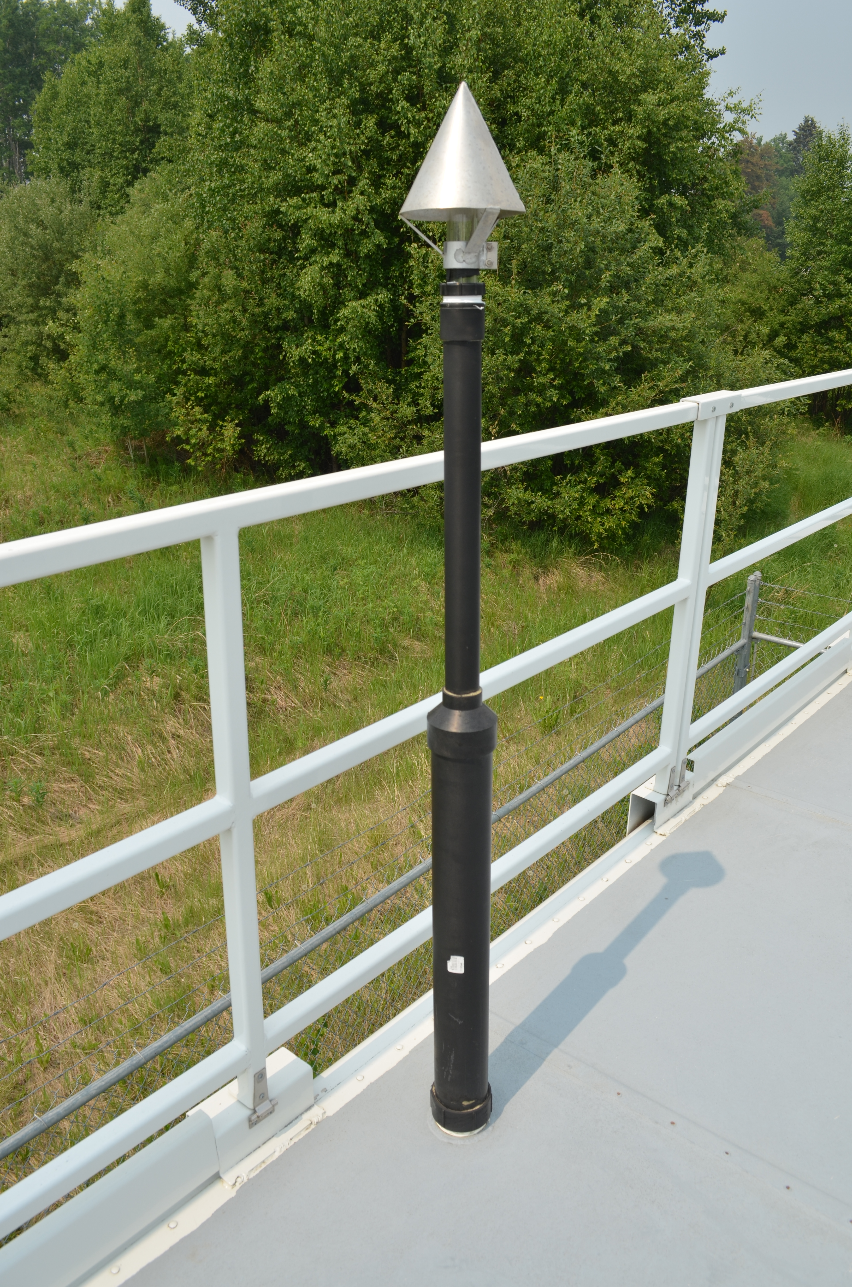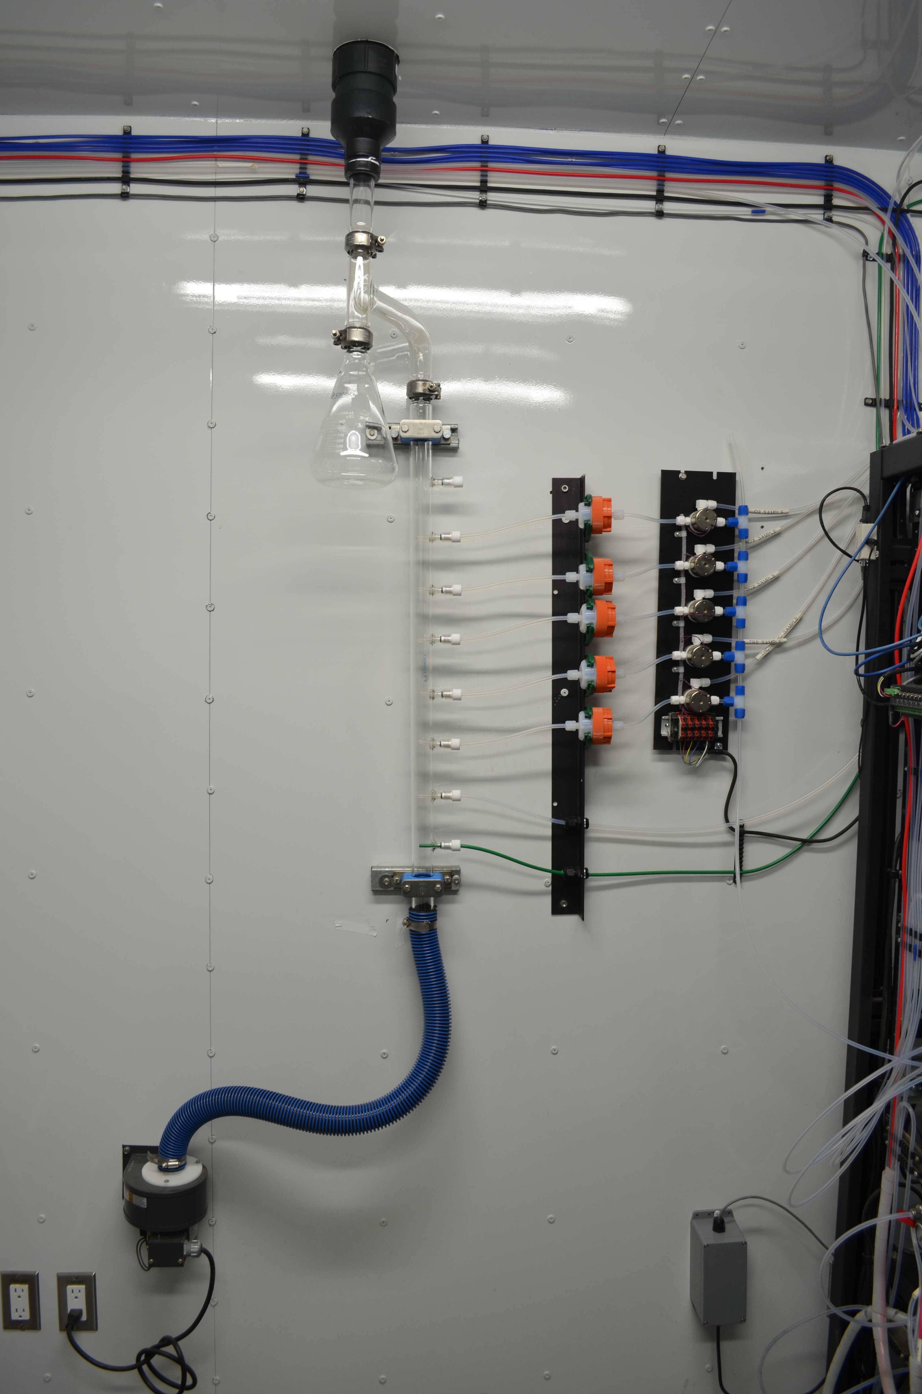
  - Figure 10 – Photo showing the inlet and sample manifold.

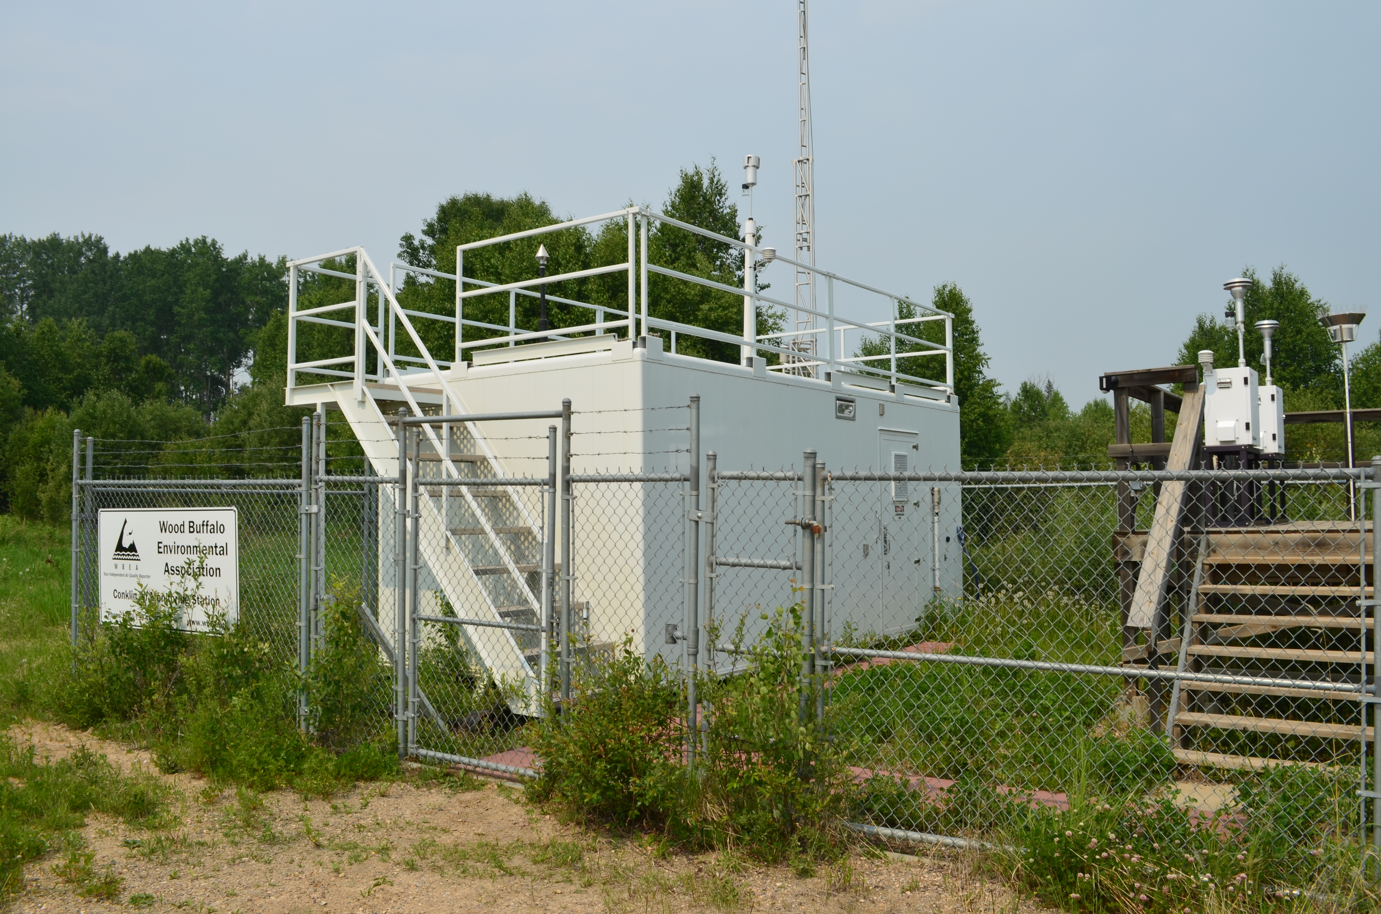
  - Figure 11 – Curb shot of the monitoring station.

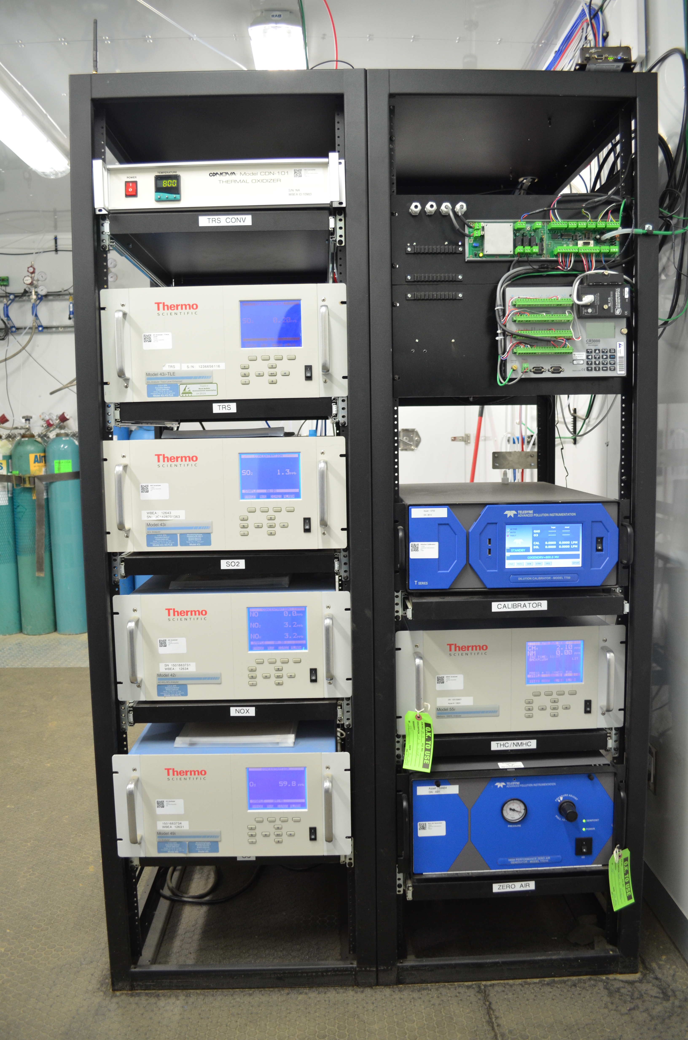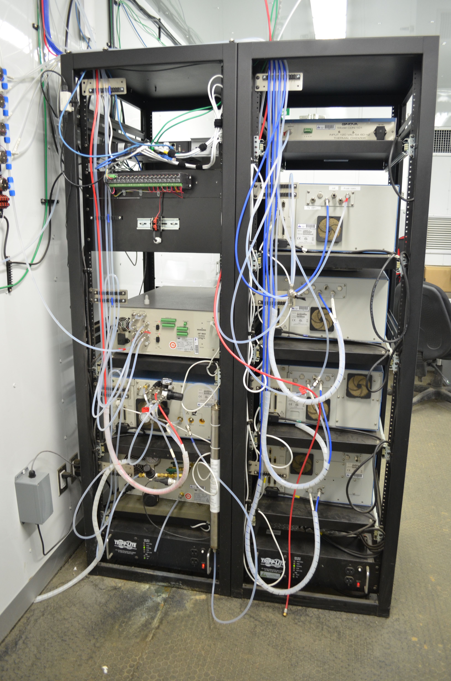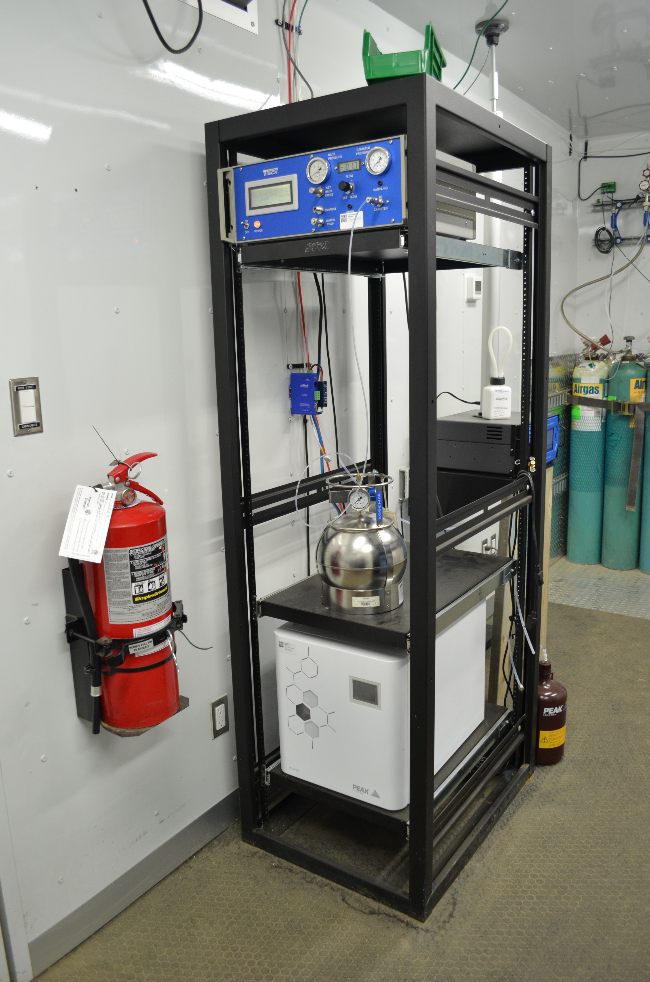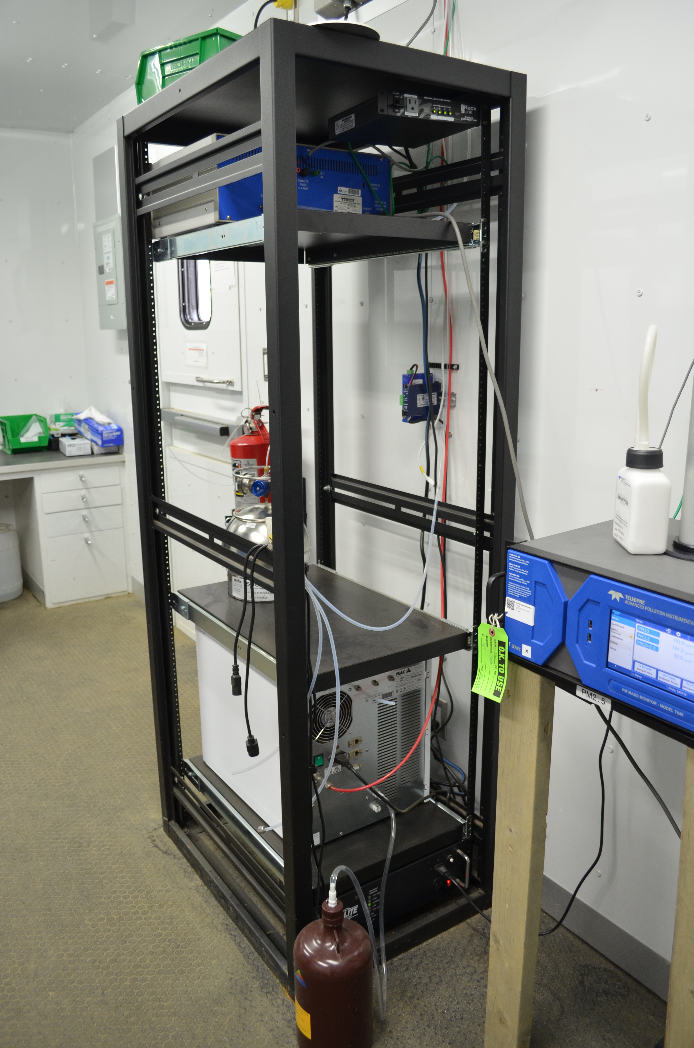
  - Figure 12 –Photo of front and back of instrument rack

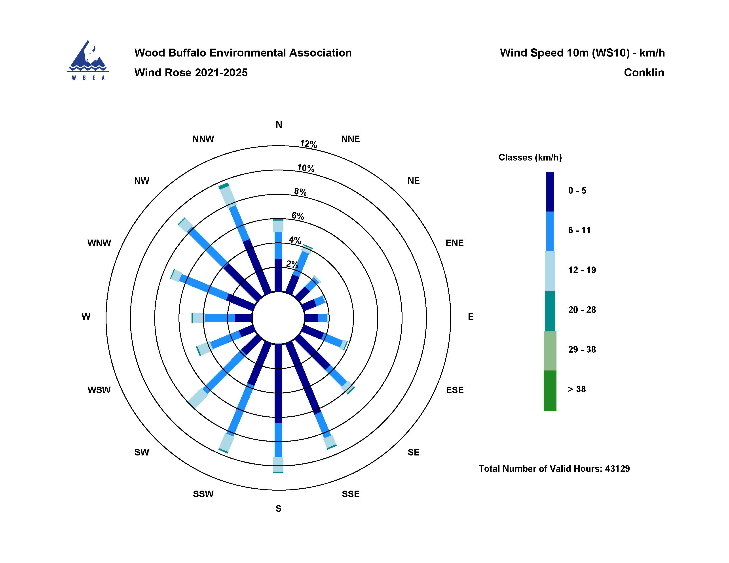
  - Figure 13 – Windrose (2021-2025)

