Wood Buffalo Environmental Association
Ambient Air Monitoring Station
Site Documentation

Mackay River

LAST UPDATED: February 18, 2026

Table of Contents
General Site Information 4
Station 4
Location 4
Owner/Operator/Approval Holder 4
Site Description 4
Site Influences 5
Localized Sources (within 20 metres of station) 5
Roadway Influences 5
Major Point Sources 5
Station Equipment 6
Analytical Equipment 6
Meteorological Equipment 6
Support Equipment 6
Site photos 11
Station Photos 16

Tables and Figures
Figure 1 – Area topographic map showing AMS 20 7
Figure 2 – Aerial image showing AMS 20 8
Figure 3 – Plan view image for AMS 20 site 9
Figure 4 – Elevation view image for AMS 20 site 10
Figure 5 – Environment looking North 11
Figure 6 – Environment looking East 12
Figure 7 – Environment looking South 13
Figure 8 – Environment looking West 14
Figure 9 – Meteorological Tower 15
Figure 10 – Photo showing the inlet and sample manifold 16
Figure 11 – Curb shot of the monitoring station 17
Figure 12 –Photo of the front and the back of instrument rack 18
Figure 13 – Windrose (2020-2025) 19

General Site Information
Revision Date: March 28, 2024

Station
Station ID | AMS 20
Station name | Mackay River
Date station established | January 7, 2016

Location
Station street address | NA
Legal land description | 10-01-090-14 W4
Airshed Zone | Wood Buffalo Environmental Association
Latitude | 56.7797279768
Longitude | -112.0890203
UTM East | 433455.57
UTM North | 6293395.78
Nearest community | Fort McMurray
Community population | 75186
Census Year | 2021

Owner/Operator/Approval Holder
Operating Agency | Wood Buffalo Environmental Association
Address of Operating Agency | Unit 3, 805 Memorial Drive, Fort McMurray, Alberta T9K 0K4
Name of Approval Holder | PetroChina Canada Ltd.
Approval number | 254465-01-00
Contact Name | Blakney Hopkins
Address | NA
Phone number | 403-880-1836
Email address | Blakney.hopkins@petrochinacanada.com

Site Description
Land use by sector | 0 – 90 degrees | Forest and SAGD project
Land use by sector | 91 – 180 degrees | Forest and SAGD project
Land use by sector | 181 – 270 degrees | Forest
Land use by sector | 271 – 360 degrees | Forest
Site elevation (m)  (above sea level) | 498
Angle of elevation to nearby buildings | Greatest angle | 0 degree
Angle of elevation to nearby buildings | Building direction | None
Airflow restrictions | North | None
Airflow restrictions | East | None
Airflow restrictions | South | None
Airflow restrictions | West | Yes
Distance to nearest trees (m) | North | 30
Distance to nearest trees (m) | East | 20
Distance to nearest trees (m) | West | 30
Distance to nearest trees (m) | South | 50
Sample manifold | Type | All glass
Sample manifold | Inlet height above roof | 1 metre
Wind Sensors | Type | Cup and vane
Wind Sensors | Height above ground (m) | 10
Wind Sensors | Distance from station (m) | Attached to the North end of the station

Site Influences

Localized Sources (within 20 metres of station)
Type | Distance (m) | Description
None | n/a | n/a

Roadway Influences
Type | Traffic Volume | Distance (m) | Description
Gravel Road | Low | 30 | Access Road

Major Point Sources
Facility Name | Source Type | Distance from site (km) | Compass direction from site
PetroChina Canada Ltd. | Oil and Gas industry | 5 | North

Station Equipment
Equipment Owner: PetroChina

Analytical Equipment
Parameter | Make | Model | Serial Number | Date Instrument Installed | WBEA Data Start Date
SO₂ | Thermo Scientific | 43i | 1501301450 | March, 2016 | February, 2016
H₂S | Thermo Scientific | 43i-LTE | 1236656117 | 2023 | February, 2016
NO/NO_{x}/NO₂ | Thermo Scientific | 42i | 1505164379 | November, 2018 | February, 2016
THC | Thermo Scientific | 51i | 1501663727 | March, 2016 | February, 2016

Meteorological Equipment
Parameter | Make | Model | Serial Number | WMO Site Class | Date Sensor Installed | WBEA Data Start Date
AT/RH | Vaisala | HMP155 | F5010002 | 3 | September, 2018 | February, 2016
WS | Met One | 010C-1 | P19838 | 3 | June, 2025 | January, 2016
WD | Met One | 020C-1 | N9937 | 3 | March, 2016 | January, 2016
PC | OTT | OTT-Pluvio2 | 363524 | 3 | May, 2016 | December, 2016

Support Equipment
Name | Description | Make | Model | Serial Number
Datalogger | Datalogger | Campbell Scientific | CR3000 | 9627
Gas Dilution Calibrator | Dynamic dilution calibrator | Teledyne/API | T700 | 1220
Zero air generator | Zero Air Generator | Teledyne/API | 701 | 4522
Shelter / Building | Air monitoring portable | ITB | 8 x 16 trailer | ITB-15-16552
Meteorological Tower | Telescoping 10 metre tower | Aluma Tower Co. | T-135 | AT-215036-AA-5-2
Datalogger | Datalogger | Campbell Scientific | CR310 | 6239
H2S Converter | Thermal Oxidizer | Global Analyzer Systems | G150 | 2022-226

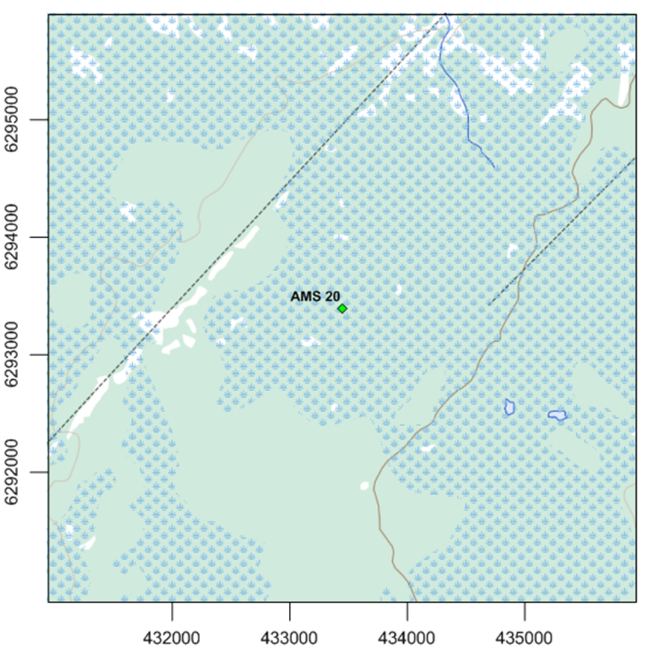
  - Figure 1 – Area topographic map showing AMS 20

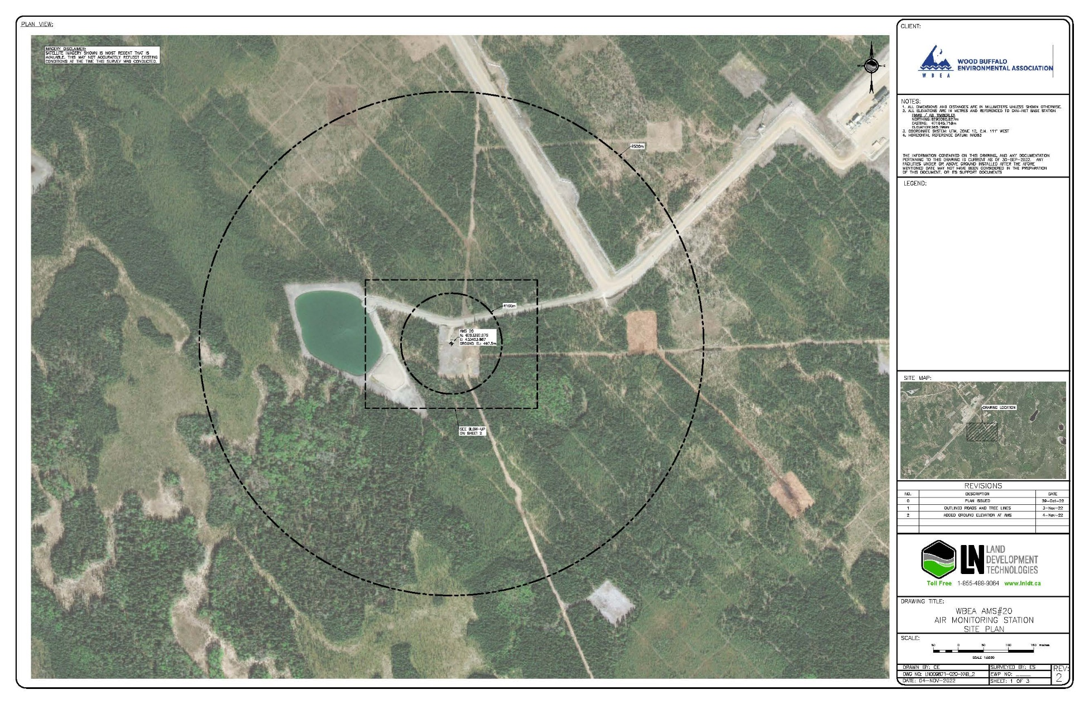
  - Figure 2 – Aerial image showing AMS 20

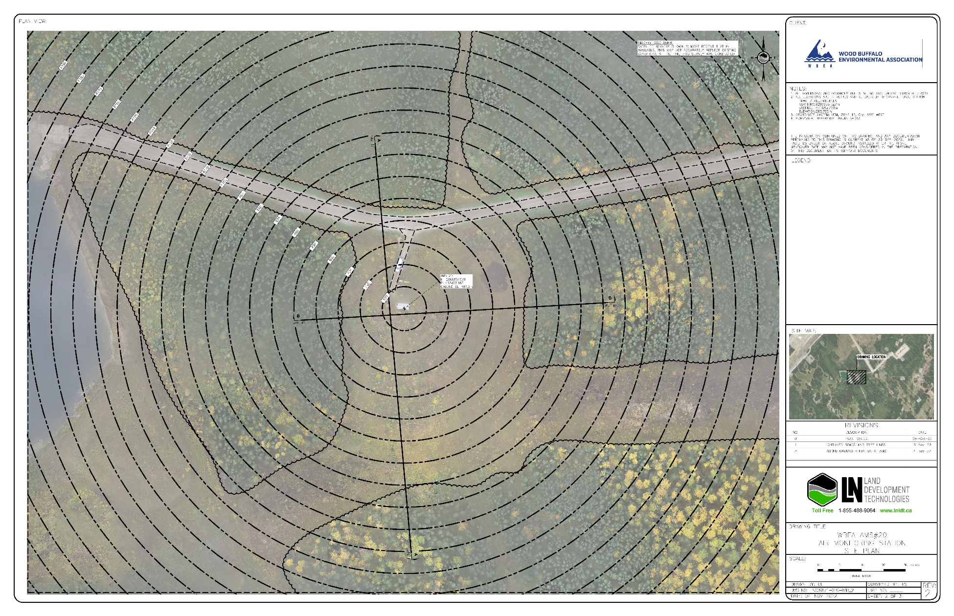
  - Figure 3 – Plan view image for AMS 20 site

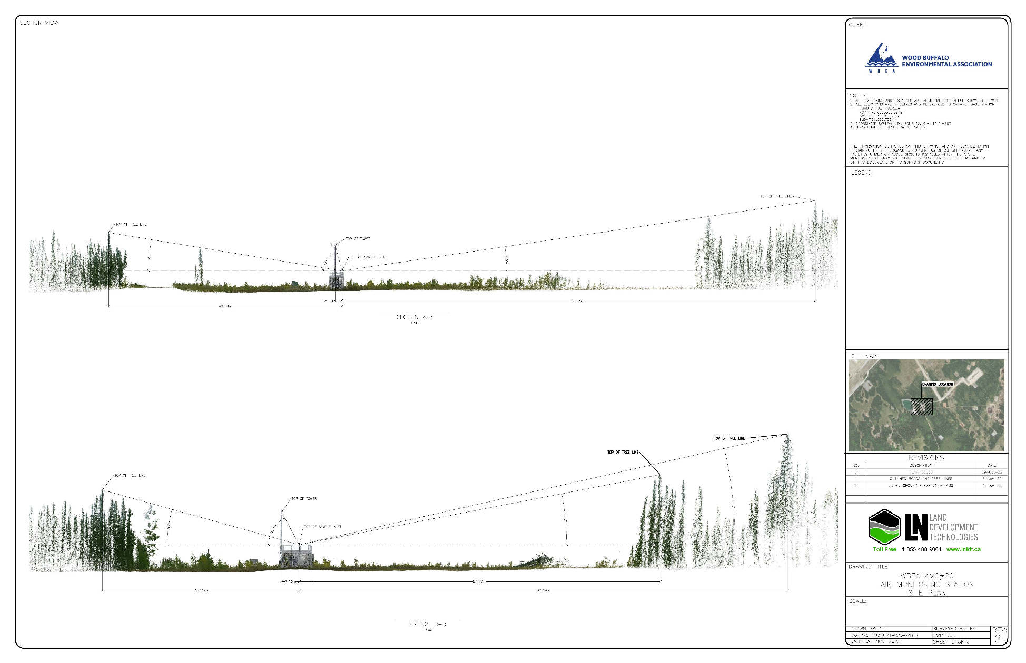
  - Figure 4 – Elevation view image for AMS 20 site

Site photos
The following photos show the environment surrounding the monitoring station.

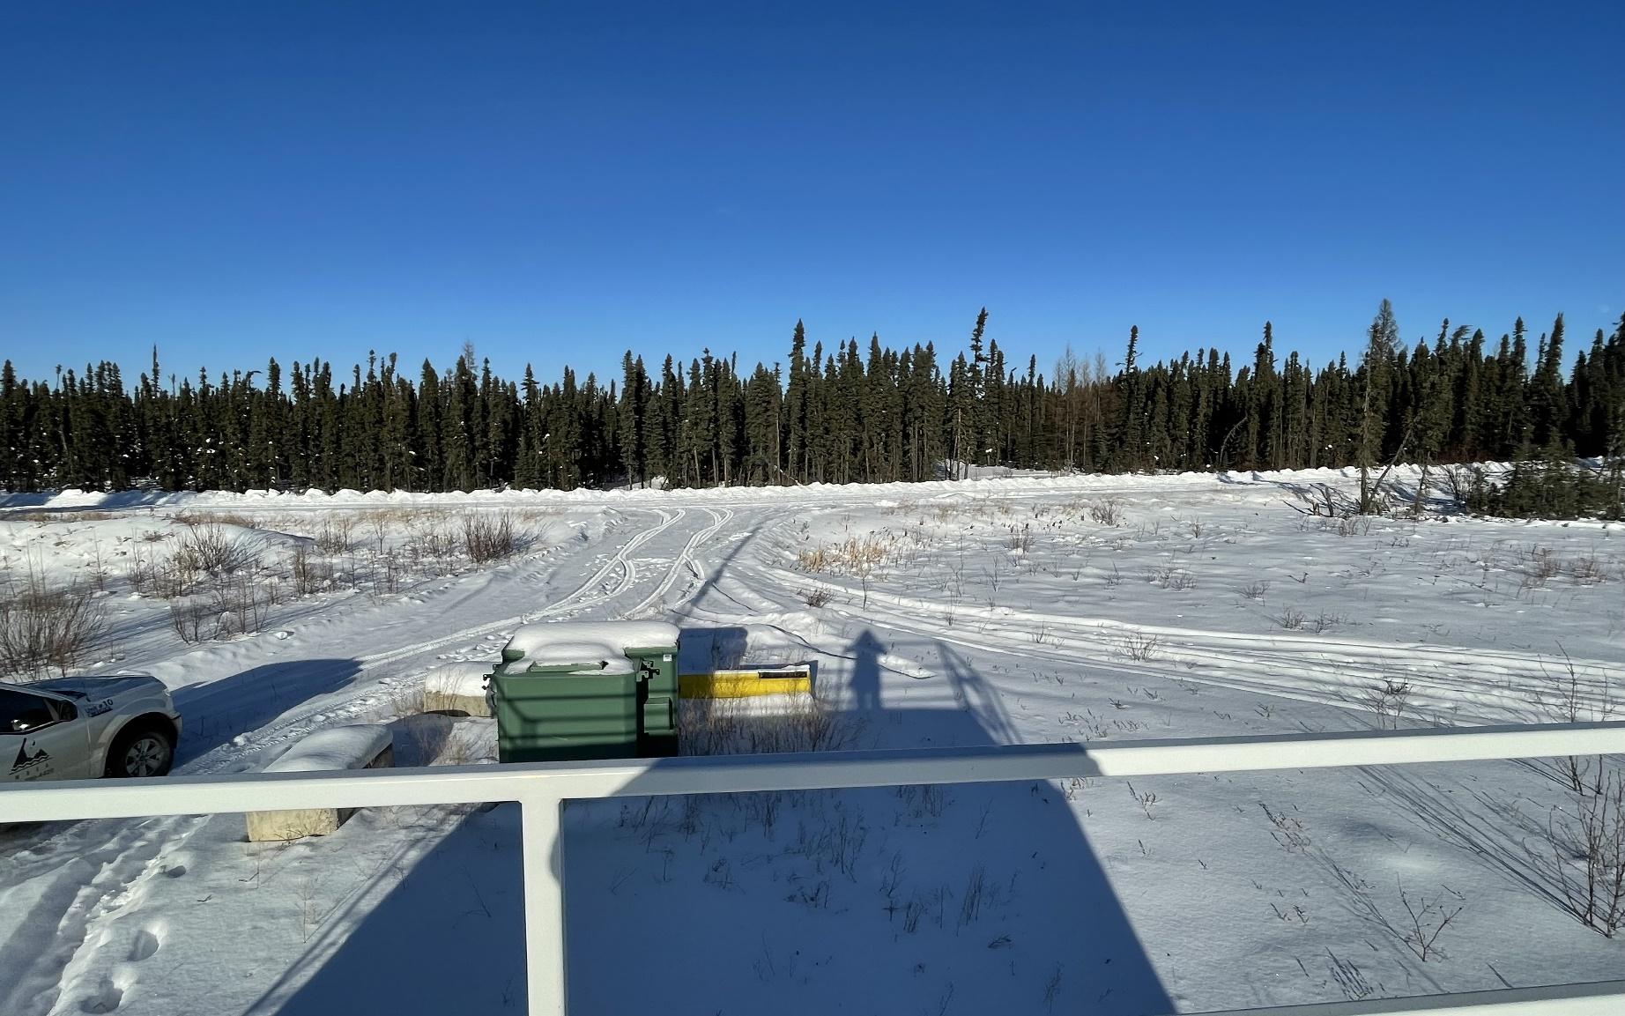
  - Figure 5 – Environment looking North

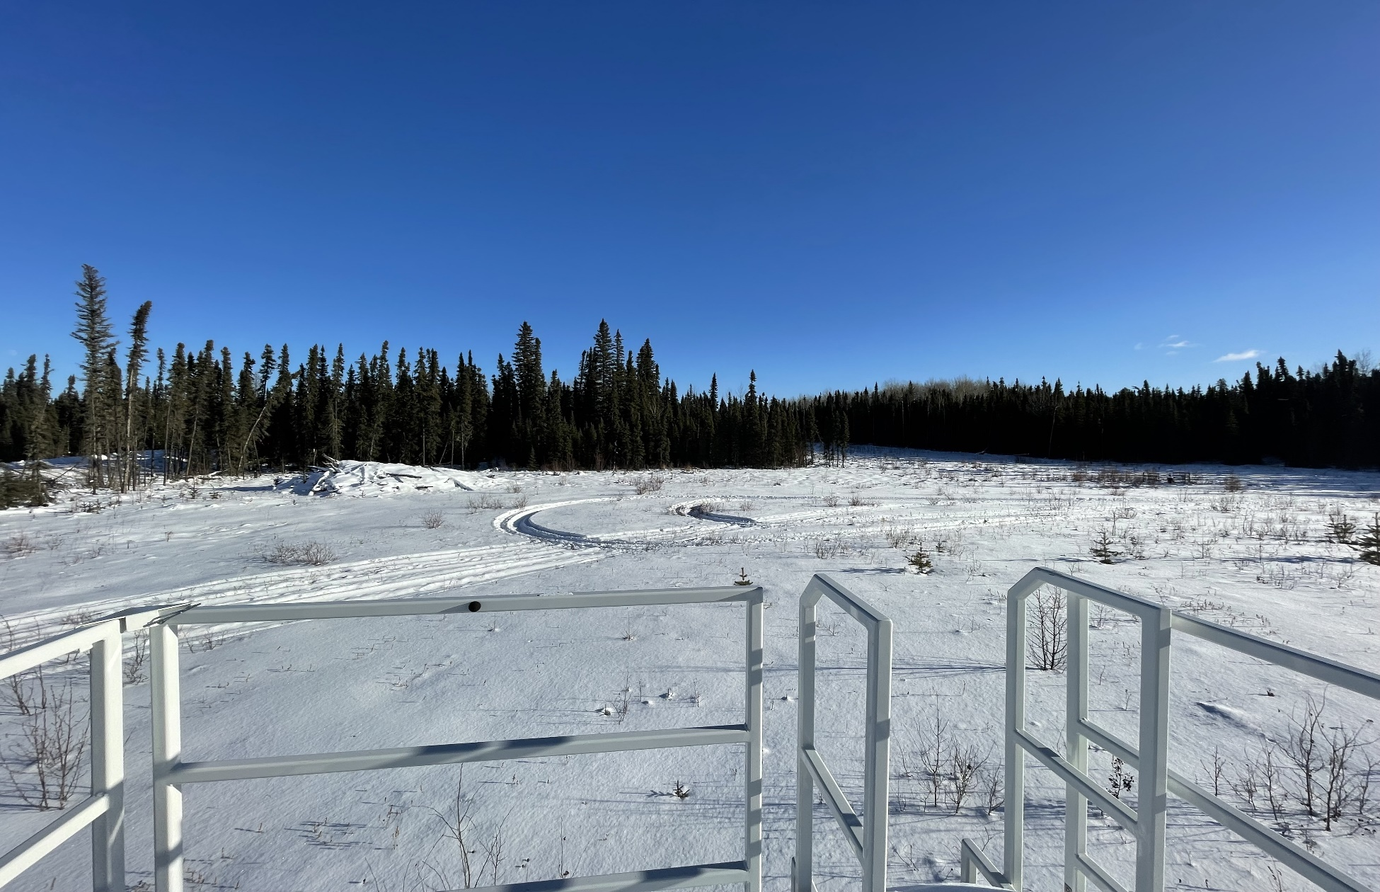
  - Figure 6 – Environment looking East

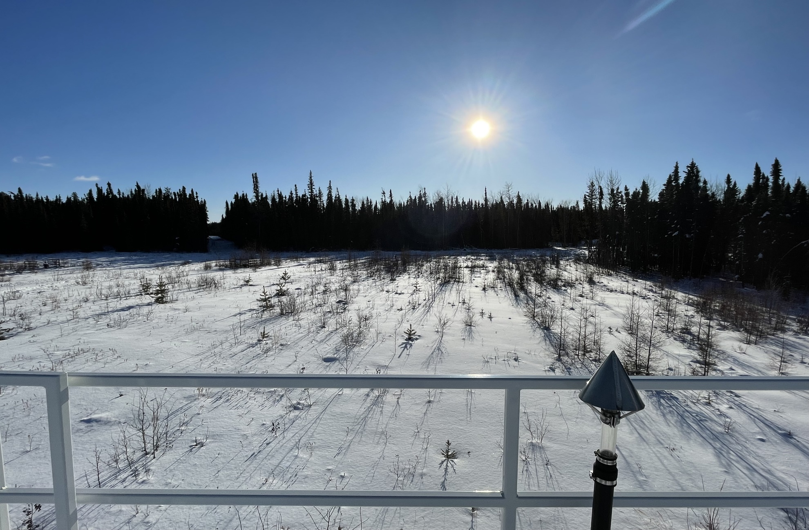
  - Figure 7 – Environment looking South

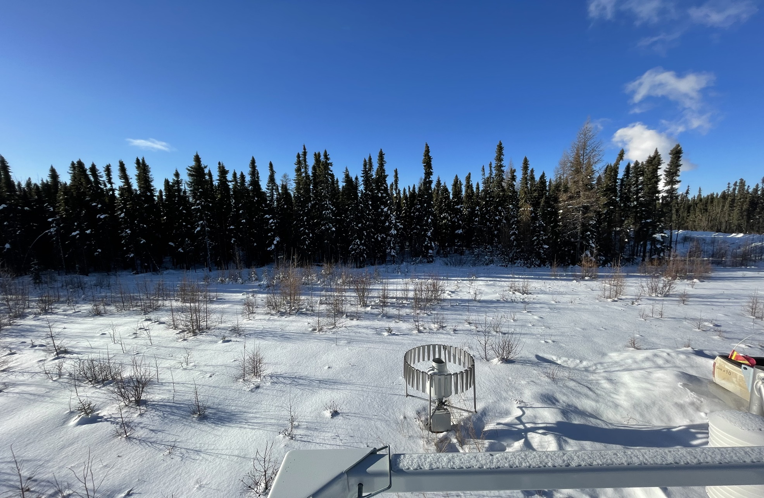
  - Figure 8 – Environment looking West

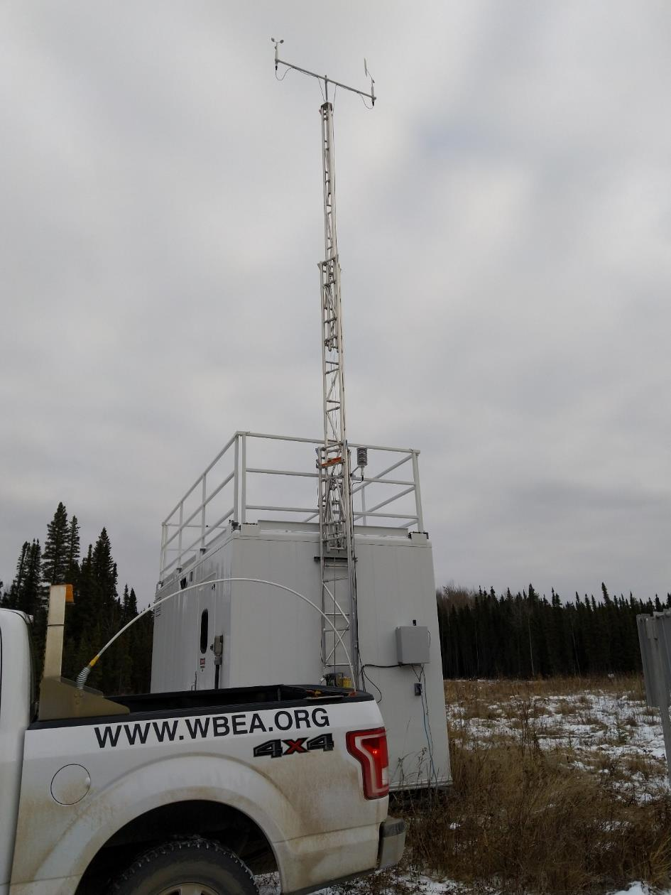
  - Figure 9 – Meteorological Tower

Station Photos
The following photos show the monitoring station and instrumentation.

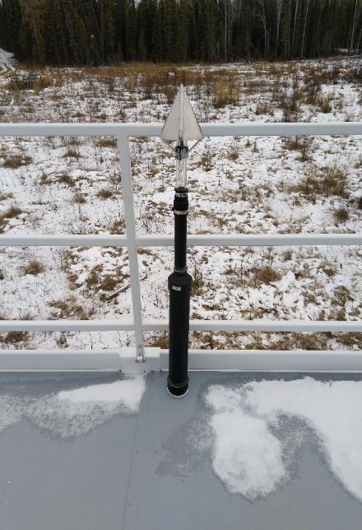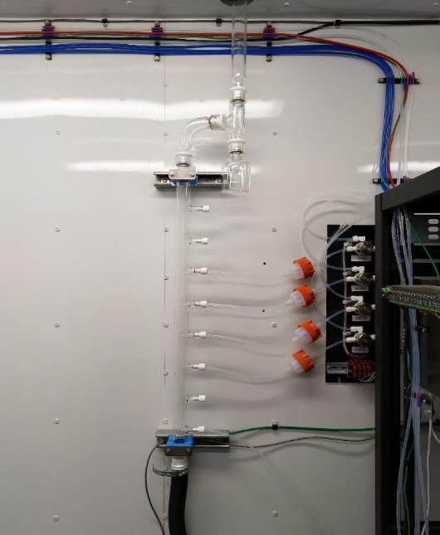
  - Figure 10 – Photo showing the inlet and sample manifold

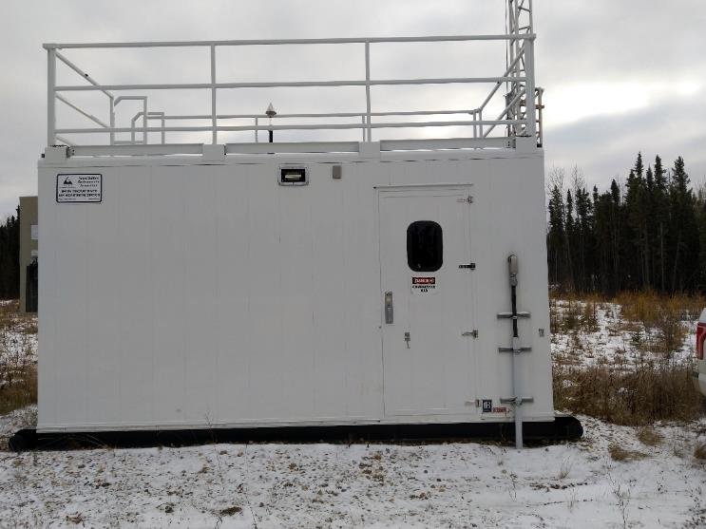
  - Figure 11 – Curb shot of the monitoring station

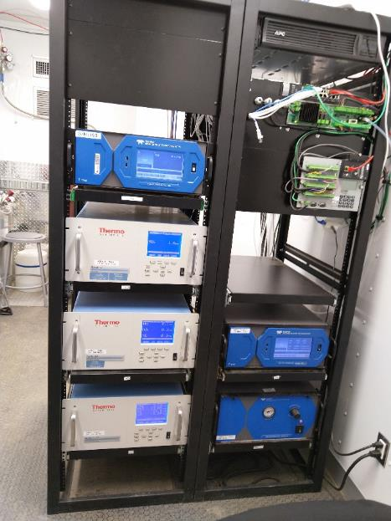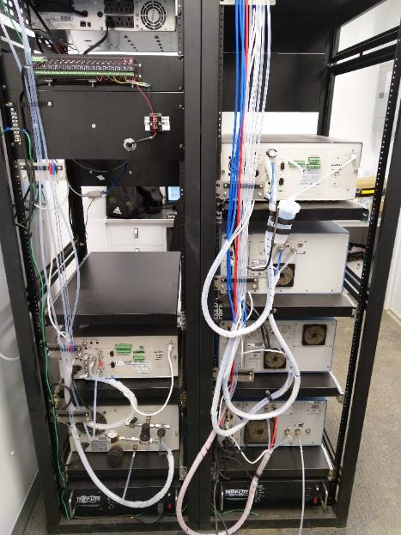
  - Figure 12 –Photo of the front and the back of instrument rack

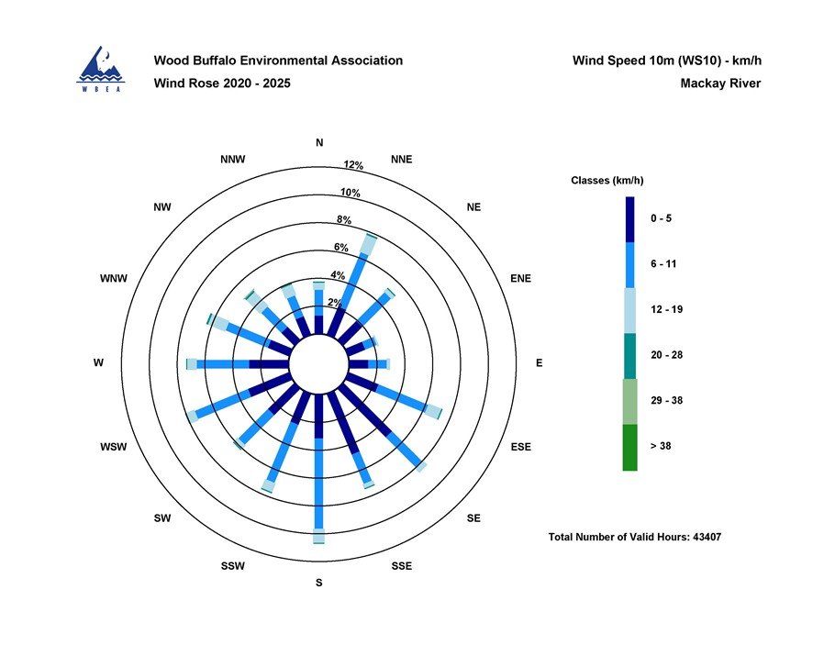

  - Figure 13 – Windrose (2020-2025)

