Wood Buffalo Environmental Association
Ambient Air Monitoring Station
Site Documentation

Stony Mountain

LAST UPDATED: February 18, 2026

Table of Contents
General Site Information 4
Station 4
Location 4
Owner/Operator/Approval Holder 4
Site Description 4
Site Influences 5
Localized Sources (within 20 metres of station) 5
Roadway Influences 5
Major Point Sources 5
Station Equipment 6
Analytical Equipment 6
Meteorological Equipment 6
Support Equipment 6
Site photos 12
Station Photos 17

Tables and Figures
Figure 1 – Area topographic map showing AMS 18 7
Figure 2 – Aerial photo showing AMS 18 8
Figure 3 – Plan view sketch for AMS 18 site 9
Figure 4 – Elevation view sketch for AMS 18 site 10
Figure 5 – Environment looking North 11
Figure 6 – Environment looking East 12
Figure 7 – Environment looking South 13
Figure 8 – Environment looking West 14
Figure 9 – Meteorological Tower 15
Figure 10 – Photo showing the inlet and sample manifold 16
Figure 11 – Curb shot of the monitoring station 17
Figure 12 –Photo of the front and the back of instrument rack 18
Figure 13 – Windrose 20m (2021-2025) 19

General Site Information
Revision Date: March 28, 2024

Station
Station ID | AMS 18
Station name | Stony Mountain
Date station established | June 2015

Location
Station street address | NA
Legal land description | 1-33-076-08 W4
Airshed Zone | Wood Buffalo Environmental Association
Latitude | 55.621487
Longitude | -111.172798
UTM East | 489125
UTM North | 6163958
Nearest community | Conklin
Community population | 229
Census Year | 2018

Owner/Operator/Approval Holder
Operating Agency | Wood Buffalo Environmental Association
Address of Operating Agency | Unit 3-805 Memorial Drive, Fort McMurray, Alberta T9K 0K4
Name of Approval Holder | NA
Approval number | NA
Contact Name | Wood Buffalo Environmental Association
Address | Unit 3-805 Memorial Drive, Fort McMurray, Alberta, T9K 0K4
Phone number | 780-799-4420
Email address | info@wbea.org

Site Description
Land use by sector | 0 – 90 degrees | Trees
Land use by sector | 91 – 180 degrees | Trees
Land use by sector | 181 – 270 degrees | Trees
Land use by sector | 271 – 360 degrees | Fire tower, trees
Site elevation (m)  (above sea level) | 673
Angle of elevation to nearby buildings | Greatest angle | 0
Angle of elevation to nearby buildings | Building direction | NA
Airflow restrictions | North | None
Airflow restrictions | East | None
Airflow restrictions | South | None
Airflow restrictions | West | None
Distance to nearest trees (m) | North | 30
Distance to nearest trees (m) | East | 30
Distance to nearest trees (m) | West | 30
Distance to nearest trees (m) | South | 30
Sample manifold | Type | All glass
Sample manifold | Inlet height above roof | 1 metre
Wind Sensors | Type | Cup and vane
Wind Sensors | Height above ground (m) | 20
Wind Sensors | Distance from station (m) | 2

Site Influences

Localized Sources (within 20 metres of station)
Type | Distance (m) | Description
Fire watch tower | 100 m NW of Station | Fire lookout tower, operated by the province of Alberta
Communication Tower | 30 m E of Station | Cell tower

Roadway Influences
Type | Traffic Volume | Distance (m) | Description
Access road | Low | 10 | Dirt/sand road

Major Point Sources
Facility Name | Source Type | Distance from site (km) | Compass direction from site
Cenovus | SAGD | 12.26 | SE
CNRL | SAGD | 15 | SE

Station Equipment
Equipment Owner:

Analytical Equipment
Parameter | Make | Model | Serial Number | Date Installed | WBEA Data Start Date
SO₂ | Thermo Environmental | 43i | JC1501301453 | 2015 | 2015
TRS | Thermo Environmental | 43i – TLE | 1218153359 | 2021 | 2015
NO₂ | Thermo Environmental | 42i | 1501663731 | 2025 | 2015
NMHC | Thermo Environmental | 55i | 1193585647 | 2024-01-31 | 2015
O₃ | Teledyne API | T400 | 825 | 2019 | 2015
CO | Teledyne API | T300 | 3504 | 2021 | 2021
CO₂ | Teledyne API | T360 | 489 | 2023-09-29 | 2023
PM _{2.5} | Teledyne API | T640 | 324 | 2024 | 2015
BC | Magee Scientific | AE-33 | 327 | 2022 | 2015
PC | N-CON Systems | 00-120-2 | 60140 | 2018 | 2015
EC/OC | Thermo Environmental | 2000i-A-N | 2000IW 20691 1702 | 2018 | 2015

Meteorological Equipment
Parameter | Make | Model | Serial Number | WMO Site Class | Date Sensor Installed | WBEA Data Start Date
AT/RH | Vaisala | HMP155 | G0840106 | 3 | 2018 | August, 2015
WS | Met One | 010C-1 | A1406 | 4 | 2022 | August, 2015
WD | Met One | 020C-1 | NA | 4 | 2022 | August, 2015
PC | OTT | OTT Pluvio-2 | 363526 | 3 | 2016 | December, 2015
LW | Decagon Devices | LWS-L | NA | N/A | 2022 | October, 2015
GR | Epply | 8-48 Solar Rad | 38007 | N/A | 2021 | August, 2015

Support Equipment
Name | Description | Make | Model | Serial Number
Datalogger | Datalogger | Campbell Scientific | CR3000 | 12345
Gas Dilution Calibrator | Dynamic dilution calibrator | Teledyne/API | T700 | 12345
Zero air generator | Zero Air Generator | Teledyne/API | 701 | 12345
Shelter / Building | Air monitoring portable | ITB | 8 x 16 trailer | 12345
HVAC | Heating and air conditioning system. Wall mount unit | BARD | 1 ton | 12345

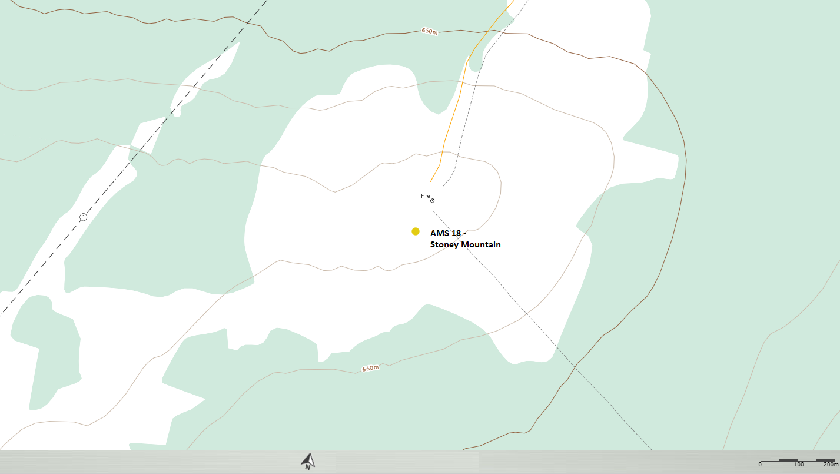
  - Figure 1 – Area topographic map showing AMS 18

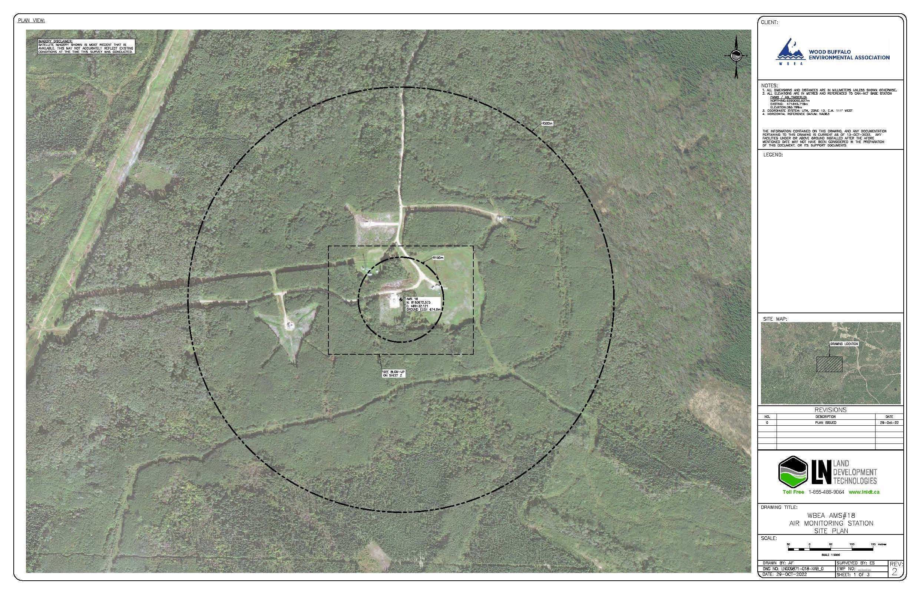
  - Figure 2 – Aerial photo showing AMS 18
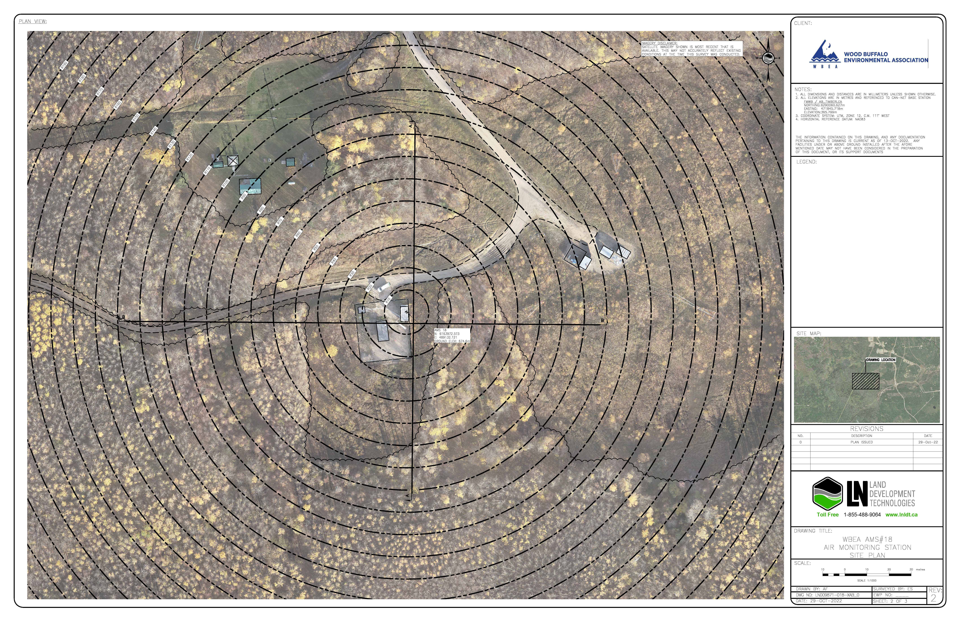
  - Figure 3 – Plan view sketch for AMS 18 site

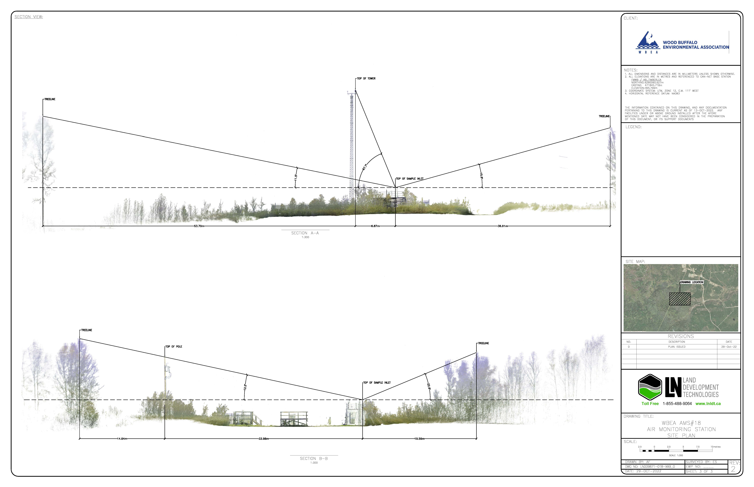
  - Figure 4 – Elevation view sketch for AMS 18 site

Site photos
The following photos show the environment surrounding the monitoring station.

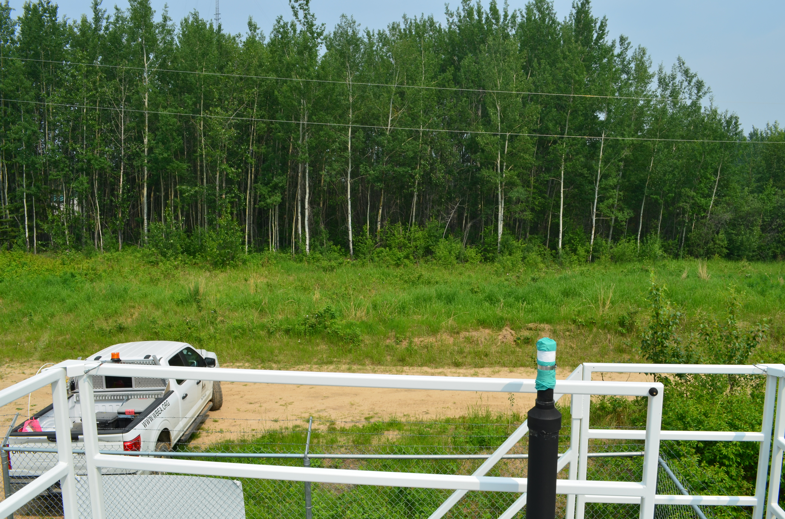
  - Figure 5 – Environment looking North

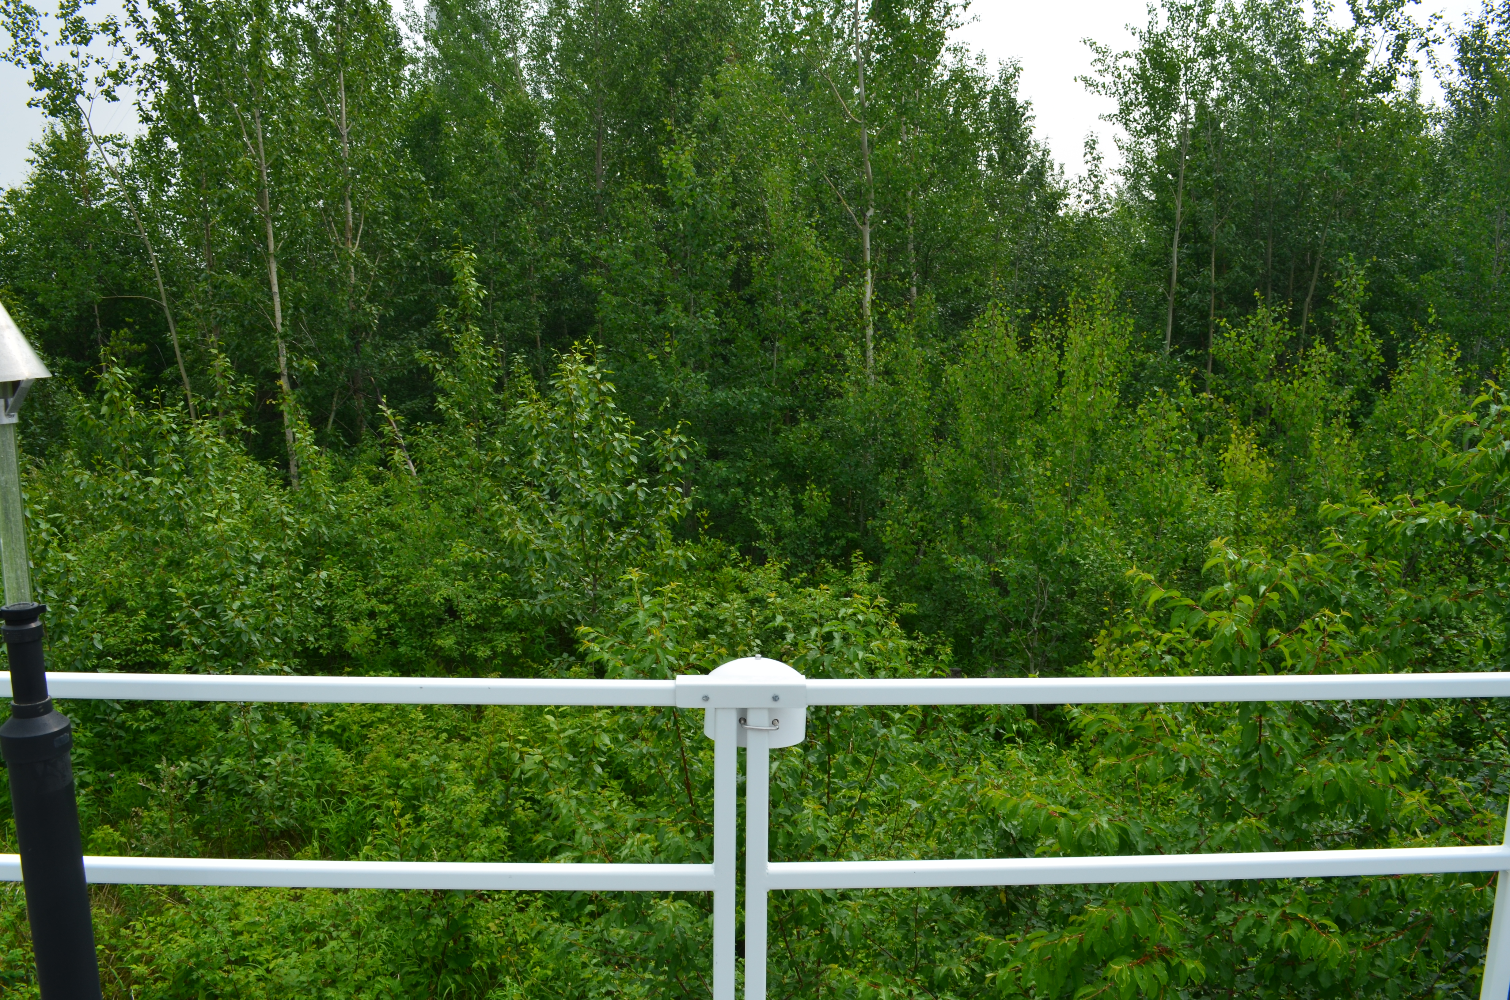
  - Figure 6 – Environment looking East

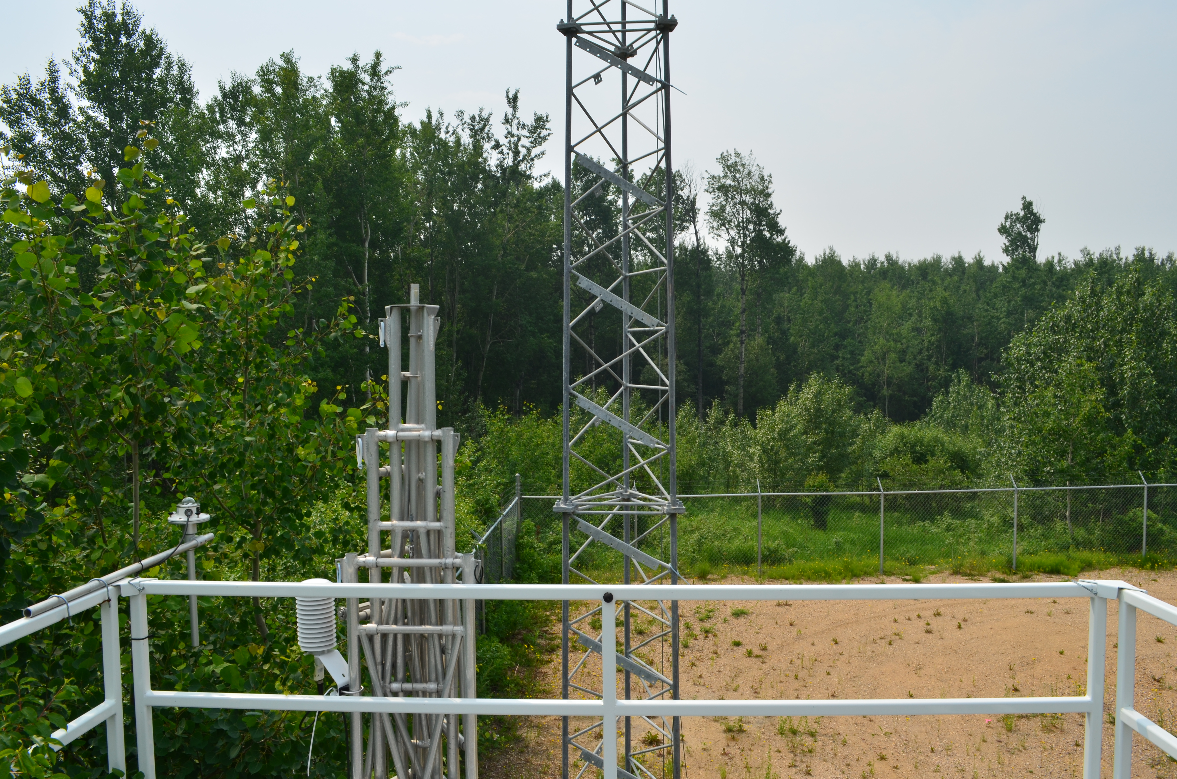
  - Figure 7 – Environment looking South

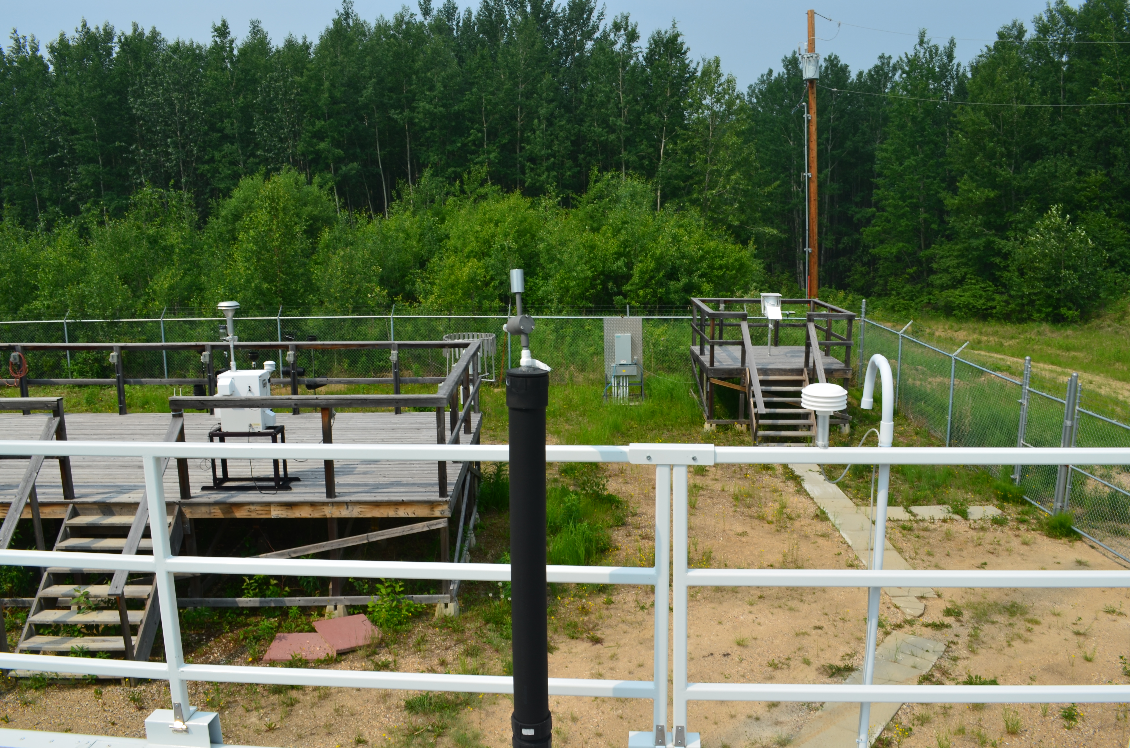
  - Figure 8 – Environment looking West

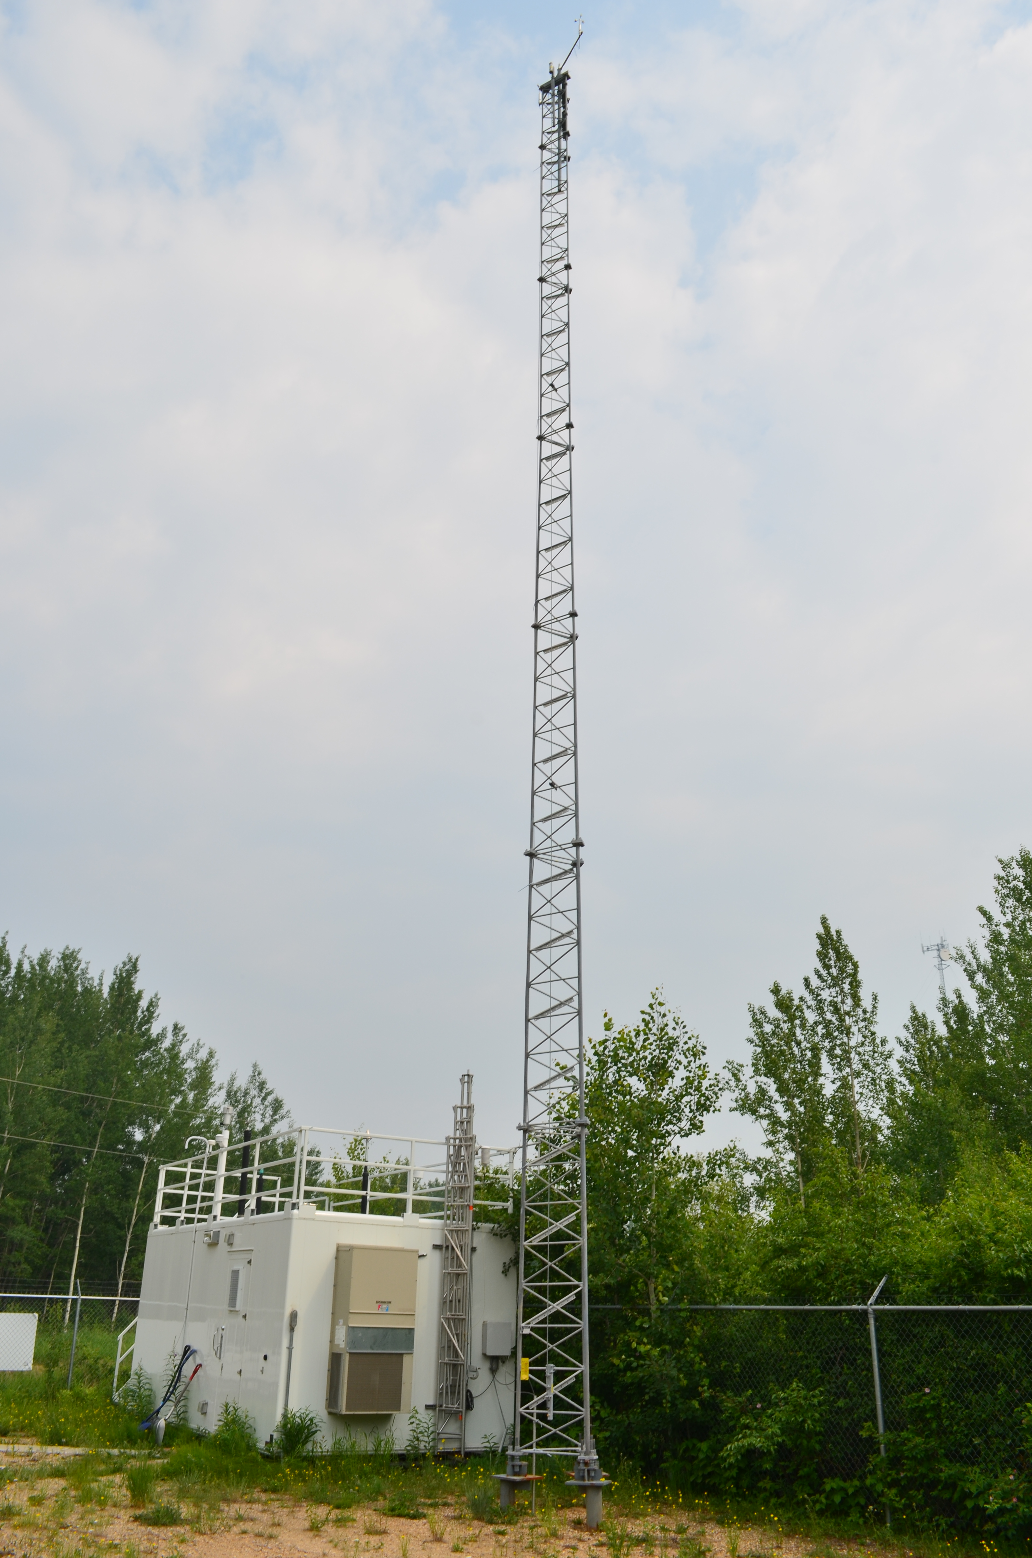
  - Figure 9 – Meteorological Tower

Station Photos
The following photos show the monitoring station and instrumentation.

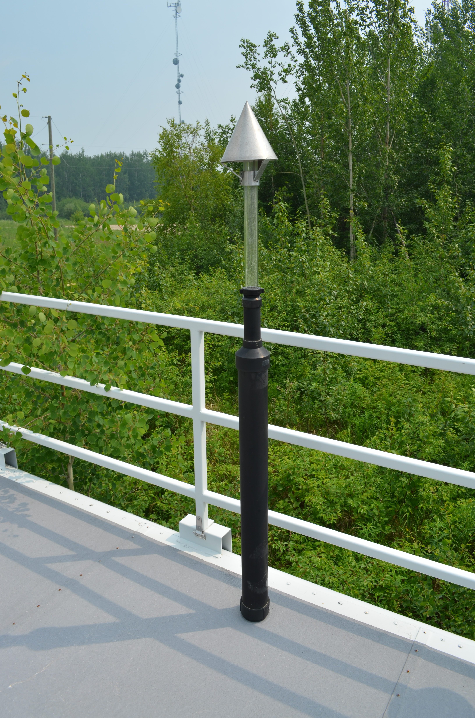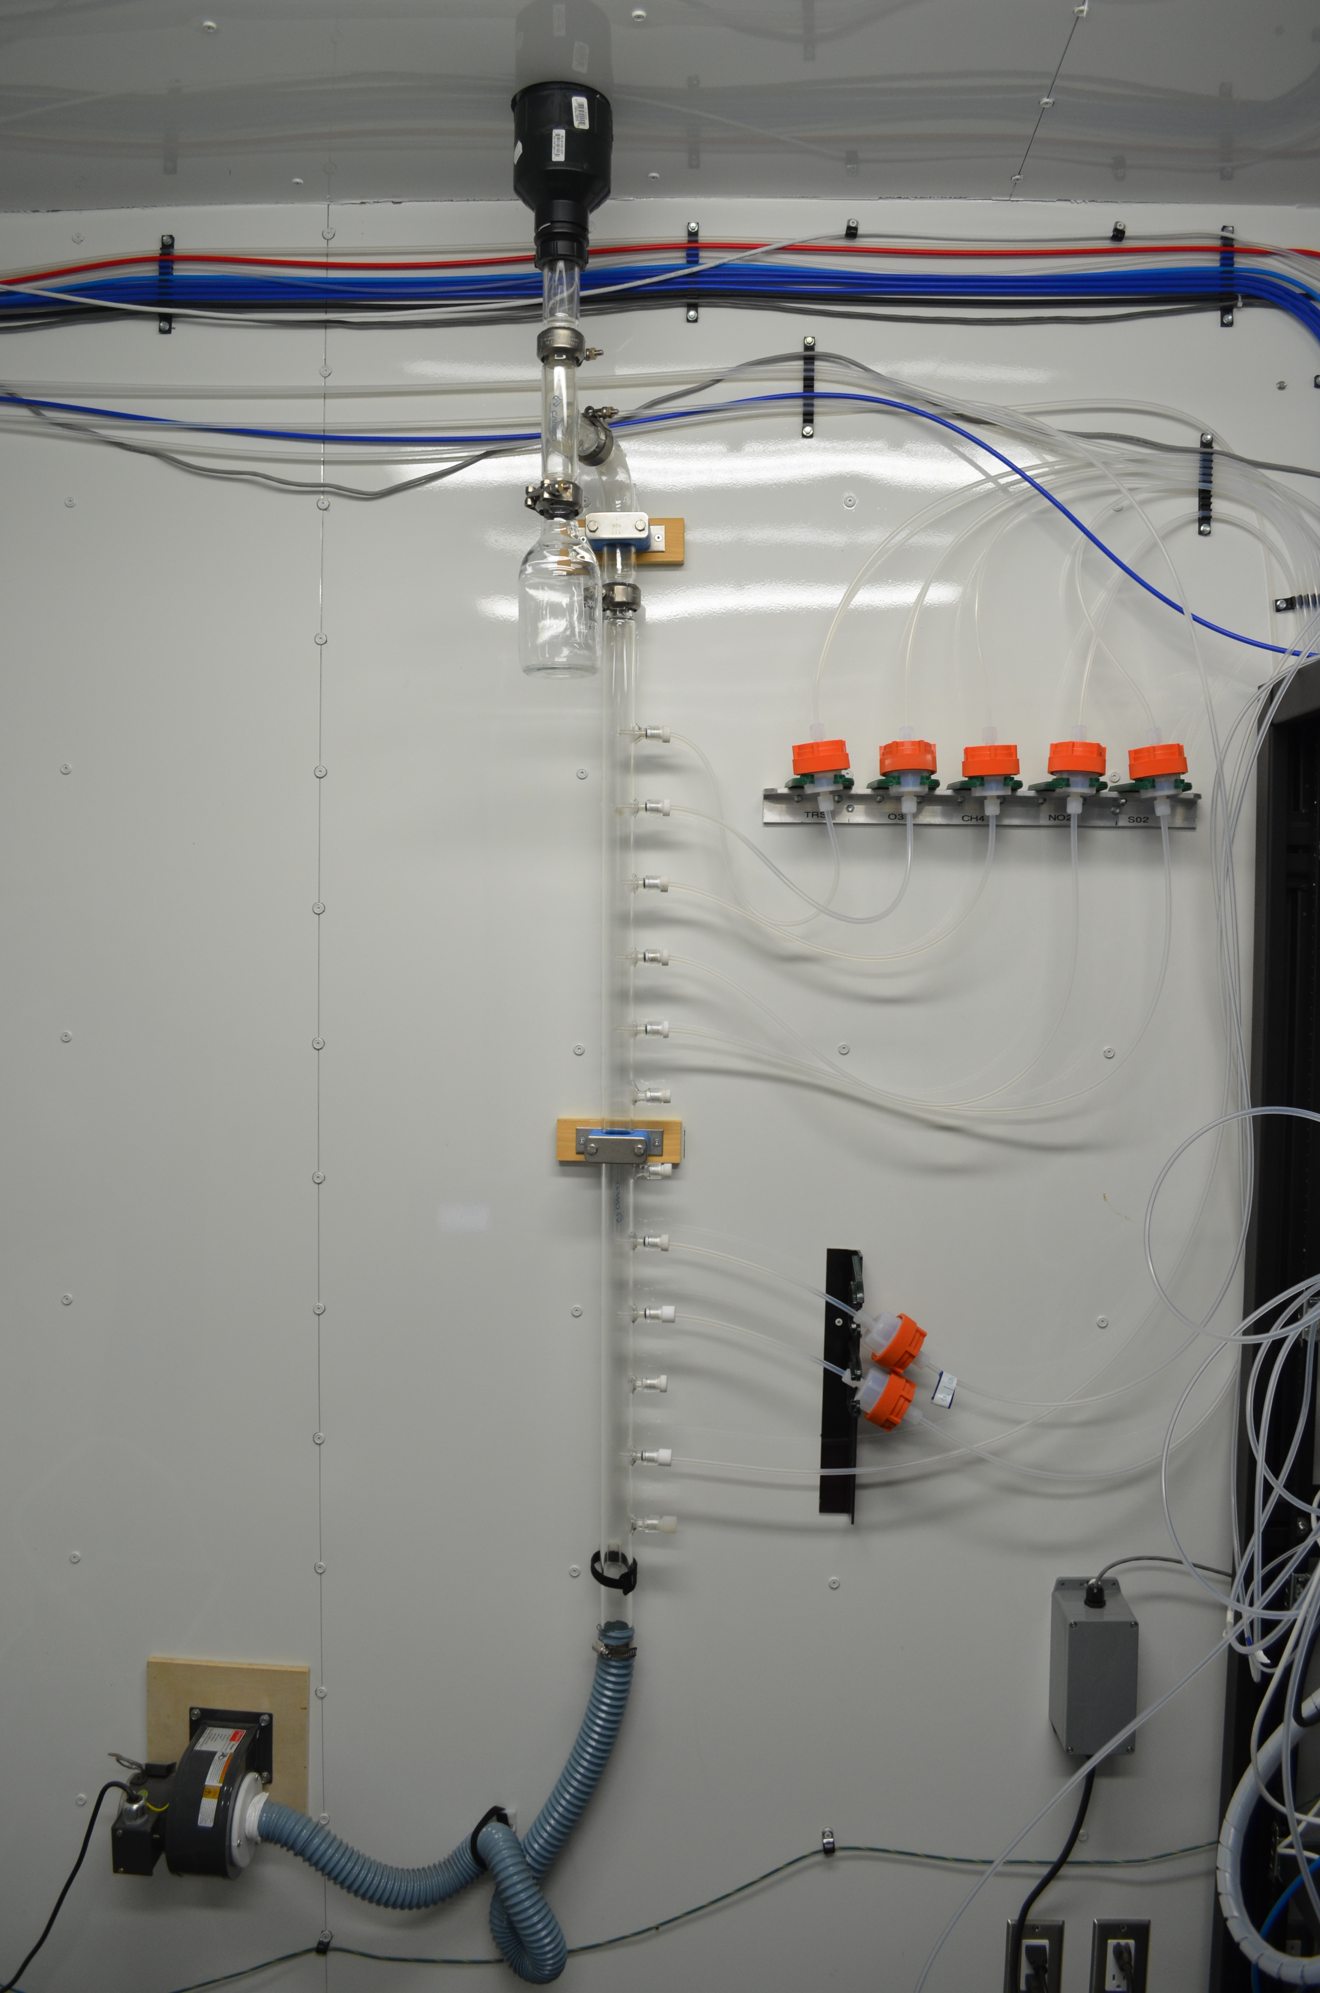
  - Figure 10 – Photo showing the inlet and sample manifold

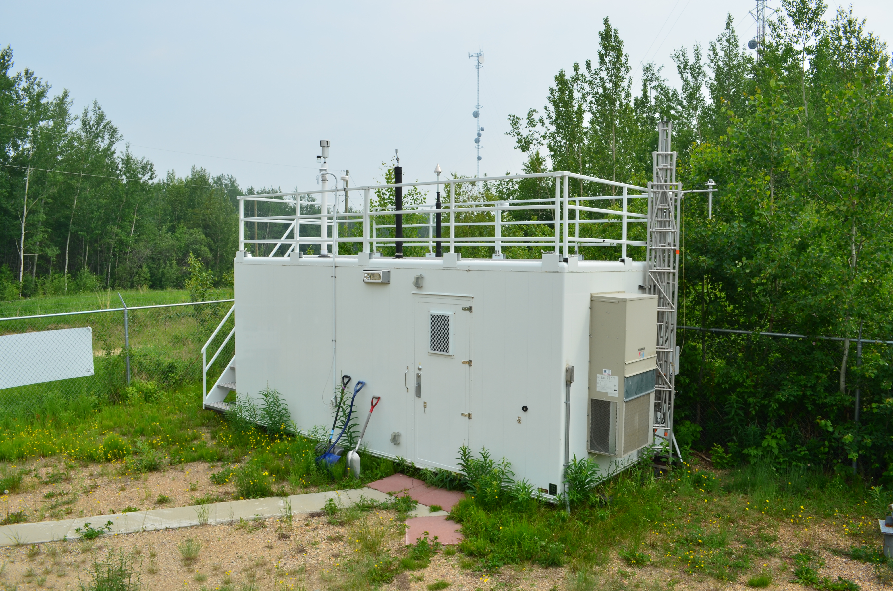
  - Figure 11 – Curb shot of the monitoring station

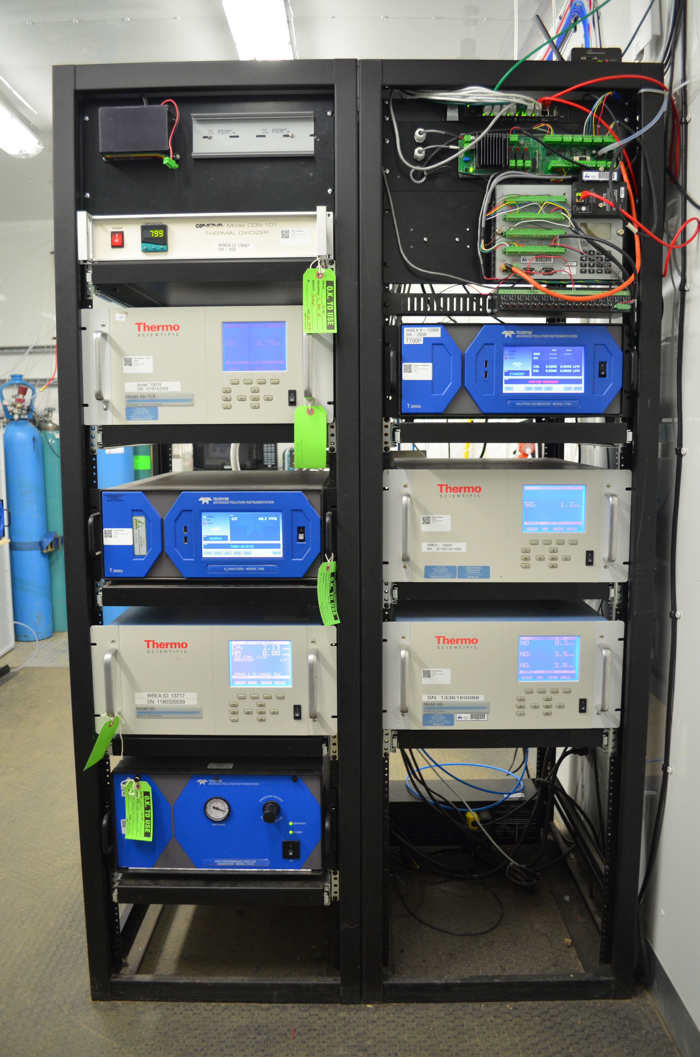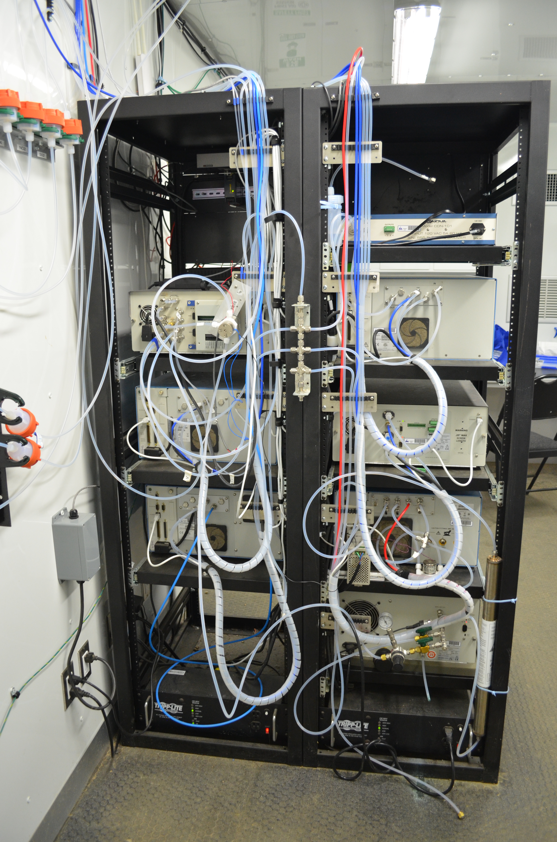
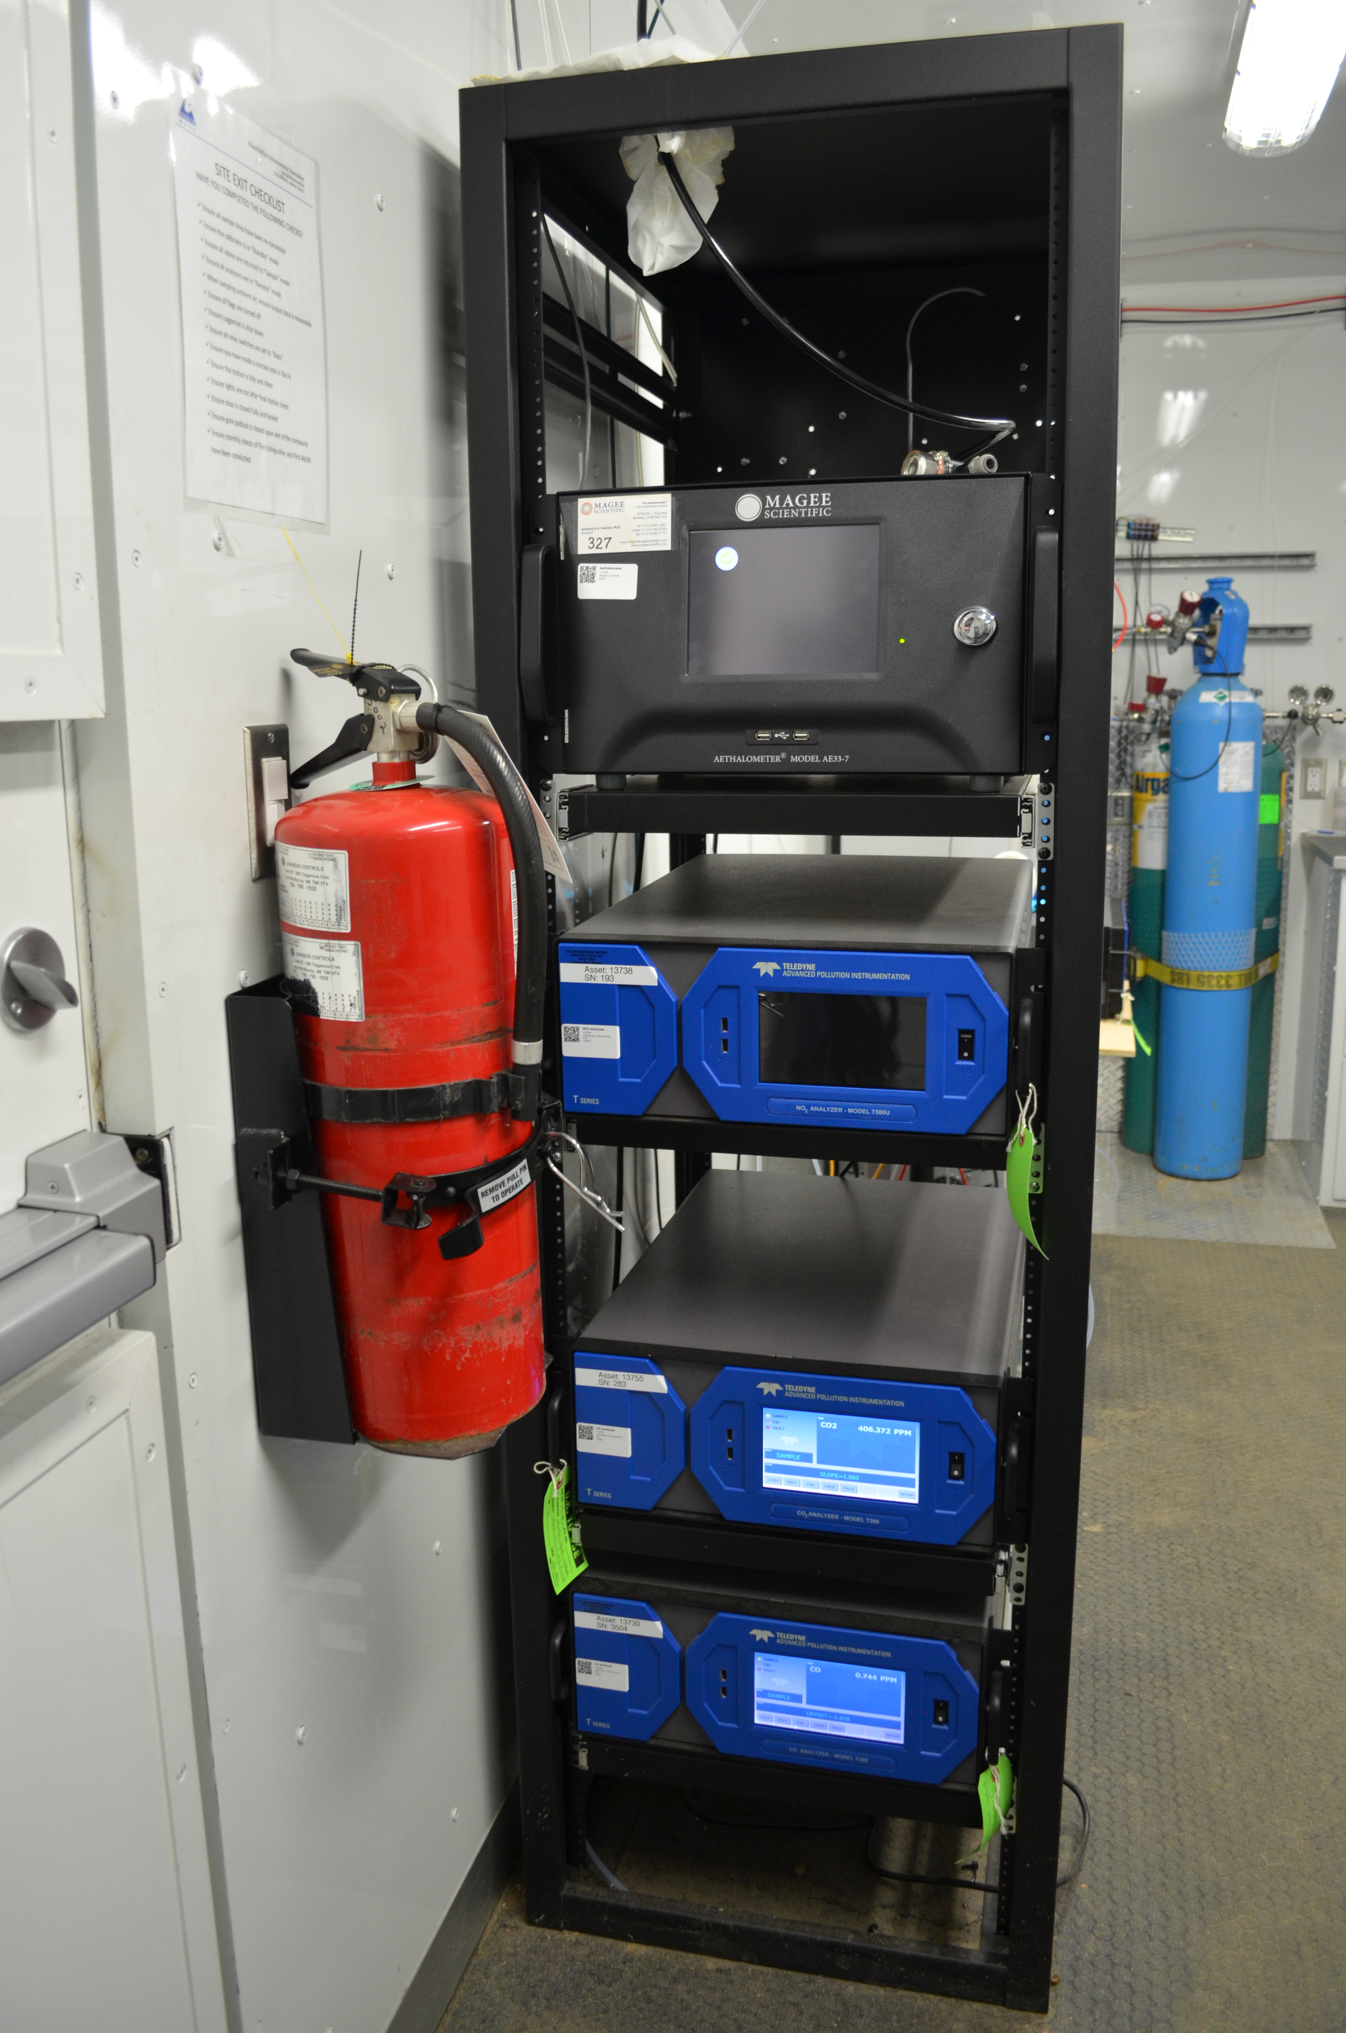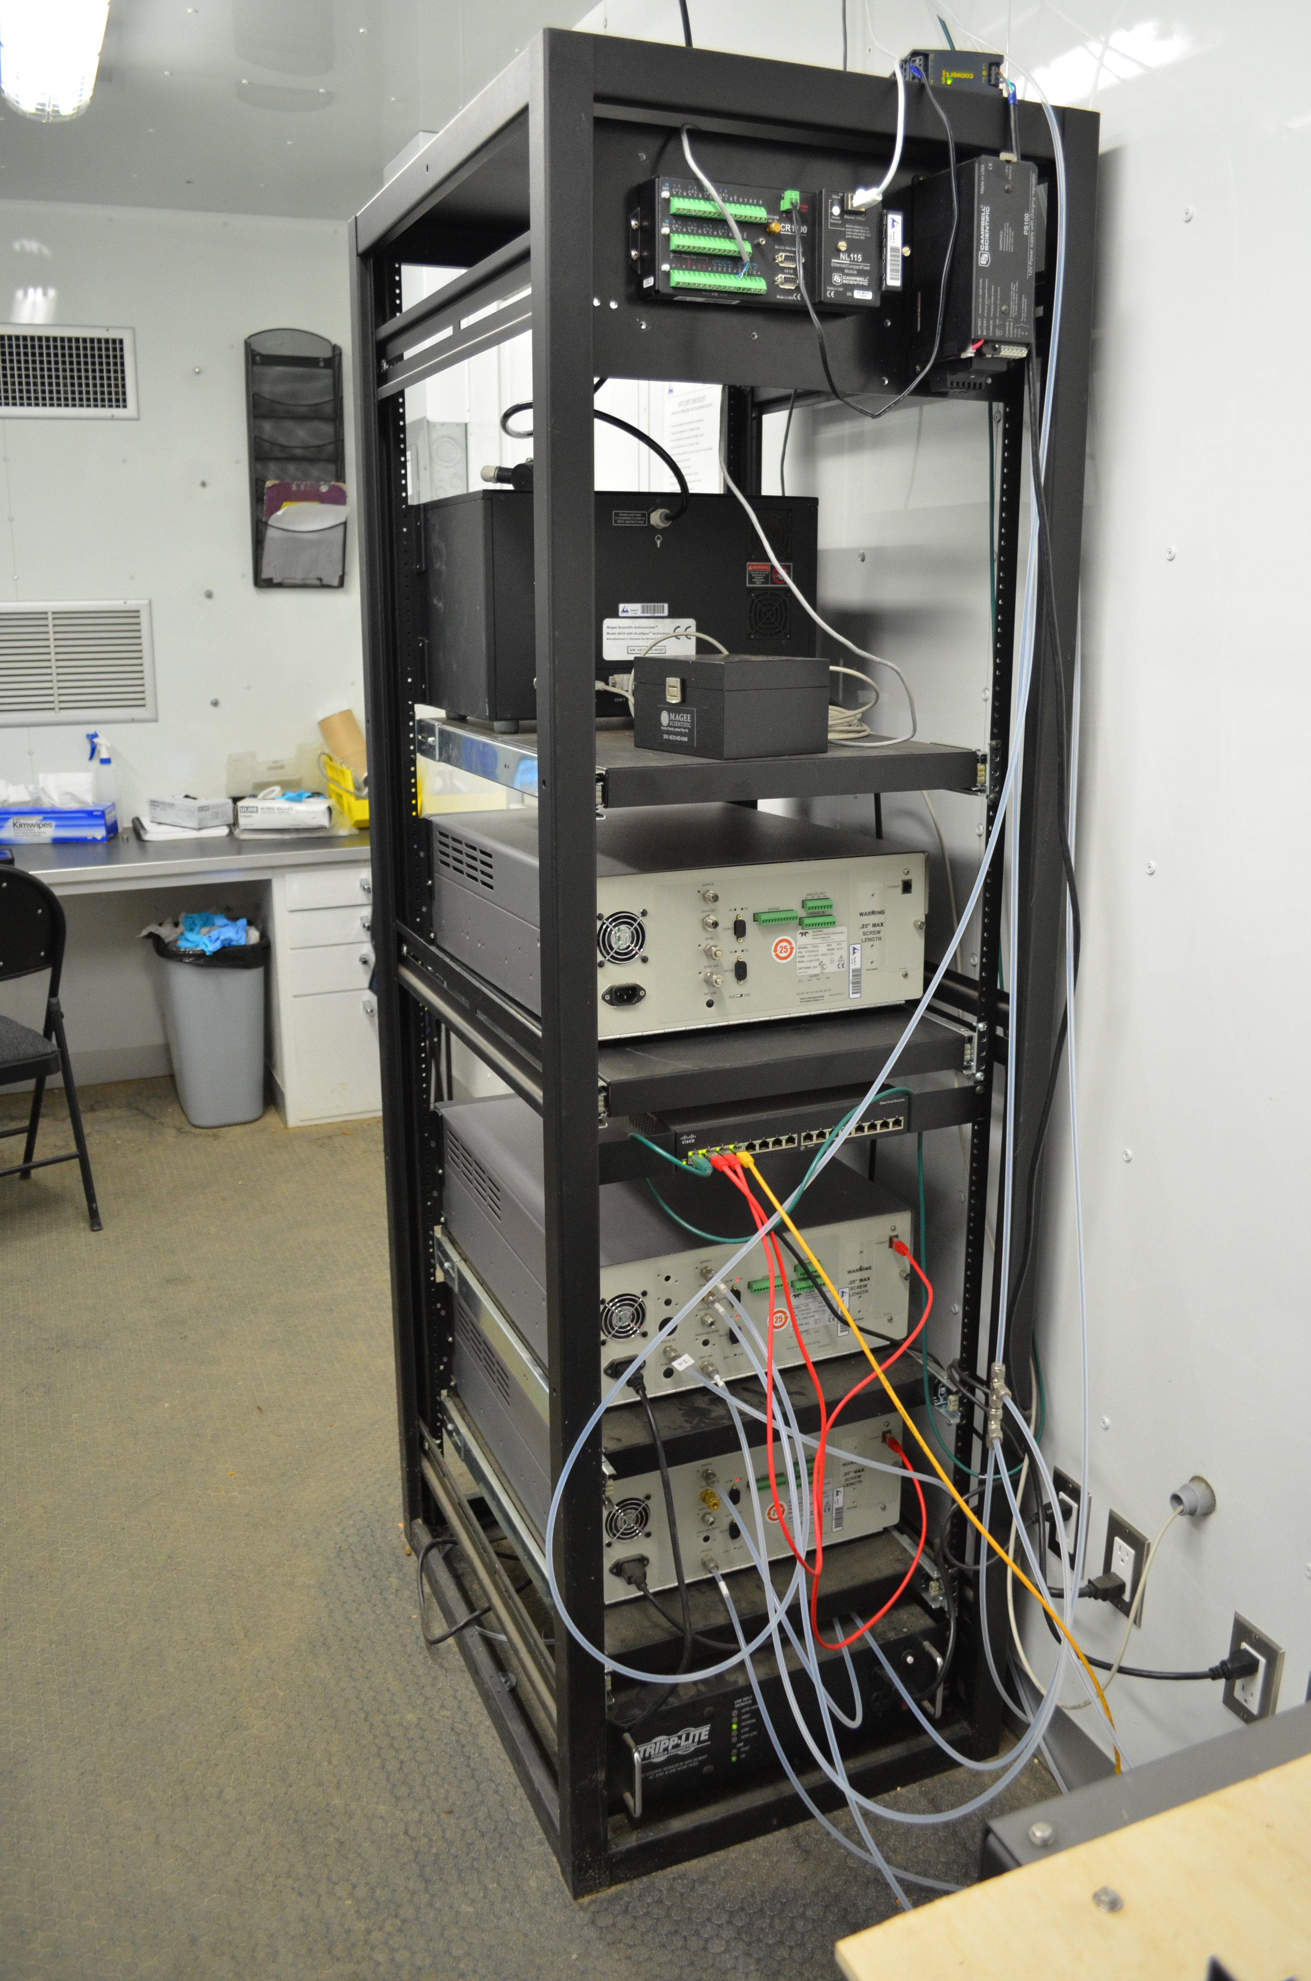
  - Figure 12 –Photo of the front and the back of instrument rack
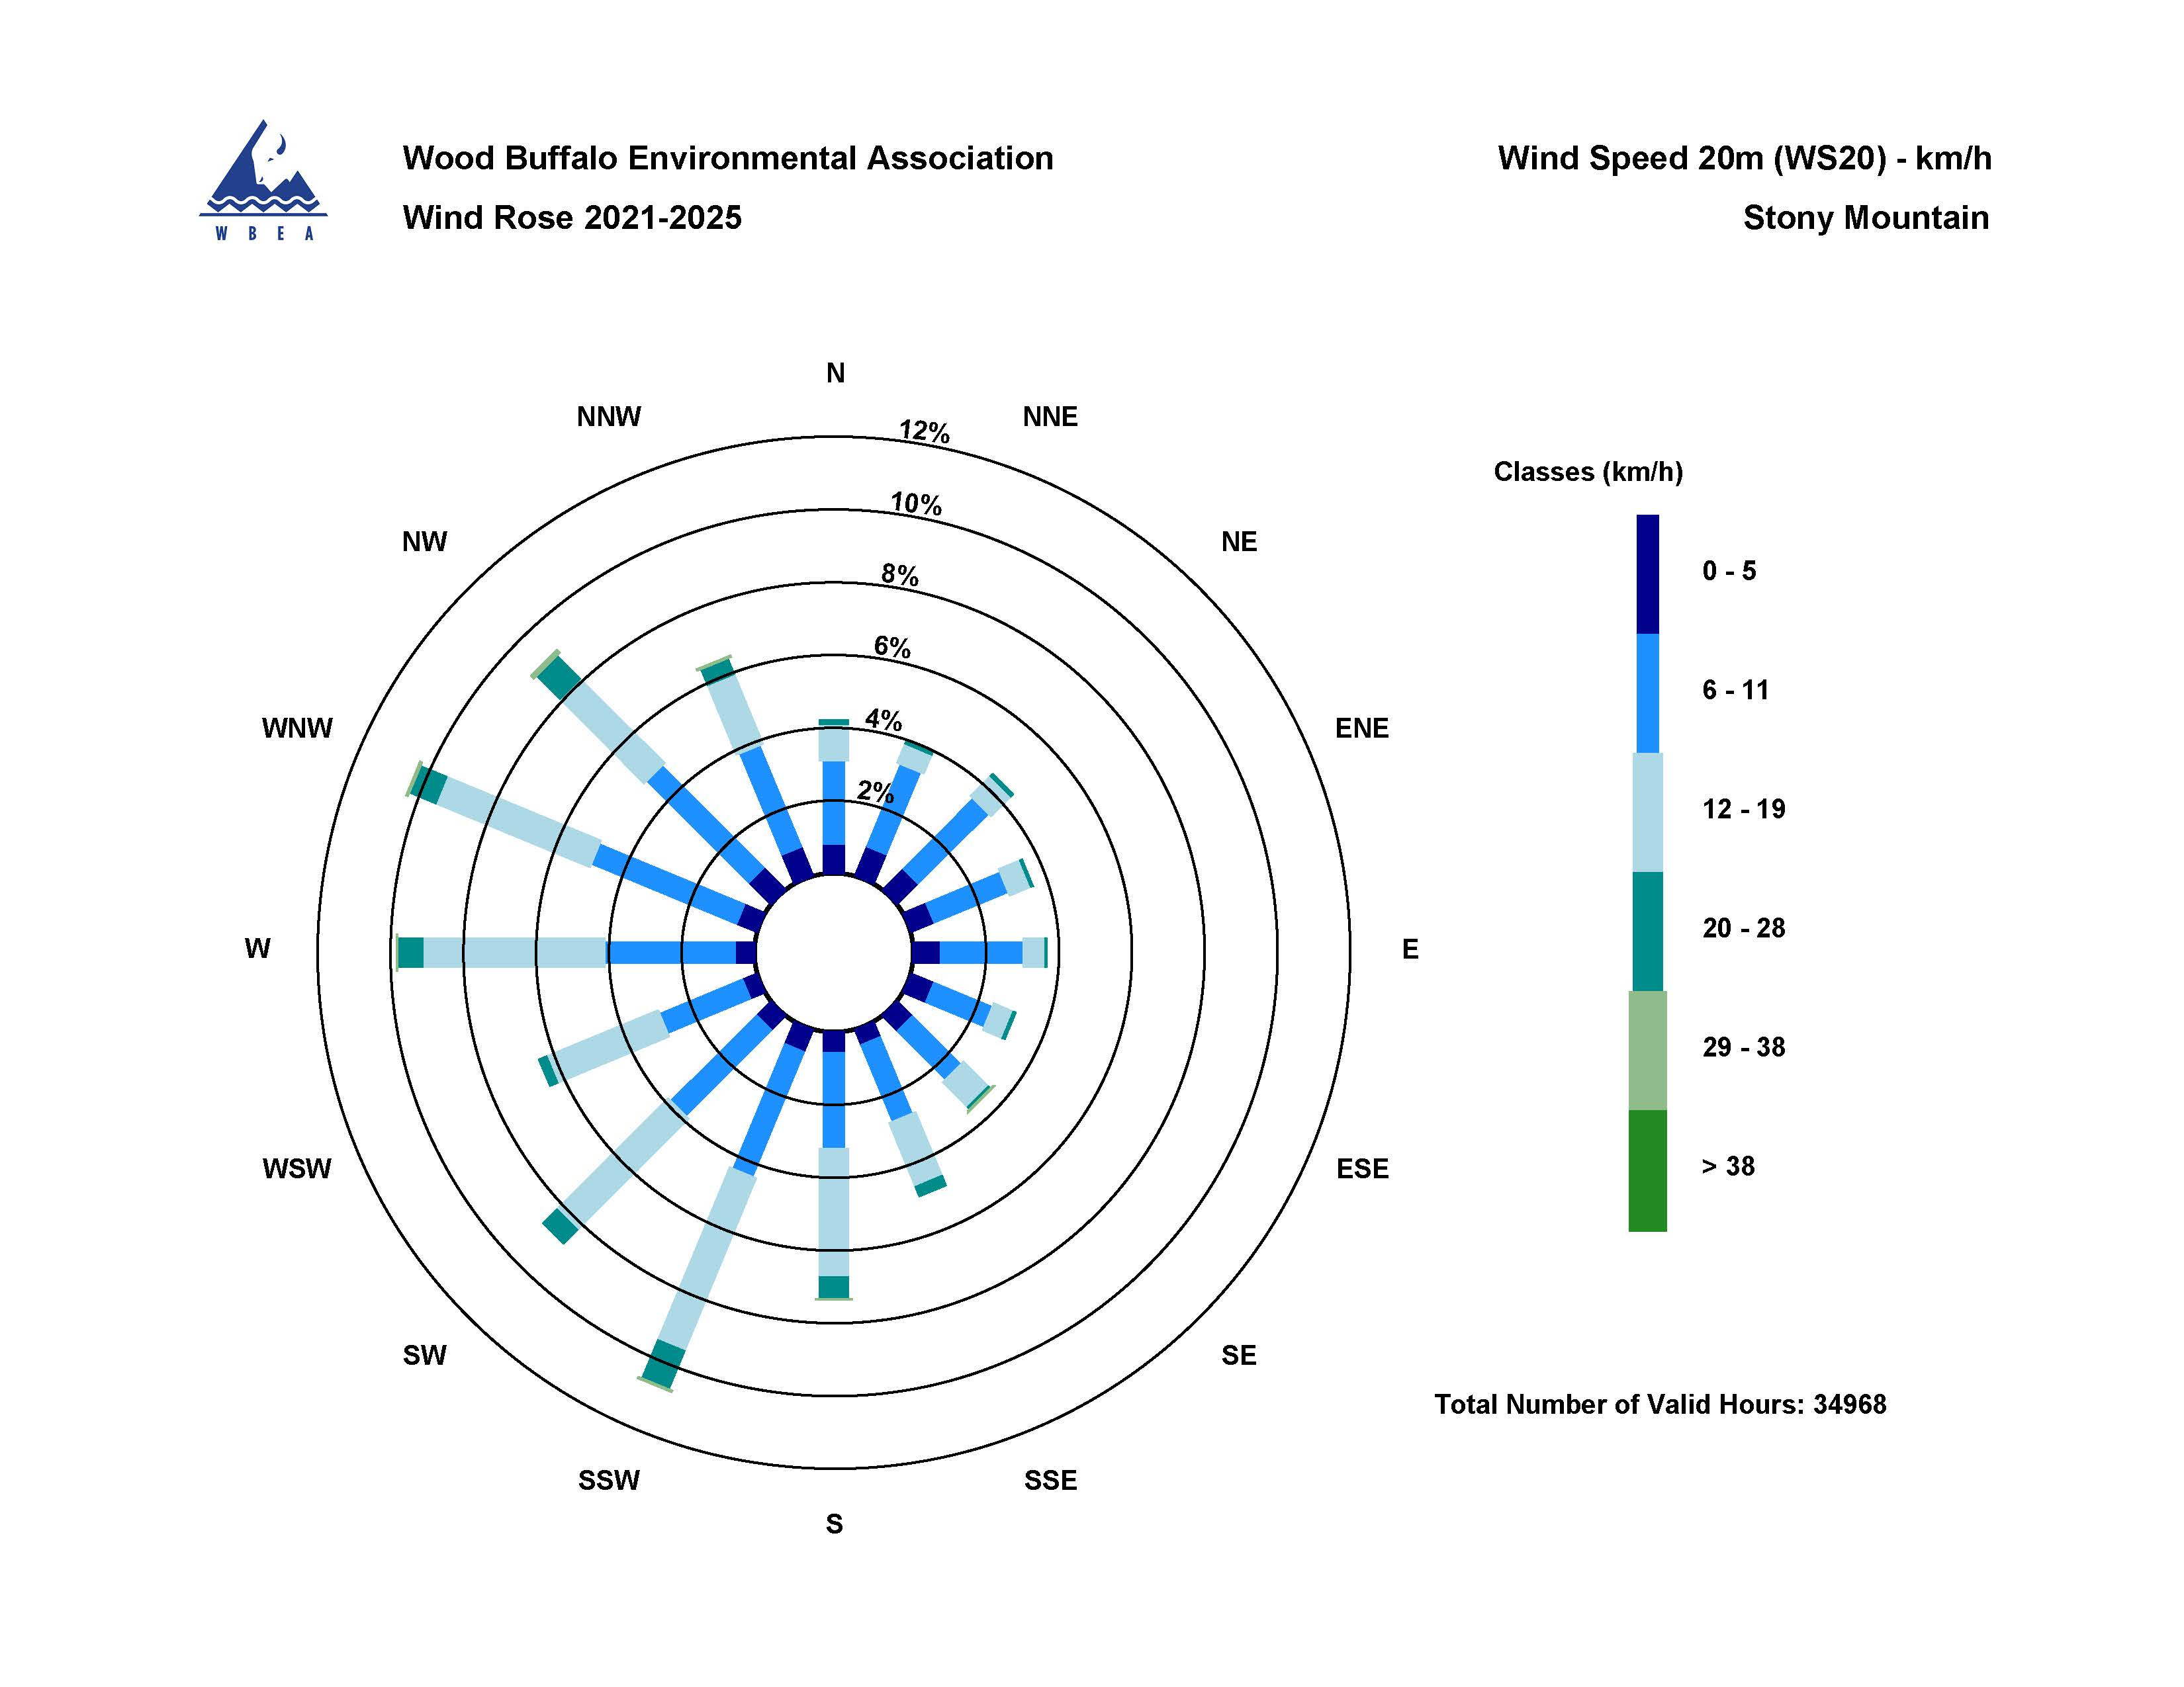

  - Figure 13 – Windrose 20m (2021-2025)

