Wood Buffalo Environmental Association
Ambient Air Monitoring Station
Site Documentation

Wapasu

LAST UPDATED: February 18, 2026

Table of Contents
General Site Information 4
Station 4
Location 4
Owner/Operator/Approval Holder 4
Site Description 4
Site Influences 5
Localized Sources (within 20 metres of station) 5
Roadway Influences 5
Major Point Sources 5
Station Equipment 6
Analytical Equipment 6
Meteorological Equipment 6
Support Equipment 6
Site photos 11
Station Photos 16

Tables and Figures
Figure 1 – Area topographic map showing AMS 17 7
Figure 2 – Aerial photo showing AMS 17 8
Figure 3 – Plan view sketch for AMS 17 site 9
Figure 4 – Elevation view sketch for AMS 17 site 10
Figure 5 – Environment looking North 11
Figure 6 – Environment looking East 12
Figure 7 – Environment looking South 13
Figure 8 – Environment looking West 14
Figure 9 – Meteorological Tower 15
Figure 10 – Photo showing the inlet and sample manifold 16
Figure 11 – Curb shot of the monitoring station 17
Figure 12 –Photo of the front and the back of instrument rack 18
Figure 13 – Windrose (2021-2025) 19

General Site Information
Revision Date: March 28, 2024

Station
Station ID | AMS 17
Station name | Wapasu
Date station established | November, 2013

Location
Station street address | Located northeast of Husky Sunrise.
Legal land description | 9-22-095-07 W4
Airshed Zone | Wood Buffalo Environmental Association
Latitude | 57.25913818
Longitude | -111.0385386
UTM East | 497672
UTM North | 6346240
Nearest community | Fort Mackay
Community population | 757
Census Year | 2021

Owner/Operator/Approval Holder
Operating Agency | Wood Buffalo Environmental Association
Address of Operating Agency | Unit 3-805 Memorial Drive, Fort McMurray, Alberta T9K 0K4
Name of Approval Holder | Cenovus
Approval number | 206355-01-00
Contact Name | Rene Morales
Address | N/A
Phone number | 403-816-6144
Email address | Rene.morales@cenovus.com

Site Description
Land use by sector | 0 – 90 degrees | Decommissioned well pad
Land use by sector | 91 – 180 degrees | Wooded area
Land use by sector | 181 – 270 degrees | Wooded area
Land use by sector | 271 – 360 degrees | Site access road
Site elevation (m)  (above sea level) | 491
Angle of elevation to nearby buildings | Greatest angle | N/A
Angle of elevation to nearby buildings | Building direction | N/A
Airflow restrictions | North | No
Airflow restrictions | East | No
Airflow restrictions | South | No
Airflow restrictions | West | No
Distance to nearest trees (m) | North | 45 m
Distance to nearest trees (m) | East | 45 m
Distance to nearest trees (m) | West | 80 m
Distance to nearest trees (m) | South | 45 m
Sample manifold | Type | All glass
Sample manifold | Inlet height above roof | 1 metre
Wind Sensors | Type | Cup and vane
Wind Sensors | Height above ground (m) | 10 m
Wind Sensors | Distance from station (m) | 0 m

Site Influences

Localized Sources (within 20 metres of station)
Type | Distance (m) | Description
None | N/A | N/A

Roadway Influences
Type | Traffic Volume | Distance (m) | Description
Access road | Low | 5 | Gravel access road used by pickup trucks.
Canterra Main Road | High | 1500 | Heavily trafficked gravel road frequented by heavy equipment, tractor trailers, and pickup trucks.

Major Point Sources
Facility Name | Source Type | Distance from site (km) | Compass direction from site
Suncor Firebag | Oilsands Operation | 10 | SE
Cenovus Sunrise | Oilsands Operation | 2 | SW

Station Equipment
Equipment Owner:

Analytical Equipment
Parameter | Make | Model | Serial Number | Date Instrument Installed | WBEA Data Start Date
Continuous
SO₂ | Thermo Environmental | 43i | 1218153459 | March, 2016 | December, 2013
H₂S | Thermo Environmental | 43i-TLE | 12228021057 | February 2026 | December, 2013
 | Global H2S Converter |  | 2022-219 | February 2026
NO/NO_{x}/NO₂ | Thermo Environmental | 42iQ | 12300522720 | June, 2023 | December, 2013
THC | Thermo Environmental | 51i | 1218153352 | March, 2016 | December, 2013
O₃ | Teledyne/API | T400 | 3870 | March, 2016 | January, 2014
PM_{2.5} | Teledyne/API | T640 | 1183 | March, 2016 | December, 2013
Time-Integrated
ECOC | Thermo Environmental | 2000i | 20001204511404 | March, 2016 | -
PC | N-CON | 00-120-2 | 60198 | March, 2016 | -

Meteorological Equipment
Parameter | Make | Model | Serial Number | WMO Site Class | Date Sensor Installed | WBEA Data Start Date
AT/RH | Vaisala | HMP155 | G4330041 | 3 | September, 2021 | December, 2013
WS | Met One | 010C-1 | N14664 | 3 | May, 2018 | December, 2013
WD | Met One | 020C-1 | P19942 | 3 | May, 2018 | December, 2013
PC | OTT | Pluvio 2 | 31209514 | 3 | March, 2016 | December, 2015

Support Equipment
Name | Description | Make | Model | Serial Number
Datalogger | Datalogger | Campbell Scientific | CR3000 | 2663
Datalogger | Datalogger | Campbell Scientific | CR310 | 6009
Gas Dilution Calibrator | Dynamic dilution calibrator | Teledyne/API | T700 | 2449
Zero air generator | Zero Air Generator | Teledyne/API | 701H | 359
Shelter / Building | Air monitoring portable | ITB | 8 x 16 trailer | ITB12-15686
HVAC | Heating and air conditioning system. Wall mount unit | BARD | 1 ton | NA

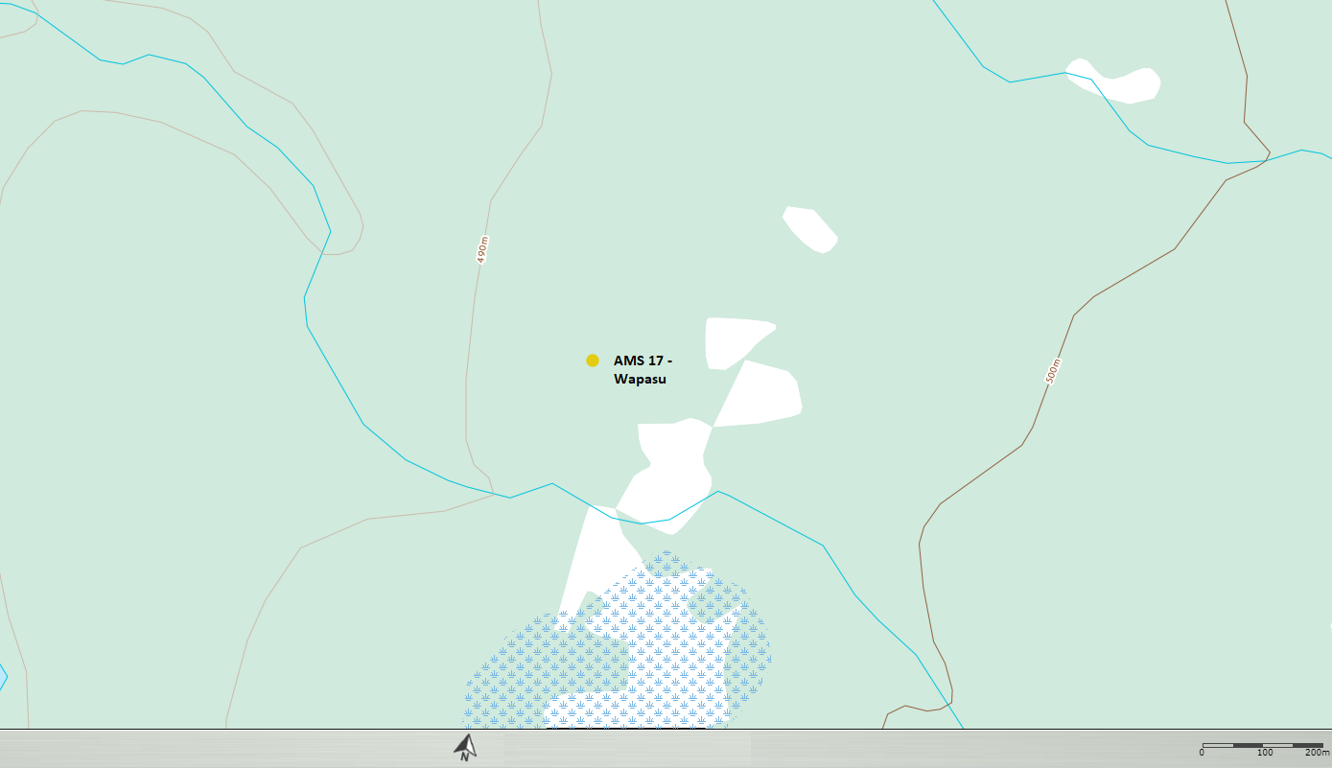

  - Figure 1 – Area topographic map showing AMS 17

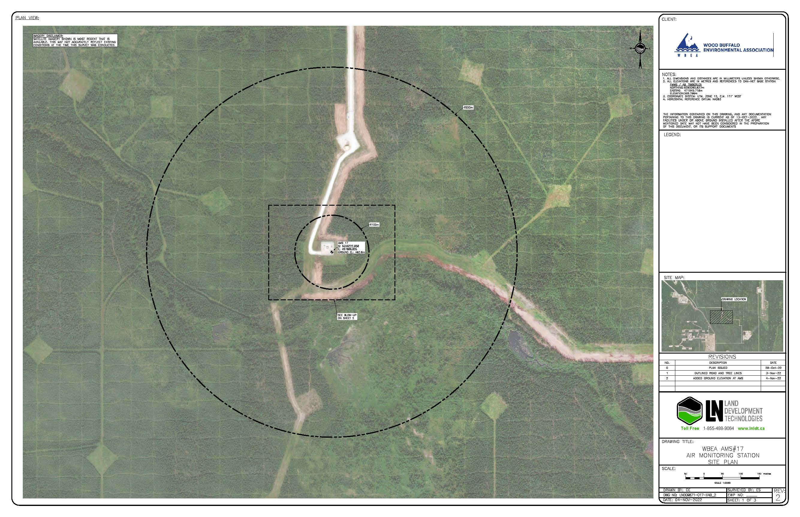

  - Figure 2 – Aerial photo showing AMS 17
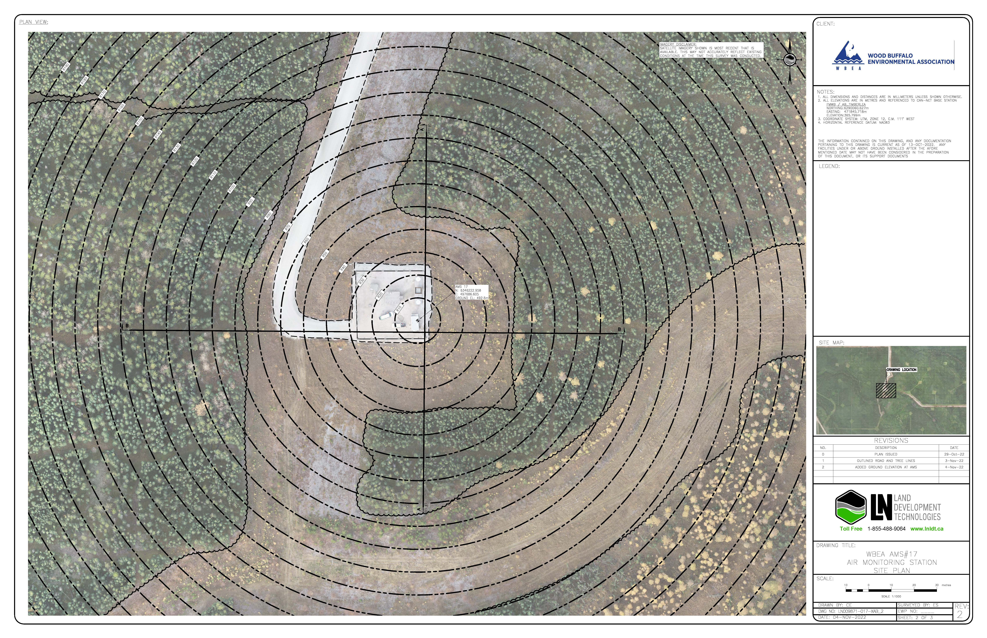

  - Figure 3 – Plan view sketch for AMS 17 site
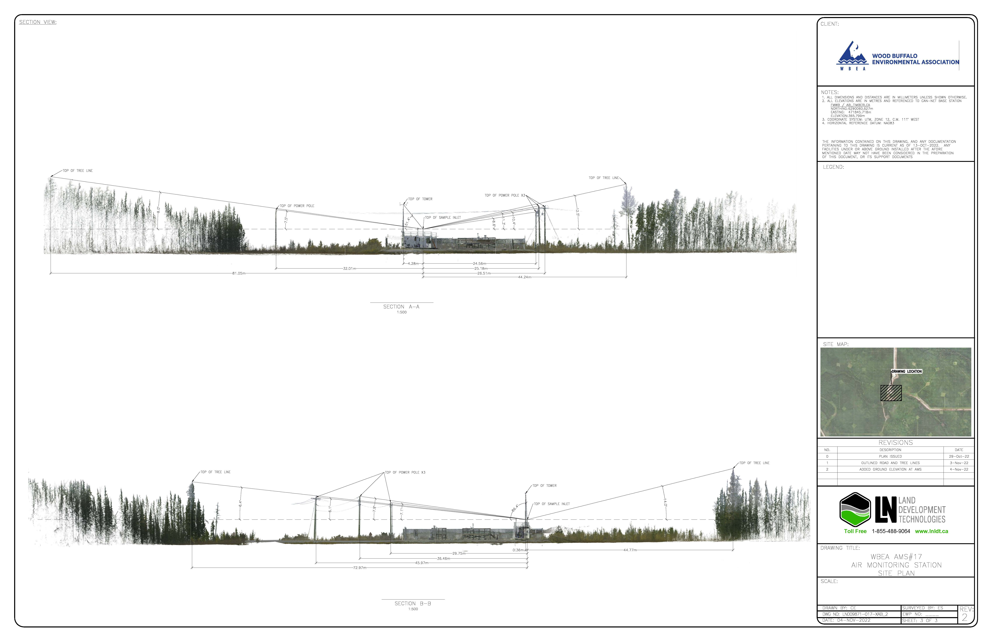

  - Figure 4 – Elevation view sketch for AMS 17 site

Site photos
The following photos show the environment surrounding the monitoring station.

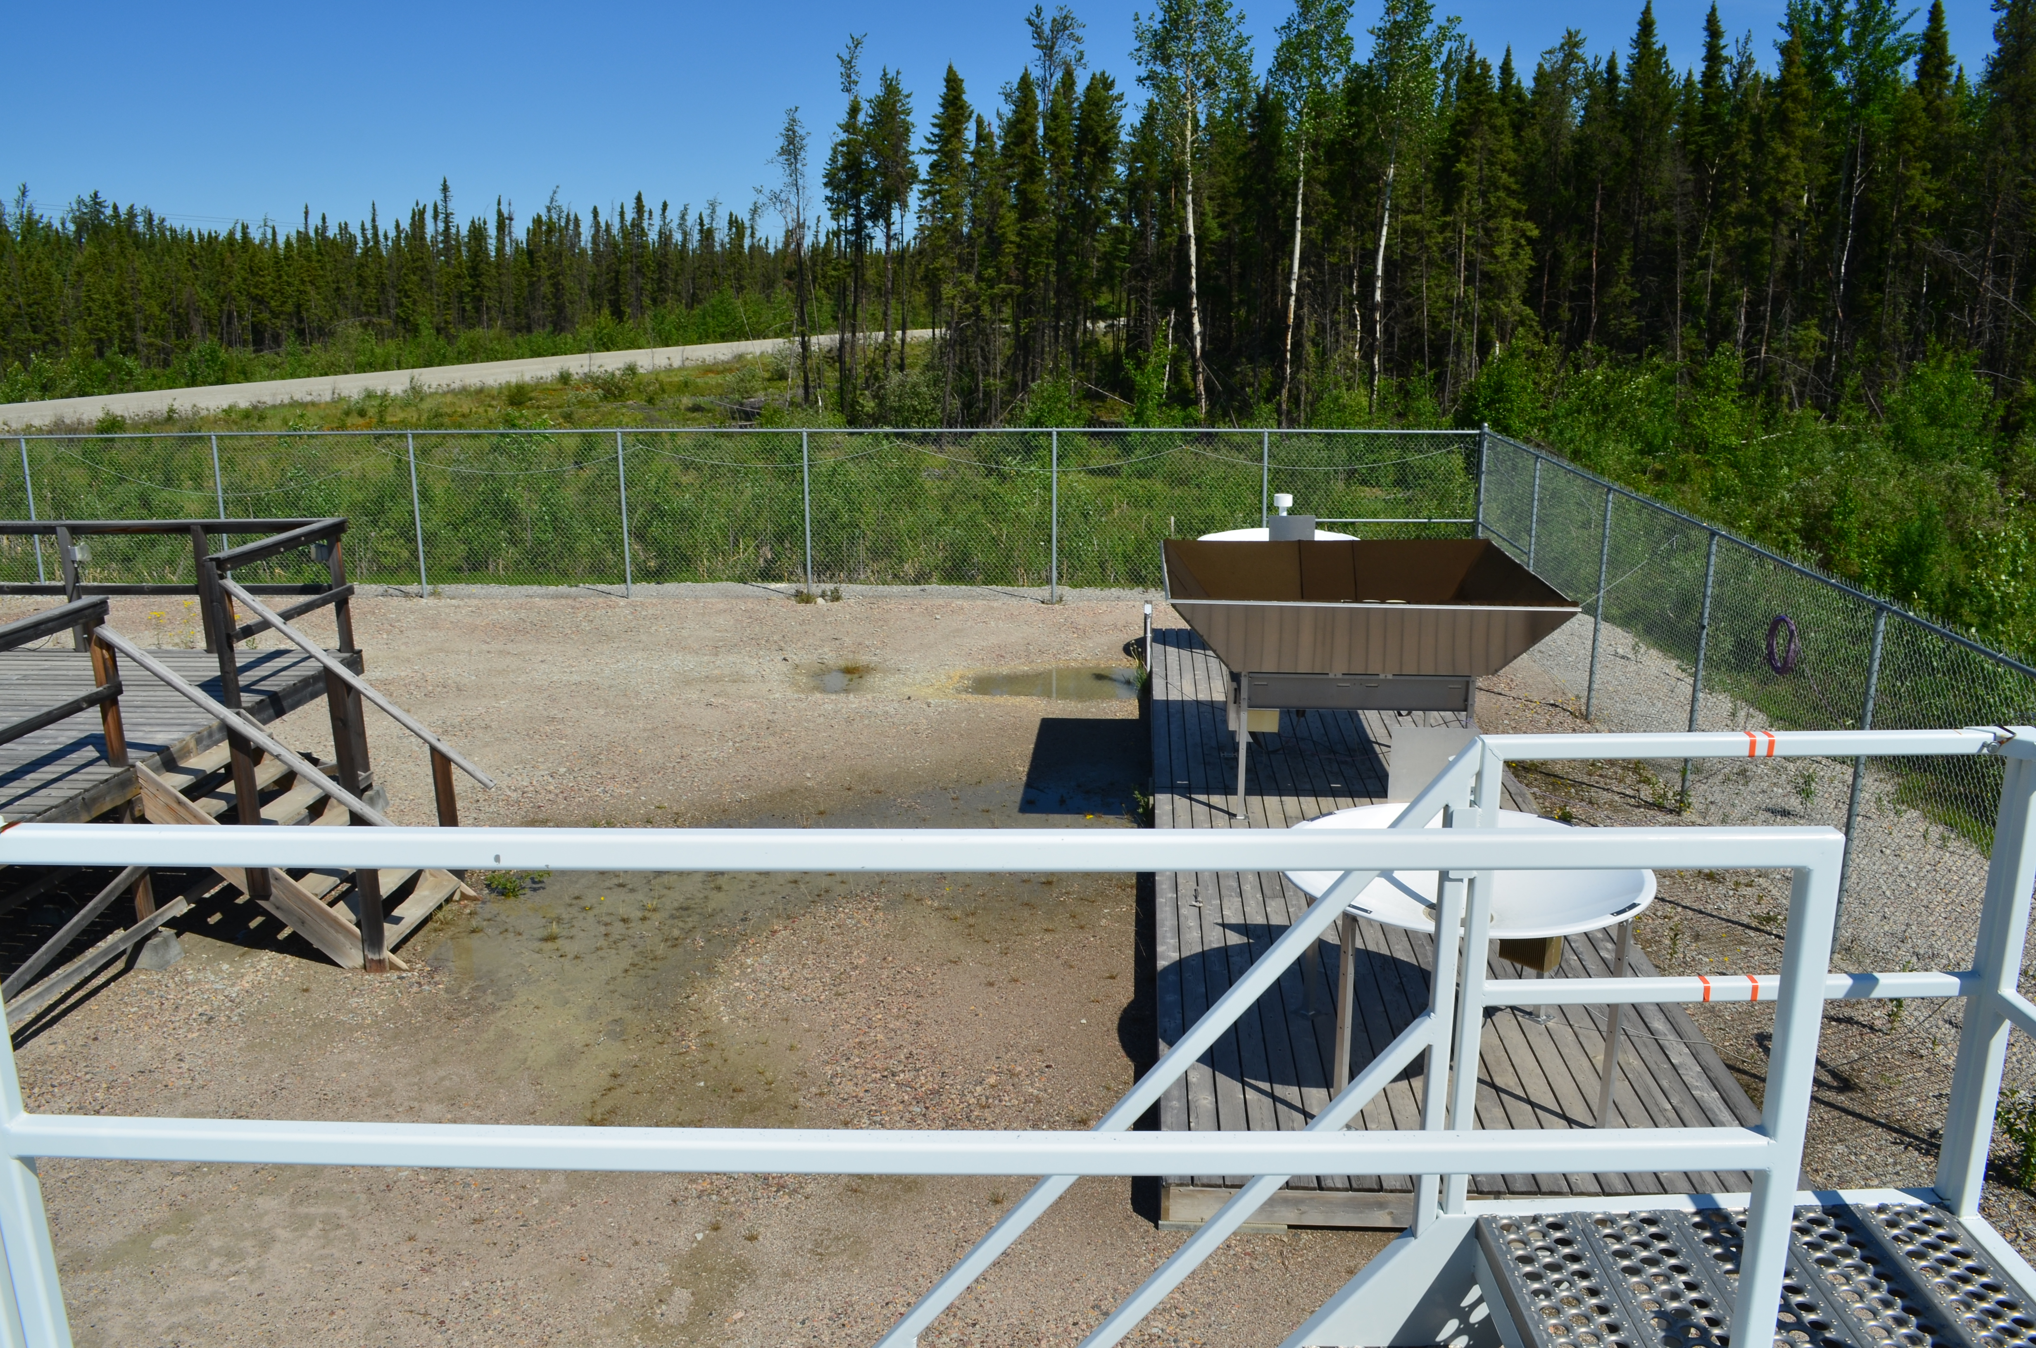
  - Figure 5 – Environment looking North

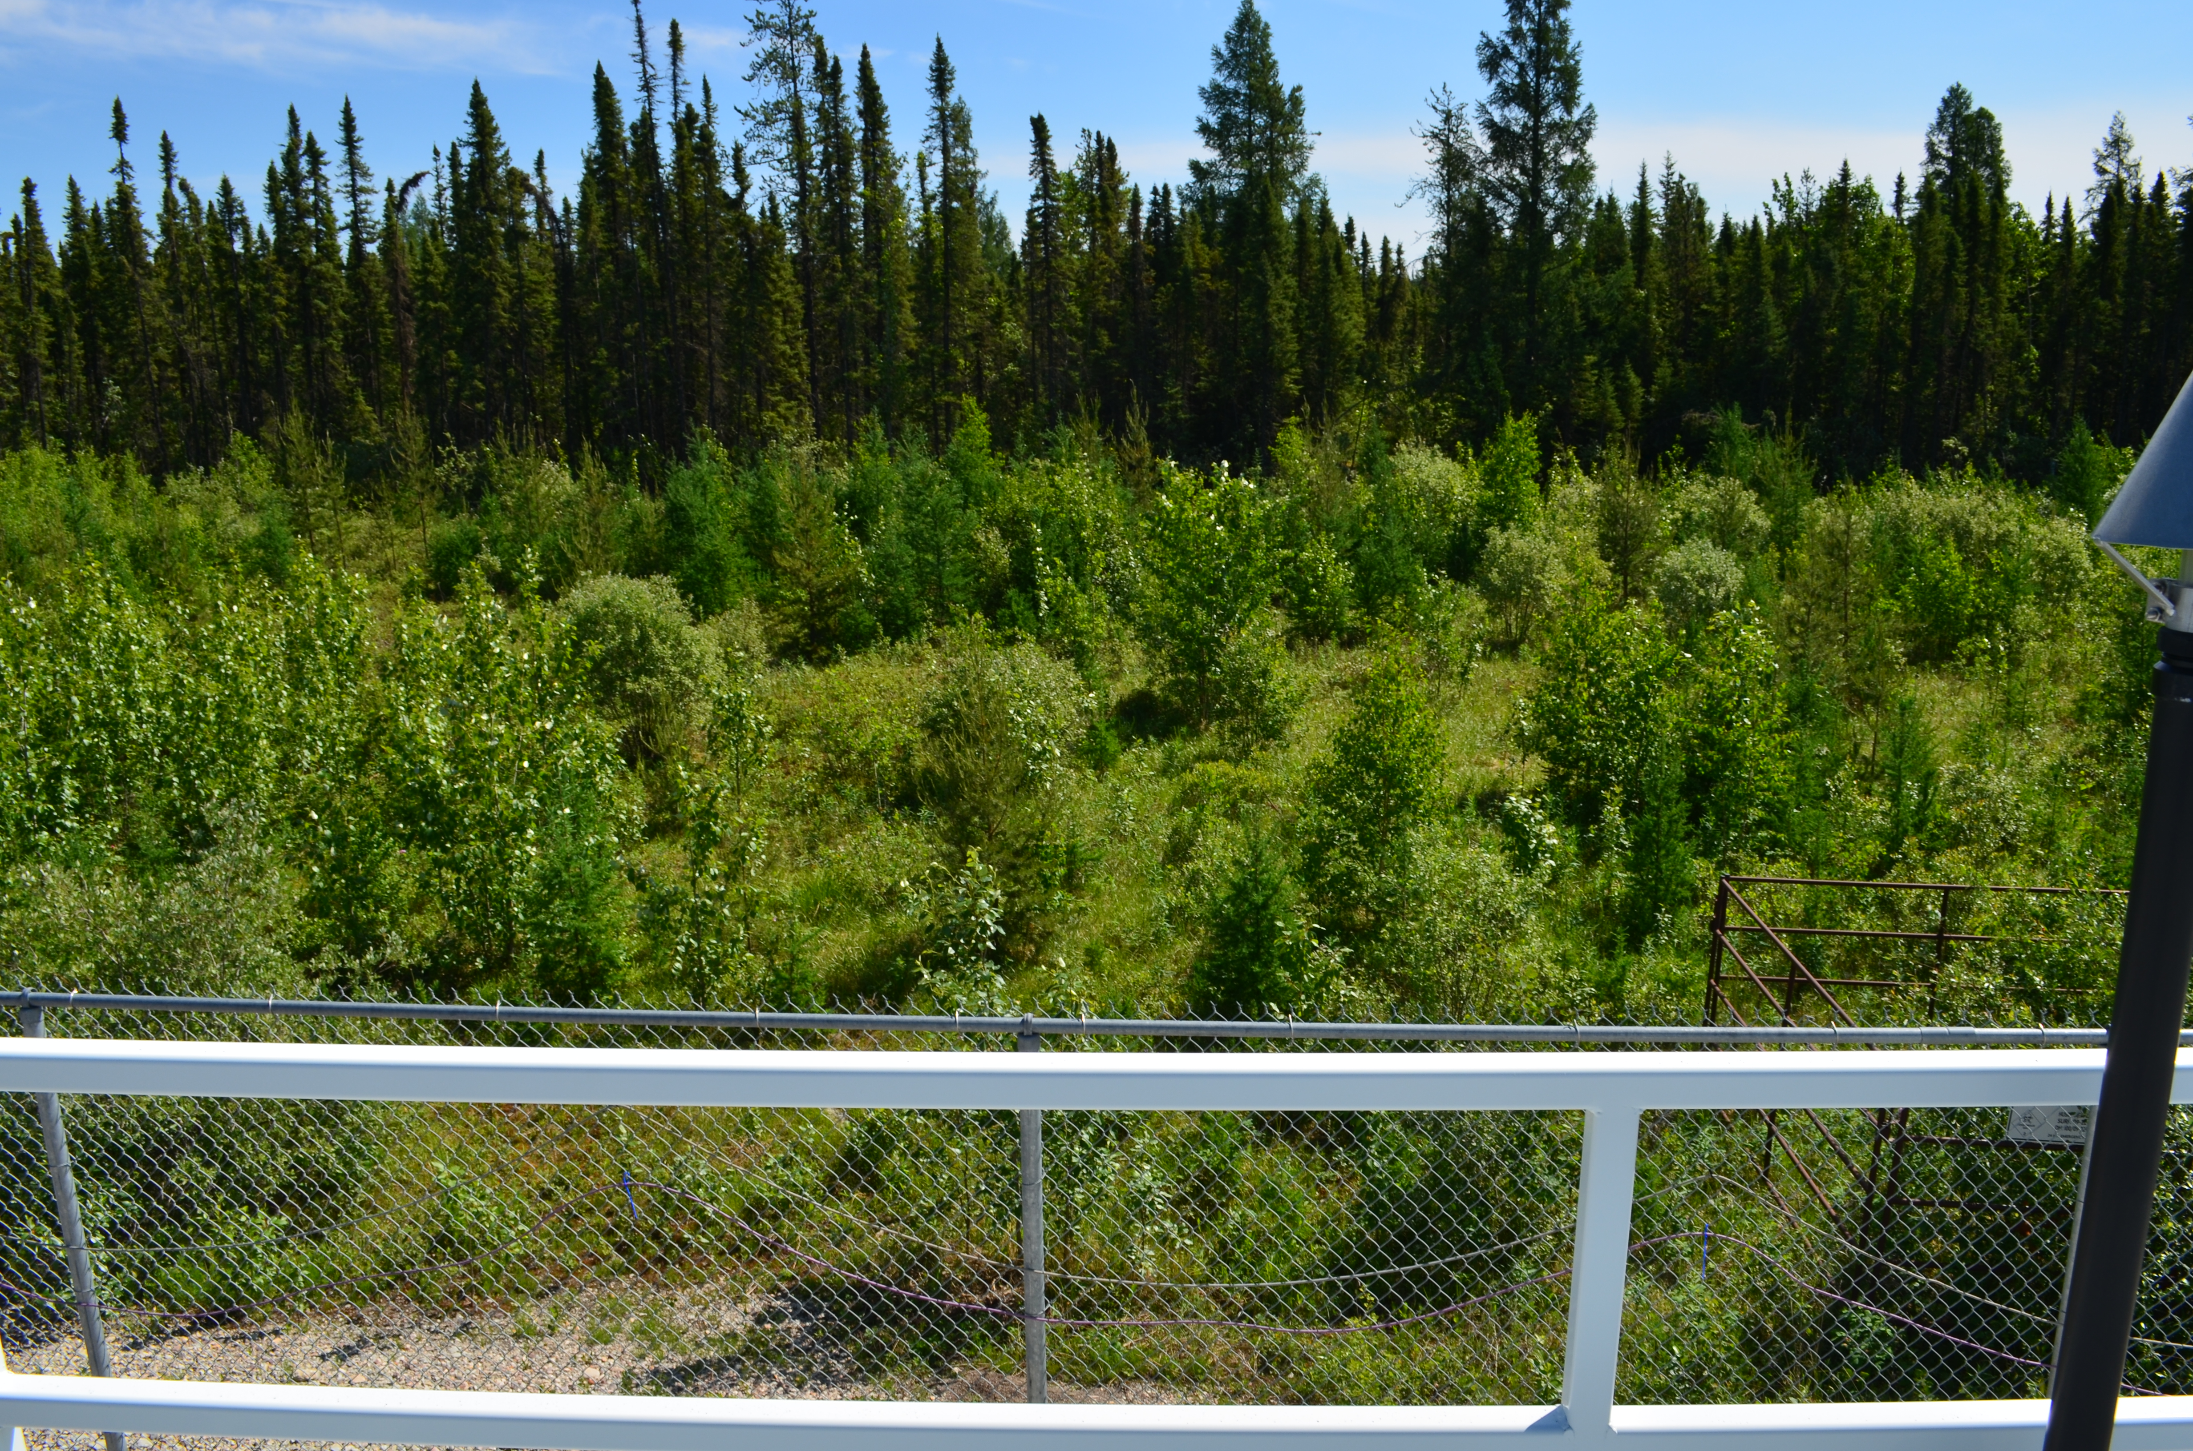
  - Figure 6 – Environment looking East

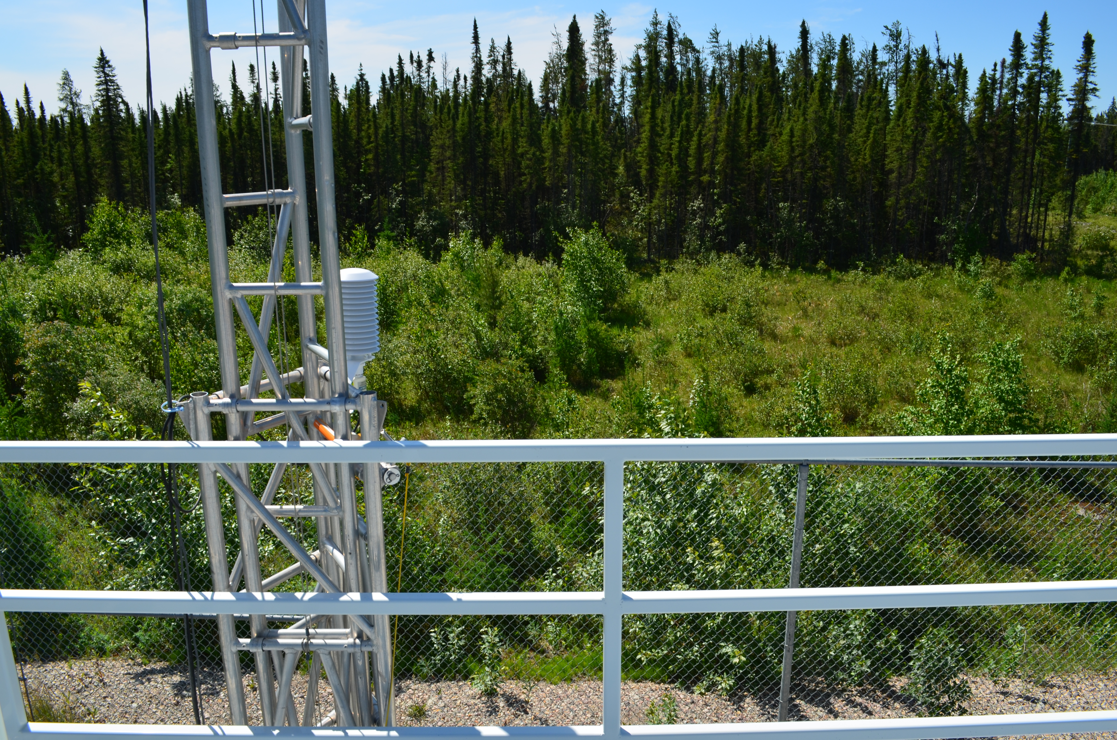
  - Figure 7 – Environment looking South

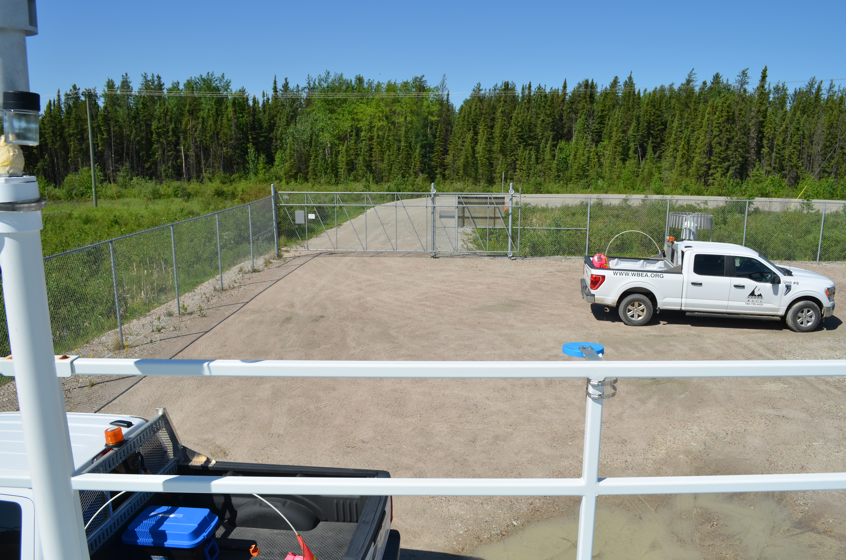
  - Figure 8 – Environment looking West

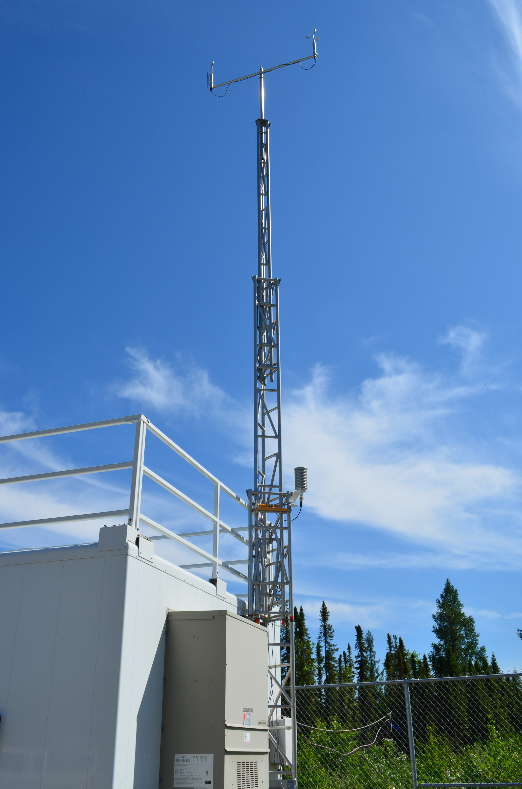
  - Figure 9 – Meteorological Tower

Station Photos
The following photos show the monitoring station and instrumentation.

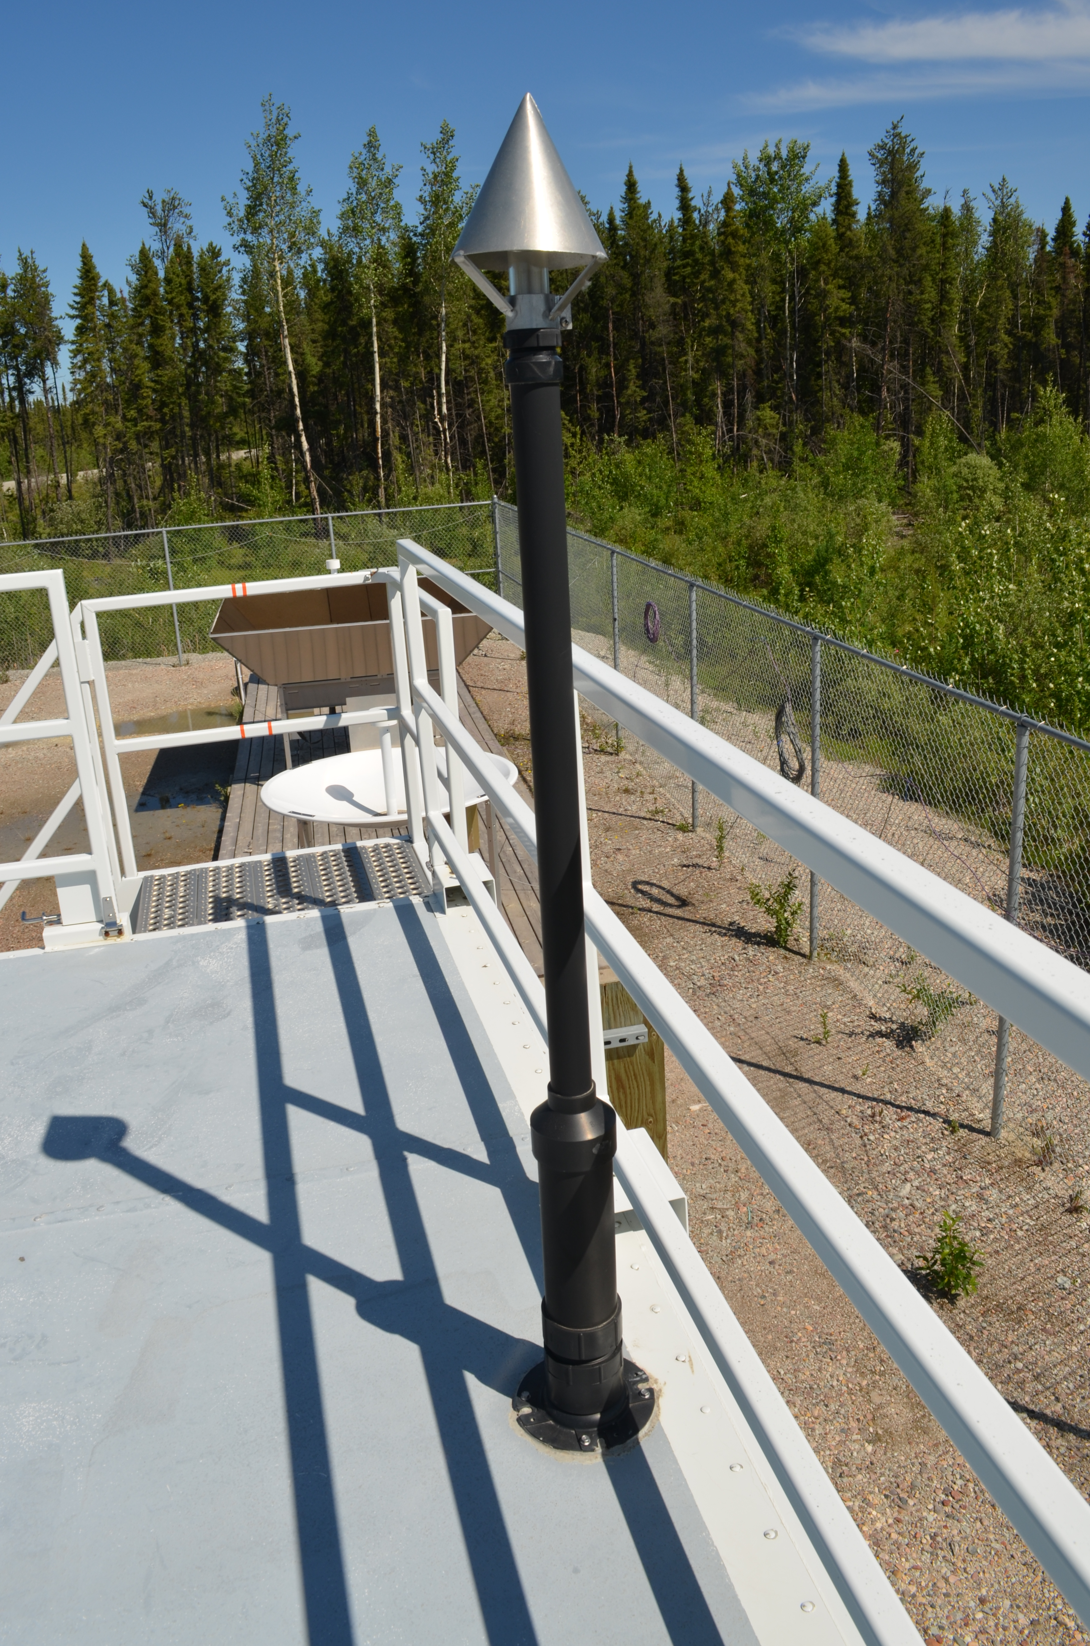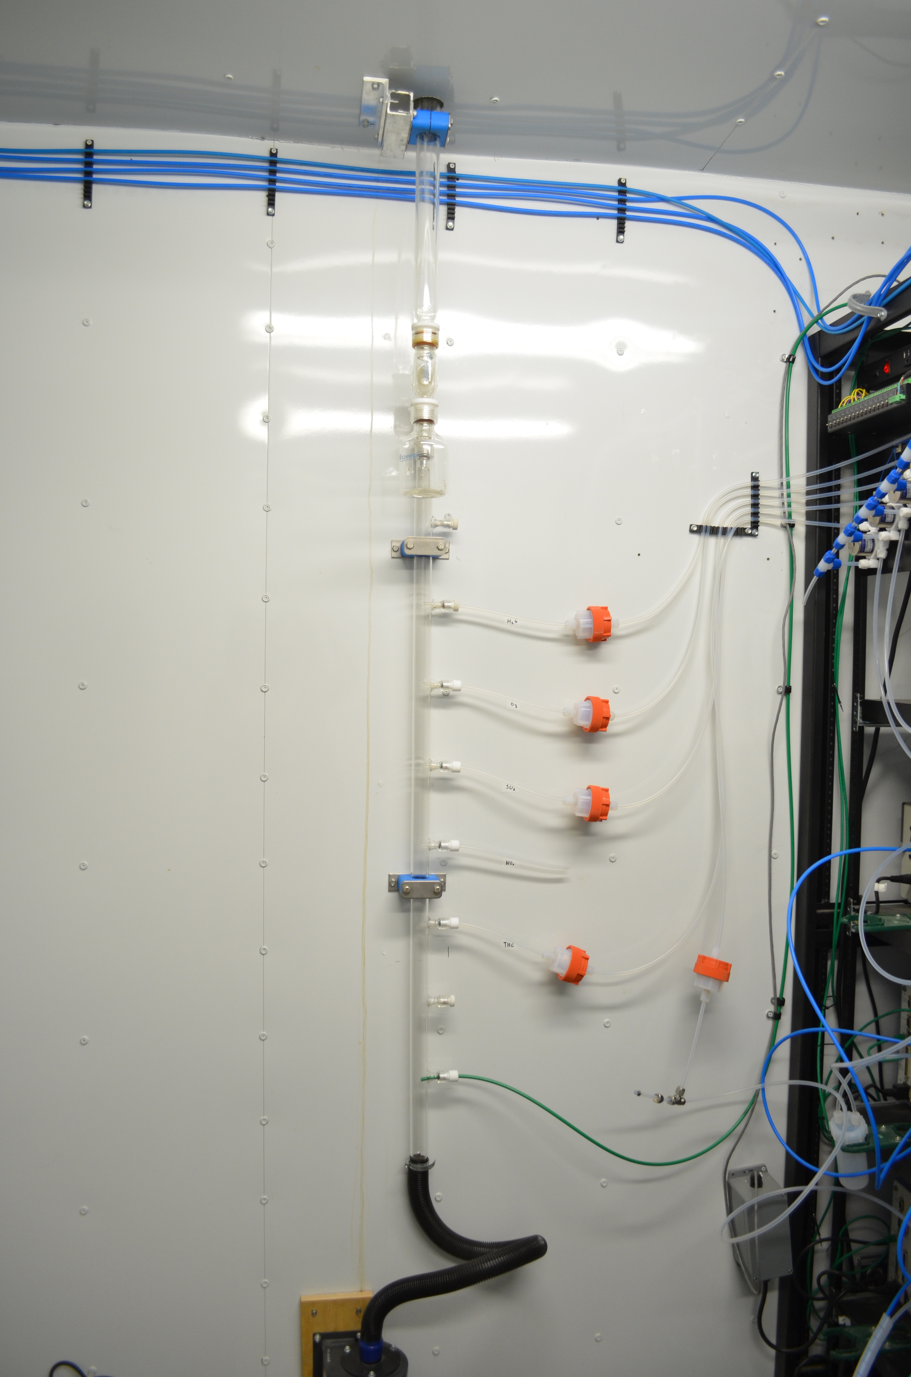
  - Figure 10 – Photo showing the inlet and sample manifold

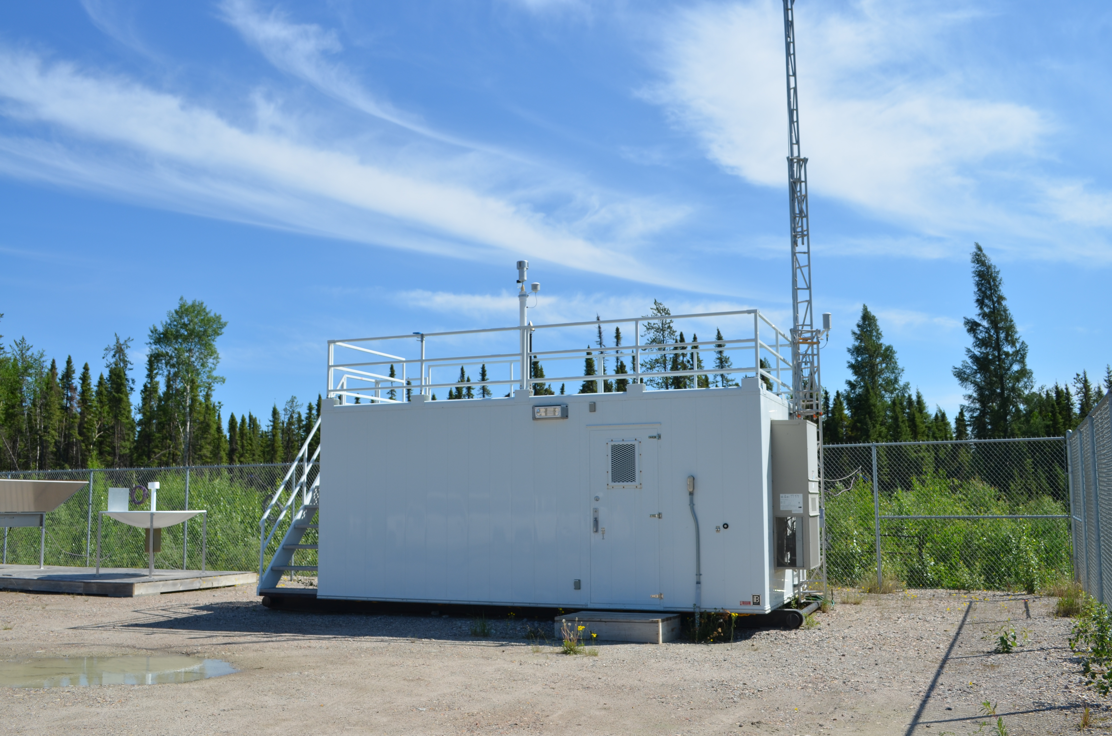
  - Figure 11 – Curb shot of the monitoring station

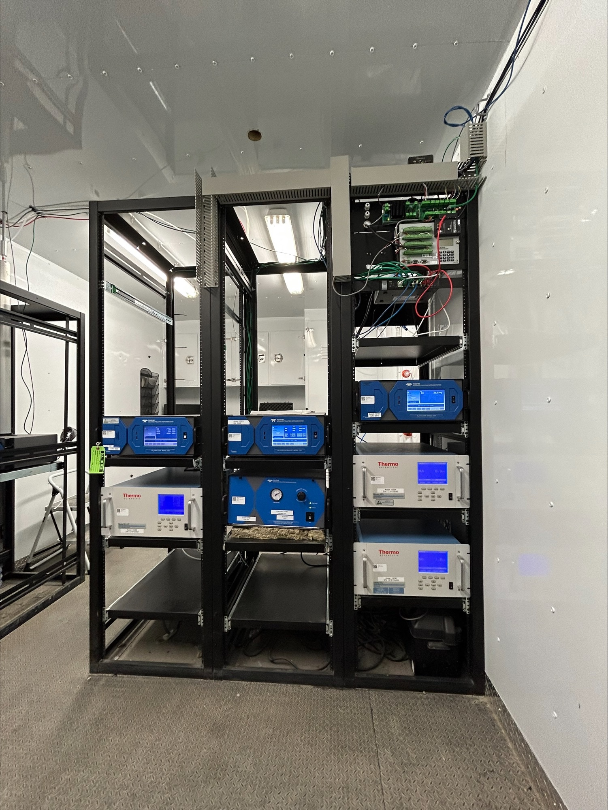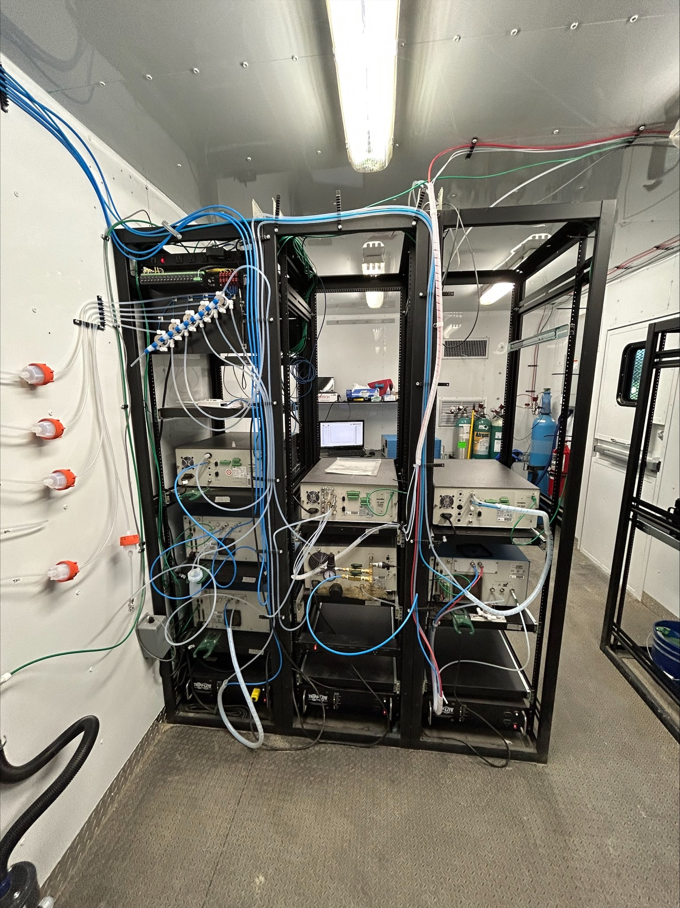
  - Figure 12 –Photo of the front and the back of instrument rack
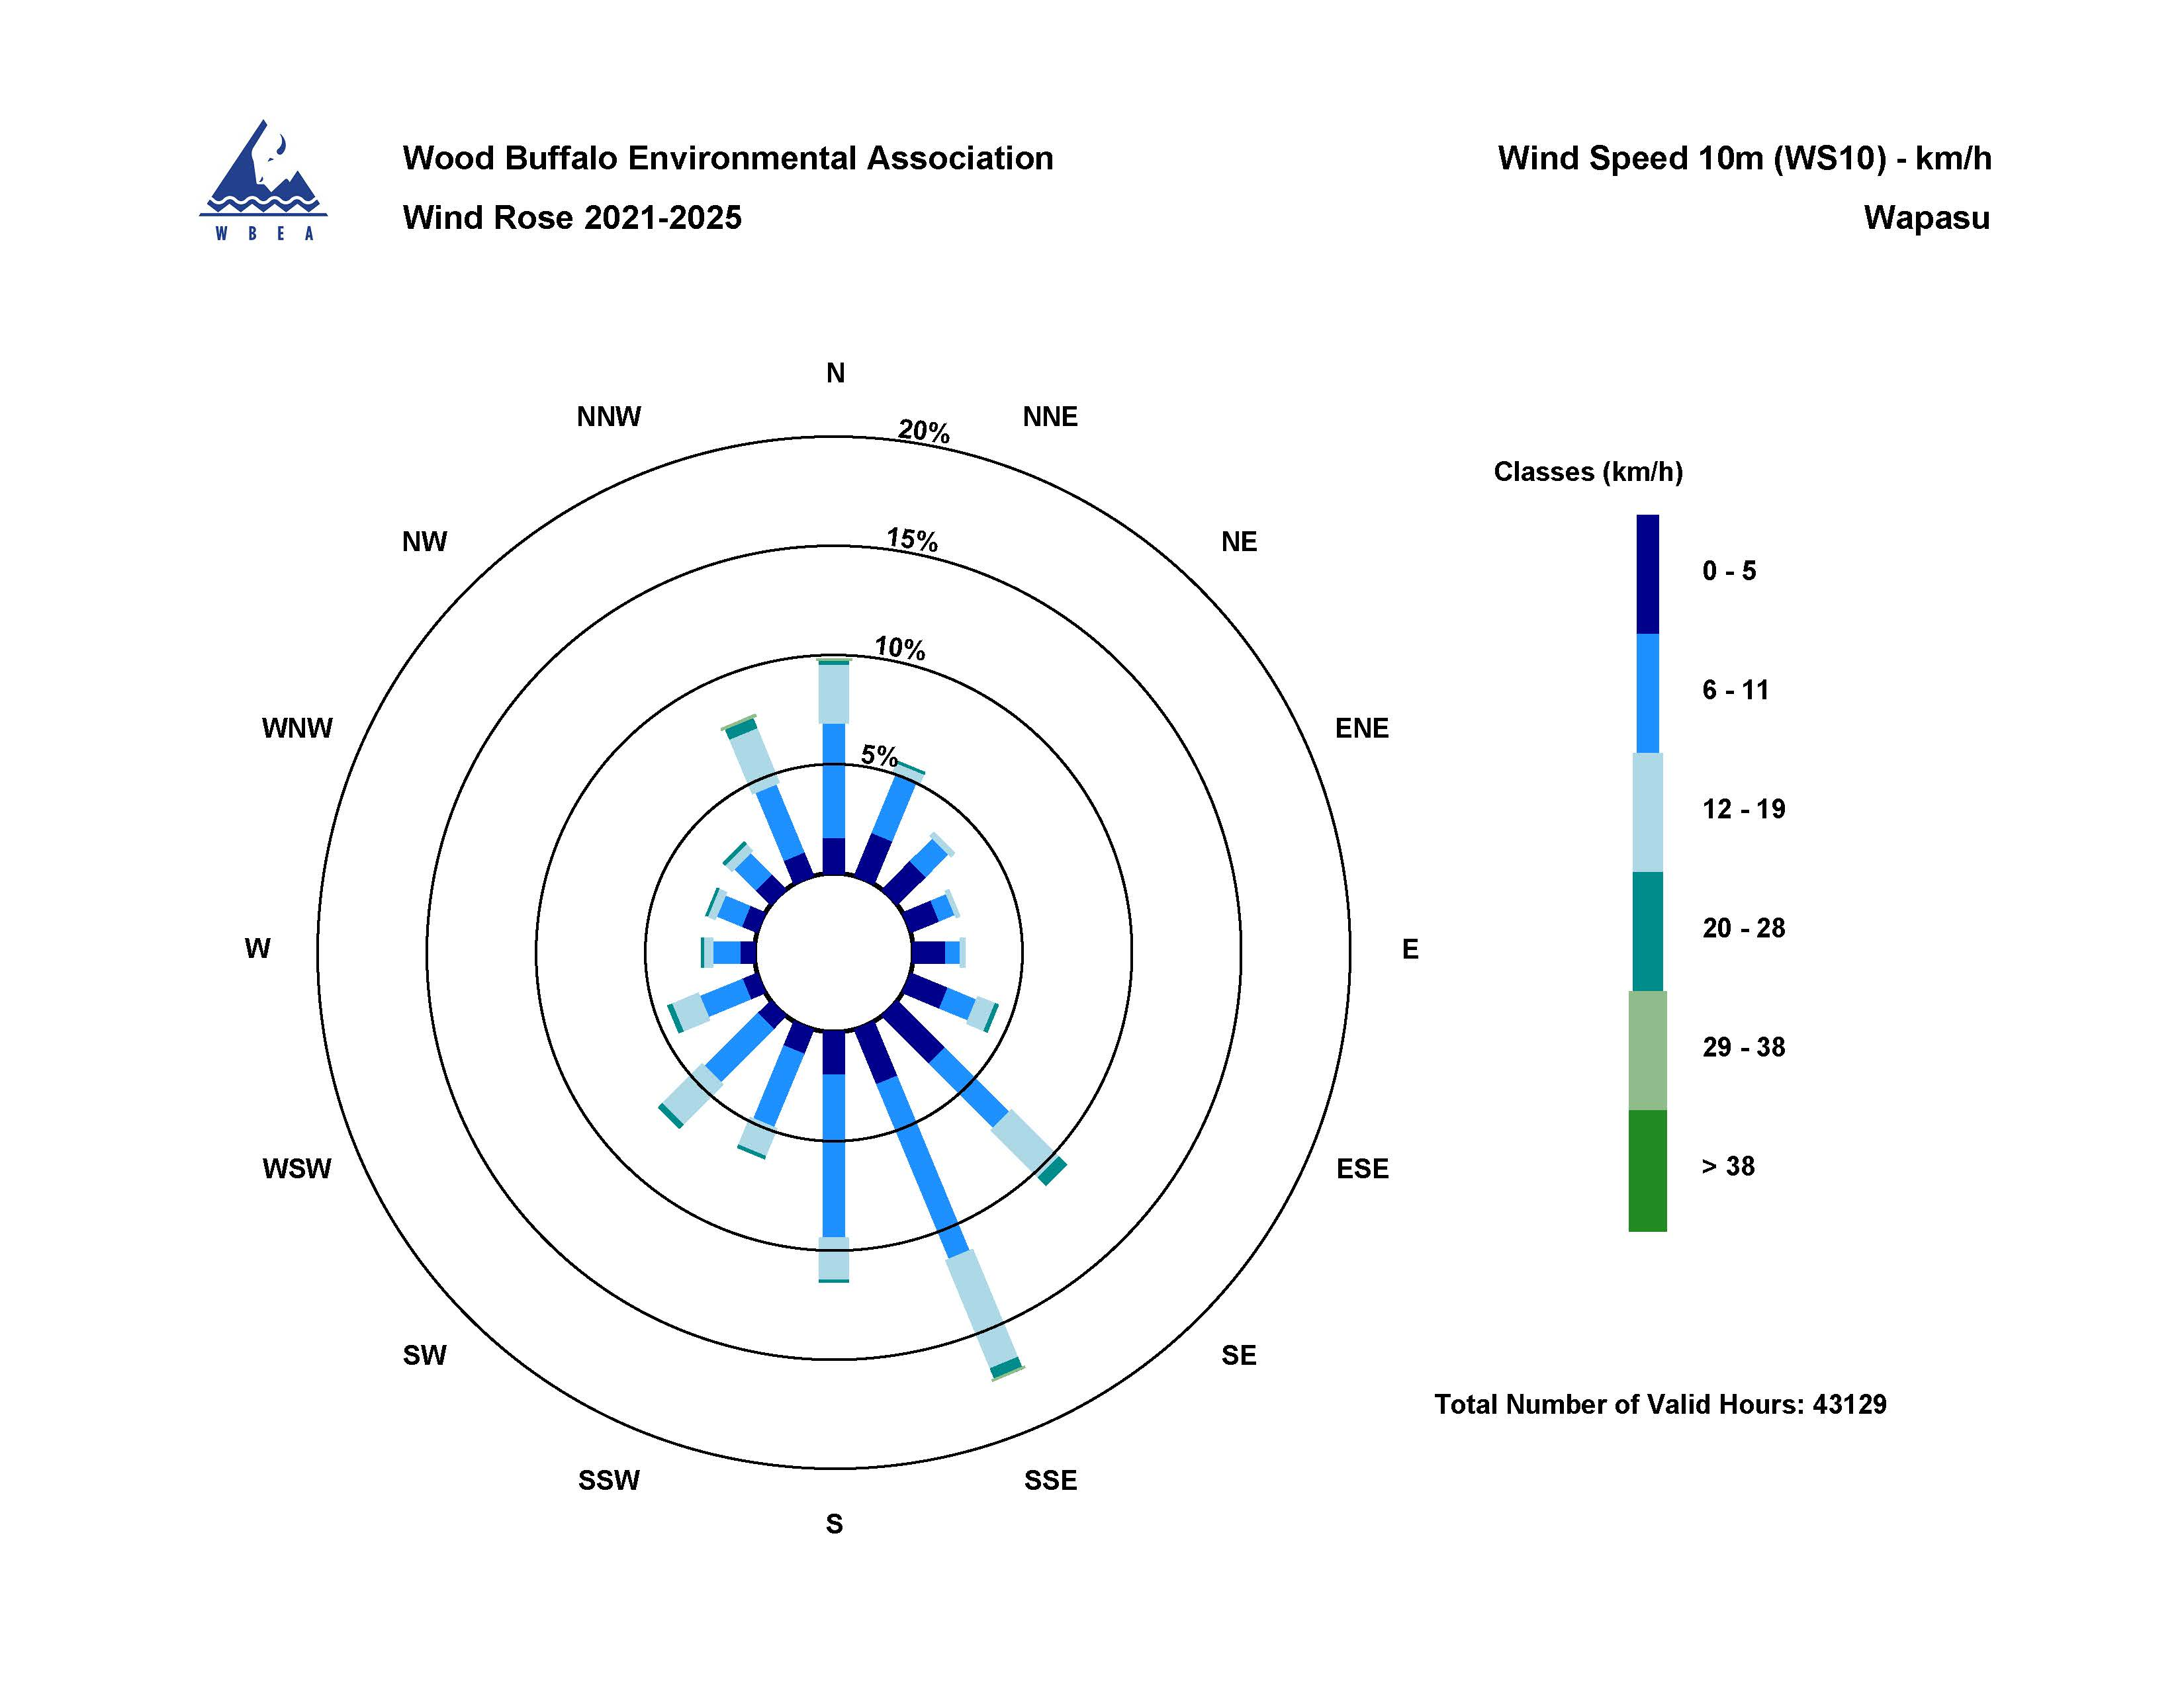

  - Figure 13 – Windrose (2021-2025)

