Wood Buffalo Environmental Association
Ambient Air Monitoring Station
Site Documentation

Fort McKay South

LAST UPDATED: March 12, 2026

Table of Contents
General Site Information 4
Station 4
Location 4
Owner/Operator/Approval Holder 4
Site Description 4
Site Influences 5
Localized Sources (within 20 metres of station) 5
Roadway Influences 5
Major Point Sources 5
Station Equipment 6
Analytical Equipment 6
Meteorological Equipment 6
Support Equipment 6
Site photos 11
Station Photos 14

Tables and Figures
Figure 1 – Area Topographic map showing AMS 13 7
Figure 2 – Aerial image showing AMS 13 8
Figure 3 – Plan view image for AMS 13 – Fort McKay South 9
Figure 4 – Elevation image for AMS 13 – Fort McKay South 10
Figure 5 – Environment looking North Figure 6 – Environment looking East 11
Figure 7 – Environment looking South Figure 8 – Environment looking West 12
Figure 9 – Meteorological Tower 13
Figure 10 – Photo showing the inlet and sample manifold. 14
Figure 11 – Curb shot of the monitoring station. 15
Figure 12 –Photo of the front and the back of instrument rack 16
Figure 13 – Windrose (2021-2025) 17

General Site Information
Revision Date: February 18, 2026

Station
Station ID | AMS 13
Station name | Fort McKay South
Date station established | 2002

Location
Station street address | None
Legal land description | 4-13-094-11 W4
Airshed Zone | Wood Buffalo Environmental Association
Latitude | 57.149175
Longitude | -111.642344
UTM East | 461136
UTM North | 6334175
Nearest community | Fort McKay
Community population | 757
Census Year | 2021

Owner/Operator/Approval Holder
Operating Agency | Wood Buffalo Environmental Association
Address of Operating Agency | Unit 3-805 Memorial Drive, Fort McMurray, Alberta T9K 0K4
Name of Approval Holder | Syncrude Canada Ltd
Approval number | 026-03-00
Contact Name | Nikola Stears
Address | Bag 4009, MD 4160, Fort McMurray, Alberta, T9H 3L1
Phone number | 780-742-7281
Email address | nstears@suncor.com

Site Description
Land use by sector | 0 – 90 degrees | Forest
Land use by sector | 91 – 180 degrees | Forest
Land use by sector | 181 – 270 degrees | Forest
Land use by sector | 271 – 360 degrees | Forest
Site elevation (m)  (above sea level) | 268 m
Angle of elevation to nearby buildings | Greatest angle | None
Angle of elevation to nearby buildings | Building direction | None
Airflow restrictions | North | None
Airflow restrictions | East | None
Airflow restrictions | South | None
Airflow restrictions | West | None
Distance to nearest trees (m) | North | 150
Distance to nearest trees (m) | East | 108
Distance to nearest trees (m) | West | 56
Distance to nearest trees (m) | South | 150
Sample manifold | Type | All glass
Sample manifold | Inlet height above roof | 1 metre
Wind Sensors | Type | Cup and vane
Wind Sensors | Height above ground (m) | 10 m
Wind Sensors | Distance from station (m) | 0 m

Site Influences

Localized Sources (within 20 metres of station)
Type | Distance (m) | Description
None | n/a | n/a

Roadway Influences
Type | Traffic Volume | Distance (m) | Description
Asphalt | High | 326 | Main Road to Fort McKay and CNRL Horizon
Dirt | Low | 99 | Road to AMS 13
Dirt | Very Low | 10 | Access Road to AMS 13

Major Point Sources
Facility Name | Source Type | Distance from site (km) | Compass direction from site
CNRL Horizon | OilSands Plant | 21.9 | N
Syncrude | Tailings pond | 6.2 | SW
Syncrude | OilSands Plant | 12.3 | S
Fort McKay Enterprises Ltd. | Laydown Yard | 1 | SE
Bouchier Group | LayDown Yard | 1 | SE
BME Ltd. | Laydown Yard | 1 | SE
Wood Buffalo Water Treatment Plant | Water Treatment Plant | 4.9 | N
CNRL Albian | Tailings pond | 9.2 | NE
CNRL Albian | Oilsands Plant | 14.1 | NE

Station Equipment
Equipment Owner: Syncrude Canada Ltd.

Analytical Equipment
Parameter | Make | Model | Serial Number | Date Instrument Installed | WBEA Data Start Date
Continuous
SO₂ | Teledyne/API | 43i-TLE | 1331259320 | 2025 | January, 1999
TRS | Thermo Scientific | 43i-TLE | 1180540017 | 2016 | January, 1999
NO/NO_{x}/NO₂ | Thermo Scientific | 42i | 12300522720 | 2025 | January, 1999
THC/CH₄/NMHC | Thermo Scientific | 55i | 1181490018 | 2025 | January, 1999
O₃ | Teledyne/API | T400 | 7413 | 2025 | January, 1999
PM_{2.5} | Teledyne/API | T640 | 1335 | 2023 | January, 1999
Time-Integrated
PM₁₀ | Thermo Scientific | 2000i | 20001203861408 | 2016 | -
VOC | Tisch | TE123 | 1023 | 2016 | -
TRS converter | Thermo Scientific | CDN-101 | 521 | 2016

Meteorological Equipment
Parameter | Make | Model | Serial Number | WMO Site Class | Date Sensor Installed | WBEA Data Start Date
AT/RH | Vaisala | HMP155 | G4340047 | Class 3 | 2016 | January, 2002
WS | Met One | 010C-1 | N10022 | Class 4 | 2022 | January, 1999
WD | Met One | 020C-1 | W16101 | Class 4 | 2021 | January, 1999

Support Equipment
Name | Description | Make | Model | Serial Number
Datalogger | Datalogger | Campbell Scientific | CR3000 | 11038
Gas Dilution Calibrator | Dynamic dilution calibrator | Teledyne/API | T700 | 2448
Zero air generator | Zero Air Generator | Teledyne/API | 701 | 1118
Shelter / Building | Air monitoring portable | C&V | 10 x 20 trailer | 18751-1
HVAC | Heating and air conditioning system. Wall mount unit | Intherem | E2EB-010HB | E2E011101302
TRS Converter | Thermal Oxidizer | C.D.Nova | CDN-101 | 521

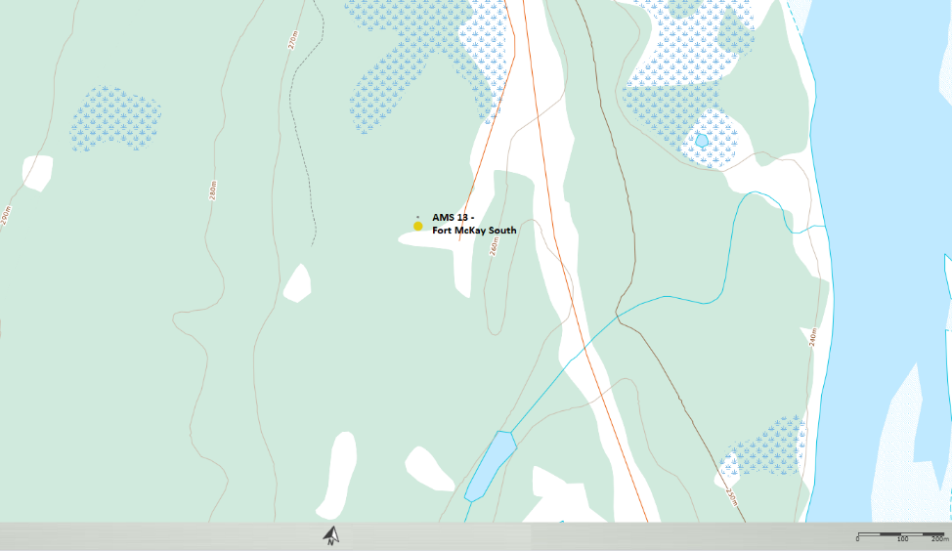
  - Figure 1 – Area Topographic map showing AMS 13

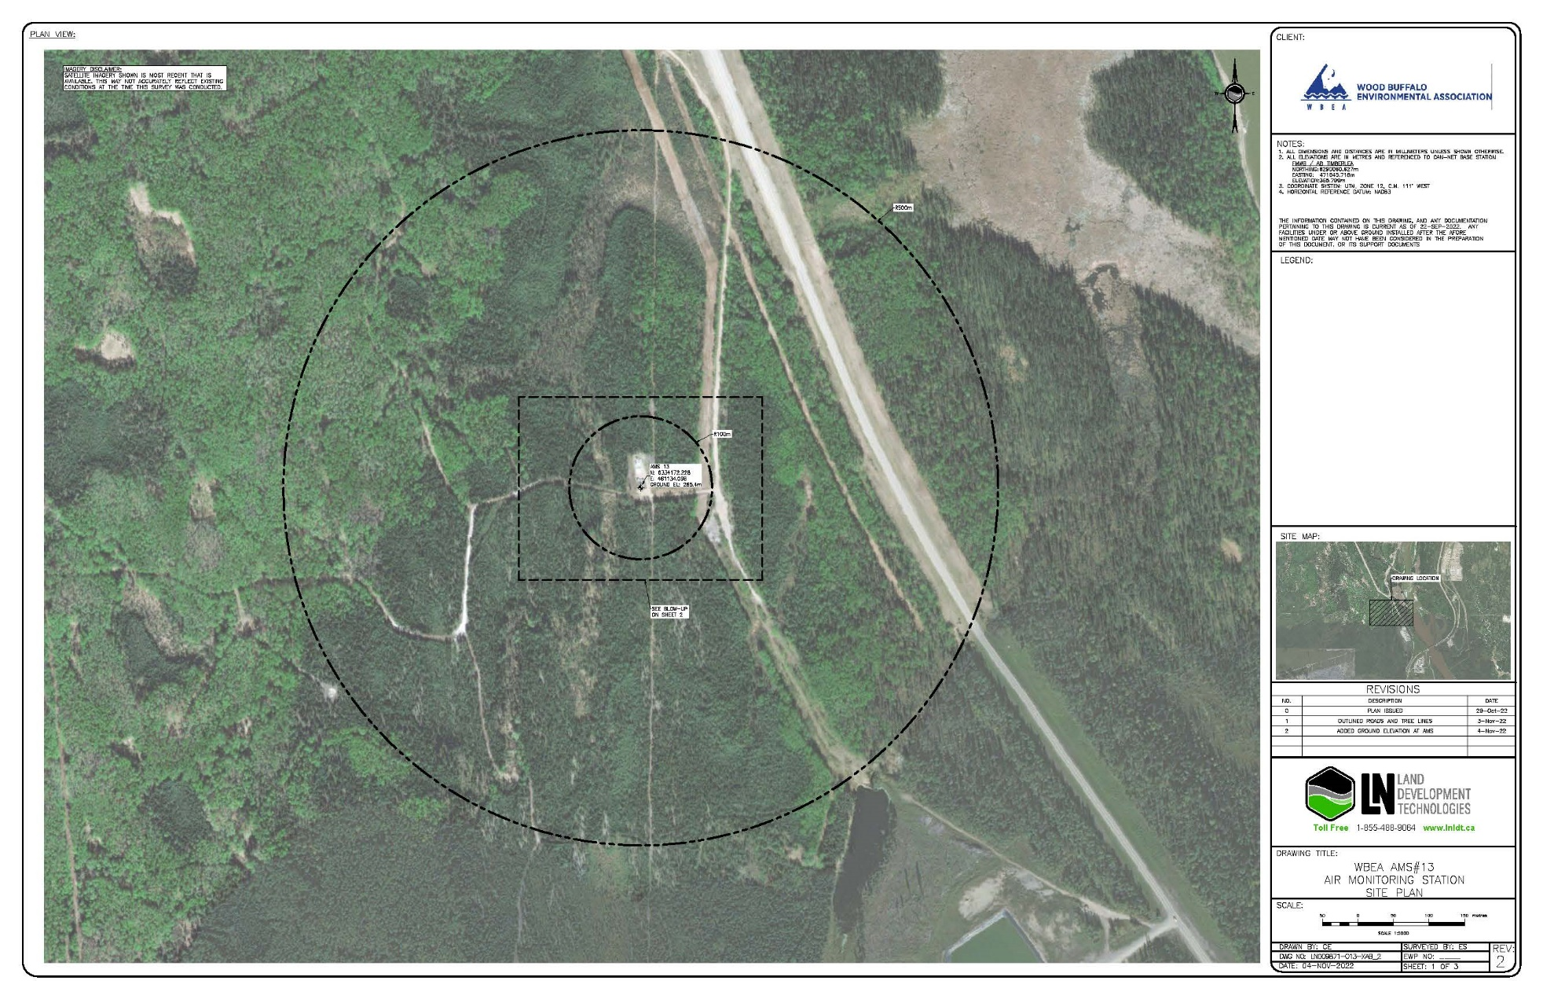
  - Figure 2 – Aerial image showing AMS 13

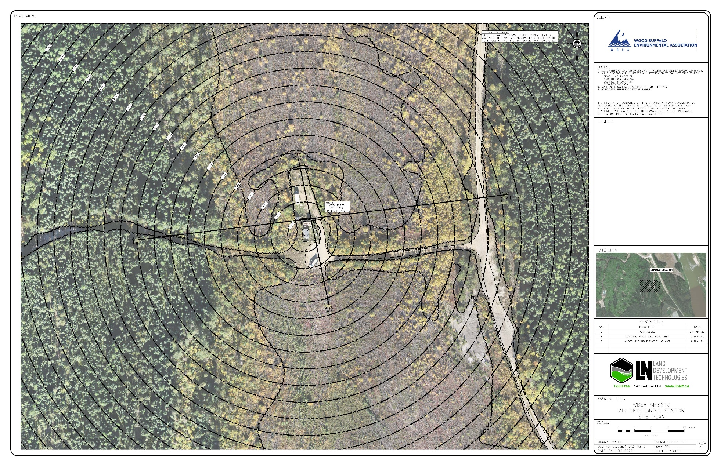
  - Figure 3 – Plan view image for AMS 13 – Fort McKay South

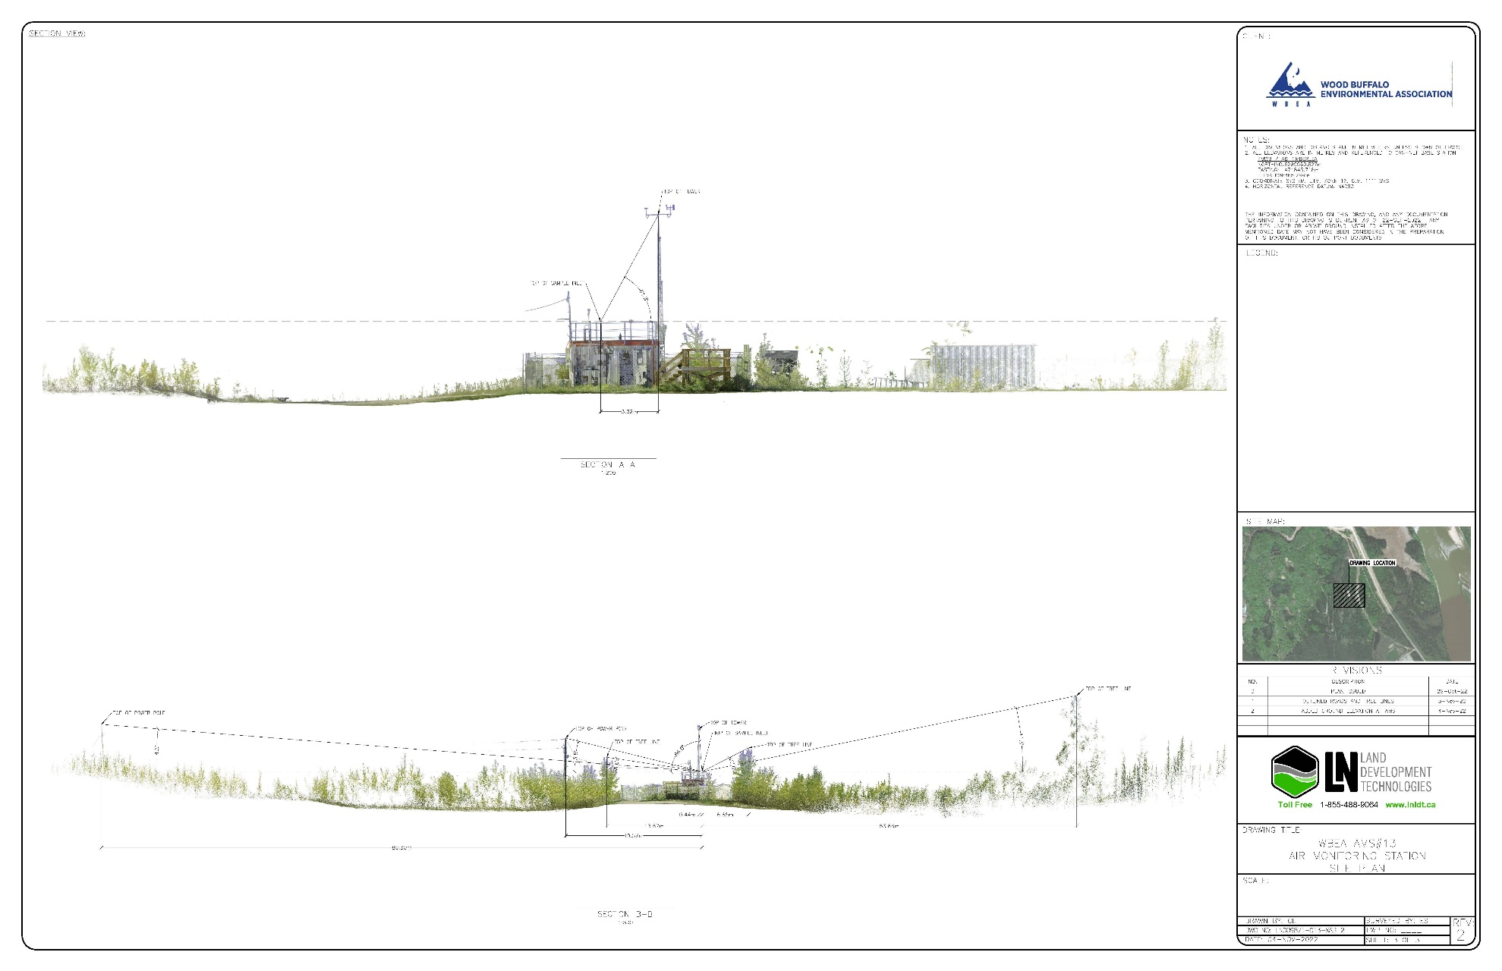
  - Figure 4 – Elevation image for AMS 13 – Fort McKay South

Site photos
The following photos show the environment surrounding the monitoring station.

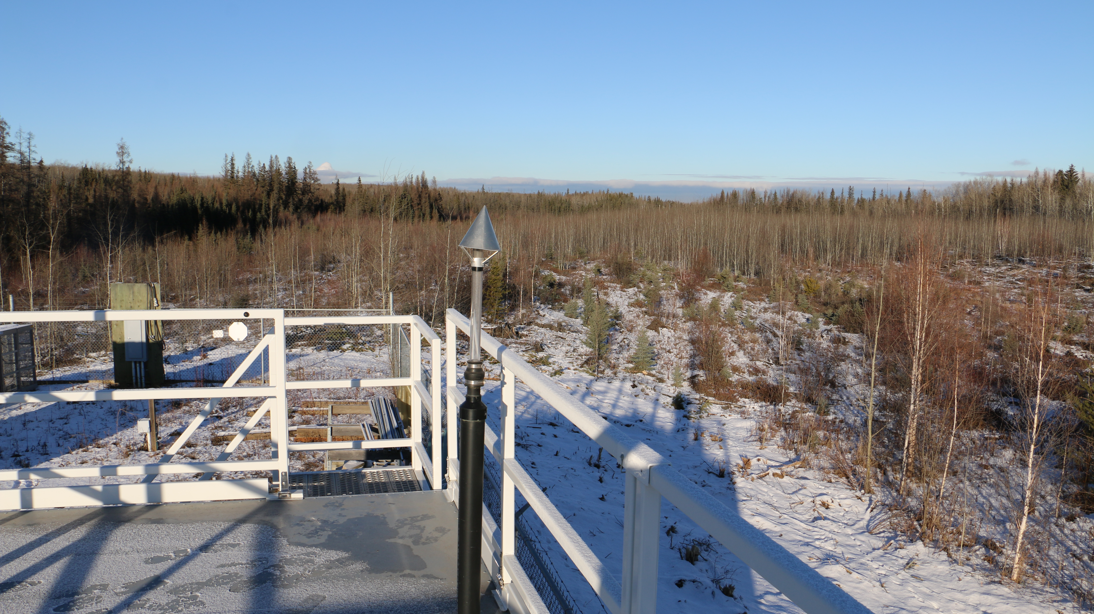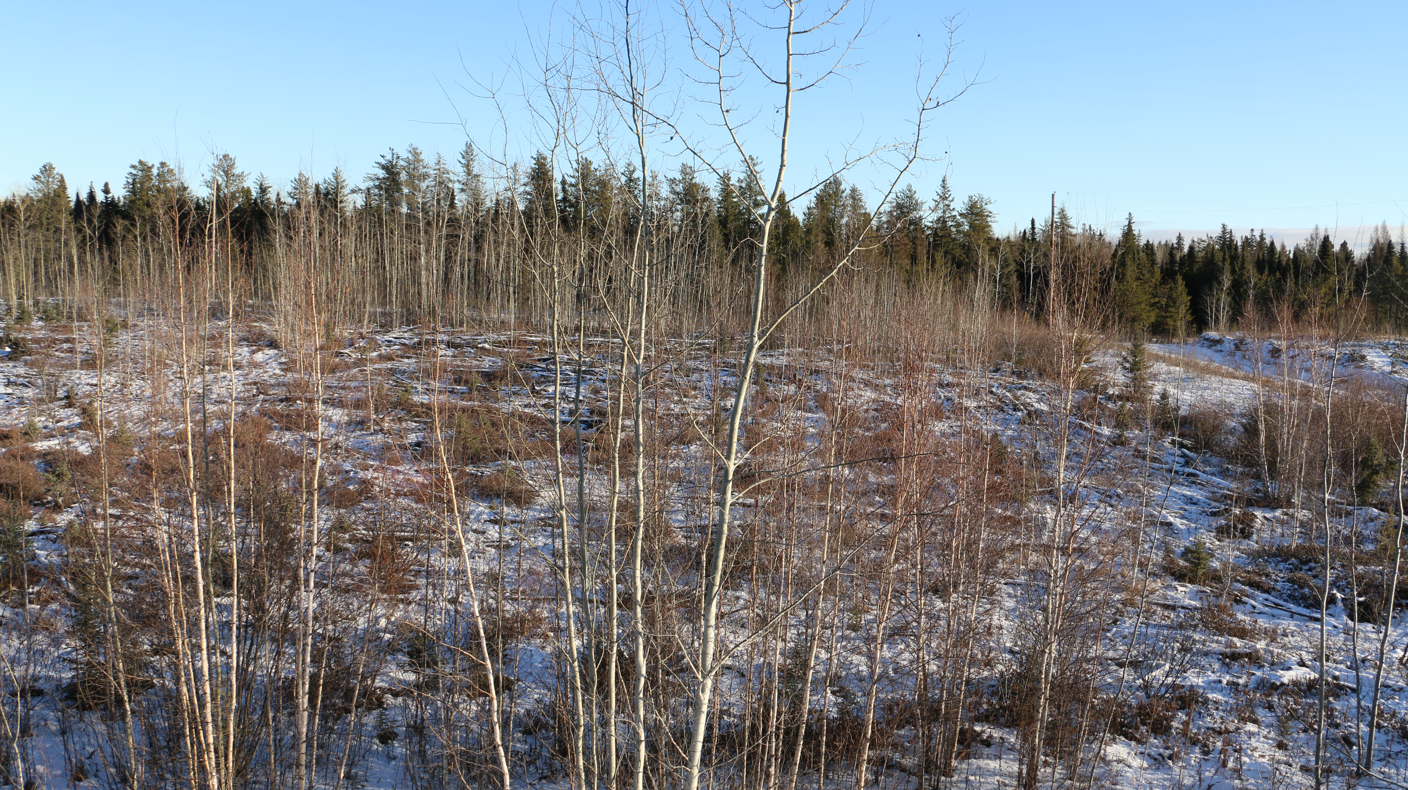
  - Figure 5 – Environment looking North Figure 6 – Environment looking East

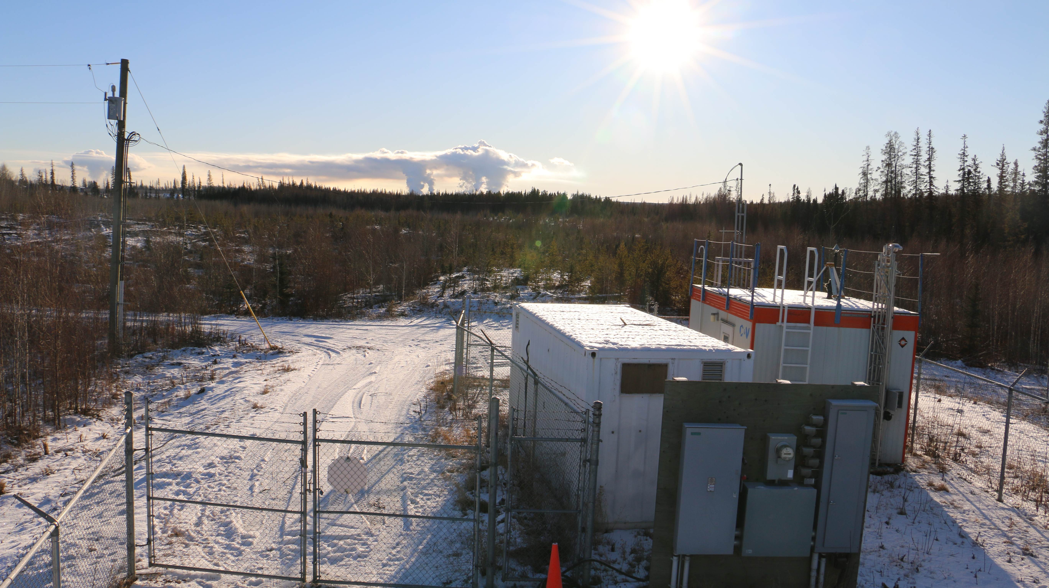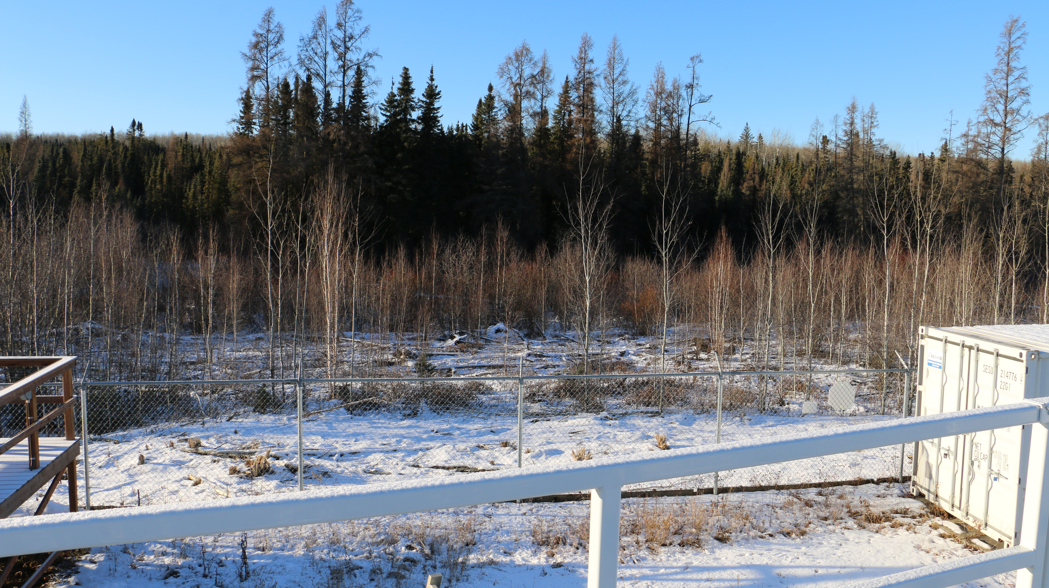
  - Figure 7 – Environment looking South Figure 8 – Environment looking West

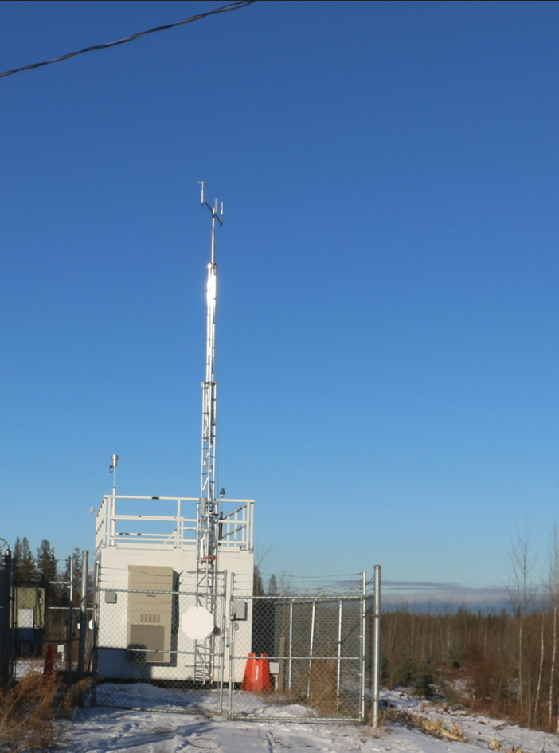
  - Figure 9 – Meteorological Tower

Station Photos
The following photos show the monitoring station and instrumentation.
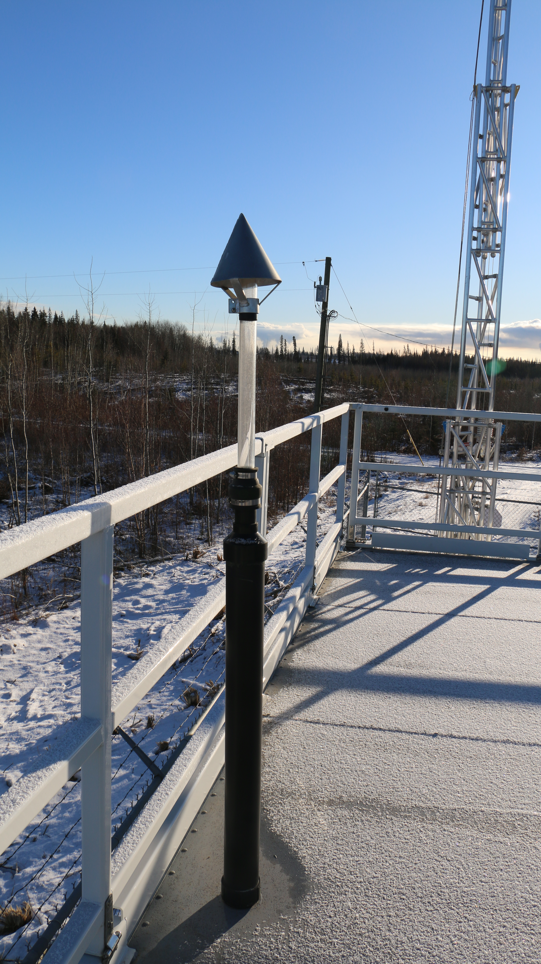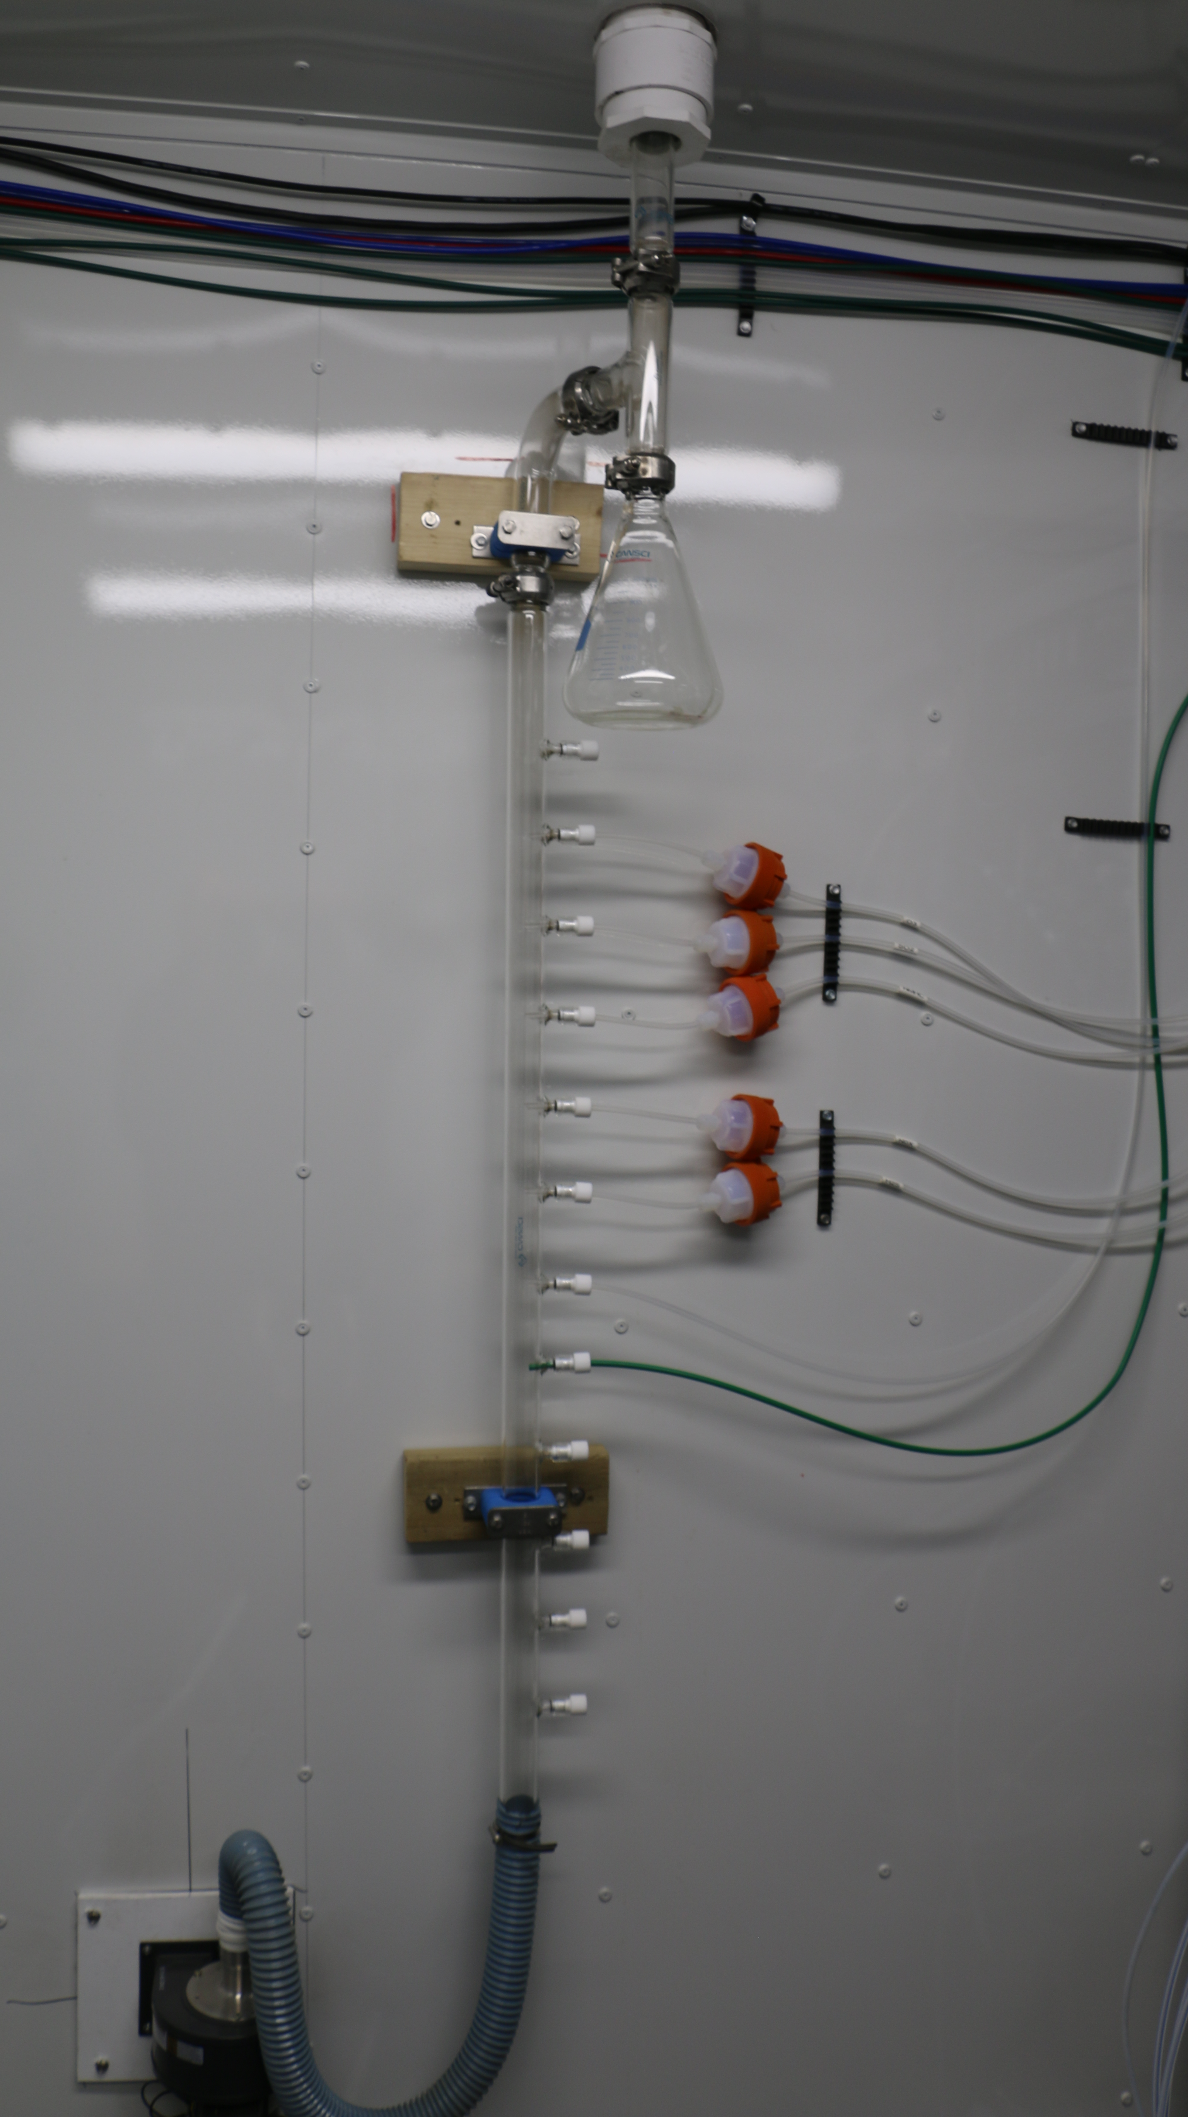
  - Figure 10 – Photo showing the inlet and sample manifold.

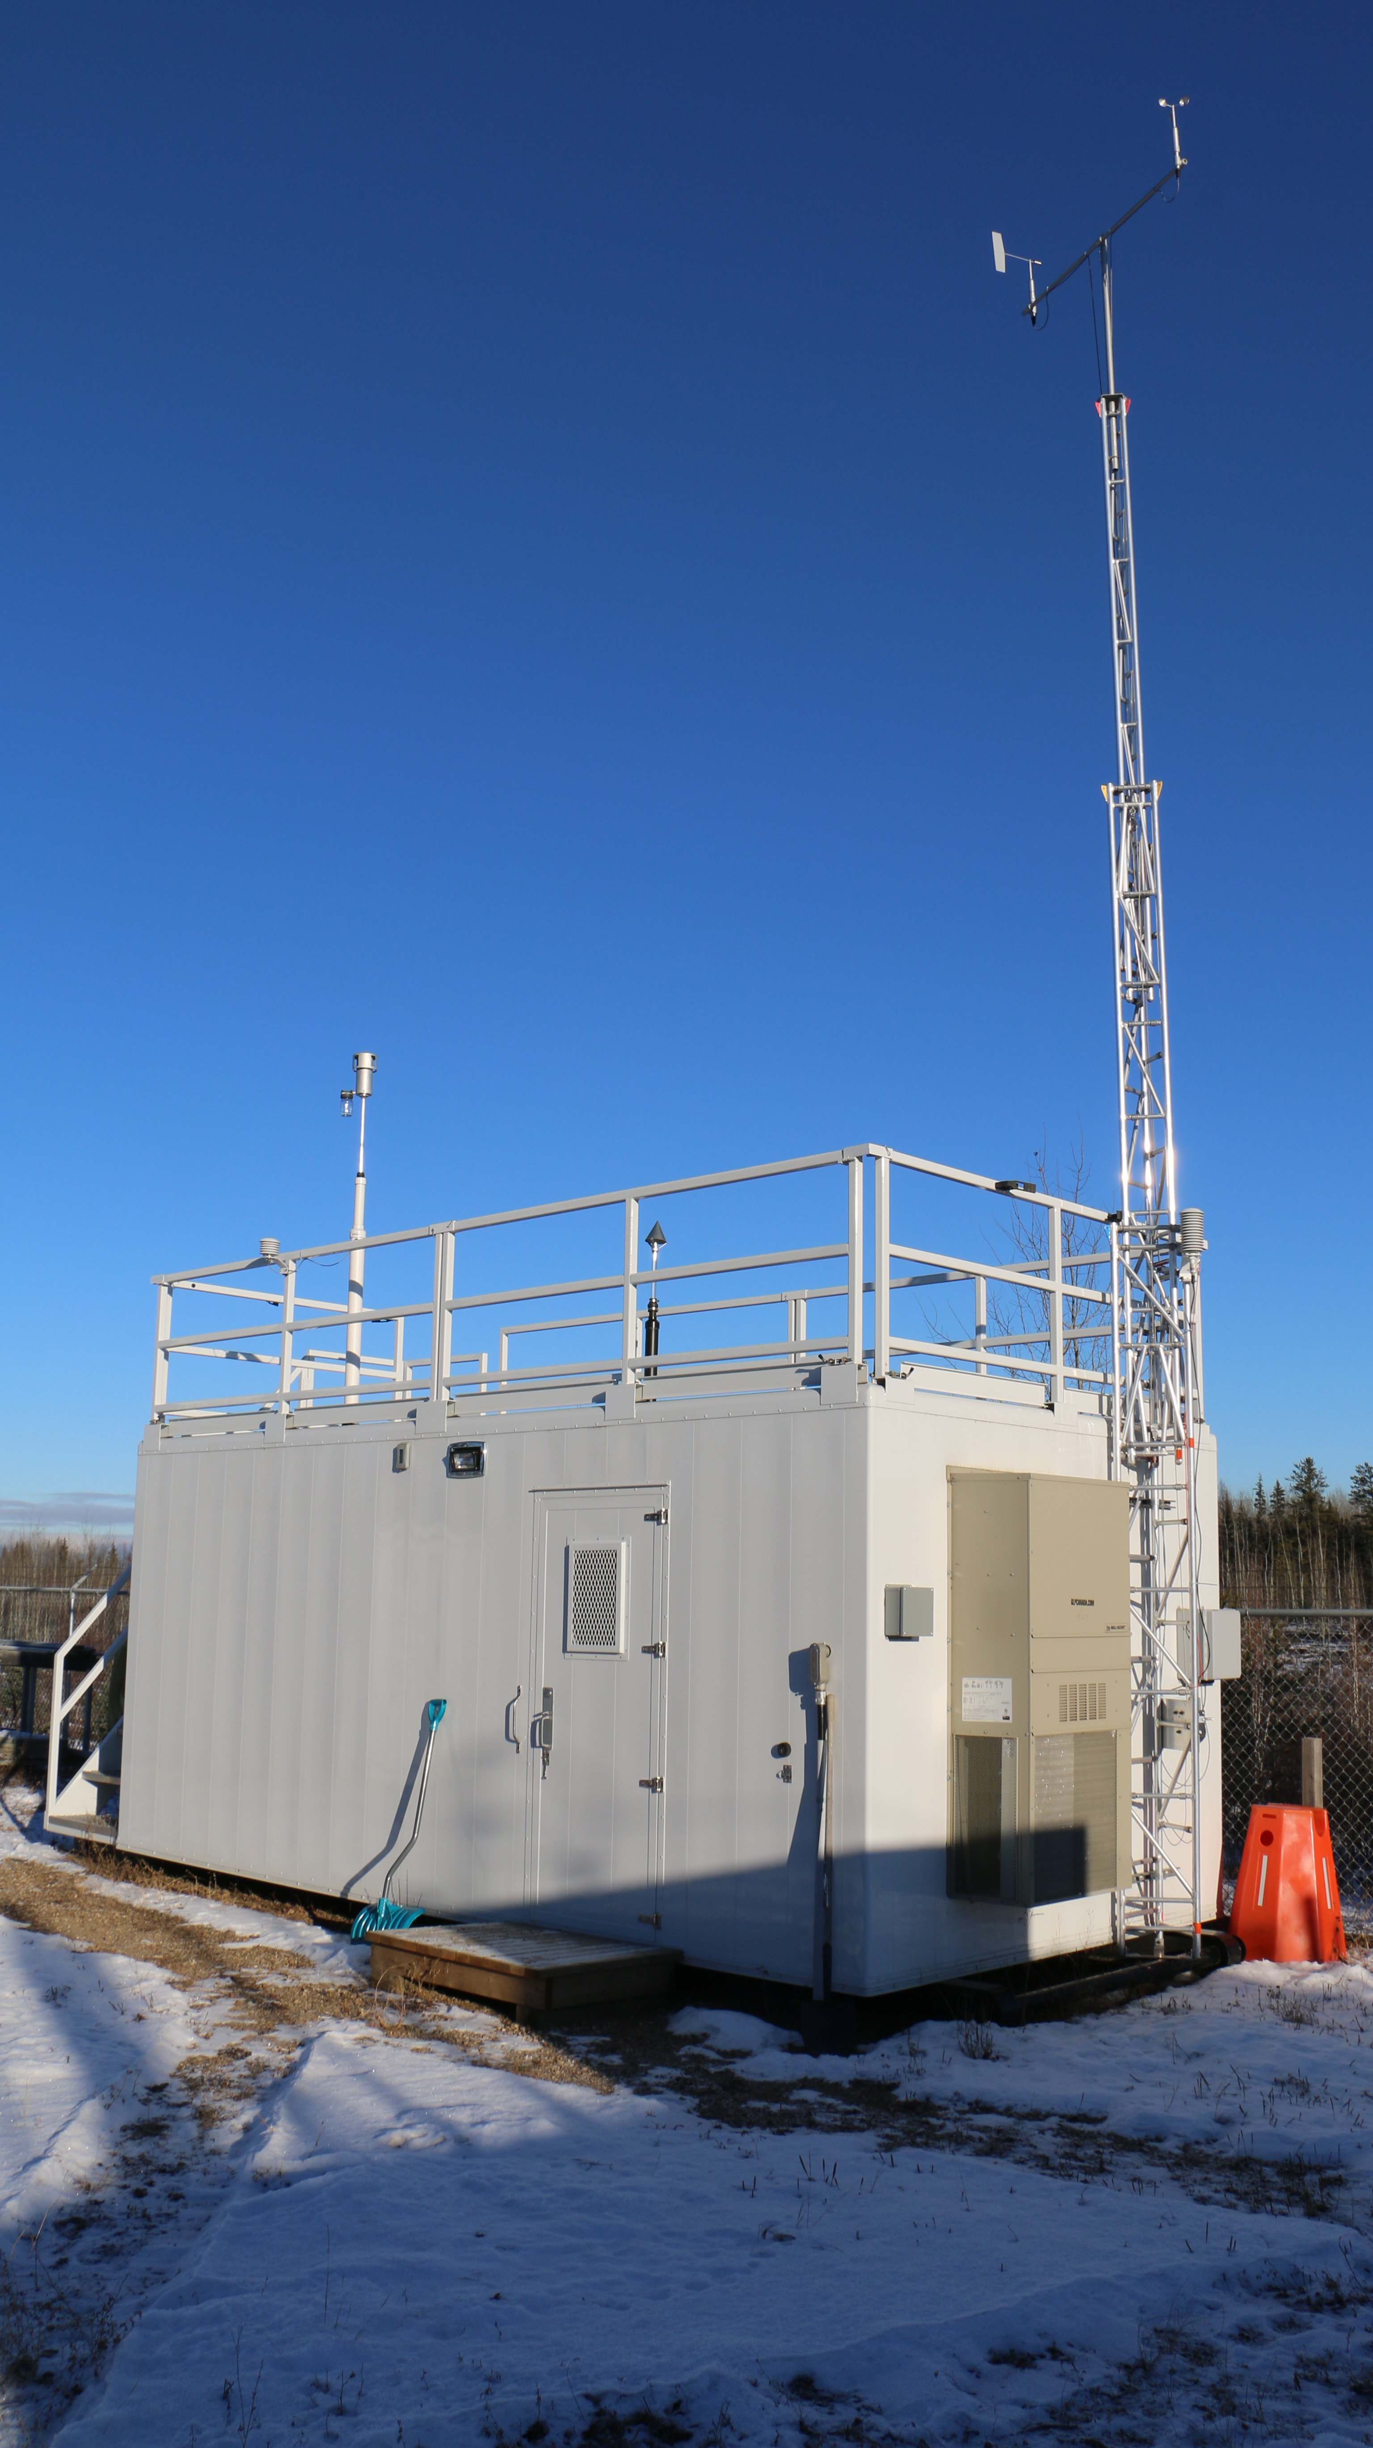
  - Figure 11 – Curb shot of the monitoring station.

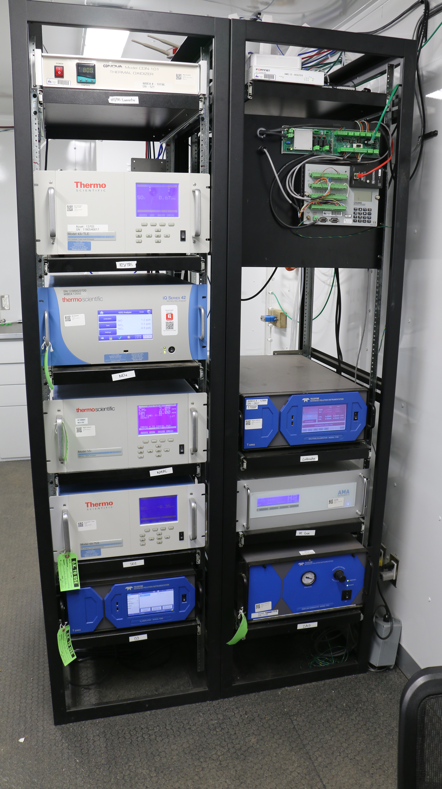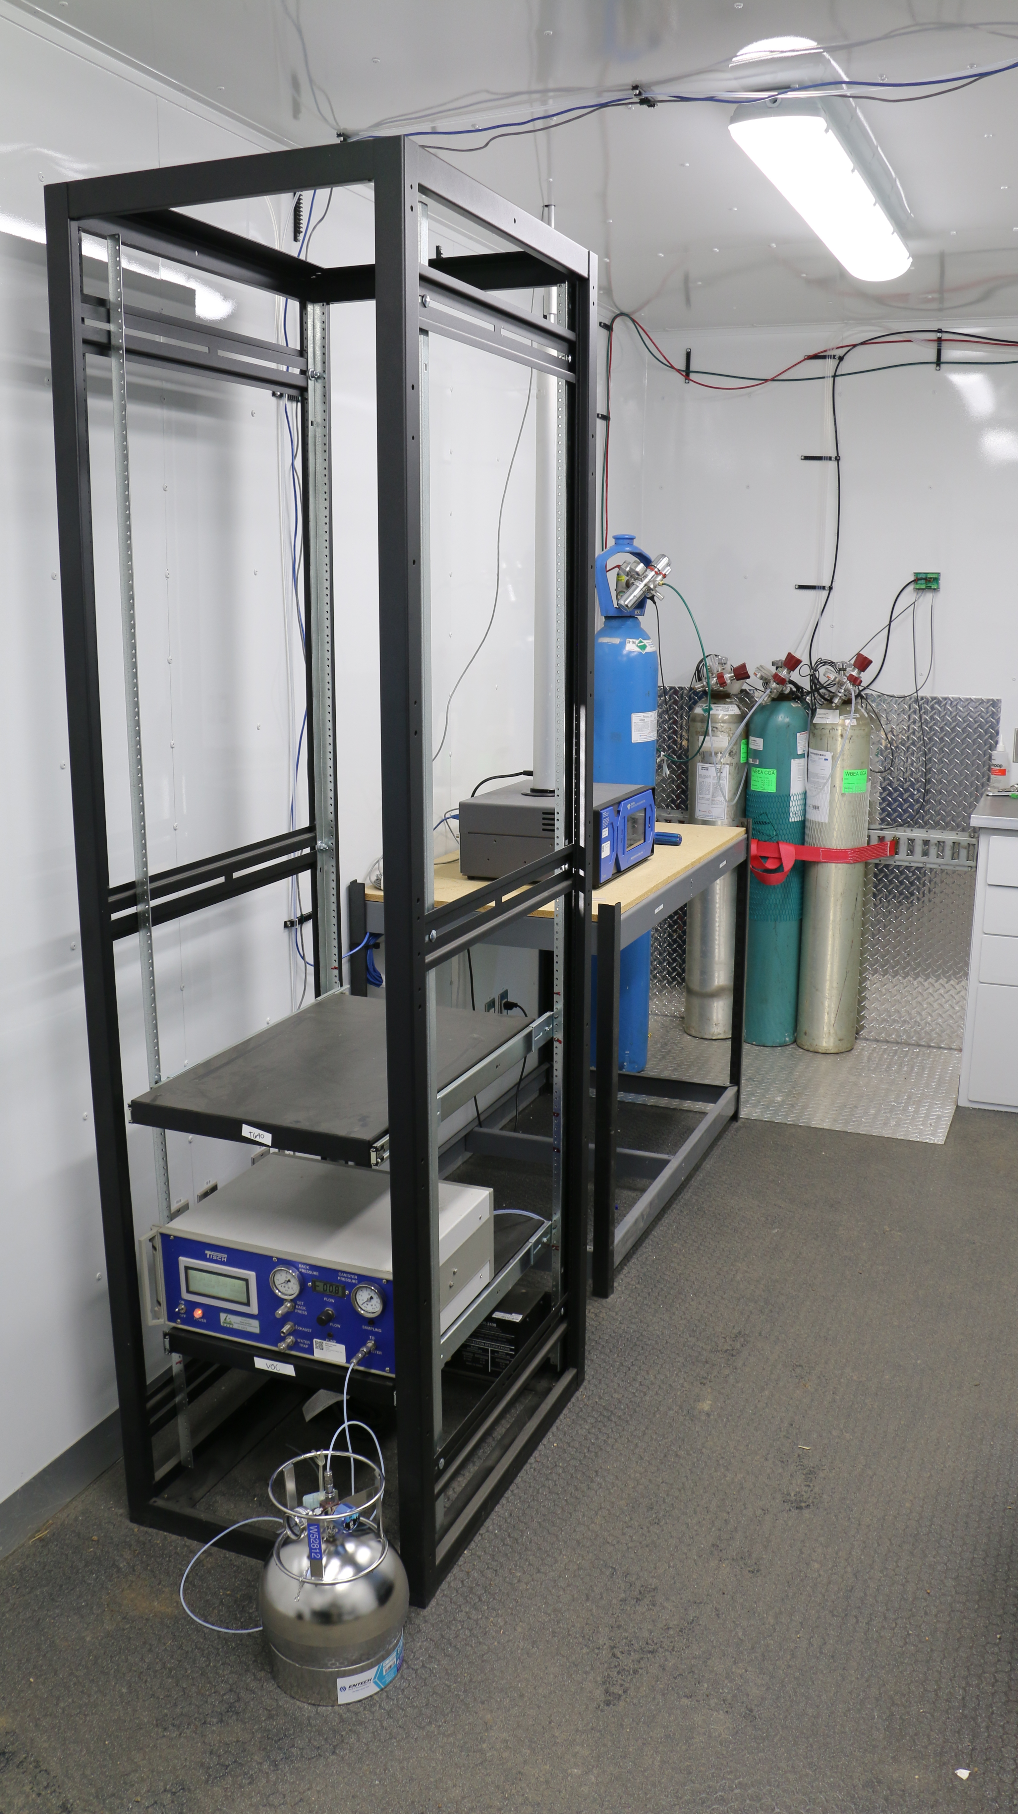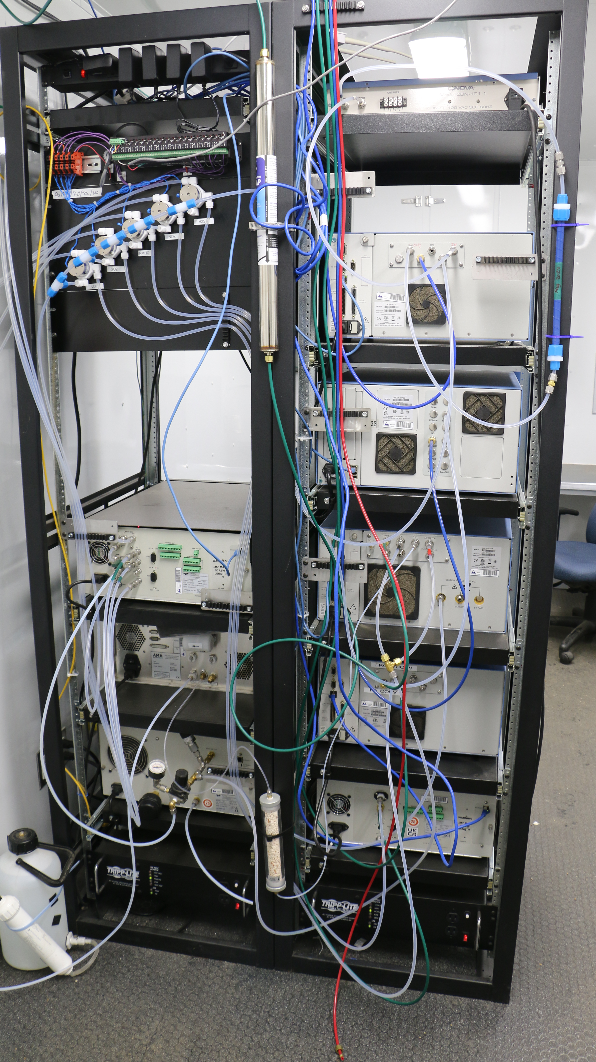
  - Figure 12 –Photo of the front and the back of instrument rack
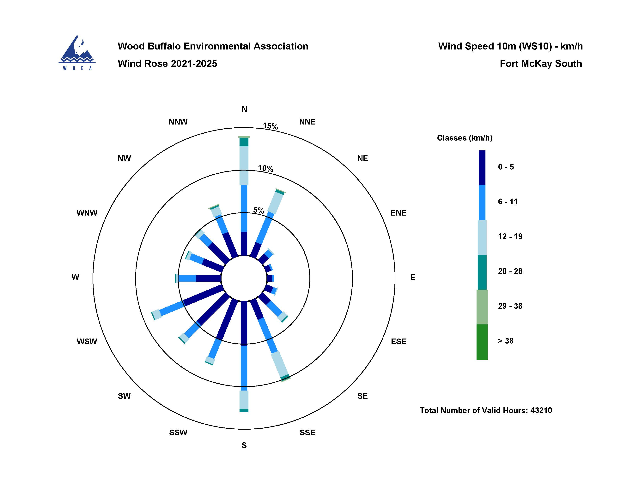
  - Figure 13 – Windrose (2021-2025)

