Wood Buffalo Environmental Association
Ambient Air Monitoring Station
Site Documentation

Lower Camp

LAST UPDATED: March 10, 2026

Table of Contents
General Site Information 4
Station 4
Location 4
Owner/Operator/Approval Holder 4
Site Description 4
Site Influences 5
Localized Sources (within 20 metres of station) 5
Roadway Influences 5
Major Point Sources 5
Station Equipment 6
Analytical Equipment 6
Meteorological Equipment 6
Support Equipment 6
Site photos 11
Station Photos 16

Tables and Figures

Figure 1 – Area topographic map showing AMS 11 7
Figure 2 – Aerial image showing AMS 11 8
Figure 3 – Plan view image for AMS 11 site 9
Figure 4 – Elevation view image for AMS 11 site 10
Figure 5 – Environment looking North 11
Figure 6 – Environment looking East 12
Figure 7 – Environment looking South 13
Figure 8 – Environment looking West 14
Figure 9 – Meteorological Tower 15
Figure 10 – Photo showing the inlet and sample manifold 16
Figure 11 – Curb shot of the monitoring station 17
Figure 12 –Photo of the front and the back of instrument rack 18
Figure 13 – Windrose (2021-2025) 19

General Site Information

Station
Station ID | AMS 11
Station name | Lower Camp
Date station established | 1975

Location
Station street address | Located by the Athabasca River Valley at about 115 meters south of the Syncrude pump house
Legal land description | 11-35-092-10 W4
Airshed Zone | Wood Buffalo Environmental Association
Latitude | 57.0267916667
Longitude | -111.500819444
UTM East | 469597.806
UTM North | 6320474.662
Nearest community | Fort McMurray
Community population | 107,740
Census Year | 2025

Owner/Operator/Approval Holder
Operating Agency | Wood Buffalo Environmental Association
Address of Operating Agency | Unit 3, 805 Memorial Drive, Fort McMurray, Alberta T9K 0K4
Name of Approval Holder | Suncor Energy Inc.
Approval number | 094-03-00
Contact Name | Brooke Bennett
Address | Base Plant Rd, Wood Buffalo, AB
Phone number | 780-790-5692
Email address | brobennett@suncor.com

Site Description
Land use by sector | 0 – 90 degrees | Syncrude open mining operations
Land use by sector | 91 – 180 degrees | Athabasca River
Land use by sector | 181 – 270 degrees | Athabasca River
Land use by sector | 271 – 360 degrees | Syncrude open mining operations
Site elevation (m)  (above sea level) | 238 meters
Angle of elevation to nearby buildings | Greatest angle | 0
Angle of elevation to nearby buildings | Building direction | North
Airflow restrictions | North | Pump House
Airflow restrictions | East | None
Airflow restrictions | South | None
Airflow restrictions | West | None
Distance to nearest trees (m) | North | 42
Distance to nearest trees (m) | East | 12
Distance to nearest trees (m) | West | 12
Distance to nearest trees (m) | South | 20
Sample manifold | Type | All glass
Sample manifold | Inlet height above roof | 1 meter
Meteorological Sensors | Type | Cup and vane
Meteorological Sensors | Height above ground (m) | 10
Meteorological Sensors | Distance from station (m) | attached

Site Influences

Localized Sources (within 20 metres of station)
Type | Distance (m) | Description
Laydown | 79.21 | Equipment Laydown
Water Pond | 136.8 | Reservoir
Athabasca River | 33.8 | River
Pumping Station | 114 | Syncrude Water Pump Station

Roadway Influences
Type | Traffic Volume | Distance (m) | Description
Gravel road | Low | 20 | Road access to lay down and pumping station

Major Point Sources
Facility Name | Source Type | Production Capacity | Distance from site (km) | Compass direction from site
Suncor Energy | Oil refinery | 330,000 bbl/day | 2 | South
Syncrude | Oil refinery/open mining | 225,000 bbl/day | 3 | West
Suncor Energy | Open mining operations | NA | 4 | East

Station Equipment
Equipment Owner: Suncor

Analytical Equipment
Parameter | Make | Model | Serial Number | Date Installed
SO₂ | Thermo Scientific | 43i | 100841398 | 2015
H2S | Thermo Scientific | 43iq | 1203169745 | 2015
NMHC | Thermo Scientific | 55i | 1152430012 | 2019
PWD | Vaisala | PWD22 | H5030008 | 2013

Meteorological Equipment
Parameter | Make | Model | Serial Number | WMO Site Class | Date Installed
AT/RH | Vaisala | HMP155 | G0840086 | 4 | 2022
WS | Met One | 010C-1 | N11710 | 4 | 2017
WD | Met One | 020C-1 | N12035 | 4 | 2022
BP | Vaisala | CS106 | T2210938 | 4 | 2022
PWD | Vaisala | PWD22 | H5030008 | 4 | 2015

Support Equipment
Name | Description | Make | Model | Serial Number
Datalogger | Datalogger | Campbell Scientific | CR3000 | 2403
Gas Dilution Calibrator | Dynamic dilution calibrator | Teledyne/API | T700 | 3811
Zero air generator | Zero Air Generator | Teledyne/API | 701 | 4428
Shelter / Building | Air monitoring portable | ITB | 8 x 16 trailer | 11447

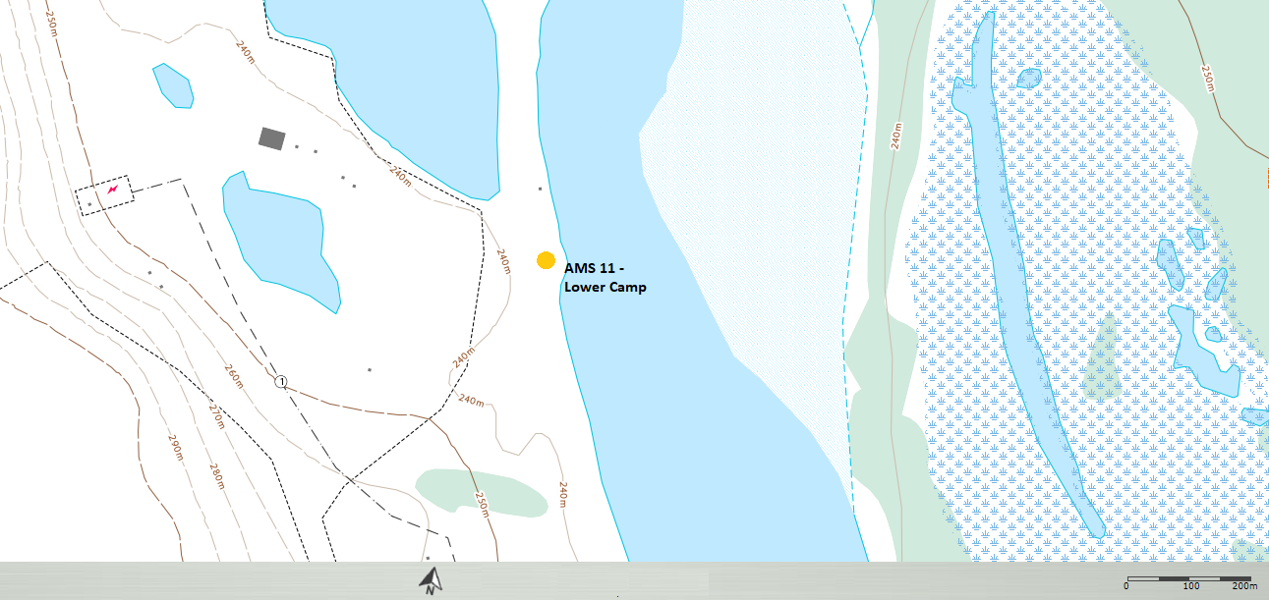
  - Figure 1 – Area topographic map showing AMS 11.
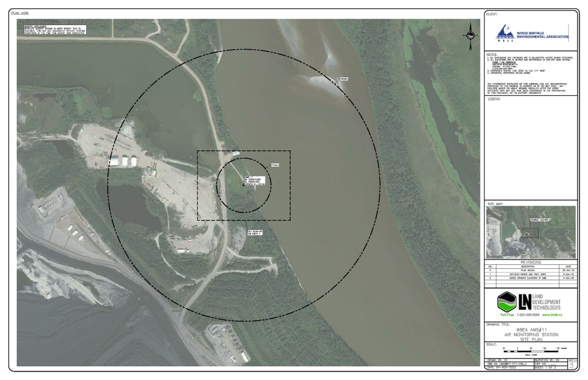
  - Figure 2.0 – Aerial image showing AMS 11.

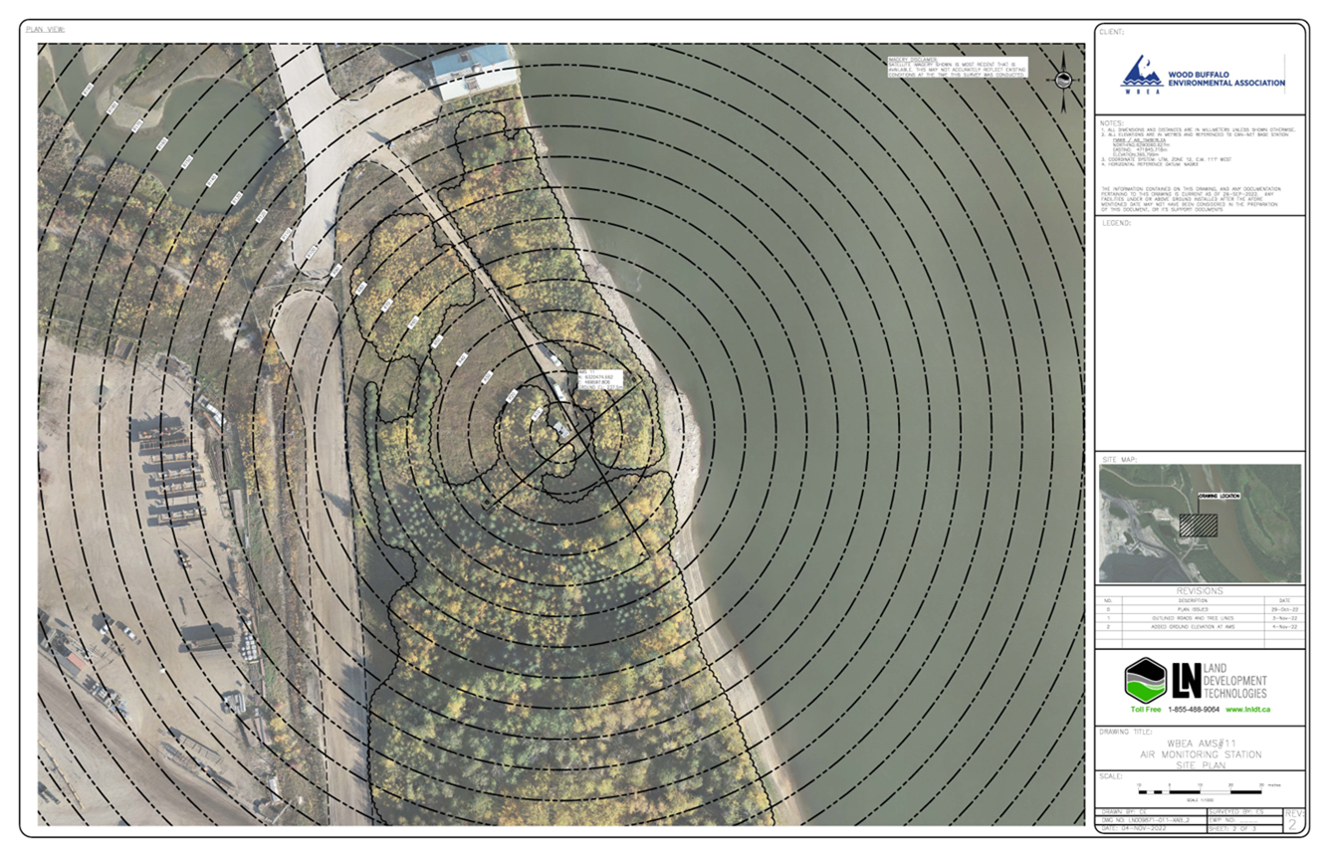
  - Figure 3.0 – Plan view image for AMS 11 site.

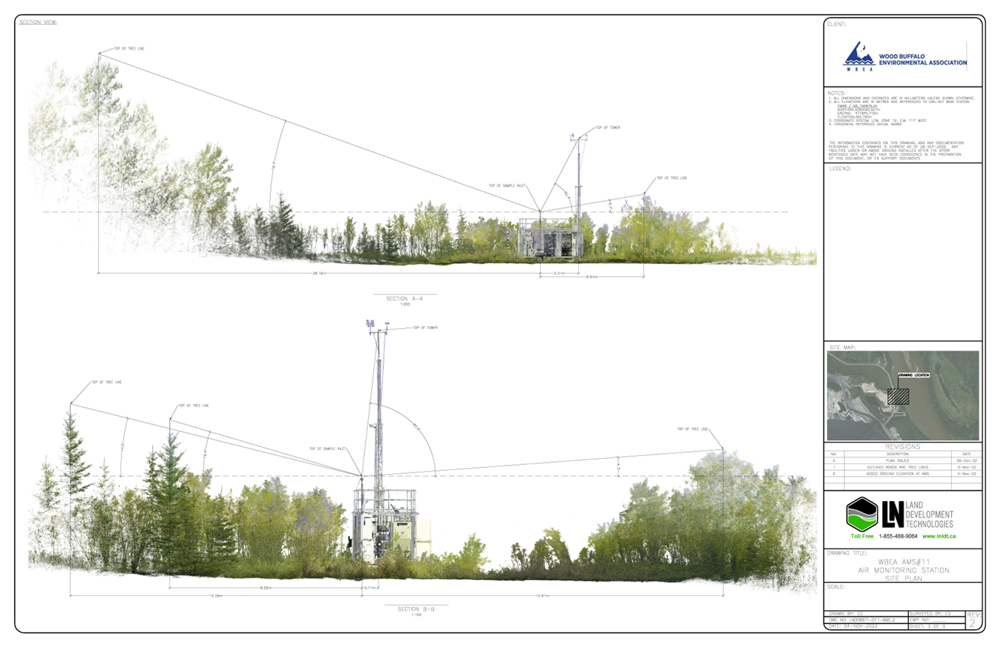
  - Figure 4.0 – Elevation view image for AMS 11 site.

Site photos
The following photos show the environment surrounding the monitoring station.

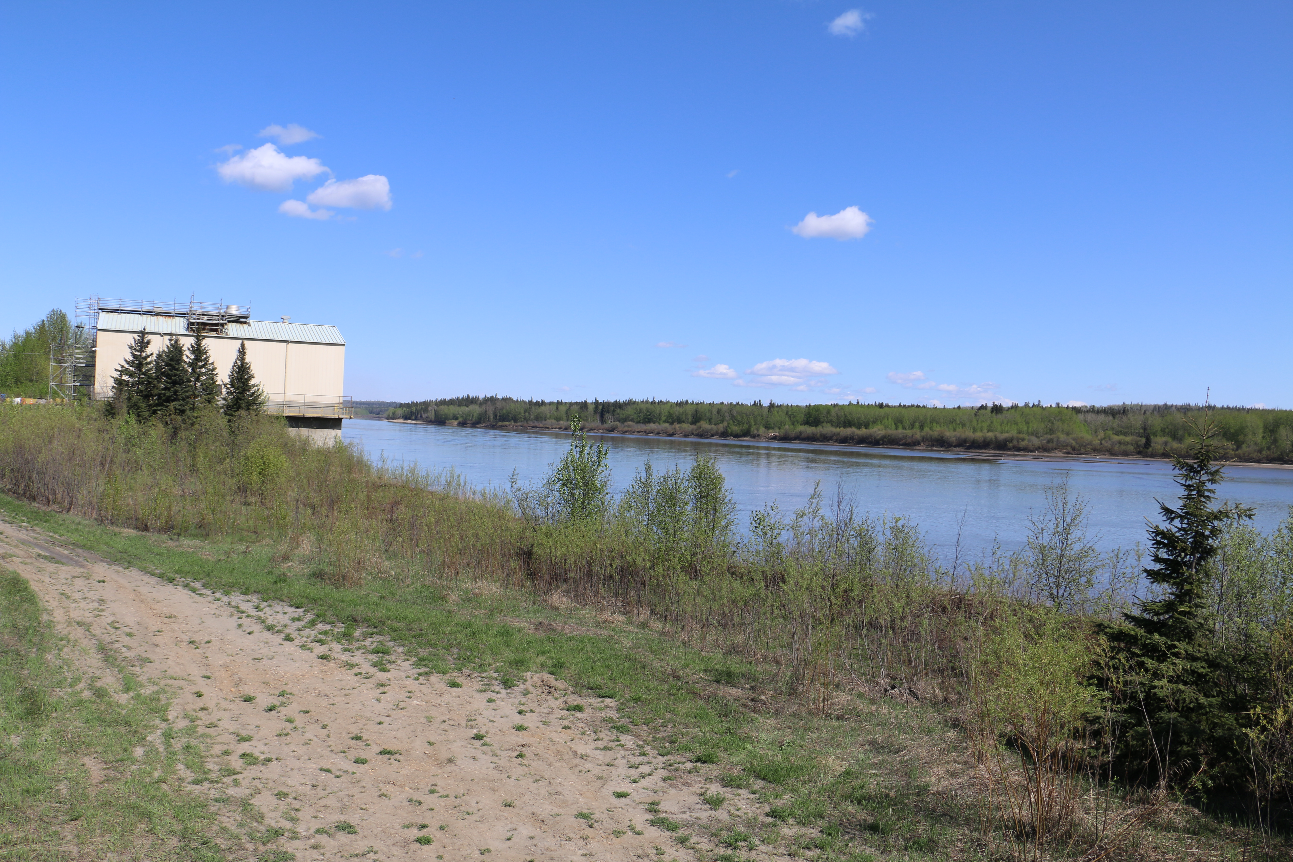
  - Figure 5.0 – Environment looking North.

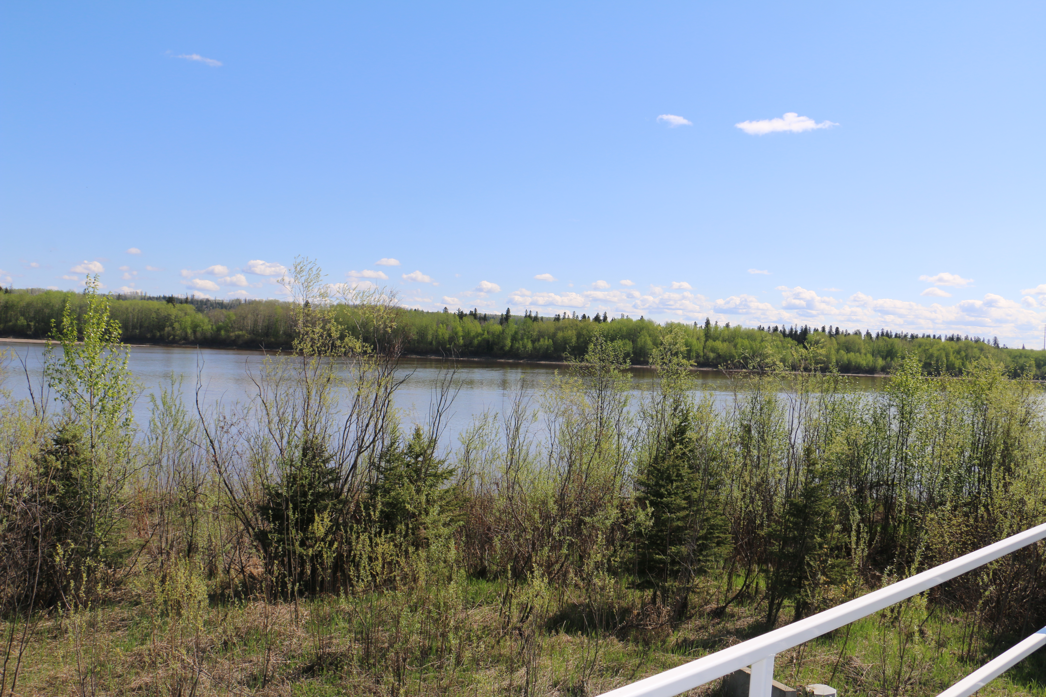
  - Figure 6 – Environment looking East.

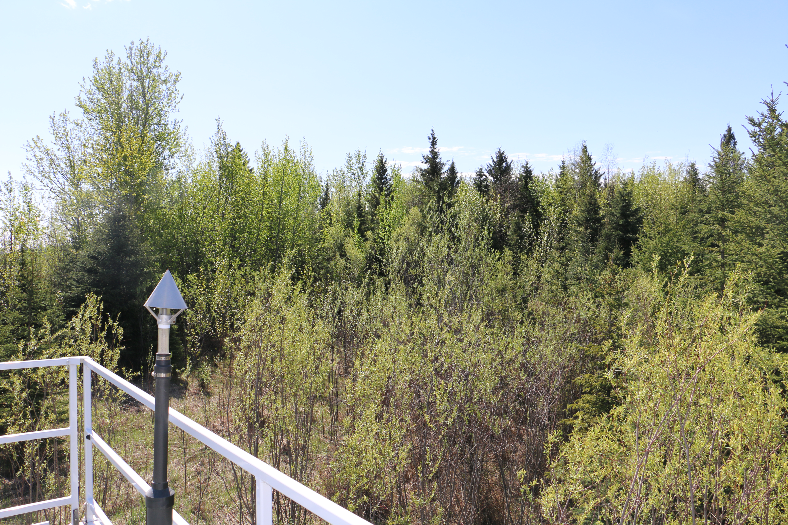
  - Figure 7 – Environment looking South.

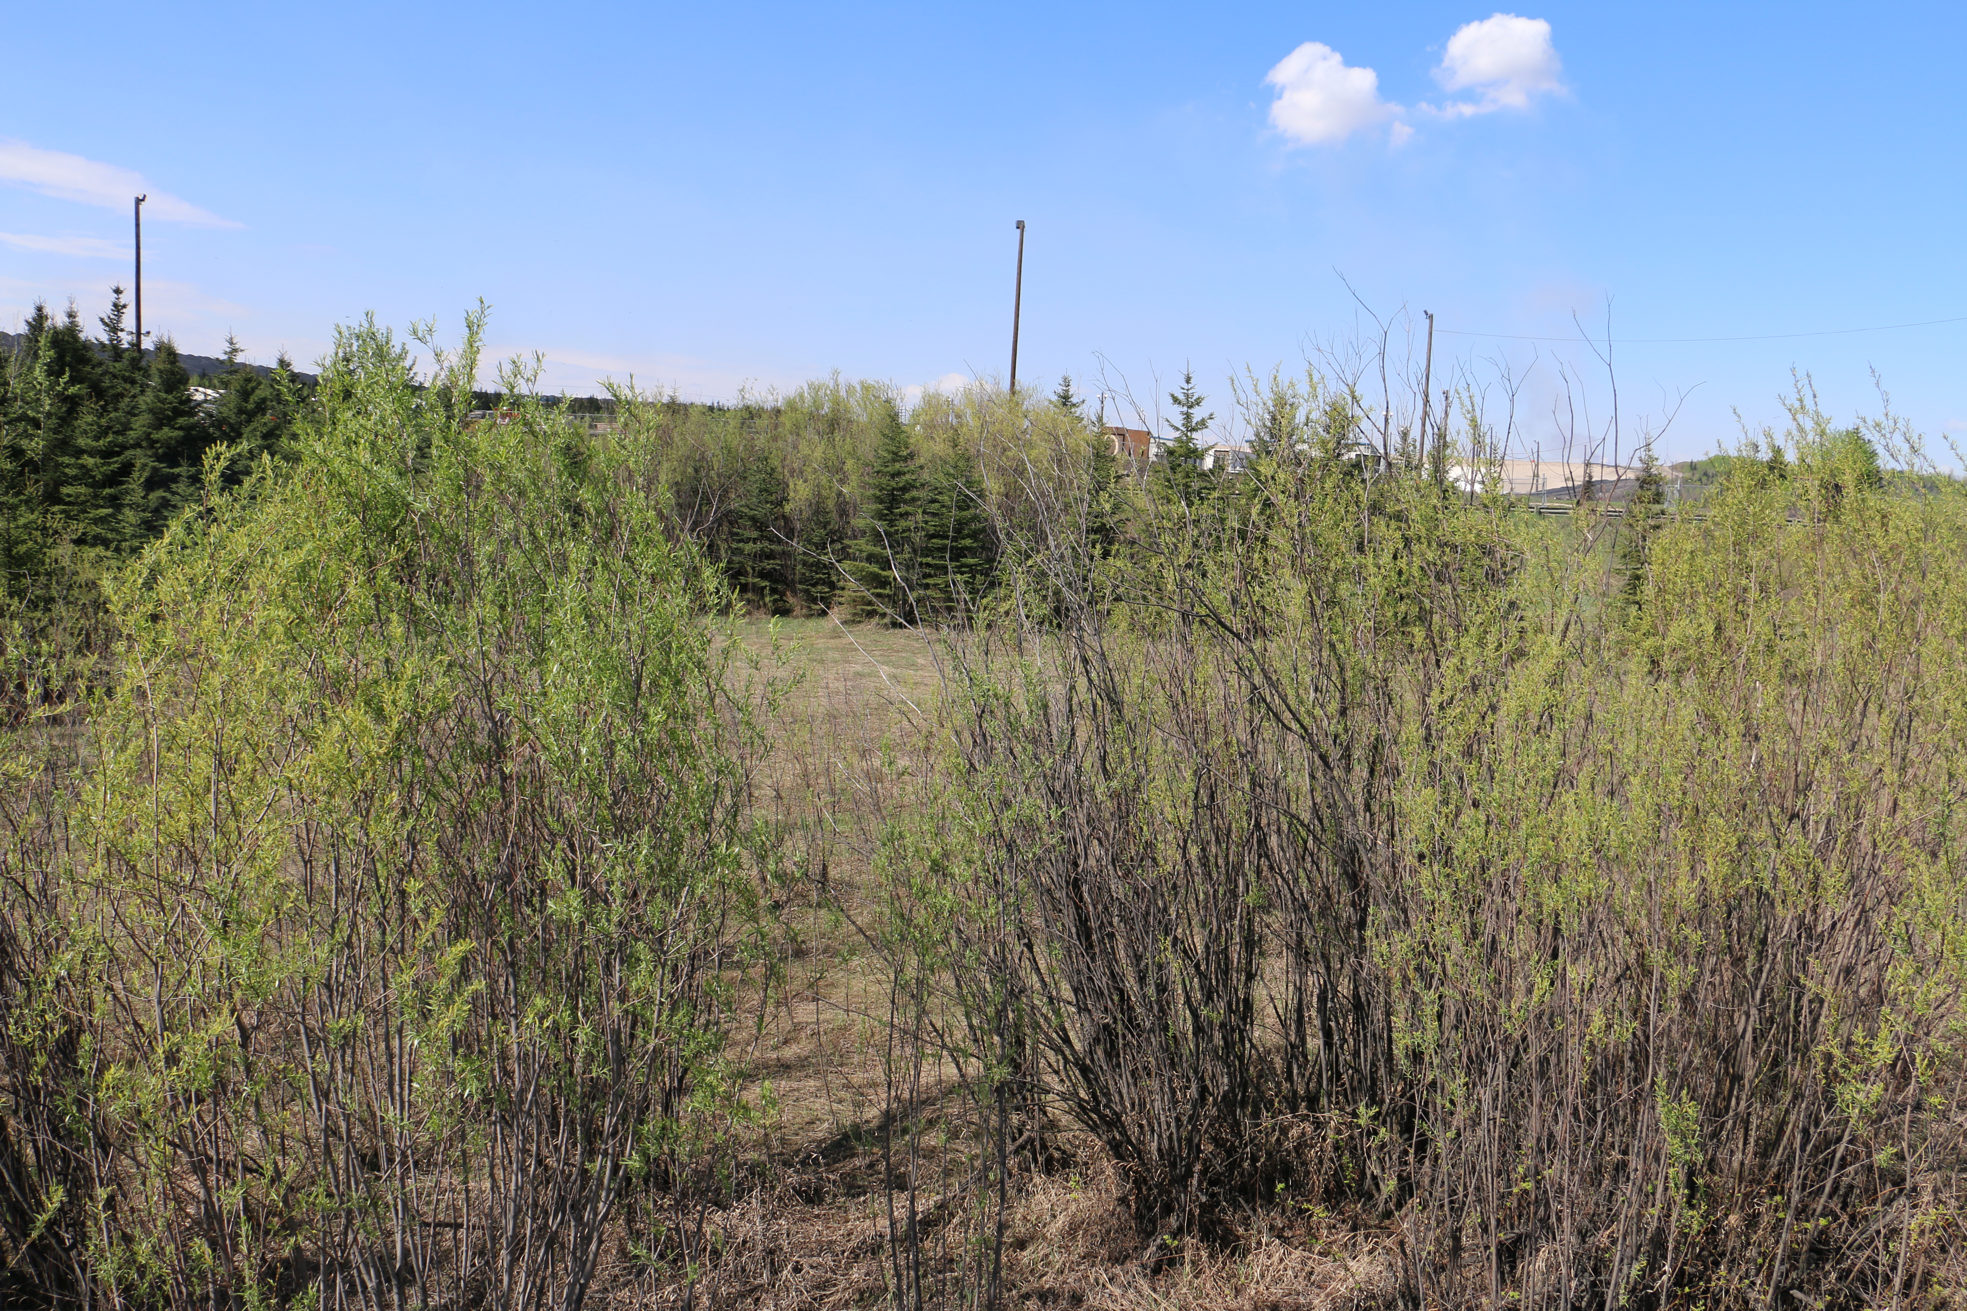
  - Figure 8– Environment looking West.

  - 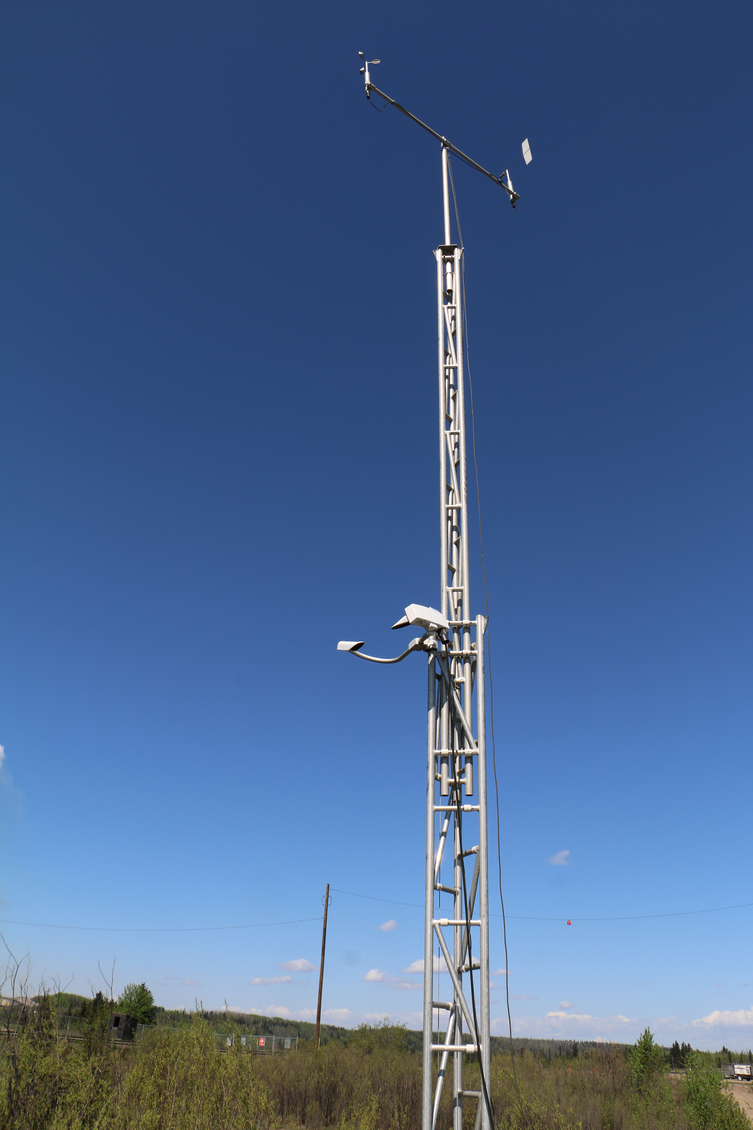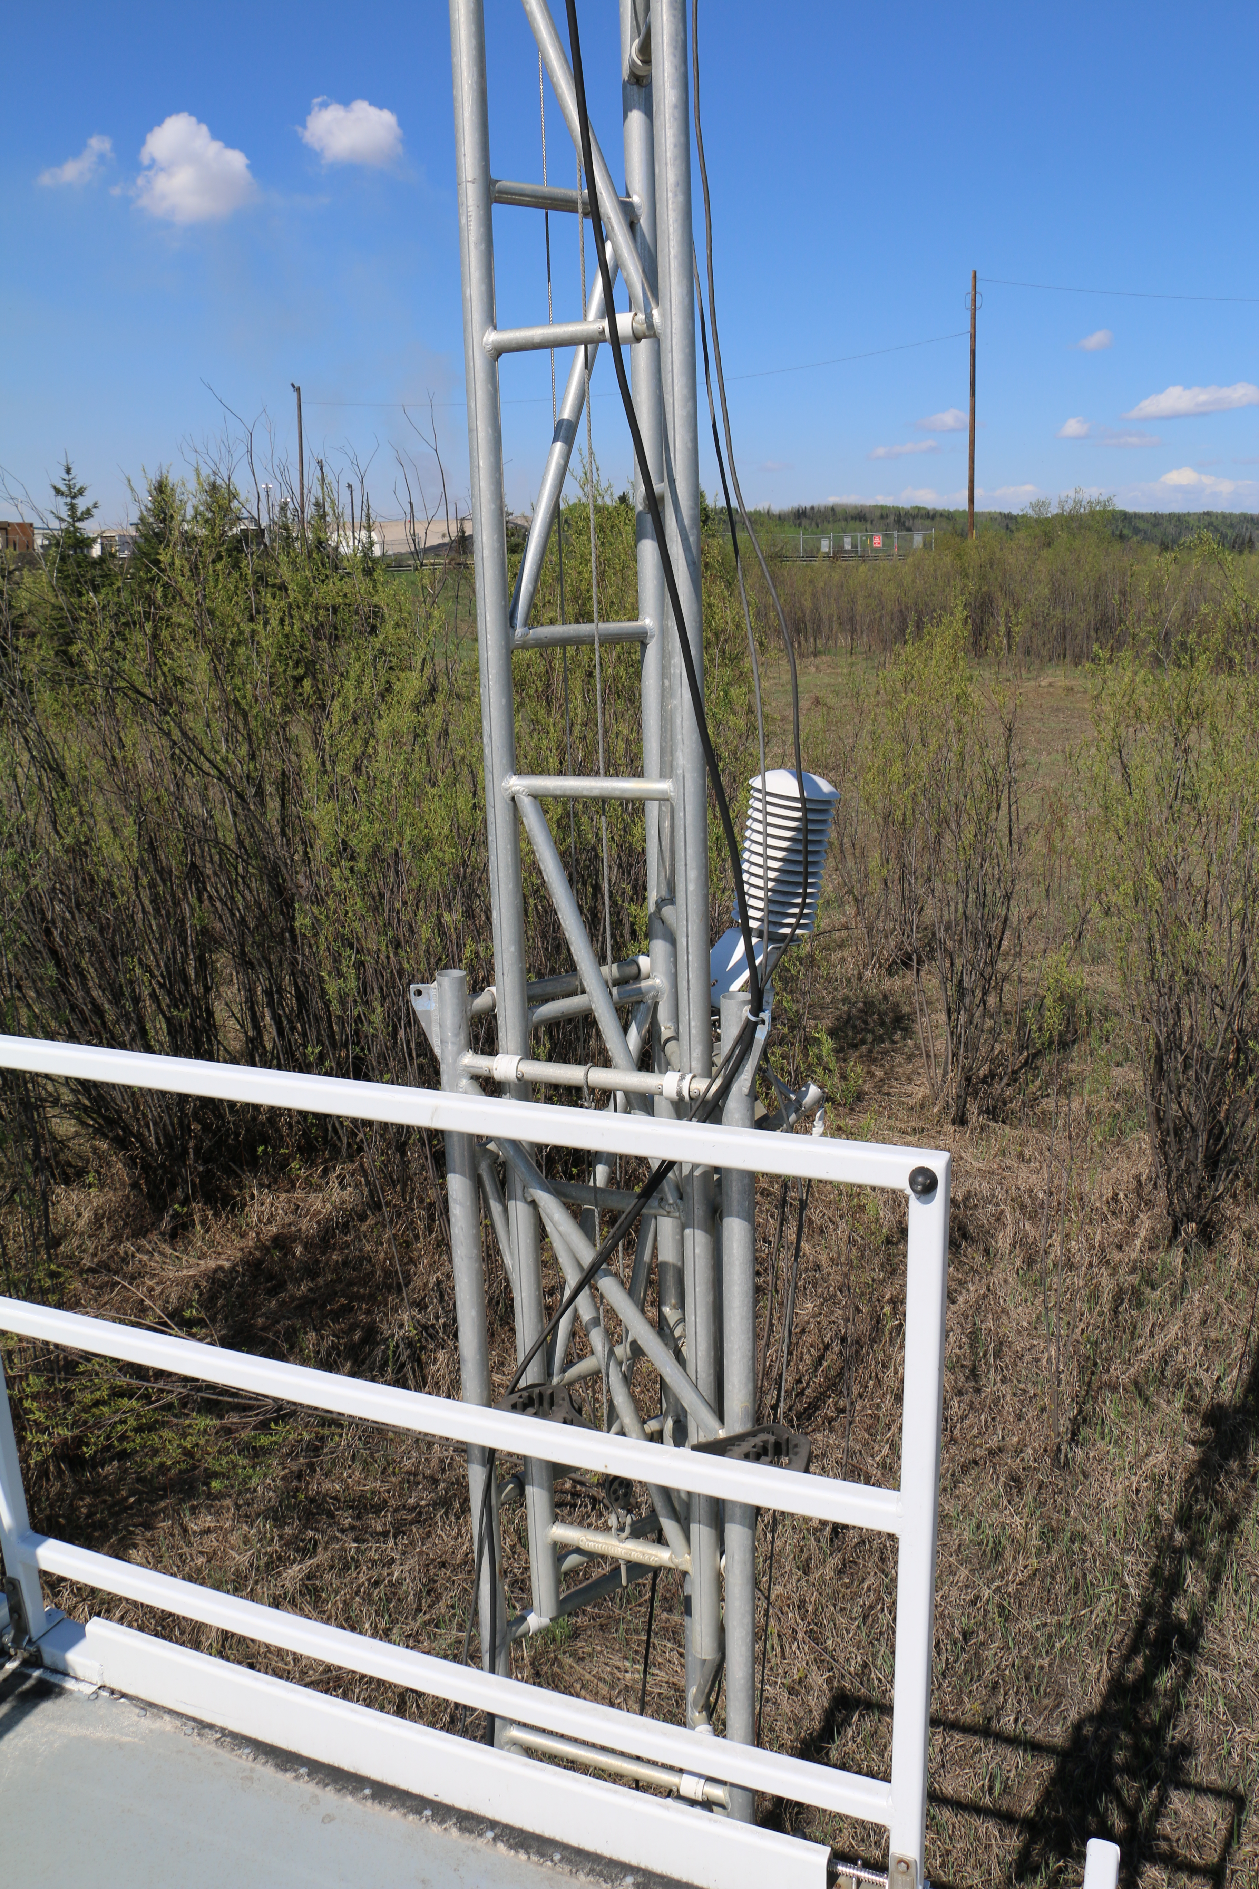
  - Figure 9 – Meteorological Tower

Station Photos
The following photos show the monitoring station and instrumentation.
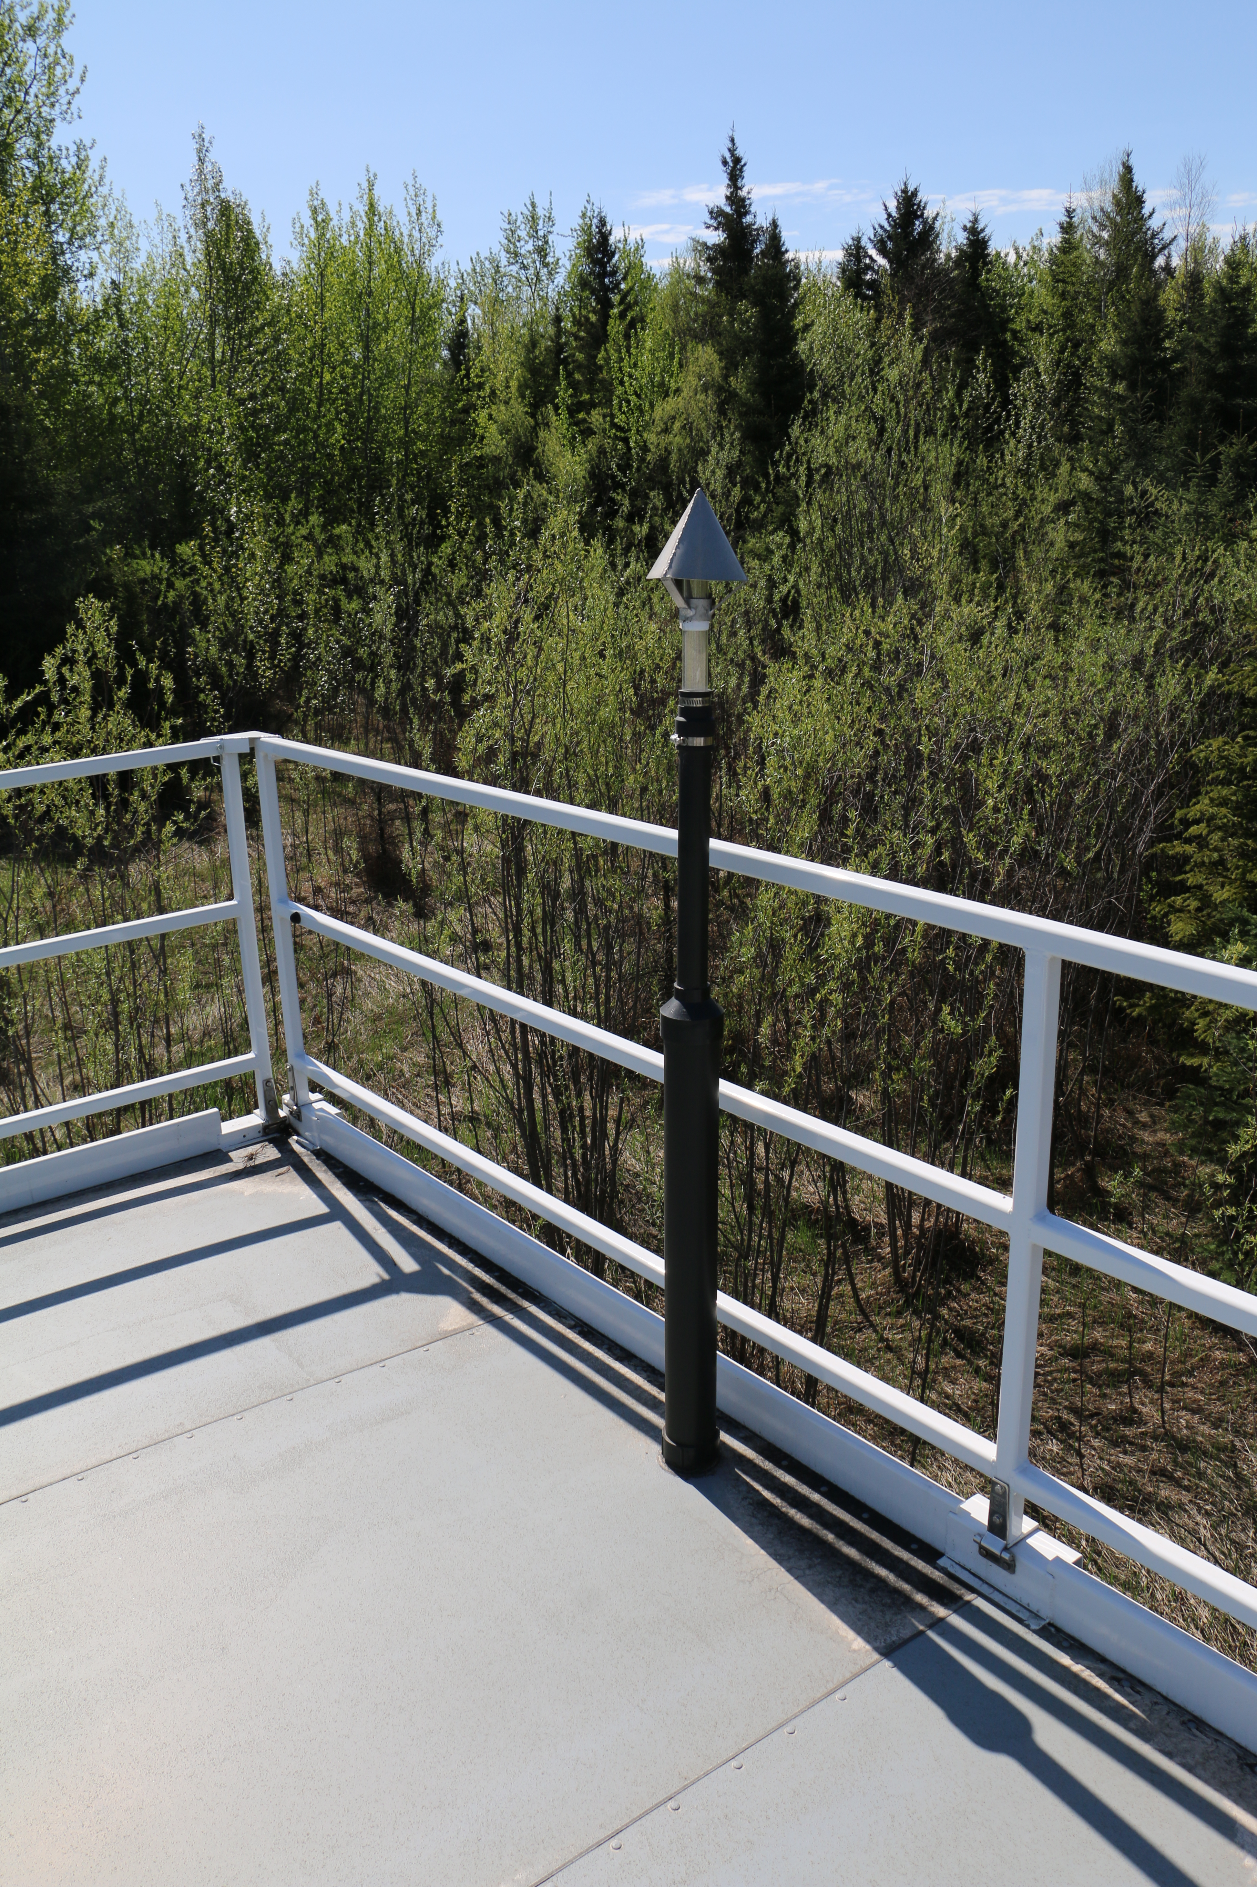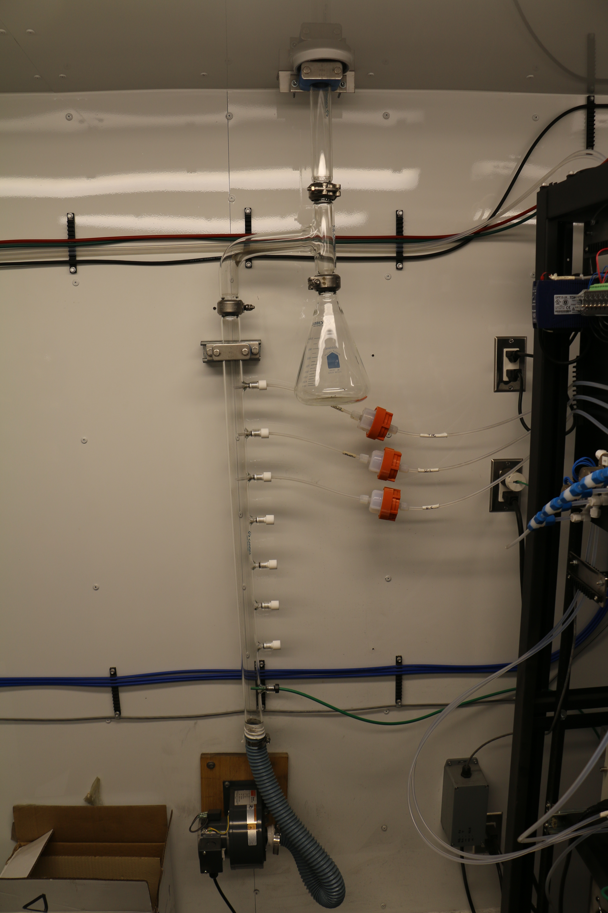
  - Figure 10 – Photo showing the inlet and sample manifold.

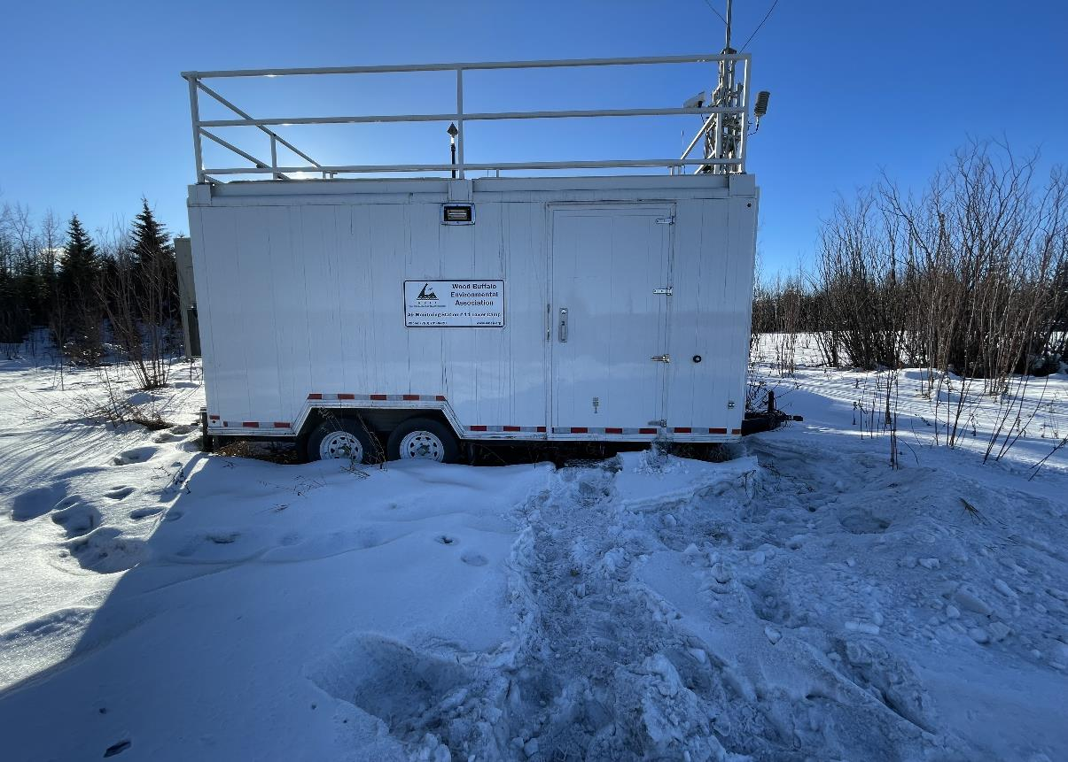
  - Figure 11 – Curb shot of the monitoring station.
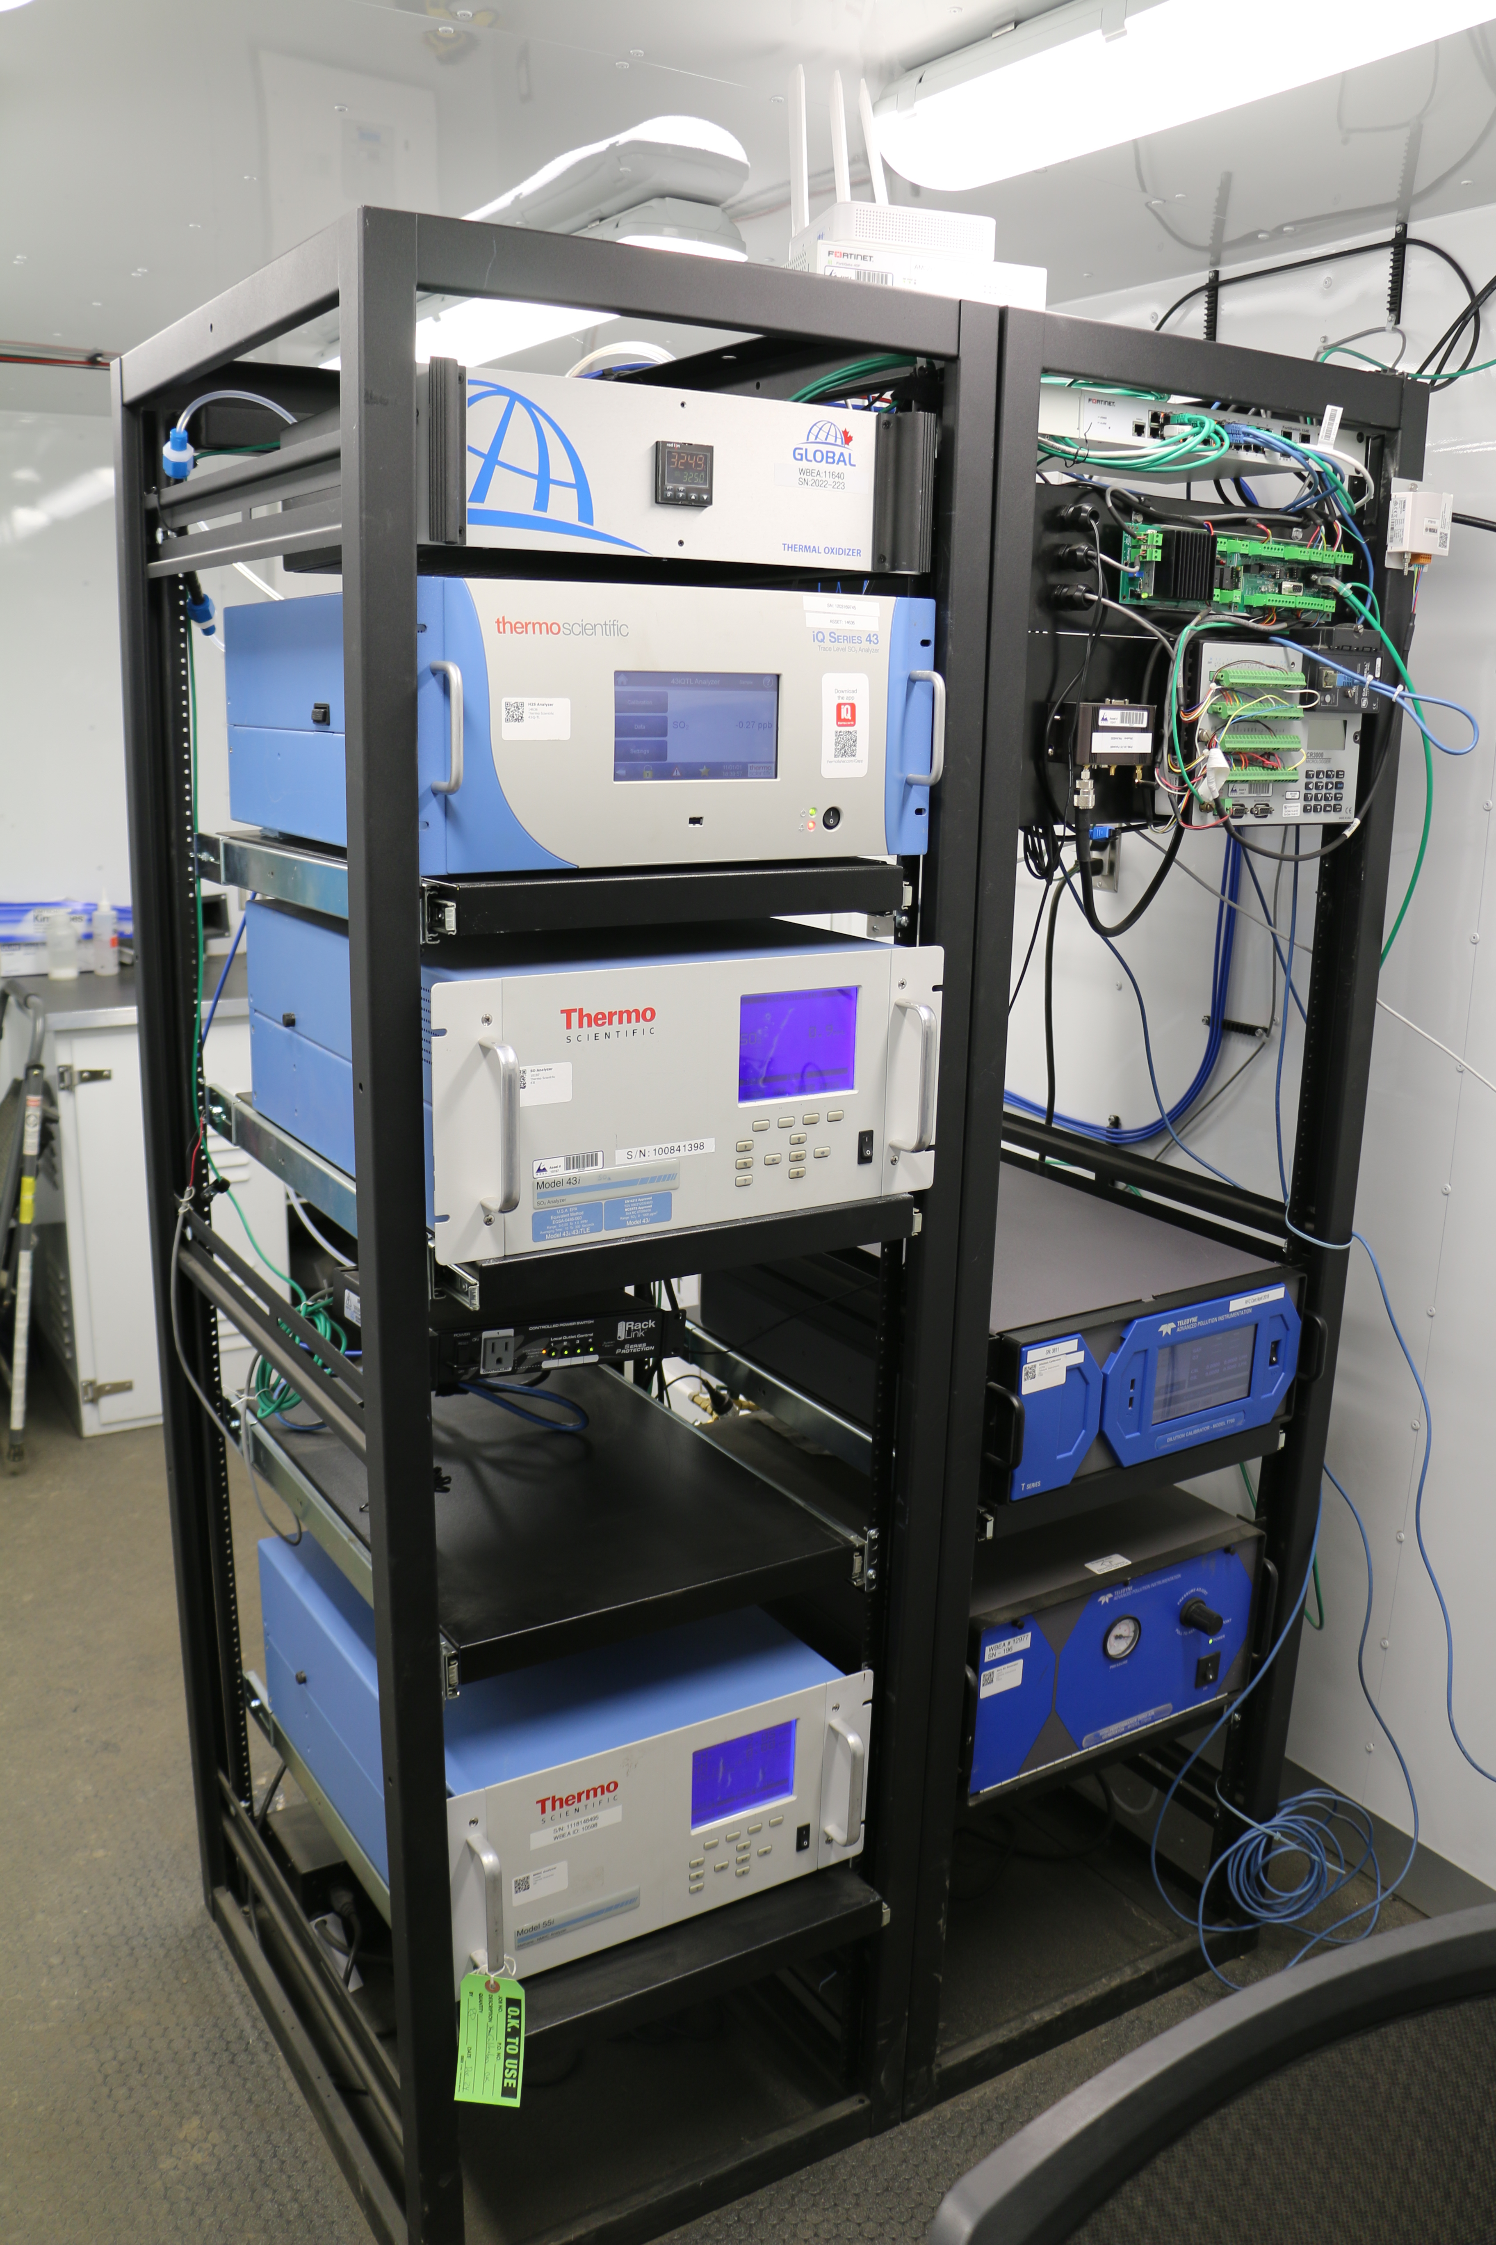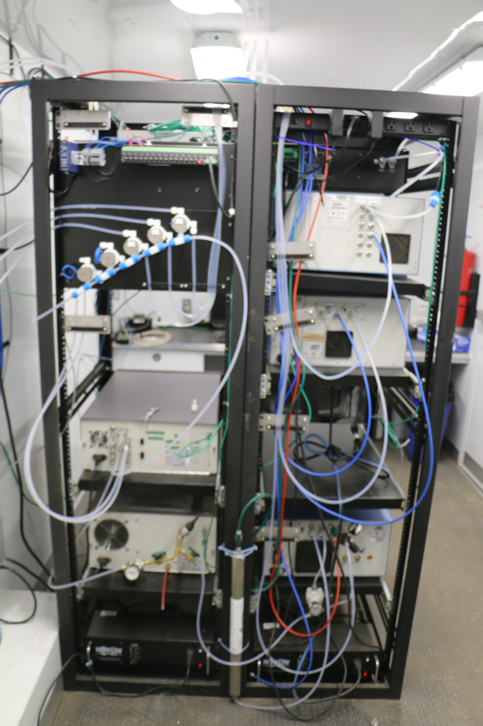
  - Figure 12 –Photo of the front and the back of instrument rack.

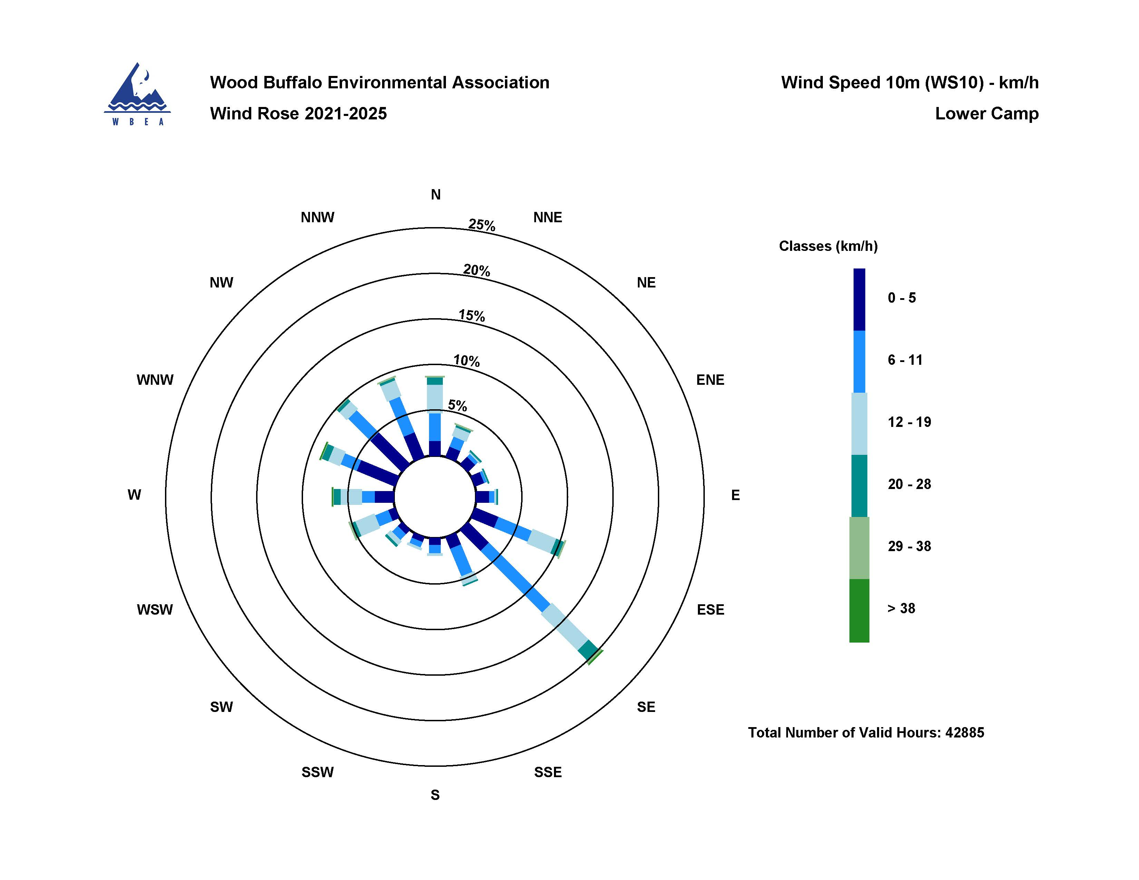
  - Figure 13 – Windrose (2021-2025).

