Wood Buffalo Environmental Association
Ambient Air Monitoring Station
Site Documentation

Barge Landing

LAST UPDATED: February 18, 2026

Table of Contents
General Site Information 4
Station 4
Location 4
Owner/Operator/Approval Holder 4
Site Description 4
Site Influences 5
Localized Sources (within 20 metres of station) 5
Roadway Influences 5
Major Point Sources 5
Station Equipment 6
Analytical Equipment 6
Meteorological Equipment 6
Support Equipment 6
Site photos 12
Station Photos 17

Tables and Figures
Figure 1 – Area topographic map showing AMS 09 7
Figure 2 – Aerial photo showing AMS 09 8
Figure 3 – Plan view sketch for AMS 09 site 9
Figure 4 – Elevation view image for AMS 09 site, section A-A 10
Figure 5 – Elevation view image for AMS 09 site, section B-B 11
Figure 6 – Environment looking North 12
Figure 7 – Environment looking East 13
Figure 8 – Environment looking South 14
Figure 9 – Environment looking West 15
Figure 10 – Meteorological Tower 16
Figure 11 – Photo showing the inlet and sample manifold 17
Figure 12 – Curb shot of the monitoring station 18
Figure 13 –Photo of the front and the back of instrument rack 19
Figure 14 – Windrose (2021 – 2025) 20

General Site Information
Revision Date: February 18, 2026

Station
Station ID | AMS 09
Station name | Barge Landing
Date station established | 2000

Location
Station street address | Northeast of the Barge Landing Road, approximately 460 meters northwest of the Highway 63 intersection
Legal land description | 7-31-094-10 W4
Airshed Zone | Wood Buffalo Environmental Association
Latitude | 57.198178
Longitude | -111.59946327
UTM East | 463778
UTM North | 6339606
Nearest community | Fort Mackay
Community population | 757
Census Year | 2021

Owner/Operator/Approval Holder
Operating Agency | Wood Buffalo Environmental Association
Address of Operating Agency | Unit 3, 805 Memorial Drive, Fort McMurray, Alberta T9K 0K4
Name of Approval Holder | Canadian Natural Upgrading Limited
Approval number | 20809-02-00
Contact Name | Tina Ding
Address | Albian Sands, P.O. Box 5670
Phone number | 780-713-4454
Email address | Tina.Ding@cnrl.com

Site Description
Land use by sector | 0 – 90 degrees | Wooded area
Land use by sector | 91 – 180 degrees | Wooded area
Land use by sector | 181 – 270 degrees | Wooded area
Land use by sector | 271 – 360 degrees | Wooded area
Site elevation (m)  (above sea level) | 282 m
Angle of elevation to nearby buildings | Greatest angle | N/A
Angle of elevation to nearby buildings | Building direction | N/A
Airflow restrictions | North | Trees
Airflow restrictions | East | Trees
Airflow restrictions | South | Trees
Airflow restrictions | West | Trees
Distance to nearest trees (m) | North | 10 m
Distance to nearest trees (m) | East | 10 m
Distance to nearest trees (m) | West | 10 m
Distance to nearest trees (m) | South | 20 m
Sample manifold | Type | All glass
Sample manifold | Inlet height above roof | 1 metre
Wind Sensors | Type | Cup and vane
Wind Sensors | Height above ground (m) | 20 m
Wind Sensors | Distance from station (m) | 2 m

Site Influences

Localized Sources (within 20 metres of station)
Type | Distance (m) | Description
None | N/A | N/A

Roadway Influences
Type | Traffic Volume | Distance (m) | Description
Barge Landing Road | Very low | 70 | Well maintained dirt access road frequented by pickup trucks and heavy equipment
Highway 63 | Medium | 400 | Provincial highway frequented by tractor trailers and pickup trucks.

Major Point Sources
Facility Name | Source Type | Distance from site (km) | Compass direction from site
CNRL Albian | Oil Sands Plant | 10 | NE
CNRL Horizon | Oil Sands Plant | 20 | NW

Station Equipment
Equipment Owner: Canadian Natural

Analytical Equipment
Parameter | Make | Model | Serial Number | Date Instrument Installed | WBEA Data Start Date
Continuous
SO₂ | Thermo Environmental | 43i | 1118148498 | 2018 | December, 2018
TRS | Thermo Environmental | 43iq-TLE | 1203169744 | 2025 | January, 1999
NO_{x}/NO/NO₂ | Thermo Environmental | 42i | 1426262593 | 2018 | December, 2018
THC/CH₄/NMHC | Thermo Environmental | 55i | 1193585652 | 2025 | January, 1999
PM 2.5 | Teledyne | T640 | 2237 | 2025 | January, 2019
Time-Integrated
VOC | Global Analyzers Systems ltd. | G170 | 2023-236 | 2023 | -

Meteorological Equipment
Parameter | Make | Model | Serial Number | WMO Site Class | Date Sensor Installed | WBEA Data Start Date
AT/RH | Vaisala | HMP155 | P3640808 | 3 | 2023 | January, 2000
WS | Met One | 010C-1 | E16831 | 4 | 2025 | August, 2021
WD | Met One | 020C-1 | E16004 | 4 | 2025 | August, 2021
Barometric Pressure | WBEA | 61302V-10 | BPA4394 | N/A | 2018 | December, 2018

Support Equipment
Name | Description | Make | Model | Serial Number
Datalogger | Datalogger | Campbell Scientific | CR3000 | 1850
Gas Dilution Calibrator | Dynamic dilution calibrator | Teledyne/API | T700 | 3812
Zero air generator | Zero Air Generator | Teledyne/API | 701 | 4888
Hydrogen Generator | Hydrogen Generator | AMA Instruments | HG 300 | 171067036
TRS Converter | Thermal Oxidizer | CD Nova | CDN-101 | 519
Shelter / Building | Air monitoring portable | ITB | 10 x 20 | ITB0814464

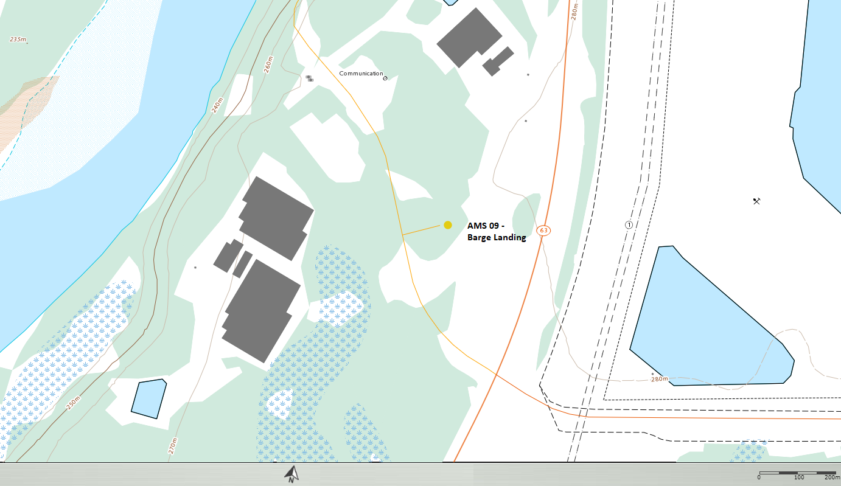
  - Figure 1 – Area topographic map showing AMS 09

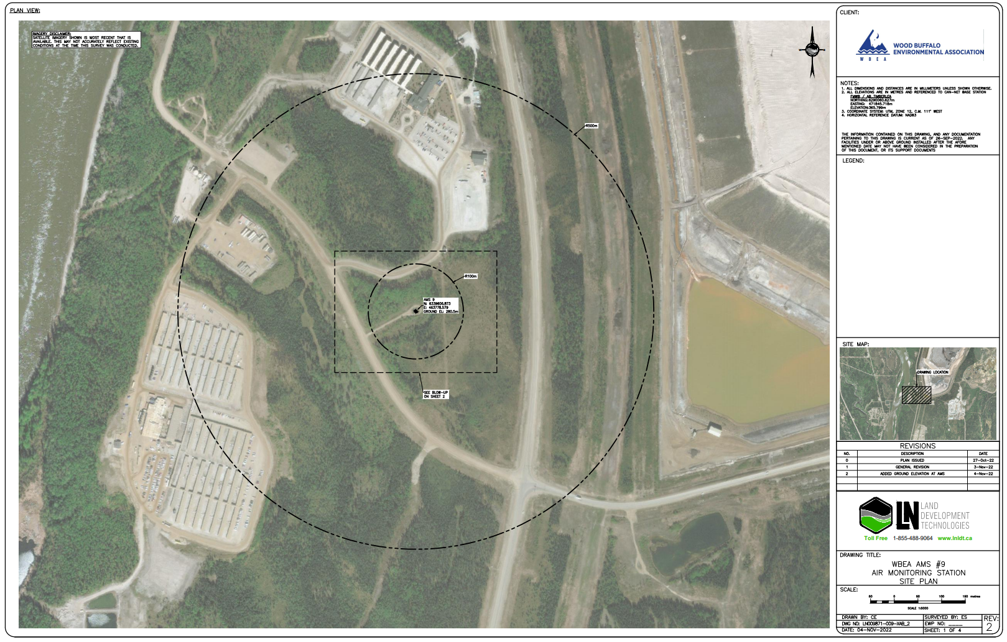
  - Figure 2 – Aerial photo showing AMS 09

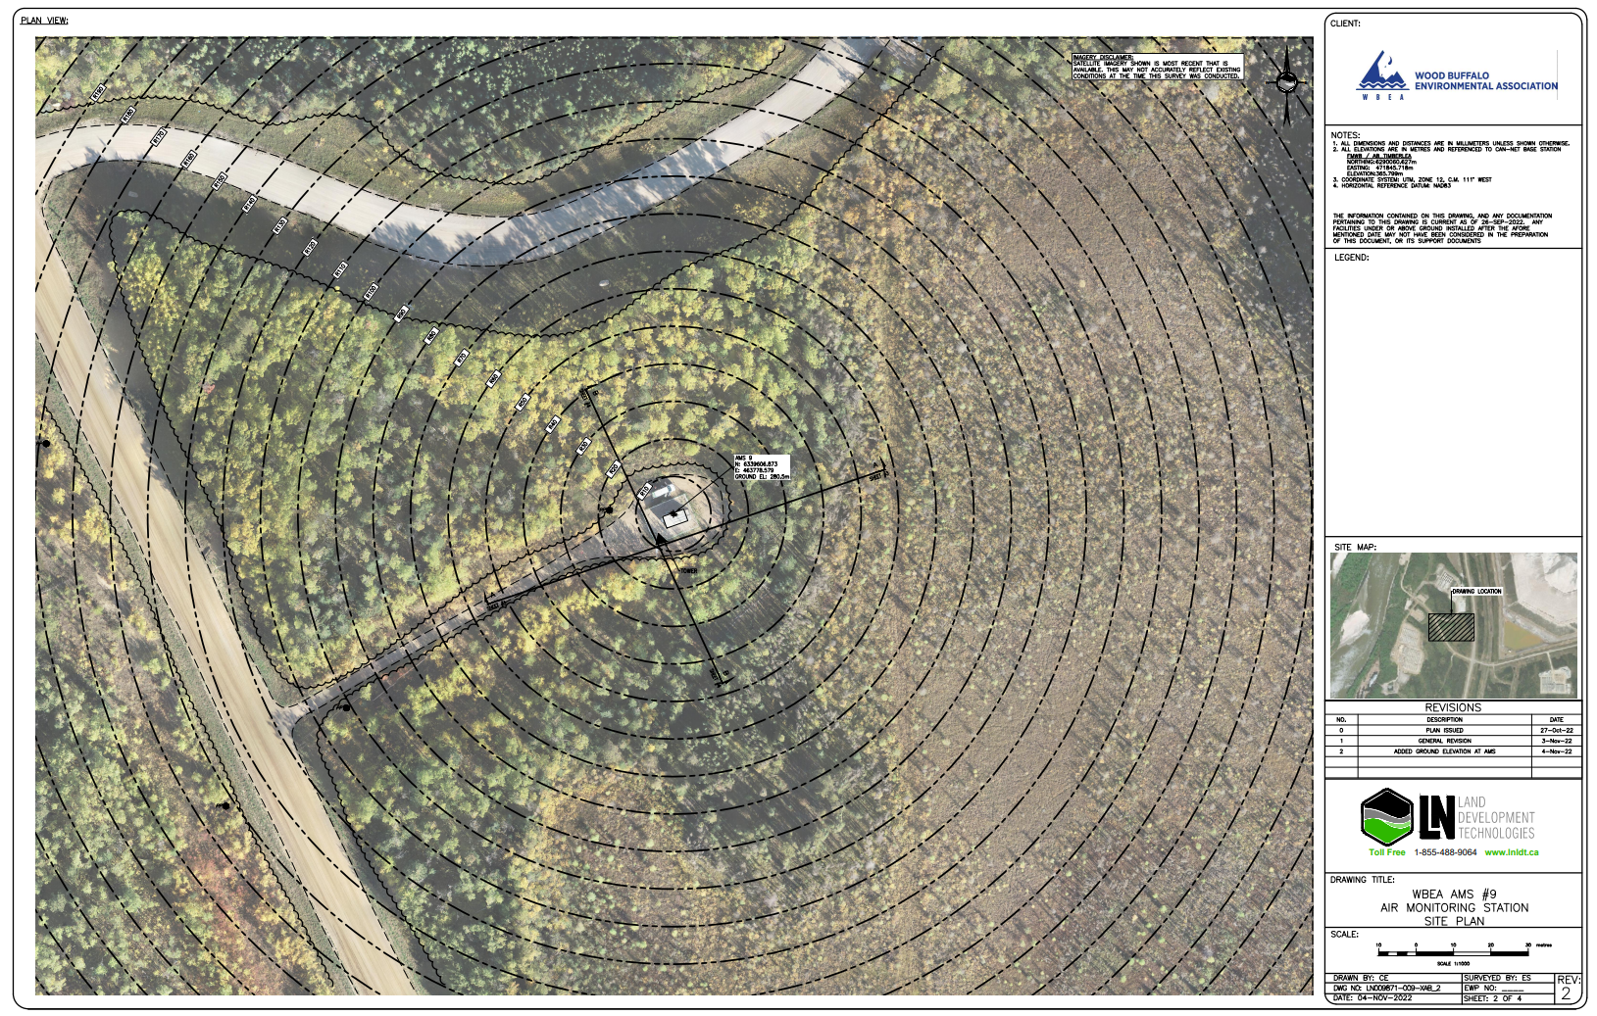
  - Figure 3 – Plan view sketch for AMS 09 site
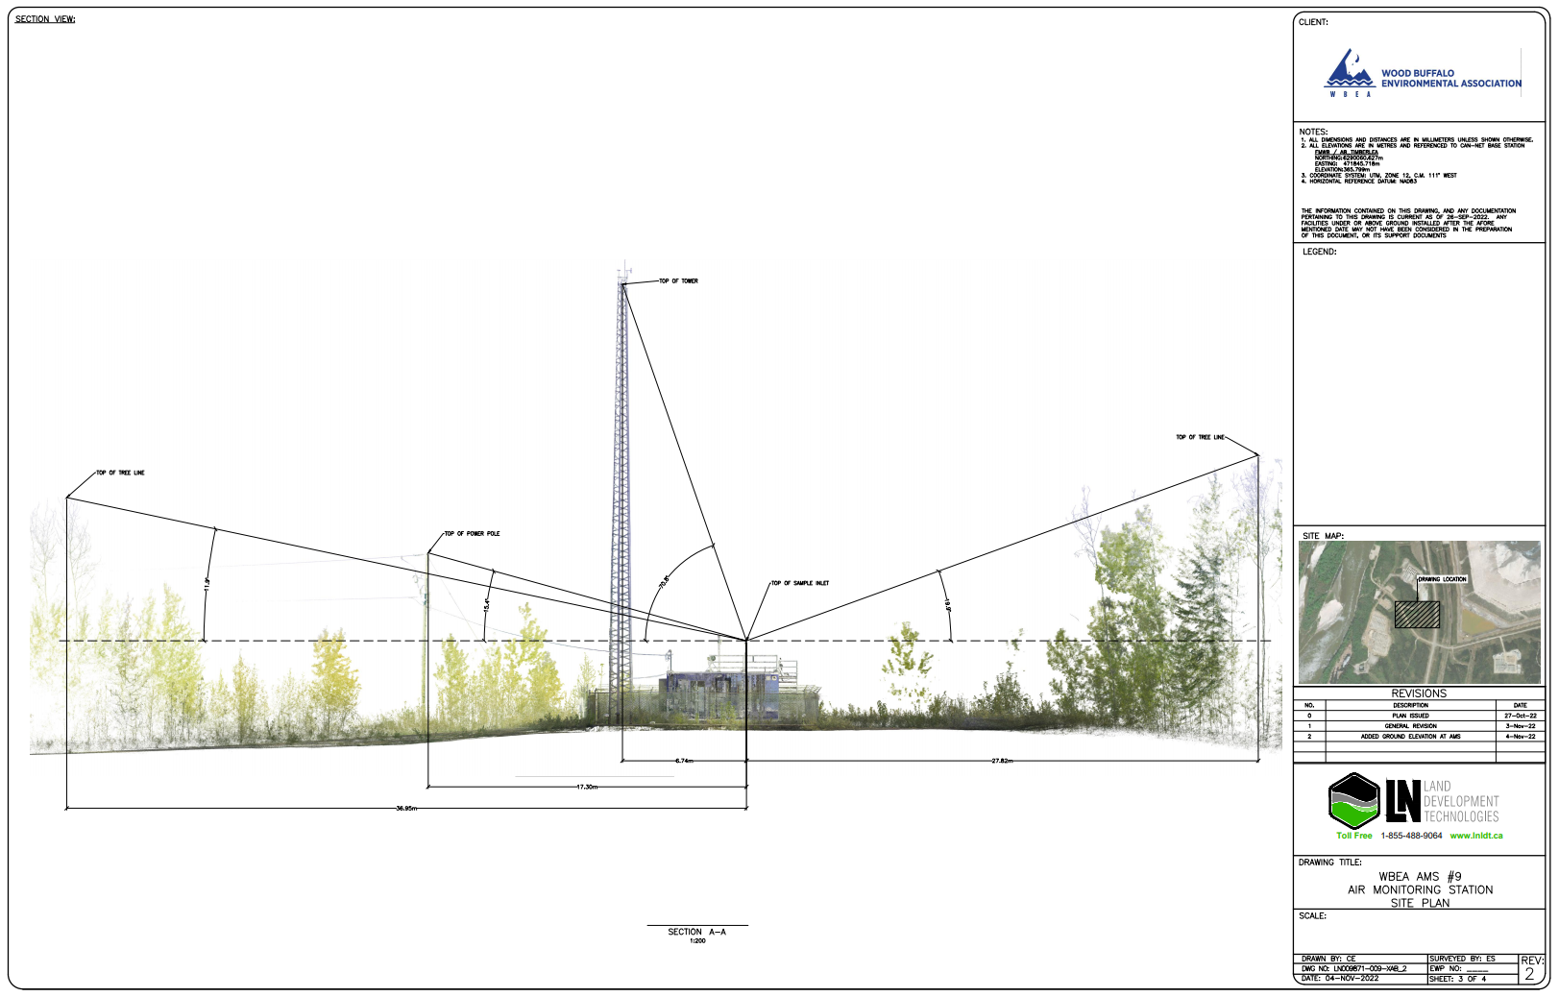
  - Figure 4 – Elevation view image for AMS 09 site, section A-A

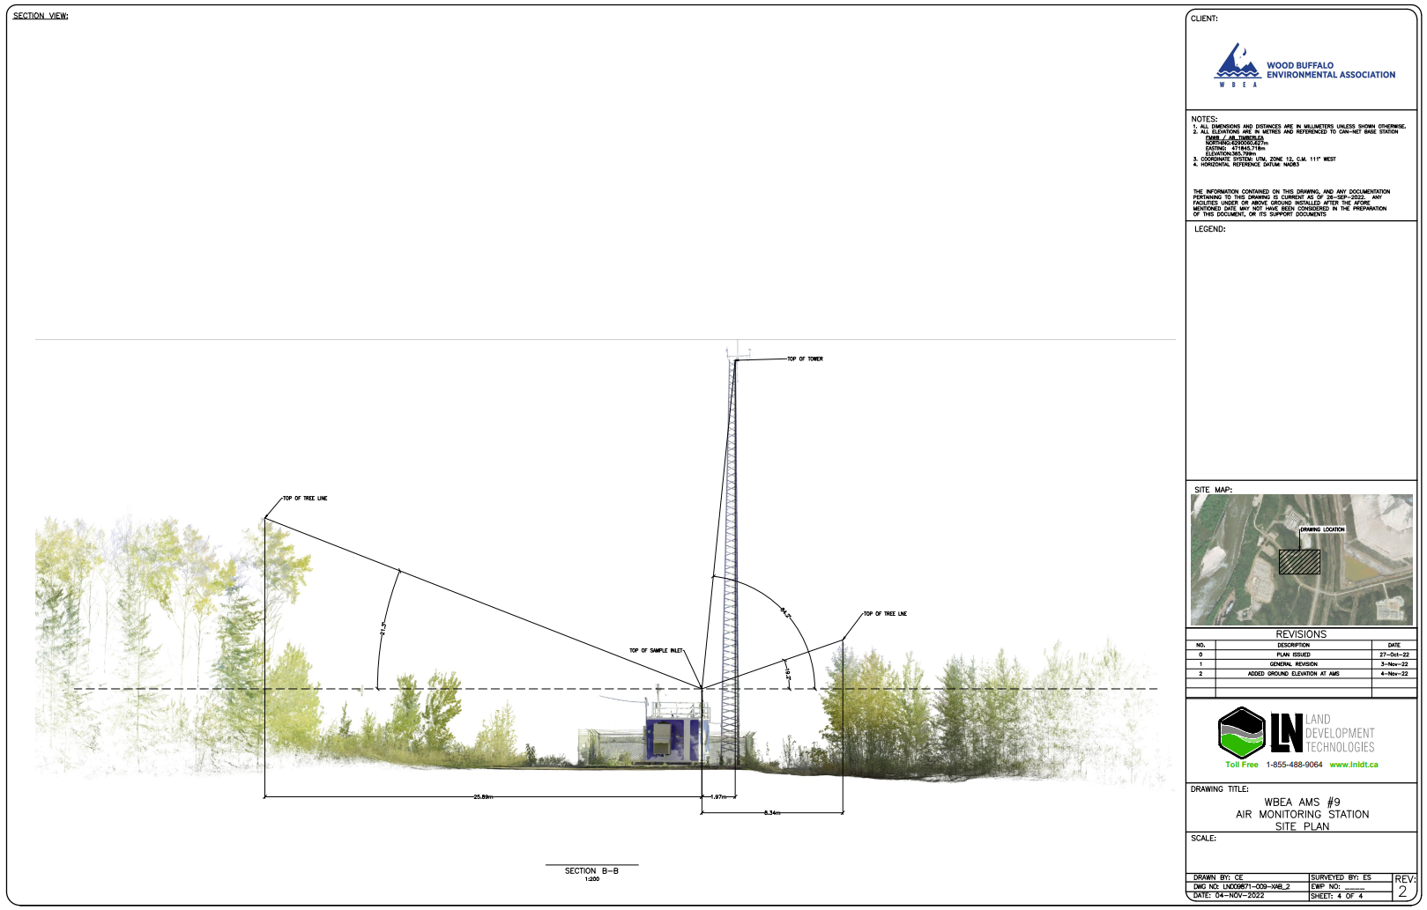
  - Figure 5 – Elevation view image for AMS 09 site, section B-B

Site photos
The following photos show the environment surrounding the monitoring station.

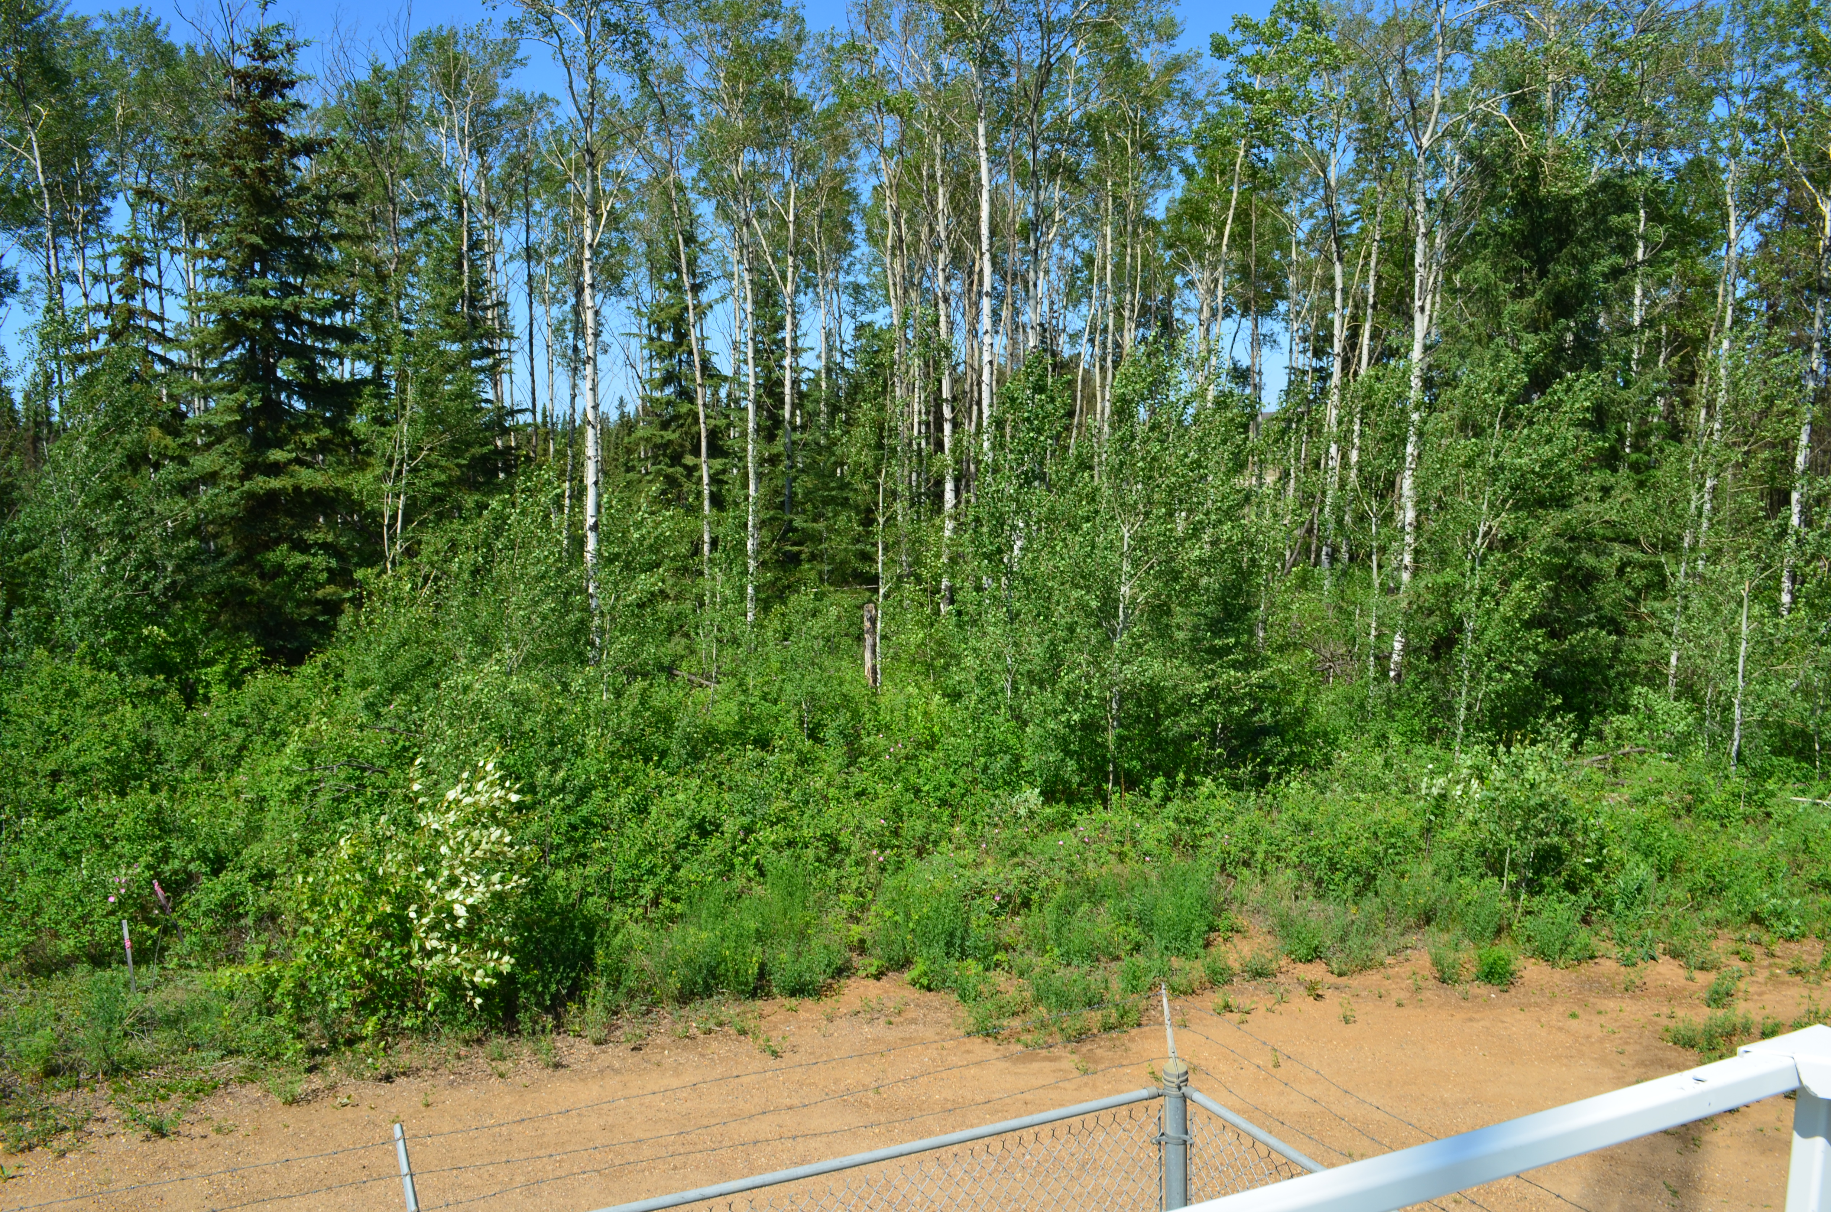
  - Figure 6 – Environment looking North

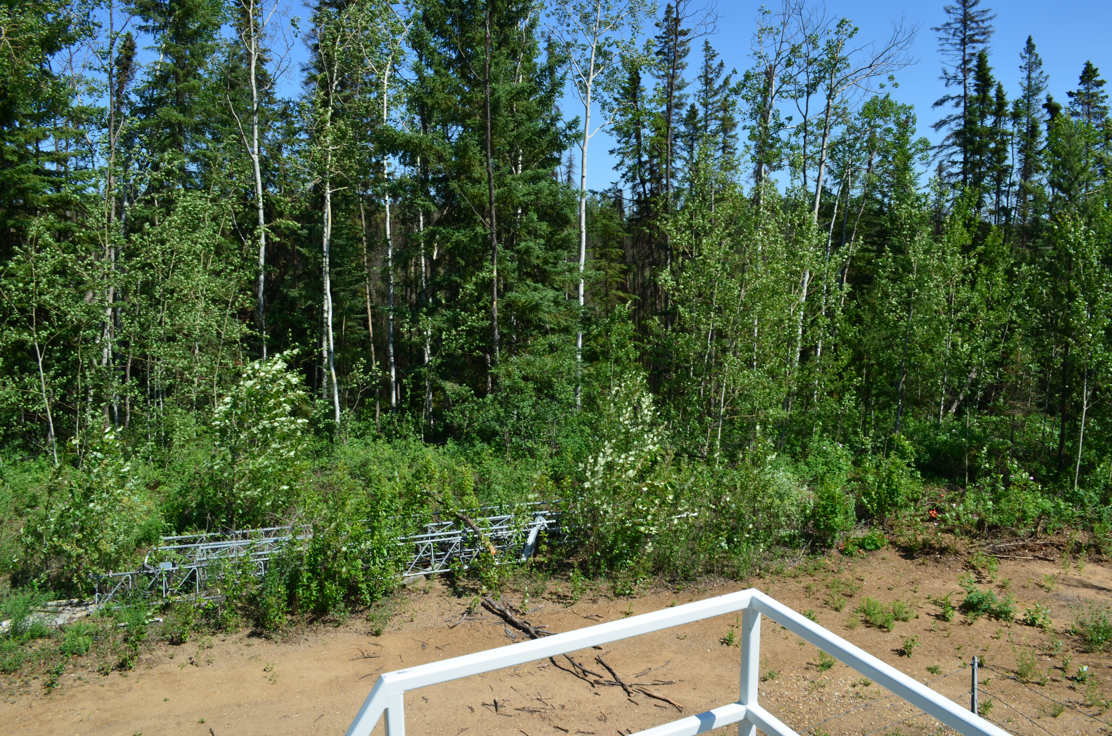
  - Figure 7 – Environment looking East
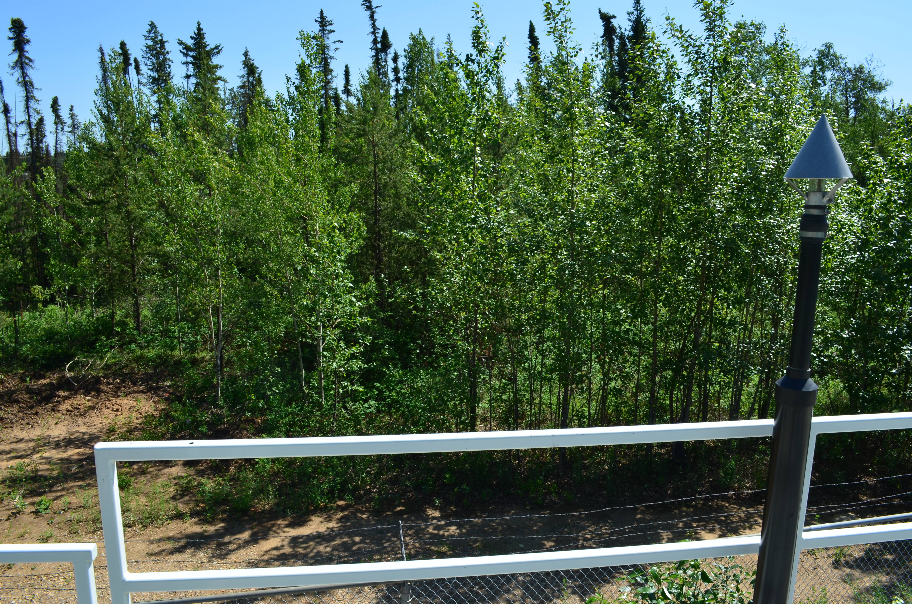
  - Figure 8 – Environment looking South

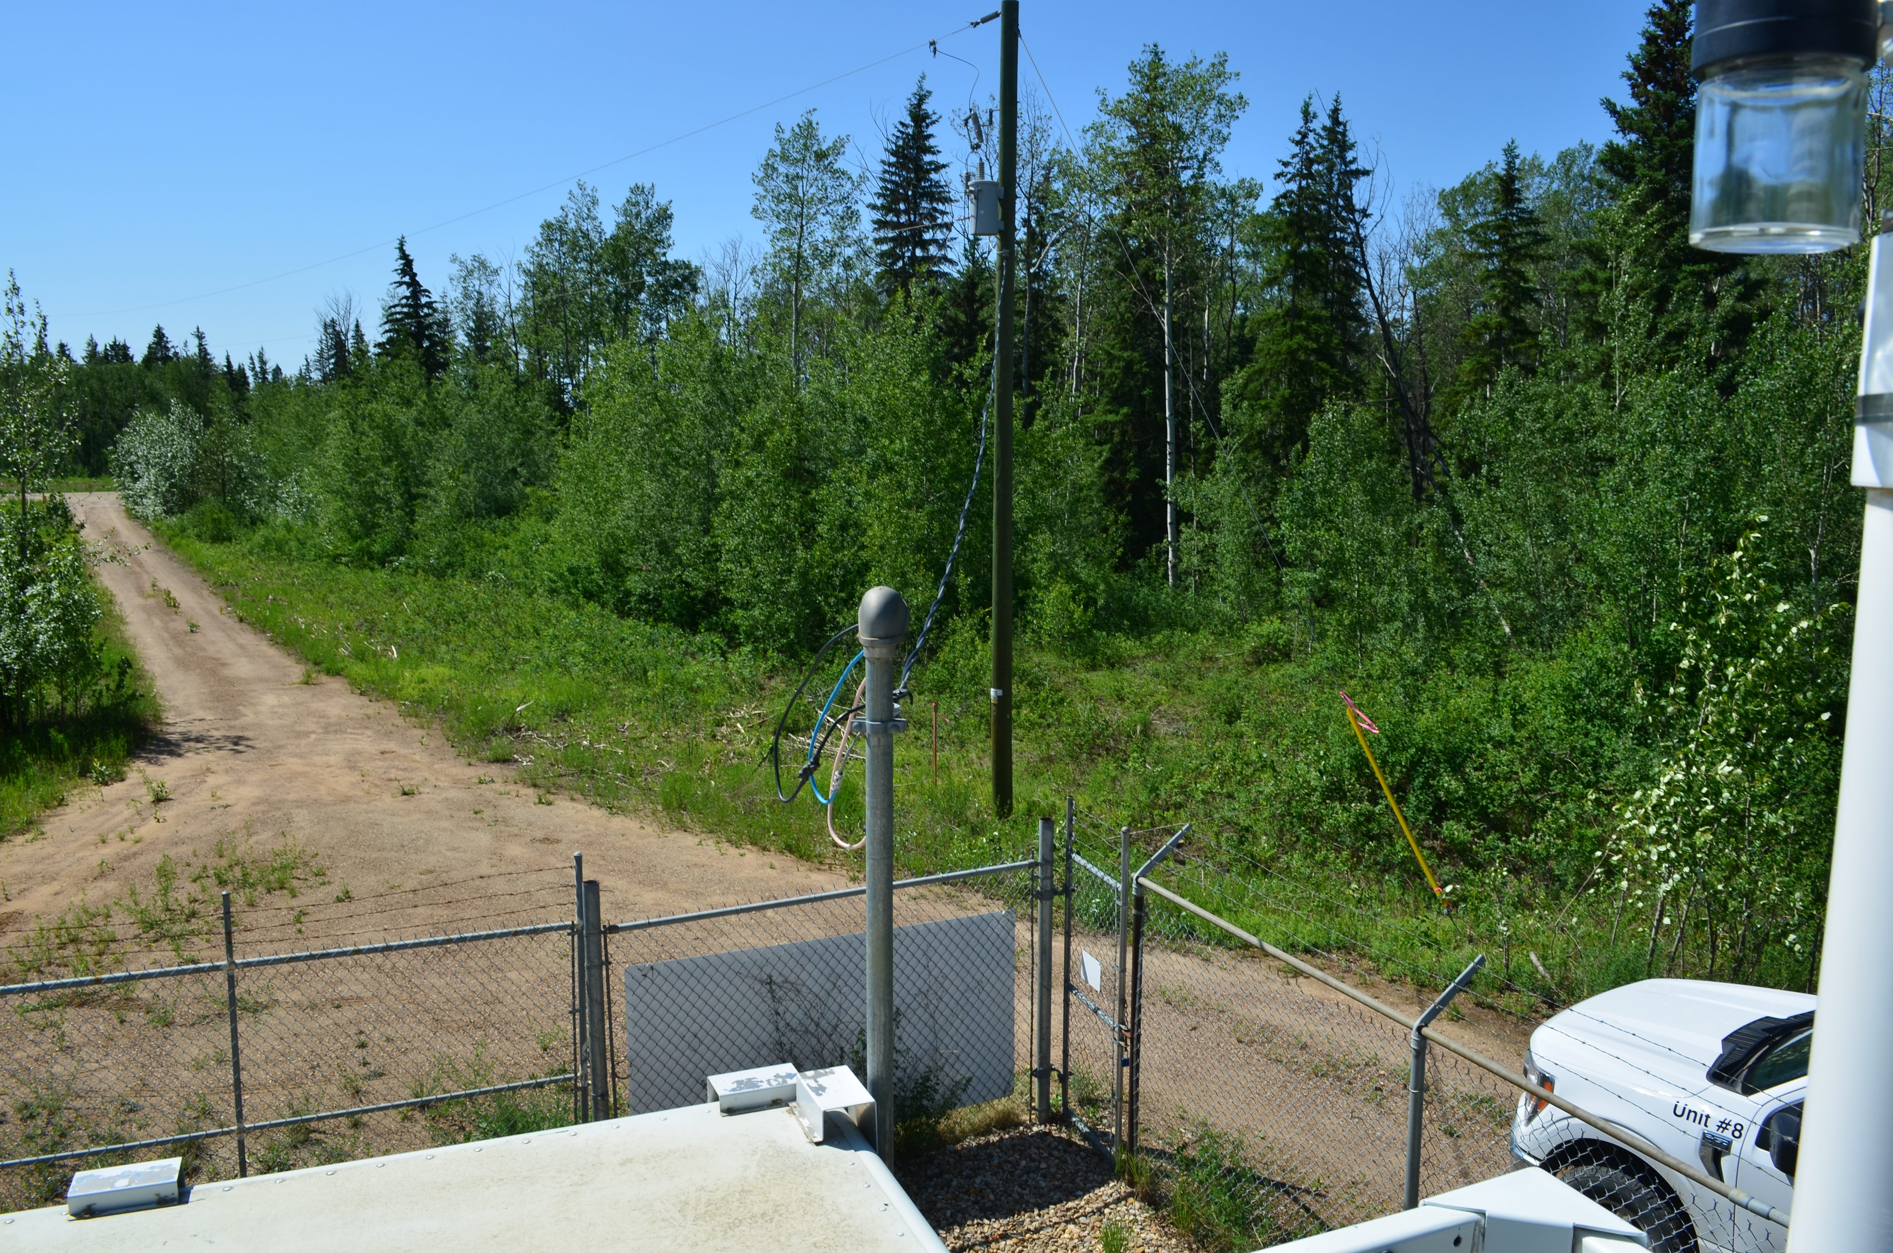
  - Figure 9 – Environment looking West
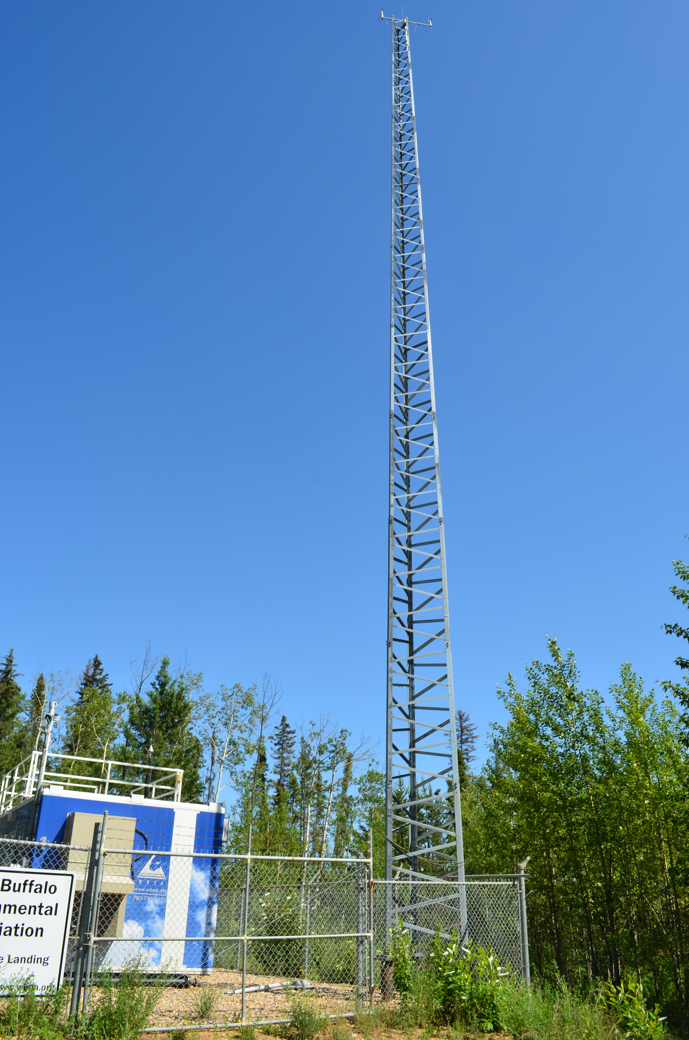
  - Figure 10 – Meteorological Tower

Station Photos
The following photos show the monitoring station and instrumentation.

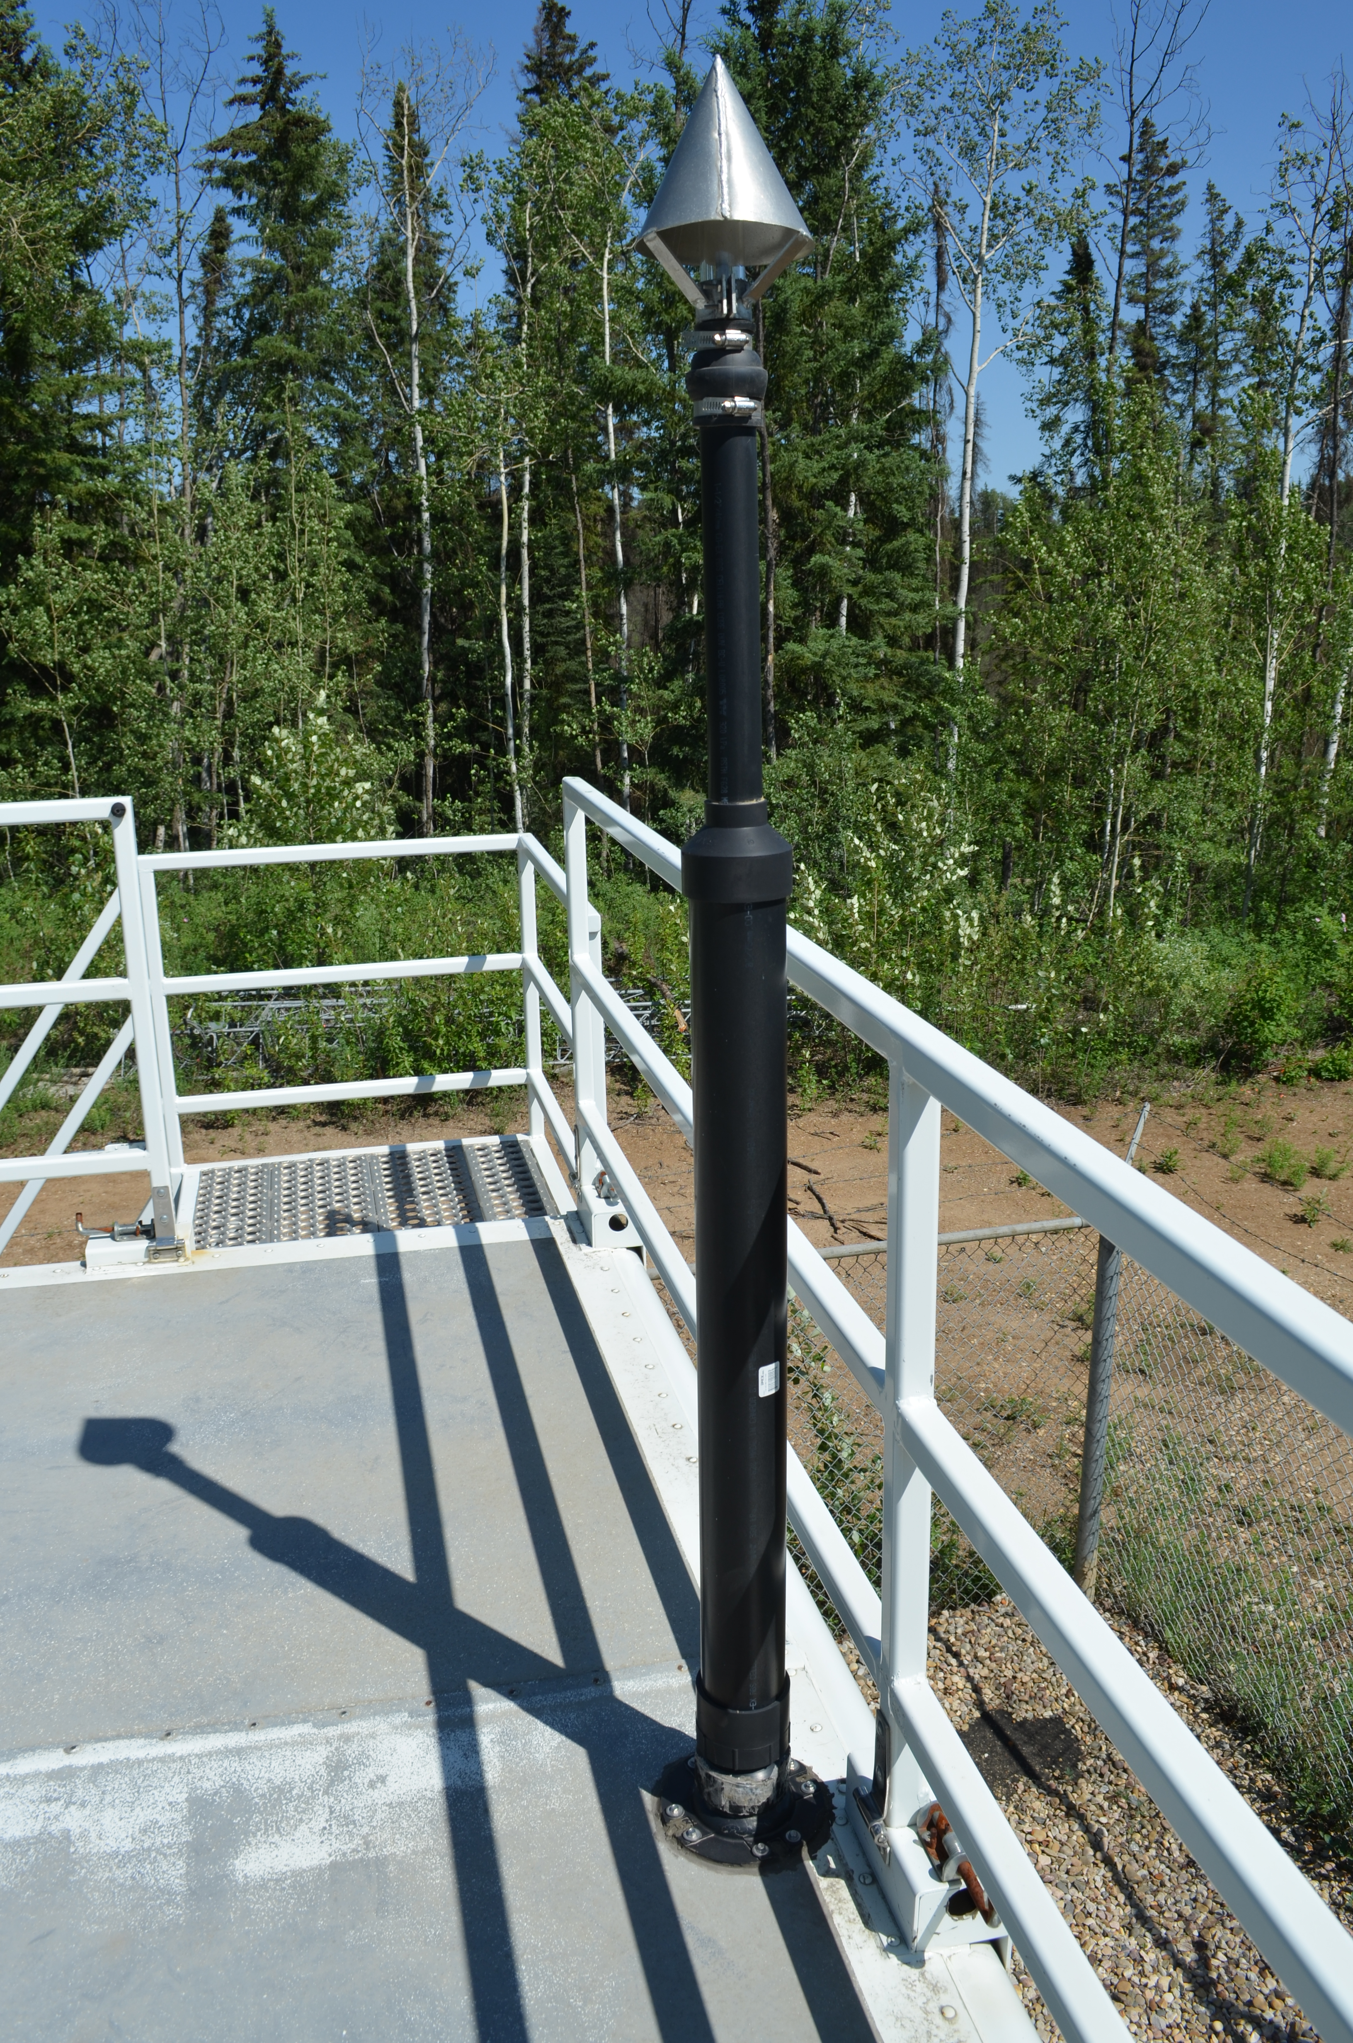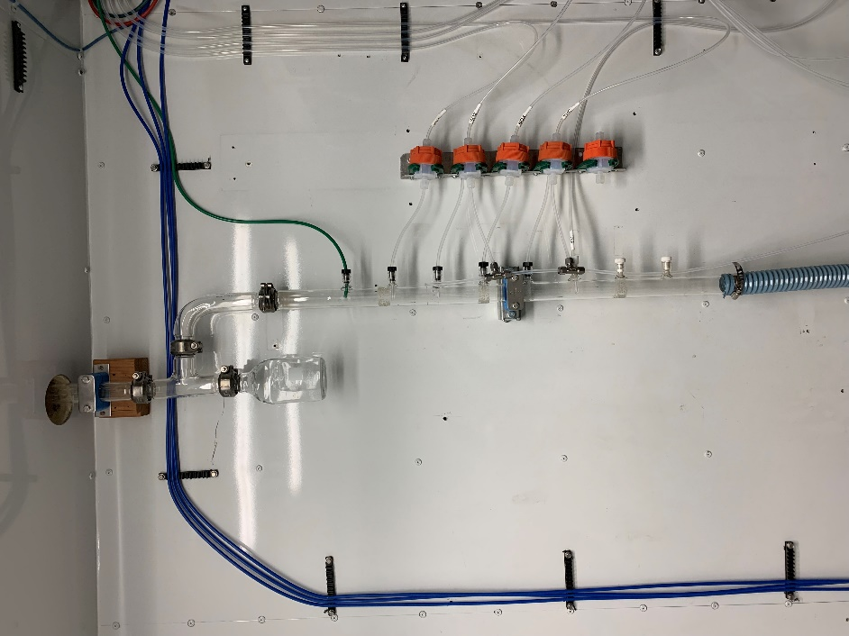
  - Figure 11 – Photo showing the inlet and sample manifold
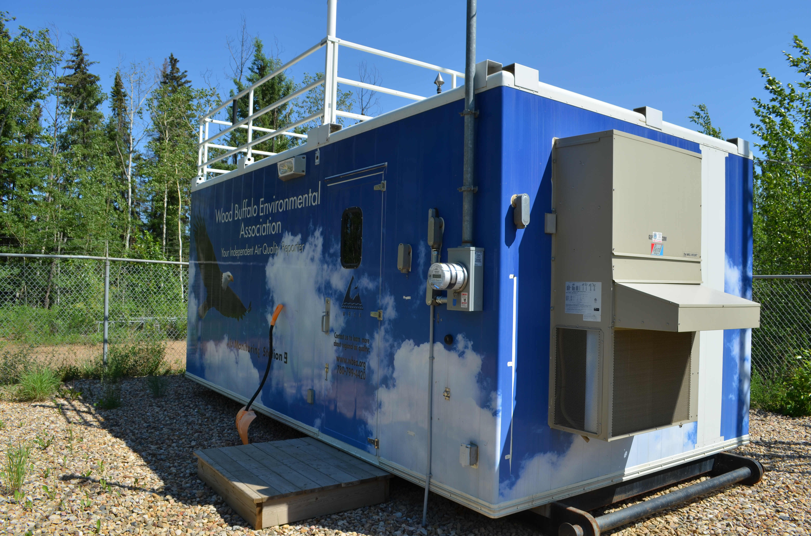
  - Figure 12 – Curb shot of the monitoring station

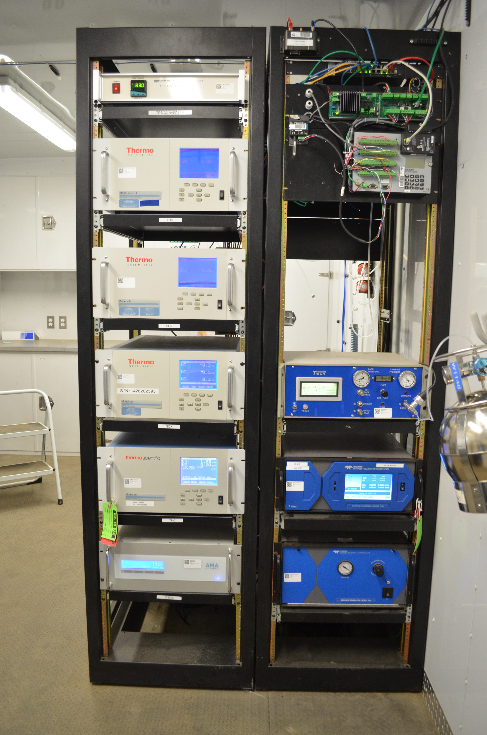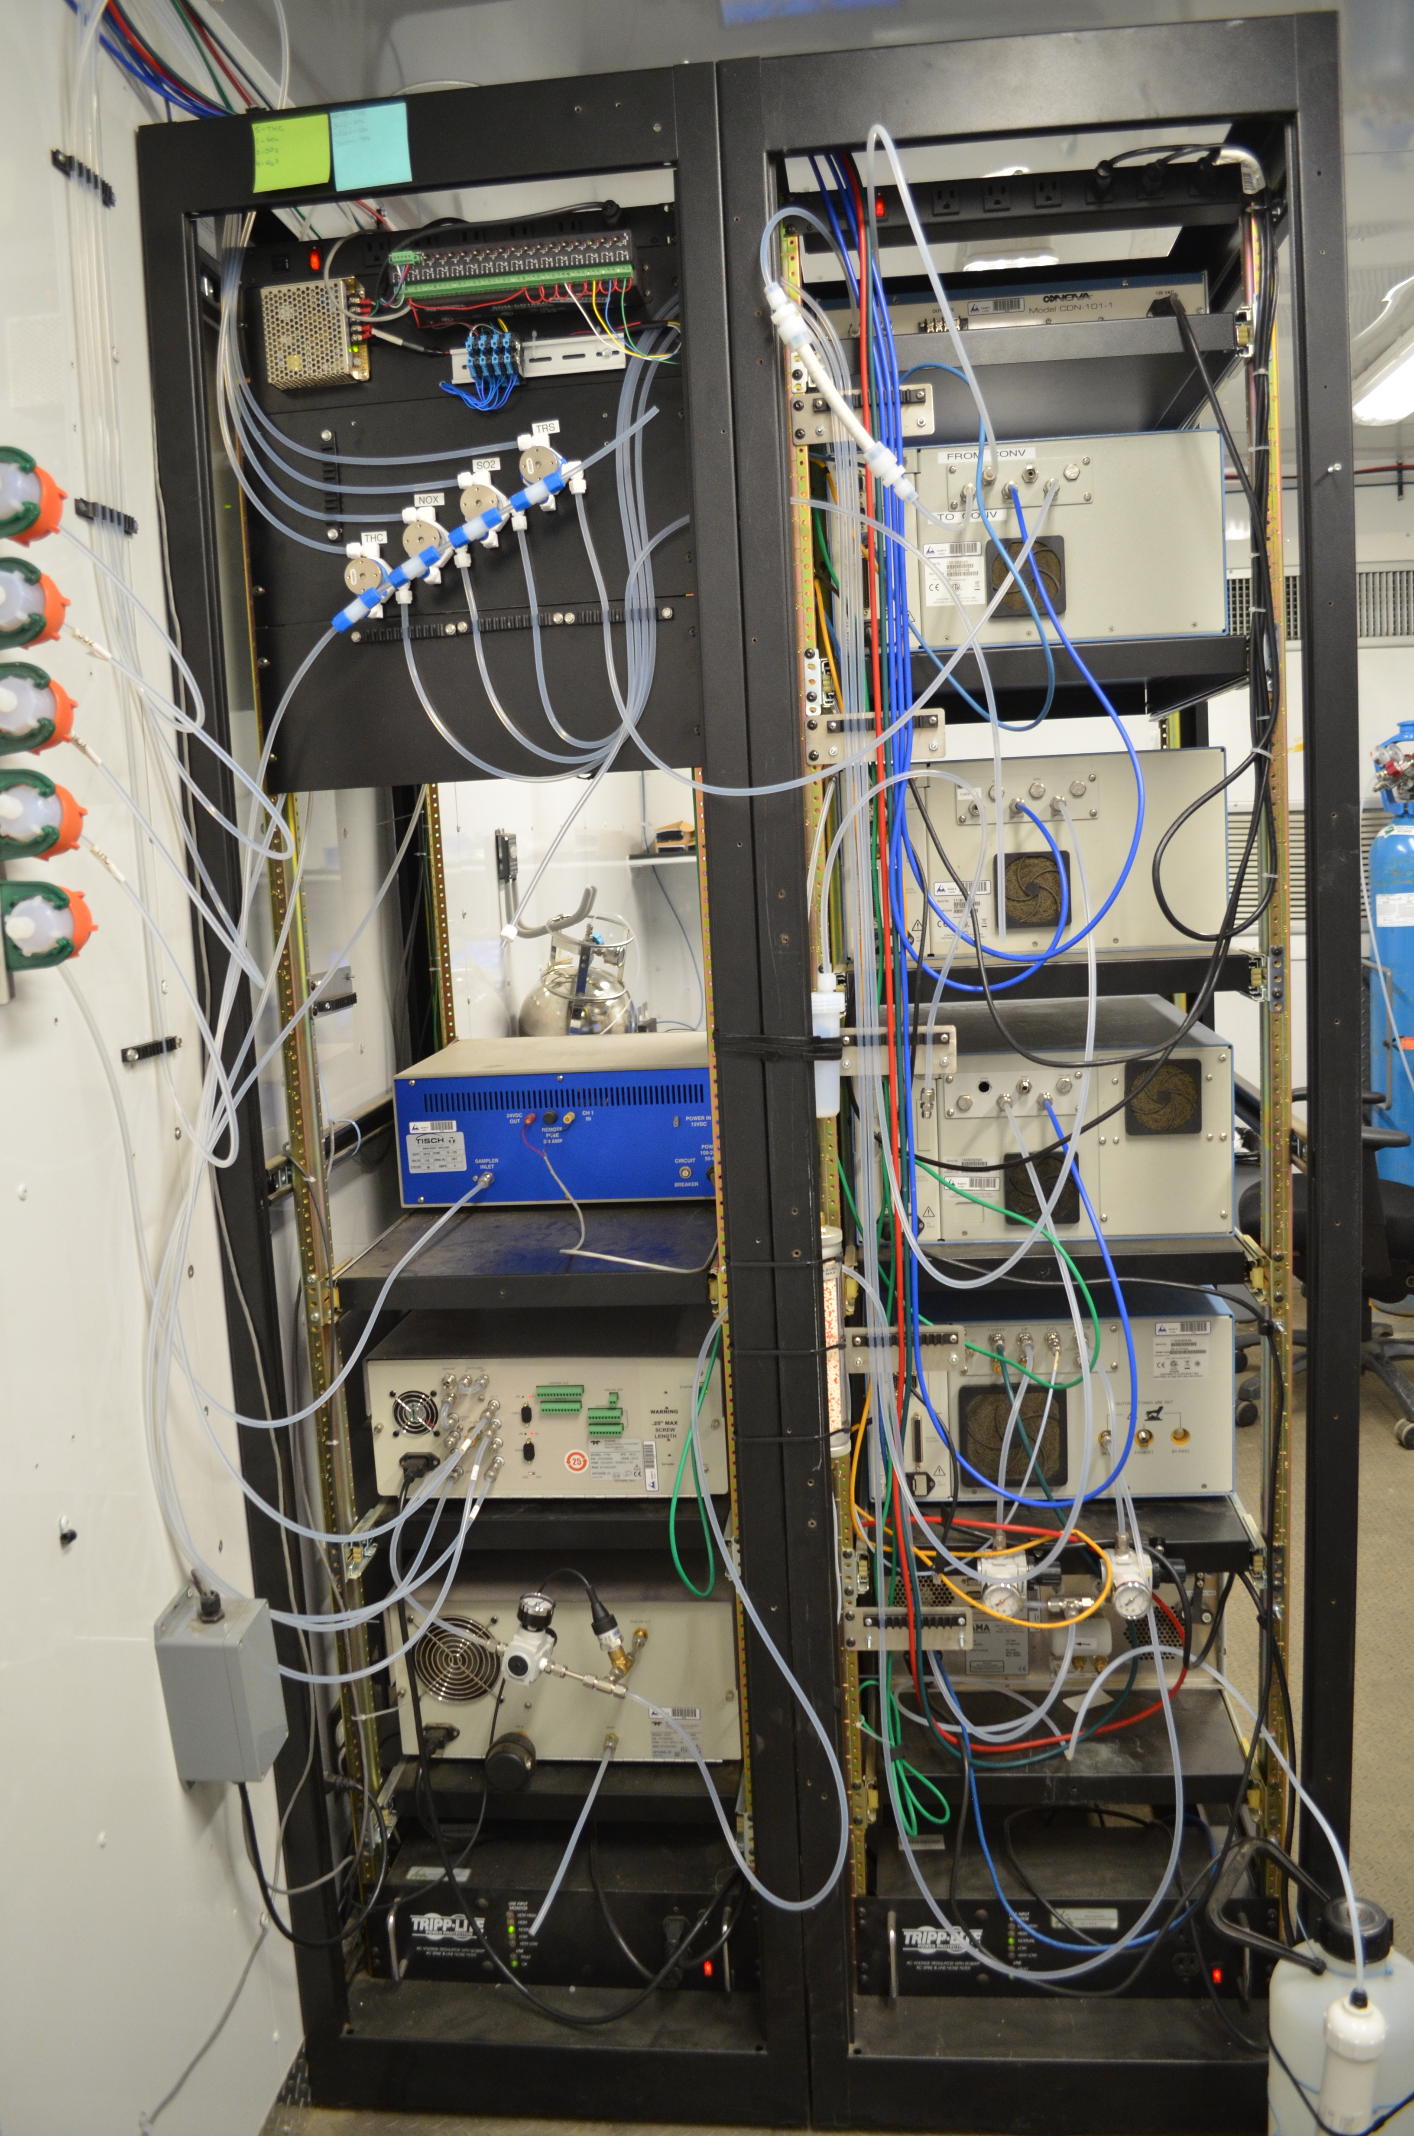
  - Figure 13 –Photo of the front and the back of instrument rack
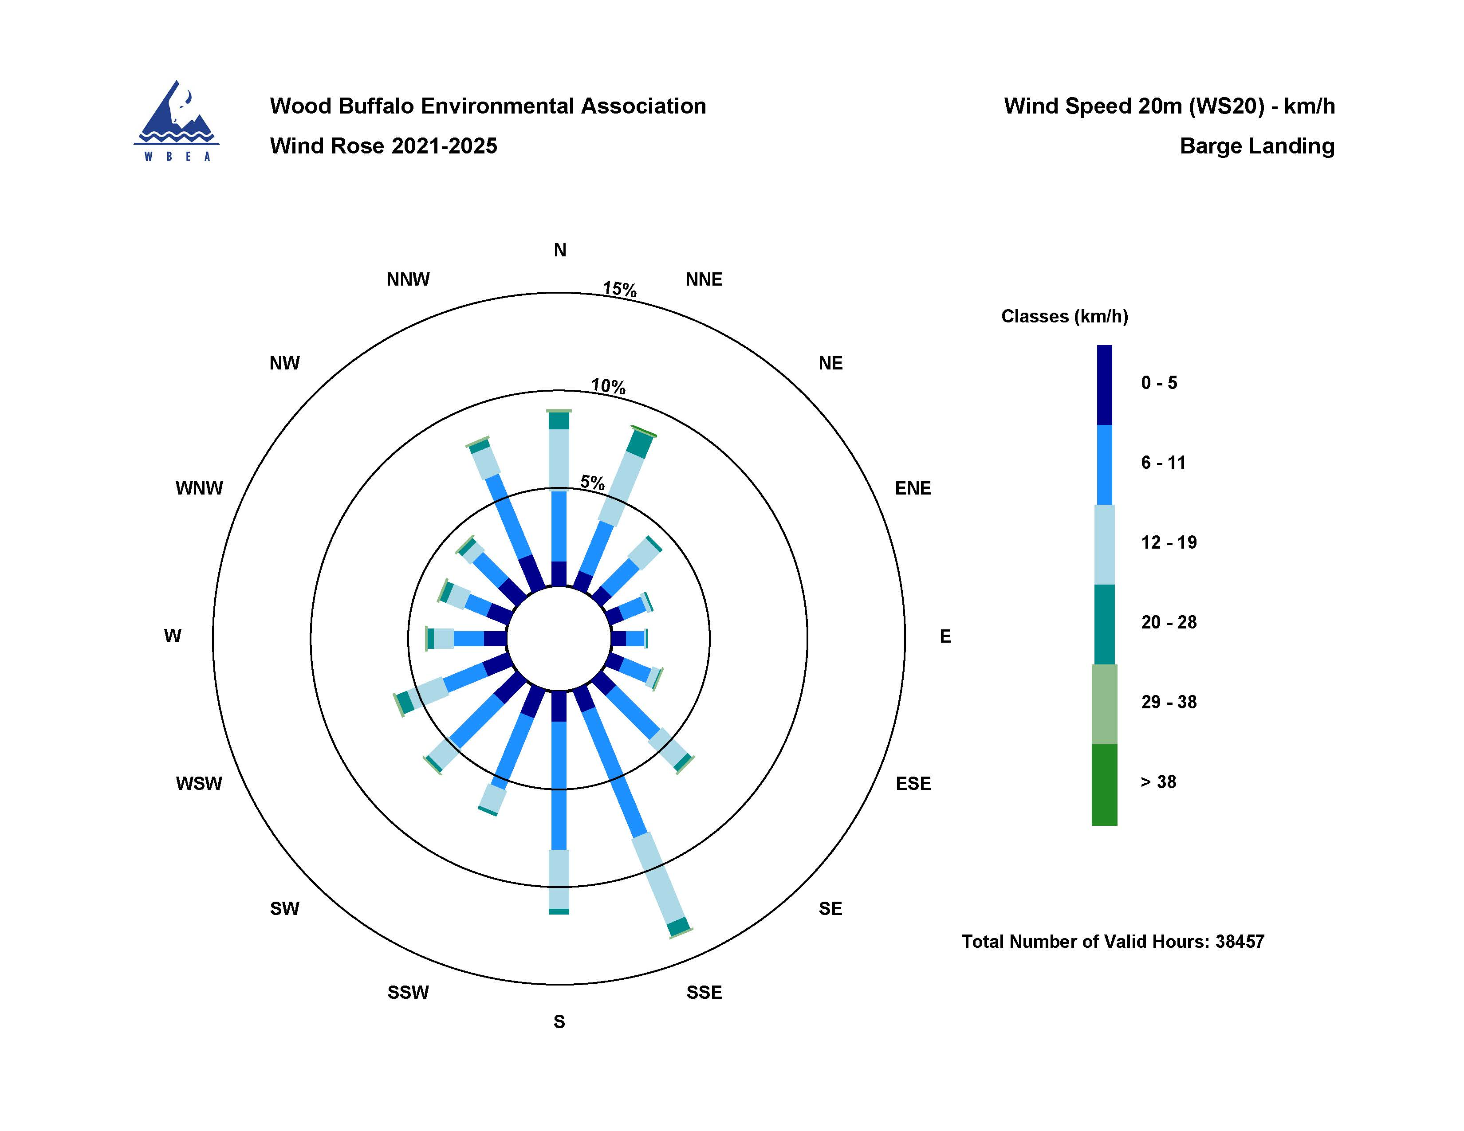
  - Figure 14 – Windrose (2021 – 2025)

