Wood Buffalo Environmental Association
Ambient Air Monitoring Station
Site Documentation

AMS 08 – Fort Chipewyan

LAST UPDATED: March 13, 2026

Table of Contents
General Site Information 4
Station 4
Location 4
Owner/Operator/Approval Holder 4
Site Description 4
Site Influences 5
Localized Sources (within 20 metres of station) 5
Roadway Influences 5
Major Point Sources 5
Station Equipment 6
Analytical Equipment 6
Meteorological Equipment 6
Support Equipment 6
Station Photos 16

Tables and Figures
Figure 1 – Area topographic map showing AMS 08 8
Figure 2 – Aerial photo showing AMS 08 9
Figure 3 – Plan view sketch for AMS 08 site 10
Figure 4 – Environment looking North 11
Figure 5 – Environment looking East 12
Figure 6 – Environment looking South 13
Figure 7 – Environment looking West 14
Figure 8 – Meteorological Tower 15
Figure 9 – Photo showing the inlet and sample manifold 16
Figure 10 – Curb shot of the monitoring station 17
Figure 11 –Photo of the front and the back of instrument rack 18
Figure 12 – Windrose (2021-2025) 19

General Site Information
Revision Date: March 13, 2026

Station
Station ID | AMS 08
Station name | Fort Chipewyan
Date station established | 1998

Location
Station street address | Fort Chipewyan
Legal land description | 6-07-112-07 W4
Airshed Zone | Wood Buffalo Environmental Association
Latitude | 58.709285
Longitude | -111.175014
UTM East | 489862
UTM North | 6507689
Nearest community | Located in Fort Chipewyan
Community population | 798
Census Year | 2021

Owner/Operator/Approval Holder
Operating Agency | Wood Buffalo Environmental Association
Address of Operating Agency | Unit 3-805 Memorial Drive, Fort McMurray, Alberta T9K 0K4
Name of Approval Holder | NA
Approval number | NA
Contact Name | Wood Buffalo Environmental Association
Address | Unit 3 – 805 Memorial Drive, Fort McMurray, AB
Phone number | 780-799-4420
Email address | info@wbea.org

Site Description
Land use by sector | 0 – 90 degrees | Residential
Land use by sector | 91 – 180 degrees | Residential, Lake
Land use by sector | 181 – 270 degrees | Residential, Lake
Land use by sector | 271 – 360 degrees | Residential
Site elevation (m)  (above sea level) | 221 m
Angle of elevation to nearby buildings | Greatest angle | 0
Angle of elevation to nearby buildings | Building direction | NA
Airflow restrictions | North | No
Airflow restrictions | East | No
Airflow restrictions | South | No
Airflow restrictions | West | No
Distance to nearest trees (m) | North | 50m
Distance to nearest trees (m) | East | NA
Distance to nearest trees (m) | West | NA
Distance to nearest trees (m) | South | NA
Sample manifold | Type | All glass
Sample manifold | Inlet height above roof | 1 metre
Wind Sensors | Type | Cup and vane
Wind Sensors | Height above ground (m) | 10
Wind Sensors | Distance from station (m) | 0

Site Influences

Localized Sources (within 20 metres of station)
Type | Distance (m) | Description
House | About 20 m, South | Local residential house; potential for wood-burning.

Roadway Influences
Type | Traffic Volume | Distance (m) | Description
Driveway | Low | 10 | Dirt road, residential use
Local roads | Low | 100 | Paved road, very low volume

Major Point Sources
Facility Name | Source Type | Distance from site (km) | Compass direction from site
Suncor/Syncrude | Oil Sands Production | 160 | South

Station Equipment
Equipment Owner: WBEA

Analytical Equipment
Parameter | Make | Model | Serial Number | Date Instrument Installed | WBEA Data Start Date
Continuous
SO₂ | Thermo Environmental | 43i-TLE | 1170050147 | 2014 | January, 1999
CO | Teledyne API | T300 | 3505 | 2019 | April, 2019
CO₂ | Teledyne API | T360 | 289 | 2020 | April, 2019
NO_{x}/NO/NO₂ | Thermo Environmental | 42i | 1426262592 | 2022 | January, 1999
O₃ | Thermo Scientific | 49i | 1152220026 | 2021 | January, 1999
TRS | Thermo Environmental | 43i-TLE | 1170050147 | 2022 | -
PM _{2.5} | Teledyne API | T 640 | 319 | 2018 | February, 2000
Time-Integrated
VOC | Tisch | TE-123 | 1029 | 2023 | -
PM10 | Thermo Scientific | 2000i | 2000IW-20929-2106 | 2023 | -
PM10 | Thermo Scientific | 2000i | 2000IW-20933-2106 | 2023 | -
PM2.5 | Thermo Scientific | 2000i | 2000IW-20932-2106 | 2023 | -
PM2.5 EC/OC | Thermo Scientific | 2000i | 2000IW-20934-2106 | 2023 | -
PAH | Tisch | TE-PUF+BL | 100111 | 2023 | -

Meteorological Equipment
Parameter | Make | Model | Serial Number | WMO Site Class | Date Sensor Installed | WBEA Data Start Date
PC | OTT | Pluvio 2 – 400 | 358347 | 2 | March, 2023 | February, 1999
AT/RH | Vaisala | HMP155 | F5010004 | 5 | March, 2014 | January, 2008
WS | Met One | 010C-1 | P22394 | 2 | March, 2014 | January, 1999
WD | Met One | 020C-1 | P22884 | 2 | March, 2014 | January, 1999
LW | Campbell Scientific | LWS-L | 23946-3 | NA | March, 2014 | February, 1999
GR | Eppley Lab Inc. | 8-48 | 38243 | 1 | March, 2014 | January, 1999

Support Equipment
Name | Description | Make | Model | Serial Number
Datalogger | Datalogger | Campbell Scientific | CR3000 | 11039
Datalogger | Datalogger | Campbell Scientific | CR310 | 2237
Zero air generator | Zero Air Generator | Teledyne/API | 701 | 197
HVAC | Heating and air conditioning system. Wall mount unit | BARD | 1 ton | 314B132990230-02
Shelter / Building | Air monitoring portable | ITB | 10 x 20 trailer | 13 15920
Gas Dilution Calibrator | Mass flow-controlled gas dilution | Teledyne/API | T700 | 3810
Hydrogen Generator | Hydrogen Generator | Peak Scientific | 100cc | 720121160
Nitrogen Generator | Nitrogen Generator | Peak Scientific | NG5000A | 771048318

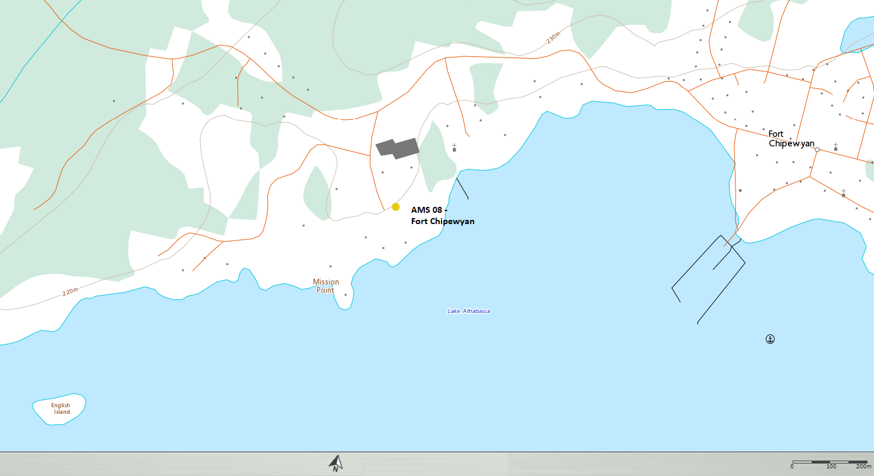
  - Figure 1 – Area topographic map showing AMS 08

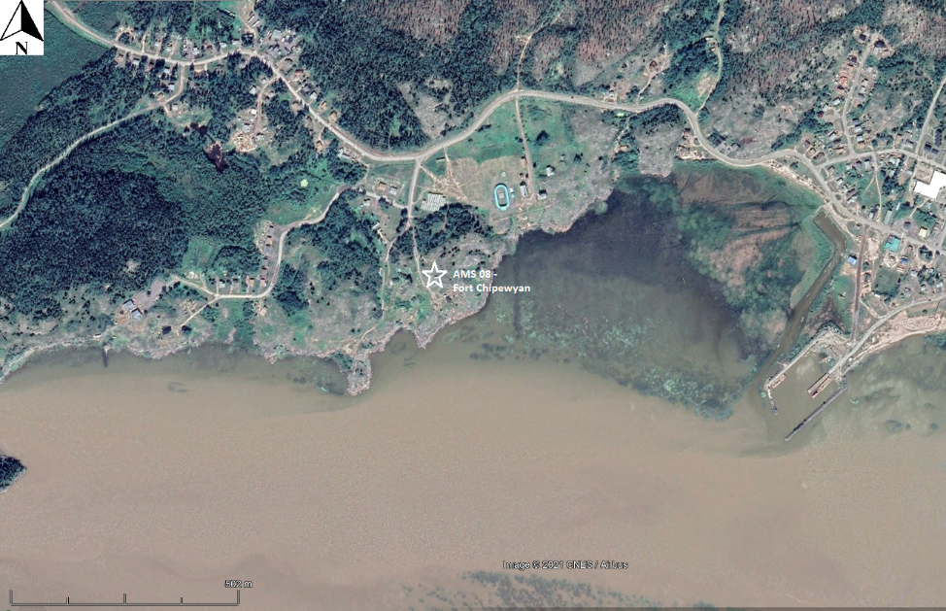

  - Figure 2 – Aerial photo showing AMS 08

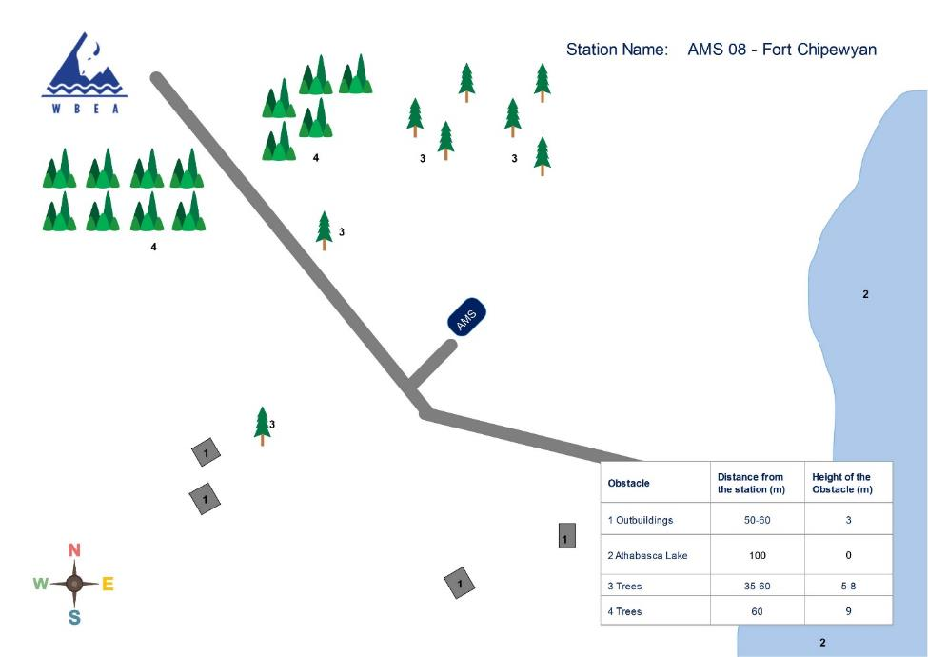
  - Figure 3 – Plan view sketch for AMS 08 site
Site photos
The following photos show the environment surrounding the monitoring station.

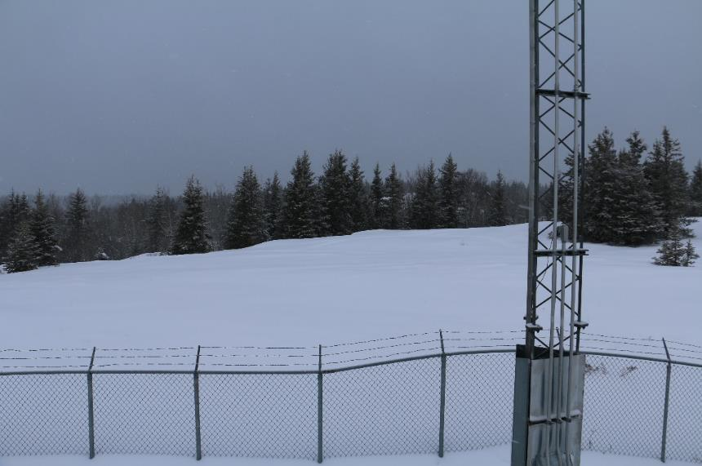
  - Figure 4 – Environment looking North
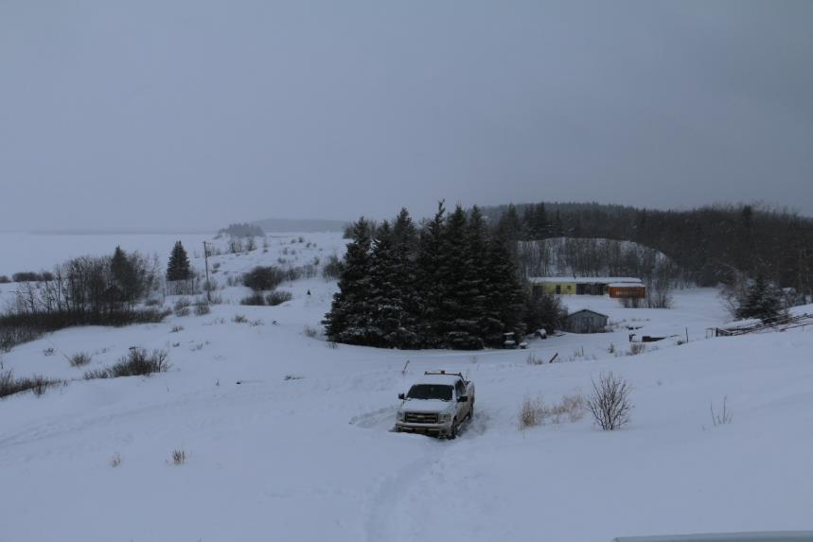
  - Figure 5 – Environment looking East
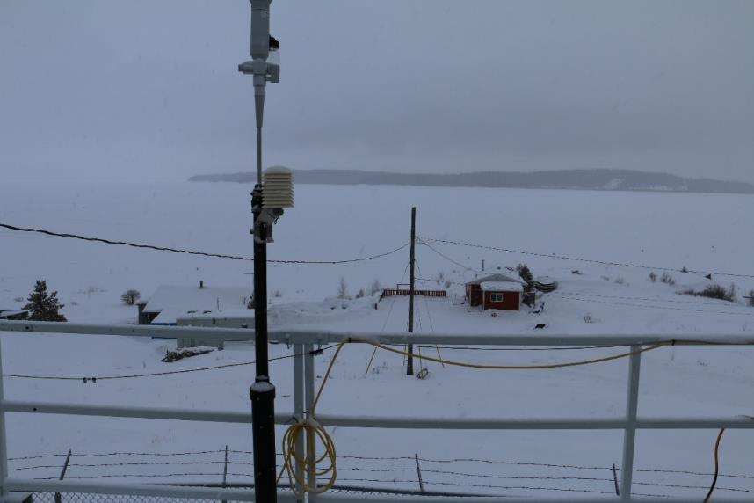
  - Figure 6 – Environment looking South
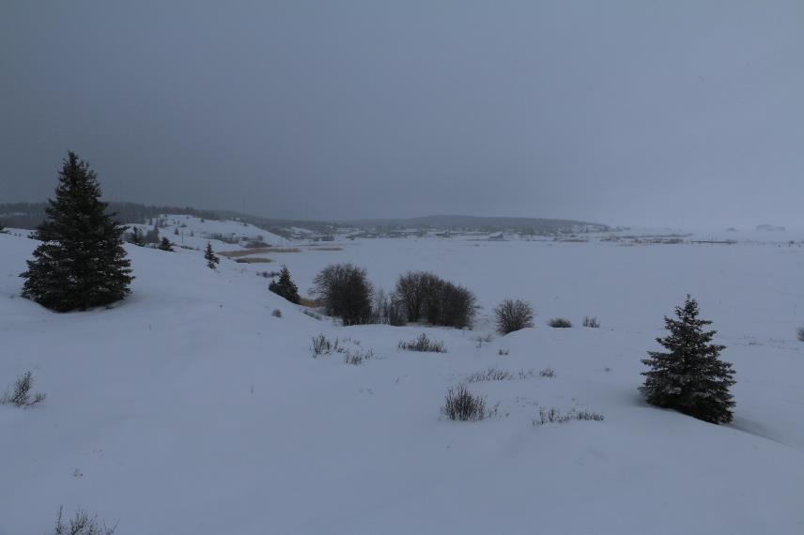
  - Figure 7 – Environment looking West
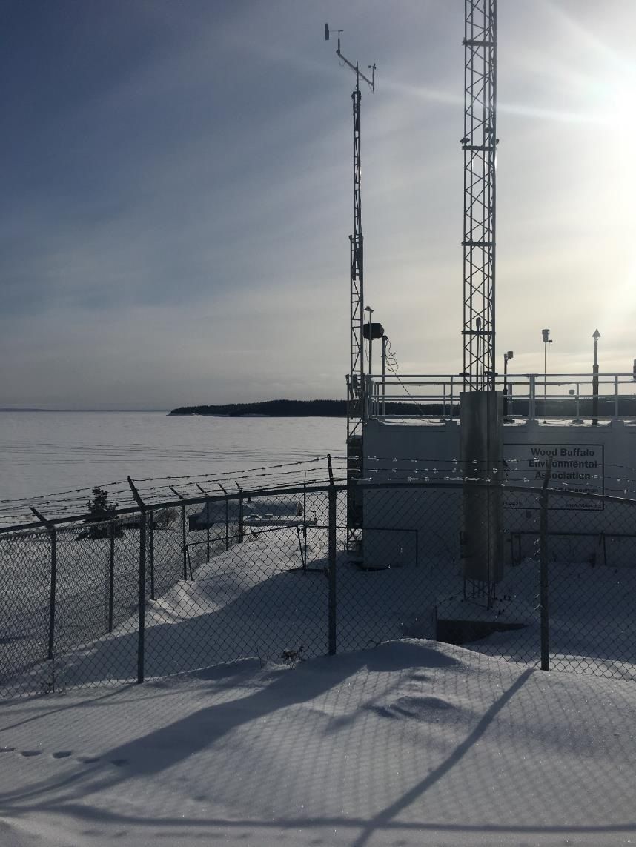
  - Figure 8 – Meteorological Tower

Station Photos
The following photos show the monitoring station and instrumentation.

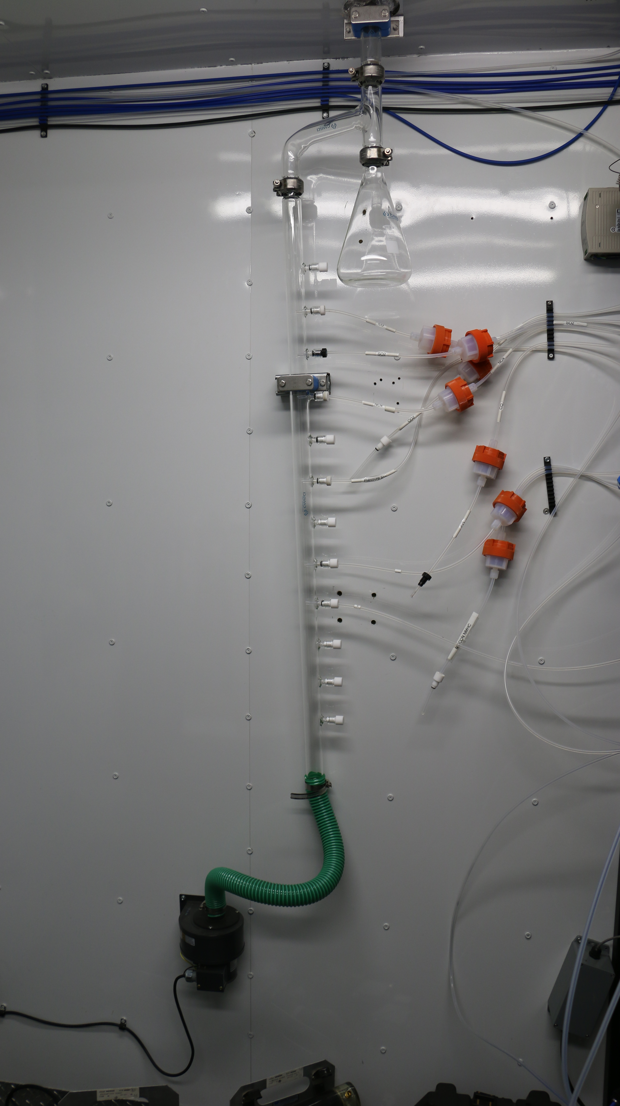
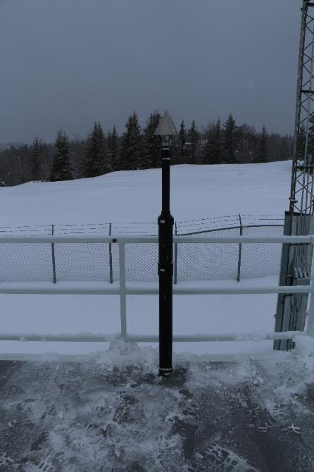

  - Figure 9 – Photo showing the inlet and sample manifold

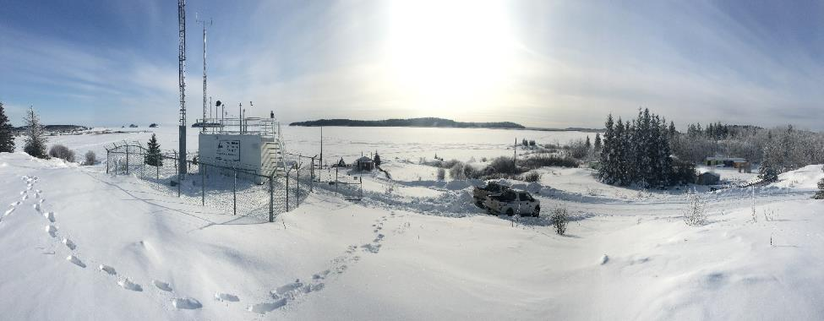
  - Figure 10 – Curb shot of the monitoring station

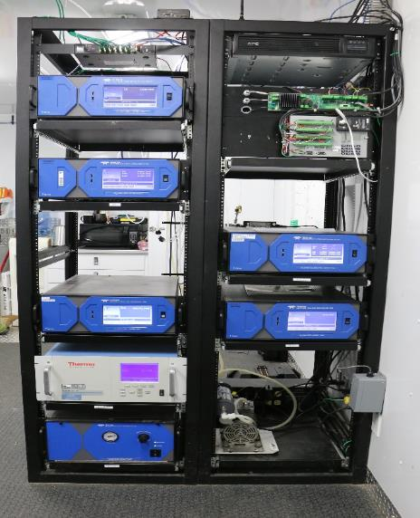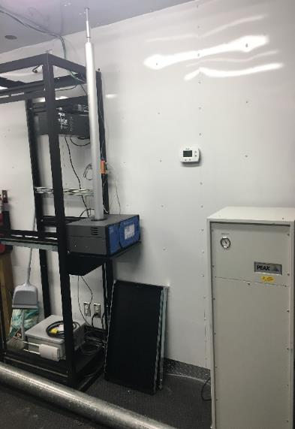

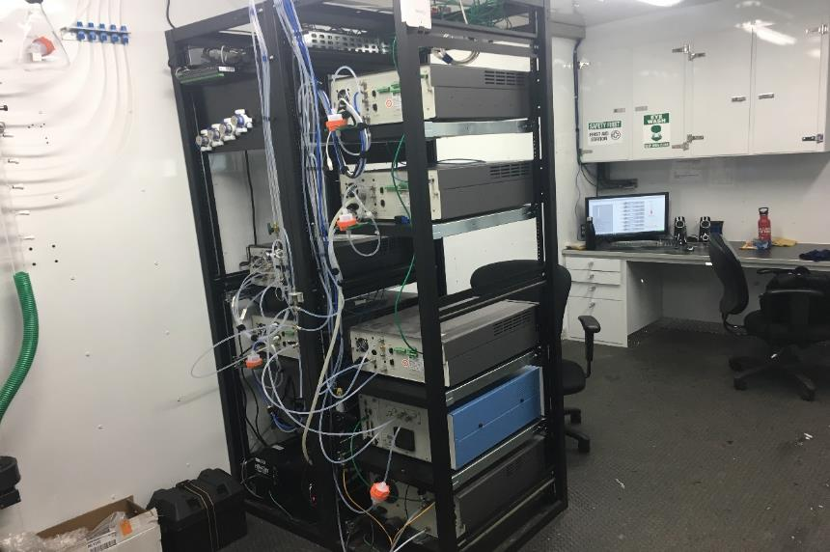
  - Figure 11 –Photo of the front and the back of instrument rack
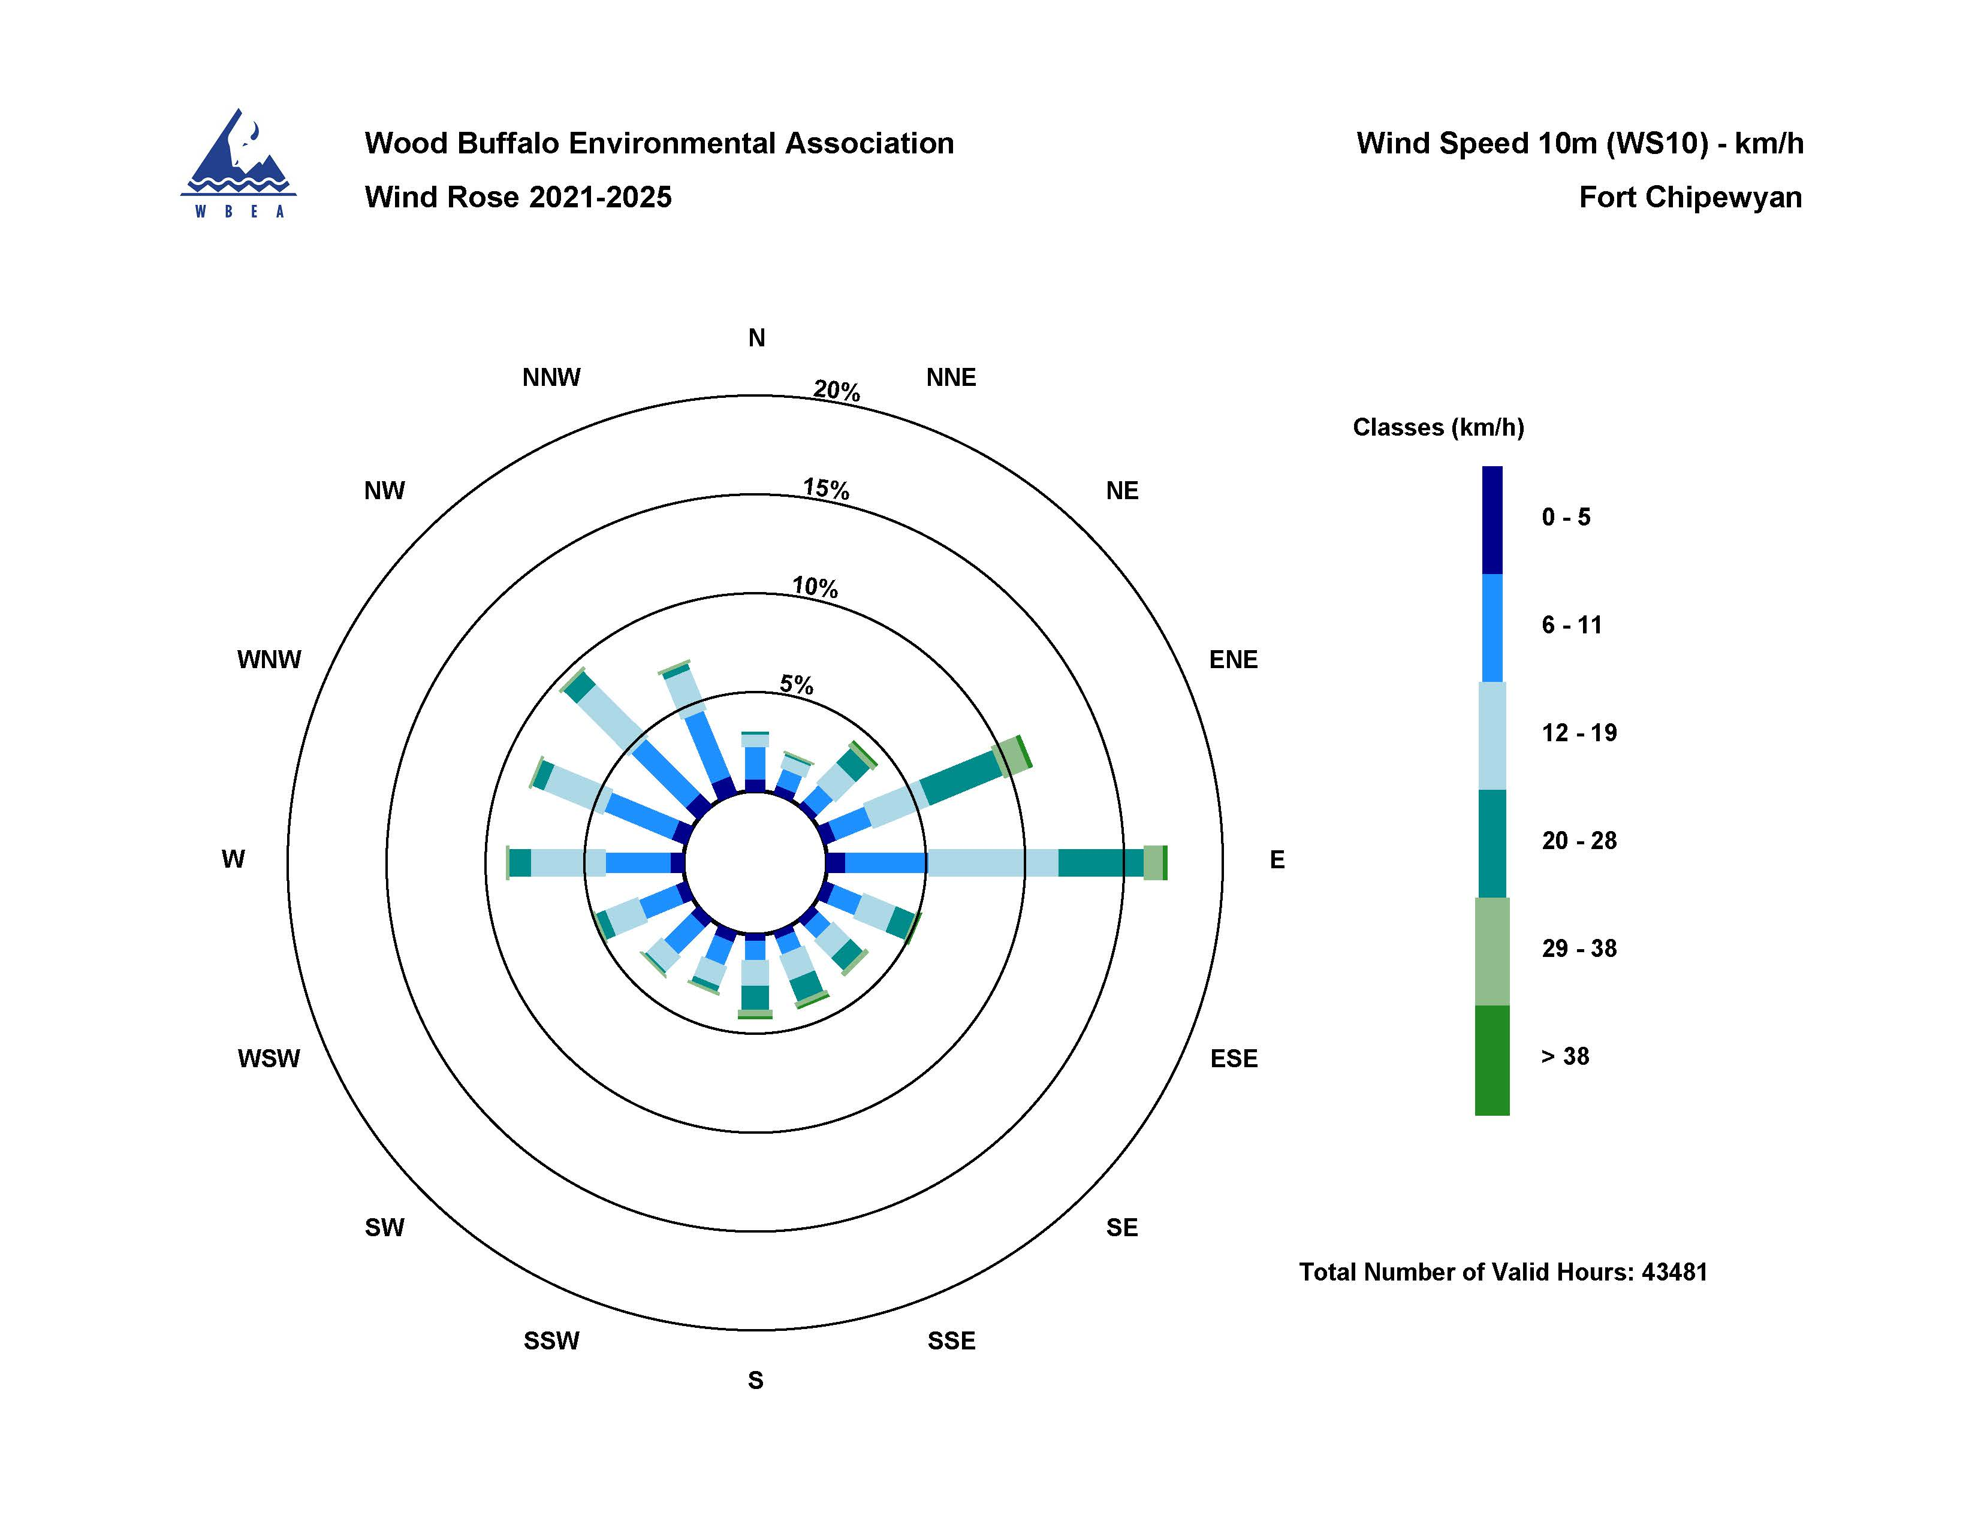

  - Figure 12 – Windrose (2021-2025)

