Wood Buffalo Environmental Association
Ambient Air Monitoring Station
Site Documentation

Athabasca Valley

LAST UPDATED: February 18, 2026

Table of Contents
General Site Information 4
Station 4
Location 4
Owner/Operator/Approval Holder 4
Site Description 4
Site Influences 5
Localized Sources (within 20 metres of station) 5
Roadway Influences 5
Major Point Sources 5
Station Equipment 6
Analytical Equipment 6
Meteorological Equipment 6
Support Equipment 6
Station Photos 17

Tables and Figures
Figure 1 – Area topographic map showing AMS 07 8
Figure 2 – Aerial image showing AMS 07 9
Figure 3 – Plan view image for AMS 07 site 10
Figure 4 – Elevation view image for AMS 07 site 11
Figure 5 – Environment looking North 12
Figure 6 – Environment looking East 13
Figure 7 – Environment looking South 14
Figure 8 – Environment looking West 15
Figure 9 – Meteorological Tower 16
Figure 10 – Photo showing the inlet and sample manifold 17
Figure 11 – Curb shot of the monitoring station 18
Figure 12 –Photo of the front and the back of instrument rack 19
Figure 13 – Windrose (2021-2025) 20

General Site Information
Revision Date: March 27, 2024

Station
Station ID | AMS 07
Station name | Athabasca Valley
Date station established | 1977

Location
Station street address | Located on MacDonald Drive, Near the Athabasca River and McDonald Island
Legal land description | 9-20-089-09 W4
Airshed Zone | Wood Buffalo Environmental Association
Latitude | 56°44’00.21”N
Longitude | 111°23’25.80”W
UTM East | 476105.865
UTM North | 6287773.834
Nearest community | Fort McMurray
Community population | 75,186
Census Year | 2021

Owner/Operator/Approval Holder
Operating Agency | Wood Buffalo Environmental Association
Address of Operating Agency | Unit 3-805 Memorial Drive, Fort McMurray, Alberta T9K 0K4
Name of Approval Holder | N/A
Approval number | N/A
Contact Name | Wood Buffalo Environmental Association
Address | Unit 3-805 Memorial Drive, Fort McMurray, Alberta T9K 0K4
Phone number | 780-799-4420
Email address | info@wbea.org

Site Description
Land use by sector | 0 – 90 degrees | Residential
Land use by sector | 91 – 180 degrees | Residential
Land use by sector | 181 – 270 degrees | Residential
Land use by sector | 271 – 360 degrees | River
Site elevation (m)  (above sea level) | 497 m
Angle of elevation to nearby buildings | Greatest angle | 3
Angle of elevation to nearby buildings | Building direction | West
Airflow restrictions | North | None
Airflow restrictions | East | None
Airflow restrictions | South | None
Airflow restrictions | West | House
Sample manifold | Type | All glass
Sample manifold | Inlet height above roof | 1 metre
Wind Sensors | Type | Cup and vane
Wind Sensors | Height above ground (m) | 10 m
Wind Sensors | Distance from station (m) | Attached to North end of monitoring station

Site Influences

Localized Sources (within 20 metres of station)
Type | Distance (m) | Description
Wood Smoke | 10m | Wood Stove from shelter (due West)

Roadway Influences
Type | Traffic Volume | Distance (m) | Description
Asphalt road | Medium | 15 | Access road to MacDonald Island
Highway | High | 300 | Hwy 63
Asphalt Road | Medium | 330 | City street

Major Point Sources
Facility Name | Source Type | Distance from site (km) | Compass direction from site
Fort McMurray Water treatment Plant | Water treatment Plant | 1.22 | SW
McDonald Island | Sports Complex | 0.265 | NE
Eveready | Asphalt Plant | 3.71 | NW
Fort McMurray Waste Water Treatment Plant | Waste Water Treatment Plant | 3.84 | NW
Diversified | Main Bus Depo | 4.48 | NW
Suncor | Oil Sands Plant | 26.81 | N
Suncor | Tailings Pond | 15.81 | N
LaFarge | Concrete Plant | 3.06 | NW
Inland | Concrete Plant | 3.32 | NW
Burnco | Concrete Plant | 4.24 | NW

Station Equipment
Equipment Owner: Alberta EPA and WBEA

Analytical Equipment
Parameter | Make | Model | Serial Number | Date Instrument Installed | WBEA Data Start Date
Continuous
SO₂ | Thermo Scientific | 43i-LTE | 1507864683 | 2020 | January, 1999
TRS | Thermo Scientific | 43i-LTE | 1180540018 | 2019 | January, 1999
TRS conv | CD-Nova | CDN-101 | 551 | 2019 | -
NO_{x}/NO/NO₂ | Thermo Scientific | 42i | 1160120024 | 2021 | January, 1999
THC/CH₄/NMHC | Thermo Scientific | 55i | 12300522720 | 2024 | January, 1999
O₃ | Thermo Scientific | 49i | 1507964700 | 2019 | January, 1999
CO | Thermo Scientific | 48i-LTE | 1408761381 | 2016 | January, 1999
PM_{2.5} | Teledyne | T640 | 645 | 2024 | January, 1999
Time-Integrated
PM₁₀ | Thermo Scientific | 2000i | 2000i 0361 1305 | 2016 | -
PM₁₀ | Thermo Scientific | 2000i | 2000iW206921702 | 2021 | -
PM_{2.5} | Thermo Scientific | 2000i | 2000i2 0370 1306 | 2018 | -
PM_{2.5} | Thermo Scientific | 2000i | 2000i2 0433 1312 | 2019 | -
PAH | Tisch Environmental | TE-PIF+BL | 1001057 | 2016 | -
VOC | Global Analyzer Systems | G23MTS-2CH | 2021-101 | 2023 | -
VOC | Global Analyzer Systems | G23MTS-2CH | 2021-102 | 2023 | -
Dustfall | Advantage Manufacturing | - | - | 2022 | -

Meteorological Equipment
Parameter | Make | Model | Serial Number | WMO Site Class | Date Sensor Installed | WBEA Data Start Date
AT/RH | Vaisala | HMP155 | G0840069 | 3 | 2020 | January, 1999
WD | Met One | 020C-1 | G3212 | 3 | 2021 | January, 1999
WS | Met One | 010C-1 | R14656 | 3 | 2019 | January, 1999
BP | Young | 61302V-10 | BPA4395 | 3 | 2016 | December, 2012

Support Equipment
Name | Description | Make | Model | Serial Number
Datalogger | Datalogger | Campbell Scientific | CR3000 | 8205
Gas Dilution Calibrator | Dynamic dilution calibrator | Teledyne/API | T700 | 3805
Zero air generator | Zero Air Generator | Teledyne/API | T701H | 198
Shelter / Building | Air monitoring portable | ITB | 8 x 16 trailer | N/A
HVAC | Heating and air conditioning system. Wall mount unit | BARD | 1 ton

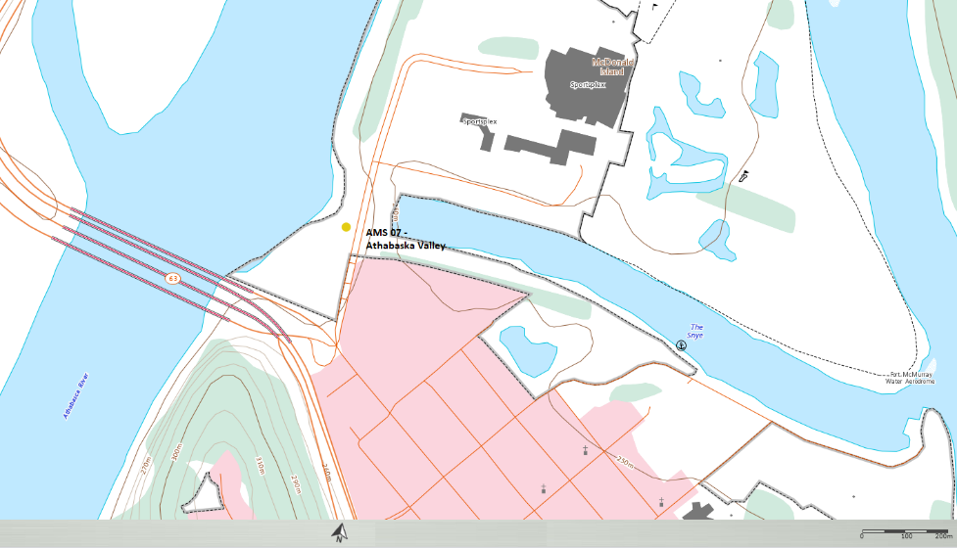
  - Figure 1 – Area topographic map showing AMS 07

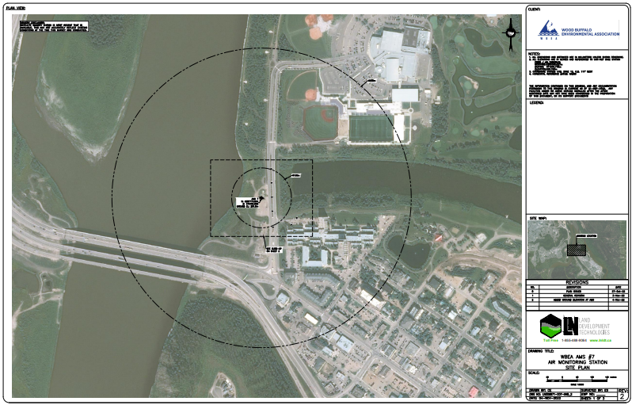
  - Figure 2 – Aerial image showing AMS 07
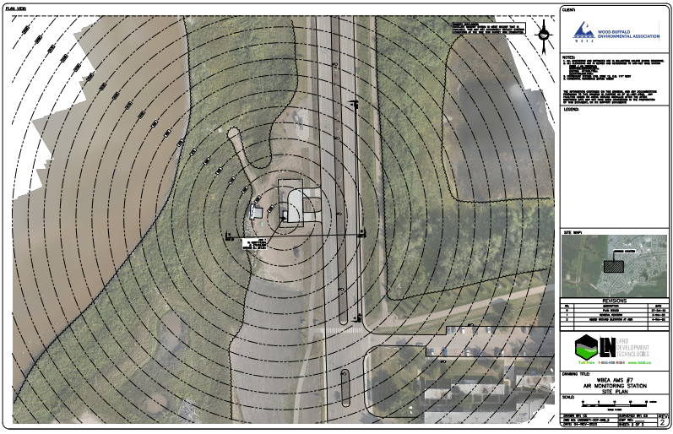
  - Figure 3 – Plan view image for AMS 07 site

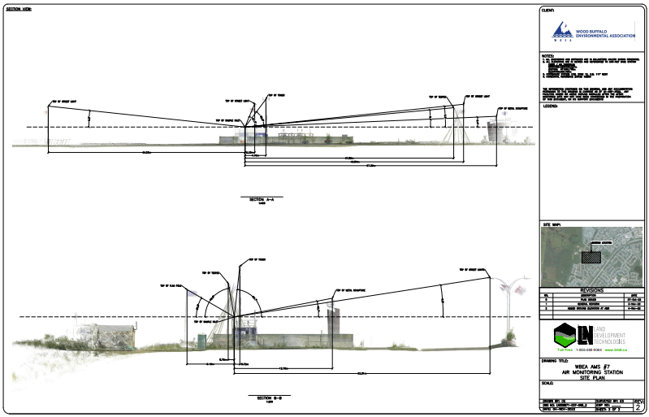
  - Figure 4 – Elevation view image for AMS 07 site

Site photos
The following photos show the environment surrounding the monitoring station.

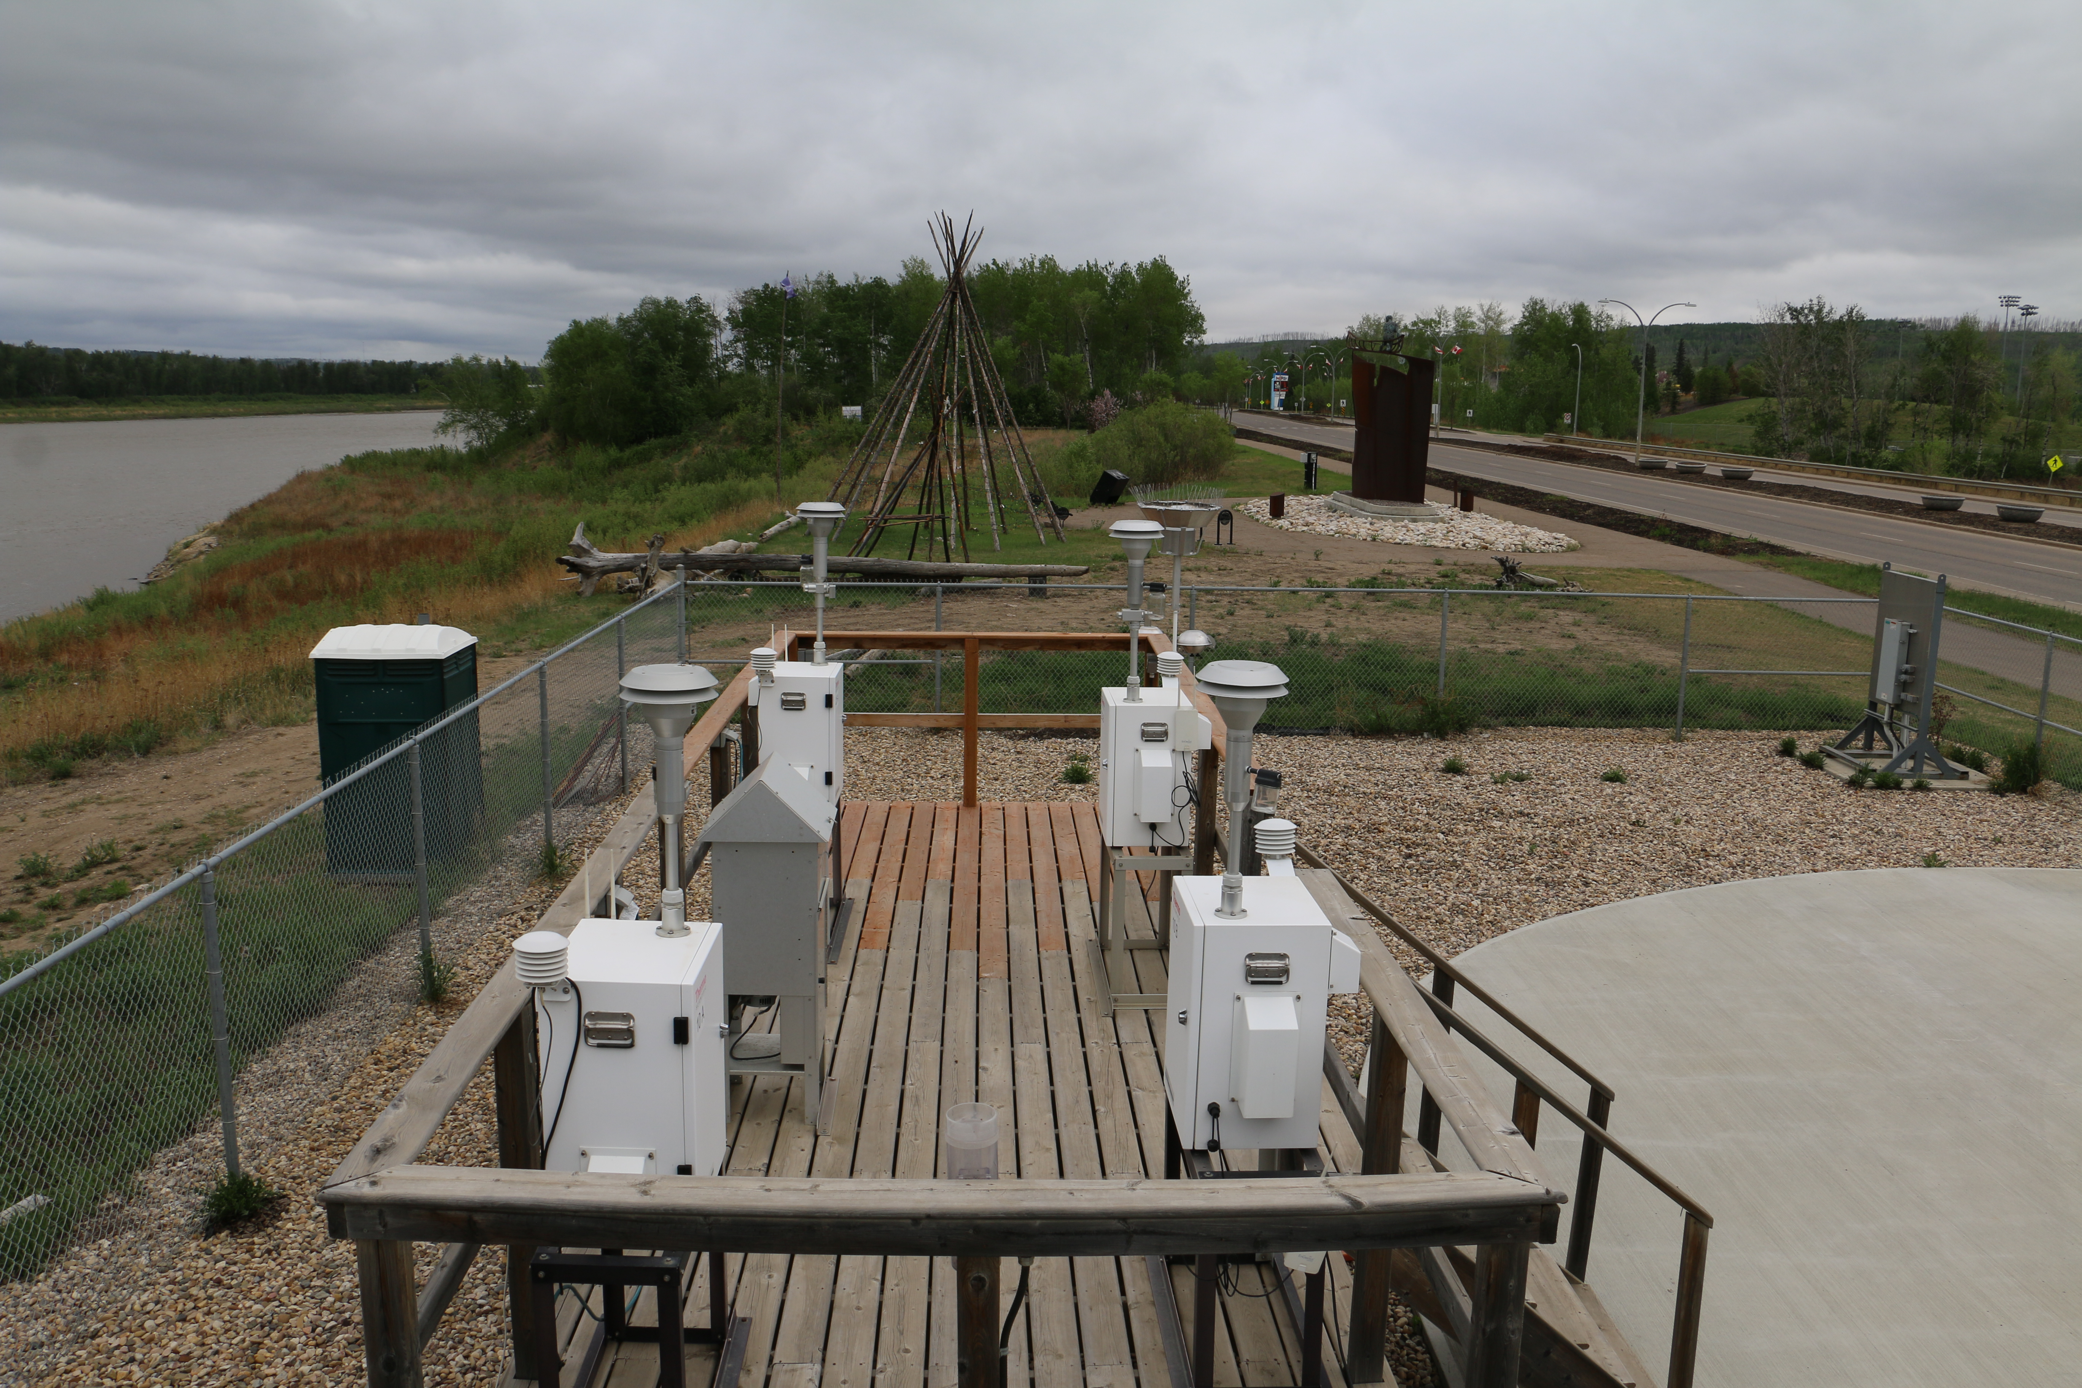
  - Figure 5 – Environment looking North

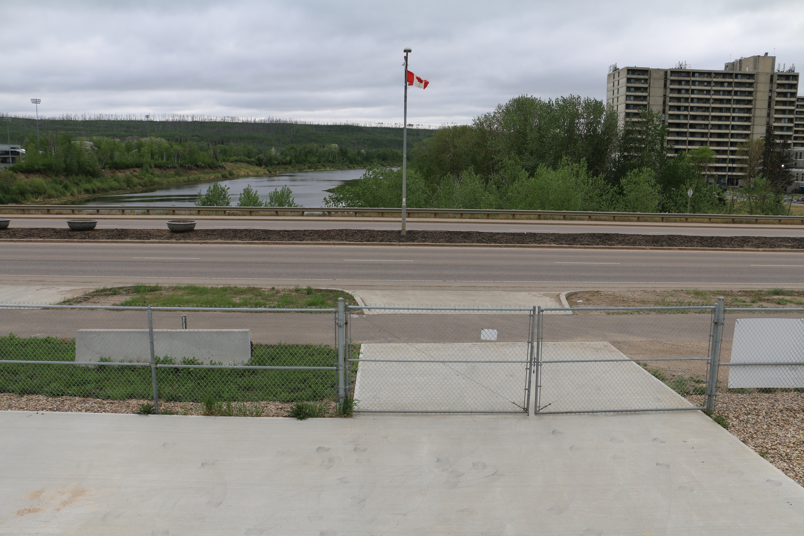
  - Figure 6 – Environment looking East
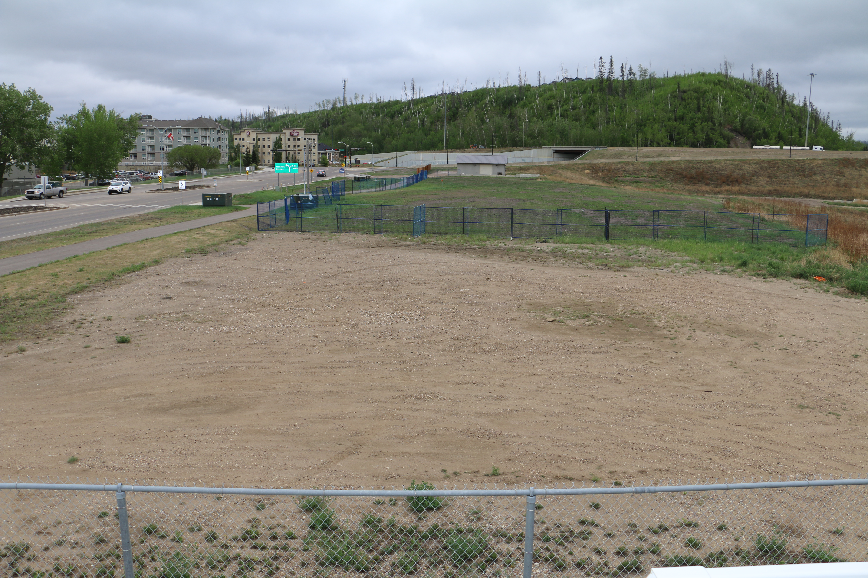
  - Figure 7 – Environment looking South
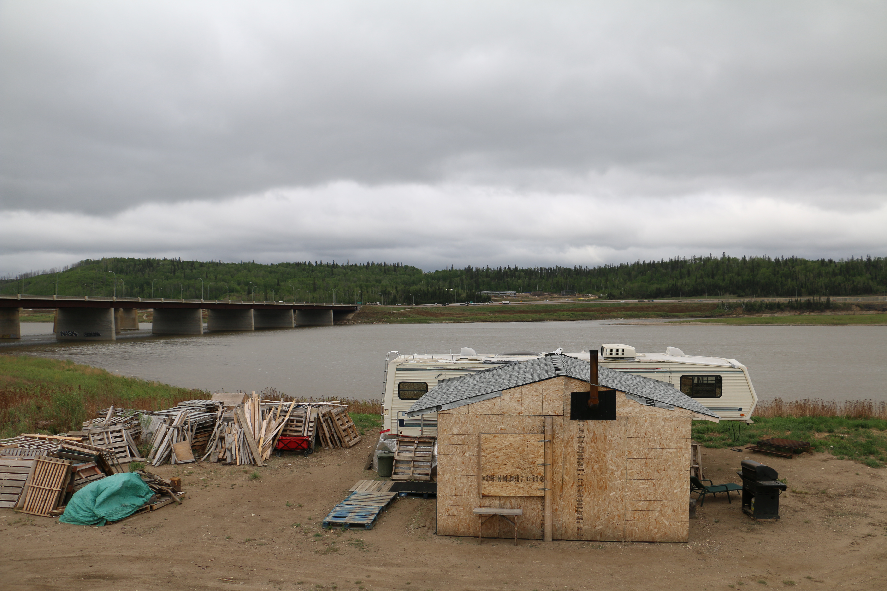
  - Figure 8 – Environment looking West
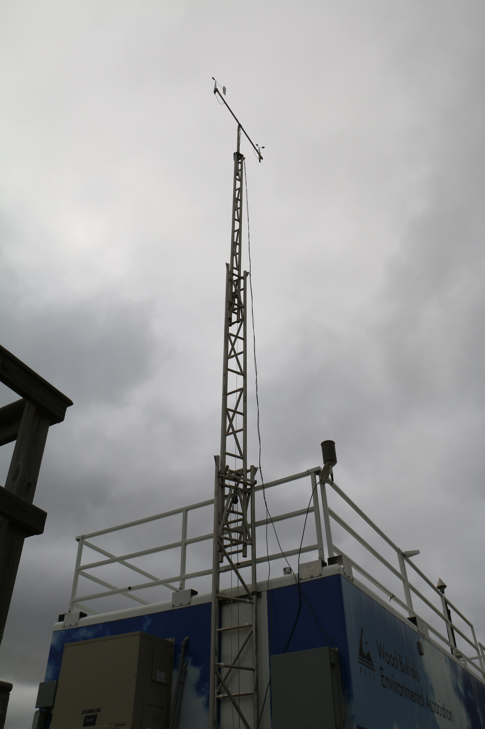
  - Figure 9 – Meteorological Tower

Station Photos
The following photos show the monitoring station and instrumentation.

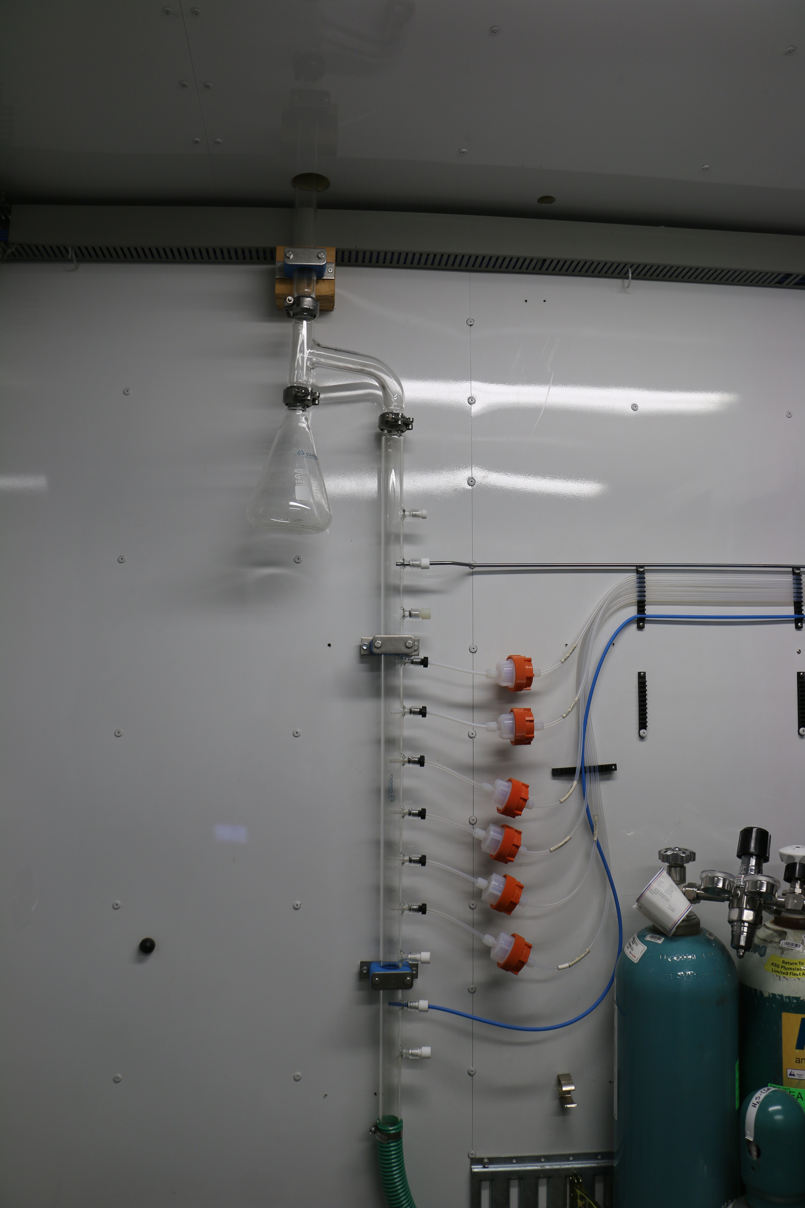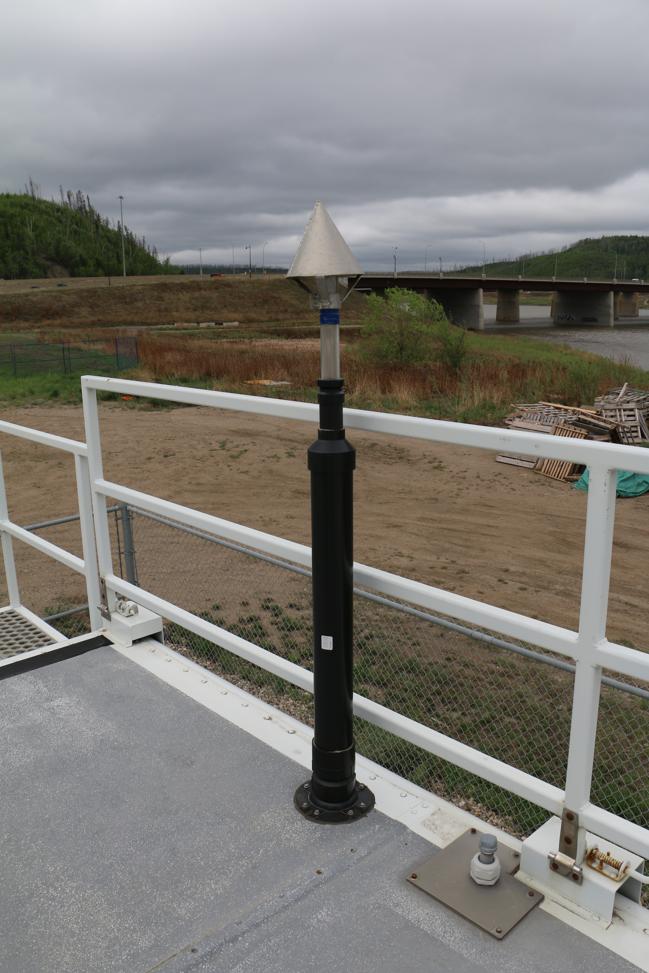
  - Figure 10 – Photo showing the inlet and sample manifold

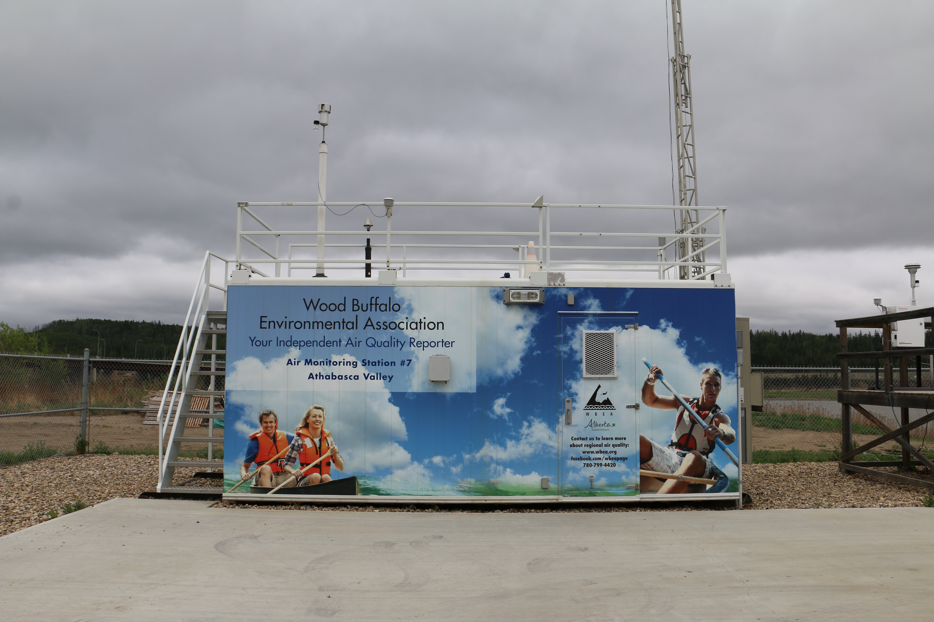
  - Figure 11 – Curb shot of the monitoring station
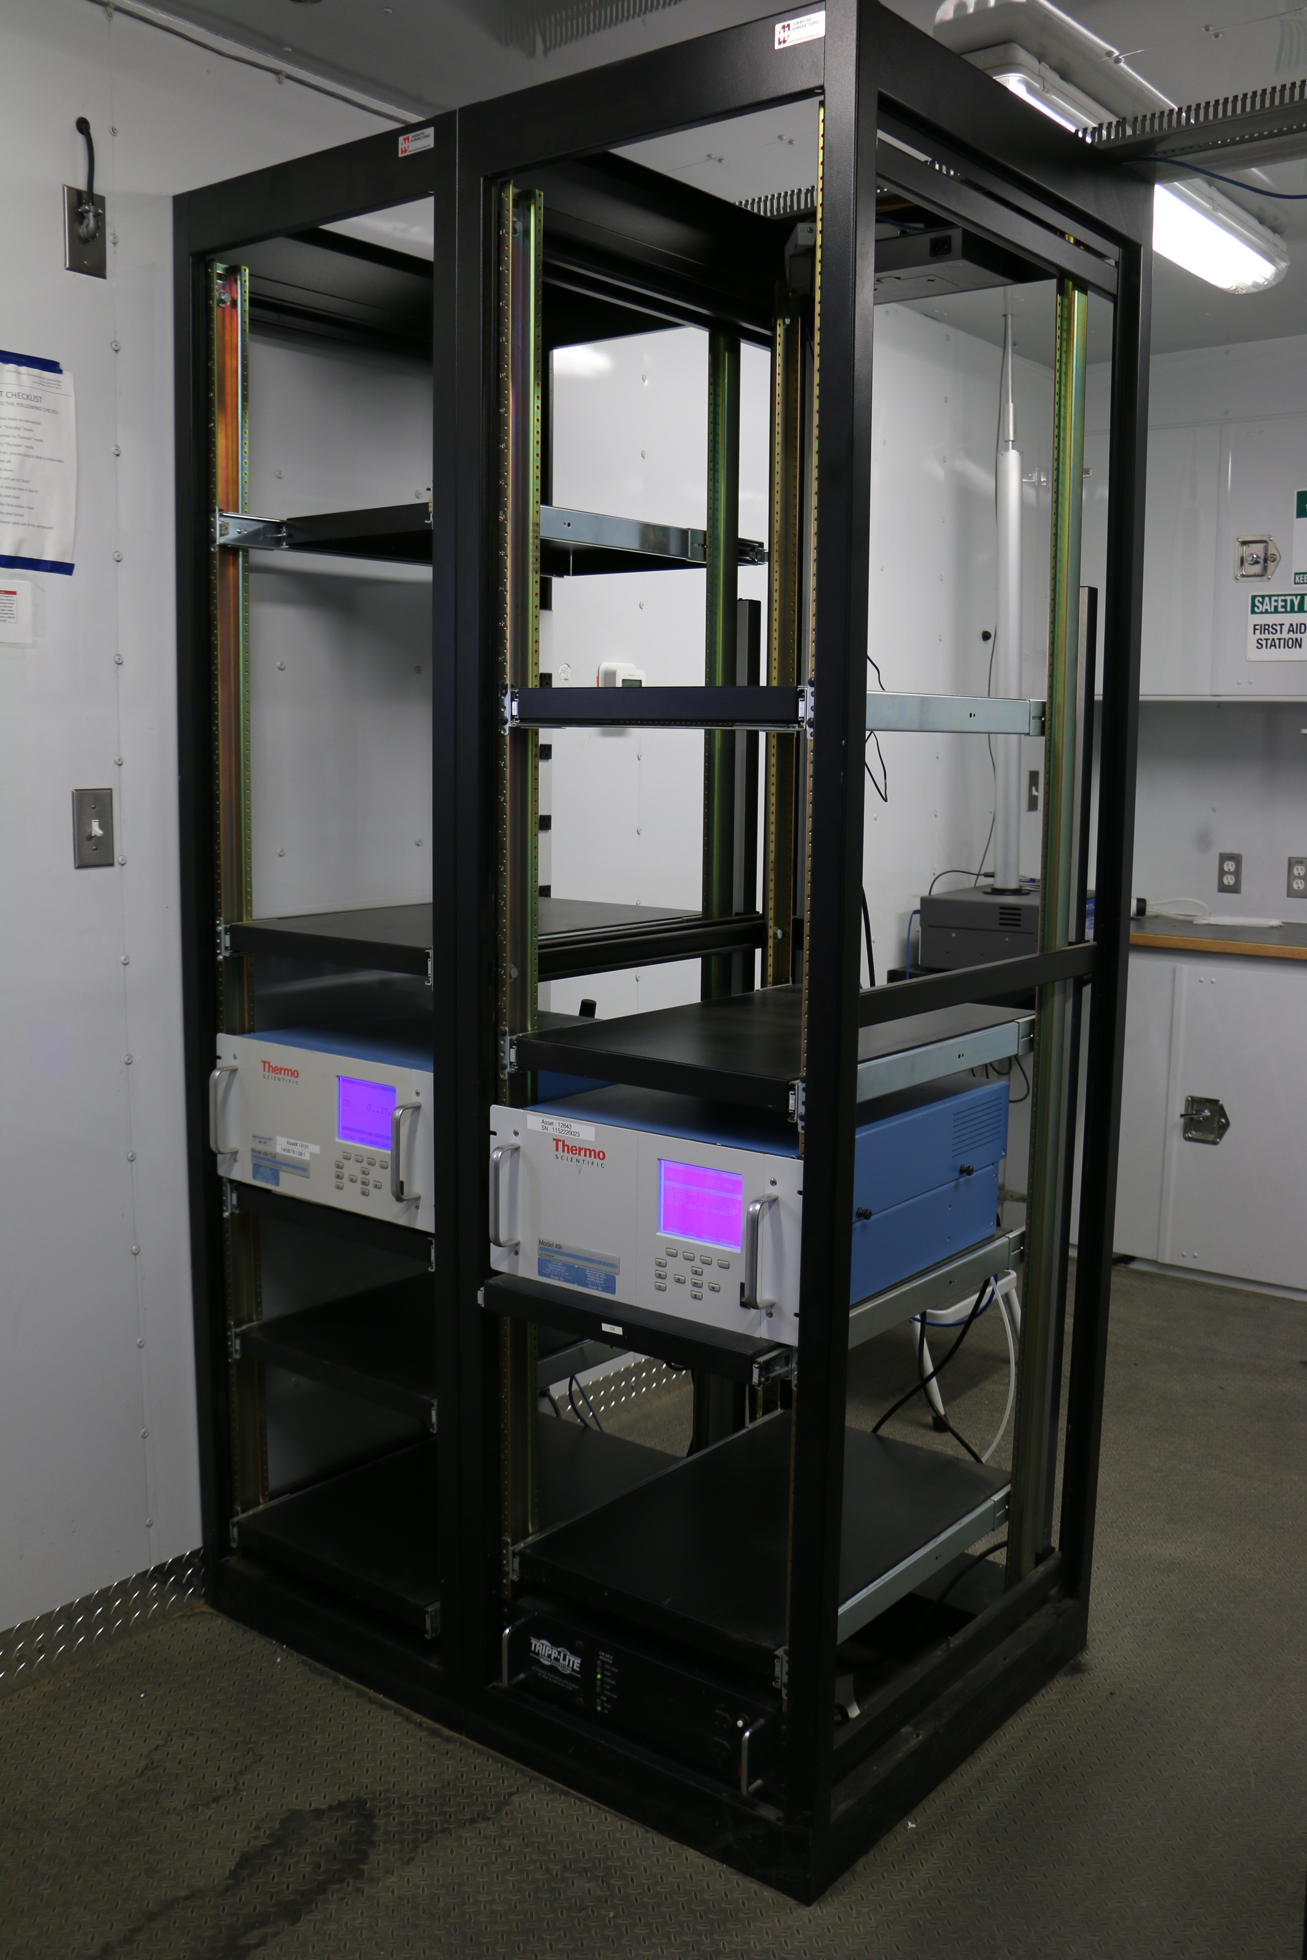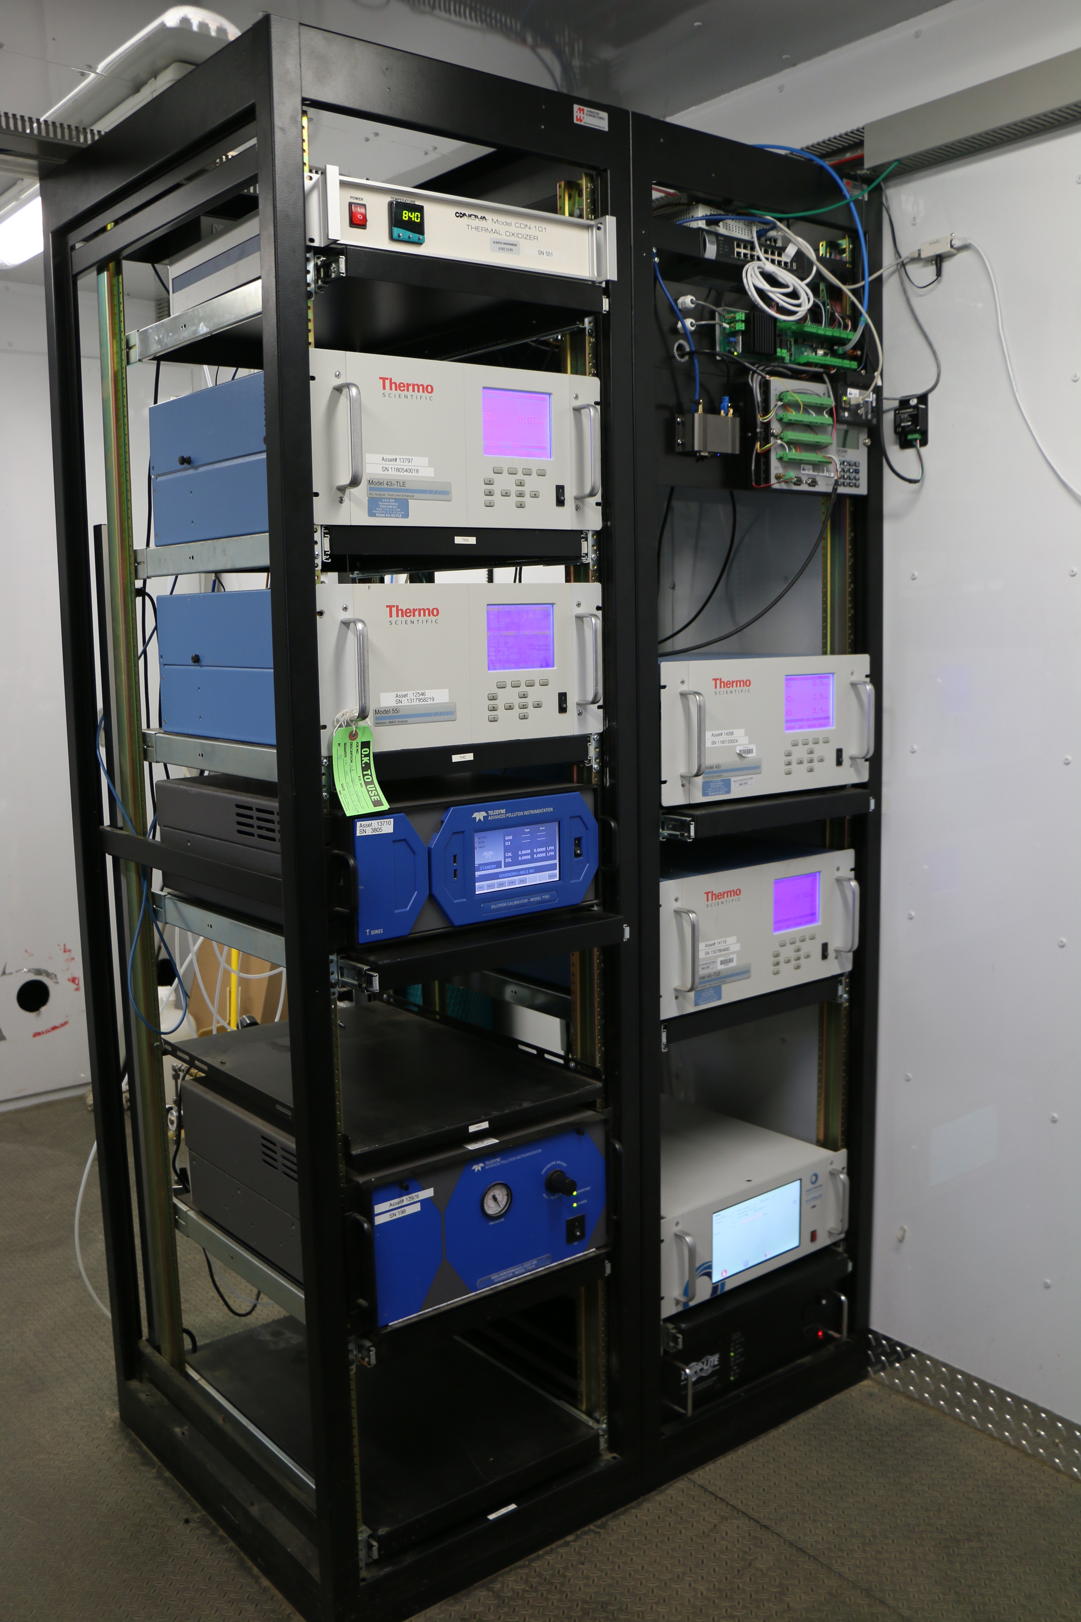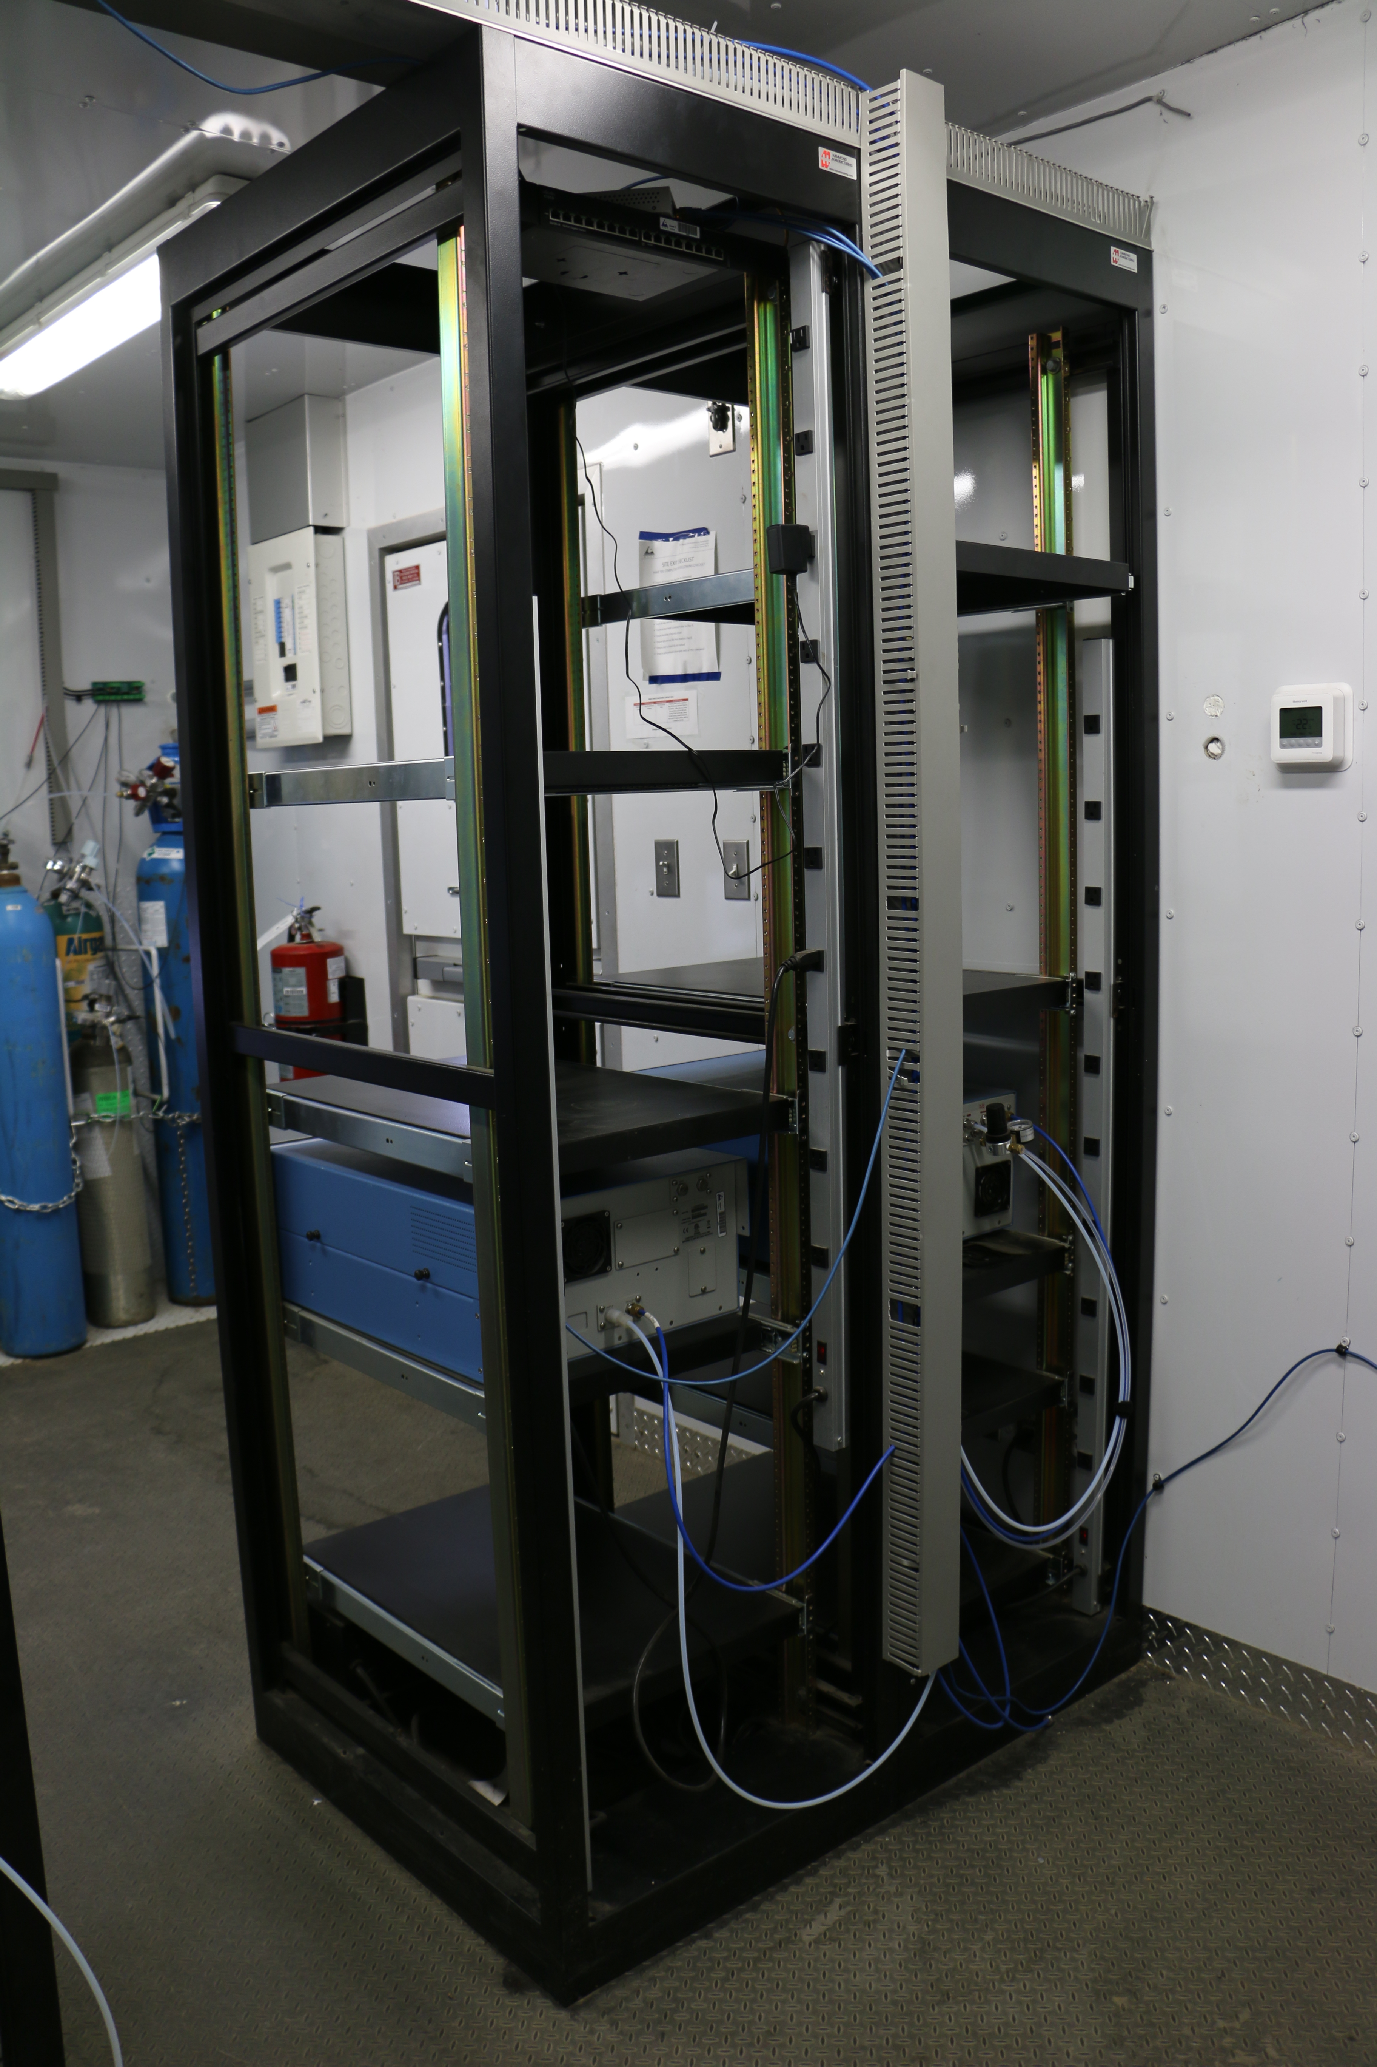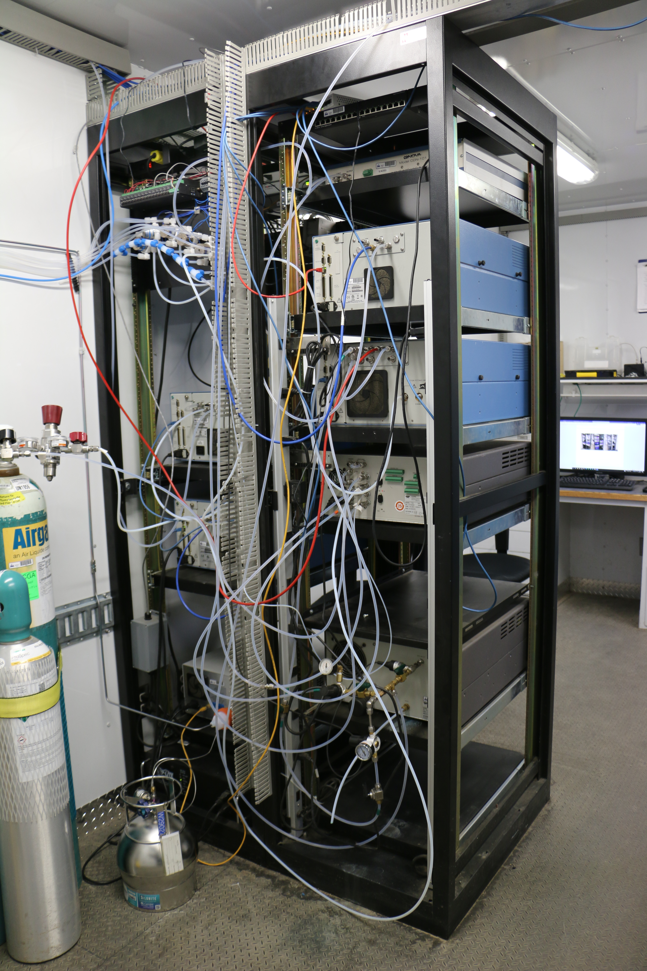
  - Figure 12 –Photo of the front and the back of instrument rack

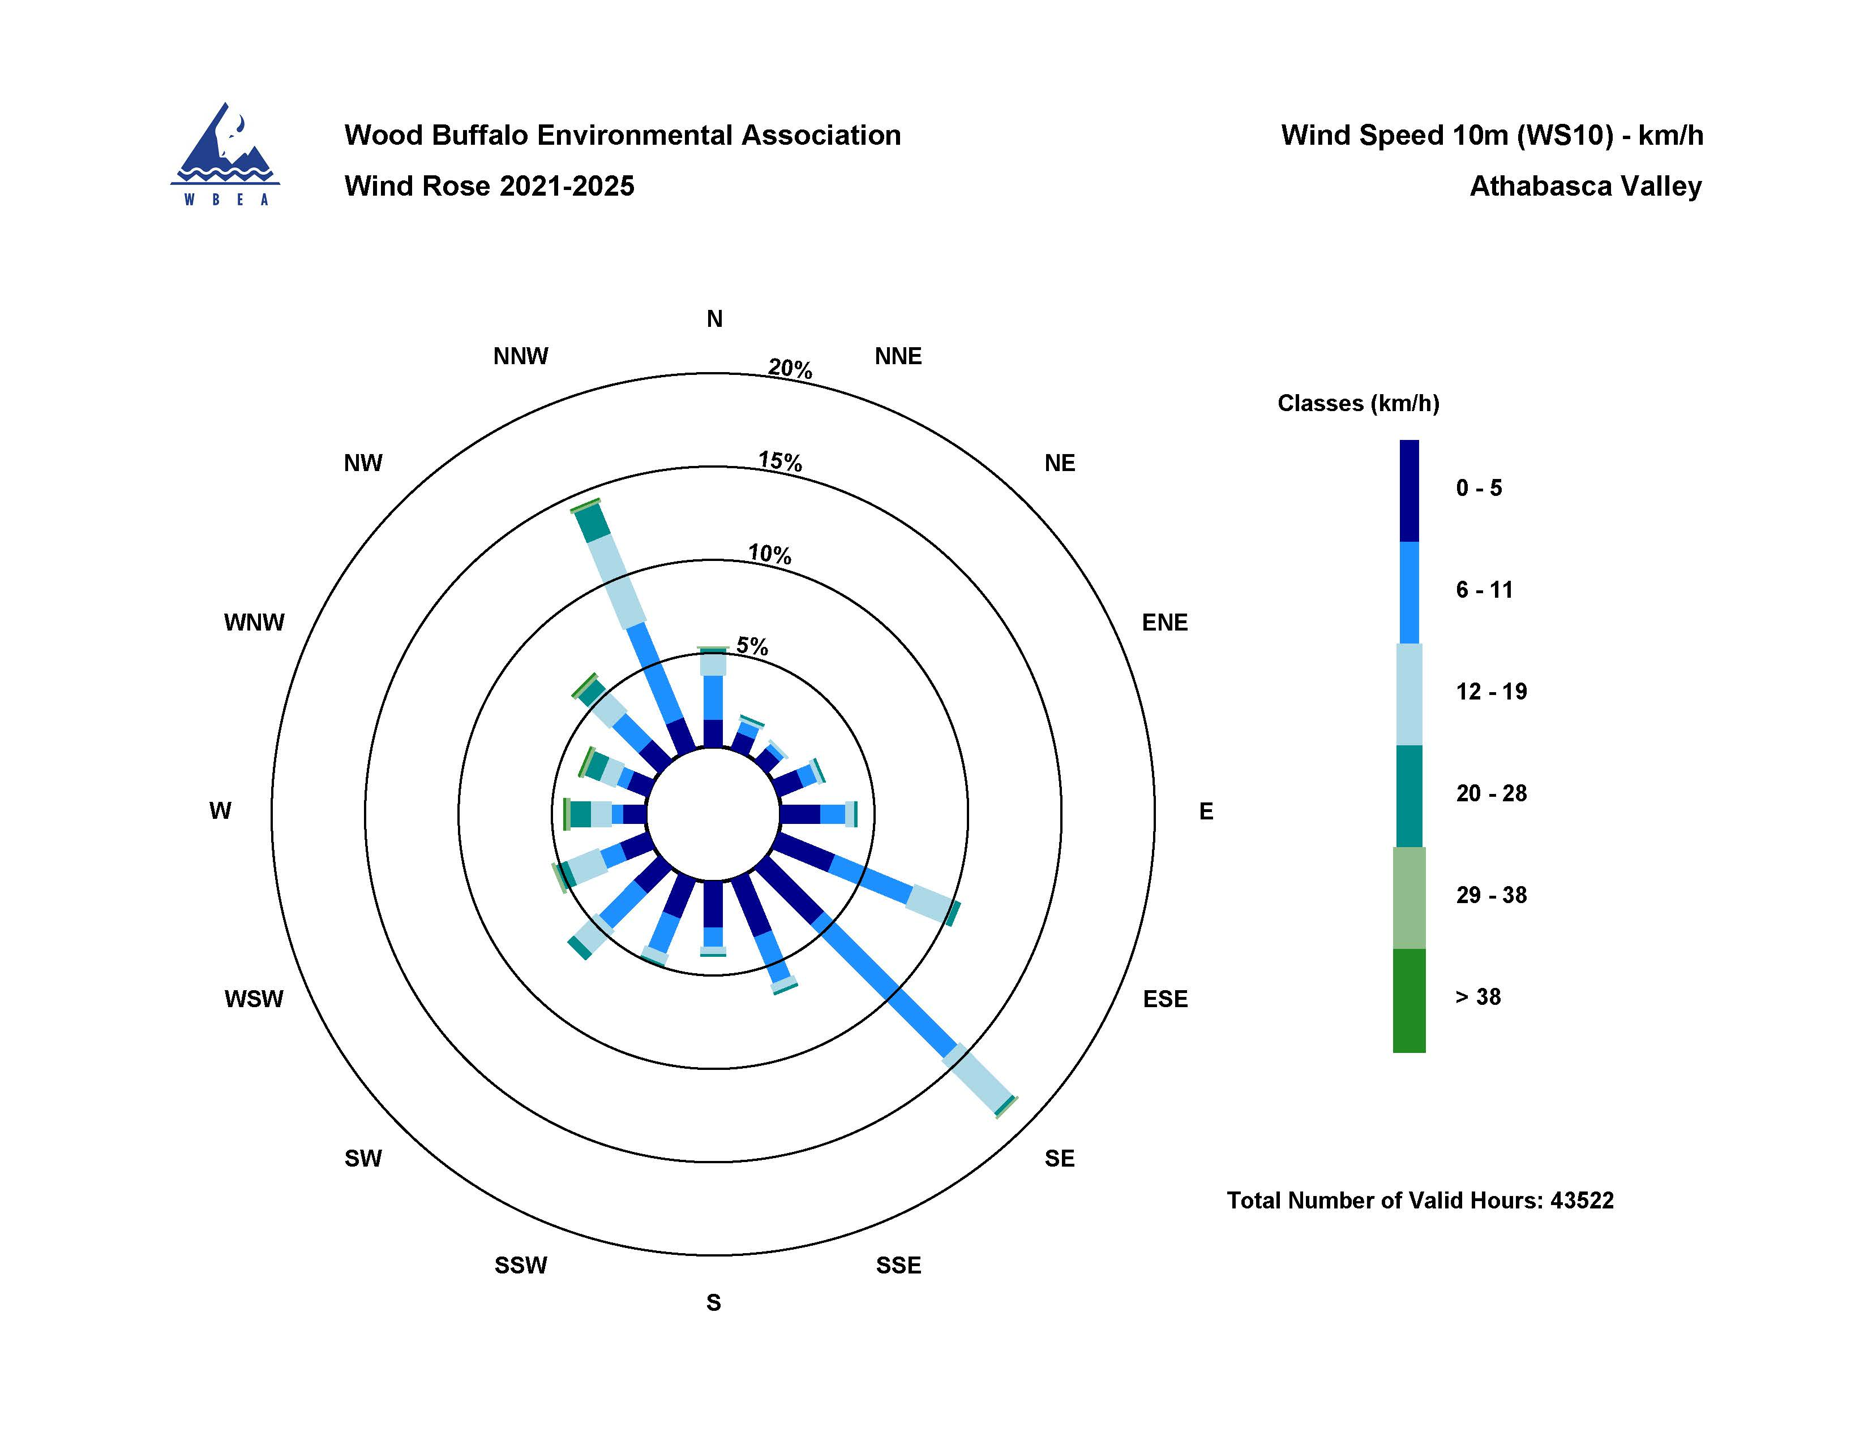

  - Figure 13 – Windrose (2021-2025)

