Wood Buffalo Environmental Association
Ambient Air Monitoring Station
Site Documentation

Kirby South

LAST UPDATED: March 2, 2026

Table of Contents
General Site Information 4
Station 4
Location 4
Owner/Operator/Approval Holder 4
Site Description 4
Site Influences 5
Localized Sources (within 20 metres of station) 5
Roadway Influences 5
Major Point Sources 5
Station Equipment 6
Analytical Equipment 6
Meteorological Equipment 6
Support Equipment 6
Site photos 10
Station Photos 15

Tables and Figures
sFigure 1 – Area Topographic map showing AMS 507 7
Figure 4 – Environment looking North 10
Figure 5 – Environment looking East 11
Figure 6 – Environment looking South 12
Figure 7 – Environment looking West 13
Figure 8 – Meteorological Tower 14
Figure 9 – Photo showing the inlet and sample manifold 15
Figure 10 – Curb shot of the monitoring station 16
Figure 11 –Photo of the front and the back of instrument rack 17
Figure 12 – Windrose (2021-2025) 18

General Site Information
Revision Date: February 18, 2026

Station
Station ID | AMS 507
Station name | Kirby South
Date station established | July 1, 2021

Location
Station street address | G-Pad
Legal land description | 15-21-73-7-W4
Airshed Zone | Wood Buffalo Environmental Association
Latitude | 55.3437334
Longitude | -111.0139229
UTM East | 499117.19
UTM North | 6133043.08
Nearest community | Conklin
Community population | 229
Census Year | 2025

Owner/Operator/Approval Holder
Operating Agency | Wood Buffalo Environmental Association
Address of Operating Agency | Unit 3, 805 Memorial Drive, Fort McMurray, Alberta T9K 0K4
Name of Approval Holder | Canadian Natural Resources Ltd.
Approval number | 20809-02-00
Contact Name | Shawn Milligan
Address | 2100, 855 – 2 st SW. Calgary, AB T2P 4J8
Phone number | 403-896-3109
Email address | shawn.milligan@cnrl.com

Site Description
Land use by sector | 0 – 90 degrees | SAGD Operation
Land use by sector | 91 – 180 degrees | SAGD Operation
Land use by sector | 181 – 270 degrees | SAGD Operation
Land use by sector | 271 – 360 degrees | SAGD Operation
Site elevation  (above sea level) | 730m
Angle of elevation to nearby buildings | Greatest angle | N/A
Angle of elevation to nearby buildings | Building direction | None
Airflow restrictions | North | None
Airflow restrictions | East | None
Airflow restrictions | South | None
Airflow restrictions | West | None
Distance to nearest trees (m) | North | 250
Distance to nearest trees (m) | East | 100
Distance to nearest trees (m) | West | None
Distance to nearest trees (m) | South | 100
Sample manifold | Type | All glass
Sample manifold | Inlet height above roof | 1 metre
Wind Sensors | Type | Cup and vane
Wind Sensors | Height above ground | 10 metres
Wind Sensors | Distance from station | 0 metre

Site Influences

Localized Sources (within 20 metres of station)
Type | Distance (m) | Description
SAGD Operation | 25 | SAGD Oil Pad

Roadway Influences
Type | Traffic Volume | Distance (m) | Description
Site Roadway | Low | 200m | Roadway used by the site workers

Major Point Sources
Facility Name | Source Type | Distance from site (km) | Compass direction from site
Kirby South | SAGD Plant | 0.5 | SW

Station Equipment
Equipment Owner: WBEA

Analytical Equipment
Parameter | Make | Model | Serial Number | Date Instrument Installed | WBEA Data Start Date
SO₂ | Thermo Scientific | 43iQ | 1182340007 | 2021 | January, 2019
H₂S | Thermo Scientific | 43i-LTE | 1150840012 | 2023 | January, 2019
NO/NO_{x}/NO₂ | Thermo Scientific | 42iQ | 1118148496 | 2024 | January, 2019
THC | Thermo Scientific | 51i | 1182340005 | 2021 | January, 2019

Meteorological Equipment
Parameter | Make | Model | Serial Number | WMO Site Class | Date Sensor Installed | WBEA Date Start Date
AT/RH | Vaisala | HMP155 | R3710976 | 4 | 2024 | January, 2019
WS | Met One | 010C-1 | X16479 | 3 | 2021 | January, 2019
WD | Met One | 020C-1 | D13601 | 3 | 2025 | January, 2019

Support Equipment
Name | Description | Make | Model | Serial Number
Datalogger | Datalogger | Campbell Scientific | CR3000 | 2372
Zero air generator | Zero Air Generator | Teledyne/API | 701H | 880
HVAC | Heating and air conditioning system. Wall mount unit | BARD | 1 ton | -
Shelter / Building | Air monitoring portable | ITB | 8 x 16 trailer | 17451-1
Gas Dilution Calibrator | Mass flow controlled gas dilution | Teledyne/API | T700 | 2445
H2S Converter | H2S converter | Global Analyzer Systems | G150 | 2022-197

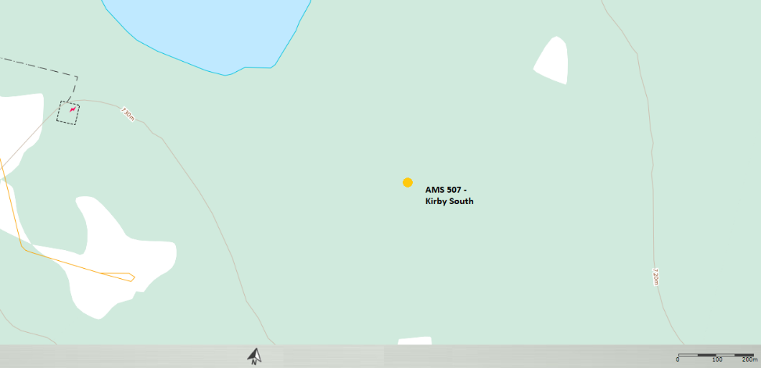
  - Figure 1 – Area Topographic map showing AMS 507

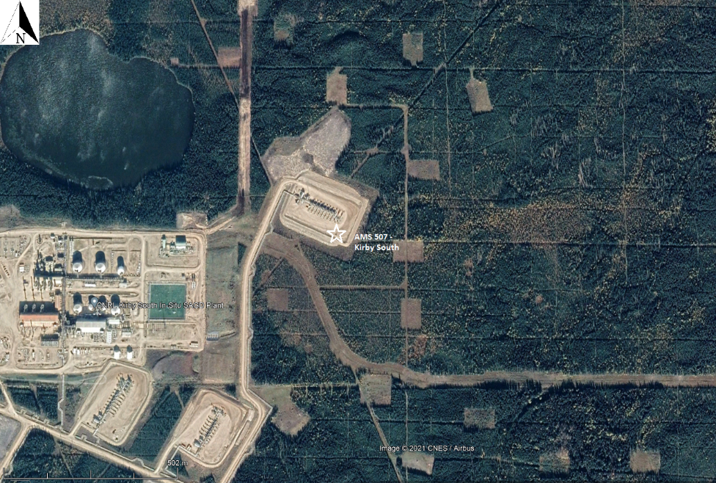Figure 2 – Aerial photo showing AMS 507

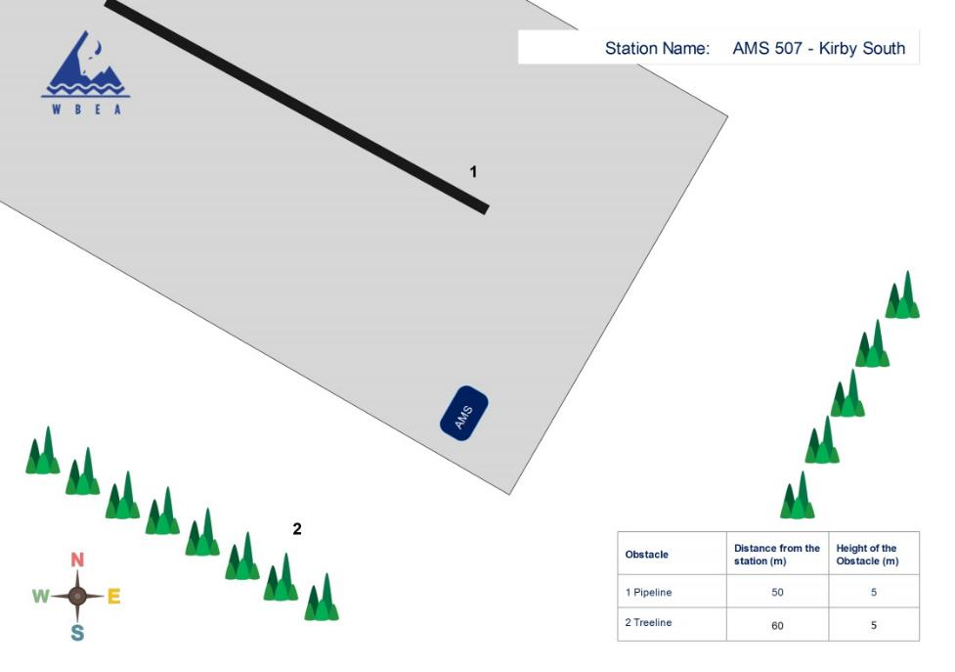Figure 3 – Plan view sketch for AMS 507 site

Site photos
The following photos show the environment surrounding the monitoring station.

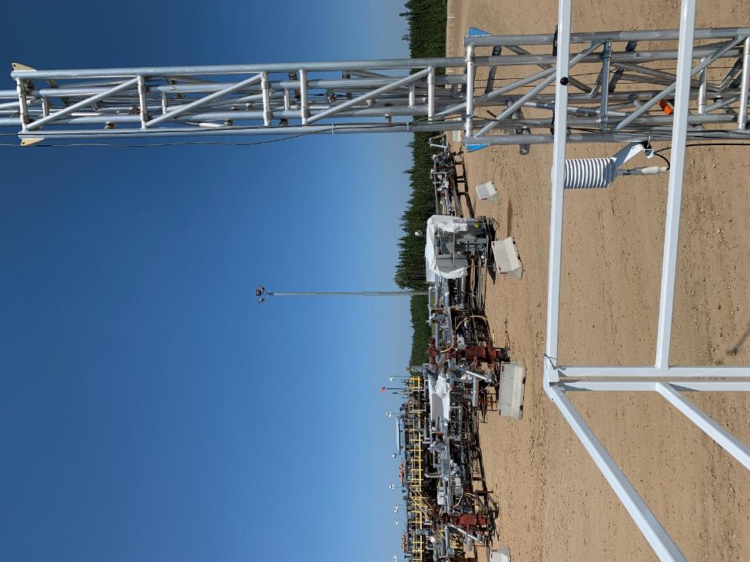
  - Figure 4 – Environment looking North

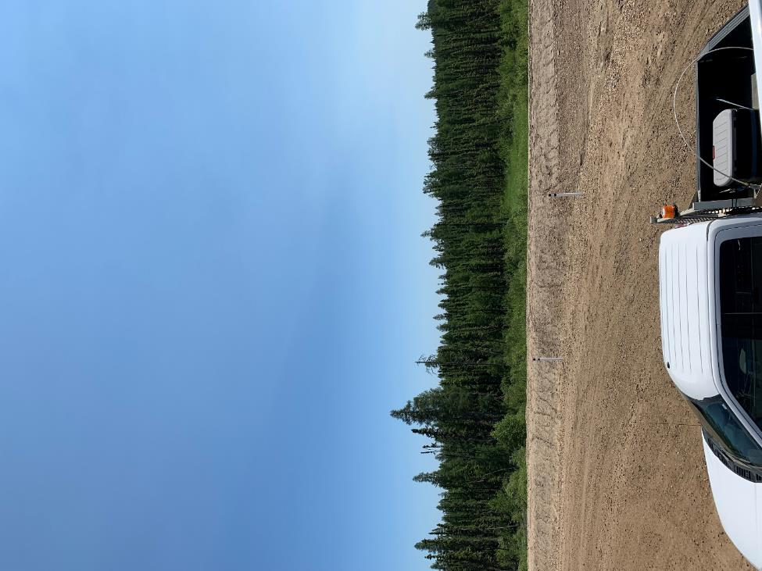
  - Figure 5 – Environment looking East

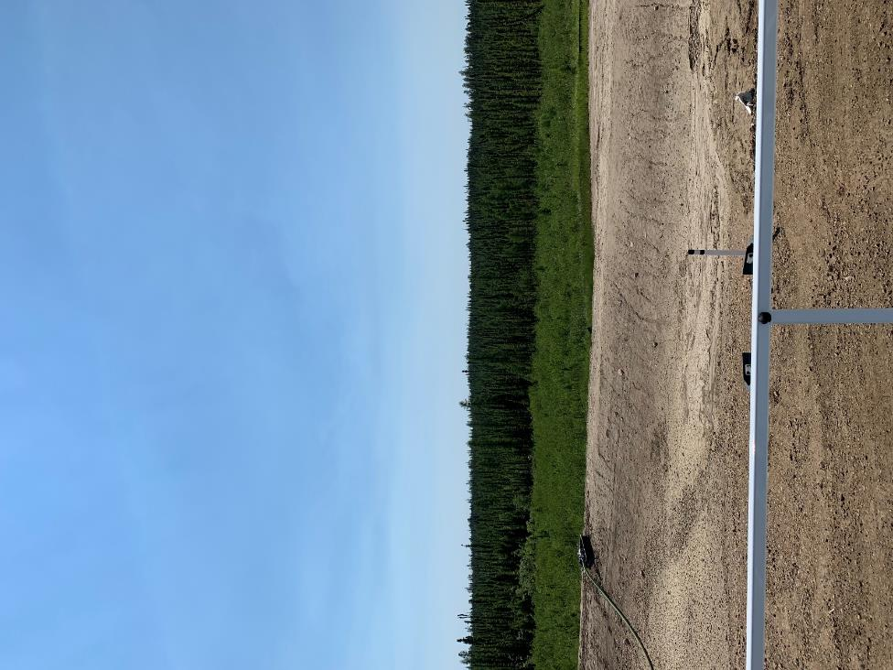
  - Figure 6 – Environment looking South

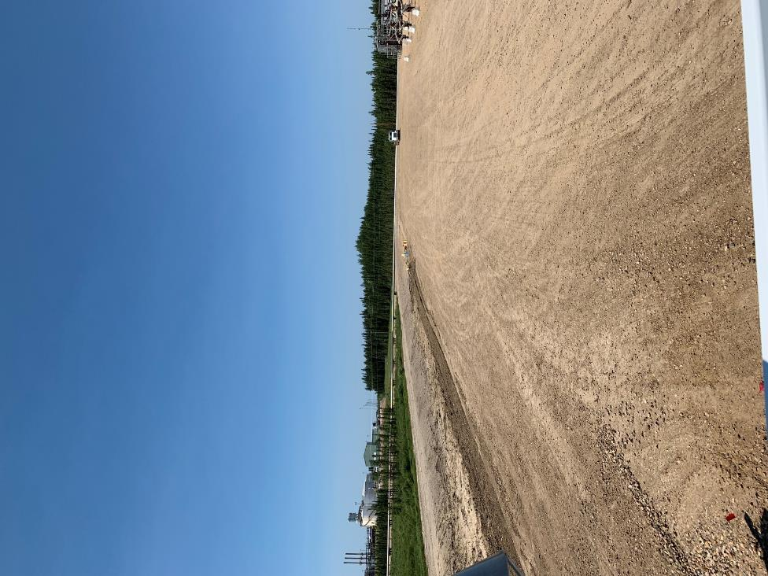
  - Figure 7 – Environment looking West

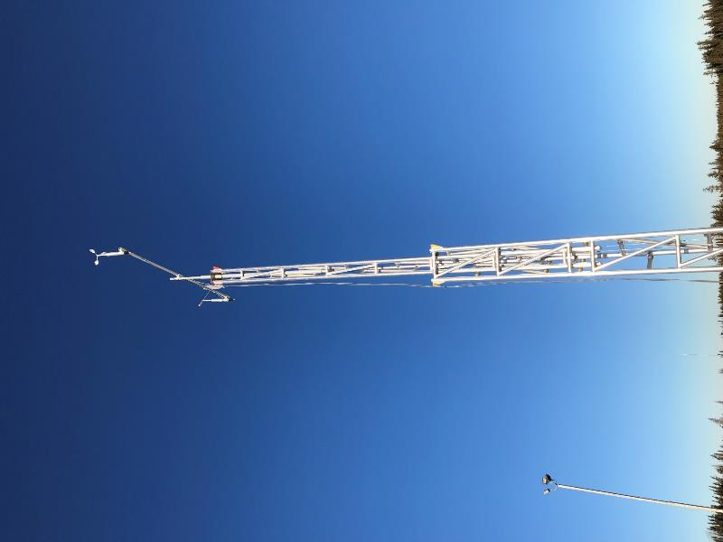
  - Figure 8 – Meteorological Tower

Station Photos
The following photos show the monitoring station and instrumentation.

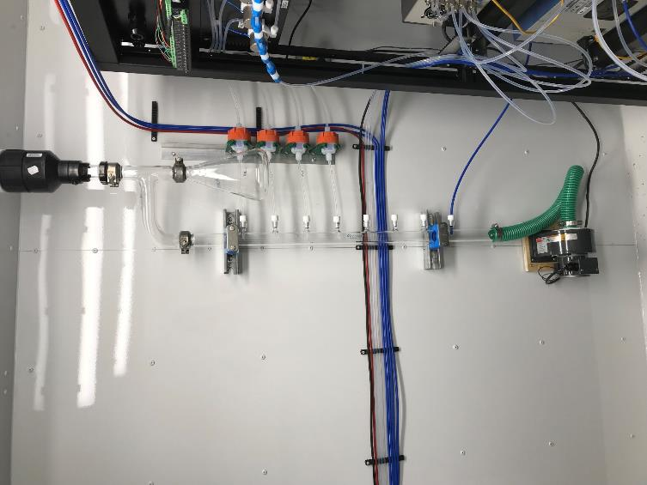
  - Figure 9 – Photo showing the inlet and sample manifold

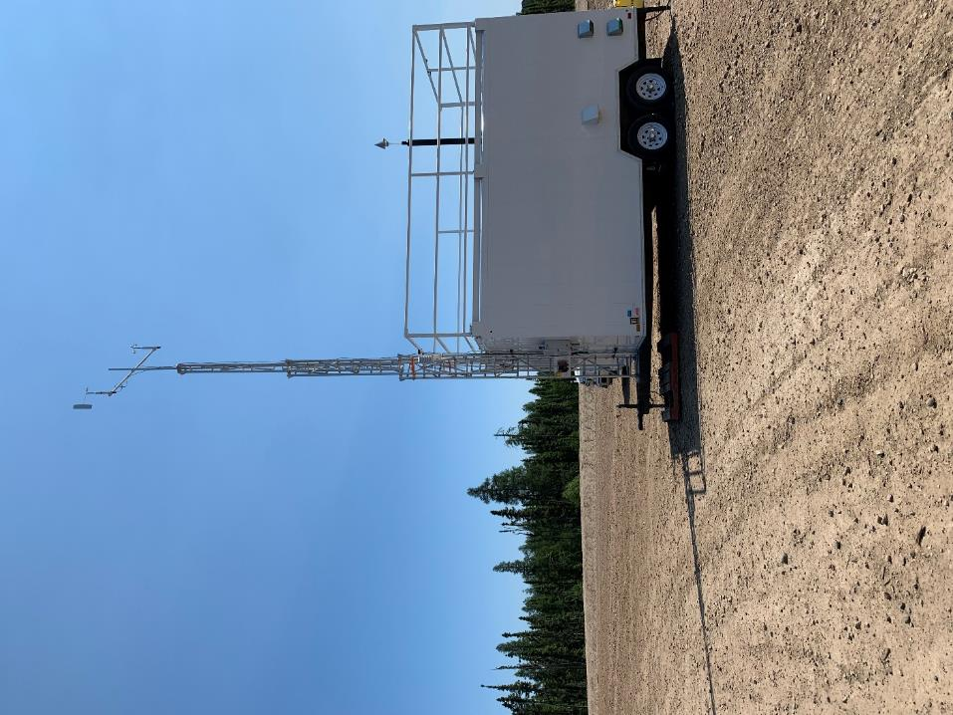
  - Figure 10 – Curb shot of the monitoring station
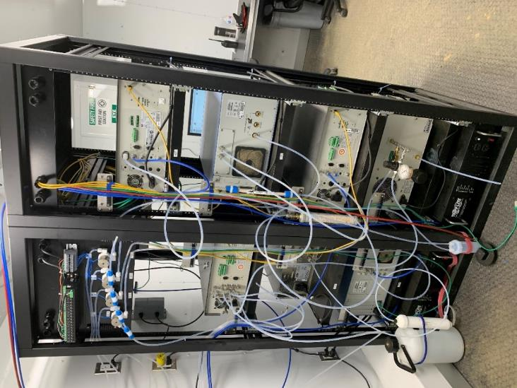
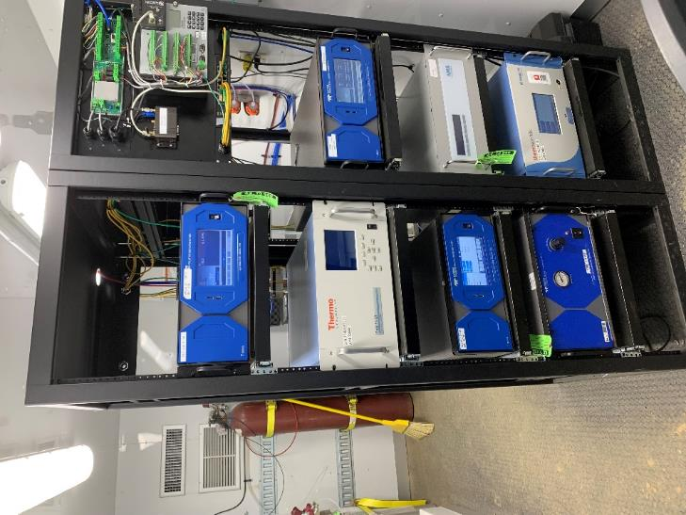
  - Figure 11 –Photo of the front and the back of instrument rack

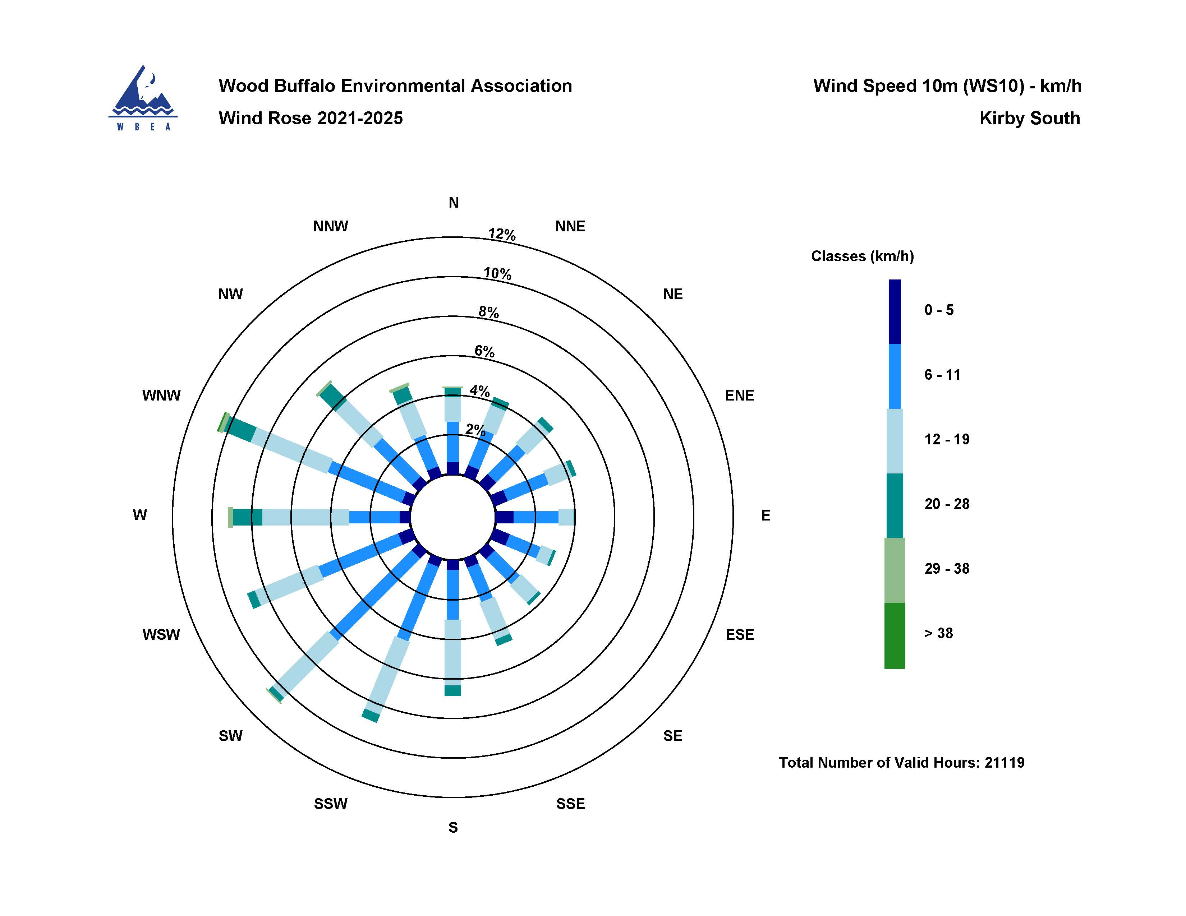

  - Figure 12 – Windrose (2021-2025)

